California Department of Education
Executive Office
SBE-003 (REV. 11/2017)
tlsb-elsd-jan19item01

California State Board of Education
January 2019 Agenda
Item #09

Subject
Approval of the recommended English Language Proficiency Assessments for California Criterion for Reclassification.

Type of Action
Action, Information

Summary of the Issue(s)
California Education Code (EC) Section 313(b) provides that “The department, with the approval of the state board, shall establish procedures for conducting the assessment required pursuant to subdivision (a) and for the reclassification of a pupil from English learner to English proficient.”
The California Department of Education (CDE) has identified an English Language Proficiency Assessments for California (ELPAC) reclassification criterion for each grade level to guide reclassification decision-making, as set forth in California EC Section 313(f)(1). This recommendation is based on the Summative ELPAC threshold scores approved by the State Board of Education (SBE) in November 2018.

Recommendation
The CDE recommends that the SBE approve the State Superintendent of Public Instruction’s (SSPI’s) proposed use of ELPAC Overall Performance Level (PL) 4 as the English language proficiency criterion for reclassification decision-making beginning with the 2018–19 Summative ELPAC administration for grades K–12.

Brief History of Key Issues
Both state and federal law require local educational agencies (LEAs) to ensure English learners make progress towards English proficiency, and remedy any academic deficits incurred while learning English, within a reasonable amount of time.
Pursuant to California EC 313(b), the department, with the approval of the state board, shall establish procedures for conducting the assessment required pursuant to subdivision (a) and for the reclassification of a pupil from English learner to English proficient.
Currently, California has four criteria in law and they remain until new legislation is passed or amended. California EC Section 313(f) defines the criteria required for determining whether to reclassify a student as proficient in English as follows:
- Assessment of language proficiency using the state test of English language proficiency;
- Teacher evaluation including a review of the student’s curriculum mastery;
- Parent opinion and consultation; and
- Comparison of student performance in basic skills against an empirically established range of performance in basic skills based on the performance of English proficient students of the same age.”
Additionally, Section 3113(b)(2) of the Elementary and Secondary Education Act (ESEA) of 1965, as amended by the Every Student Succeeds Act (ESSA), requires each state agency to establish standardized entrance and exit procedures for English learners. The December 2018 memo describes the department’s ongoing efforts to develop standardized tools to guide the teacher evaluation and parent consultation elements of reclassification decision-making.
In November 2018, the SBE approved the new Summative ELPAC threshold scores for use beginning with the 2018–19 administration. The new Summative ELPAC threshold scores were set by grade level for K–8 and by grade span for 9–10 and 11–12, which are reported on a Level 1–4 scale. The new threshold scores will be used to determine the overall designation level for English language proficiency.
With the approval of the state board, the CDE will update reclassification guidance to LEAs regarding use of Summative ELPAC results to determine whether a student has met the English language proficiency criterion. Additionally, the CDE will report annually to the U.S. Department of Education, the number of English learners meeting proficiency on the ELPAC and the number of students making progress towards proficiency.

Approval of ELPAC Reclassification Criterion Based on Updated Supplemental Empirical Analyses
In November 2018, the Assessment Development and Administration Division presented two studies related to threshold scores using the first operational Summative ELPAC scores. The purpose of this work was to evaluate the degree to which threshold scores and performance levels of the Summative ELPAC consistently distinguish between levels of students’ English proficiency based on the teacher ratings. The supplemental empirical analyses, performed by the California Comprehensive Center at WestEd, examined how ELPAC Overall PL 4 students might perform on the California Assessment of Student Performance and Progress (CAASPP) English language arts/literacy (ELA) using the 2017–18 threshold scores.
These studies indicated that threshold scores should be modified from grade spans to grade levels in grades K–8. Based on these studies, the CDE recommended new threshold scores and the SBE approved them. With these threshold scores, the CDE increased the rigor of the ELPAC.
A similar supplemental empirical analysis study was conducted using the new SBE-approved threshold scores to establish a recommended ELPAC reclassification criterion for each grade level. This second empirical analysis provides evidence that students who meet this recommended ELPAC reclassification criterion are more likely to perform similar to recent reclassified students and more likely to approximate their English-only peers' performance on the Smarter Balanced Assessments.
Included in Attachment 1 is a report of the supplemental empirical analyses. The results from these updated analyses were presented to the ELPAC Technical Advisory Group (TAG) in November. The ELPAC TAG members recommended the use of Overall PL 4 as the ELPAC criterion for EL reclassification decisions. (One TAG member abstained from making a recommendation.) The TAG members also suggested additional analyses be conducted to support their recommendation. The additional analyses confirm their November 2018 recommendation.

Next Steps
If the SBE approves the recommended criterion for EL reclassification decisions, the CDE will notify superintendents and charter school administrators of the policy decision regarding the 2018–19 ELPAC criterion for EL reclassification as well as develop and disseminate guidance for LEAs on the statewide criterion for determining proficiency using the ELPAC per California EC Section 313(f)(1). The CDE will engage in conversations with the legislature about standardizing the remaining criteria.
The CDE is contracting with WestEd, beginning in December 2018, and ending in June 2020, to develop, pilot, and validate an observation protocol to support teacher evaluation of EL proficiency as it pertains to EL reclassification. The Observation Protocol for Teachers of English Learners (OPTEL), a teacher-administered observational tool, will provide an opportunity to standardize teacher evaluation of a pupil’s English language proficiency while engaging in academic content learning and interacting with peers. Development and validation of the OPTEL will be completed by June 30, 2020, and driven by the specifications of California EC Section 313.3, as added by Assembly Bill 1808, Chapter 32, Statutes of 2018. The CDE anticipates recruiting the same teachers from the ELPAC standard setting panel to participate in the development of the OPTEL.

Summary of Previous State Board of Education Discussion and Action
In December 2018, an Information Memorandum provided the SBE with a summary of the Updated Supplemental Empirical Analyses of the Summative ELPAC utilizing the 2018–19 SBE-approved threshold scores (https://www.cde.ca.gov/be/pn/im/index.asp).
In November 2018, the SBE approved the SSPI’s recommended Summative ELPAC threshold scores for the 2018–19 administration and beyond (https://www.cde.ca.gov/be/ag/ag/yr18/documents/nov18item09.docx).
In October 2018, an Information Memorandum provided the SBE with a summary of the Summative ELPAC Threshold Score Validation Study and Supplemental Empirical Analyses (https://www.cde.ca.gov/be/pn/im/infomemooct2018.asp).
In July 2018, the SBE approved amended ELPAC regulations (https://www.cde.ca.gov/be/ag/ag/yr18/documents/jul18item04.docx).
In December 2017, an Information Memorandum provided the SBE with an update on the development of the ELPAC, including a detailed timeline (https://www.cde.ca.gov/be/pn/im/documents/memo-pptb-adad-dec17item03.docx).
In November 2017, the SBE approved the SSPI’s recommended Summative ELPAC threshold scores establishes through an ELPAC standard setting workshop (https://www.cde.ca.gov/be/ag/ag/yr17/documents/nov17item08.doc).
In September 2006, the SBE reviewed and adopted modified guidelines for reclassification of English learners (https://www.cde.ca.gov/be/ag/ag/documents/agenda0906.pdf).
In July 2006, the SBE received information regarding proposed modifications to guidelines for reclassification of English learners based on modified CELDT scores (https://www.cde.ca.gov/be/ag/ag/documents/agenda0706corrected.pdf).
In March 2006, the SBE received a report on the new reporting scale and standard setting for the CELDT. The adjusted performance level scores that resulted from the standard setting were approved at that time (https://www.cde.ca.gov/be/ag/ag/documents/agenda0306.pdf).
In December 2005, the SBE received information about a CELDT performance level standard setting scheduled to be conducted in February 2006.

Fiscal Analysis (as appropriate)
None.

Attachment(s)
Attachment 1: Updated Report on Supplemental Empirical Analyses of the English Language Proficiency Assessments for California (15 Pages)

Attachment 1

Updated Report on Supplemental Empirical Analyses of the English Language Proficiency Assessments for California
Robert Linquanti, Min Huang, and Eric Crane
California Comprehensive Center at WestEd

Background
At the request of the California Department of Education (CDE), in August through September 2018, the California Comprehensive Center at WestEd (CA CC) conducted initial supplemental empirical analyses to examine the relationship of English Learners’ (ELs) achievement on the California Assessment of Student Performance and Progress (CAASPP) English language arts/literacy (ELA) relative to their Summative English Language Proficiency Assessments for California (ELPAC) performance. These analyses of ELs’ CAASPP ELA performance by ELPAC Overall performance level used the 2017–18 ELPAC threshold scores approved by the State Board of Education (SBE) in November 2017. In addition, the Educational Testing Service (ETS) conducted a threshold score validation study utilizing teacher judgments of students’ English language proficiency compared to student performance on the Summative ELPAC. Validation of threshold scores and empirical analyses of the relationship of ELPAC to CAASPP ELA are critical for appropriate test use and state-level policy discussions on establishing an ELPAC criterion for EL reclassification decisions.
The results from the threshold score validation study and the initial empirical analyses suggested that increasing the threshold scores, particularly where ELPAC Overall performance level (PL) 3 ends and PL 4 begins, would set the ELPAC Overall PL 4 threshold to more closely approximate the performance level estimations of EL students given by teachers and the achievement distribution of the English-only (EO) students on the CAASPP ELA assessment. The CDE therefore proposed new threshold scores for the summative ELPAC, which the SBE unanimously approved at its November 2018 meeting. As a result, the CDE requested the CA CC to conduct further supplemental analyses of the achievement of EL students on CAASPP ELA disaggregated by the Summative ELPAC performance levels using the SBE’s newly adopted Summative ELPAC threshold scores. These additional empirical analyses are intended to help inform the CDE’s proposal to the SBE for the ELPAC English language proficiency criterion to be used in EL reclassification for the 2018–19 administration and beyond.
Specifically, the present empirical analyses examined the relationship of student Summative ELPAC test scores and performance levels—applying the SBE’s November 2018 threshold scores to the first operational (2018) Summative ELPAC—to student test scores and performance levels on the 2018 CAASPP ELA. Both assessments were administered in spring 2018. The ELPAC is administered in test forms by grade (kindergarten, one, and two) or grade span (three through five, six through eight, nine through ten, and eleven through twelve). The CAASPP is administered by grade in grades three through eight and grade eleven.

Timeline and Data Sources
For these analyses, which were conducted in November through December 2018, the CDE supplied the CA CC with an updated, matched student level data file containing: (a) 2018 CAASPP ELA assessment data for all students in grades three through eight and grade eleven, including overall scale score and achievement level results, as well as results for each ELA claim area; and (b) 2018 Summative ELPAC assessment data for all EL students in grades three through eight and grade eleven, including scale score and performance level results at the overall, and oral and written composite domains using the newly SBE-adopted Summative ELPAC threshold levels.
The CA CC team conducted the empirical analyses during early November, and presented preliminary results to staff from the CDE Assessment Development and Administration Division (ADAD) and English Learner Support Division (ELSD) as well as members of the ELPAC Technical Advisory Group (TAG) on November 16, 2018. The CA CC team conducted further empirical analyses during November through December, and shared results periodically with staff from ADAD and ELSD. The CA CC team also prepared a brief summary of these updated supplemental analyses for the CDE’s December Information Memorandum to the SBE regarding findings to date and additional analyses suggested by the ELPAC TAG.

Analytic Methods
Three analytical methods were undertaken:
- Descriptive box plot analysis examines the distribution of overall scale scores on CAASPP ELA for ELs by each performance level on ELPAC, for each applicable grade level. This analysis also includes the distribution of overall scale scores on CAASPP ELA for reclassified fluent English proficient (RFEP), initially fluent English proficient (IFEP), and monolingual English (English-only, or EO) students for comparison. The purpose of the analysis is to identify an ELPAC performance level where (a) ELs have an equal likelihood of scoring at or above the CAASPP ELA Level 3 threshold (Standard Met); or (b) ELs’ score distribution on CAASPP ELA is very similar to that of EO students statewide.
- Logistic regression analysis estimates the probability of reaching Level 3 (Standard Met) on CAASPP ELA for each ELPAC overall scale score. This approach helps to identify the ELPAC overall scale score range in which ELs have a probability equal to or greater than 50 percent of attaining that standard on the CAASPP ELA.
- Decision consistency analysis analyzes ELPAC and CAASPP ELA proficient-level categorizations and optimizes consistent categorization of ELs at or above the current CAASPP ELA threshold score for Level 3 (Standard Met). The analysis determines the ELPAC overall scale score range that maximizes the amount of agreement between achieving ELPAC proficiency and CAASPP ELA proficiency.

Findings
Distribution of ELs by ELPAC overall performance level
For grades three through eight and grade eleven, a total of 15.3 percent of ELPAC examinees attained the 2018 ELPAC Overall performance level (PL) 4, which is currently the performance level for the English-proficient criterion based on the 2018–19 threshold scores approved by the SBE at its November 2018 meeting. This represents a decrease from the total of 24 percent of ELPAC examinees that attained Overall PL 4 under the 2017–18 ELPAC threshold scores approved by the SBE in November 2017. While the proportion of ELPAC examinees at Overall PLs 3 and 1 changed little in the examined grades (from 41.6% to 39.8%, and from 11.7% to 11.9%, respectively), the proportion of students at Overall PL 2 has increased substantially (from 22.7% to 33.1%) under the new threshold scores. Figure 1 illustrates the distribution of ELs’ ELPAC Overall performance levels by grade. As can be seen, the new threshold scores, now set for each grade within grade-span test forms, yield more uniform proportions of ELs at each ELPAC performance level across grades, and effectively eliminate the “sawtooth” effect previously seen across grades within grade-span test forms where performance standards had been set by grade span.

Figure 1. Distribution of ELs by ELPAC overall performance level and grade, applying SBE November 2018 Thresholds.
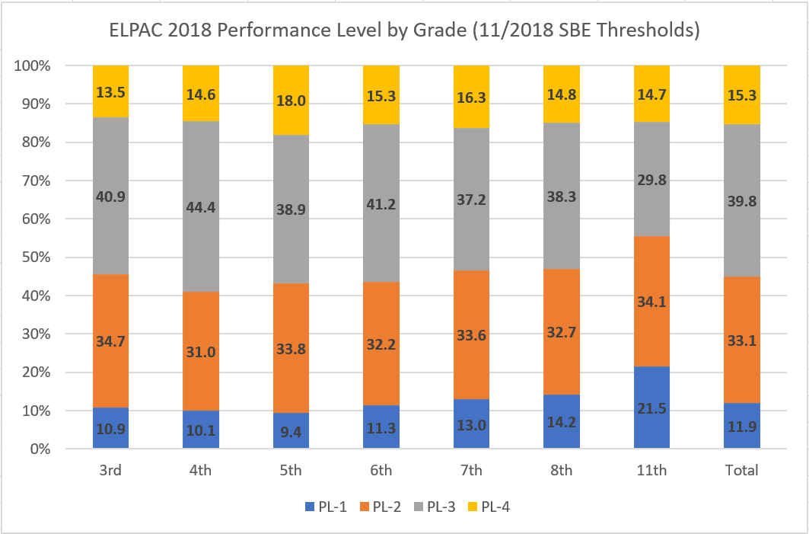

ELs’ performance on CAASPP ELA by ELPAC overall performance level
Updated grade-level ELPAC-CAASPP empirical analyses largely converged across methods. Analyses suggest that, across all grades tested on CAASPP ELA, the performance of ELs at ELPAC Overall PL 4 improves under the newly adopted ELPAC threshold scores when compared to the 2017–18 threshold scores. That said, for grades five through eight and grade eleven, ELs at ELPAC Overall PL 4 still do not demonstrate an equal likelihood of attaining Level 3 on CAASPP ELA, nor do they approximate EO student performance. This is particularly so for ELs in grades seven, eight, and eleven. In grades three and four, ELs at ELPAC Overall PL 4 have an equal or greater likelihood of reaching Level 3 on CAASPP ELA, and of approximating or exceeding the performance of EO students on CAASPP ELA. The following sections illustrate these findings at selected grades for each of the analytic methods used.
Results from descriptive box plot analyses
Figures 2 through 4 display box plots for grades four, seven, and eleven, respectively, and examine the distribution of overall scale scores on CAASPP ELA for ELs by each overall performance level on ELPAC for these grades. Each figure also displays the distribution of overall scale scores on CAASPP ELA for RFEP, IFEP, and EO students for comparison. As illustrated in Figure 2, in grade four, ELs at ELPAC Overall PL 4 have an equal likelihood of reaching Level 3 on CAASPP ELA and approximate the performance of EO students. ELs at ELPAC Overall PL 4 in grade three (not shown) also exceed the performance of EO students on CAASPP ELA. ELs at ELPAC Overall PL 4 in grades five and six (not shown) drop below an equal likelihood of attaining Level 3 on CAASPP ELA and, as seen in Figures 3 and 4, in grades seven and eleven, respectively, the proportion of ELs at ELPAC Overall PL 4 attaining Level 3 on CAASPP ELA drops well below 50 percent, with median and mean values that are below those of their EO counterparts. Similar results (not shown) were found in grade eight for ELs at Overall PL 4.

Figures 2 through 4. CAASPP ELA performance by ELPAC overall performance level or language status (box plot analysis)
Figure 2. Grade 4 Figure 3. Grade 7
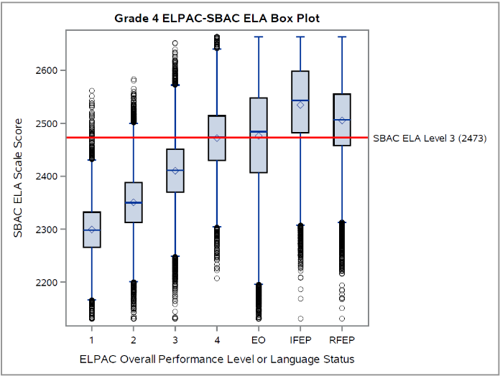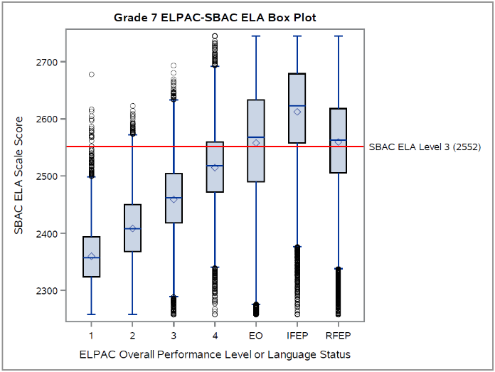
Figure 4. Grade 11
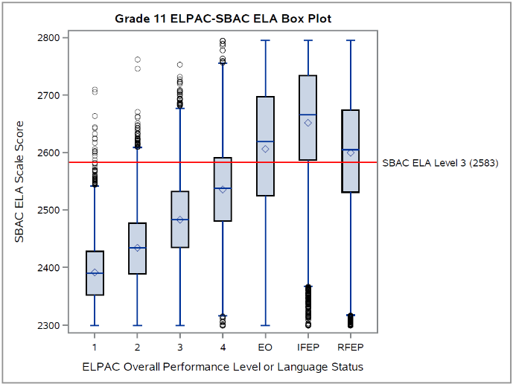
Results from logistic regression analysis
The CA CC team also conducted logistic regression analyses of EL student performance on CAASPP ELA by ELPAC overall scale score to estimate the probability of reaching Level 3 (Standard Met) on CAASPP ELA for each ELPAC overall scale score value. These analyses largely corroborated the findings from the box plot analyses. That is, other than grade three (not shown), where ELs at ELPAC Overall PL 4 were estimated to have an equal probability of scoring at Level 3 on CAASPP ELA, ELs at Overall PL 4 in all other grades examined displayed probabilities well below the 50 percent level. For example, the fitted logistic regression model for grade four (see Figure 5) predicts that 30 percent of ELs at Overall PL 4 would score at or above Level 3 on CAASPP ELA, while those for grades seven and eleven (see Figures 6 and 7) predicts that 10% of ELs at Overall PL 4 would attain such a score on CAASPP ELA.

Figures 5 through 7. Estimated CAASPP ELA performance by ELPAC overall scale score (logistic regression analysis)
Figure 5. Grade 4 Figure 6. Grade 7
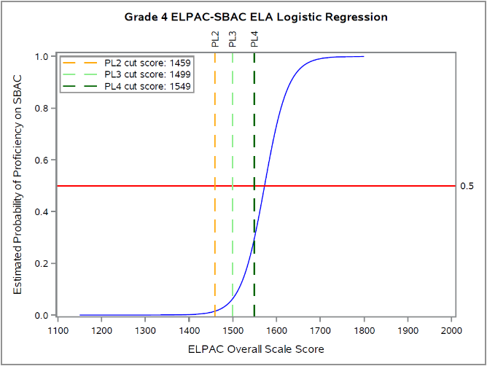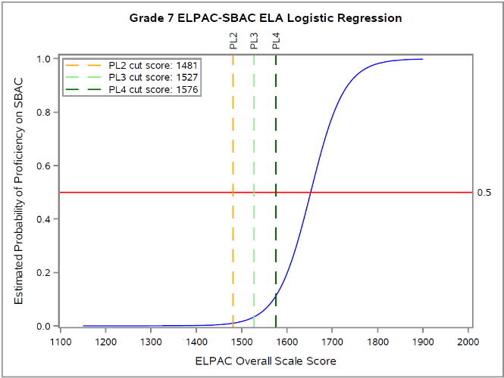
Figure 7. Grade 11
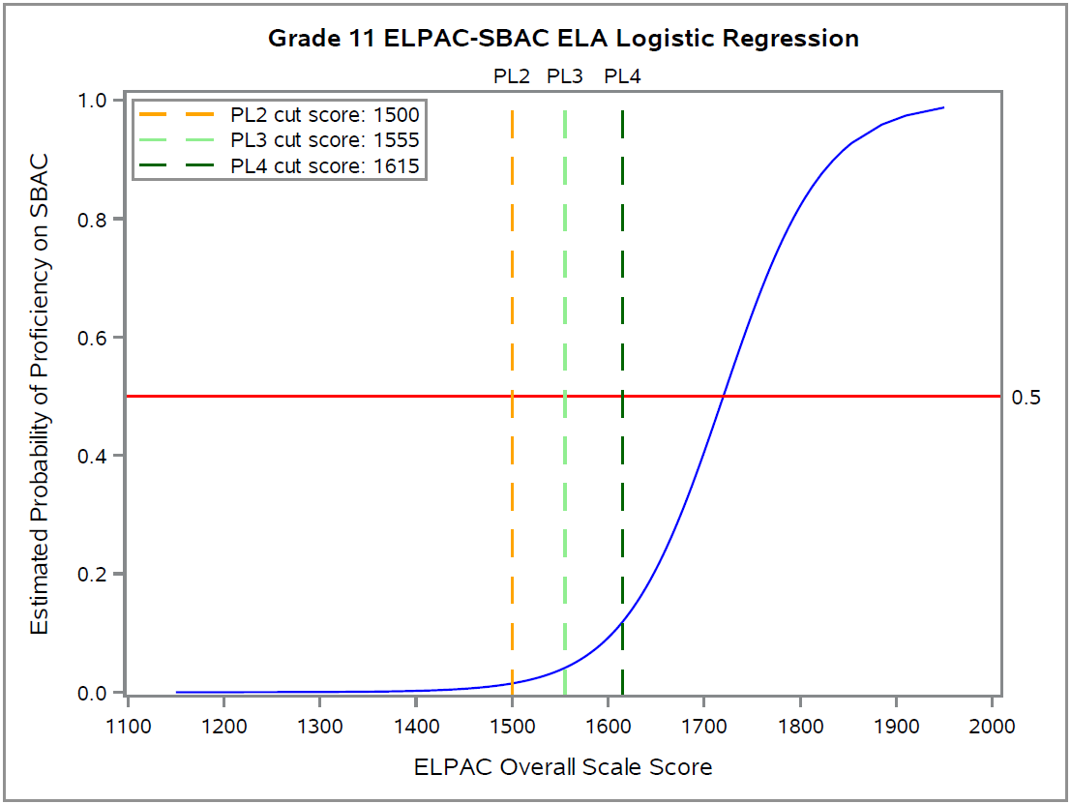
Results from decision consistency analysis
The CA CC team also conducted for each applicable grade level a decision consistency analysis, which analyzes ELPAC and CAASPP proficient-level categorizations and optimizes consistent categorization of ELs at or above the current CAASPP ELA threshold score for Level 3 (Standard Met). Again, results of these analyses corroborate earlier findings from box plot and logistic regression analyses. As Figure 8 illustrates, for grade four (as with grade three, not shown), consistent decisions are maximized at the lower end (threshold to below the midpoint) of the Overall PL 4 scale score range. That is, after that point, the curves slope downward, indicating a student’s ELP performance no longer contributes to maximizing consistent decisions. However, all other grades examined—see Figures 9 and 10, for grades seven and eleven, respectively—indicate that consistent decisions are not maximized (i.e., the curves at the median value of both the lower and higher half of Overall PL 4 continue to have increasing slopes through the scale score range). However, under the new threshold scores, these slopes rise more gradually than before, suggesting that consistent decisions have improved in these grades.
Figures 8 through 10. ELPAC overall performance level and CAASPP ELA Level 3 categorization consistency (decision consistency analysis)

Figure 8. Grade 4Figure 9. Grade 7
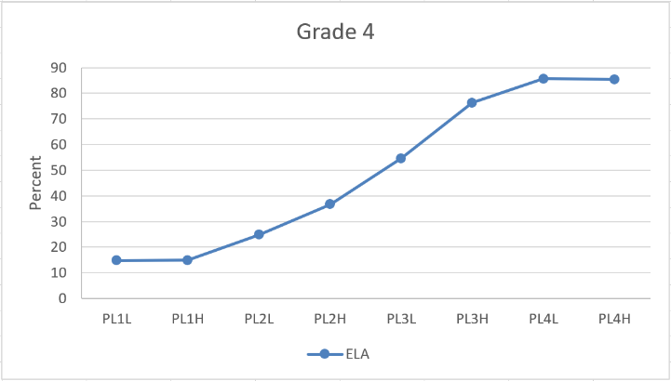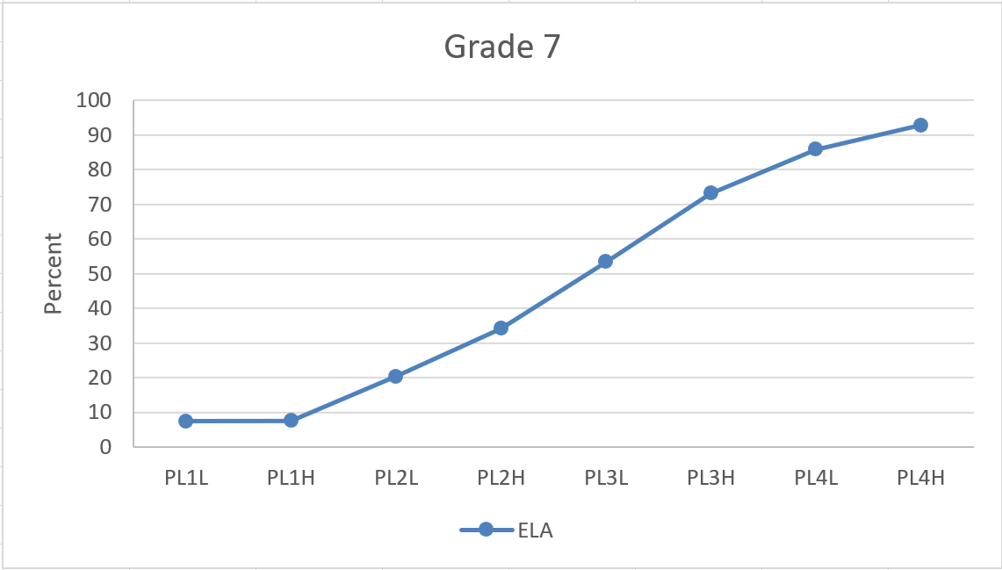
Figure 10. Grade 11
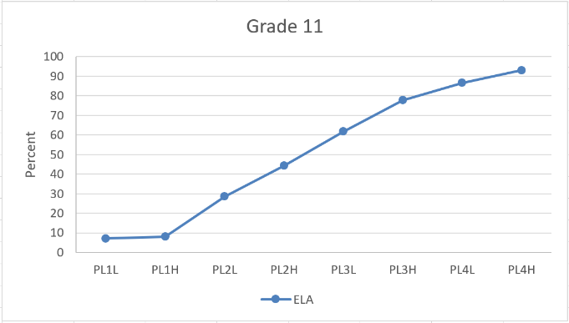
Note: PL#L and PL#H denote scale scores below the midpoint, and at or above the midpoint, respectively, of the scale score range for each ELPAC Performance Level.
Exploratory analysis of performance on CAASPP ELA for ELs with ELPAC Overall PL 4 using conjunctive rule options
In light of these findings, the CA CC team again analyzed options for applying conjunctive rules related to the ELPAC oral and written composite domains for EL students at ELPAC Overall PL 4. Specifically, the team examined how conjunctive rules that further disaggregate the performance of ELs at Overall PL 4 might identify a subgroup of these ELs demonstrating an equal probability of attaining Level 3 on CAASPP ELA or approximating EO students’ performance.
First, in re-examining the performance level of each composite domain for ELs with ELPAC Overall PL 4 using the November 2018 threshold scores (Figure 11), the CA CC team found, in grades four through eight, a decrease in the proportion of students with both oral and written composite domains at PL 4, and increases in the proportion with either the oral composite domain (comprising listening and speaking) or the written composite domain (comprising reading and writing) at or below PL 3, compared to those under the 2017–18 threshold scores. Those ELs at Overall PL 4 in grades three and eleven showed a slight increase in the proportion with both oral and written composite domains at PL 4.

Figure 11. Distribution of ELs at ELPAC Overall PL 4 by composite domain level and grade
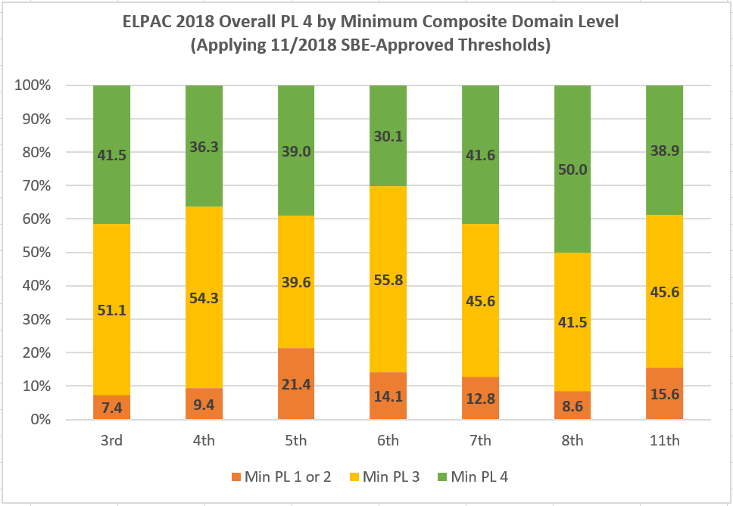

The team again disaggregated ELs with ELPAC Overall PL 4 into various profiles for analysis to explore whether composite domain performance affects performance on CAASPP ELA and warrants inclusion in defining an English-proficient criterion. Applying these conjunctive rules shifted outcomes for those ELs at ELPAC Overall PL 4 meeting conjunctive minimum requirements to more often meet or exceed an equal likelihood of attaining CAASPP ELA Level 3 or to more closely approximate the performance of EO students. For example, applying a conjunctive minimum rule that requires Overall PL 4 and written composite domain at PL 4, ELs in grades three through seven approximate equal likelihood of attaining CAASPP ELA Level 3, while under the 2017–18 threshold scores only ELs in grades three and four did so. ELs meeting this conjunctive minimum rule in grades eight and eleven did not attain these levels, although they did substantially improve relative to their performance under the 2017–18 thresholds. Figures 12 through 14 below illustrate these outcomes for ELs in grades four, seven, and eleven, respectively.

Figures 12 through 14. CAASPP ELA performance by ELPAC overall PL 4 composite domain profile or language status (box plot analysis)

Figure 12. Grade 4 Figure 13. Grade 7
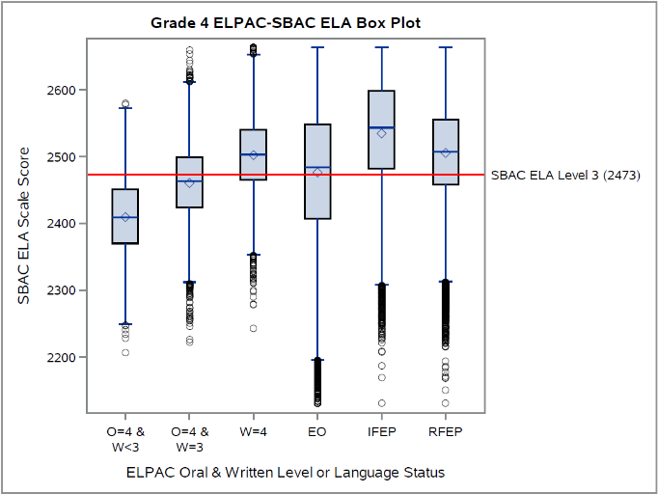 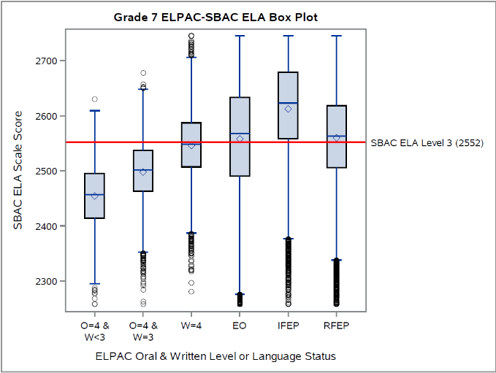 Note: O: Oral composite domain; W: Written composite domain; PL levels of each are as indicated.
Figure 14. Grade 11
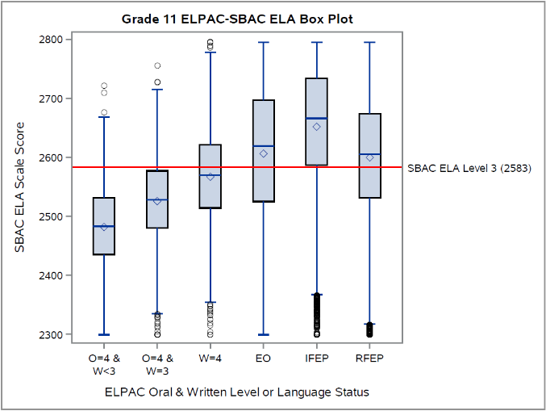
Note: O: Oral composite domain; W: Written composite domain; PL levels of each are as indicated.
However, the proportion of ELs meeting these conjunctive minimum requirements decreased substantially: Under the 2017–18 ELPAC threshold scores, 11.5 percent to 12.3 percent of ELs met the requirements; under the current ELPAC threshold scores, 6.0 percent to 6.6 percent of ELs met them (depending upon conjunctive minimum rules applied).
Comparing performance on CAASPP ELA of ELs with ELPAC Overall PL 4 to similarly situated EO students and new RFEP students
In an additional analysis endorsed by the CDE and the ELPAC TAG, the CA CC team compared the performance on CAASPP ELA of ELs scoring at ELPAC overall PL 4 using the SBE-approved November 2018 thresholds to three sub-groups of non-EL students: (a) new RFEP students—who were most recently reclassified (in school year 2016–17) using locally determined district criteria in place across the state’s LEAs; (b) EO students who are similarly situated to the EL student population with respect to economic disadvantage and IDEA status; and (c) similarly situated new RFEP students. Regarding similarly situated populations, the rationale for doing these additional analyses was to consider the effect of factors that are well-documented to influence academic performance beyond English language proficiency. Regarding new RFEP students, it was to consider those students who most recently exited EL status and are therefore most comparable to ELs that meet any proposed ELPAC exit criterion.
For the latter, Figures 15 through 17 illustrate the performance of ELs on CAASPP ELA at ELPAC overall PL 3 and PL 4 compared to EO students and new RFEP students at grades four, seven, and eleven, using the November 2018 ELPAC thresholds. Importantly, these figures depict the performance threshold for CAASPP ELA Level 3 (with a solid red line), as well as that for the midpoint of the scale score range for CAASPP ELA Level 2 (Standard Nearly Met) with a dashed red line.
Figures 15 through 17. CAASPP ELA performance by ELPAC overall performance level or language status (EO and new RFEP) (box plot analysis)
Figure 15. Grade 4 Figure 16. Grade 7
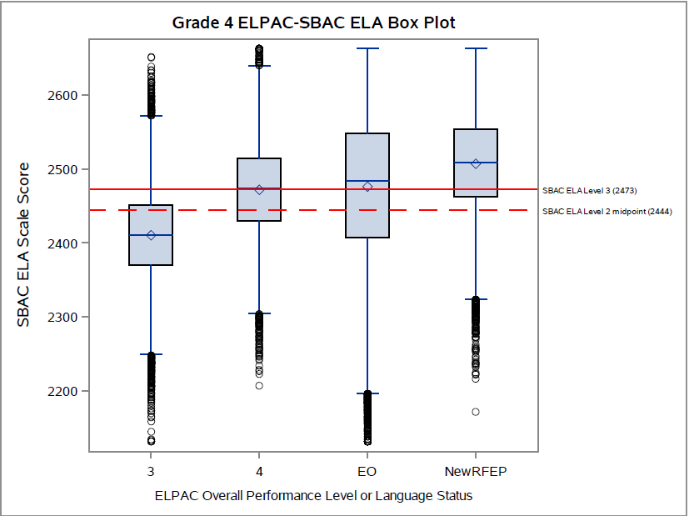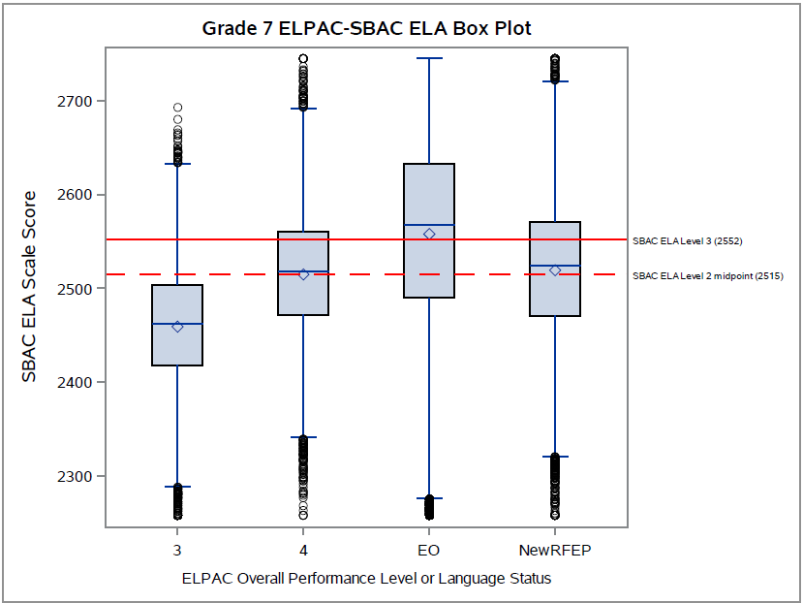
Figure 17. Grade 11
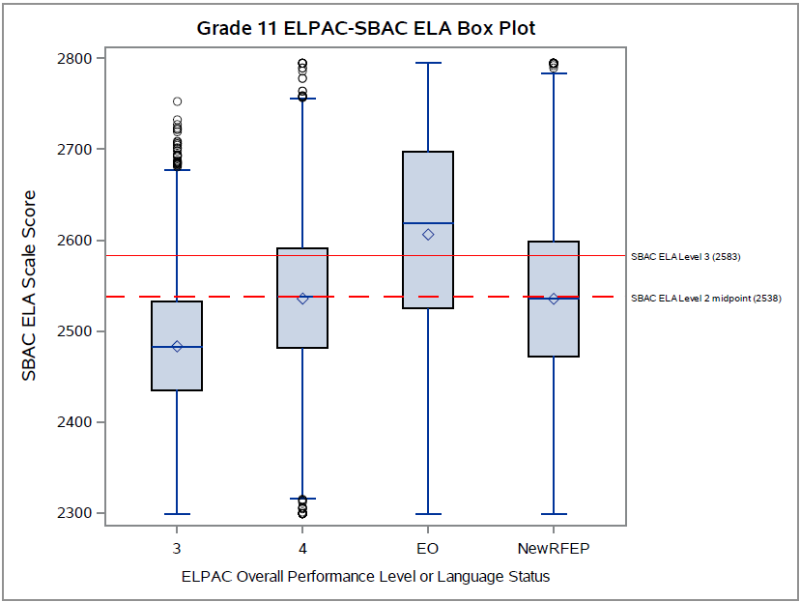
For all grades examined (except grade five), ELs at overall PL 4 performed very similarly to new RFEP students on CAASPP ELA. Specifically, they attained or exceeded an equal likelihood of scoring at CAASPP ELA Level 3 in grades three and four (Figure 15), and of scoring at the midpoint of CAASPP ELA Level 2 in grades six, seven (Figure 16), eight, and eleven (Figure 17). In grade five (not shown), these ELs performed lower than EO and new RFEP students, but still exceeded an equal likelihood of scoring at the midpoint of CAASPP ELA Level 2.
The CA CC team repeated the above analysis using a further refined subset of these students. Specifically, we selected a subgroup of students from each language group that had both “economically disadvantaged” as well as “non-IDEA” status. When these similarly situated groups of EL, EO, and new RFEP students are compared, the performance gaps diminish between ELs at PL 4 and new RFEP students compared to EO students. Specifically, the performance of similarly situated EO students declines at all grade levels, while that of EL and new RFEP students remains the same at grades three, six, seven, and eleven; and diminishes only slightly at grades four, five, and eight. The results for students in grades four, seven, and eleven are illustrated in Figures 18 through 20, respectively.

Figures 18 through 20. CAASPP ELA performance by ELPAC overall performance level or language status (similarly situated EO and similarly situated new RFEP) (box plot analysis)
Figure 18. Grade 4 Figure 19. Grade 7
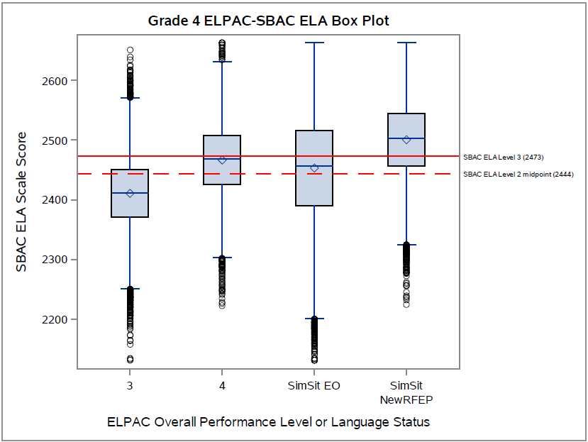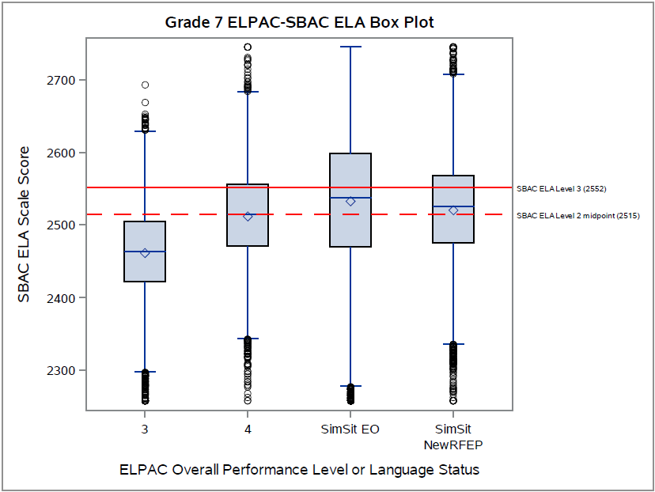

Figure 20. Grade 11
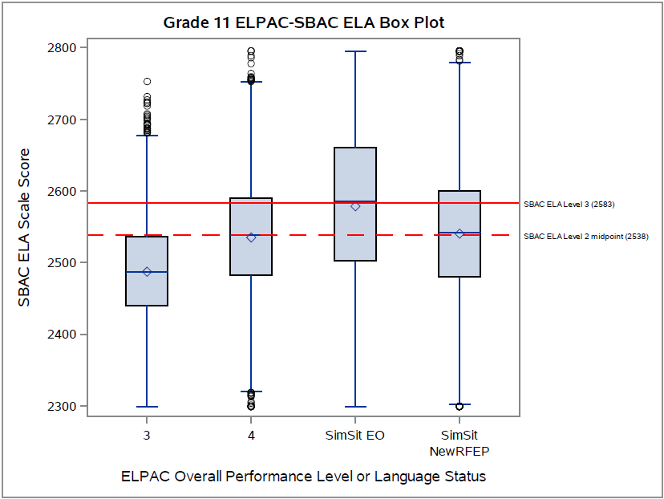
Comparing performance on CAASPP ELA Reading claim area of ELs with ELPAC Overall PL 4 to EO students and RFEP students
Following the suggestion of the ELPAC TAG, the CA CC team examined the performance on CAASPP ELA claim area in reading of ELs with ELPAC overall PL 4 to EO students and new RFEP students. The Smarter Balanced ELA tests comprise four broad claim areas: reading, writing, listening, and research/inquiry. The rationale for doing these additional analyses was to focus on reading as a way of removing those tested aspects of English language arts (e.g., genres in writing, research/inquiry) that may have less to do with English language proficiency per se. The team analyzed the student ability scores (known as “thetas”) for the reading claim area provided by the CDE for all students who took the 2018 CAASPP ELA. Note that this analysis only provides a comparison of relative performance among the groups, since at the claim level we did not use the ELA scale score and therefore could not define a performance standard for Level 3 (Standard Met). As illustrated in Figures 21 through 23 (which represent the results in grades four, seven, and eleven, respectively), for all grades examined we found no meaningful variations in the differences among the EL, EO, and new RFEP student groups in these analyses compared to those using the CAASPP ELA overall scale scores. This is likely due to the high correlation between performance on the reading claim area and the overall ELA construct.
Figures 21 through 23. CAASPP ELA reading claim area performance by ELPAC overall performance level or language status (EO and new RFEP) (box plot analysis)
Figure 21. Grade 4 Figure 22. Grade 7
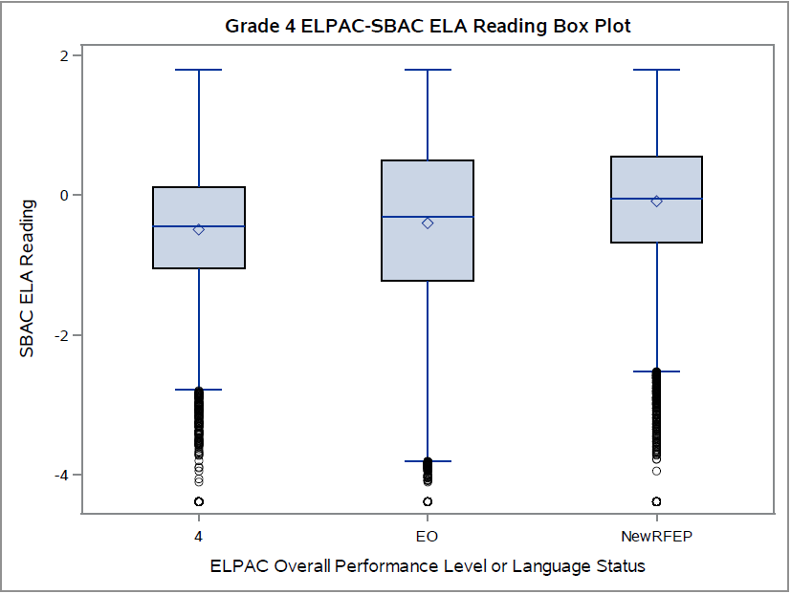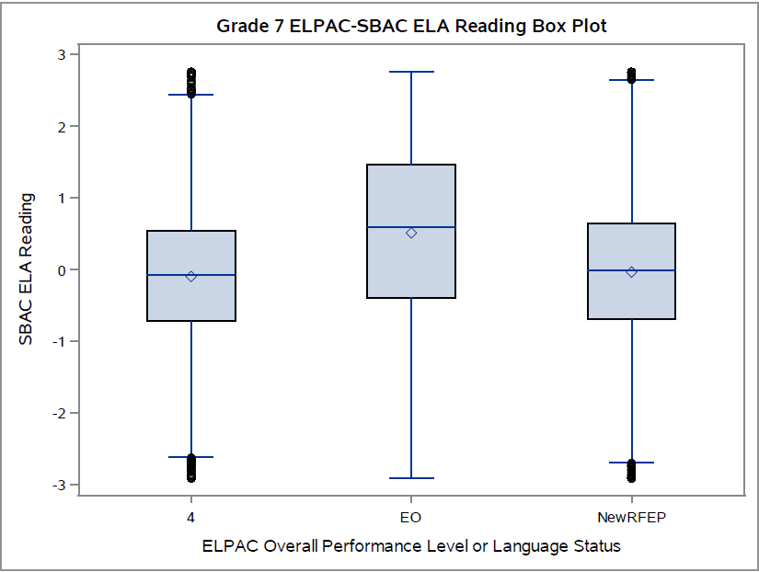

Figure 23. Grade 11
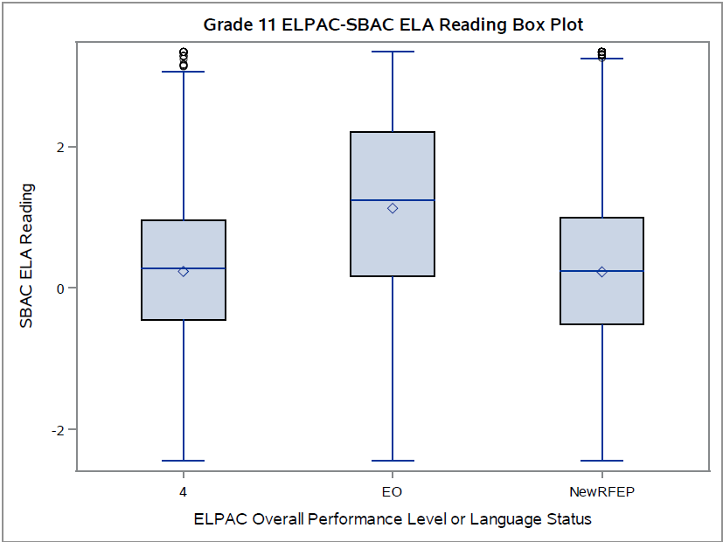

Summary and Considerations
At the CDE’s request, the CA CC conducted updated and additional supplemental analyses of the achievement of EL students on CAASPP ELA disaggregated by the Summative ELPAC performance levels using the SBE’s newly adopted Summative ELPAC threshold scores. For grades three through eight and grade eleven, a total of 15.3 percent of ELPAC examinees attained the 2018 ELPAC Overall performance level (PL) 4, a decrease from the total of 24 percent under the 2017–18 Summative ELPAC threshold scores.
Grade-level ELPAC-CAASPP empirical analyses largely converged across methods. Analyses suggest that, across all grades tested on CAASPP ELA, the performance of ELs at ELPAC Overall PL 4 improves under the newly adopted ELPAC threshold scores when compared to the 2017–18 thresholds. That said, for grades five through eight and grade eleven, ELs at ELPAC Overall PL 4 still do not demonstrate an equal likelihood of attaining Level 3 on CAASPP ELA, nor do they approximate EO student performance. In grades three and four, ELs at ELPAC Overall PL 4 have an equal or greater likelihood of reaching Level 3 on CAASPP ELA, and of approximating or exceeding EO performance on CAASPP ELA.
Given these findings, the CA CC team again analyzed options for applying conjunctive rules related to the ELPAC oral and written composite domains for EL students at ELPAC Overall PL 4. Applying such rules shifted outcomes for those ELs at ELPAC Overall PL 4 meeting conjunctive minimum requirements to more often meet or exceed an equal likelihood of attaining CAASPP ELA Level 3 or to more closely approximate the performance of EO students. However, the proportion of ELs meeting these conjunctive minimum requirements decreased, from 11.5 percent to 12.3 percent under the 2017–18 ELPAC threshold scores, to 6.0 percent to 6.6 percent of ELs under the current ELPAC threshold scores (depending upon conjunctive minimum rules applied).
In additional analyses endorsed by the CDE and the ELPAC TAG, the CA CC team compared the performance on CAASPP ELA of ELs scoring at ELPAC overall PL 4 using the SBE-approved November 2018 thresholds to new RFEP students, as well as to similarly situated EO and new RFEP students. For all grades examined except grade five, ELs at Overall PL 4 performed very similarly to new RFEP students on CAASPP ELA. When similarly situated groups of EL, EO, and new RFEP students are compared, the performance gaps further diminish between ELs at PL 4 and new RFEP students compared to EO students. These analyses also showed that ELs at Overall PL 4 attained or exceeded an equal likelihood of scoring at or above the midpoint of CAASPP ELA Level 2.
Finally, our analyses of the performance of ELs at ELPAC Overall PL 4 to EO students and new RFEP students on the CAASPP ELA reading claim area yielded no meaningful variations in the differences among these groups compared to those using the CAASPP ELA overall scale scores.
The findings from these updated and additional supplemental analyses suggest that a balanced approach is merited in determining an English-proficient performance standard on the Summative ELPAC for EL reclassification. Such an approach would consider the performance of ELs at PL 4 on CAASPP ELA with the following considerations: (a) the proportion that meet the standard, particularly in light of California’s ongoing requirement to meet multiple criteria for exit from EL status; (b) the performance of recently reclassified students as well as similarly situated students; and (c) the level of English proficiency necessary to ensure exited EL students can continue to progress both linguistically and academically on California’s college and career ready standards. Using this balanced approach, the evidence from these updated and additional supplemental analyses supports the recommendation of the CDE and the ELPAC TAG.
References
Cook, H. G., Linquanti, R., Chinen, M., & Jung, H. (2012). National evaluation of Title III implementation supplemental report: Exploring approaches to setting English language proficiency performance criteria and monitoring English learner progress. Washington D.C.: US Department of Education, Office of Planning, Evaluation and Policy Development. Available at https://www2.ed.gov/rschstat/eval/title-iii/implementation-supplemental-report.pdf.
Thompson, K. D. (2017). What blocks the gate? Exploring current and former English learners’ math course-taking in secondary school. American Educational Research Journal, 54(4), 757-798.
Umansky, I. M. (2016a). Leveled and exclusionary tracking: English Learners’ access to core content in middle school. American Educational Research Journal, 53(6), 1792–1833.
Umansky, I. M. (2016b). To be or not to be EL: An examination of the impact of classifying students as English Learners. Educational Evaluation and Policy Analysis, 38(4), 714-737.

These methods, described in Cook, Linquanti, Chinen, & Jung (2012), are used by many states to support decision making on setting an optimal English-proficient performance standard on their state English Language Proficiency (ELP) assessments.
2 A box plot shows graphically five-number summaries—the smallest observation, lower quartile, median, upper quartile, and largest observation—as well as individual outliers, if applicable.
3 The analysis takes the CAASPP Level 3 as given, and determines the ELPAC overall score range that maximizes the percentage of agreement (i.e., proficient on ELPAC and "standard met" on CAASPP; not proficient on ELPAC and below “standard met” on CAASPP) and minimizes the percentage of non-agreement (i.e., proficient on ELPAC, below “standard met” on CAASPP; not proficient on ELPAC, “standard met” on CAASPP).
For economy of presentation, each analysis will display results for grades four, seven, and eleven (to provide examples of elementary, middle, and high school results within the tested grades). The narrative will describe the full range of analytic results.
California utilized a conjunctive rule to define the English-proficient performance standard on CELDT (Overall Performance Level at Early Advanced or Advanced, with each domain at Intermediate or higher).
See https://www.cde.ca.gov/be/ag/ag/yr18/documents/nov18item09.docx, Attachment 3, for results using prior threshold scores.
Figures 12 through 14 illustrate results for three profiles of ELs with Overall PL 4: Written at PL 4; oral at PL 4 and written at PL 3; and oral at PL 4 and written below PL 3.
That is, EO students having both “economically disadvantaged” as well as “non-IDEA” status.
For example, empirical research (e.g., Thompson, 2017; Umansky, 2016a, 2016b) in California and other states has shown that the longer a student has been reclassified, the more likely she has received access to grade-level content instruction.
The number and percent of each examined subgroup in our grades three through eight and eleven matched data set satisfying these two “similarly situated” criteria are as follows: ELs at PL 4: 57,830 of 78,037 (74.1%); EOs: 716,985 of 1,785,409 (40.2%); and new RFEP: 106,282 of 136,605 (77.8%).
The student “theta” reading ability scores are depicted using a scale that is centered at zero and ranges from roughly -5 to 4. Unlike the overall ELA scale scores, they have not been transformed to another scale.
The CA CC team also analyzed reading claim area results for all RFEP students (not shown), and found no variation in differences in their performance relative to that of EL and EO groups on CAASPP ELA overall.

