A Guide for Vision Screening in California Public Schools

California Department of Education
1430 N Street
Sacramento, CA 95814-5901
October 2018
Table Of Contents
A Guide For Vision Screening in California Public Schools i
Acknowledgements 3
Section 1: Introduction 5
Objectives of the Vision Screening Program 5
Legal Basis for Vision Screening 6
Minimum Requirements for a Vision Screening Program 6
Table 1: Legal Requirements for Periodicity of the School Screening Program 6
Early Vision Screening Interventions 7
Personnel Authorized to Conduct Screening 7
Preparation of the Student for Vision Screening 8
Observation of the Student 8
Principles of Vision Screening 9
Visual Acuity 9
Visual Acuity Screening 10
Basic Principles 10
Table 2: Evidence-Based Pediatric Optotypes 10
Instrument-Based Screening 11
Section 2: Vision Screening Procedures 13
External Observations 13
Distance Visual Acuity Optotype-Based Screening 13
Critical Line and Threshold Screening 19
Near Visual Acuity Optotype-Based Screening 21
Color Vision Deficiency Screening 24
Instrument-Based Screening 26
Functional Vision Screening for Students with Special Needs 27
Optional Tests 27
Near Point of Convergence 27
Stereopsis 30
Section 3: Planning and Follow-Up Procedures for Vision Screening 33
Checklists for Implementation of a Vision Screening Program 33
Follow-Up Procedures 37
Follow-Up for Students with Glasses or a Known Vision Disorder 38
Appendix A 41
Legal and Administrative Provisions for School-Based Vision Assessments 41

Appendix B 44
Notifications and Forms 44
Appendix C 50
Frequently Asked Questions 50
Appendix D 54
Glossary 54

Acknowledgements
This edition of A Guide for Vision Screening in California Public Schools (2018 edition) is the result of collaborative efforts focused on children’s health. A sincere appreciation to the following individuals and organizations for their concerted efforts:
Kira Baldonado, BA, Director of the National Center of Children’s Vision and Eye Health
Lydia C. Bourne, MA, BSN, RN, PHN, Legislative Advocate, Bourne, and Associates
Susie Brown, MSN, RN, Credentialed School Nurse, San Lorenzo Unfired School District
Cheryl Burden, MSN, RN, PHN, NP, Program Manager Nursing Services, Oakland Unified School District
Sheri E. Coburn, EdD, MS, RN, Director of Comprehensive Health Programs, San Joaquin County Office of Education
Joyce Cox, BSN, MPH, RN, Program Specialist, Long Beach Unified School District
Vincent J. Cianci, OD, Pediatric Optometrist, Department of Pediatric Eye Services, Neuro-ophthalmology, Binocular Vision and Strabismus, Kaiser Permanente
Angela M. Chen, OD, MS, Pediatric Optometrist, Southern California College of Optometry at Marshall B. Ketchum University
Sue Cotter, OD, MS, FAAO, Professor, Southern California College of Optometry
Marshall B. Ketchum University
Anne DeJarnatt, BA, BSN, MSN, Credentialed School Nurse, Jefferson Elementary School District
Joan D. Donofrio, MSN, Credentialed School Nurse, Folsom Cordova Unified School District
Bob Garr, PDG 4C1, Sight Preservation and Awareness Volunteer, Lions Club
Helen Garr, MD4, Sight Preservation and Awareness Chair, MD4 Lions Club
Elise Harb, OD, MS, FAAO, Clinician Scientist, University of California, Berkeley, School of Optometry
Kristine Huang, OD, MPH, Southern California College of Optometry at Marshall B Ketchum University
Pamela Kahn, MPH, RN, Coordinator, Health and Wellness, Orange Department of Education
Melinda B. Landau, RN, MS, Manager, Health and Family Support Programs, San Jose Unified School District
John Lagomarsino, School Health Education Consultant, California Department of Education
Yolanda Lasmarias, MA, MBA, RN, Administrator, Nursing Services, Los Angeles Unified School District
Rachel McClanahan, DNP, RN, NCSN, Assistant Professor of Nursing, California State University Fullerton.
Luisa Monson, MEd, BSN, RN, PHN, Vision Program Coordinator, Credentialed School Nurse, San Diego Unified School District
April Nakayoshi, MPH, CHES, Vice President of Programs and Evaluation, Prevent Blindness Northern California
P. Kay Nottingham Chaplin, EdD, Advisory Committee to the National Center for Children’s Vision and Eye Health at Prevent Blindness, Good-Lite, School Health Corporation, and Consultant to the Vision Screening Committee of the American Association for Pediatric Ophthalmology and Strabismus
Mary O’Hara, MD, Professor of Ophthalmology and Pediatrics, University of California, Davis.
Deborah Orel-Bixler, PhD, OD, Professor of Clinical Optometry, University of California, Berkeley School of Optometry
Reena Patel, OD, Pediatric Optometrist, Southern California College of Optometry, Marshall B Ketchum University
Susan E. Proctor, PhD, RN, FNASN, Professor Emerita, Community Health & School Nursing, California State University, Sacramento
Kathy Ryan, MS, RN, FNP, President, California School Nurses Organization
James B. Ruben, MD, FAAP, Pediatric Ophthalmologist, The Permanente Medical Group
Anne Deem Saitofi, MSN, RN, NCSN, Credentialed School Nurse, Fontana Unified School District
Sharyn W. Turner, RN, MA, PHN, President, California School Nurses of California Foundation

Section 1: Introduction
The California Department of Education (CDE) is pleased to provide these vision screening guidelines for students in California’s public schools. The CDE, working in collaboration with representatives from the ophthalmology and optometry professions, credentialed school nurses, educational leaders, and community-based organizations specializing in vision screening, has established these standardized vision screening guidelines to update the current school screening practice. The guidelines described in this manual represent evidence-based methodology and current best practice in the field of vision screening. They are intended to facilitate the identification of students with common vision problems as early as possible, when treatment is most effective, to support academic success.
California public schools are committed to providing equal educational opportunities to all students. The school vision screening program has a vital role in the early identification of serious vision problems that may contribute to academic disparities. To fulfill this commitment, schools need to identify students with vision deficits that could adversely affect learning so that the students can receive timely and appropriate care.
This publication is divided into three sections: (1) Introduction; (2) Vision Screening Procedures that includes procedures for vision screening of students who are non-literate, nonverbal, non-English-speaking, and/or very young students and/or students with special needs; and (3) Planning and Follow-up. Forms related to vision screening and applicable provisions from the California Code of Regulations (5 CCR) and the California Education Code (EC) are included in the appendices. In addition, a glossary of technical terms and a list of selected references are provided.

Objectives of the Vision Screening Program
A vision screening program meets state requirements when it is provided under the direction of qualified personnel. The major objectives of the vision screening program are to:
- Identify students with potential vision deficits through:
    - Administration of selected vision screening tools
    - Planned procedures of observation
- Notify parents of each student identified as having a possible vision deficit and to encourage further examination through a professional comprehensive eye and vision evaluation.
- Establish follow-up procedures that will ensure that each identified student receives appropriate follow-up care.
- Inform teachers of students who have vision deficits about vision eye care professional’s recommendations and assist them in planning for needed adjustments in the educational program.

Legal Basis for Vision Screening
The 5 CCR and EC provide the legal basis for vision screening in California public schools. Hyperlinks to pertinent sections of the EC and 5 CCR may be found in Appendix A.

Minimum Requirements for a Vision Screening Program
Table 1 shows the legal requirements for periodicity of the school vision screening program. Specific guidelines for screening procedures can be found in Section 2 of this document.

Table 1: Legal Requirements for Periodicity of the School Screening Program
Grade Level | Distance Vision | Near Vision | Color Vision Deficiency
Transitional Kindergarten/ Kindergarten | Required | Required | Not Required
Grade 1 | Not Required | Not Required | Required
Grade 2 | Required | Required | Required in subsequent years only if not screened in grade 1
Grade 5 | Required | Required | See Above
Grade 8 | Required | Required | See Above
Special Education | Required | Required | Required
Early screening for Color Vision Deficiency is recommended. Since Transitional Kindergarten and Kindergarten (TK/K) are not compensatory grades in California, and in accordance with EC Section 49455, color vision deficiency screening appraisal need not begin until the male pupil has reached the first grade. Color vision deficiency screening is conducted once.
Vision screening initial assessment for special education students should occur with the establishment of the Individualized Education Plan (IEP) and at each triennial review.
In addition, the vision screening program requirements should include the following:
- Using evidence-based and/or best-practice screening procedures as outlined in Section 2 of this document.
- Recording vision screening results on the student’s permanent health record.
- Having teachers continuously observe students for signs and symptoms that may indicate possible eye or vision problems.
- Conducting vision screening with students whose school performance indicates a suspected vision problem.
- Rescreening all students who fail the initial screening.
- Notifying parents/guardians of students who fail the second vision screening.
- When necessary, assisting parents/guardians of students who fail the second vision screening with obtaining follow-up care.

Early Vision Screening Interventions
While the EC does not require vision screening of preschool students, the National Expert Panel to the National Center for Children’s Vision recommends vision screening children ages three, four, and five years for eye and visual system disorders (Cotter, Cyert, Miller, and Quinn, 2014). Best practice for this age group is screening at least once (accepted minimum standard) or optimally, annually. Preschoolers at risk for vision disorders and those with noticeable eye abnormalities, i.e., strabismus, ptosis, should be referred directly to an eye care professional. Since children with neurodevelopmental disorders, i.e., cerebral palsy, hearing impairment, Down syndrome, cognitive impairment, autism spectrum disorders, or speech delay, have a higher rate of vision problems than those without neurodevelopmental abnormalities, they should also be referred directly to an ophthalmologist or optometrist for a comprehensive eye examination. Additionally, when a parent or guardian believes his or her child may have a vision-related problem, an eye care professional should examine that child.

Personnel Authorized to Conduct Screening
Personnel in a school district or county offices of education (COE) who may be required or permitted to screen vision shall be qualified to conduct such tests (EC Section 49452 and the 5 CCR, Section 591).
Only the following persons shall conduct vision screening:
- Duly qualified supervisors of health employed by the school district or COE.
- A registered nurse who holds both (1) a license from the appropriate California board or agency; and (2) a health and development credential, a standard designated service credential with a specialization in health, a health services credential as a school nurse, or a school nurse services credential.
- Certificated school district or county employees who hold a teaching credential and are qualified by training, including satisfactory completion of (1) six (6) hours of vision screening (5 CCR, EC Section 592); or (2) an accredited college or university course in vision screening of at least one semester unit.
- Contracting agents who have met the requirements noted above and who have been authorized by the County Superintendent of Schools in which the district is located to perform tests.

Preparation of the Student for Vision Screening
All students should be educated in an age and developmentally specific manner so that they understand the purpose of vision screening and their role. For example, when preparing to screen preschool, kindergarten or younger primary students, the school nurse should plan time to demonstrate screening procedures to the students and/or practice optotype matching.

Observation of the Student
The teacher plays a key role in detecting suspected vision problems by observing a student in classroom activities. A teacher’s observations of a student’s behavior and appraisal of a student’s achievement throughout the year are exceedingly important because unusual behavior and/or poor school performance may indicate health problems, including eye or vision problems. Any student suspected of having a vision problem, regardless of whether they are due for a screening, should be referred to the school nurse for screening. Signs and symptoms of eye or vision problems may be found in Section 2.
Screening Procedure Considerations for Non-literate, Non-verbal, Non-English-Speaking, and/or Very Young Students and/or Students with Special Needs
Personnel conducting vision screenings need to be aware of the following considerations when screening students in preschool, TK/K, and special education programs, as well as non-English speaking students. Students may have:
- Short attention spans
- Limited receptive and/or expressive language
- English as a second language
- Partially developed eye–hand coordination
- Fear of new experiences and unfamiliar people
- Disabilities that hinder their responses
Young students and students with special needs require particular attention. The cooperation of parents/guardians, teachers, teacher aides, and other school personnel in ancillary services is critical for a successful outcome. Adults need to be sensitive to the student’s actions and reactions to new experiences by:
- Understanding the student’s fear of examiners and examinations.
- Avoiding the use of terms such as nurse, examination, and testing.
- Establishing rapport with the student.
- Having personnel familiar to the student accompany the student to the vision screening.
- Conducting screening in familiar surroundings.
- Presenting screening as a game.
- Orienting students to screening by storytelling or other innovative methods.
Planning, organizing, and implementing a vision screening program for students in need of special care parallel the steps in the regular screening program and processes described earlier. The exact type of vision screening equipment and supplies used should remain open as new ones may be developed in the future. The addition of instrument-based equipment for vision screening may be particularly applicable in this more difficult to screen population.

Principles of Vision Screening
The rationale for school-based vision screening is for early identification of visual problems that can impact a student’s ability to learn. These visual conditions include amblyopia, strabismus, significant refractive errors, and/or eye pathology. Risk factors include significant refractive errors, eye misalignment and/or media opacity in younger students and myopia in older students. Standardized and efficient evidence-based and/or best practice vision screening procedures, proper equipment, tools, and suitable physical environment must be considered when vision screening students. Section 2 outlines equipment needs, room requirements, arrangement of equipment, screening procedures, recording of results, referral procedures for optotype-based screening and color deficiency screening, and additional procedures.

Visual Acuity
Good visual acuity is a strong indicator that the visual system is functioning normally. Normal eye and brain anatomy and communication, appropriate correction of significant refractive error or absence of significant refractive error, and normal brain interpretation of visual information are prerequisites for good visual acuity. While screening for visual acuity is critical because it evaluates major aspects of the visual system, it is important to realize that it does not appraise all aspects of cognitive processing, which could affect a student’s ability to learn (e.g., learning disabilities such as dyslexia).

Visual Acuity Screening
Per mandated screening requirements, distance and near visual acuity screening must be performed. Careful attention must be paid to the screening distance for both distance and near vision screening; therefore, all acuity screening procedures should follow manufacturer’s guidelines. Please refer to the California School Nurses Organization (CSNO) website at www.csno.org for tips regarding visual acuity screening.

Basic Principles
- Regardless of vision screening results, if the school nurse or screener has professional concerns that the student may have a vision problem, refer the student to an eye care professional.
- Distance vision should be screened for each eye independently (monocularly) using appropriate occlusion methods that control for peeking (i.e., monocularly-occluded screening glasses). Appropriate occlusion methods are discussed in Section 2.
- Evidence-based pediatric optotypes should be employed for screening, with matching, if necessary, for younger students (Table 2). According to the American Academy of Pediatrics, American Association for Pediatric Ophthalmology and Strabismus, and the American Academy of Ophthalmology, “Although the traditional Snellen chart remains in wide usage, Sloan letter charts present letters in a standardized fashion and should be used for acuity testing if they are available.”

Table 2: Evidence-Based Pediatric Optotypes
Currently Acceptable Optotypes | Not Acceptable Optotypes
LEA SYMBOLS® | Allen pictures
HOTV | Tumbling E
Sloan Letters* | Blackbird
LEA NUMBERS®* | Landolt C
Patti Pics | “Sailboat” or Kindergarten Chart
Snellen* | Wright figures©
 | “House, Apple, Umbrella” or Lighthouse symbols
*Indicated in children seven years and older
- Optotype screening should utilize crowding to screen for amblyopia. For example:
- Isolated optotypes with contour interaction/surround bars for younger students.
- Line of optotypes on a multiple lined chart for older students.
- Vision screening protocols should minimize opportunities for the students to memorize answers. For example:
  - Computer-based optotype software with optotype randomization.
  - Printed optotypes with multiple optotype choices at a given screening acuity level.
  - Identifying optotypes from left to right with first eye and right to left with second eye.
- Following any necessary practice/orientation with younger students, present age-specific critical acuity level optotypes for screening.
- To pass a line, a student must correctly identify at least 51 percent (e.g., 3/5) of the optotypes correct at that particular acuity level.
- If performing critical screening (as recommended in Table 6), there is no need to record threshold visual acuity. Instead, record pass or fail at age-specific critical visual acuity level.
- Perform near visual acuity binocularly.
- The critical visual acuity level to pass for all ages is 20/30.

Instrument-Based Screening
Instrument-based technologies, such as photoscreeners or handheld auto-refractors, do not assess visual acuity, but rather identify amblyopia risk factors, primarily refractive error. The use of instrument-based screening under an agreement with, or the supervision of, an optometrist or ophthalmologist has been approved by the California Legislature (EC Section 49455). A sample Memorandum of Understanding may be found in Appendix B. Instrument-based (photoscreening) uses optical images of the eye’s red reflex to estimate refractive error, eye gaze, and identify media opacity as well as other visual conditions, such as ocular adnexal deformities (e.g., ptosis), all of which put students at risk for developing amblyopia (American Academy of Pediatrics, 2016).
Best practices for instrument-based screening should be evidence-based, also referred to as scientifically validated, and will evolve as technology changes. Screening devices require instrument- and age-specific pass/fail refractive error criteria. For a listing of recommended instrument-based screening protocols by the National Center for Children’s Vision and Eye Health, visit the CSNO website at www.csno.org. In addition, up-to-date scientific evidence on instrument-based screening may also be found at www.csno.org. Evidenced-based, instrument-based screening is particularly useful as an alternative to optotype-based screening for:
- Students with developmental disabilities.
- Students who are younger (e.g., preschool or kindergarten) or pre-literate.
- Students who are unable to be screened with traditional optotype-based screening.
For students who are unable to complete visual acuity screening, instrument-based (photoscreening) may detect the risk factors for amblyopia; including refractive error, strabismus and media opacities.
- Show the instrument (photoscreener) to the student and tell them that you will be taking their picture. If, during screening, they do not look directly at the device, re-screening is suggested.
- Adjust room lighting to avoid glare into the instrument.
- High refractive error may exceed the measurement range of the instrument (photoscreener). If results cannot be obtained after three attempts, the student should be referred for a comprehensive eye examination by a professional.
- Be aware that the cut-off for clinically significant refractive error varies with age (from infants, preschoolers, and elementary school-age students). Most instruments (photoscreeners) have different cut-off criteria for children versus adults. Use the age-appropriate referral criteria.

Section 2: Vision Screening Procedures

External Observations
School nurses, teachers, and other personnel should observe students for signs and symptoms that may indicate a possible eye or vision problem. Various eye or vision problem signs and symptoms are included below (Table 3). Observations should be made throughout the year as students use varied types of materials, i.e., books, whiteboards, and computer screens. If the student begins to frequently and or consistently exhibit signs or symptoms, a referral should be made to the school nurse for screening or to an eye care professional.

Table 3: Signs and Symptoms of a Possible Eye or Vision Problem
Student Signs | Student Symptoms
- Eye turns in or out at any time  - Pupils/eyes appear to be different sizes  - Red eyes and/or swollen eyelids  - Excessive tearing  - Droopy eyelids  - Discharge from the eyes  - Sensitivity to light  - Excessive Blinking  - Squints, closes, or covers one eye  - Squints to see board or far away  - Frequent headaches  - Abnormal head posture or head tilt | - Double vision  - Blurry vision  - Hazy vision  - Difficulty seeing small print  - Eye pain

Distance Visual Acuity Optotype-Based Screening
Distance visual acuity screening is considered the recommended practice for detecting a vision problem for school-aged students in a vision screening setting.
The American Association for Pediatric Ophthalmology and Strabismus, American Academy of Pediatrics, National Center for Children’s Vision and Eye Health, American Academy of Ophthalmology and American Association of Certified Orthoptists recommend attempting distance visual acuity screening of preschool students starting at age three.
Screening should be done with the use of furniture appropriate to the student’s size and equipment suggested by the manufacturer for a particular screening method. For more details on room environment and arrangement of equipment, refer to Section 2 Recommendations for Screening for Visual Acuity, Recommendations for Photoscreening, and Recommendations for Testing Color Vision Deficiency Screening.

Grades:
- TK/K or upon first enrollment or entry into a California school.
- Grades two, five, and eight.
- Students being assessed for, or currently enrolled in, special education services for the purposes of reporting on the IEP.

Room Requirements:
- Adequate distance for screening chart (e.g., if screening with a 10-foot chart, available space should be at least 12 feet).
- Relatively quiet.
- Normal classroom lighting.
- Avoid glare on the chart surface or into the student’s eyes.

Equipment:
Visual Acuity Charts
Tests of visual acuity have an inverted pyramid or triangle format when visualizing a drawn line around the outside of the opotypes and should meet national and international eye chart design guidelines (Nottingham Chaplin & Bradford, 2011). Examples of evidence-based, developmentally appropriate optotypes are pictured below.
- Optotypes should be of approximate equal legibility.
- Each line should have five optotypes per line, unless the test of visual acuity is 9 x 14 inches, where chart size will not accommodate five optotypes on the top two lines.
- Horizontal spacing between optotypes should be equal to the width of the optotypes on that line.
- Vertical spacing between lines should be the height of the optotypes in the next line down.
- Opotype size should progress geometrically up or down the chart by approximately 0.1 log units, which lists 20/32 instead of 20/30.
- Optotypes should be high-contrast black on a white background and good lighting conditions should be present.

Examples of evidence-based developmentally appropriate optotypes:

For Use with Students in Preschool
EyE Check Screener with LEA SYMBOLS®

For Use with Students in Transitional Kindergarten, Kindergarten, or
Grade 1
LEA SYMBOLS® HOTV
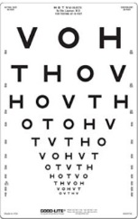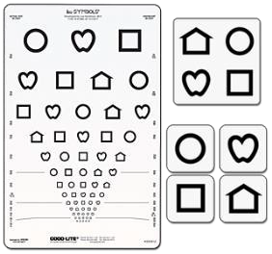

For Use with Students in Grades 2–12

LEA NUMBERS® Sloan Letters
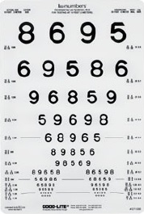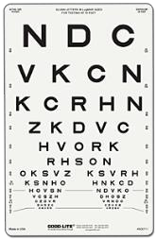

Digital/Computer-Based Optotypes
Digital or computer-based optotypes, like acuity charts, are designed to identify student’s visual abilities. Digital or computer-based systems feature an array of screening tools that can be used among multi-age student populations. Some digital/computer-based systems allow for randomization, thereby minimizing memorization of the screening tool. Electronic optotypes can be presented following a predetermined screening algorithm. Instead of a long instruction manual telling thousands of screening personnel how to present different size optotypes on a wall chart, the electronic system can be programmed to present age appropriate optotypes according to pre-established screening algorithms. There is less dependence on the examiner subjectively determining what optotype to pick next as the software will independently choose the next optotype size based upon response (correct vs incorrect) from the prior optotype. Additionally, digital/computer-based systems minimize screener bias by providing results based upon the student’s response.
Make sure the chart selected is developmentally appropriate and meets national chart design guidelines. For example, many TK, K or non-English speaking students may not know their alphabet, thus the LEA SYMBOLS® chart with matching card would be an appropriate chart to use with those students. Please visit the CSNO website at www.csno.org for updated information on technological evidence-based practices for visual acuity screening.

Occluders
Occuding one eye is necessary to obtain accurate monocular measures of visual acuity; the eye not being tested needs to be covered completely. Holding a hand, tissue or paper/plastic cup over the eye is not acceptable and not best practice because students can easily peek. Additionally, students may have an increased risk of exposure to bacteria or viral pathogens by covering their eye with their bare hand. Patching one with 2-inch surgical tape or adhesive patch is a recommended best practice as it assures complete eye coverage. Examples of acceptable forms of occluder (patch) options are identified below.
Examples of developmentally appropriate forms of occluders:
- For Use with Students in Preschool –Grade 1
Adhesive Eye Patch 2-in Hypoallergenic Surgical Tape
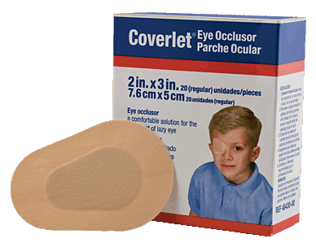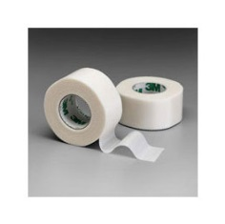
- Use the same patch/tape to occlude each eye of an individual student, unless the student has visible crusty eye drainage.

- Use a new patch/tape for each student.
Occluder Glasses
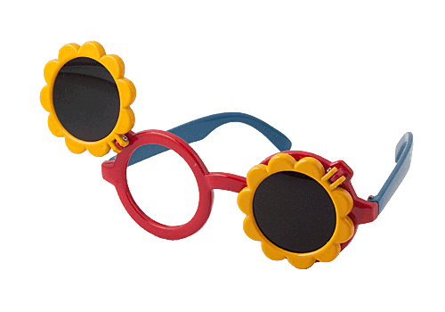
- Clean occluder glasses between students with 70 percent isopropyl alcohol.
- Tip: Have more than one pair of occlude glasses for each screener to allow alcohol to dry fully between students.
- For Use with Students in Grades 2–12
Paddle Occluder Mask Occluder
- Clean occluder between students with 70 percent isopropyl alcohol.
- Tip: Have more than one occluder for each screener to allow alcohol to dry fully between students.

Positioning of Chart and Student
- Students who are waiting to be screened should not be able to see the chart or hear the responses of other students being screened.
- Place the chart at the approximate eye level of the students to be screened.
- If using a 10-foot chart, place a piece of tape on the floor to mark a 10-foot (3 meter) distance between the chart and the student’s eyes. (10-foot distance better captures the student’s attention compared with 20 feet).
- If screening a preschool student, place a piece of tape on the floor to mark a 5-foot (1.5 meter) distance between the chart and the student’s eyes or use the cord accompanying many 5-foot tools.
- Have the student stand with the measurement line midfoot (arch of foot) (Figure 1).
Figure 1: Recommended tape placement with midfoot measurement
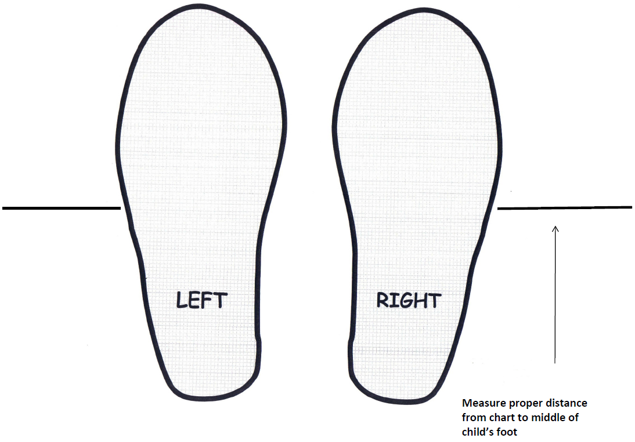

Procedure
- Screen with glasses on if student normally wears glasses for distance viewing. If the student shares they have left their glasses at home, flag the student’s file/name so that you may try again when rescreening is done. Keep the student’s contact information so you may contact the student/parent the evening before to remind them to bring their glasses to school.
- Screen right eye first (occlude left eye) then screen left eye (occlude right eye).
- Carefully observe student during procedure to ensure there is no peeking, squinting, leaning forward, turning of the head or other signs and symptoms related to visual problems (Table 3).
- Encourage the student to guess if the student is unsure, but do not provide sample answers (e.g., does that look like a circle?) and do not coach the student (e.g., are you sure?).
- Do not rush the student.

Critical Line and Threshold Screening
Visual acuity referral criteria can be based on critical line or threshold screening criteria. Critical line screening requires the student to correctly identify 3 of 5 optotypes on a particular line based upon their age. Threshold screening requires the student to start at the top of the eye chart and read down until they miss 3 of the 5 optotypes.
Table 6 identifies developmentally recommended approaches to vision screening.
Table 7 identifies the recommended pass/fail criteria for respective age groups.

Table 6: Developmentally Recommended Approaches to Vision Screening
Preschool, Transitional Kindergarten | Kindergarten and First Entry | Grades 1 and Up
(Critical Line Screening) | (Threshold Screening) | (Critical Line Screening)
Use a matching card for students who are shy, nonverbal, or do not know their letters or shapes. | Start with the top line and ask the student to identify the first letter/symbol of each line until the student misses a letter/symbol. | Familiarize the student with optotypes by having the student identify optotypes on the top line, if needed.
Familiarize the student with optotypes by having the student identify optotypes on the top line, if needed. | If the student misses a letter/symbol on a line, go to the line above and ask the student to identify optotypes across the line. | Have the student identify optotypes across the 20/32 critical line.
Have the three year-old students identify optotypes across the 20/50 critical line and the four year-old students identify optotypes across the 20/40 critical line. | The last line on which the student correctly identifies 3 of 5 optotypes is the visual acuity value for that eye. | The student must correctly identify at least 3 out of 5 optotypes to pass the critical line.
No further screening is necessary if the student is unable to pass the critical line. Refer this student for an eye examination. | Attempt to screen to the 20/20 line. | No further screening is necessary if the student is unable to pass the critical line. Refer this student for an eye examination.

Referral Criteria:
During student screening, results will indicate a pass or fail response. Below, in Table 7, are the developmentally appropriate visual acuity criteria that indicate a referral to an eye care professional.

Table 7: Developmentally Appropriate Referral Criteria
Group | Referral Criteria
Preschool (Age Three) | 20/60 or worse in either eye
Preschool/Transitional Kindergarten (Age Four) | 20/50 or worse in either eye
Transitional Kindergarten/Kindergarten (Age Five) | 20/40 or worse in either eye
Grades One and up | Unable to read 20/32 critical line
All age groups | Greater than or equal to two line difference between eyes (e.g., 20/20, 20/32), if conducting threshold screening.  Students who cannot be screened are considered an automatic fail and should be referred for comprehensive eye examination.
Students who cannot be screened should be referred for a comprehensive eye examination (e.g., student will not tolerate patch or tape, will not wear occluder glasses, refuses to identify optotypes, has variability in responses, etc.). These students are at a higher risk of having vision problems. If students are unable to be screened (untestable) they should be considered an automatic fail and referred to an eye care professional for further evaluation.

Rescreening:
If a student fails a vision screening that is conducted by a credentialed school nurse, physician or surgeon, osteopath, or optometrist, a rescreen is not required (EC sections 49591, 49455, 49594). A rescreen is required if initial screening is done by someone other than those listed here and should be done prior to the vision screening results report being given to the student’s family.

Recording:
Districts should record results based on specific documentation systems. The results may be recorded as pass (P) or fail (F). An example for recording results is:
Distance: Right Pass/Fail
Left Pass/Fail
Two-Line Difference Pass/Fail/Not Tested
A two-line difference will not be tested if:
- The failure criterion was already met for either eye, and
- Critical line screening was done.

Visual Acuity Screening Considerations for Students with Special Needs
Vision screening of preschool students or students with special needs should be conducted by using methods and equipment suitable to the student’s developmental level. The use of isolated optotype tests are to be avoided as they may fail to detect amblyopia. For students who are unable to perform screening with letter visual acuity screening charts (Sloan Letters), more appropriate tools include the LEA SYMBOLS® (apple/heart, house, circle, and square shapes) or HOTV optotypes. Instrument-based screening procedures can also be used. The following accommodations are presently considered best practice for visual acuity screening of students aged three, four, and five years:
- Decreasing the screening distance from 10 feet (3 m) to 5 feet (1.5 m) improves testability and sensitivity in detecting vision problems in preschoolers. Do not, however, use a tool at 5 feet that is calibrated for a 10-foot distance.
- A training card within arms’ reach is used to teach the student to point to the matching symbol on a lap card.
- The student should wear occluder glasses (fun frames with an opaque occlude/frosted lens for each eye) rather than hands, tissues, or cups.
- The student is first screened on either the 20/200 or 20/80 line (depending on the chart version) to get them familiar with the task and then at the critical line for their age (20/50 for age three and 20/40 for ages four and five years).
- Prescreening activities may be carried out in regular classrooms to familiarize the student with the English names of the symbols or the act of pointing to the matching card.

Near Visual Acuity Optotype-Based Screening
Near vision screening is an assessment that determines the student’s ability to see up close.

Grades:
- TK/K or upon first enrollment or entry into a California school district
- Grades 2, 5, and 8
- Students being assessed for or currently enrolled in special education services for the purposes of reporting on the IEP.

Room Requirements:
- Relatively quiet
- Normal classroom lighting
- Avoid glare on the chart surface or into the student’s eyes

Equipment:
- Visual Acuity Cards
Age-appropriate near vision cards that meet national and international eye chart design guidelines as detailed under “Distance Visual Acuity Optotype-Based Screening” are recommended (see below). Cards with an attached string are preferred to help maintain the screening distance of 16 inches (40 cm).

Examples of Grade Level Appropriate Charts for Near Visual Acuity Optotype-Based Screening
For Use with Students in TK/K—Grade 1
LEA SYMBOLS®
LEA NUMBERS HOTV
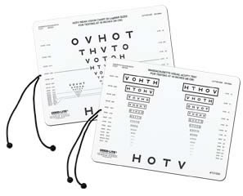
For Use with Students in Grades 2–12
Sloan Letters
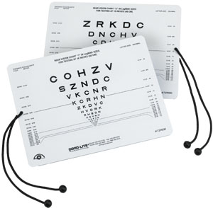

Procedure:
- Screen with glasses on if student normally wears glasses for distance viewing. If the student shares they have left their glasses at home, ask the runner or have the student go to the office and ask a parent/caregiver or emergency contact to bring the student’s glasses to school so they may be screened. If unable to screen the student with glasses on, flag the student’s file/name so that you may try again when rescreening is done. Keep the student’s contact information so you may contact the student/parent the evening before to remind them to bring their glasses to school.
- Screen with both eyes open.
- Hold card at 16" (40 cm) screening distance.
- If using a chart with a string, place the string at the temple near the eye and ensure string is taut.
- Do not allow the student to lean forward.
- Familiarize the student with optotypes by asking the student to identify large optotypes, if needed.
- Ask the student to identify optotypes on the 20/32 critical line.
- The student must correctly identify at least 3 out of 5 optotypes to pass that line.
- No further screening is necessary if the student is unable to pass the critical line.

Referral Criteria:
Refer if the student is unable to pass the 20/32 line with both eyes open.

Recording:
Districts should record results based on specific documentation systems. The results may be recorded as Pass or Fail:
Near Both eyes Pass/Fail

Color Vision Deficiency Screening
Color vision deficiency is the inability to discern certain shades of color. The term color blindness is incorrectly used to describe this visual condition. Most people with color vision deficiency are able to see colors, but they have difficulty differentiating between certain colors:
- Shades of reds and greens (most common)
- Shades of blues and yellows (less common).
People who are totally color blind, a condition called achromatopsia, can only see things as black and white or in shades of gray. Depending on the cause, color vision deficiency can range from mild to severe. It affects both eyes if it is inherited and usually just one eye if it is caused by injury or disease. Color vision is possible due to photoreceptors in the retina of the eye known as cones. These cones have light-sensitive pigments that enable us to recognize color. Found in the macula (the central part of the retina), each cone is sensitive to red, green, or blue light. The cones recognize these lights based on their wavelengths.
Normally, the pigments inside the cones register different colors and send that information through the optic nerve to the brain. This enables a person to distinguish countless shades of color. However, if the cones don't have one or more light-sensitive pigments, then a person will be unable to see one or more of the three primary colors.

Grades:
- Early screening for color vision deficiency is recommended, since TK/K are not compensatory grades in California and in accordance with EC Section 49455, color vision deficiency screening appraisal need not begin until the male pupil has reached the first grade. Color vision deficiency screening is conducted once.

Room Requirements:
- Relatively quiet
- Normal classroom lighting
- Avoid glare on the chart surface or into the student’s eyes

Equipment:
There are a few currently acceptable color vision deficiency screening books that may be used in the educational setting (Table 9).

Table 9: Examples of Color Vision Deficiency Screening Tools.
Color Check Complete Vision Screener | Ishihara Color Deficiency  Plates | Color Dx Pediatric | HRR Pseudoisochromatic Plates
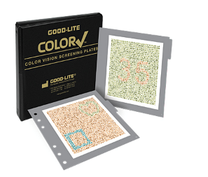 |  | 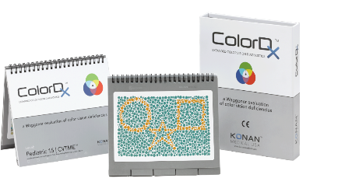 | 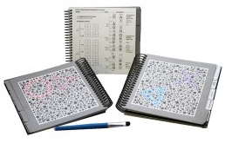

Procedure:
- Follow the manufacturer’s instructions regarding procedures for screening and scoring.
- Screening should be done with both eyes open.
- For students who are shy, nonverbal, or do not know their shapes or numbers, show the student how to use a clean, soft paint brush or cotton swab to point/trace targets on the color plates (do not allow use of fingers to trace because oil on the skin can cause color changes to the plates).

Referral Criteria:
No referral needed. If the student does not pass the color vision deficiency screening, inform the parents and advise them to consult with their eye care professional for additional information on color vision deficiency. Inform the teachers and counselors so they may adjust educational materials that require color discrimination.

Recording:
Districts should record results based on specific documentation systems. The results should be recorded as Pass (P) or Fail (F). An example for recording results is:
Color Vision PASS/FAIL

Color Vision Deficiency Screening for Students with Special Needs
The prevalence of color vision deficiencies in boys is 8 percent whereas, it is only 0.5 percent in girls; therefore, only boys are screened and need to be tested for color vision deficiencies. Color vision deficiencies are inherited on the X-chromosome. Both X-chromosomes need to be affected for a girl to have a color vision deficiency, whereas boys inherit the affected X-chromosome from their mother (not their father). Good lighting (illuminant-C or natural sunlight) is important. Follow the color vision deficiency screening tool manufacturers’ instructions.

Instrument-Based Screening
Automated devices estimate refractive error and sometimes eye misalignment; they do not measure visual acuity. Distance visual acuity screening is considered the preferred practice for detecting a vision problem in school-age students in a vision screening setting (American Academy of Pediatrics Section on Ophthalmology and Committee on Practice and Ambulatory Medicine; American Academy of Ophthalmology; American Association for Pediatric Ophthalmology and Strabismus; and American Association of Certified Orthoptists, 2012). However, instrument-based screening is quick and it requires minimal cooperation of the student; therefore it is useful in students who are preverbal, preliterate, or developmentally delayed.

Grades:
- Students who are younger (e.g., preschool) or pre-literate
- Students with special needs
- Students who are unable to be screened with traditional optotype-based visual acuity screening

Equipment:
Since technology is constantly evolving, check CSNO’s website at www.csno.org for updated recommendations and referral criteria for instrument-based screening tools.
Follow manufacturer’s guidelines for all instrument-based vision screeners.
For students who are unable to complete visual acuity screening, instrument-based photoscreening may be done to detect the risk factors for amblyopia and reduced vision; including refractive error, eye alignment, and anisocoria (unequal pupil gaze.)

Procedure:
- Show the photoscreener instrument to the student and tell them that you will be taking their picture. If they do not look directly at the device during screening, screen again, directing the student’s attention to the front of the device.
- Adjust room lighting to avoid glare into the instrument.
- High refractive errors may exceed the measurement range of the instrument. If results cannot be obtained after three attempts, the student should be referred for significant refractive error.
- Be aware that the cutoff for clinically significant refractive error varies with age (from infants, preschoolers, and elementary school-age students). Most instruments have different cut-off criteria for students versus adults. Use the age-appropriate referral criteria.

Functional Vision Screening for Students with Special Needs
For students who are untestable during in the vision screening (visual acuity, color vision deficiency screening, photoscreening), Functional Vision Screening may be considered. As a minimum, this includes:
- A review of the medical record
- Consultation with the parent and teacher
- Classroom observation
If based on the above functional vision screening results, no impact on classroom participation is noted or anticipated, then a referral may not be needed. Remember that referral for a comprehensive eye examination is appropriate due to the high prevalence of vision disorders in the population of students with special needs. Preschoolers, that are unable to complete screening, are twice more likely to have vision problems than their peers who completed screening. Re-screening within six months or referral for a comprehensive eye examination are recommendation actions when initial screening efforts are not incomplete.

Optional Tests

Near Point of Convergence
This screening evaluates the student’s ability to converge their eyes to a near target. Poor convergence ability may cause symptoms such as double vision, headaches, eyestrain, or loss of place when reading.

Grades:
- Grades One through Twelve

Room Requirements:
- Relatively quiet
- Normal classroom lighting

Equipment:
- A small hand-held fixation target with details (e.g., tongue depressor with a picture sticker) (Figure 2)
- Ruler

Figure 2: Examples of Small Hand-Held Fixation Target
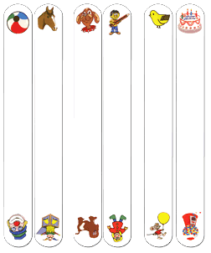
Procedure:
- Screen with glasses on if student normally wears glasses for reading or near work.
- Screen with both eyes open.
- Hold fixation target approximately 16 inches (40 cm) away from the student’s eyes and instruct the student by saying, “Focus on this target and keep on it as long as you can, but tell me if it becomes two.”
- Slowly move the target toward the student’s eyes until the student sees two (double) or the examiner observes a loss of fusion (e.g., one eye moves outward). Figure 3.
- If double is reported, ask the student if the target stays two or if it goes back into one; if it becomes one within 1–2 seconds, continue moving the target toward the student’s eyes until the target becomes double and stays double.
6. Measure the distance from the temple near the eye to the point where the target was double (break point).

Figure 3: Tool Used to Move Toward the Student’s Eyes.
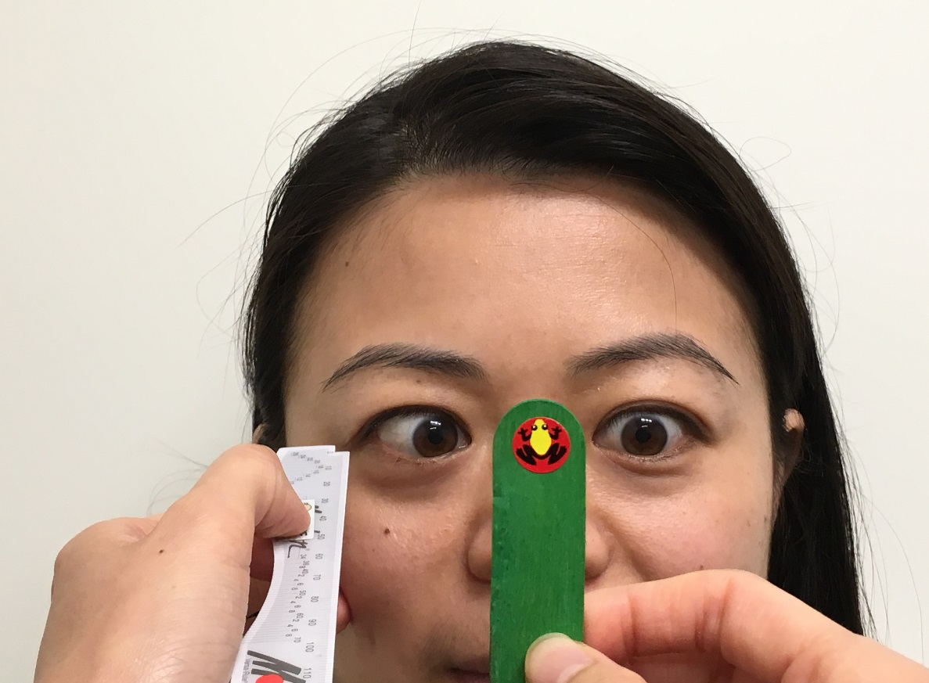

Referral Criteria:
Refer if break point is ≥ 2.5 inches (6 cm).

Recording:
Point of Convergence PASS/FAIL

Stereopsis
Stereopsis screening evaluates how well the eyes work together to achieve depth perception. Poor depth perception can be found in those with amblyopia, strabismus, or other ocular pathologies.

Grades:
- Preschool–Grade Twelve

Room Requirements:
- Relatively quiet
- Normal classroom lighting
- Avoid glare on the card surface or into the student’s eyes

Equipment:
- Stereopsis Screening
A screening for stereopsis that uses random dot stereograms is recommended. The Preschool Assessment of Stereopsis with a Smile (PASS 2) uses random dot stereograms and can easily be used with preschool-age students (Table 10.)

Table 10: Preschool Assessment of Stereopsis with a Smile (PASS 2)
Picture of Kit and Contents | Description of Kit Contents
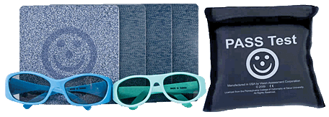 | - Card A: Demonstration Card  - Card B: 480 seconds of arc for students in preschool and TK  - Card C: 240 seconds of arc for students in Kindergarten through Grade Twelve  - Blank Card

Procedures:
- Screen with glasses on if student normally wears glasses.
- Have the student wear the polarized glasses (over glasses, if worn).
- Hold cards at 16 inches (40 cm) with the top of cards slightly tilted back towards the screener at about 10 degrees.
- For Preschool/TK:
- Show card A (demo card) and the blank card and ask the student to point to the card with the smiley face to ensure that the student can identify the figure.
- If the student is unable to identify the demo card when presented with the blank card, stop screening and refer.
- Show card B and the blank card and ask the student to point to the smiley face.
- Shuffle the cards behind your back to change the position of the smiley face and present the cards again; Repeat 5 times.
- Student must correctly identify at least 4 out of 5 presentations to pass.
- For Kindergarten–Grade Twelve:
- Show card A (demo card) and the blank card and ask the student to point to the card with the smiley face to ensure that the student can identify the figure.
- If the student is unable to identify the demo card when presented with the blank card, stop screening and refer. Show card C and the blank card and ask the student to point to the smiley face.
- Shuffle the cards behind your back to change the position of the smiley face and present the cards again.
- Repeat 5 times.
- Student must correctly identify at least 4 out of 5 presentations to pass.

Referral Criteria:
When making a referral for stereopsis, similar to other screening, age considerations should be made (Table 11.)
Table 11: Referral Criteria for Stereopsis
Group | Referral Criteria
Preschool/Transitional Kindergarten  (Age Three and Four Years Old) | Unable to identify card B at least 4 out of 5 presentations
Kindergarten–Grade Twelve  (Age ≥ Five years) | Unable to identify card C at least 4 out of 5 presentations
If the student is unable to identify the demo card when presented with a blank card, stop screening and refer.

Recording:
Districts should record results as based on specific documentation systems; an example for recording results is:
Stereopsis PASS/FAIL

Section 3: Planning and Follow-Up Procedures for Vision Screening

Checklists for Implementation of a Vision Screening Program
These checklists may be used to help school administrators and vision screeners plan for and perform the screening:

Implementation Checklist for the Administrator
This checklist indicates some of the essential requirements for a vision screening program in the school. It may be used in planning and evaluating a program.
Essential Requirements
- Is the school doing the vision screening on each student during kindergarten or upon first enrollment or entry in a California school district of a pupil at an elementary school, and in grades two, five, and eight (as mandated in EC Section 49455)?
- Does the vision screener meet the state requirements for personnel conducting vision screening?
- Has the school calendar been cleared and dates established for staff training, student orientation, screening, and screening of absentees?
- Has the qualified vision screener been provided with the necessary forms, equipment, and appropriate space, and the latter confirmed with impacted school personnel?
- Does the school nurse have a plan for follow-up on all referrals and vision problems found?
- Has the school identified community resources available?
- Does the school have a plan to coordinate with community agencies that offer help free of charge?
- Have parents/caregivers been informed, in writing, about the vision screening program in the annual notification of parents’ rights?
- Have parents/caregivers been informed about waiving the vision screening, if desired, by presenting a certificate from a physician and surgeon, a physician assistant, or an optometrist that include the results of the student’s vision screening, including visual acuity and color vision deficiency within the past 12 months?
- Have parents/caregivers been informed about waiving the vision screening, if desired, by filing a written statement with the school principal stating that they depend upon prayer for healing in the practice of their religion?

Implementation Checklist For the Vision Screener
The vision screener may be the school nurse or other authorized employee pursuant to EC Section 49452, 5 CCR, and EC sections 590–592.
Essential Elements
- As mandated in EC Section 49455, is the school performing the vision screening on each student in kindergarten or upon first enrollment in elementary school, and in grades two, five, and eight? A pupil whose first enrollment occurs in grade four or seven shall not be required to undergo vision screening in grades five or eight.
- Are vision screeners trained and qualified in accordance with 5 CCR, and EC sections 590 –592?
- Have arrangements been made for appropriate facilities to conduct the screening and confirmation of screening dates?
- Have appropriate screening materials, and supplies been obtained; including equipment/tools for distance visual acuity, near vision, and color deficiency vision screening (for males only), and if appropriate, photoscreeners?
- If instrument-based screening is performed, is there an agreement with, or the supervision, of an optometrist or ophthalmologist?
- Is there a plan in place for continual and regular observation (by the school nurse and the classroom teacher) of the student’s eyes, appearance, behavior, visual performance, and perception that may indicate vision difficulties?
- Is there confirmation of community resources to assist in the implementation of the program? Appropriate community personnel may include licensed ophthalmologists, optometrists, and personnel from the Child Health and Disability Prevention Program, California Children Services, Parent Teachers Association, local public health departments, service clubs, and other voluntary organizations
- Is there a supply of forms for the program, including “Report of School Vision Screening,” “Report of Vision Exam to the School,” “Rechecks of Vision Screening?”

Implementation Timeline Checklists for Vision Screener and Administrator
At the Beginning of the Year
- Has the school calendar been cleared and program dates established for a student orientation to vision screening? Ensure vision screening date does not conflict with other school-related activities (i.e., Mandated fire or evacuation drill; picture day).
- Has the school calendar been cleared and program dates established for staff education?
- Has the school calendar been cleared and dates established for the screening?
- Has the school calendar been cleared and dates established for screening of absentees?
- Have necessary ancillary services been secured (e.g., persons to provide screening assistance and custodial services)?
- Has a suitable physical environment been selected for screening and has the schedule of room use been communicated to impacted personnel?
- Has the equipment been inspected for proper functioning (e.g., extra bulbs and extension cords)?
Two to Three Weeks Before the Vision Screening Date
- Have appropriate personnel confirmed the dates and locations of screening and rescreening?
- Are the screening/recording work sheets, list of students, classrooms, and health records available?
- Has a vision education program for students been scheduled as close to the screening date as possible?
- Is there a plan for follow-up procedures?

One Week Before the Screening Date
- Has the list of students to be screened been updated?
- Have staff and volunteers been reminded of screening dates and locations?
- Was a notice included in the school bulletin, paper, email, or website? Have phone calls been made, using the district’s automated system, reminding parents of vision screening and encouraging students to bring their glasses to school for screening?
- Has the screening equipment been checked and is it ready for use?
- Are all screening materials ready for the implementation of the program?
- Confirm that the location for screening is available on the date of screening for exclusive use for vision screening.
- Request bell schedules, campus maps, and duplicative student lists from school office staff.
Day of Screening
- Arrive early to set up instrument and equipment. Ensure availability of extension cords, tape, measuring tapes.
- Sign in at the office.
- Obtain bell schedule, campus map, and multiple class lists from office staff. Thank office staff for their assistance.
- Greet and thank runner/volunteer. Provide just-in-time training to volunteer that will ensure student confidentiality and optimal student screening.
- Identify screening pattern, which grade levels should be screened first based upon setting (i.e., some eighth grade students only have home room first period and then change classes. To save time the school nurse will want to screen these students first to minimize “chasing” students in other subject matter classes).
- Record student results on screening sheets or in electronic student system as soon as possible.
- For students that have vision screening, visit student’s class(es) and connect with student’s teacher to share that screening results indicate vision difficulty. Discuss classroom accommodations/considerations to make to support the student until a formal report from eye care professional is returned (i.e., move student from back of classroom, closer to the board; recommend teacher observes student for additional signs or symptoms of eye or vision problems).

Follow-Up Procedures
The focus of a follow-up program includes interpretation of findings; and transmittal of information among school personnel, parents/guardians, and eye care professionals. These important tasks are carried out mainly by the school nurse, assisted by other school personnel. The success of the program, however, depends on the implementation of systematic follow-up procedures, such as the following:
- Mail a written notification home (in their native language) to the parents or guardians of a student with suspected vision problems (Appendix B, “Vision Screening Report”) in a timely manner (two weeks). Written notification should be culturally sensitive, easy to read, and should include next steps, including the importance of a follow-up eye examination with an eye care professional with students who fail vision screening. In addition, it is recommended to include a copy of the report in the student’s backpack.
- Consider additional follow-up notification by telephone, text, email, or through a parent-nurse conference to ensure parental follow-through with the referral recommendation.
- Advise and strongly encourage the parents/guardians to take the referral form with them to the student’s appointment with an eye care professional.
- Refer parents/guardians in need of financial assistance to one of the following sources:
- County health and human services agency for Temporary Assistance to Needy Families
- Lions Clubs and other fraternal organizations for glasses
- Parent Teacher Association and other service organizations
- California Children Services
- Vision care plans-Vision Service Plan Sight for Students
- Child Health and Disabilities Prevention Program (CHDP)
- Medi-Cal for Families Program
- Covered California (Affordable Care Act)
- Other resources (First Five California, Vision to Learn, Prevent Blindness Northern California, Faith-Based Organizations, Boys and Girls Club of America)
  - Advise the parents/guardians to return the referral form to the school after obtaining an examination with an eye-care professional. The information on the form will help determine if adjustments are needed to the student’s educational program.
  - Do not recommend a particular person or class of practitioner (ophthalmologist or optometrist) for examining, treating, or correcting any eye or vision defect of the student (EC Section 49456).
  - Maintain contact with the parents/guardians until the student has received the comprehensive eye examination and necessary follow-up care. Communication may be by telephone, email, text, or through a parent–nurse conference. A conference should be supplemented by a written notice to the parents/guardians regarding their student’s apparent eye or vision disorder.
  - Develop and supervise a system for recording screening results, pertinent information and communication on a student’s health record or cumulative electronic record.
  - Inform parents/guardians at the time of registration, if it is the policy of the district, that screening for visual acuity does not replace a professional comprehensive eye examination and does not identify all vision problems.
After confirmation of any eye or vision disorders from the eye care professional, the school nurse or designated school personnel, is to take the following actions:
  - Consult with teachers and counselors and recommend educational adjustments, if necessary, to meet a student’s individual needs.
  - Follow through with appropriate procedures for non-correctable vision loss (severe vision disabilities).

Follow-Up for Students with Glasses or a Known Vision Disorder
If the student wears glasses or has a known vision disorder, the school nurse or designated school personnel should first check to determine whether the school has a record of the student’s eye examination. It is imperative to obtain the results of a professional examination and any recommendations that might affect school performance. If a student has a vision disorder, the school nurse or designated school personnel should:
- Ensure the student wears glasses if he or she has been prescribed corrective lenses and/or monitor compliance with other therapeutic intervention, such as wearing an eyepatch.
- Facilitate student counseling regarding eye health and safety.
- Emphasize the importance of continued follow-up with the student’s eye care professional.
Follow-Up Procedures for Non-Correctable Vision Loss (Severe Vision Disabilities Including Visual Impairment and/or Legal Blindness)
Eye care professionals may identify students who have vision disorders that cannot be fully corrected through treatment. In those cases the school nurse or designated school personnel should take the following actions:
- Advise parents/guardians to consult with the student’s physicians or eye care professionals regarding monitoring, treating or rehabilitating severe vision loss.
- Refer parents/guardians to a special education program in the school district or to the county office of education (COE) for necessary information regarding social services, teachers for the visually impaired, orientation and mobility instructors, low-vision specialists, and guidance in school placement.
- Refer parents/guardians to California Children Services as the student may be eligible for services related to his or her vision disability (visual impairment or legal blindness).
- Review the eye care professional’s reports to determine if any adjustments in the classroom arrangement or educational program are needed based on the student’s vision loss.
- Maintain identification procedures for students with severe vision impairment as well as monitor referral and follow-up services.

Follow-Up Procedures for Students Who Fail Color Vision Deficiency Screening
  - Failure in this screening is not cause for referral to an eye care professional. Color vision deficiencies are inherited from the mother’s side of the family (X-linked). A positive maternal family history of color vision deficiencies augments the student’s screening results.
  - Use the “Color Vision Deficiency Screening” form letter in Appendix B to inform the parents/guardians of the student’s suspected color vision deficiency.
  - For additional information on notifying parents/guardians and teachers about the student’s color vision deficiency, see Table 7 of this guide.
  - Consult with teachers to modify the use of color-coded educational materials.

Follow-up Procedures for Students in Special Education
- Referral for a comprehensive eye examination is indicated due to the high prevalence of vision disorders (refractive error, strabismus, amblyopia, ocular disease, and visual impairment and/or legal blindness) in the population of students with special needs.
- For students who are untestable in the vision screening (distance and near, color vision deficiency screening, or instrument-based (photoscreening), the school nurse may conduct a Functional Vision Screening. At a minimum, this includes:
  - A review of the medical record
  - Consultation with the parent and teacher
  - Classroom observation
  - If, based on the above functional vision screening results, no impact on classroom participation is noted, then a referral may not be required.

Appendix A
Page 1 of 3

Legal and Administrative Provisions for School-Based Vision Assessments
These guidelines were developed following legal and administrative provisions found in the California Code of Regulations and California Education Code sections referenced below.
California Code of Regulations
The California Code of Regulations (CCR), is the official compilation and publication of the regulations adopted, amended or repealed by state agencies pursuant to the Administrative Procedure Act. Properly adopted regulations that have been filed with the Secretary of State have the force of law.

The CCR is compiled into Titles and organized into Divisions containing the regulations of state agencies.
CCR provisions related to Vision Testing are listed under Title 5 CCR, Division 1, Chapter 2, Subchapter 3, Article 4 and may be accessed via the web at https://govt.westlaw.com/calregs/Browse/Home/California/CaliforniaCodeofRegulations?guid=IB7F35940D47E11DEBC02831C6D6C108E&originationContext=documenttoc&transitionType=Default&contextData=(sc.Default)
California Education Code
Provisions of California Education Code (EC) that address, or are related to, vison assessment are listed below with a short descriptor of the section and a web link to access the full text.
Supervision of Health
EC Section 1750: Employment of Supervisors of Health
http://leginfo.legislature.ca.gov/faces/codes_displaySection.xhtml?sectionNum=1750.&lawCode=EDC
EC Section 1751: Authority to Contract for Provision of Health Services
http://leginfo.legislature.ca.gov/faces/codes_displaySection.xhtml?sectionNum=1751.&lawCode=EDC

Appendix A
Page 2 of 3

EC Section 1752: Provision of Health Service under District Agreement
http://leginfo.legislature.ca.gov/faces/codes_displaySection.xhtml?sectionNum=1752.&lawCode=EDC

EC Section 1753: Credential Requirement
http://leginfo.legislature.ca.gov/faces/codes_displaySection.xhtml?sectionNum=1753.&lawCode=EDC

EC Section 1754: Duties of Supervisors of Health
http://leginfo.legislature.ca.gov/faces/codes_displaySection.xhtml?sectionNum=1754.&lawCode=EDC
Employment

EC Section 44871: Qualifications of Supervisors of Health
http://leginfo.legislature.ca.gov/faces/codes_displaySection.xhtml?sectionNum=44871.&lawCode=EDC
EC Section 44872: Standard Designated Services Credential with a Specialization in Health; Services Credential with a Specialization in Health
http://leginfo.legislature.ca.gov/faces/codes_displaySection.xhtml?sectionNum=44872.&lawCode=EDC

EC Section 44873: Qualifications for a Physician
http://leginfo.legislature.ca.gov/faces/codes_displaySection.xhtml?sectionNum=44873.&lawCode=EDC

EC Section 44877: Qualifications for Nurse
http://leginfo.legislature.ca.gov/faces/codes_displaySection.xhtml?sectionNum=44877.&lawCode=EDC

EC Section 44878: Qualifications for Optometrist
http://leginfo.legislature.ca.gov/faces/codes_displaySection.xhtml?sectionNum=44878.&lawCode=EDC
General Powers—School Boards
EC Section 49400: Health and Physical Development of Pupils
http://leginfo.legislature.ca.gov/faces/codes_displaySection.xhtml?sectionNum=49400.&lawCode=EDC

Appendix A
Page 3 of 3
Employment of Medical Personnel
EC Section 49422: Supervision of Health and Physical Development of Pupils
http://leginfo.legislature.ca.gov/faces/codes_displaySection.xhtml?sectionNum=49422.&lawCode=EDC
EC Section 49426: School Nurse; Permissible Services; Legislative Intent
http://leginfo.legislature.ca.gov/faces/codes_displaySection.xhtml?sectionNum=49426.&lawCode=EDC
Physical Examinations
EC Section 49450: Rules to Insure Proper Care and Secrecy
http://leginfo.legislature.ca.gov/faces/codes_displaySection.xhtml?sectionNum=49450.&lawCode=EDC
EC Section 49451: Parent’s Refusal to Consent
http://leginfo.legislature.ca.gov/faces/codes_displaySection.xhtml?sectionNum=49451.&lawCode=EDC
EC Section 49452: Sight and Hearing Test
http://leginfo.legislature.ca.gov/faces/codes_displaySection.xhtml?sectionNum=49452.&lawCode=EDC
EC Section 49455: Vision Appraisal
http://leginfo.legislature.ca.gov/faces/codes_displaySection.xhtml?sectionNum=49455.&lawCode=EDC
EC Section 49456: Report to Parent
http://leginfo.legislature.ca.gov/faces/codes_displaySection.xhtml?sectionNum=49456.&lawCode=EDC
EC Section 49457: Report to Governing Board
http://leginfo.legislature.ca.gov/faces/codes_displaySection.xhtml?sectionNum=49457.&lawCode=EDC
Solicitations
EC Section 51520: Licensed Optometrist Solicitation
http://leginfo.legislature.ca.gov/faces/codes_displaySection.xhtml?sectionNum=51520.&lawCode=EDC

Appendix B
Page 1 of 6

Notifications and Forms
Notifications and forms provided within Appendix B are to assist local educational agencies in meeting California Education Code requirements.
Sample Parent Notification
It is recommended that the local educational agencies place the following notification in student handbooks and annual notifications to parents and guardians of students.
Health
In accordance with the California Education Code (EC) Section 49455, student vision screening will be provided at school entry Transitional Kindergarten/Kindergarten, two, five, and eighth grades and to all students enrolled in special education as required for their Individualized Education Plan. Additionally, vision screening may be provided to any student who exhibits signs and symptoms of eye or vision problems. Parents may opt their child out of any non-emergency, invasive physical examination or screening required as a condition of attendance, administered by the school or its agent, and not necessary to protect the immediate health and safety of a student, including hearing or vision screenings, or any physical examination or screening permitted or required under state law. Parents have the right to have their child’s vision tested outside of school (at the parent’s expense) to meet the state law requirement.

Appendix B
Page 2 of 6
Vision Screening Report Template
Student Name: (Enter student name) Date of Screening: (MM/DD/YY)
School: (Enter school name) Grade: (enter grade) Teacher: (Enter teacher name)
Dear Parent/Guardian:
Your child recently received vision screening at school. Below are the screening results.
Visual Acuity Assessment
Lenses | Left Eye | Right Eye | Near Both Eyes
With lenses | Left 20/ (or PASS/FAIL) | Right 20/ (or PASS/FAIL) | PASS/FAIL
Without lenses | Left 20/ (or PASS/FAIL) | Right 20/ (or PASS/FAIL) | PASS/FAIL

Optional Screening | Pass or Fail
☐ NPC | PASS/FAIL
☐ Stereo | PASS/FAIL
☐ Other | PASS/FAIL
Comments:
Based on the above vision screening findings, your child needs to see an eye doctor for a full eye examination. Please take this form with you to the examination. Have the reverse side completed by the eye doctor, and return the completed form to your school health office.
(Signature of School Nurse)
Signature of School Nurse
(Enter School Nurse’s Name)
School Nurses’ Name
(Enter Telephone Number)
Telephone Number
(Enter School Nurse’s email)
School Nurses’ email
Appendix B
Page 3 of 6
Report of Eye Examination Results to the School Template
(To be filled out by Eye Care Professional)
Patient Name: (Enter patient Name) Date of Birth: DD/MM/YY
Name of Examiner: (Enter Name of Examiner) Date of Exam: DD/MM/YY
Street Address of Examiner: (Enter Street Address of Examiner)
City: (Enter city) State: (Enter State) Zip Code: (Enter Zip Code)
Phone Number: (Enter phone number)
Visual Acuity
Lens | Left Eye | Right Eye | Near Both Eyes
With lenses | Left 20/_____ | Right 20/_____ | 20/_____
Without lenses | Left 20/_____ | Right 20/_____ | 20/_____
Diagnosis:
Lens Requirements
Correction Not Required  Correction Required | Glasses  Contact Lens | Wear at all times  Wear for distance only  Wear for close work
Additional Recommendations (Special seating, large print, special education placement, etc.):
(Enter Additional Recommendations here.)
This form is approved by the State Superintendent of Public Instruction, as required by California Education Code Section 49456, for reporting results of vision testing to parents and guardians and for obtaining recommendations from the professional examiner.
Appendix B
Page 4 of 6
Color Vision Screening Results Template
Student: (Enter student name) Date: DD/MM/YY
School: (Enter school name) Grade: (enter grade) Teacher: (Enter teacher name)
Dear Parent/Guardian:
By law (California Education Code [EC} Section 49455), your child received vision screening and was found to have a color vision deficiency.
When children have a color vision deficiency they have a hard time telling the difference between certain shades of color. These difficulties are usually related to telling the difference between red and green or the colors with red and green in them. For example, a person with a color deficiency may see red, orange and green colors as a yellow color. Also, violet and purple colors may look like blue colors.
Color vision deficiency is not a disease. It is something that is passed from parents to their children (usually in male children.) It is thought that 1 in 12 males are born with it. There is no treatment for color vision deficiency. Most people with color vision deficiency adjust by learning to tell the difference between colors based on how bright they are.
Awareness of a color vision deficiency is important as it may affect a person’s performance in certain kinds of school activities involving color. We suggest you share this information with your child’s teacher at the beginning of each school year. In addition, note that a color vision deficiency may exclude some people from certain occupations for which normal color vision is required. If you would like more information regarding your child’s color vision deficiency, please contact your family eye doctor or your school nurse.
Sincerely,
(Enter signature of School Nurse)
Signature of School Nurse
This form is approved by the State Superintendent of Public Instruction, as required by EC Section 49456, for reporting results of vision testing to parents and guardians and for obtaining recommendations from the professional examiner.

Appendix B
Page 5 of 6
Memorandum of Understanding (Sample)
(xxxx-xxxx School Year)
This Memorandum of Understanding (MOU) stands as evidence that XXXXXX District/County Office of Education (COE) and Dr. XXXXX, (Optometrist/Ophthalmologist/Medical Doctor) intend to work together for the mutual goal of providing safe, effective, evidence-based, or best practice vision screening approaches to pre-kindergarten through Twelfth grade students attending the XXXXXXX District/COE. The entities agree that the implementation of a vision screening program using instrument-based (photoscreening) approaches will assist in furthering this goal. In accordance with California Education Code (EC) Section 49455, an agreement with or supervision by an eye care professional is required when instrument-based (photoscreeners) tools are used by school nurses or trained individuals in providing vision screening services to students. Additionally, in accordance with EC Section 51520(c) it is mutually understood that solicitation of a pupil, or the pupil's parent or guardian, or encourage, or advise treatment or consultation for the pupil by the licensed optometrist, or any entity in which the licensed optometrist has a financial interest, for any condition discovered in the course of the vision testing is prohibited.
The School District/COE shall: (examples only; may modify as needed)
  - Provide the vision screening personnel.
  - Provide vision screening equipment.
  - Orchestrate student vision screening among district/COE students.
  - Ensure appropriate calibration and servicing as recommended by the manufacturer.
  - Make referral for students who fail screening and follow up on those student referrals.
The Optometrist/Ophthalmologist shall: (Examples only; may modify as needed)
- Provide just-in-time training on instrument-based screening equipment.
- Check for competency of the school nurse to use instrument-based equipment.
- Provide technical assistance on instrument-based equipment.
- Assist with troubleshooting questions or other questions the school nurse may have surrounding the use of instrument-based screening.
Appendix B
Page 6 of 6
As part of this MOU the district shall compensate Dr. XXXXXXX in the amount of XXXXX for the agreement/supervision of instrument-based support. This agreement will terminate at the end of the school year. OR This agreement will continue until one party elects to terminate the MOU by providing 30 days written notice.
(Enter District/COE Superintendent Signature)
Superintendent,
District/COE
Date MM/DD/YYYY
(Enter Optometrist/Ophthalmologist Signature)
Optometrist/Ophthalmologist
Business Name
Date MM/DD/YYYY

Appendix C
Page 1 of 4

Frequently Asked Questions
- In what grades does vision screening need to take place?
Per California Education Code (EC) Section 49455, vision screening shall take place during the kindergarten year or upon first enrollment or entry in a California school district of a pupil at an elementary school, and in grades two, five, and eight. A pupil whose first enrollment or entry occurs in grade four or seven shall not be required to be appraised in the year immediately following the pupil's first enrollment or entry.
- Do we need to screen students who are entering the school in grade three or six?
A student would need to be screened at grade three or six only if this is their first enrollment or entry in a California school district or if they are enrolled in special education.
- Is vision screening no longer required for students in grade ten?
EC Section 49455 specifies that vision screening shall take place through the eighth grade. Hearing screening is required through tenth grade (California Code of Regulations, Title 17), so it is likely that many school nurses made the assumption that vision screening was also required through tenth grade. While a district may certainly choose to continue vision screening through the tenth grade, the EC mandates that it take place through the eighth grade.
- When students are new to a California high school, do they still need to be screened at that level (since we are not screening other high school students)?
No, EC Section 49455 requires that vision screening take place only through grade eight.
- If a student is screened using a photoscreener or autorefractor, do you still need to screen near/far visual acuity utilizing an eye chart according to the EC?
EC Section 49455 does not indicate that both a photoscreening device and an eye chart need to be used when screening vision, but does require that

Appendix C
Page 2 of 4
visual acuity be measured. If you use an instrument, and you cannot capture an acuity measurement with the instrument, you will want to do a separate screening in order to satisfy the requirements of EC Section 49455.
- Who is authorized to perform a screening if it is done outside of the school?
If the parent chooses to have their child’s vision tested outside of school, EC Section 49455 states that a physician and surgeon, physician’s assistant, or an optometrist may do the screening in order to fulfill the screening mandate.
- Can a parent request to waive the screening requirement for their child?
Yes. There are two options that a parent may use to waive the vision screening mandate if they so desire:
- The parent/guardian presents a certificate from a physician and surgeon, a physician assistant practicing in compliance with Chapter 76.7 (commencing with Section 3500) of Division 2 of the Business and Professions Code, or an optometrist providing evidence of a vision screening, including visual acuity and color vision. (In accordance with EC Section 49455).
- A parent/guardian files a written statement stating that they will not consent to a physical examination of their child. (In accordance with EC Section 49451).
Note: If a parent does not turn in any type of outside examination results or a written request refusing to have their child undergo physical examinations, the child will be screened during the mandated screening process per EC Section 49455.
- If a parent wants to waive the vision screening for their student, does the school also need a note from a health care provider?
EC Section 49451 allows a parent/guardian to exempt their child from screenings in school by signing a statement indicating that they do not consent to a physical examination of the child. There is no need for a health care provider to sign such an exemption.

Appendix C
Page 3 of 4
- Why do we not point to optotypes on eye charts? It is tough to get small children to know what we want them to see.
The World Health Organization (2003) states that it is permissible to point line-by-line, but not optotype by optotype. Pointing at an optotype makes the optotype easier to identify and may lead to false visual acuity value. If you need to help young children know which optotype to identify, you can briefly point to the optotype and quickly remove the pointer. If the optotype is in a rectangle box, avoid breaking the box with the pointer.
- Are there any certificate programs to train Licensed Vocational Nurses (LVNs) to help provide the vision screenings?
LVNs are not authorized to perform vision screenings in public schools. California Code of Regulations, Title 5, Division 1, Chapter 2, Subchapter 3, Article 4 indicates who may perform vision screenings in public schools, and LVNs are not included in the list of those who may do so.
- Do the regulations also include charter schools in California?
EC Section 49455 does not specifically address charter schools, so absent a specific mandate in a charter school’s authorizing documents (Petition/Memorandum of Understanding [MOU]), it would not be required to comply with this provision. A charter school would need to defer to its petition and MOU to confirm whether the charter has incorporated the vision appraisal (pupil health screenings) or is collecting categorical funding for this program. If a charter school representative is not sure of its obligation, it should check with its school administrator or legal counsel. Although charter schools were not included in the law specifically, they always have the option to elect to perform vision screening.
- May we accept the vision screening results on the Child Health and Disability Prevention (CHDP) Health Assessment in place of a school-based vision screening?
Yes, if the CHDP examination was done within the past year, was performed by one of the authorized practitioners listed in EC Section 49455 (a physician and surgeon, a physician assistant practicing in compliance with Chapter 76.7 [commencing with Section 3500] of Division 2 of the Business and Professions Code, or an optometrist) and includes the results of a determination of the pupil’s vision, including visual acuity and if applicable, color vision.

Appendix C
Page 4 of 4
- Does the mandated vision screening need to include other tests such as cover/uncover, muscle balance, or binocularity?
EC Section 49455 only requires screening of distance and near visual acuity, and color vision. A district may choose to screen for additional vision problems, but not in place of screening for visual acuity and color vision.
- Does color vision have to be tested in first grade, or can it take place any time after first grade?
EC Section 49455 states that color vision appraisal need not begin until the male pupil has reached the first grade. There is no specific requirement as to what grade it needs to take place in, however, earlier diagnosis of color vision deficiency can lead to earlier intervention in the classroom, if need be.
- Will these new regulations apply to pre-school programs such as Head Start?
EC Section 49455 was written to apply to grades kindergarten through eight only.
- Is the code the same for special education students? Do we need to screen these students every year?
EC Section 49455 applies to all students, including special education students. Special education students may have other assessments done as a part of their educational planning and it may be necessary to screen these students more often than the law requires due to certain special education requirements.

Appendix D
Page 1 of 3

Glossary
Term | Definition
Accommodation | Power (or ability) of the eye to alter the shape of its lens to adjust the focus for near and far.
Amblyopia | Often called lazy eye, amblyopia is loss of vision occurring at the brain level when nerve cells in the visual part of the brain do not receive sufficient use while the sense of sight is developing.
Anisometropia | Condition in which the two eyes have significantly different refractive error.
Astigmatism | Type of refractive error in which light rays do not focus evenly on the retina due to an irregularly shaped cornea or lens curvature; objects at distance and near appear blurry and distorted.
Binocular Vision | Fusion of the separate images seen by each eye, allowing adequate depth perception.
Convergence | Coordinated inward movement of both eyes when looking at a near object.
Convergence insufficiency | Eye coordination deficiency in which the eyes have difficulty converging when reading or doing close work.
Color Deficiency | Reduced ability to discriminate between colors, usually red-green, less frequently blue-yellow.
Cover Test | The unilateral cover test (cover-uncover test) checks for strabismus. The alternate cover test measures the magnitude of the eye alignment.
Conjugate Eye Movements | Simultaneous movement of both eyes in the same direction.
Credentialed  School Nurse | A registered nurse that has completed a baccalaureate program, up to 28 post baccalaureate units, and received a specialized credential from the State of California on Teacher Credentialing (California Education Code Section 49426).

Appendix D
Page 2 of 3
Term | Definition
Diopter | Unit of measurement of the refractive power of a lens.
Diplopia | Double vision or the perception of seeing two images of a single object; images may be horizontal, vertical or diagonal.
Esophoria | Tendency for the eyes to turn inward.
Esotropia | Type of strabismus in which one eye is looking straight and the other eye is turned inward.
Exophoria | Tendency for the eyes to turn outward.
Exotropia | Type of strabismus in which one eye is looking straight and the other eye is turned outward.
Fixation | Ability to hold focus on an object.
Fusion | Overlapping of the separate images seen by each eye into one composite image.
Hyperopia (farsightedness) | Type of refractive error in which light rays come to focus behind the retina: Distance objects can be seen more clearly than near objects.
Hypertropia | Type of strabismus in which one ye is looking straight and the other eye is turned upward.
Hypotropia | Type of strabismus in which one eye is looking straight and the other eye is turned downward.
Myopia  (nearsightedness) | Type of refractive error in which light rays come to focus in  front of the retina, resulting in blurred distance vision.
Nystagmus | A rapid involuntary oscillation of the eyes; the oscillation can be side to side, up and down or rotary.
OD | Oculus dexter (right eye).
OS | Oculus sinister (left eye).

Appendix D
Page 3 of 3
Term | Definition
Occlusion | Obscuring the vision of one eye in order to test the vision of the other.
Ophthalmologist | Physician who specializes in the diagnosis and treatment of refractive and medical conditions related to eye. An ophthalmologist may prescribe glasses, contact lenses, and other corrective measures and perform surgery. The initials M.D. are used after the person’s name.
Optician | Professional who fills optical prescriptions for glasses by grinding lenses, fitting them into frames, and performing frame adjustments.
Optometrist | Doctor who specializes in the diagnosis and treatment of refractive and medical conditions related to the eye. An optometrist may prescribe glasses, contact lenses, and other corrective measures. The initials O.D. are used after the person’s name.
Optotype | Standardize target (often letters or symbols) on a visual acuity chart used to test vision.
Refraction | Technique used to determine the refractive error of the eye.
Refractive error | Occurs when light rays are not focused on the retina; myopia, hyperopia and astigmatism are refractive errors.
Strabismus | Misalignment of the eyes; esotropia, exotropia, hypertropia and hypotropia are types of strabismus.
Stereopsis | Perception of depth which results from the fusion of the  separate images seen by each eye; also known as 3D vision.
Threshold Screening | Method of visual acuity screening that where the student begins at the top of the eye chart and reads down the chart until the student misses 3 of 5 optotypes on a particular line.
Visual acuity | Sharpness of vision; ability to distinguish target details at a standardized distance.

