California Department of Education
Executive Office
SBE-003 (REV. 11/2017)
ssb-sftsd-jul19item01

California State Board of Education
July 2019 Agenda
Item #12

Subject
Request by Compton Unified School District regarding Education Code sections 17515 through 17526, Joint Public/Private Occupancy Proposal, allowing the Compton Unified School District and Prologis, L.P. to enter into leases and agreements relating to real property and buildings to be used jointly.

Type of Action
Action, Information

Summary of the Issues
California Education Code (EC) Section 17524(a) specifies the governing board of a school district shall not approve any joint occupancy proposal nor enter into a lease or contract incorporating a proposal until the governing board has submitted the proposal to the State Board of Education (SBE) for its approval or disapproval.
Upon receiving approval from the SBE, Compton Unified School District (USD) will enter into negotiations with Prologis, L.P. regarding the specific terms of the joint occupancy agreement. The district has indicated that any such agreement will be in accordance with all legal requirements.

Recommendation
The California Department of Education (CDE) recommends that the SBE approve the Compton USD’s proposal to enter into a joint occupancy agreement with Prologis, L.P. to develop a logistics warehouse, district warehouse and related administration facility, and workforce internship training program.

Brief History of Key Issues
California EC Section 17515 allows a school district to enter into a joint occupancy agreement providing certain requirements are met, and, pursuant to EC Section 17517, the agreement does not exceed 99 years. A joint occupancy agreement allows the district and a private or public party to jointly develop and operate buildings on district owned property.
Pursuant to EC sections 17521 et seq., the district governing board issued a Request for Proposals (RFP) on July 2, 2018, for a ground lease of an 8.71 acre property located at 723 South Alameda/604-704 South Tamarind Avenue, Compton, California. This property was the former Lincoln Elementary School and Lincoln Regional Occupational Center which were both closed in 1989; since then the property has been used as parking for buses and warehouse space. Additionally, the district has experienced a decline in enrollment over the past decade, from a high of 33,500 students in the 2002-2003 school year, to an average of enrollment of approximate 22,800 students for the past five years. The ground lease of this property would be in exchange for the design, construction, operation, maintenance, and all associated costs related to the development of the property, including district related improvements. The district received four responses to the RFP.
The district tentatively selected the proposal submitted by Prologis, L.P. after consideration of all developers’ proposals received. The selection was based on the criteria that best supports the district’s goals of generating long-term revenue for the district, and benefiting the district’s students and community at large including internship opportunities for students that would provide exposure to the construction and real estate industries, and community workforce initiatives.
The proposal includes construction of a 177,240 square foot, Class-A industrial warehouse facility, of which approximately 18,000 square feet will be allocated to the district for warehouse and/or administrative use(s) along with designated parking. The development will include 237 auto parking stalls, 21 dock doors, and eight trailer stalls. The facility is being designed to achieve Leadership Energy Environmental Design certification. This proposal will provide warehouse and office space, educational opportunities, and generate approximately $850,000 per year in revenue.

Summary of Previous State Board of Education Discussion and Action
The SBE has previously approved public/private joint occupancy agreements including several with the Los Angeles Unified School District, the San Diego Unified School District, Napa Valley Unified School District, Chula Vista Elementary School District, Emery Unified School District, and Lemon Grove School District.

Fiscal Analysis (as appropriate)
There is no state fiscal impact.

Attachments
- Attachment 1: Compton Unified School District Board Resolution (4 pages)
- Attachment 2: Prologis Proposal Letter (2 pages)
- Attachment 3: Aerial Photograph and Conceptual Site Plan (2 pages)

COMPTON UNIFIED SCHOOL DISTRICT
ITEM NO. 18/19-5039
RESOLUTION NO. 18/19-21
RESOLUTION OF THE BOARD OF TRUSTEES OF THE COMPTON UNIFIED SCHOOL DISTRICT TO APPROVE ENTERING INTO TENTATIVE AGREEMENT TO DEVELOP CERTAIN DISTRICT REAL PROPERTY FOR JOINT OCCUPANCY
November 5, 2018
WHEREAS, the Compton Unified School District ("District") is the owner of certain real property located at 723 South Alameda Street/604-704 South Tamarind Avenue, Compton, California 90220, Assessor's Parcel No. 6160-024-900, and commonly known as Alameda Warehouse ("Property"); and
WHEREAS, the mission of the District is to empower leaders to lead, teachers to teach and students to learn by fostering an environment that encourages leaders and teachers to be visionary, innovative and accountable for the achievement of all students; and
WHEREAS, in support of its mission, the District seeks to provide resources, educational opportunities and support to the students of the District and the community at large by generating long-term revenue for the District and supporting revitalization of the communities within the District's boundaries; and
WHEREAS, in furtherance of these efforts, the District is exploring opportunities to develop its real property to create long-term revenue streams that will benefit both the District's students and the community at large; and
WHEREAS, the District Board of Trustees ("Board") is authorized, subject to approval by the State Board of Education ("SBE"), to enter into leases and agreements between the District and any private person, firm, local governmental agency, or corporation, in which the other party either constructs, or provides for the construction of, a building for joint occupancy through a request for proposal, and the Board may select the proposal that best meets the needs of the District, pursuant to Education Code Section 17515 et seq.; and
WHEREAS, on June 27, 2018, the Board adopted 17/18-5116 - Resolution No. 17/18-83, Resolution of Intention of the Board of Trustees of the Compton Unified School District to Consider Proposals to Enter Into Agreements to Develop Certain District Real Property for Joint
Occupancy, which authorized staff to provide notice of the District's intent to accept proposals for the joint occupancy of the Property, for a term not to exceed sixty-six (66) years, in the manner required by Education Code sections 17521 and 17522; and
WHEREAS, Resolution No. 17/18-83 further directed the Superintendent or his designee to issue a Request for Proposal ("RFP") and authorized staff to evaluate all proposals, plans and packages submitted in response to the RFP; and
WHEREAS, access to the RFP was provided through the District's website on or before July 2, 2018 per the Resolution, and the Resolution was published pursuant to Education Code Section 17522; and
WHEREAS, on August 15, 2018, the District received Initial Interest and Qualifications Submittals from five (5) interested developers in response to the RFP; and
WHEREAS, on September 12, 2018, the District received Final Submittals from four (4) developers in response to the RFP (collectively, "Developers"); and
WHEREAS, on October 10, 2018 the Developers were interviewed and were subsequently invited to submit Best and Final Term Sheets in response to the RFP; and
WHEREAS, all proposals submitted by Developers in response to the RFP, including the Initial Interest and Qualifications Submittal, Final Submittal and Term Sheets have been provided to the Board as Exhibit "A" to the Agenda Item Detail in support of this Resolution; and
WHEREAS, after careful consideration of the Developers' proposals, the Board has tentatively selected the proposal that best fits the needs of the District, based on the following criteria that supports the District's mission of generating long-term revenue for the District and will provide benefits for the District students and community at large: Community outreach, including diversity initiatives, internship opportunities for students' that provide exposure to the construction and real estate industries, and community workforce initiatives; Rental revenue, including total revenue over 66 years; Amount of upfront payment; Developer's experience with development projects in the City of Compton; and selected Developer's experience in joint ventures, specifically public­ private partnerships; and
WHEREAS, under the selected Developer's proposal, the District's functions currently on the Property would be maintained and consolidated at new or existing District facilities, minimizing disruptions and without impacting District staff positions or functions; and
WHEREAS, pursuant to Education Code Section 17524(a) and based on the foregoing, the Board has determined that it is in the best interest of the District to enter into a tentative Agreement with the selected Developer for the joint occupancy development of the Property,
WHEREAS, pursuant to Education Code Section 17524(a), the tentative Agreement, including the selected Developer's proposal, shall be submitted to the SBE for approval prior to the District entering into a binding Agreement with selected Developer; and

NOW, THEREFORE, BE IT RESOLVED that the District's Board of Trustees ("Board") hereby finds, determines and orders as follows:
Section 1. The foregoing recitals are adopted as true and correct.
Section 2. The Board hereby tentatively selects the proposal that best fits the needs of the District.
Section 3. The Superintendent, or his designee, is directed to enter into a tentative Agreement with the selected Developer for the joint occupancy development of the Property pursuant to Education Code sections 17515 et seq.
Section 4. The Superintendent, or his designee, is further directed to submit the tentative Agreement, including the selected Developer's proposal, to the SBE for approval pursuant to Education Code Section 17524(a).
Section 5. Pursuant to Education Code Section 17524(a), the SBE has forty-five (45) days from the date of receipt to notify the Board of its approval or disapproval.
Section 6. Upon receipt of final approval by the SBE, the District may approve entering into a binding Agreement with the selected Developer.
Section 7. The Superintendent or his designee is hereby further authorized to perform all actions and execute all documents necessary to carry out the intent of this Resolution.
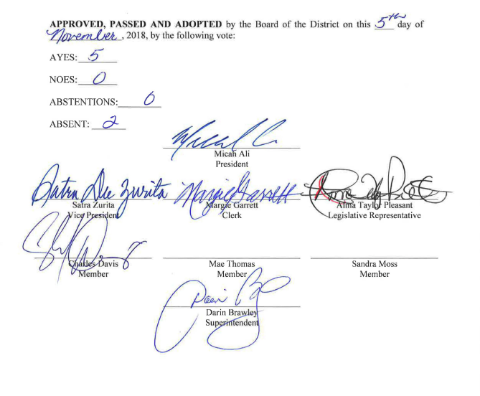

April 25, 2019
To Whom It May Concern:
We are very interested in exploring the creation of a Community Workforce Initiative (CWI) program in the City of Compton in collaboration with CUSD, building on best practices of our CWI programs and the successful programs and resources already in place in your community. We currently have programs in several locations throughout the U.S., and we are in the process of launching new programs. The attached brochure describes our vision and strategy, and examples of our current CWI programs.
To illustrate the potential of a CWI partnership with CUSD, below frames one approach we could take in establishing a Compton CWI program. This is intended to start our conversation about this exciting project and, is, of course, subject to further discussion and collaboration with CUSD, potential local community workforce partners and other stakeholders and agreements made in connection with our Compton development proposal.
- Training and program organization: Prologis to partner with local community workforce organizations to provide technical and soft skills training and internship/job placement services to CUSD. For example, we could explore a Compton program with EXP, a current Prologis CWI partner and community workforce organization in the LA area. We understand that EXP has already expressed interest in bringing a workforce program to CUSD (but funding was an issue). This could be an opportunity to see how Prologis might help to bridge that gap. In addition to offering job skills training, EXP has an alumni program offering job placement services for high school students and young adults that could benefit Compton as well.
- Trainees: High school, college students or young adults from the Compton community. The partner organization to work with CUSD to identify and onboard trainees.
- Resources and partners: Mix of community workforce development partners, CUSD, technical or trade schools and instructors, depending on structure. Availability of resources and partner commitments will determine short- and long-term vision and program strategy.
- Training location: Classroom or other available space at a Compton school, or other location as determined by CUSD and the partner organization, located as conveniently as possible to Compton trainees. Other possibilities: Any available CUSD warehouse space to be used for training opportunities, with the potential to incorporate elements of the Prologis Trade and Logistics Lab from our Miami CWI program, such as a forklift training simulator, etc.
- Curriculum: Skills development and logistics-related training and learning opportunities (such as trade and logistics industry and career overviews, OSHA training, forklift training, health and safety training in the warehouse setting, job shadowing, etc.). As an example of skills development training we have provided, 400 mock interviews were recently conducted with 135 students and 80 industry professionals through our CWI program with EXP.
- Internships: Trade internships with Prologis customers and local businesses organized through the community workforce partner.
- Job placement services: Opportunities for young adults seeking employment in the logistics industry to connect with Prologis customers and other potential employers seeking to fill logistics job openings. We are holding an event in May, for example, to connect recent graduates from our Chicago CWI program with our customers who are hiring workers at our facilities.
An important next step in the process will be a series of conversations to determine CUSD, community and customer needs, potential local community workforce organization partners, potential Compton trainees and current trends in the labor market. It will also be important to learn about existing training resources, curriculum, infrastructure and programs to best customize the program to CUSD needs.
We look forward to your thoughts and engaging with you to launch a CWI program for CUSD in connection with our Compton development proposal.
Kind regards,Jeannie Renne-Malone
Vice President ESG
Prologis

Depiction of Property
Real property located at 723 S. Alameda Street/604-704 South Tamarind Avenue, Compton, CA
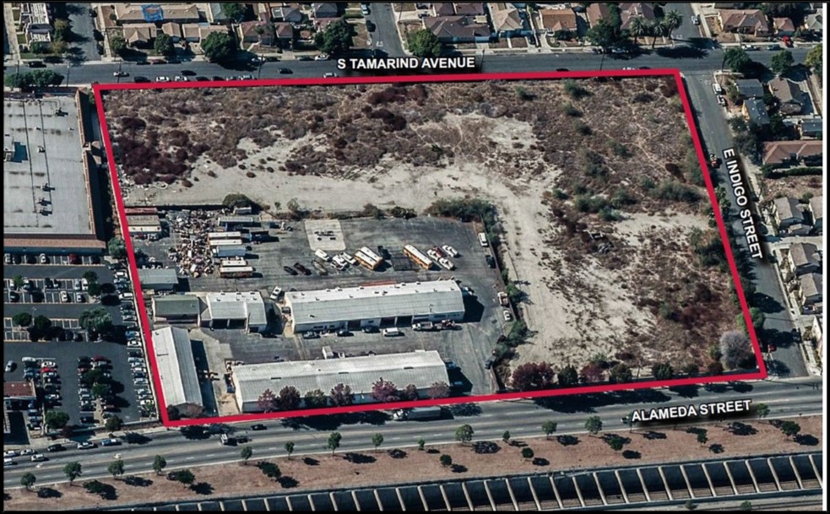

Lessee Improvements and Facilities
Structures, appurtenances, landscaping, and all other permanent improvements located on the property
