California Department of Education
Executive Office
SBE-004 (REV. 11/2017)
addendum01-nov19item01

ITEM ADDENDUM
DATE: November 6, 2019
TO: MEMBERS, State Board of Education
FROM: KAREN STAPF WALTERS, Executive Director, California State Board of Education
SUBJECT: Item 1 – 2020-2021 State Board of Education Student Member: Recommendation of Three Finalists for Submission to the Governor for Consideration and Appointment.

Summary of Key Issues
The State Board of Education Screening Committee (consisting of Members Straus (Chair), Ortiz-Licon, and Pattillo Brownson) and Student Board Member Pangelinan recommend that the State Board of Education approve three 2020-21 student member finalists for submission to the Governor, as indicated in Attachment 1.

Attachment(s)
Attachment 1: Recommended Finalists for the 2020-21 Student Member of the Board for the Governor’s Consideration and Appointment (2 Pages)
STATE OF CALIFORNIA
CALIFORNIA STATE BOARD OF EDUCATION
1430 N Street, Suite 5111
Sacramento, CA 95814
Phone:(916) 319-0827
GAVIN NEWSOM, Governor
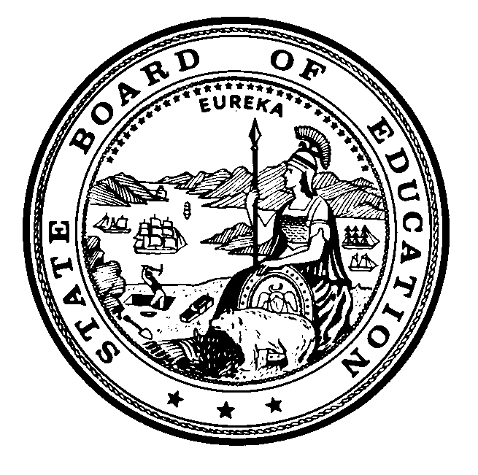

Attachment 1
November 5, 2019
TO: Members, State Board of Education
FROM: Ilene Straus, Chair, and Members of Screening Committee of the State Board of Education
RE: Recommended Finalists for the 2020-2021 Student Member of the Board for the Governor’s Consideration and Appointment
The State Board of Education (SBE) Screening Committee met on Tuesday, October 15, 2019 to review the applications that were submitted for consideration of the 2020-2021 Student Member of the Board, and selected 12 semi-finalists. The semi-finalists have attended the 2019 Student Advisory Board on Education (SABE) conference beginning on November 3, where student delegates listened to presentations made by the semi-finalists, and then voted to select six candidates.
On Tuesday, November 5, 2019, the SBE Screening Committee interviewed the six candidates, and identified three finalists for consideration by the Board. If approved, the names of these individuals will be submitted to the Governor’s Office for the Governor’s review and consideration. He will appoint one of them as the 2020-2021 Student Member of the Board.
We wish to thank all the students who made the effort to apply, and would like to encourage them to continue offering their impressive abilities to local, regional, or other state activities.
Students who are being recommended as finalists to the State Board of Education by the Screening Committee of the State Board of Education are provided in alphabetical order below:
- Michelle Alas, Northgate High School, within the Mt. Diablo Unified School District, Contra Costa County
- Arlene Campa, Los Angeles County High School for the Arts, within the Los Angeles County Office of Education, Los Angeles County
- Zaid Fattah, Monte Visa High School, within the San Ramon Valley Unified School District, Contra Costa County
In addition to the finalists named above, the following students were identified as candidates for the 2020-2021 Student Member of the Board:
- Ethan Collier, Hilltop High School, within the Sweetwater Union High School District, San Diego County
- Elena Medina, High Tech High Chula Vista, within the San Diego Unified School District, San Diego County
- Deyi (Oliver) Zhang, Castro Valley High School, within the Castro Valley Unified School District, Alameda County
The following students were also identified as semi-finalists for the 2020-2021 Student Member of the Board:
- Christian Calcines, Valley Academy of Arts and Sciences, within the Los Angeles Unified School District, Los Angeles
- Jennifer Chavez-Veyna, Ramona High School, within the Riverside Unified School District, Riverside County
- Rosemary Gomes, Ramona High School, within the Riverside Unified School District, Riverside County
- Dayla Mecham, Paradise High School, within the Paradise Unified School District, Butte County
- Leah Perez, Shasta High School, within the Shasta Union High School District, Shasta County
- Jessica Ramos, Skyline High School, within the Oakland Unified School District, Alameda County

