California Department of Education
Executive Office
SBE-003 (REV. 11/2017)
oab-sfsd-jan20item01

California State Board of Education
January 2020 Agenda
Item #09

Subject
Appeal from an Action of the San Bernardino County Committee on School District Organization to Disapprove a Petition to Transfer Territory from the Fontana Unified School District to the Etiwanda Elementary School District and the Chaffey Joint Union High School District.

Type of Action
Action, Information, Public Hearing

Summary of the Issue(s)
The San Bernardino County Committee on School District Organization (County Committee) disapproved a petition to transfer territory from the Fontana Unified School District (USD) to the Etiwanda Elementary School District (ESD) and the Chaffey Joint Union High School District (JUHSD). Pursuant to California Education Code (EC) Section 35710.5, the chief petitioner submitted an appeal to the California State Board of Education (SBE) from the County Committee’s action.
The SBE may affirm or reverse the County Committee’s decision to disapprove the territory transfer proposal. If the SBE reverses the County Committee’s action, thus approving the territory transfer, it must establish an election area for the proposal.

Recommendation
The California Department of Education (CDE) recommends that the SBE affirm the decision of the County Committee to disapprove the proposal to transfer territory from the Fontana USD to the Etiwanda ESD and the Chaffey JUHSD.

Brief History of Key Issues
The San Bernardino County Superintendent of Schools (County Superintendent) received a petition signed by at least 25 percent of the voters residing in 59 homes from the 118-home Van Daele Avellino housing development. These 59 homes are within the boundaries of the Fontana USD, while the remaining homes already are part of the Etiwanda ESD and the Chaffey JUHSD. According to the petition, the transfer is requested because:
- There is strong community identity between the transfer area and the Van Daele Avellino homes that are in the Etiwanda ESD and the Chaffey JUHSD;
- Schools of the Etiwanda ESD and the Chaffey JUHSD are closer to the proposed transfer area than are the Fontana USD schools; and
- Commutes to Fontana USD schools are less safe than are commutes to schools in the Etiwanda ESD and the Chaffey JUHSD.
The Van Daele Avellino housing development is part of ongoing residential, commercial, and office space development planned for the Fontana USD territory adjacent to and near the proposed transfer area. One housing development near the transfer area, and currently under construction, will have over 3,500 homes and contain two new Fontana USD schools. Another housing development (489 homes) will be built immediately adjacent to the proposed transfer area. Significant infrastructure improvements associated with the new development (and near the proposed transfer area) have occurred—and will continue to accompany future housing developments.
After conducting public hearings in each affected school district and receiving recommendations from an independent consultant who analyzed the proposal, the County Committee determined that one of the nine minimum threshold conditions of EC Section 35753(a) is not substantially met. That condition is:
- EC Section 35753(a)(4): The reorganization of the school districts will preserve each affected district’s ability to educate pupils in an integrated environment and will not promote racial or ethnic discrimination or segregation.
The County Committee subsequently disapproved the proposed transfer of territory from the Fontana USD to the Etiwanda ESD and the Chaffey JUHSD. Pursuant to EC Section 35710.5, the chief petitioner submitted an appeal from the County Committee action. The County Superintendent then transmitted the appeal and materials related to the County Committee’s review and action (administrative record) to the SBE.
The CDE reviewed the entire administrative record provided by the County Superintendent (including summaries and transcripts of public hearings and meetings, documentation prepared by the Fontana USD and the chief petitioner, and information presented to the County Committee by its independent consultant)—as well as new information requested and received from the County Superintendent and the affected school districts (pursuant to EC Section 35751). After this review, the CDE completed an analysis of the proposed territory transfer and the subsequent appeal. This analysis and resultant recommendations are contained in Attachment 1.

CDE Findings and Recommendations
Approval of a school district reorganization by the SBE is a discretionary action, whether the SBE finds that all EC Section 35753 conditions are substantially met or even if all the conditions are not met. The SBE may consider compelling information offered by affected districts, petitioners and appellants, community members, and the CDE in making its determination regarding this appeal.
Below is a summary of the CDE’s findings and recommendations from Attachment 1 that the SBE may consider when making its decision.
The CDE makes the following findings:
- All minimum threshold standards of EC Section 35753 are substantially met. The CDE disagrees with the County Committee’s determination that the “racial/ethnic segregation” condition is not substantially met.
- Current and future construction in the areas adjacent to the proposed transfer area has mitigated (and will continue to mitigate) the concerns that have been raised by petitioners to justify the territory transfer.
- There are no compelling local educational reasons or concerns to justify overturning the County Committee decision to disapprove the proposed transfer.
Based on these findings, the CDE recommends that the SBE affirm the decision of the County Committee to disapprove the proposal to transfer territory from the Fontana USD to the Etiwanda ESD and the Chaffey JUHSD.

Summary of Previous State Board of Education Discussion and Action
The SBE has not considered a territory transfer involving the Fontana USD and the Etiwanda ESD/Chaffey JUHSD previously.

Fiscal Analysis (as appropriate)
Affirming the action of the County Committee will result in no financial costs to any local or state agency. Overturning the action of the County Committee constitutes an order to the County Superintendent to call an election for the proposed territory transfer. Costs for this election will depend upon the timing of the election and the size of the election area established by the SBE—election costs will be borne by the county.

Attachment(s)
Attachment 1: Analysis of Administrative Record (19 pages)
Attachment 2: Views of Coyote Canyon Road (3 pages)

ATTACHMENT 1
Analysis of Administrative Record
Appeal from an Action of the
San Bernardino County Committee on School District Organization
to Disapprove a Petition to Transfer Territory
from the Fontana Unified School District
to the Etiwanda Elementary School District
and the Chaffey Joint Union High School District

1.0 Recommendation
The California Department of Education (CDE) recommends that the California State Board of Education (SBE) affirm the action of the San Bernardino County Committee on School District Organization (County Committee) to disapprove a petition to transfer territory from the Fontana Unified School District (USD) to the Etiwanda Elementary School District (ESD) and the Chaffey Joint Union High School District (JUHSD).

2.0 Background

2.1 Affected Districts
The Fontana USD serves approximately 36,000 kindergarten through twelfth grade students at 29 elementary schools, seven middle schools, and five comprehensive high schools. Fontana USD’s territory encompasses a majority portion of the City of Fontana, as well as a small portion of the City of Rialto, in San Bernardino County.
The Etiwanda ESD educates approximately 14,000 kindergarten through eighth grade students in 12 elementary schools and four middle schools. The territory of the district includes the community of Etiwanda (within the City of Rancho Cucamonga), portions of the City of Fontana, and other territory in San Bernardino County. The Etiwanda ESD is a component elementary school district of the Chaffey JUHSD.
The Chaffey JUHSD provides secondary education services to approximately 24,000 ninth through twelfth grade students in eight comprehensive high schools. Territory of the Chaffey JUHSD encompasses the cities of Montclair and Rancho Cucamonga along with portions of the cities of Chino, Fontana, Ontario, and Upland.
Table 1 depicts the percentage of students in the most populous racial/ethnic categories for each of the school districts from the California Longitudinal Pupil Achievement Data System (CALPADS). The largest racial/ethnic category in all districts is “Hispanic.”
Table 1: Percent Race/Ethnicity in Districts Affected by Proposed Transfer
District | African American | Asian | Hispanic | White | Other*
Fontana USD  (K-12 enrollment: 36,355) | 5.1% | 1.2% | 87.4% | 3.9% | 2.4%
Etiwanda ESD  (K-8 enrollment: 14,082) | 9.4% | 12.9% | 45.0% | 22.9% | 9.7%
Chaffey JUHSD  (9-12 enrollment: 23,883) | 7.6% | 6.4% | 64.3% | 16.3% | 5.4%
Source: 2018–19 CALPADS
* The “Other” category includes “American Indian or Alaska Native,” “Filipino,” “Pacific Islander,” and “Two or More.” Students in the “Not Reported” CALPADS category are omitted from calculations for this table.

2.2 Territory Transfer Proposal
A petition signed by at least 25 percent of the voters from a portion of the Van Daele Avellino housing development requests the transfer of 59 homes from the Fontana USD to the Etiwanda ESD and the Chaffey JUHSD. Sixty-four parcels from this development already were within the Etiwanda and Chaffey districts at the time the petition was submitted.
Petitioners provide the following three reasons for requesting the transfer:
- The homes identified in the petition are completely isolated from the Fontana USD, which has a negative effect on the petitioners’ sense of community identity.
- Travel to Fontana USD schools places the safety of the children from the neighborhood at risk.
- The proposed transfer area is significantly closer to the Etiwanda ESD elementary and middle schools that students would attend.
A map of the proposed transfer area is Figure 1.
Figure 1: Overview Map of Area Proposed for Transfer
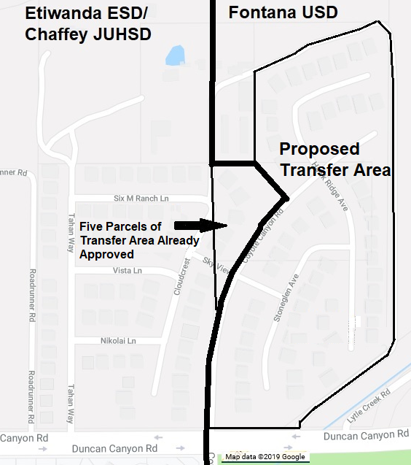
Source map: Google Maps © 2019; School district boundary source: US Census Bureau, Geography Division (https://tigerweb.geo.census.gov/tigerweb/).
The current boundary line between the Fontana USD and the Etiwanda ESD/Chaffey JUHSD (subsequent to transfer of five of the parcels in the original proposed transfer area) is depicted by the heavy black line. A map of the area surrounding the territory proposed for transfer (and showing school site locations) is on page 15 of this attachment (Figure 3).

2.3 Current and Future Residential Development
The proposed transfer area is located along the Interstate 15 corridor on the northern edge of the City of Fontana and near the southern foot of the San Gabriel Mountains. Primary access to the area is provided by Duncan Canyon Road. The construction of the Duncan Canyon Road interchange to Interstate 15 is in response to expected rapid growth in residential, commercial, and office development along this portion of the Interstate 15 corridor over the next 25 years. Two of the housing development projects, which are part of this growth, are of particular relevance to the territory transfer proposal: The Arboretum and Monarch Hills (see Figure 2 on next page).
The Arboretum currently is under construction, with home sales occurring and some sites already occupied by residents. The Specific Plan for this development includes over 3,500 residential units. Additionally, two new school sites will be built within The Arboretum—Fontana USD plans are for an elementary school and a kindergarten through twelfth grade magnet school.
Monarch Hills was approved by the City of Fontana in early 2019 and will include a total of 489 homes. Primary access to the new development will be an extension of Coyote Canyon Road, which runs through the middle of the proposed transfer area (and is the access road to that area). The Fontana USD projects that between 300 and 400 students will be generated from the Monarch Hills project.
Along with The Arboretum and Monarch Hills (and other areas being developed in the vicinity of the proposed transfer area) will come improvements to the surrounding infrastructure, including new streets, improvements to existing streets, traffic controls, and extensions of bike paths and paved sidewalks.
Figure 2: New Developments Adjacent to Proposed Transfer Area
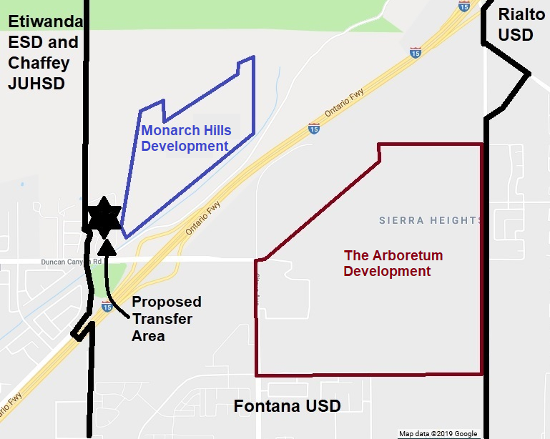
Source map: Google Maps © 2019; School district boundary source: US Census Bureau, Geography Division (https://tigerweb.geo.census.gov/tigerweb/).

3.0 Action of the County Committee
The County Committee held two public hearings for the proposed transfer of territory—one within the boundaries of the Fontana USD and one within the boundaries of the Etiwanda ESD (which also is within the Chaffey JUHSD). The San Bernardino County Superintendent of Schools (County Superintendent) contracted with an outside consultant for an analysis of the proposal and recommendations for the County Committee’s consideration. Under the California Education Code (EC), the County Committee had the following options:
- If the County Committee determined that all nine minimum threshold standards of EC Section 35753(a) are substantially met, it could approve the petition (though not required to do so).
- The County Committee could disapprove the petition to transfer territory for other concerns even if it finds that all nine conditions of EC Section 35753(a) have been substantially met.
- If the County Committee determined that all nine minimum threshold standards of EC Section 35753(a) are not substantially met, it would be required to disapprove the petition to transfer territory.
The County Committee found that the proposal failed to substantially meet the following EC Section 35753 minimum threshold standard: The reorganization of the school districts will preserve each affected district’s ability to educate pupils in an integrated environment and will not promote racial or ethnic discrimination or segregation. The County Committee subsequently voted 5 to 4 on a motion to disapprove the transfer.
Chief petitioners or affected school districts may appeal a County Committee decision on territory transfers for issues of noncompliance with the provisions of EC sections 35705, 35706, 35709, 35710, and 35753(a). The chief petitioner for the territory transfer submitted such an appeal to the County Superintendent, who subsequently transmitted the appeal, along with the complete administrative record of the County Committee action, to the SBE.

4.0 Positions of Affected School Districts

4.1 Fontana USD
The Fontana USD is opposed to the proposed transfer of territory, noting that there is no compelling reason to approve the transfer other than the petitioners’ desire that their students attend the same schools as students on the other side of the district boundary. Moreover, approval of the transfer would set a precedent for future transfer requests based solely on the proximity of homes to the district’s boundaries. Such transfers could set in motion the incremental erosion of established boundaries, leading to serious long-term problems for the district.
The district further claims that the minimum threshold conditions established by EC Section 35753 typically are easily met by small territory transfers such as the proposal—so other critical issues must be considered when reviewing this proposal, including:
- Planned future development adjacent to and near the proposed transfer area will address concerns raised by petitioners regarding community identity.
- The proposed transfer area is one of the wealthier areas of the Fontana USD. The long-term socioeconomic segregation created by continued transfers of these wealthier areas out of the district (and into neighboring districts of higher socioeconomic status) potentially will affect the racial and ethnic status, educational programs, school performance, and fiscal stability of the Fontana USD.

4.2 Etiwanda ESD and Chaffey JUHSD
Both the Etiwanda ESD and the Chaffey JUHSD maintain a neutral position regarding the proposed territory transfer, noting that they would abide by the County Committee’s decision regarding the proposal.

5.0 Reasons for the Appeal
The chief petitioner for the territory transfer proposal appeals the County Committee’s decision to disapprove the transfer for the following four reasons:
- Evidence clearly indicates that the EC Section 35753(a)(4) condition (The reorganization of the school districts will preserve each affected district’s ability to educate pupils in an integrated environment and will not promote racial or ethnic discrimination or segregation) is substantially met.
- Information presented to the County Committee by the Fontana USD was false and misleading. The Fontana USD also disregarded County Committee direction to submit information prior to presenting it in public session.
- The meeting at which the County Committee disapproved the territory transfer proposal was operationally deficient, and County Committee members demonstrated confusion and lack of understanding of their actions.
- The safety of children from the proposed transfer area remains in jeopardy as a result of the County Committee’s action.
CDE analysis of the racial/ethnic segregation condition (EC Section 35753[a][4]) is contained in the Section 6.0. Responses to the petitioner concerns regarding the safety of neighborhood children during school commutes is in Section 7.1. Petitioner’s general claims regarding the accuracy of information considered by the County Committee, deficient meeting procedures, and lack of procedural understanding by County Committee members are not addressed in this analysis as they are not matters subject to appeal to the SBE.

6.0 CDE Analysis of Education Code Section 35753
CDE staff reviewed the administrative record provided by the County Superintendent, which details (1) the reorganization feasibility study completed by the independent consultant (County Committee Study), (2) the County Committee actions in its consideration of the EC Section 35753 threshold conditions, and (3) the concerns raised in the appeal regarding the County Committee’s actions. As noted in previous sections, the County Committee determined that the following EC Section 35753 condition is not substantially met by the proposed transfer of territory:
- EC Section 35753(a)(4): The reorganization of the school districts will preserve each affected district’s ability to educate pupils in an integrated environment and will not promote racial or ethnic discrimination or segregation.
For its analysis of the effects of territory transfer proposal, the CDE conducted its own study of this condition, using information provided by the County Superintendent and the affected school districts, as well as data that is maintained by the CDE.
The County Committee determined that the remaining EC Section 35753 conditions are substantially met—however, the Fontana USD raised concerns regarding a number of these conditions, primarily in the context of future residential development adjacent and near to the proposed transfer area. The district believes that approval of this proposed transfer would be precedent-setting—leading to additional transfer requests from this future residential development, which, if approved, would result in significant negative effects on the Fontana USD. The CDE will address this issue of future development in in Section 7.2 of this report.

6.1 Standard of Review
SBE regulations (5 CCR Section 18573[a][2]) regarding this “racial/ethnic segregation” condition specifically address formation of new districts and list the following factors to be considered:
- The current number and percentage of pupils in each racial and ethnic group in the affected districts and schools in the affected districts, compared with the number and percentage of pupils in each racial and ethnic group in the affected districts and schools in the affected districts if the proposal or petition were approved.
- The trends and rates of present and possible future growth or change in the total population in the districts affected, in each racial and ethnic group within the total district, and in each school, of the affected districts.
- The school board policies regarding methods of preventing racial and ethnic segregation in the affected districts and the effect of the proposal or petition on any desegregation plan or program of the affected districts, whether voluntary or court ordered, designed to prevent or to alleviate racial or ethnic discrimination or segregation.
- The effect of factors such as distance between schools and attendance centers, terrain, and geographic features that may involve safety hazards to pupils, capacity of schools, and related conditions or circumstances that may have an effect on the feasibility of integration of the affected schools.
- The effect of the proposal on the duty of the governing board of each of the affected districts to take steps, insofar as reasonably feasible, to alleviate segregation of minority pupils in schools regardless of its cause.

6.2 County Committee Action
The following summary of the racial and ethnic composition of the affected districts is contained in the County Committee Study and was presented to the County Committee in public session:
Fontana USD is predominantly Hispanic at 86.30% followed by African American (5.71%) and White (4.55%). Etiwanda SD and Chaffey Joint Union HSD are also both predominantly Hispanic—at 44.12% and 63.53%, respectively—though at a lower percentage than Fontana USD. White (24.42% at Etiwanda SD and 18.00% at Chaffey Joint Union HSD) and Asian (15.43% at Etiwanda SD) and African American (8.07% at Chaffey Joint Union HSD) round out the top three ethnicities.
The recommendation in the County Committee Study regarding this condition is that the criterion is “substantially met as the proposed territory transfer would not promote racial or ethnic discrimination or segregation.”
The County Committee, after hearing a presentation by the consultant who prepared the County Committee Study and considering testimony provided by the affected districts, the chief petitioner, and members of the public, voted that this EC Section 35753(a)(4) condition is not substantially met on an 8-1 vote. Although no specific reasons were provided for the vote, comments by County Committee members (taken from a transcript of the meeting) suggest that the County Committee members were concerned about:
- The existing differences between minority student populations in the affected districts (especially the substantially greater percentage of Hispanic students in the Fontana USD); and
- The combination of these existing differences in student populations with effects of future transfers from proposed new residential developments, which could promote racial/ethnic segregation.

6.3 Appeal
The chief petitioner argues that the County Committee erred in its finding because:
- Its action contradicts the independent analysis and findings regarding the condition provided in the County Committee Study.
- It is unreasonable to believe that the transfer of approximately 35 students would have substantial effects on racial/ethnic integration in districts that range in size between 13,600 and 39,800 students.
- The County Committee appeared to be swayed by false and misleading information presented by the Fontana USD regarding (1) the demographics of the proposed transfer area and (2) a preference among developers in the area to market new homes that are within the Etiwanda ESD and Chaffey JUHSD.
The chief petitioner further noted that an informal survey of the proposed transfer area shows that the racial makeup of the community is similar to that of the nearest Fontana USD school (Sierra Lakes Elementary). The removal of the nine enrolled elementary school-age students from the petition area would have no effects on the racial/ethnic integration of the 734-student Sierra Lakes Elementary School.

6.4 CDE Findings/Conclusion
As stated above, SBE regulations identify a number of factors to be included in an analysis of the effects of the ability of newly formed school districts to educate students in an integrated environment. Since this appeal does not involve the formation of a new school, and given the small number of students directly affected by the proposed transfer of territory, the CDE is not including an analysis of all the listed regulatory factors.
Table 1 of this report (see page 2) displays the percentages of students in the most populous CALPADS categories for each of the affected school districts. In the Fontana USD over 96 percent of its students are in one of the minority student categories (87.4 percent are Hispanic), while 71.1 percent of Etiwanda ESD’s students are minority students (45 percent Hispanic) and 83.7 percent of Chaffey JUHSD’s students are minority students (64.3 percent Hispanic).
Table 2 provides similar comparisons at the school level.
Table 2: Percent Race/Ethnicity in Schools Affected by Proposed Transfer
School | District | African American | Asian | Hispanic | White | Other*
Sierra Lakes Elementary | Fontana USD | 14.4% | 7.1% | 56.2% | 11.3% | 10.9%
Long Elementary | Etiwanda ESD | 9.2% | 5.0% | 45.1% | 29.6% | 11.2%
Ruble Middle | Fontana USD | 7.7% | 2.5% | 77.4% | 6.3% | 6.1%
Summit Intermediate | Etiwanda ESD | 11.2% | 7.6% | 45.3% | 26.6% | 9.5%
Summit High | Fontana USD | 8.8% | 3.5% | 74.9% | 7.9% | 4.8%
Etiwanda High | Chaffey JUHSD | 15.1% | 6.6% | 49.4% | 18.6% | 10.2%
Source: 2018–19 CALPADS
* The “Other” category includes “African American,” “American Indian or Alaska Native,” “Asian,” “Filipino,” “Pacific Islander,” and “Two or More.” Students in the “Not Reported” CALPADS category are omitted from calculations for this table.
Regarding the affected elementary schools, Sierra Lakes Elementary (Fontana USD) has 88.7 percent minority students (56.2 percent Hispanic), while Long Elementary (Etiwanda ESD) has 70.4 percent minority students (45.1 percent Hispanic). At the middle/intermediate schools, Ruble Middle (Fontana USD) has 93.7 percent minority students (77.4 percent Hispanic) and Summit Intermediate (Etiwanda ESD) has 73.4 percent minority students (45.3 percent Hispanic). In the high schools, 92.1 percent of the Summit High (Fontana USD) students are minority students (74.9 percent Hispanic), while 81.4 percent of the students at Etiwanda High (Chaffey JUHSD) are minority students (49.4 percent Hispanic).
Removing the students residing in the proposed transfer area from the Fontana USD schools and placing them in the Etiwanda ESD and the Chaffey JUHSD schools would have minimal effects on the ability of these schools to educate students in an integrated environment. The demographic composition of these students is unknown to the CDE (the chief petitioner reports that, through an informal review of families, 42 percent of the students in the proposed transfer area are Hispanic). However, even if all students from that community are non-minorities (which is highly unlikely), removal of 35 students would increase the percentage of minority students at the Fontana USD schools by the following percentage points: Sierra Lakes Elementary School (2.3); Ruble Middle School (0.6); and Summit High School (0.4). Such transfer would reduce the percentage of minority students at the Etiwanda ESD and the Chaffey JUHSD schools by similar percentage points.
It is the CDE’s opinion that the removal of the approximately 35 students residing in the proposed transfer area from the Fontana USD schools and placing them in the Etiwanda ESD and the Chaffey JUHSD schools would not (1) promote racial or ethnic segregation or (2) effect the ability of any affected school from educating students in an integrated environment.
The CDE disagrees with the County Committee’s finding and recommends that this “racial/ethnic segregation” condition is substantially met.

7.0 Compelling Reasons and Concerns
Approval of a territory transfer by the SBE is a discretionary action, whether the SBE finds that all EC Section 35753 conditions are substantially met or even if all the conditions are not met. The SBE may consider compelling reasons offered by affected districts, petitioners and appellants, community members, and the CDE in making its determination to approve a territory transfer. It also may consider any concerns raised by these same parties in a determination to disapprove the transfer.
The chief petitioner and the Fontana USD have offered a number of reasons and concerns regarding the proposed transfer, some of which have been discussed in other sections of this report. In this section, the CDE will summarize the potential compelling reasons and concerns it considers most relevant.

7.1 Compelling Reasons for Approval of Transfer
Based on analyses of the information available, the CDE finds that the proposed territory transfer substantially meets all nine minimum threshold standards of EC Section 35753. However, the SBE is not compelled to take an action that would approve the transfer even if it agrees with this CDE recommendation. The SBE may consider any issue it determines to be compelling as a reason to reverse the County Committee’s disapproval of the transfer proposal. Petitioners propose two compelling reasons for SBE consideration: Community identity and safety of school commutes.

Community Identity
Petitioners note the following negative effects of the current school boundary on the community identity of their neighborhood:
- The neighborhood is divided by the school district boundaries. The proposed transfer area contains 54 of the 118 homes in the Van Daele Avellino housing development—thus, 64 of the homes in this neighborhood already are in the Etiwanda ESD and the Chaffey JUHSD. Approval of the transfer would unify the neighborhood.
- The transfer area contains the only homes west of Interstate 15 that are within Fontana USD boundaries. Children in the neighborhood are separated from Fontana USD schools by this freeway.
- The Etiwanda ESD elementary school is geographically closer to the proposed transfer area than is the Fontana USD elementary school. Although that proximity issue does not exist for the middle and high schools, it is not as important at those schools since older students are more independent.
The CDE agrees that the above conditions do exist—however, the CDE also notes that these conditions are not unique to this neighborhood. School district boundaries frequently split neighborhoods and separate them from schools in another district that are geographically closer. Freeways, especially in urban areas such as this, frequently are between neighborhoods and the schools to which they are assigned.
Future development in surrounding areas will change the circumstances behind some of the concerns raised by petitioners. The Monarch Hills development (see Figure 2) also will be on the west side of Interstate 15. Coyote Canyon Road, the primary access to the proposed transfer area, will be extended into this new development—thus connecting it to transfer neighborhood. Monarch Hills will add a total of 489 new homes adjacent to area proposed for transfer, with a projection of well over 300 new students.

Safety of School Commutes
At the time the petition to transfer territory was submitted, petitioners noted a number of safety concerns regarding their students’ commutes to and from Fontana USD schools. These concerns included:
- There is not a marked crosswalk or a four-way stop sign at the intersection of Coyote Canyon Road (the street that is the only access into the proposed transfer area) and Duncan Canyon Road (a busy street that must be crossed to get to Fontana USD schools).
- There are no bike paths or paved sidewalks over the Duncan Canyon Road freeway overpass and along the route to Fontana USD schools.
- There is considerable traffic at the Duncan Canyon Road/Interstate 15 interchange.
- The Etiwanda ESD elementary school is geographically closer to the proposed transfer area than is the Fontana USD elementary school. Such proximity decreases the potential safety issues in traveling to elementary school, which is more important than safety issues for middle and high school commutes. Figure 3 (on the next page) shows the locations of the affected districts’ schools to which students from the transfer area are assigned (or would be assigned if the transfer is approved).
- There is undeveloped land between the neighborhood and Fontana USD schools where coyotes constantly roam.
The CDE notes that the above-described claims were made prior to significant changes in the area. As noted in Section 2.3, the area surrounding the territory proposed for transfer currently is undergoing considerable development (and is slated for continued development for many years to come). As a result of this development, the following concerns raised by the petitioners either have been addressed or will be addressed in the near future:
- There now is a marked crosswalk and a four-way stop sign where students would cross Duncan Canyon Road when exiting the neighborhood.
- Bike paths and paved sidewalks are being extended toward the areas of new residential development (and along the path to existing and new Fontana USD schools).
- The new Fontana USD elementary school (scheduled for construction within The Arboretum development) will be closer to the proposed transfer area than is the Etiwanda ESD elementary school.
- The undeveloped land surrounding the proposed transfer area is under development (or proposed for future development), which likely will discourage the presence of coyotes.
The CDE understands that students in the proposed transfer area need to travel along a freeway overpass to attend schools in the Fontana USD. However, as noted previously, the existence of freeways and major traffic arteries between the residences of students and the schools they attend is commonplace in urban areas such as the City of Fontana. If the territory transfer is approved (and students from this area were in the Chaffey JUHSD), students would have to cross a freeway to attend Etiwanda High School (see Figure 3 on page 15). Similarly, there are many neighborhoods within the Etiwanda ESD and the Chaffey JUHSD that are separated from their assigned schools by freeways.
The CDE also notes that the Fontana USD provides bus transportation between the proposed transfer area and their schools that serve that area’s students.
Figure 3: Schools Near the Proposed Transfer Area
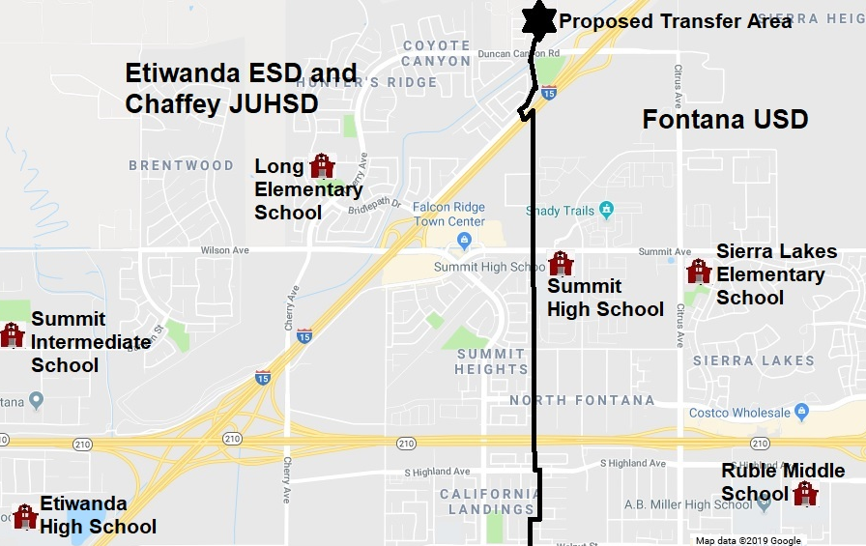
Source map: Google Maps © 2019; School district boundary source: US Census Bureau, Geography Division (https://tigerweb.geo.census.gov/tigerweb/).

7.2 Concerns Regarding Moving the Proposal Forward
The SBE, even if it determines the transfer substantially meets EC Section 35753 conditions, may consider any concerns that warrant disapproving the proposal, including (but not limited to) the following:

Current and Proposed Residential Development
In Section 2.3 and 7.1, the CDE referenced the considerable new residential construction currently occurring (and planned for the future) in the territory around the proposed transfer area. It is the CDE’s opinion that this construction already has mitigated many concerns regarding community identity and commute safety raised by the petitioners. Future construction will continue such mitigation as well as bring two new school sites closer to the proposed transfer area (together, these two schools will serve kindergarten through twelfth grade students). The SBE might consider that changing school district boundaries in the midst of this current and future change along the boundary is unwarranted at this time.

Encouragement of Future Transfers
The future construction of the Monarch Hills housing development (see Figure 2 on page 5) will provide 489 homes in the Fontana USD with circumstances that are very similar to the proposed transfer area. These new homes also will be on the west side of Interstate 15 and separated from Fontana USD by that freeway. Additionally, if the current territory transfer is approved, students from the Monarch Hills neighborhood will travel through the transfer area to attend Fontana USD schools. The SBE might consider that future territory transfer requests will be generated from these homes if the current proposal is approved.

Existing Boundary
The current school district boundary line that runs through the Van Daele Avellino housing development is along Coyote Canyon Road. This street is a wide street with no homes on either side. Instead, there are brick walls on each side between the street and the houses behind the walls. The SBE could consider that Coyote Canyon Road is an appropriate boundary between the school districts.

8.0 Staff Recommended Amendments
The SBE has authority to amend or add certain provisions to any petition for reorganization. The CDE recommends only one provision be added to the petition if the SBE overturns the action of the County Committee by approving the appeal—the determination of the area of election (pursuant to EC Section 35732). The following information details the CDE recommendation regarding this provision.

8.1 Area of Election
District opposition to a territory transfer approved by a County Committee is one of the factors that triggers a local election (see EC sections 35709 and 35710). The Fontana USD is opposed to the territory transfer—however, the County Committee voted to disapprove the proposed territory and, therefore, did not take any action regarding establishing an election area. If the SBE approves the appeal (thus triggering a local election for approval of the territory transfer proposal due to the opposition of the Fontana USD), the SBE must determine the territory in which this election will be held (pursuant to EC Section 35756).
The “default” election area in EC Section 35732 is the territory proposed for reorganization (i.e., the proposed transfer area). The SBE may expand the election area if it determines that conditions warrant such expansion.

8.2 Area of Election Principles
In establishing the area of election, the CDE and SBE follow the legal precedent set by the California Supreme Court in Board of Supervisors of Sacramento County, et al. v. Local Agency Formation Commission (1992) 3 Cal. 4th 903 (the “LAFCO” decision). LAFCO holds that elections may be confined to within the boundaries of the territory proposed for reorganization (the “default” area), provided there is a rational basis for doing so. LAFCO requires we examine: (1) the public policy reasons for holding a reorganization election within the boundaries specified; and (2) whether there is a genuine difference in the relevant interests of the groups that the election plan creates.
A reduced voting area has a fair relationship to a legitimate public purpose. State policy favors procedures that promote orderly school district reorganization statewide in a manner that allows for planned, orderly, community-based school systems that adequately address transportation, curriculum, faculty, and administration.
Discussion of other judicial activity in this area is warranted. In a case that preceded LAFCO, the California Supreme Court invalidated an SBE reorganization decision that approved an area of election that was limited to the newly unified district. As a result, electors in the entire high school district were entitled to vote (Fullerton Joint Union High School District v. State Board of Education [1982] 32 Cal. 3d 779 [Fullerton]). The Fullerton court applied strict scrutiny and required demonstration of a compelling state interest to justify the exclusion of those portions of the district from which the newly unified district would be formed.
The Fullerton case does not require that the SBE conduct a different analysis than that described above. The LAFCO decision disapproved the Fullerton case, and held that absent invidious discrimination, the rational basis approach to defining the election area applied. In this matter of the proposed transfer of territory from the Fontana USD to the Etiwanda ESD and the Chaffey JUHSD no discrimination, segregation, or racial impacts are identified. Accordingly, the LAFCO standard and analysis applies.

8.3 Recommended Area of Election
The CDE finds no reason to believe that the proposed transfer would affect the present or future racial composition of any affected district, or have any significant negative fiscal effect. Therefore, the CDE recommends that the election area only be the territory proposed for transfer if the SBE takes action to reverse the County Committee’s disapproval of the territory transfer proposal.

9.0 State Board of Education Action
Subdivision (c) of EC Section 35710.5 provides that the SBE, upon receiving an appeal from an action of a County Committee, may review the appeal (either in conjunction with a public hearing or based solely on the administrative record) or ratify the County Committee’s decision by summarily denying review of the appeal. The practice of the SBE has been to hear all appeals in conjunction with a public hearing—thus, the assumption in this section is that the SBE will conduct a public hearing as part of its review.

9.1 State Board of Education Options
The SBE has the following three options for this territory transfer appeal:
- The SBE may review the appeal in conjunction with a public hearing.
- Following review of the appeal, the SBE must affirm or reverse the action of the County Committee.
- If the proposal will be sent to election, the SBE must determine the territory in which the election is to be held.
- The SBE may reverse or modify the action of the County Committee in any manner consistent with law.
- The SBE may request additional information regarding the appeal or the territory transfer, and choose not to take action until a later meeting.
- The SBE, pursuant to EC Section 35720, may direct the County Committee to formulate plans and recommendations for an alternative reorganization. The County Committee then would report back to the SBE regarding its actions.

9.2 California Department of Education Findings
The CDE makes the following findings regarding the territory transfer proposal:
- All minimum threshold standards of EC Section 35753 are substantially met. The CDE disagrees with the County Committee’s determination that the “racial/ethnic segregation” condition is not substantially met.
- Current and future construction in the surrounding area has (and will continue to) mitigate the concerns raised by petitioners to justify the transfer proposal.
- There are no compelling local educational reasons or concerns to justify overturning the County Committee decision to disapprove the proposed territory transfer.

9.3 Recommended Action
The CDE recommends that the SBE deny the appeal, thus affirming the action of the County Committee to disapprove the proposal to transfer territory from the Fontana USD to the Etiwanda ESD and the Chaffey JUHSD. Should the SBE decide to reverse the County Committee’s decision, thus approving the appeal and the territory transfer proposal, the CDE recommends that the SBE establish the territory proposed for transfer as the election area.

ATTACHMENT 2
Views of Coyote Canyon Road
The following pages contain views of Coyote Canyon Road within the Van Daele Avellino housing development in Fontana, California. These views are obtained from Google Street View (© 2019).

Figure 1: Terminus of Coyote Canyon Road
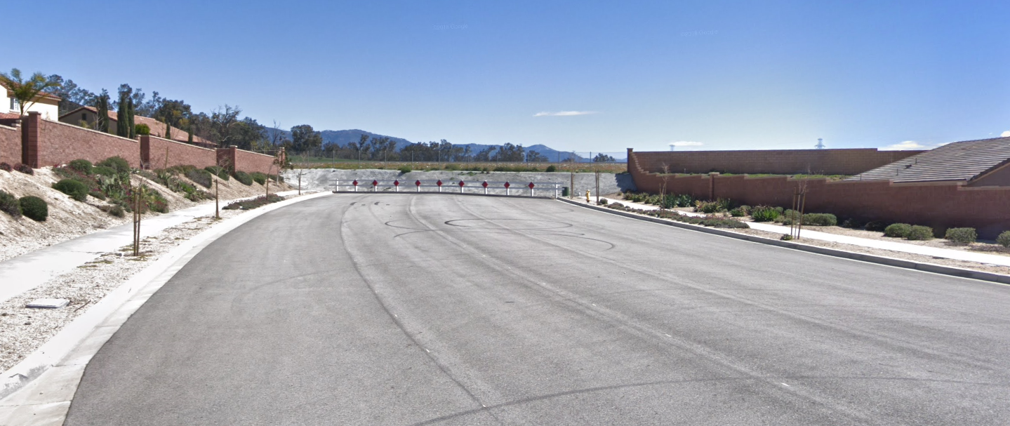
Source: Google Street View (© 2019)
The above view depicts the terminus of Coyote Canyon Road within the proposed transfer area. Coyote Canyon Road is the current boundary between the affected districts. This street will be extended into the Monarch Hills development (which is within the Fontana Unified School District [USD]) and provide access to schools of the Fontana USD.
Figure 2: Coyote Canyon Road
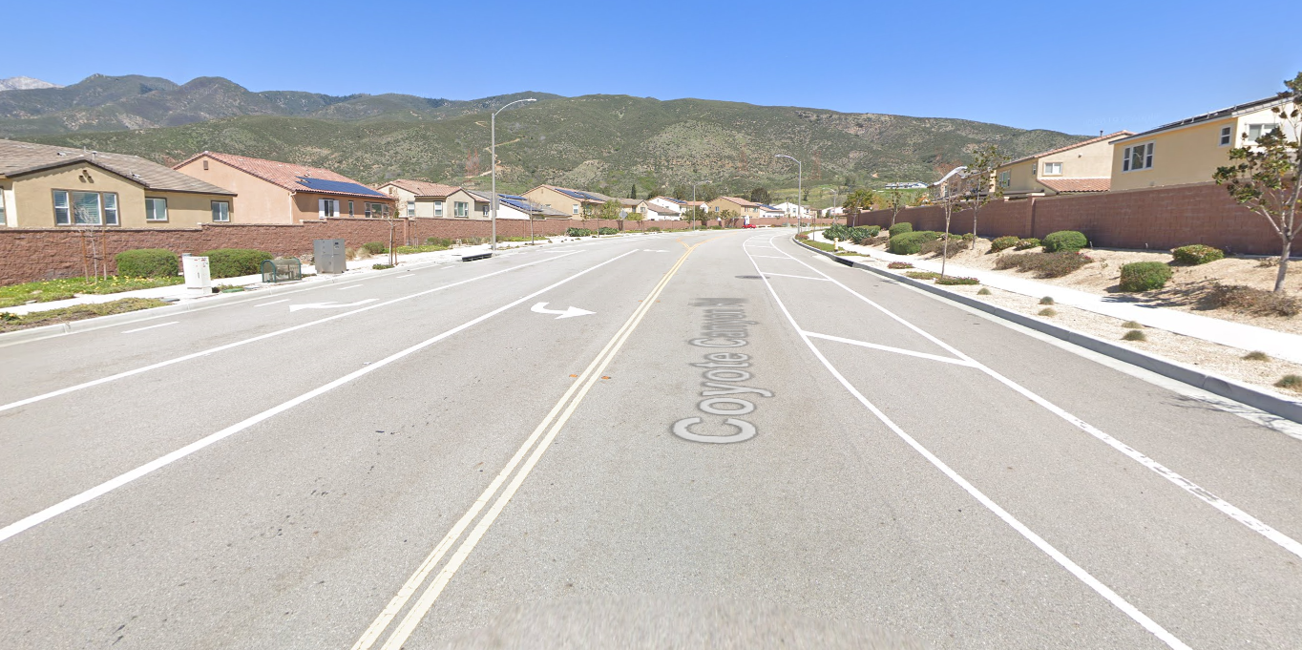
Source: Google Street View (© 2019)
The above view depicts Coyote Canyon Road within the proposed transfer area. There are no homes along the entire length of this street, which is lined with brick walls on both sides. Homes on the left side are within the Etiwanda Elementary School District and the Chaffey Joint Union High School District, while homes on the right side are in the Fontana Unified School District.

Pursuant to EC Section 35701, in a petition to reorganize school districts no more than three of the petitioners shall be designated as chief petitioners. There is only one chief petitioner designated for this petition.
Pursuant to EC sections 35709 and 35710, a county committee may approve a territory transfer only if it finds all conditions in EC Section 35753 substantially met.
Construction of the Van Daele Avellino housing development was completed in 2012, with home sales through 2013.
Five of the 59 parcels in this territory transfer proposal also were part of a separate transfer proposal that was approved by the County Committee (see Figure 1). For purposes of this report, only the remaining 54 parcels are considered.
The five parcels previously approved for transfer by the County Committee were adjacent to, and on the same street as, homes that were in the Etiwanda and Chaffey districts. The current boundary, after this transfer, is Coyote Canyon Road. There are no homes along the entire length of this road, which is lined with brick walls on both sides (see Figure 2 in Attachment 2).
Specific plan development is for more than 1,580 acres of residential, commercial, and office centers adjacent to the Duncan Canyon Road interchange (http://www.caltrop.com/project-details/i-15-duncan-canyon-interchange/).
Figure 1 in Attachment 2 depicts the current terminus of Coyote Canyon Road, which will be extended in the Monarch Hills development.
School Services of California, Inc.
Based on Fontana USD student yield factors (0.59 students per parcel), the assumption from the County Committee Study is that the 54 parcels in the proposed transfer area would yield approximately 32 to 33 students. The chief petitioner estimated that 35 school-age children reside in the transfer area.
Figure 1 in Attachment 2 provides view from the transfer area of the point at which Coyote Canyon Road will be extended in the Monarch Hills development.
A view of Coyote Canyon Road and the brick walls bordering each side of this street is shown in Figure 2 of Attachment 2.

