California Department of Education
Executive Office
SBE-004 (REV. 11/2017)
addendum-nov20item02

ITEM ADDENDUM
DATE: November 4, 2020
TO: MEMBERS, State Board of Education
FROM: BROOKS ALLEN, Executive Director, California State Board of Education
SUBJECT: Item 02 – 2021-2022 State Board of Education Student Member: Recommendation of Three Finalists for Submission to the Governor for Consideration and Appointment.

Summary of Key Issues
The State Board of Education Screening Committee (consisting of Members Straus (Chair), and Sun), along with SBE Liaisons to the California Association of Student Councils McQuillen and Student Board Member Fattah recommend that the State Board of Education approve three 2021-22 student member finalists for submission to the Governor, as indicated in Attachment 1.

Attachment(s)
Attachment 1: Recommended Finalists for the 2021-22 Student Member of the Board for the Governor’s Consideration and Appointment (2 Pages)
STATE OF CALIFORNIA
CALIFORNIA STATE BOARD OF EDUCATION
1430 N Street, Suite 5111
Sacramento, CA 95814
Phone:(916) 319-0827
GAVIN NEWSOM, Governor
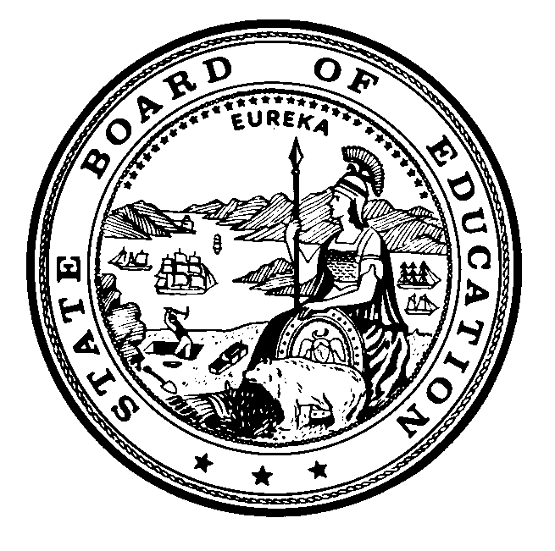

Attachment 1
November 4, 2020
TO: Members, State Board of Education
FROM: Ilene Straus, Chair, and Members of Screening Committee of the State Board of Education
RE: Recommended Finalists for the 2021-2022 Student Member of the Board for the Governor’s Consideration and Appointment
The State Board of Education (SBE) Screening Committee met on Friday, October 23, 2020 to review the applications that were submitted for consideration of the 2021-2022 Student Member of the Board, and selected 12 semi-finalists. The semi-finalists attended the 2020 Student Advisory Board on Education (SABE) conference beginning on October 31, where student delegates listened to presentations made by the semi-finalists, and then voted to select six candidates.
On Monday, November 2, 2020, the SBE Screening Committee interviewed the six candidates, and identified three finalists for consideration by the Board. If approved, the names of these individuals will be submitted to the Governor’s Office for the Governor’s review and consideration. He will appoint one of them as the 2021-2022 Student Member of the Board.
We wish to thank all the students who made the effort to apply, and would like to encourage them to continue offering their impressive abilities to local, regional, or other state activities.
Students who are being recommended as finalists to the State Board of Education by the Screening Committee of the State Board of Education are provided in alphabetical order by last name below:
- Rana Banankhah, Modesto High School, within the Modesto City Schools District, Stanislaus County
- Zachary Patterson, University City High School, within the San Diego Unified School District, San Diego County
- Jaden Stewart, North Hollywood High School Highly Gifted Magnet, within the Los Angeles Unified School District, Los Angeles County

In addition to the finalists named above, the following students were identified as candidates for the 2021-2022 Student Member of the Board:
- Stephanie Hu, Tesoro High School, within the Capistrano Unified School District, Orange County
- Jeffrey Oh, South Pasadena High School, within the South Pasadena Unified School District, Los Angeles County
- Catherine Xu, Westlake High School, within the Conejo Valley Unified District, Ventura County
The following students were also identified as semi-finalists for the 2021-2022 Student Member of the Board:
- Michael Balerite, James C. Enochs High School, within the Modesto City Schools District, Stanislaus County
- Paula Escobar, Evergreen Valley High School, within the East Side Union High School District, Santa Clara County
- Alexander Fan, Centennial High School, within the Kern High School District, Kern County
- Emma Jacquay, Turlock High School, within the Turlock Unified School District, Stanislaus County
- Benjamin Salop, Oakland Technical High School, within the Oakland Unified School District, Alameda County
- Jennifer Tran, Bolsa Grande High School, within the Garden Unified School District, Orange County

