ofab-eed-jan23item01
Attachment 01
Page 1 of 26

California Department of Education (CDE) PreKindergarten (PreK) Fact Sheet December 2022

Executive Summary
Effective learning opportunities before kindergarten provide children with advantages in school and in life, strengthening early literacy, language, math, problem solving, creativity, and social and emotional skills. These benefits are especially apparent for children with adverse childhood experiences. Yet in California, few children have access to these experiences:
- California is home to approximately 2.8 million children under the age of six and approximately one million three- and four-year-old children.
- California lacks the licensed capacity to meet children and family’s needs, with approximately 560,000 licensed center spaces for all children from birth to age six and 268,000 licensed family child care home spaces for all children from birth to 12 in 2021.
- In Fiscal Year (FY) 2019–20, only 23 percent of all three- and four-year-old children in California had access to a state PreKindergarten (PreK) program through the California State Preschool Program (CSPP) or Transitional Kindergarten (TK).
California launched Universal PreKindergarten (UPK) in the 2021–22 state budget in an effort to address this gap. By 2025–26, California is poised to realize UPK by providing a free year of public PreK for all interested four-year-old children through TK and serving a growing number of three-year-old children through the CSPP. UPK in California will be provided through a mixed delivery system that will include not only TK and CSPP, but also Head Start, private providers, and other options. While not all sectors of UPK will be available free of cost to families, families will be able to choose whether to enroll their child in PreK and in which program to enroll them.
The 2022 PreK Fact Sheet includes information about barriers to equitable access to a high-quality learning experience for all children in California, including unmet need, licensed capacity, and incoherence of program standards and reimbursement rates across options for UPK service delivery. The Fact Sheet further describes California’s current plans for how UPK will be expanded, including the incremental expansion of TK and funding changes to CSPP.

The Evidence in Favor of UPK
Decades of research demonstrate that an early and strong foundation for learning matters. Children who have effective learning opportunities before kindergarten have an advantage in school and in life over children who do not, especially children with adverse childhood experiences. Children who attend quality PreK programs are more prepared for school in terms of their early literacy, language, and math skills, as well as their problem solving, creativity, and social and emotional skills. In some cases, PreK participants are less likely to be identified for special education services or held back in elementary school than children who do not attend developmentally-informed PreK programs that include strong educational components.
Informed by this growing body of evidence, access to PreK has expanded dramatically in the last two decades. Currently, 44 states, Washington D.C., and many large cities and school districts now provide PreK to millions of children; only nine state-administered PreK programs universally serve children regardless of income while most serve only income-eligible families.
Figure 1. provides a snapshot of how many four-year-old children have access to State PreK and Head Start learning experiences nationwide.
Figure 1. Enrollment in State PreK and Head Start Nationwide (four-year-old children)
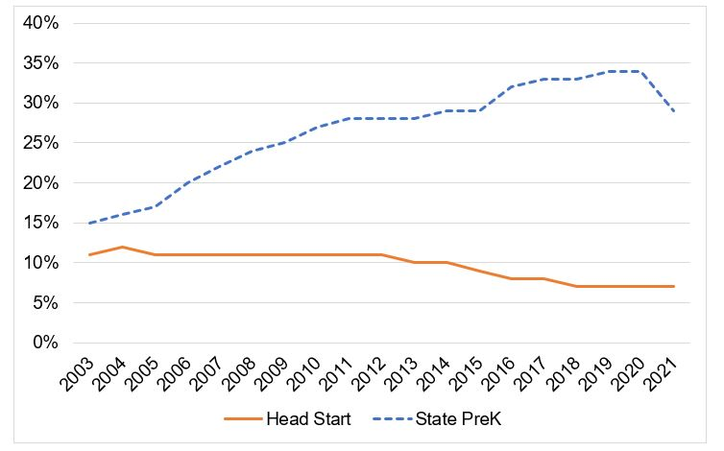

Universal PreKindergarten in California
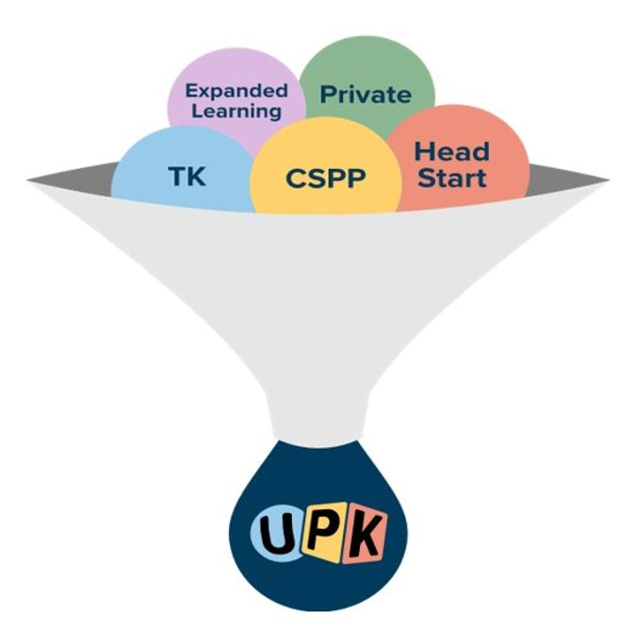
California launched UPK in the 2021–22 state budget by putting into action recommendations laid out in the California Master Plan for Early Learning and Care through a dramatic expansion of TK for all four-year-old children, becoming Universal Transitional Kindergarten (UTK), and the CSPP to provide targeted access for more three-year-old children. By 2025–26, UPK in California will be provided through a mixed delivery system that will bring together programs across early learning, expanded learning, and TK through grade 12 (TK-12).
While it relies heavily on UTK and CSPP, it also includes other PreK programs serving three- and four-year-old children, including the federal Head Start Program, subsidized programs that operate a PreK learning experience and are operated by community-based organizations (CBOs) - including family child care - and private pay PreK.
TK is the only option that will be universally available, and free of cost, for all four-year-old children as part of California’s public education system. However, families will be able to choose whether and in which PreK program to enroll their child. UPK also includes the Expanded Learning Opportunities Program, which will provide many TK through Sixth Grade students in public schools with a full-working-day program aligned with family needs.
Across UPK options, there is variability in quality and program standards (See Table 1.). For example, some subsidized programs fall under Title 22 licensing standards, while others fall under Title 5 education standards. These standards have different requirements for class size, adult-child ratios, and the education requirements of the lead teachers, factors which research has demonstrated matter for child outcomes. The expansion of CSPP and TK will provide an opportunity for California to ensure every child receives a quality early learning experience.

Table 1. Comparison of UPK Service Deliveries and Standards
Type | Age | Eligibility | Minimum Lead Teacher Requirement | Ratios | Facilities
Title 22 Center-Based and Family Child Care Home (FCCH) Standards (for example, private-pay for families and/or part of subsidized voucher system CalWORKs Child Care, Alternative Payment) | Centers: 2-5  FCCHs: Under age 10 | Private, fee paying or, for subsidized voucher eligibility family income at or below 85% of state median income, adjusted for family size; parents must have a “need” for care by working, going to school, and so on. | 12 units in child development (CD) or early childhood education (ECE). FCCHs caregivers are not required to have ECE units. | Centers: 1:12  Small FCCHs: 1:4 infants; or 1:6 children, no more than three may be infants; or 1:8 only if the criteria in Health and Safety Code (HSC) Section 1597.44 are met.  Large FCCHs: 1:6, no more than one-third may be infants; or 1:8 only if the criteria in HSC Section 1597.465 are met. | Centers: Minimum classroom size; 35 sq. ft. per child  FCCHs: Not Applicable
Title 5 Education Standards (for example, CSPP) | 3-5 | Family Income at or below 100% of state median income, adjusted for family size | Child Development Associate Teacher Permit | 1:8 adult-child ratio;  1:24 teacher-child ratio | Minimum classroom size 1,350 sq. ft.
Head Start | 3-5 | Family income below federal poverty line | Associate Degree (AA) or Bachelor’s Degree in ECE OR  AA in other with 24 units in CD or ECE OR  60 units, including 24 units of CD or ECE and 36 units of general education | 1:10  Max of 17 students (3’s)  Max of 20 students (4’s) | Minimum classroom size; 35 sq. ft. per child
TK | 4 | Child turns 5 between Sep 2 and Feb 2 (2022–23 year) and moving to 4 by Sep 1 (2025–26) | Teaching Credential (and 24 units of CD or ECE by August 1, 2023) | 1:12;  Max of 33 students;  24 average across school site and required as a condition of apportionment | Minimum classroom size 1,350 sq. ft.

Universal PreKindergarten Access
UPK will also provide the opportunity to address more of California’s unmet need and the imperative for California’s subsidized early learning and care programs to focus on underserved ages, such as three-year-old children and infants and toddlers. As Figure 2 demonstrates, California had approximately 958,000 licensed spaces for children from birth to age 12 in 2021. Though not all children under age six need non-parental care, many of the approximately 2.8 million children do and California significantly lacks the licensed capacity to meet children and family’s needs.
Figure 2. Unmet Need for Licensed Child Care Capacity 2021. Child Population and Licensed Spaces.
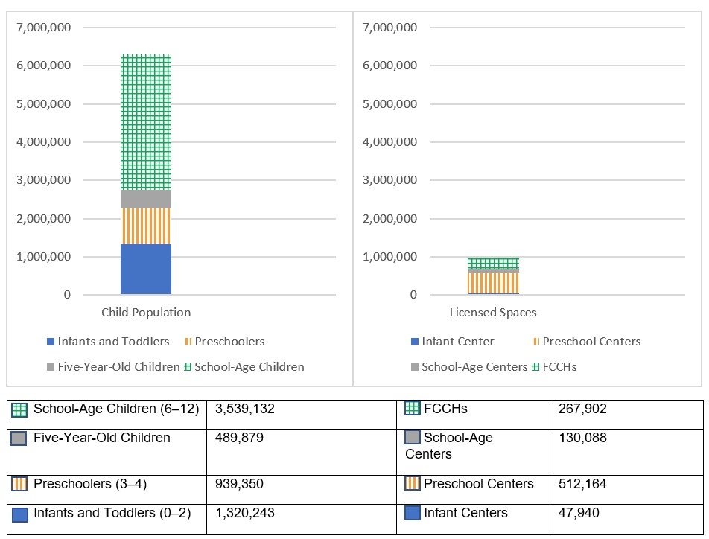
In California, most eligible PreK-age children lack access to a publicly funded PreK program. In 2019, there were approximately one million three- and four-year-old children in California, yet only a fraction of eligible children are served by federally or state funded PreK programs (see Table 2.) and there is variability in enrollment by children’s race and or ethnicity (see Figure 3. and Table 3.). Access to PreK is increasing in California, starting in 2022–23, the first year the birthdate range for TK is being expanded. The exact effects of this change will depend on parental choices regarding sending their four-year-old children to TK or another program.
To the extent that four-year-old children who otherwise would have enrolled in CSPP, Head Start, or another state subsidized program enroll in TK, more spaces in those programs will be available for three-year-old children. In 2021–22, CSPP served only 8.5 percent of eligible three-year-old children, and 5 percent of all three-year-old children. Table 2. shows that CSPP and Head Start programs should be able to pivot to serve more three-year-old children, especially if more four-year-old children are served in TK. For example, the total number of three-year-old children eligible for CSPP (303,603) in 2021–22 was more than three times the total CSPP enrollment (91,902). The 2022–23 budget includes multiple program changes to CSPP that make even more three-year-old children eligible, so it will be even easier moving forward for programs to pivot to serve younger children. CSPP can also provide extended learning and care to TK- and kindergarten-age students.

Table 2. Access to UPK Programs, FY 2021–22
Age | All | Eligible for CSPP FY 2021–22 | Served in CSPP10 Oct 2021 (% of Eligible) | Estimated Served in TK, FY 2021–22 | Estimated Unduplicated Head Start Funded Enrollments | Estimated # Unserved by UPK (Estimated % Unserved by UPK)
Three-year-old Children | 498,416 | 303,603 | 25,921  (8.5%) | N/A | 19,017 | 453,478  (91%)
Four-year-old Children | 507,294 | 316,917 | 65,980  (21.5%) | 69,584 | 18,820 | 352,910  (70%)
Total Three- and Four-year-old Children | 1,005,710 | 620,520 | 91,901  (14.8%) | 69,584 | 37,837 | 806,388  (80%)
Figure 3. Proportion of Four-Year-Old Children Served in CSPP and TK by Race or Ethnicity
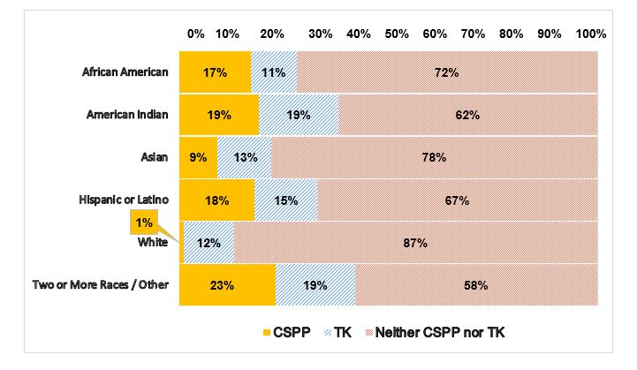
Table 3. Enrollment in UPK by Race or Ethnicity, FY 2021–22
Race or Ethnicity | Total three-year-old Children | CSPP three-year-old Children | Head Start three-year-old Children15 (Unduplicated) | Total four-year-old Children12 | CSPP four-year-old Children13 | TK Estimated (% of four-year-old Children) | Head Start four-year-old Children (Unduplicated)
African American | 25,762 | 2,003  (8%) | 1,473  (6%) | 24,277 | 4,116  (17%) | 2,715  (11%) | 1,458  (6%)
American Indian | 1,870 | 121  (6%) | 148  (8%) | 1,293 | 251  (19%) | 247  (19%) | 146  (11%)
Asian | 55,301 | 2,023  (4%) | 942  (2%) | 54,112 | 4,966  (9%) | 6,826  (13%) | 932  (2%)
Hispanic | 257,488 | 18,124  (7%) | 13,673  (5%) | 268,340 | 47,780 (18%) | 39,183  (15%) | 13,531  (5%)
White | 128,102 | 540  (<1%) | 1,373  (1%) | 126,724 | 1,358  (1%) | 14,782  (12%) | 1,359  (1%)
Two or More Races or Others | 29,893 | 3,110 (10%) | 607  (2%) | 32,548 | 7,509  (23%) | 6,101  (19%) | 600  (2%)
Total | 498,416 | 25,921  (5%) | 18,357  (4%) | 507,294 | 65,980 (13%) | 69,854  (14%) | 18,166  (4%)

Universal PreKindergarten Implementation
California will implement access to UPK through:
- Incrementally expanding TK birthdate eligibility annually through 2025–26 until all four-year-children can voluntarily access TK.
- Adjusting the Early Admittance Transitional Kindergarten (ETK) birthdates in a complementary way, enabling districts to incrementally expand beyond TK to ETK-eligible children.
- Implementing targeted expansion of CSPP, including any changes to eligibility for CSPP to make it easier for families to access this program for their young children.
In September 2022, the CDE was tasked with establishing a UPK Mixed Delivery Quality and Access Workgroup. The goals of the workgroup are to:
- Provide recommendations on best practices for increasing access to high-quality UPK programs for three- and four-year-old children offered through a mixed-delivery model that provides equitable learning experiences across a variety of settings.
- Provide recommendations to update PreK standards pursuant to Education Code (EC) Section 8203 to support equitable access to high-quality PreK and TK programs through the mixed-delivery model and across all appropriate settings and funding sources.
The workgroup will ensure that recommendations are in alignment with the work of the
Administration's Master Plan for Early Learning and Care without recommending new system changes that create increased state or local costs to offer PreK across the mixed-delivery system. If implemented, these recommendations could broaden the mixed delivery system of UPK in California and extend access to more three-year-old children while preserving authentic, high-quality choices for families.

Universal Transitional Kindergarten Implementation
Table 4. illustrates the coming changes in birthdate-eligibility across the UPK implementation period for TK and ETK--the core of the UPK expansion. Local educational agencies (LEAs) can include in their ETK children turning five between the last day of TK eligibility and the end of the school year. An ETK child turns five during the school year after the TK age eligibility cutoff. LEAs can choose to serve children in ETK from the beginning of the school year, but these children do not begin generating average daily attendance until their fifth birthdays. Rules for children with birthdays between July 1 and September 1 remain the same. Children who do not qualify for TK or ETK, can enroll in CSPP or Head Start if they meet eligibility requirements, or enroll in locally funded or private pay programs.
Table 4. UTK Implementation Roll Out
Birthdays | 2021–22 | 2022–23 | 2023–24 | 2024–25 | 2025–26
Sept. 2–Dec. 2 | TK | TK | TK | TK | TK
Dec. 3–Feb. 2 | ETK | TK | TK | TK | TK
Apr. 3–Jun. 2 | ETK | ETK | TK | TK | TK
Jun. 3–Jun. 30 | ETK | ETK | ETK | ETK | TK
Jul. 1–Sept. 1 | Other | Other | Other | Other | TK
Note: TK and ETK remain voluntary, and families can continue to choose to enroll their children in, CSPP, Head Start, locally funded, or private programs, or no PreK program at all.

Universal PreKindergarten Quality Matters
Research on early education programs and their impact on children’s developmental and learning outcomes clearly demonstrates that quality matters. In California, Quality Counts California was created to help ensure families have access to information about the quality of their early education program options, and support programs to improve overall quality by improving individual elements within the Quality Rating Improvement System matrix. However, questions have emerged about how best to measure quality and whether the current matrix generates accurate and useful information about the quality elements that matter for children’s development and learning.
A recent study from the Learning Policy Institute, UC Berkeley, and WestEd found that the quality elements measured by California’s current quality matrix do matter for children’s outcomes as measured by the Desired Results Developmental Profile. Specifically, the study found that children in programs that were rated higher on the quality matrix showed greater gains than those in programs that were rated lower, and that the gains were educationally meaningful. Further, the study found that multilingual learners, children with disabilities, and children from all racial and ethnic groups exhibited more learning and development in programs that were rated higher on the quality matrix.
The benefits associated with attending these programs were larger for multilingual learners than non-multilingual learners in each area of development. Likewise, children with disabilities benefited more from attending a higher quality program than children without disabilities in each area of development. Finally, the study found that children from all racial and ethnic groups experienced greater learning and development when attending programs that were rated higher on the quality matrix than those attending programs that were rated lower. Yet, preschoolers who are Black, Multiracial, and Latino(a) were less likely to be enrolled in the highest quality programs than their peers. The systematic underrepresentation of some groups of children of color in higher quality programs is a significant equity concern.
Another recent study has received outsized media attention after finding that children who participated in the Tennessee Voluntary PreKindergarten (TN) program scored lower on state achievement tests, had higher rates of special education placement, and had greater disciplinary infractions between kindergarten and Sixth Grade than their peers. The authors conclude that “academic” PreK experiences are detrimental to young children, without providing evidence for how the PreK classrooms were deemed “too academic.”
However, the evaluation of the TN program is just one of many studies examining the impacts of public PreK for children’s learning and development. The vast majority of evaluations, including the earliest study of the TN program, find that PreK participants are more prepared for kindergarten than their peers. Further, a 2017 meta-analysis of 22 programs found average reductions in special education placements and grade retention, and higher high school graduation rates among PreK participants than their peers.
One important take away from the TN program evaluation is that lasting academic benefits from preschool are not guaranteed. Educational programs that support young children’s development over time must be intentionally built and maintained. PreK programs must be intentionally designed and adequately funded to provide developmentally supportive learning experiences. Head Start programs, for example, which set a high standard for program quality and often provide at least two years of learning experiences, have recently revealed significant long-term and second-generation benefits and that two-year programs are more effective than those that only offer a single year. Furthermore, research suggests that high-quality full-day programs are more effective at ensuring children get the learning experiences needed, through a mix of small and large-group activities designed to support optimal whole child development.
These studies have led experts to reaffirm the power of robust PreK in addressing the cycle of poverty. In the 2017 consensus statement, the field’s leading experts recommended that using evidence-based curricula and providing ongoing professional learning for teachers can help make PreK classrooms dynamic and engaging environments that support children’s learning. It is critical that California invest in access not to any program, but to the highest quality programs for all children to reap the benefits of UPK.

Inclusion
In October 2021, 4.3 percent of children in CSPP had an Individualized Education Program (IEP) (of the three-year-old children, 4.1 had IEPs and of the four-year-old children, 4.4 percent had an IEP). The proportion of children with IEPs was larger for LEA-based CSPP compared to CBO-based CSPP. For comparison, in the California TK-12 system in 2021-22 school year, 12.7 percent of students had an IEP.
Starting on July 1, 2022, at least 5 percent of a CSPP contracting agency’s funded enrollment must be reserved for children with exceptional needs. The set aside amount will increase to 7.5 percent in FY 2023–24 and to 10 percent in FY 2024–25. This new set aside requirement should increase the percentages of three-year-old children and four-year-old children in CSPP with IEPs.
Additionally, we do not have data on whether children with disabilities in CSPPs are experiencing inclusive classroom settings aligned with their least restrictive environment. However, for all children with disabilities enrolled in any PreK setting in California in the 2021–22 school year, 27 percent of children participated in an inclusive classroom setting, which varied depending on disability type (see Figure 5). In the California TK-12 system in the 2021–22 school year, 60.8 percent of children with disabilities participated in an inclusion classroom for 80 percent or more of the day—which is lower than the national average of 66 percent in 2020.

Figure 5. Inclusive vs. Separate PreK Classroom by Disability Type
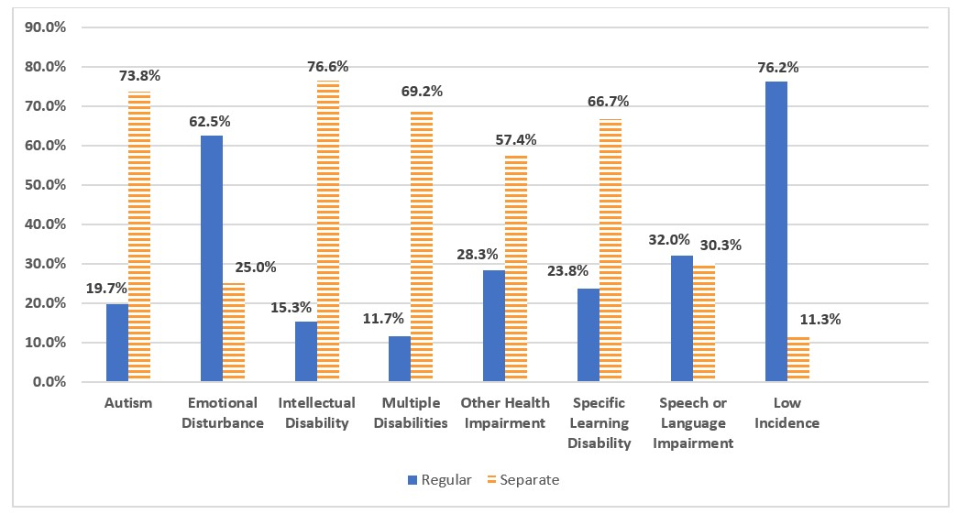

Funding
The Governor’s FY 2022–23 Budget Act appropriated $614 million to fund expanded eligibility for TK, along with a re-benching of the Proposition 98 education funding guarantee. Aligned with the phased implementation of UTK in last year’s budget, the funding will support an additional two months of eligibility for TK. Under the proposed budget, beginning July 2022, eligibility moves from all children turning five-years-old between September 2 and December 2 to all children turning five-years-old between September 2 and February 2. The budget also appropriated $383 million to reduce adult-to-child ratios in TK classrooms to meet the 12:1 ratio now required by law.
The CSPP is funded primarily with Proposition-98 funds for LEAs and non-Proposition 98 funds for non-LEAs to provide part- and full-day CSPP. As shown in Table 5, the FY 2022–23 Budget Act approved a total of $2.6 billion for CSPP:
- $1.7 billion in Proposition 98 funds
- $950 million in non-Proposition 98 funds

Table 5. Appropriations or Proposed Funding for CSPP
Appropriated or Proposed Funding | FY 2020–21 | FY 2020–22 | FY 2020–23
Proposition 98 | $787,899,000 | $1,174,189,000 | $1,668,041,000
Non-Proposition 98 | $489,583,000 | $663,268,000 | $950,633,000
Total | $1,277,482,000 | $1,837,457,000 | $2,618,674,000
*FY 2021–22 Non-Prop 98 funds include $152.544 million in American Rescue Plan Act (ARPA) funds. FY 2022–23 Non-Prop 98 funds include $210.450 million in ARPA funds.

California State Preschool Program Reimbursement Rate Changes in Fiscal Year 2022–23
The FY 2022–23 Budget Act included a 6.56 percent cost-of-living adjustment (COLA) effective July 1, 2022, setting CSPP reimbursement at the greater of the 75th percentile of the 2018 regional market rate (RMR) survey or the contract per-child reimbursement as of December 31, 2021, increased by the COLA. As a result of the Budget Act of 2022 COLA:
- Contractors that previously had a full-day rate less than $55.27 or a part-day rate less than $34.23 automatically received a rate increase effective July 1, 2022.
- 44 counties received rate increases as their contract per-child reimbursement amount as of December 31, 2022, increased by the 6.56 percent COLA was greater than the daily reimbursement rate based on the 75th percentile of the 2018 RMR.
- 14 counties did not receive rate increases as their previous reimbursement rate based on the 75th percentile of the 2018 RMR is greater than the contract per-child reimbursement amount as of December 31, 2021, increased by the 6.56 percent COLA.
- The weighted statewide average reimbursement rate for full-day CSPP is $62.03 and the weighted average rate for part-day CSPP is $38.84.

Reimbursement Rates Across PreKindergarten Programs
Figure 6. reports the daily funding rates providers receive for different programs. The length of a day varies across these programs. For programs that are reimbursed for care at the RMR, full-time care is defined as at least 30 hours per week. For these programs, there is no specific minimum regarding hours per day and most programs operate year-round for approximately 246 days. For TK programs, a full day lasts for four to six hours, for 175 to 180 days per year. For center-based CSPP programs, full-time is now defined as 30 hours or more per week, and part-time is less than 30 hours per week. Both CSPP and TK part-day programs run for at least three hours per day, 175 to 180 days per year. In practice, CSPP part- and full-day programs typically operate year-round for 246 days per year, or more. Figure 6 provides the average daily reimbursement rates across CSPP, voucher-based Pre-K, and TK.

Figure 6. Comparison of Daily PreK Reimbursement Rates
*Average daily reimbursement rates across CSPP and voucher-based preschool and CSPP full-day and part-day daily reimbursement rate
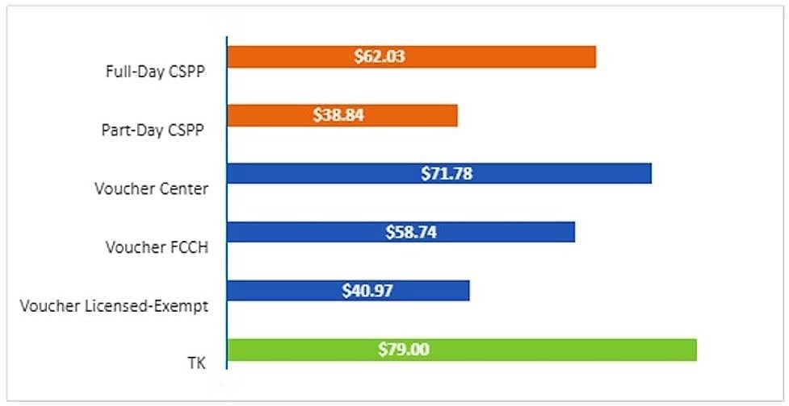

Coronavirus Disease 2019 Pandemic’s Impact on PreKindergarten

Transitional Kindergarten
The Coronavirus Disease 2019 (COVID-19) pandemic had a negative impact on TK enrollment. TK enrollment dropped from 100,852 in 2019–20 to 79,382 in 2020–21. The pandemic also precipitated a decline in the number of children born, and this decline will likely impact enrollment in the coming years.

California State Preschool Program
CSPP programs have also been affected by the COVID-19 pandemic. The highest monthly enrollments in this program occurred in March during FY 2019–20. From March – May 2020, total cumulative CSPP monthly enrollment decreased by 11,224 (7.5 percent) from 150,094 to 138,870. Of the total CSPP enrollment decline during this period:
- Part-day CSPP by 8,926 (8.9 percent) from 100,695 to 91,769.
- Full-day CSPP by 2,298 (4.7 percent) from 49,399 to 47,101.
Overall, total CSPP enrollment dropped by 65,097 children (45 percent) from 142,723 children in October 2019 to 77,626 children in October 2020.
In 2021–22, CSPP enrollment began to recover from the COVID-19 declines. Overall enrollment increased by 14,819 (19 percent) from October 2020 to October 2021, though it was still below pre-pandemic enrollment levels.
Figure 7. California State Preschool Program Enrollment
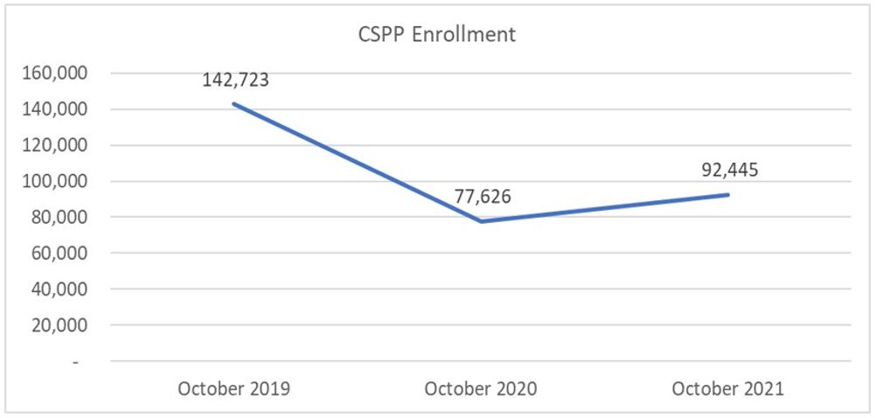
Figure 7, above, depicts pre-COVID pandemic CSPP enrollment of 142,723 children in October 2019, COVID-19 pandemic CSPP enrollment of 77,627 in October 2020, and post-COVID-19 pandemic CSPP enrollment of 92,445 in October 2021.
Figure 8, below, shows CSPP enrollment by age. Enrollment of four-year-old children in CSPP fell from 101,990 in October 2019 to 55,640 in October 2020 to rose again to 65,980 in October 2021. Enrollment of three-year-old children in CSPP decreased from 40,732 in October 2019 to 17,046 in October 2020 and then rebounded to 25,921 in October 2021.

Figure 8. CSPP Enrollment by Age
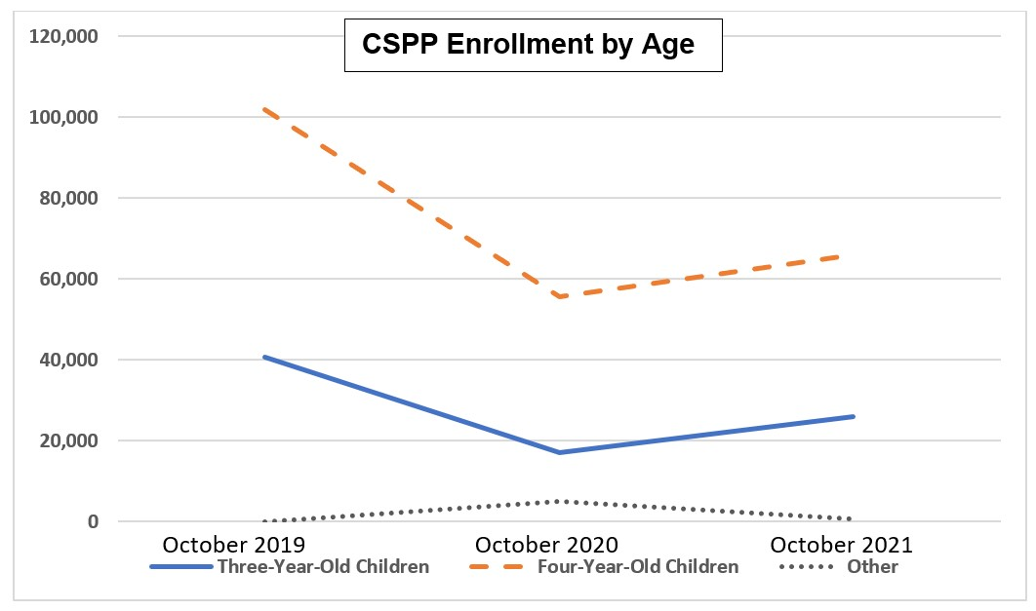

Appendix:

2019 One Year Census American Community Survey Estimates. The California Department of Finance projects that there are 2.7 million children under the age of six in 2022, though census data is not yet available.
Meloy, B., Gardner, M., & Darling-Hammond, L. (2019). Untangling the evidence on preschool effectiveness: Insights for policymakers. Palo Alto, CA: Learning Policy Institute.
Chart compiled from Friedman-Krauss, et al. (2021). The State of Preschool 2020: State Preschool Yearbook. National Institute for Early Education Research and previous publications of the same.
Data from the National Institute for Early Education Research State of Preschool Yearbooks 2003-2021
By 2025–26, all children who are four-years-old by September 1st of 2025 and annually thereafter shall be eligible for TK as part of California’s public education system.
Wechsler, M., Melnick, H., Maier, A., & Bishop, J. (2016). The Building Blocks of High-Quality Early Childhood Education Programs (policy brief). Palo Alto, CA: Learning Policy Institute.
Families can also be eligible to be served in a subsidized setting meeting if they are a current aid recipient, homeless, who have children identified as or at risk of being abused, neglected, or exploited. In part-day CSPP, children with disabilities are also eligible, regardless of income.
DOF Projections for California population in 2021
Data from California Child Care Resource and Referral Network Data Tool, 2021
Calculated with 2019 American Community Survey (ACS) data.
Calculated with 2019 American Community Survey (ACS) data and 2021-22 eligibility thresholds.
TK enrollment is estimated by applying the proportion of TK to all kindergarten enrollment in 2020–21 to 2021–22 kindergarten enrollment, as TK enrollment figures are not available.
Estimated number of Head Start funded enrollment not serving CSPP-enrolled children, estimated by applying the proportions of three- and four-year-old children served in Head Start in 2021-22 to total Head Start funded enrollment from the Head Start Program Information Report for 2022, and assuming 32 percent of Head Start enrollment overlaps with CSPP enrollment (based on analysis of dual enrollment in Head Start and CSPP in FY 2016–17).
Data from October 2021 CSPP Enrollment (CDMIS 801A) and TK enrollment estimates for 2021–22.
Child population is based on 2019 American Community Survey (ACS) data.
Enrollment data from October 2021 CSPP CDMIS 801A for children who are three- or four-years old as defined by statute
TK enrollment is estimated by applying the proportion of TK to all kindergarten enrollment in 2020–21 to 2021–22 kindergarten enrollment, as TK enrollment figures are not available.
Estimated number of Head Start funded enrollment not serving CSPP-enrolled children, estimated by applying the proportions of three- and four-year-old children served in Head Start in 2021–22 to total Head Start funded enrollment from the Head Start Program Information Report for 2022, and assuming 32 percent of Head Start enrollment overlaps with CSPP enrollment (based on analysis of dual enrollment in Head Start and CSPP in FY 2016–17).
Sussman, J., Melnick, H., Newton, E., Kriener-Althen, K., Draney, K., Mangione, P., Gochyyev, P. (Forthcoming.) How do California Preschool Quality Ratings Relate to Children’s Development? Berkeley Evaluation and Assessment Research Center, Learning Policy Institute, and WestEd.
Durkin, K., Lipsey, M. W., Farran, D. C., & Wiesen, S. E. (2022). Effects of a statewide pre-kindergarten program on children’s achievement and behavior through sixth grade. Developmental Psychology, 58(3), 470–484. https://doi.org/10.1037/dev0001301
McCoy, D. C., Yoshikawa, H., Ziol-Guest, K. M., Duncan, G. J., Schindler, H. S., Magnuson, K., Yang, R., Koepp, A., & Shonkoff, J. P. (2017). Impacts of Early Childhood Education on Medium- and Long-Term Educational Outcomes. Educational researcher (Washington, D.C.: 1972), 46(8), 474–487.
Barr, A., & Gibbs, C. R. (2017). Breaking the Cycle?: Intergenerational Effects of an Anti-Poverty Program in Early Childhood.
Wasik, B. A., & Snell, E. K. (2019). Synthesis of preschool dosage: How quantity, quality, and content impact child outcomes. In A research conference convened by the Human Capital Research Collaborative (HCRC)., Oct, 2015, Federal Reserve Bank, Minneapolis, MN, US.
Phillips, D. A., Lipsey, M. W., Dodge, K. A., Haskins, R., Bassok, D., Burchinal, M. R., Duncan, G. J., Dynarski, M., Magnuson, K. A., & Weiland, C. (2017). Puzzling it out: The current state of scientific knowledge on pre-kindergarten effects. A consensus statement. Washington, DC: Brookings Institution.
Average daily reimbursement rates across CSPP and voucher-based preschool represent the statewide average weighted reimbursement rate.
CSPP full-day and part-day daily reimbursement rate updated to reflect the rate after application of the 6.56% cost of living adjustment pursuant to the Budget Act of 2022 and Education Code Section 8242(c)(1). Voucher daily reimbursement rates based on the rates established in Assembly Bill 131 (Chapter 116, Statutes of 2021), which was applicable in FY 2022–23, and include an administrative and support allowance. TK daily reimbursement rate as of January 1, 2022.
Age as defined in Education Code 8205 (aa) and (ab)
Long description of Figure 1. Enrollment in State PreKindergarten and Head Start Nationwide (four-year-old-children). This chart is data compiled from Friedman-Krauss,et al. (2021). The State of Preschool 2020: State Preschool Yearbook. National Institute for Early Education Research and previous publications of the same. The chart describes the nationwide percentages of enrollment for four-year-old children in Head Start and State PreKindergarten from the year 2003 through 2019. This chart is displayed as a line graph with percentages ranging from 0 to 40 percent, with a blue line depicting the nationwide percentages for State PreKindergarten from 2003 – 2021 starting with 2003 at (15%), 2004 (16%), 2005 (17%), 2006 (20%), 2007 (22%), 2008 (24%), 2009 (25%), 2010 (27%), 2011 (28%), 2012 (28%), 2013 (28%), 2014 (29%), 2015 (29%), 2016 (32%), 2017 (33%), 2018 (33%), 2019 (34%), 2020 (34%), and 2021(29%) and an orange line depicting the nationwide percentages for Head Start from 0 to 40 percent starting with 2003 at (11%), 2004 (12%), 2005 (11%), 2006 (11%), 2007 (11%), 2008 (11%), 2009 (11%), 2010 (11%), 2011 (11%), 2012 (11%), 2013 (10%), 2014 (10%), 2015 (9%), 2016 (8%), 2017 (8%), 2018 (7%), 2019 (7%), 2020 (7%), and 2021(7%).
Long description of Figure 2. Unmet need for licensed child care capacity in 2019, Child Population, data taken from the DOF Projections for California population in 2021 and Licensed Spaces data from California Child Care Resource and Referral Network Data Tool, 2021. This image shows two bar graph that depicts the number of child population by age group versus licensed spaces by type from a total of 6,000,000. For school-age children (6-12) shows a child population of 3,539,132, five-year-old children shows a child population of 489,879, Preschoolers (3-4) shows a child population of 939,350, and Infants and toddlers (0-2) shows a child population of 1,320,243 versus “Licensed Child Care Capacity for 2021”) for FCCHs (Age 0-12) with 267,902 licensed spaces, school-age centers with 130,088 licensed spaces, Preschool Centers with 512,164 licensed spaces, and Infant Centers with 47,940 licensed spaces.
Long description of Figure 3. Proportion of 4-year-old children served in CSPP and TK by Race and Ethnicity. Using a color-coded chart, the table to displays the percentage of four-year-old children served in the California State Preschool Program (CSPP) and Transitional Kindergarten (TK) compared to those not participating in either program with rows of race and ethnicity and columns of the percentage ranging from “0%” to “100%” with the color “yellow” representing the percentage of four- year- old children in CSPP, blue for the percentage of four- year- old children in TK, and orange for the percentage of four- year- old children in neither CSPP nor TK. In the table, the first row shows African American with 17% for CSPP, 11% for TK, and 72% for Neither CSPP nor TK. The second row shows American Indian with 19% for CSPP, 19% for TK, and 62% for Neither CSPP nor TK. The third row shows Asian with 9% for CSPP, 13% for TK, and 78% for Neither CSPP nor TK. The fourth row shows Hispanic or Latino with 18% for CSPP, 15% for TK, and 67% for Neither CSPP nor TK. The fifth row shows White with 1% for CSPP, 12% for TK, and 87% for Neither CSPP nor TK, and the sixth row shows Two or More Races/Other with 23% for CSPP, 19% for TK, and 58% for Neither CSPP nor TK.
Long description of figure 5. Inclusive versus separate PreKindergarten classroom by disability type. The chart in figure five describes the percentages (0.0% to 90.0%) in each setting according to inclusive disability type versus separate PreKindergarten classroom. There are two colors shown for these categories - blue for regular settings and orange for separate settings. Based on the type of disability, the statistics on this chart are as follows: Autism at 19.7 percent for regular setting and 73.8 percent for separate setting. Emotional Disturbance at 62.5 percent for regular setting and 25.0 percent for separate setting. Intellectual Disability at 15.3 percent for regular setting and 76.6 percent for separate setting. Multiple Disabilities at 11.7 percent for regular setting and 69.2 percent for separate setting. Other Health Impairment at 28.3 percent for regular setting and 57.4 percent for separate setting. Specific Learning Disability at 23.8 percent for regular setting and 66.7 percent for separate setting. Speech or Language Impairment at 32.0 percent for regular setting and 30.3 percent for separate setting, and Low Incidence at 76.2 percent for regular setting and 11.3 percent for separate setting.
Long description for Figure 6. Comparison of Daily PreK Reimbursement Rates. This bar graph depicts the average daily reimbursement rates per child for six different programs. The orange and green bars denote CDE programs and the blue bars denote CDSS programs. The first orange bar shows on average that Full-Day CSPP receives a daily reimbursement of $60.74 per child. The second orange bar shows the average daily reimbursement for Part-Day CSPP is $38.05 per child. The third, fourth, and fifth bars are blue and show that the daily average reimbursement per child for Voucher Centers is $58.91, Voucher FCCH centers receive $48.53, and Voucher License-Exempt Home-Based Centers receive $33.74. The sixth and final bar is green and shows that the daily average reimbursement for TK Programs is $79.00 per child
Long description of Figure 7. California State Preschool Program Enrollment above, depicts pre-COVID pandemic CSPP enrollment of 142,723 children in October 2019, COVID-19 pandemic CSPP enrollment of 77,627 in October 2020, and post-COVID-19 pandemic CSPP enrollment of 92,445 in October 2021.
Long description of Figure 8. California State Preschool Program Enrollment by Age below, shows CSPP enrollment by age. Enrollment of four-year-old children in CSPP fell from 101,990 in October 2019 to 55,640 in October 2020 to rose again to 65,980 in October 2021. Enrollment of three-year-old children in CSPP decreased from 40,732 in October 2019 to 17,046 in October 2020 and then rebounded to 25,921 in October 2021.

