Item 2.A.
Attachment 11
History–Social Science Subject Matter Committee
August 13, 2020
Page 1 of 2

Attachment 11: Additional CDE Recommendations
The California Department of Education (CDE) has prepared these additional recommendations for edits to the draft Ethnic Studies Model Curriculum that is currently posted on the August 13, 2020, Instructional Quality Commission agenda page at https://www.cde.ca.gov/be/cc/cd/aug2020iqcagenda.asp.

The Model Curriculum (preface)
- Replace “Native American and Indigenous Studies” with “Native American Studies” throughout the document.

Appendix B: Sample Lessons and Topics
- The CDE recommends the lesson that follows, which generally speaking, focuses on the Pacific Islander experience.
- The CDE recommends adding a sample lesson on Arab American Studies that focuses on the Arab American experience in the United States. Additional time and input is necessary to fulfill this recommendation.

Pacific Islanders in the United States
Pacific Islanders in the United States
Sample Lesson: Historical and Contemporary Experiences of Pacific Islanders in the United States
Theme: History and Movement, Identity
Disciplinary Area: Asian American and Pacific Islander Studies
Ethnic Studies Principles Alignment:
- Celebrate and honor Native People/s of the land and communities of color by providing a space to share their stories of struggle and resistance, along with their intellectual and cultural wealth.
- Center and place high value on the pre-colonial, ancestral knowledge of Native people/s and people of color that is typically marginalized in society.
- Critique empire-building in history and its relationship to white supremacy, racism and other forms of power and oppression.
- Challenge imperialist/colonial beliefs and practices on multiple levels.
Standards Alignment:
- CCSS ELA: RH.9–10.1, 2, 3, 6, 7; W.9–10.1; SL.9–10.1, SL.11–12.4
- HSS: 11.4.2
Lesson Purpose and Overview:
This lesson is designed to be an introduction to the study of people of Pacific Islander descent in the United States, while drawing connections to the Pacific Islands and the Pacific Island diaspora more broadly. Pacific Islanders in the United States are often left out of conversations about communities of color in America. The purpose of this lesson is to understand the ways in which American expansion in the Pacific since the 1800s has grown and created a variety of issues among growing Pacific Islander communities in Oceania and in the U.S. today. This lesson will use geography, data aggregation, and narratives to explore the U.S. experiences of Pacific Islanders from Guam, American Samoa, Palau, Marshall Islands, Fiji, Samoa, and Tonga. This lesson is designed to be an introduction to the study of Pacific Islander migrations to the continental United States, including the history, culture, and politics of Hawai'i and U.S. Pacific territories.
Key Terms and Concepts: Pacific Islanders, race, annexation, migration, militarization, citizenship, Oceania, Melanesia, Micronesia, Polynesia, data disaggregation, Census
Lesson Objectives (Students will be able to…):
- Identify varying experiences of Pacific Islanders in relation to the United States
- Analyze differences and similarities between Pacific Islander experiences and history
- Explore the relationships between colonialism, citizenship, and identity
Essential Questions:
- Who are Pacific Islanders in the United States? What is their history with immigration and settlement?
- What systems, structures and events have contributed to the racialization of Pacific Islanders in the US? Why is it important to disaggregate census, educational, and demographic data to understand the Pacific Islander population?
- What are the contemporary experiences of Pacific Islanders in the United States? How do they respond to discrimination and displacement?
Lesson Steps/Activities:
Day One: Pacific Islander Immigration to the U.S.
Who are Pacific Islanders in the United States? What is their history with immigration and settlement?
- Students will write down seven words that describe their identity that will be shared later in the lesson.
- Teacher displays an example of a world map.
- Teacher will lead a discussion by asking the following questions, writing down student responses:
- What are maps and what do they tell us?
- Who and what gets left out of understanding people through maps?
- What do maps tell us about who created them?
Teacher notes: ex: borders, boundaries, difference, power, etc.
- Students will answer the question, “How might maps connect to the seven words you chose?” on a piece of paper and then share out to class.
- Teacher shares examples of maps of the Pacific Islands and explains:
- The Pacific includes 1200 distinct cultural groups among 7–10 million people living in and around the world’s largest and oldest ocean, in some of the world’s most vulnerable and precious ecosystems. These groups maintain their respective cultural, political, familial knowledge systems under categories known as Melanesia, Micronesia, and Polynesia (http://asiapacific.anu.edu.au/mapsonline/sites/default/files/styles/cartogis_700x700/public/maps/bitmap/standard/2019/06/00-341_Micro%2CMela%2C%20Polynesia.png?itok=0aGPnngd) (Link Not Active). However, when encountering the U.S. – they are defined by their relationships with maps, borders, and American empire in the Pacific.
Teacher notes:
- Melanesia: Papua New Guinea, the Solomon Islands, Vanuatu, New Caledonia, and Fiji
- Micronesia: Guam, Mariana Islands, the Federated States of Micronesia (Yap, Chuuk, Pohnpei, Kosrae), Kiribati, Nauru, Marshall Islands, and Palau Polynesia: Hawaiian Islands, Samoa, American Samoa, Tonga, Tuvalu, Tokelau, Wallis and Futuna, the Cook Islands, French Polynesia, Niue, Easter Island, Pitcairn, Norfolk, and New Zealand
- Teacher displays and explains the “U.S. Immigration Status by Pacific Island Birth” infographic, which shows the varying U.S. immigration statuses of Pacific Islanders that continue to shift over time.
- Students will share observations of the graphic, while answering the following question: “What do you immediately recognize about the different statuses?”
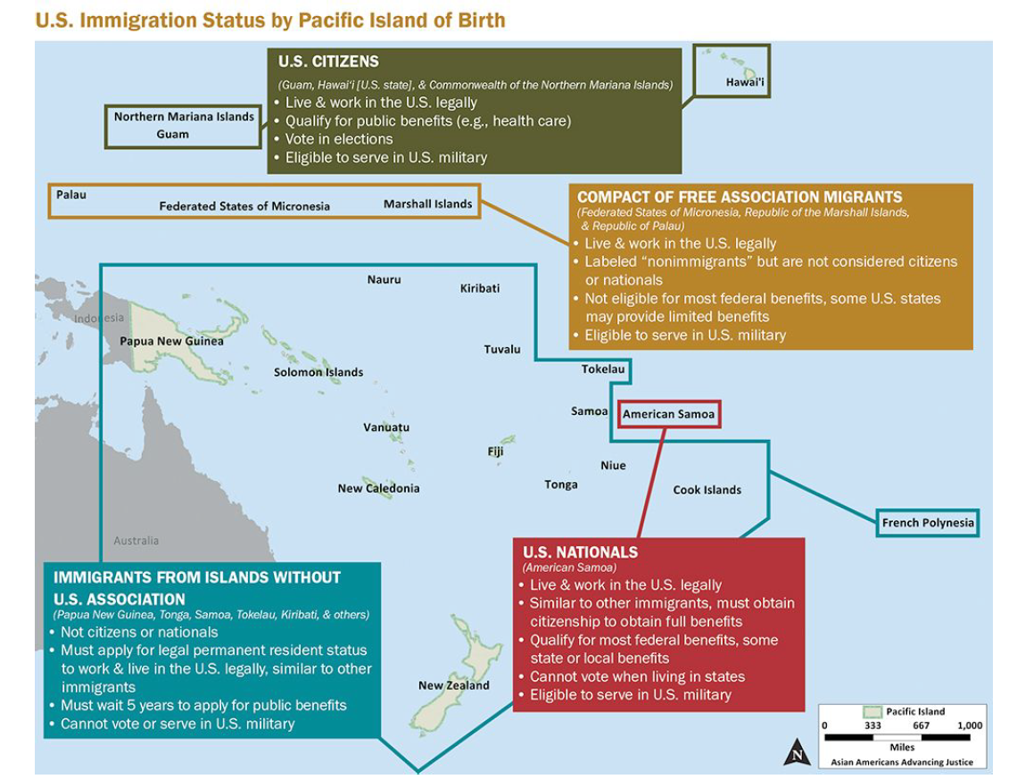
Source: Empowering Pacific Islander Communities. “Native Hawaiian & Pacific Islanders: A Community of Contrasts in the United States.” Policy Report, Los Angeles, CA, 2014. Long Description.
- Teacher passes out a worksheet and explains each short write up prior to viewing each video, while students follow along.
- U.S. Citizens: Hawai’i
- Hawai’i was colonized by Euro-American capitalists and missionaries in the eighteenth and nineteenth centuries. In 1893 Americans invaded, overthrew Indigenous peoples, and secured an all-white planter oligarchy in place of reigning ali'i (nobility), Queen Lili'uokalani - which led to annexation in 1898. This included dispossession of the Hawaiian government, lands, and citizenship that colonized Indigenous Hawaiians.
- Students watch a clip of Act of War (21:45-36:25) (https://www.youtube.com/watch?v=yBmrPH1sNqg&t=2917s) (Link Not Active) and write down 7–10 explicit details/facts from the video. Teachers can also provide the full documentary online for the students to watch outside of class.
- Compact of Free Association: Marshall Islands
- In 1946, the United States started testing nuclear bombs in the Marshall Islands under the codename Operation Crossroads. To clear the way for the tests, the US Navy negotiated with leaders of Bikini Atoll to move 167 residents east to Rongerik Atoll—a move that Bikinians understood as temporary and believed would be “for the good of mankind.” When Rongerik’s food supply proved insufficient to support the population, the US relocated the Bikinians to Kwajalein Atoll and finally to Kile Island. On Kile, Bikinians faced numerous challenges including insufficient food supplies, lack of fishing grounds, drought, typhoons, dependence on canned food supplied by the US Department of Agriculture, and accompanying health problems (e.g., high blood pressure and diabetes).
- Students watch Kathy Jetnil-Kijiner - Anointed (0:00-6:08) (https://www.youtube.com/watch?v=hEVpExaY2Fs) and write down 5–7 explicit details/facts from the video.
- U.S. Nationals: American Samoa
- In the 1890s - Germany, the United Kingdom, and the United States were locked in a dispute over who should have control over the Samoan islands. In 1899, these countries came to an agreement where the Germans had influence in the eastern islands, and the U.S. would maintain influence in the eastern islands. The U.S. Navy wanted to utilize Pago Pago Harbor as a coaling site for their ships, which also became key during World War II until the closing of the base in 1951.
- Teachers can have students watch the first ten minutes of the 1978 film Omai Fa'atasi by Takashi Fuji and write down 7–10 explicit details/facts from the video.
- Using examples from the lecture and videos, students will work in groups to complete the worksheet and provide an analysis of American influence in the Pacific.
- As a class, each group will share their reflections and answers to: What does this tell us about “American expansion” in the Pacific? How might this impact migration to the U.S.?
Extension Assignment:
Teachers can assign an essay that utilizes the information on the worksheet to write about the impact of American expansion on the Pacific Islanders.
Day Two: Analyzing Racialization of Pacific Islanders through Data
What systems, structures and events have contributed to the racialization of Pacific Islanders in the US? Why is it important to disaggregate census, educational, and demographic data on the Pacific Islander population?
- Teacher begins with a group discussion.
- Teacher asks: What is a Pacific Islander? Who is a Pacific Islander? Is it one group or many groups?
- In this lesson, we are going to learn that this broad label is composed of many groups, and we are going to analyze what has contributed to this label and what are the outcomes of only relying on this label.
Teacher notes:
- The poverty rate of Pacific Islanders is 20% vs. 12% of the general population.
- Pacific Islanders are half as likely to have a bachelor’s degree in comparison with 27% for the total population and 49% of Asian Americans.
- Bachelor degree attainment rate is 69.1% for Asian Indians whereas only 9.4% for Samoans.
- This data shows there is a large difference between the Pacific Islander community and the general and Asian American community.
- It is important to disaggregate the data to identify the needs of the Pacific Islander community.
- This shows there is a need for more services and programs for the Pacific Islander community, i.e. to get into and graduate from college.
- By lumping Pacific Islanders under Asian Americans, Pacific Islander issues become invisible.
- Students read and analyze the following sources:
- What Census Calls Us: A Historical Timeline
- Excerpt of Community of Contrasts - Executive Summary and Demographics (5-10)
- The State of Higher Education in California
- Teacher will pass out the worksheet “The Disaggregation of Pacific Islander Data” which has a number of content questions. Students can work in pairs or in groups to help each other answer the questions.
- Before students answer the last question from the worksheet and write their paragraph, have a class discussion on what they have learned. Ask the question: How have racial categories impacted Pacific Islanders? Provide 1 example. Why is it important to disaggregate census, educational, and demographic data on the Pacific Islander population?
Extension Assignment:
The handout and paragraph can develop into a larger assignment that uses data disaggregation to do a report on Pacific Islanders. This report can be an infographic or in essay form. This can also lead in a Youth Participatory Action Research project that provides students an opportunity to do more research on Pacific Islander communities. This could consist of interviews and oral histories. This could potentially add to the growing research on Pacific Islanders.
Day Three: Contemporary Pacific Islander Experiences
What are the contemporary experiences of Pacific Islanders in the United States? How do they use storytelling to share about these experiences and reframe dominant narratives about Pacific Islanders?
- Students will draw two images, side by side, showing 1) How they think the world/society views them and 2) Who they really are. Students will share and explain their drawings.
- Students will review the following narratives to read/hear examples of Pacific peoples stories on contemporary issues of land displacement, climate change and movements for independence.
  - Standing Above the Clouds (https://www.youtube.com/watch?v=peDRsxYaF1U) - short documentary
- Frontline Truths by the Pacific Climate Warriors (https://350.org/frontline-truths/) - first person narratives of Climate Justice Warriors
- Students will create “I Am” poems to share:
  - For each of the items, write 3-5 things that answer each item about you. Use the list to create a poem which repeats the line, “I am from…” followed by your lists. Be creative.
    - Items commonly found around your home or yard growing up
    - Events that changed your life
    - Names of relatives, especially ones that link you to your past
    - Names of food and dishes that are always at family gatherings
    - Places important to you
    - Saying and beliefs repeated often in your family
Assessment, Application, Action, and Reflection:
Assessment: The summative assessment has three parts in this lesson. Part 1: An essay on the impact on American expansion on the immigration of Pacific Islanders. Part 2: Data analysis infographic. Part 3: “I Am” poem. These three parts come together to both build the analytical skills of the students and also provide direct opportunities for them to connect to the lesson.
Application: Students will apply the ethnic studies principles to their essay, data analysis, and poems.
Action: Students can do a number of things with what they learned. First, they can use the material to analyze immigration policy that is important today. The teacher can include an extension activity that can compare Pacific Islander immigration with immigration of other Asian American groups. These immigration patterns and trends can be connected back to American expansion and imperialism. Another option is having students choose another racialized group and compare their experiences to Pacific Islanders. The teacher could also have students apply the content and skills of this lesson to develop a more robust Youth Participatory Action Research Project to learn more about Pacific Islanders by conducting interviews or collecting oral histories with community members. This could contribute to the growing research and literature on Pacific Islanders.
Reflection: Students will use the “I Am From” poems to reflect on how the lesson on Pacific Islanders connects to their own lives.

Materials & Resources

Day 1 Worksheets:

Name: Period: Date:

PACIFIC ISLANDERS IN THE U.S.

Learning Target(s):
- Identify varying experiences of Pacific Islanders in relation to the United States.
- Analyze differences and similarities between Pacific Islander experiences & history.
- Explore the relationships between colonialism, citizenship, and identity.
Essential Question:
- Who are Pacific Islanders in the United States?
- What is their history with immigration and settlement?

Directions: Read the three descriptions about U.S. American involvement in the following islands below. For each island nation, you will watch a short video. While watching, you will write down explicit details/facts from the video. After, you will work with your group to write a collective response.
1. HAWAI’I – U.S. Citizenship
Hawai’i was colonized by Euro-American capitalists and missionaries in the eighteenth and nineteenth centuries. In 1893 Americans invaded, overthrew Indigenous peoples, and secured an all-white planter oligarchy in place of reigning ali’i, Queen Lili’uokalani – which led to annexation in 1898. This included dispossession of the Hawaiian government, lands, and citizenship that colonized Indigenous Hawaiians.

Video: Act of War – produced by PBS Hawai’i (Write 7-10 explicit details)

2. MARSHALL ISLANDS – Compact Free Association
In 1946, The United States started testing nuclear bombs in the Marshall Islands under the codename Operation Crossroads. To clear the way for the tests, the US Navy negotiated with leaders of Bikini Atoll to move 167 residents east to Rongerik Atoll-a move that Bikinians understood as temporary and believed would be “for the good of mankind.” When Rongerik’s food supply proved insufficient to support the population, the US relocated the Bikinians to Kwajalein Atoll and finally to Kile Island. On Kile, Bikinians faced numerous challenges including insufficient food supplies, lack of fishing grounds, drought, typhoons, dependence on canned food supplied by the US Department of Agriculture, and accompanying health problems (e.g., high blood pressure and diabetes).
Video: Anointed by Kathy Jetnil-Kijiner (Write 5-7 explicit details)

3. AMERICAN SAMOA – U.S. Nationals
In the 1890s – Germany, the United Kingdom, and the United States were locked in a dispute over who should have control over the Samoan islands. In 1899, these countries came to an agreement where the Germans had influence in the eastern islands, and the U.S. would maintain influence in the eastern islands. The U.S. Navy wanted to utilize Pago Pago Harbor as a coaling site for their ships, which also became key during World War II.
Video: Omai Fa’atasi by Takashi Fujii w/Pacific Islander Communications
(Write 7-10 explicit details)

PART B: Analysis
In your group, share your notes from each of the videos. Using your notes from the lecture and videos, discuss and write a collective response explaining U.S. American influence in the Pacific, on a separate lined sheet of paper.
**Remember to us a proper heading and include all members names.

Day 2 Worksheets:

Name: Period: Date:

THE DISAGGREGATION OF PACIFIC ISLANDER DATA

Learning Target(s):
- Identify varying experiences of Pacific Islanders in relation to the United States.
- Analyze differences and similarities between Pacific Islander experiences & history.
- Explore the relationships between colonialism, citizenship, and identity.
Essential Question:
- What systems, structures, and events have contributed to the racialization of Pacific Islanders in the US?
- Why is it important to disaggregate census, educational, and demographic data on the Pacific Islander population?
Directions: Using the four different readings discussed and analyzed in class, answer the following questions about disaggregating Pacific Islander data. Answer in complete sentences.
1. How has the Census changed over time?
2. How do these sources define Pacific Islanders?
3. List ALL the Pacific Islander ethnicities.
4. List three important data points for Pacific Islanders
Name: Period: Date:

THE DISAGGREGATION OF PACIFIC ISLANDER DATA

5. What does this data tell us about race and Pacific Islanders?
Part B:
Write a paragraph using the evidence from the sources you have read and analyzed. Answer the following questions: 1) How have racial categories impacted Pacific Islanders? Provide at least one example. 2) Why is it important to disaggregate census, educational, and demographic data on the Pacific Islander population?

Long Description Text for Graphic:
U.S. Immigration Status by Pacific Island of Birth
U.S. Citizens
(Guam, Hawai’i [U.S. state], & Commonwealth of the Northern Mariana Islands)
- Live & work in the U.S. legally
- Qualify for public benefits (e.g., health care)
- Vote in elections
- Eligible to serve in U.S. military
COMPACT OF FREE ASSOCIATION MIGRANTS
(Federated States of Micronesia, Republic of the Marshall Islands & Republic of Palau)
- Live & work in the U.S. legally
- Labeled “nonimmigrants” but are not considered citizens or nationals
- Not eligible for most federal benefits, some U.S. states may provide limited benefits
- Eligible to serve in U.S. military
U.S. NATIONALS
(American Samoa)
- Live & work in the U.S. legally
- Similar to other immigrants, must obtain citizenship to obtain full benefits
- Qualify for most federal benefits, some state or local benefits
- Cannot vote when living in states
- Eligible to serve in U.S. military
IMMIGRANTS FROM ISLANDS WITHOUT U.S. ASSOCIATION
(Papua New Guinea, Tonga, Samoa, Tokelau, Kiribati, & others)
- Not citizens or nationals
- Must apply for legal permanent resident status to work & live in the U.S. legally, similar to other immigrants
- Must wait 5 years to apply for public benefits
- Cannot vote or serve in U.S. military

California Department of Education, August 2020

