Item 3.A.1.
Attachment 1
Education Technology Committee
March 22–23, 2018

2018 California Computer Science Standards (CA CSS) Development Process
This chart illustrates the major events in the CA CSS development process. All meetings are open to the public.
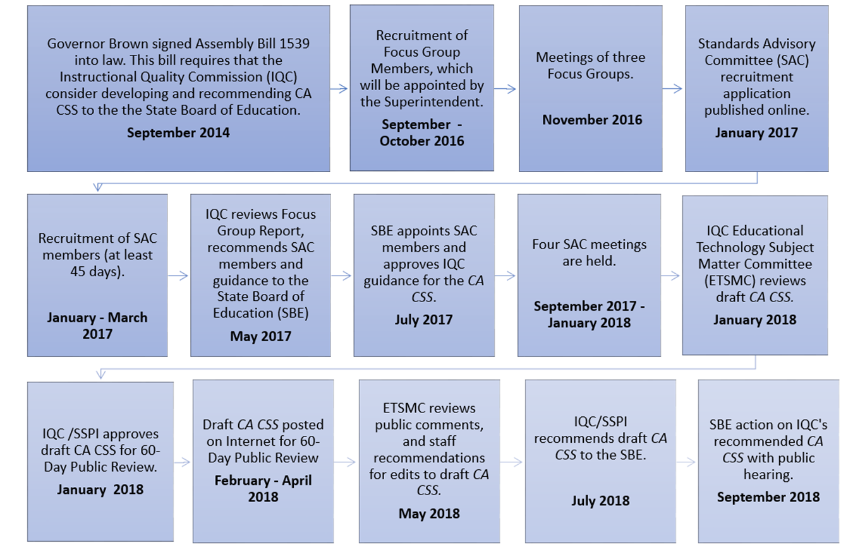
Note: This standards development schedule has not been adopted by the Instructional Quality Commission or the
State Board of Education
California Department of Education. A long description of this flowchart is available at https://www.cde.ca.gov/be/cc/cd/cacssflowchartalttext.asp

