Item 4.A.1
Attachment 1: Health SMC
March 22–23, 2018
2019 Health Education Framework Revision Process
This chart illustrates the major events in the Health Education Framework revision process. All meetings are open to the public.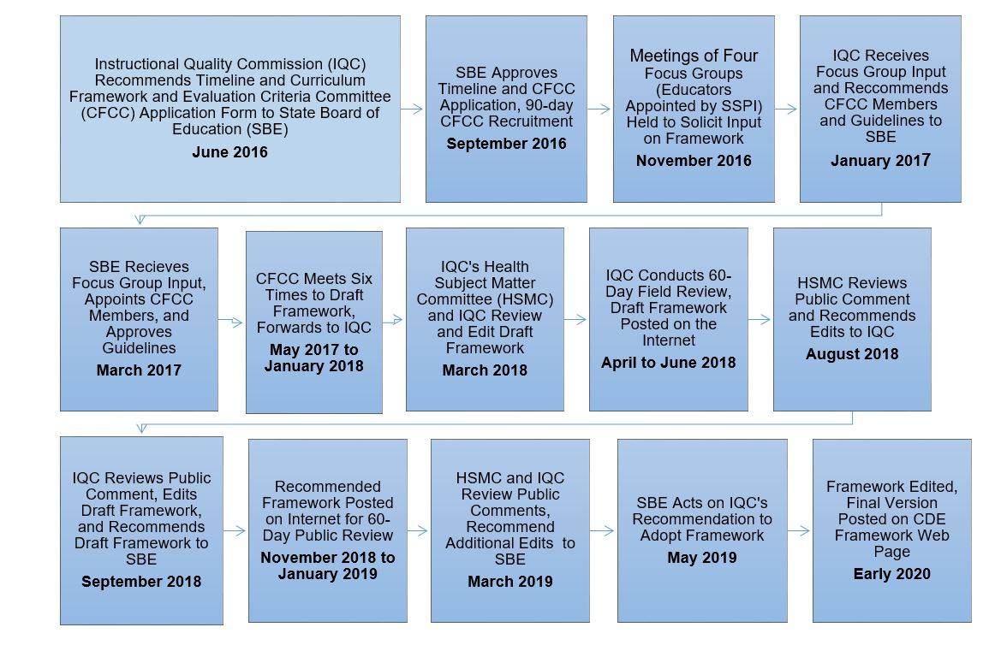
Curriculum Frameworks and Instructional Resources Division, California Department of Education – Updated September 2016
A long description of this flowchart is available at https://www.cde.ca.gov/be/cc/cd/hefwrevprocessflowchart.asp

