Item 1.H.
Full Commission
May 17, 2018

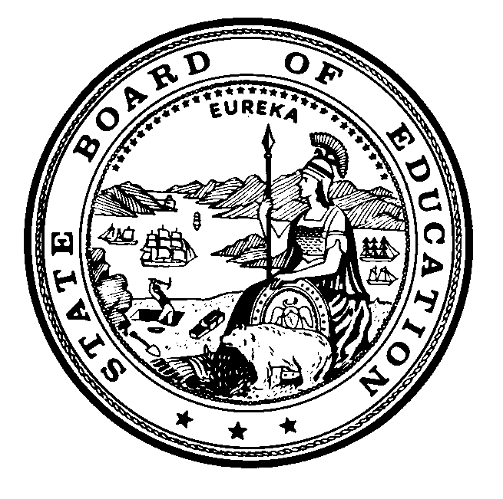
Edmund G. Brown Jr., Governor
State of California

Instructional Quality Commission
An advisory body to the California State Board of Education

Instructional Quality Commission
Meeting Dates for 2018
Commission will consider for approval on May 17, 2018
Thursday–Friday, January 11–12, 2018
Thursday–Friday, March 22–23, 2018
Thursday–Friday, May 17, 2018
Thursday–Friday, July 26–27, 2018
NEW Monday, August 13, 2018, Health Subject Matter Committee Meeting
Monday, August 13, 2018, Science Adoption Public Comment Meeting
Thursday–Friday, September 20–21, 2018
Thursday–Friday, November 15–16, 2018
All meetings, unless otherwise indicated, will be held at the:
California Department of Education Building
1430 N Street, Room 1101, Sacramento, CA 95814

