California Department of Education  Executive Office  SBE-002 (REV. 01/2011) | memo-dsib-amard-aug16item01

memorandum

Date: | August 19, 2016

TO: | MEMBERS, State Board of Education

FROM: | TOM TORLAKSON, State Superintendent of Public Instruction

SUBJECT: | Developing a New Accountability System: An Overview of the College/Career Indicator Structure and Proposed Measures

SUMMARY OF KEY ISSUES

This is an update to the State Board of Education (SBE) on the high school College/Career Indicator (CCI) as it relates to the design of the Local Control Funding Formula (LCFF) evaluation rubrics. The CCI will be used to establish standards for Priority 7 (Access to Broad Course of Study) and Priority 8 (Outcomes in a Broad Course of Study) based on the approved methodology of calculating performance for state indicators. At the July 2016 SBE meeting, members approved the inclusion of a measure of college and career readiness as a state indicator in the new accountability and continuous improvement system. They also directed California Department of Education (CDE) staff to prepare a recommendation for the September 2016 SBE meeting on the technical specifications for the CCI. This memorandum provides an overview of the structure of the CCI model and an in-depth review of the proposed measures for the CCI.

BACKGROUND

As referenced in a February 2016 SBE Information Memorandum on Developing a New Accountability System: An Overview of the College and Career Indicator (http://www.cde.ca.gov/be/pn/im/documents/memo-dsib-amard-feb16item02.doc) and a July 2016 SBE Agenda Item on Developing a New Accountability System (http://www.cde.ca.gov/be/ag/ag/yr16/documents/jul16item02.doc), the Public Schools Accountability Act (PSAA) Advisory Committee, along with expert guidance from the Technical Design Group (TDG) and feedback from regional meetings and a statewide Webinar, worked on the initial development of the CCI in 2014 and 2015. They reviewed and recommended measures to include in the CCI. To support this decision-making process, the CDE contracted with the Educational Policy Improvement Center (EPIC), with Dr. David Conley as the project lead. They provided analyses of potential college and career measures summarized in a series of literature reviews with a final report that was presented to the SBE at the May 2015 SBE meeting.

More recently, since June 2016, input from the California Practitioners Advisory Group (CPAG); Advisory Commission on Special Education (ACSE); regional assessment and Career and Technical Education (CTE) experts; advocacy stakeholder meetings and written communication; along with feedback from two statewide CCI Stakeholder Webinars, allowed for further improvements to the model. Of the 300 plus CCI Stakeholder Webinar participants, 195 represented schools, districts, or county offices of education; 25 represented charter schools; 19 represented Regional Occupational Programs (ROPs); 19 represented higher education; and 48 represented various education stakeholder groups such as EdVoice, the Linked Learning Alliance, California School Boards Association, California Teachers Association, California Charter Schools Association, and Children Now. At their August 2016 meeting, the TDG considered the feedback received and made recommendations to the placement of each CCI measure across the performance levels.

The College/Career Indicator

The CCI is designed to be an accountability indicator for local educational agencies (LEAs) and schools. LEAs and schools will receive a CCI report, but students will not receive their own individual college/career status.

The CCI model contains both college and career measures which recognizes that students pursue various options to prepare for postsecondary and allows for fair comparisons across all LEAs and schools.

The CCI model (Attachment 1) is designed to allow, with very little effort, for new measures to be easily added and for measures to be removed as they become obsolete. Initially, there were four performance levels in the model to align with the Smarter Balanced Summative Assessment achievement levels:

- Well Prepared
- Prepared
- Approaching Prepared
- Not Prepared

However, in the absence of robust career data, valid and reliable career criteria for the “Well Prepared” performance level could not be determined. Proceeding with a “Well Prepared” category at this time would result in an over-emphasis on college measures. This would undercut the indicator’s value as measuring preparedness for college and career. CDE staff, with input from education researchers, practitioners, and stakeholders, will evaluate the CCI model through the first phase of the LCFF evaluation rubrics and will propose a revised CCI model for implementation in 2017–18. For the initial reporting of the CCI, the CDE recommends that the CCI model be limited to three performance levels:

- Prepared
- Approaching Prepared
- Not Prepared

Only measures currently collected statewide at an individual student level are included in the CCI model. Each measure has specific benchmarks across three performance levels that allows schools to demonstrate students’ preparedness for postsecondary. By using the graduation cohort, performance determinations are based on accomplishments achieved by students throughout their four years in high school. A student’s highest achievement on the CCI model determines their performance level. For example, if a student scored at least Level 3 “Standards Met” on the Smarter Balanced Summative Assessments in English language arts/literacy (ELA) and mathematics and does not meet any other criteria (e.g., complete a-g requirements, complete a CTE pathway, etc.), the student’s performance level will be based solely on their Smarter Balanced Summative Assessment performance. Therefore, a student could be considered prepared for postsecondary by meeting only one achievement criteria.

The CCI is designed to encourage high schools to provide all students with a rigorous broad course of study (see Attachment 3, Table 2 for comparison of broad course of study verses a-g coursework) that will lead to likely success in postsecondary. Whether a student focuses on completing: (a) a CTE Pathway, (b) course requirements for a-g, or (c) a course of study specifically designed to meet the student’s individual interests, the completion of a set of rigorous courses (inclusive of ELA and mathematics content), should prepare a student for the Smarter Balanced Summative Assessments. The CCI takes into consideration the diverse resources, needs, and student populations across the state, by including multiple pathways for schools to demonstrate that students are prepared for postsecondary. (It is also recognized that schools and districts may have additional local data that can contribute to their Local Control and Accountability Plan [LCAP], as appropriate.)

The California Model establishes cut scores using the current distributions of status and change. In the initial phase, the status distributions were established based on the percent of students who were identified as “Prepared.” The proposed criteria for “Prepared” are rigorous; however, there will be a distribution of LEAs/schools across all five performance categories (i.e., red, orange, yellow, green, and blue).

Note: Because a separate accountability system is being developed for alternative schools, data from alternative schools were excluded from the placement analyses conducted for each measure.

College and Career Readiness

The future goal is to have a CCI that measures college and career readiness. California does not currently have a statewide definition of what it means to be “college and career ready,” and indeed, college and career preparation are not identical in every sense. The EPIC has used the following definition: "A student who is college or career ready can qualify for and succeed in entry-level, credit-bearing postsecondary courses without the need for remedial or developmental coursework." The CDE has found this emphasis on avoiding postsecondary remediation to be a fundamental part of both college and career readiness, as a study at the Georgetown Public Policy Institute estimates that by 2020, 65 percent of all jobs in the economy will require some sort of postsecondary education and training beyond high school.
This projection falls in line with Dr. Conley’s three levels of career preparedness: “work” preparedness, “job” preparedness, and “career pathway” preparedness. Being “work prepared” involves being able to be on-time and professional within the workspace; being “job” prepared involves successful participation in a job-training program that teaches essential communication skills; and being “career pathway prepared” requires both work and job preparedness in addition to “the academic and technical skills required to move vertically or branch out horizontally within an occupational area,” which requires postsecondary education in a certificate program, at a trade school, or in pursuing an associate’s degree. Finally, Dr. Conley asserts that for a student to be truly career prepared in today’s economy, students must master the skills of all three levels, not just one.

Similarly, in a study conducted by the College and Career Readiness and Success Center at the American Institutes for Research reviewing 37 state definitions of college and career readiness, it was found that 19 definitions require some form of academic content knowledge and 14 definitions require demonstration of critical thinking and/or problem-solving skills. Thirty-three of the definitions focus on the “interconnectedness of readiness to succeed in both college and careers,” and only four states separately define college and career readiness. Because California also seeks to provide students with lifelong career preparedness, rather than simply “work” or “job” preparedness, the current indicator emphasizes the interrelation between college and career readiness, with the flexibility to add additional innovative career measures in the future as statewide data become available. For example, the CDE will be seeking input and advice in adding the new integrated college and career pathways when data become available (e.g., International Baccalaureate [IB] Career-related Programme).

Analysis Completed to Determine Measure Placement on the College/Career Indicator

In developing the CCI, CDE staff built on the work completed by the PSAA Advisory Committee and conducted additional data simulations, with input from the TDG. That research and analysis informed the initial placement of each measure across the CCI performance levels in the version of the CCI presented to the CPAG in June 2016, which was updated based on further feedback from the TDG in August 2016. Detailed information about these analyses and stakeholder input from the two Webinars conducted, following the July 2016 SBE meeting, are provided in Attachment 2.

For those analyses, students’ performance on each measure, with the exception of IB, was compared to students’ performance. The grade eleven ELA EAP results from the enhanced Standardized Testing and Reporting (STAR) Program (under which the EAP was voluntary and students could elect to answer the additional EAP questions) were used for the analyses for several reasons. First, it was developed in partnership between the CDE and the California State University (CSU) in order to provide students with an early indication on their readiness to take college-level course work. Second, a substantial amount of research conducted by the University of California (UC) Davis School of Education found that the introduction of the EAP reduced remediation rates among first-time freshmen at the CSU system-wide, in both ELA and mathematics. An exemption from postsecondary remediation is central to preparation for college and/or career readiness. As a result, the EAP could serve as a reliable comparison measure in evaluating the validity of other CCI measures. Additionally, the CCI is based on the four-year graduation cohort, which is always lagged (i.e., these data are traditionally available one year after other data). Finally, the analyses showed that the EAP covers more students in the graduation cohort than any other CCI measure—75 percent of students voluntarily participated in the EAP.

As shown in Attachment 1, the EAP is now calculated entirely from the Smarter Balanced Summative Assessments; therefore, the reference has been changed from EAP to Smarter Balanced Summative Assessments in the CCI for clarity purposes. California’s new ELA and mathematics assessments are aligned to the Common Core State Standards which are more rigorous than the former standards. These new standards expect students to demonstrate critical thinking, analytical writing, and problem-solving skills needed to be ready for college and the 21st century job market. The new assessment system is designed to better measure these skills through computer adaptive tests and performance tasks. Students who score Level 3 “Standards Met” have demonstrated progress toward mastery of knowledge and skills in ELA or mathematics that are needed for likely success in entry-level, credit-bearing college course work after high school. All of California’s state universities and most community colleges are using the grade eleven Smarter Balanced Summative Assessment results as an early signal of readiness to take credit-bearing college level courses upon enrollment. The proposed placement of Smarter Balanced Summative Assessment results across the performance levels of the proposed CCI reflects the increased rigor of the assessments and the underlying academic content standards.

The achievement level on the Smarter Balanced Summative Assessments will be used in the proposed CCI beginning with the 2015–16 four-year graduation cohort. Students graduating in 2015–16 took the Smarter Balanced Summative Assessments as juniors in the spring of 2015, when the assessment first became operational. Accordingly, the data simulations used to inform the proposed cut points for status and change, which will be provided prior to the September 2016 SBE meeting, were established by modeling former EAP results (i.e., enhanced STAR Program assessment).

To further the work on refining the CCI model, especially with the placement of each CCI measure across the CCI performance levels, the CDE garnered feedback from stakeholders by holding two statewide CCI Stakeholder Webinars in June 2016. Attachment 2 reviews each measure and provides the TDG’s recommendation for the placement of each CCI measure. Also included are the poll results from the two Webinars, the percent of students cumulatively covered by each measure, and the rational for the placement of each measure. More robust definitions of each measure are detailed in Attachment 3. Attachment 4 expands on the definition of the “coverage” noted during the discussion of each measure in Attachment 2. It also includes a graph that displays at-a-glance the percent of students in the 2013–14 four-year graduation cohort covered and not covered by each measure.

Students with Disabilities

At their June 2016 meeting, the CPAG expressed concern that the CCI does not allow special education students to demonstrate progress, specifically those with the most severe cognitive disabilities. At the August 2016 TDG meeting, members recommended removing students who took the CAA from the CCI model. The CDE presented these recommendations to the ACSE for consideration in August 2016. After a robust discussion, the ACSE requested additional data from the CDE for further discussion and consideration.

Potential Future Measures

When statewide data are available at the student level, the CDE will explore adding the following measures to the CCI model within a relatively short timeline:

  - Articulated CTE Pathways
  - Work Study/Career Internship
  - IB Career-related Programme
  - State Seal of Biliteracy
  - Golden State Seal Merit Diploma
  - Other Innovative Career Measures

Other measures CDE staff will further explore and review for future inclusion in the CCI are:

  - Course Information

  - Industry Certificate

  - Additional Career related data elements (e.g. Career Pathway Trust and CTE Incentive Grant, etc.)

  - Pilot career ready assessment (i.e., National Occupational Competency Testing Institute)

Future Work

The CCI is a measure designed for flexibility and adaptability, and the CDE will continue to work with internal subject matter experts in the Career and College Transition Division to research career measures for inclusion in the CCI model. There are a number of innovative career measures currently being piloted in the field, and a recent paper, authored by Soung Bae and Linda Darling-Hammond of the Stanford Center for Opportunity Policy in Education, offers three recommendations for incorporating career readiness in the state accountability system. First, Dr. Darling-Hammond and Dr. Bae recommend improving integration between CTE and college preparation by better aligning CTE Pathways with a-g requirements and/or utilizing the certification processes as an indication of CTE program quality. Second, Dr. Darling-Hammond and Dr. Bae recommend the inclusion of work-based learning experiences such as internships, apprenticeships, and mentoring. Lastly, Dr. Darling-Hammond and Dr. Bae recommend incorporating technical-based and performance-based assessments, certifications, licenses, and badges into the state accountability system as innovative measures of career-related knowledge and skill. The CDE recognizes the growing need for the assessment of both “hard” and “soft” skills to fully prepare students for the 21st century workforce, and will continue to research measures such as the National Occupational Competency Testing Institute Job Ready and Pathway Assessments and the possibility of creating a standardized system of acknowledging high-intensity work-based learning experiences within the accountability system. As potential new measures become available with statewide, student-level data for the CCI, the CDE will present them to the SBE for discussion.

Works Cited

Darling-Hammond, L., & Bae, S. (2014). Recognizing College and Career Readiness in the California School Accountability System. Stanford, CA: Stanford Center for Opportunity Policy in Education. Retrieved from https://edpolicy.stanford.edu/sites/default/files/publications/recognizing-college-and-career-readiness-california-school-accountability-system_1.pdf

The Education Policy Improvement Center. (2014). Measures for a College and Career Indicator: Research Brief on Career Preparedness Assessments. Retrieved from [Note: Invalid link removed.]

The Education Policy Improvement Center. (2016). Website Homepage. Retrieved from http://www.epiconline.org

Georgetown Public Policy Institute: Center on Education and the Workforce. (2013). Recovery: Projections of Jobs and Education Requirements Through 2020. Retrieved from https://cew.georgetown.edu/wp-content/uploads/2014/11/Recovery2020.FR_.Web_.pdf

Kurlaender, M., & Jackson, J. (2015). California’s Early Assessment Program: Assessing Intended and Unintended Consequences. Davis, CA: UC Davis School of Education. Retrieved from http://edpolicyinca.org/sites/default/files/pace%20eap%20talk%203-13-15.pdf

Kurlaender, M., & Jackson, J. (2013). Identifying Indicators of College Readiness & Success. Davis, CA: UC Davis School of Education. Retrieved from http://education.ucdavis.edu/sites/main/files/file-attachments/kurlaenderjacksonpsaa9-6-13_presentation-distribute.pdf

Mishkind, Anne (2014). Overview: State Definitions of College and Career Readiness. Washington, D.C.: College and Career Readiness and Success Center at the American Institutes for Research. Retrieved from http://www.ccrscenter.org/sites/default/files/CCRS%20Defintions%20Brief_REV_1.pdf

Attachment(s)

Attachment 1: College/Career Indicator Model (1 page)

Attachment 2: College and Career Measures: Initial Placement and Stakeholder Feedback (8 pages)

Attachment 3: College/Career Indicator Glossary (7 pages)

Attachment 4: Students Covered Under Each College/Career Measure (2 pages)

College/Career Indicator Model
All students in the four-year graduation cohort minus students who take the California Alternate Assessment.
WELL PREPARED – To Be Determined
The College/Career Indicator (CCI) measures for “Well Prepared” will be determined following further review of potential state and local CCI measures as statewide data becomes available.¹ California Department of Education staff, with input from education researchers, practitioners, and stakeholders, will evaluate the CCI model through the first phase of the Local Control Funding Formula evaluation rubrics and will propose a revised CCI model for implementation in 2017–18.
PREPARED
Does the graduate meet at least 1 measure below?
- Career Technical Education (CTE) Pathway Completion plus one of the following criteria:
  - Smarter Balanced Summative Assessments: At least a Level 3 “Standard Met” on English language arts/literacy (ELA) or Mathematics and at least a Level 2 “Standard Nearly Met” in the other subject area
  - One semester/two quarters of Dual Enrollment with passing grade (Academic/CTE subjects)

- At least a Level 3 “Standard Met” on both ELA and Mathematics on Smarter Balanced Summative Assessments

- Completion of two semesters/three quarters of Dual Enrollment with a passing grade (Academic and/or CTE subjects)

- Passing Score on two Advanced Placement (AP) Exams or two International Baccalaureate (IB) Exams

- Completion of courses that meet the University of California (UC) a-g criteria plus one of the following criteria:
  - CTE Pathway completion
  - Smarter Balanced Summative Assessments: At least a Level 3 “Standard Met” on ELA or Mathematics and at least a Level 2 “Standard Nearly Met” in the other subject area
  - One semester/two quarters of Dual Enrollment with passing grade (Academic/CTE subjects)
  - Passing score on one AP Exam OR on one IB Exam
APPROACHING PREPARED
Does the graduate meet at least 1 measure below?
- CTE Pathway completion

- Scored at least Level 2 “Standard Nearly Met” on one or both ELA and Mathematics Smarter Balanced Summative Assessments

- Completion of one semester/two quarters of Dual Enrollment with passing grade (Academic/CTE subjects)

- Completion of courses that meet the UC a-g criteria
NOT PREPARED
Student did not meet any measures above, so considered NOT PREPARED
¹Future Local and State CCI Measures

Note: The following measures will be explored as statewide data becomes available:
- Articulated CTE Pathway
- Work Experience/Career Internship
- AP/IB Career Program
- State Seal of Biliteracy
- Golden State Seal Merit Diploma

Further Exploration on the following:
- Course Information
- Industry Certificate
- Additional career related data elements (e.g., Career Pathways Trust and CTE Incentive Grant)
- Pilot career ready assessments (i.e., National Occupational Competency Testing Institute)
College and Career Measures: Initial Placement and Stakeholder Feedback

This attachment provides the Technical Design Group’s (TDG’s) recommendations on the placement of each measures made at their August 2016 meeting. Their recommendations took into consideration the information included in this attachment. The attachment reviews and briefly defines each measure in the College/Career Indicator (CCI), reports the percent of students cumulatively covered by each measure, provides poll results from the two statewide CCI Stakeholder Webinars held in June 2016, and includes the rationale for the placement of each measure.

As discussed earlier, the CCI model has been revised from having four performance levels to three performance levels. However, the polling questions and responses from the CCI Stakeholder Webinars reference the prior four CCI levels, along with the Early Assessment Program (EAP) analyses completed for the placement of measures. Because Smarter Balanced Summative Assessments results are not yet available for use in the CCI determinations, the EAP from the enhanced Standardized Testing and Reporting (STAR) Program were used as a reliable comparison measure in evaluating the validity of other CCI measures. The analyses provides the rationale for placing measures in a specific performance level and the poll results provide meaningful feedback from stakeholders. As stated previously, in the future, the Smarter Balanced Summative Assessments will replace the EAP in the CCI determinations.

Note that the EAP, referenced in the polling questions and analyses, were based on the enhanced STAR Program, which provided students one of three college readiness statuses: Ready, Conditionally Ready, and Not Ready. The Smarter Balanced Summative Assessments student report provides students with one of four college readiness statuses: Ready, Conditionally Ready, Not Yet Ready, and Not Ready.

Career and Technical Education Pathway Completion

- Definition: A pathway completion consists of finishing a sequence of courses (typically three to four) totaling at least 300 hours and the completion of a capstone course, with a grade of C or better in the capstone course. Note: One local educational agency’s (LEA’s) pathway may require a sequence of two courses totaling 300 hours while another may require a sequence of four courses totaling 300 or more hours.

- Coverage: 17.0 percent of students in the four-year graduation cohort have completed at least one Career and Technical Education (CTE) Pathway. Further analysis on these students revealed that CTE Pathway completion is very evenly distributed among the eleven race/ethnic and special population student groups (i.e., English learner, Socioeconomically Disadvantaged, and Students with Disabilities).

- Placement (Table 1):
Performance Level | Measure
Approaching Prepared | - CTE Pathway completion (grade C or better in the capstone course)
Prepared | - CTE Pathway completion plus one of the following:  - Scored at least “Conditionally Ready” on both the EAP English-language arts (ELA) and mathematics,  - a-g completion (grade C or better), or  - Two semesters/three quarters of dual enrollment (grade C- or better).

- Rationale: 64.5 percent of students who completed a CTE Pathway scored “Not Ready” on the EAP ELA. Thus, completion of a CTE Pathway only was placed as “Approaching Prepared.” The TDG was supportive of this placement.

- Poll Question: Where would you place a student who completed at least one CTE Pathway and completed one additional measure from the “Approaching Prepared” level (see Attachment 1) in the CCI model?
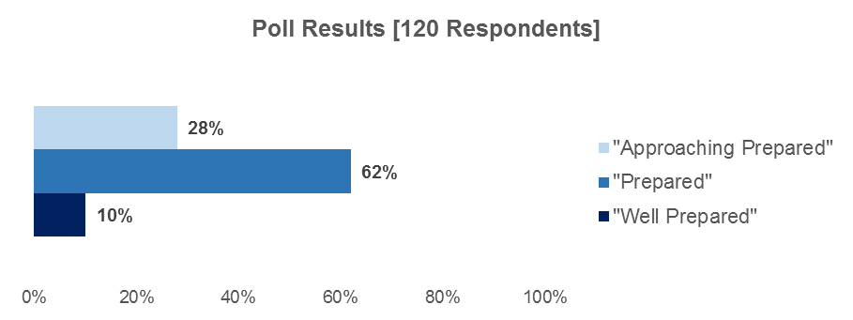

Recommendation: The TDG recommended that the completion of a CTE Pathway be considered as “Prepared” only if it is paired with the EAP, a-g, or dual enrollment criteria noted in the table 1. The CCI Stakeholder Webinar poll results shown above also support the TDG’s recommendation.

Beginning with the 2015 testing, the EAP became a component of the Smarter Balanced Summative Assessments, which all grade eleven students are required to take (e.g., it is no longer voluntary). Although there is extensive research on the STAR EAP, there is currently no research on the Smarter Balanced Summative Assessments EAP. The CDE recommends that students who score “Conditionally Ready” in one EAP subject area and “Not Yet Ready” in the other subject area and complete a CTE Pathway be placed in the “Prepared” performance level.

Note: Measures containing CTE concentrators have been removed from the current CCI model. “CTE concentrators” are students who completed more than 50 percent of a planned program sequence in a state-recognized CTE Pathway. The CTE concentrator measures received the least support by the participants during the CCI Stakeholder Webinars and by the TDG. The TDG expressed concerns about using CTE concentrators due to the lack of consistent implementation of the statewide CTE standards.

Completion of Courses that meet the University of California “a-g” Requirements

- Definition: The completion of the required a-g courses, with a grade of C or better in all courses. (Reference Table 2 in Attachment 3 for specific a-g courses.)

- Coverage: 35.8 percent of students in the four-year graduation cohort have completed a-g.

- Placement (Table 2):
Performance Level | Measure
Approaching Prepared | - a-g completion (grade C or better in all courses)
Prepared | - a-g completion (grade C or better in all courses) plus one of the following:  - Scored at least “Conditionally Ready” on the EAP ELA and mathematics,  - CTE Pathway completion (with a grade of C or better in the capstone course), or  - One semester/two quarters of dual enrollment (grade C- or better).

- Rationale: 36.2 percent of students who completed a-g scored “Not Ready” on the ELA EAP. Furthermore, research by the University of California Davis School of Education also revealed that 40 percent of students admitted to the California State University (CSU) (almost all of which have completed a-g or an equivalent) need to enroll in at least one remedial English or mathematics course. As a result of the evidence demonstrating that students who complete a-g are often still not yet prepared for college, completion of a-g only was placed in the CCI model as “Approaching Prepared.” The TDG also concurred that completing a-g only should be identified as “Approaching Prepared.”

- Poll Question: Where would you place a student who completed a-g and completed one additional measure from the “Approaching Prepared” level (see Attachment 1) in the CCI model?
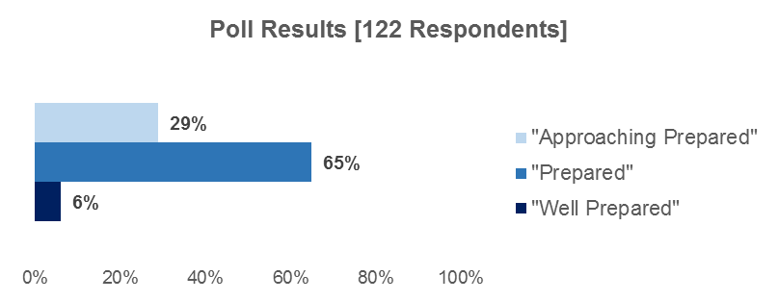

Recommendation: The TDG recommended that the completion of a-g can be considered as “Prepared” only if it is paired with the EAP, CTE, or dual enrollment criteria noted in the table 2. The CCI Stakeholder Webinar poll results shown above also support the TDG’s recommendation.

Early Assessment Program

- Definition: Students participate in the EAP in grade eleven as part of the Smarter Balanced Summative Assessments. The EAP informs students if they are ready for college-level work in ELA and mathematics by reporting one of four statuses: Ready, Conditionally Ready, Not Yet Ready, and Not Ready. (Note: In the CSU system, students who score “Conditionally Ready” can be exempt from taking placement exams and remedial courses by passing approved grade twelve English and/or mathematics courses with a grade C or better).

The CCI Webinar asked participants two polling questions regarding the EAP. The results for both questions are provided below.

- Coverage: 75.7 percent of students in the four-year graduation cohort participated in the EAP under the enhanced STAR Program.

- Placement (Table 3):
Performance Level | Measure
Approaching Prepared | - Scored at least “Conditionally Ready” on both ELA and mathematics EAP
Prepared | - Scored “Ready” on the EAP in one subject area and at least “Conditionally Ready” in the other subject area

- Poll Question: Where would you place a student who scored “Conditionally Ready” on the EAP ELA and the EAP mathematics, and passed the approved grade twelve courses?

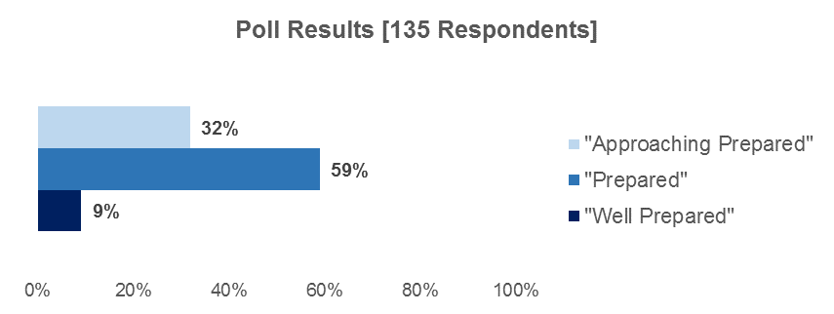

- Poll Question: Where would you place a student who scored “Ready” in one EAP subject area and “Conditionally Ready” in the other subject area but did not pass the approved grade twelve course?

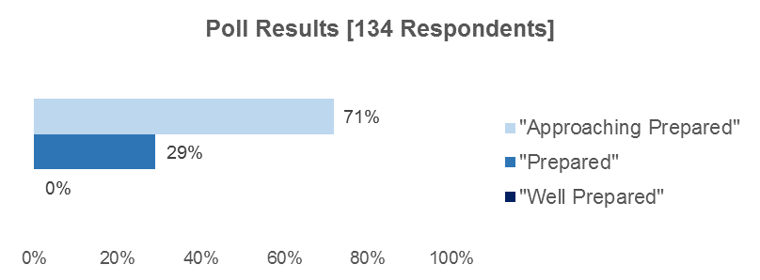

Recommendation: Both the TDG and CCI Stakeholder Webinar participants expressed the expectation that in order to be “Prepared,” students must pass the approved grade twelve course(s) if they scored “Conditionally Ready” on the EAP. The TDG recommended that students who scored “Ready” in one subject area and “Conditionally Ready” in the other subject area should be placed in the “Approaching Prepared” performance level. The CCI Stakeholder Webinar poll results shown above also support the TDG’s recommendation.

However, as stated earlier, the EAP data used in these simulations were based on the enhanced STAR Program and the Smarter Balanced Summative Assessments EAP are more rigorous than the enhanced STAR Program. Therefore, the CDE recommends that students who scored at least “Conditionally Ready” in both subject areas be placed in the “Prepared” performance level.

Advanced Placement

- Definition: The College Board offers college-level courses (called Advanced Placement [AP]) in 37 subjects. Exams are scored on a scale of one to five, where a score of three or higher is considered passing by The College Board. Students do not have to be enrolled in an AP course to take an AP exam.

- Coverage: 21.5 percent of students in the four-year graduation cohort took at least one AP exam. The average number of AP exams taken among AP exam takers is four.

- Placement (Table 4):
Performance Level | Measure
Approaching Prepared | Not applicable
Prepared | - Two AP exams (Score 3 or higher)

- Rationale: Of the students who passed two AP exams, 77.3 percent scored either “Ready” on both the EAP ELA and mathematics, or “Ready” on one subject area and “Conditionally Ready” on the other subject area and only 10.8 percent scored “Not Ready” on EAP ELA.

- Poll Question: Where would you place a student who passed two AP exams with a score of 3 or higher?

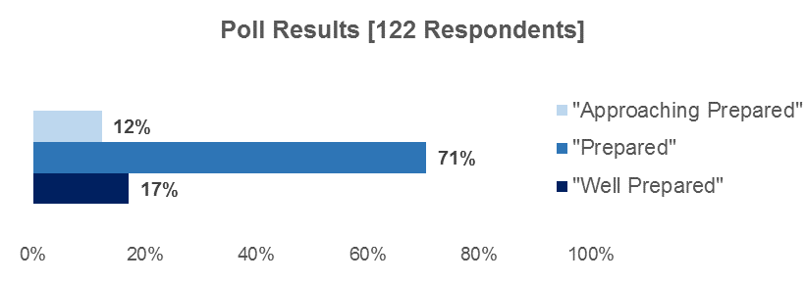

Recommendation: As a result of this evidence of preparedness, the TDG and CCI Stakeholder Webinar participants supported the placement of students who passed two AP exams in the CCI model as “Prepared.”

International Baccalaureate Exams

- Definition: There are six subject area exams which are graded on a scale of one to seven. A score of four is considered passing by the International Baccalaureate (IB).

- Coverage: 1.0 percent of students in the four-year graduation cohort took at least one IB exam.

- Placement (Table 5):
Performance Level | Measure
Approaching Prepared | Not applicable
Prepared | - Two IB Exams (Score 4 or higher)

- Poll Question: Where would you place a student who passed two IB exams with a score of four or higher?

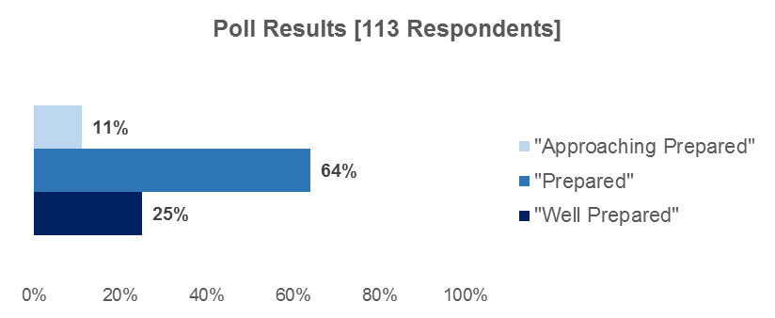

Recommendation: The TDG recommended that students who passed two IB exams be placed as “Prepared,” indicating that the IB program was rigorous and academically challenging. The CCI Stakeholder Webinar poll results shown above also support the TDG’s recommendation.

Dual Enrollment

- Definition: Students who are dually enrolled are those who, while enrolled in high school, achieved a grade of C- or better in courses delivered at a college. Dual enrollment courses may be in either academic disciplines such as mathematics, ELA, and arts, or also in CTE disciplines such as welding or refrigeration. Note: Physical education classes are not counted in this measure.

- Coverage: 0.1 percent of students in the four-year graduation cohort took at least one dual enrollment course at a college.

- Placement (Table 6):
Performance Level | Measure
Approaching Prepared | - One semester/two quarters of a dual enrollment course (grade C- or better)
Prepared | - Two semesters/three quarters of a dual enrollment course (grade C- or better)

- Rationale: Of students who took two dual enrollment courses, 48 percent scored “Ready” and only 25 percent scored “Not Ready” on the EAP ELA; of students who took three dual enrollment courses, 61 percent scored “Ready” and only 11.8 percent scored “Not Ready” on the EAP ELA.

- Poll Question: Where would you place a student who took two semesters or three quarters of dual enrollment at a college while enrolled in high school?

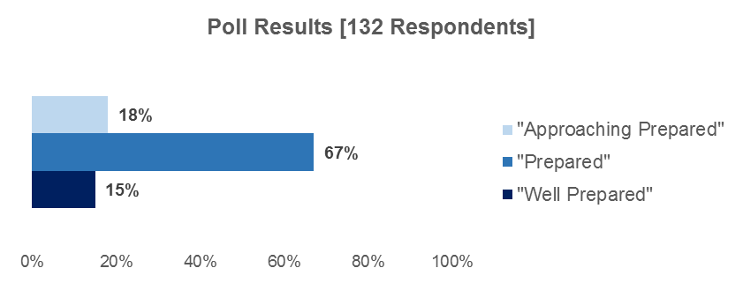

Recommendation: The TDG recommended placing two semesters or three quarters of dual enrollment as “Prepared,” reasoning that this aligns with the standards of credit for college admissions purposes. The CCI Stakeholder Webinar poll results shown above also support the TDG’s recommendation.

College/Career Indicator Glossary

College/Career Indicator Measures

This document will provide an overview of the following College/Career Indicator (CCI) measures:

- Career Technical Education (CTE) Pathway Completion
- Completion of courses that meet the University of California “a-g” requirements
- Early Assessment Program (EAP)
- Advanced Placement (AP)
- International Baccalaureate (IB)
- Dual Enrollment

Career Technical Education Pathway Completion

CTE Pathway completion is the completion of a sequence of CTE courses totaling at least 300 hours and completion of a capstone course with a grade of C or better. Most CTE Pathways consist of three to four courses in order to meet the 300 hour requirement. However, the 300 hour requirement can be achieved through multiple methods. For example, one local educational agency’s (LEA’s) CTE Pathway completion for welding might be completed over two years of coursework, while another LEA’s CTE Pathway completion for welding might be completed over three years. In both cases, the CTE Pathway must consist of the same minimum 300 hours with the completion of a capstone course.

There are 15 industry sectors that contain a total of 58 CTE Pathways. Table 1 lists the 15 industry sector and their corresponding CTE Pathways:

Table 1
Industry Sector | CTE Pathway
Agriculture and Natural Resources | - Agricultural Business  - Agricultural Mechanics  - Agriscience  - Animal Science  - Forestry and Natural Resources  - Ornamental Horticulture  - Plant and Soil Science
Arts, Media, and Entertainment | - Media and Design Arts  - Performing Arts  - Production and Managerial Arts
Building Trades and Construction | - Cabinetmaking and Wood Products  - Engineering and Heavy Construction  - Mechanical Construction  - Residential and Commercial Construction
Education, Child Development, and Family Services | - Child Development  - Consumer Services  - Education  - Family and Human Services
Energy and Utilities | - Electromechanical Installation and Maintenance  - Energy and Environmental Technology  - Public Utilities  - Residential and Commercial Energy and Utilities
Engineering and Design | - Architectural and Structural Engineering  - Computer Hardware, Electrical, and Networking Engineering  - Engineering Design  - Engineering Technology  - Environmental and Natural Science Engineering
Fashion and Interior Design | - Fashion Design, Manufacturing, and Merchandising  - Interior Design, Furnishings, and Maintenance
Finance and Business | - Accounting Services  - Banking and Related Services  - Business Financial Management
Health Science and Medical Technology | - Biotechnology Research and Development  - Diagnostic Services  - Health Informatics  - Support Services  - Therapeutic Services
Hospitality, Tourism, and Recreation | - Food Science, Dietetics, and Nutrition  - Food Service and Hospitality  - Hospitality, Tourism, and Recreation
Information Technology | - Information Support and Services  - Media Support and Services  - Network Communications  - Programming and Systems Development
Manufacturing and Product Development | - Graphic Arts Technology  - Integrated Graphics Technology  - Machine and Forming Technology  - Welding Technology
Marketing, Sales, and Service | - E-Commerce  - Entrepreneurship  - International Trade  - Professional Sales and Marketing
Public Services | - Human Services  - Legal and Government Services  - Protective Services
Transportation | - Aviation and Aerospace Transportation Services  - Collision Repair and Refinishing  - Vehicle Maintenance, Service, and Repair
Source: http://www.cde.ca.gov/ci/ct/sf/documents/ctestandards.pdf
Completion of Courses that Meet the University of California “a-g” Requirements

The a-g requirements consist of 15 courses students must complete in order to be eligible to attend a California State University (CSU) or University of California (UC) school. Students must complete all courses with a grade of C or better to be considered having met the a-g requirements for CSU or UC admission. LEAs indicate a-g completion in the California Longitudinal Pupil Achievement Data System (CALPADS) by checking a box when submitting graduation data. By checking a-g completion, the LEA is assuring that the student received a grade of C or better in all required a-g courses.

Because the CCI will be used to establish standards for Priority 7 (Access to Broad Course of Study) and Priority 8 (Outcomes in a Broad Course of Study) for the Local Control Funding Formula (LCFF) evaluation rubrics, Table 2 compares the CSU and UC a-g course requirements to the broad course of study (California Education Code [EC] Section 51220) and the high school graduation requirements (EC Section 51225.3):

Table 2: Comparison Between Broad Course of Study, High School Graduation Requirements, and “a-g” Subject Requirements
Subject Area | Broad Course of Study | State High School Graduation Requirements | CSU “a-g” Subject Requirements | UC “a-g” Subject Requirements
- History/ social science |  | 3 years  U.S. history and geography, world history or culture and geography, and ½ government, ½ civics | 2 years  U.S. history or American government and a social science course | 2 years  World history, cultures and historical geography and either U.S. history or ½ U.S. history and ½ government
(b) English |  | 3 years | 4 years  College preparatory English that includes composition and literature | 4 years  College preparatory English that includes literature, writing, speaking and listening
(c) Mathematics |  | 2 years  including Algebra I | 3 years  (4 years recommended)  Algebra I, geometry, algebra II | 3 years  (4 years recommended) Algebra I, geometry, algebra II

Subject Area | Broad Course of Study | State High School Graduation Requirements | CSU Subject Requirements | UC Subject Requirements
(d) Science/  Laboratory |  | 2 years  Biological and physical sciences | 2 years  Including one year of biological and one year of physical science with lab. | 2 years  (3 years recommended)  Biology, chemistry, and physics.
(e) Language other than English |  | 1 year* | 2 years  Two years in the same language. | 2 years  (3 years recommended)  Two years in the same language.
(f) Visual and performing arts (VPA) |  | 1 year* | 1 year  Dance, drama/ theater, music, or visual art. | 1 year  Dance, drama/ theater, music, or visual art.
(g) College preparatory elective |  | NA | 1 year | 1 year
Physical Education |  | 2 years | NA | NA
CTE |  | 1 year* | NA | NA
Applied Arts |  | N/A | Required | Required
Automotive driver education |  | N/A | N/A | N/A
Other studies prescribed by a governing board |  | N/A | N/A | N/A
* For high school graduation requirements, only one year of VPA, foreign language, or CTE is required.

Source: http://www.cde.ca.gov/ci/gs/hs/hsgrtable.asp

Early Assessment Program

The EAP is an indicator that students receive on their California Assessment of Student Performance Progress (CAASPP) Student Score Report. It informs parents and students if they are ready for college-level coursework in English and mathematics. The EAP is used by CSU and participating California Community Colleges (CCCs) to exempt students who meet the criteria from taking the English Placement Test (EPT) and/or Entry Level Mathematics (ELM) exam.
The EAP has four statuses:

- Ready
- Conditionally Ready
- Not Yet Ready
- Not Ready

Students who have an EAP status of “Ready” can take credit-bearing courses at a CSU or participating CCC schools. Student who have an EAP status of “Conditionally Ready” are required to take the approved grade twelve course(s) and pass with a C or better in order to take credit-bearing course at a CSU or CCC school. Table 3 outlines the required courses in English language arts/literacy (ELA) and mathematics:

Table 3
Subject | Approved Grade 12 Year-Long Courses
English | Expository Reading & Writing Course (ERWC), AP or IB, or Weighted Honors English.
Mathematics | All courses with a prerequisite of Algebra II or Integrated Math III, including: Trigonometry, Math Analysis, Pre-Calculus or Calculus, AP Calculus AB or BC, AP Physics or AP Statistics

All grade eleven students who take the Smarter Balanced Summative Assessments also participate in the EAP. Each performance level on the grade eleven Smarter Balanced Summative Assessments has a corresponding EAP Status. Table 4 provides the grade eleven Smarter Balanced Summative Assessments performance levels, the corresponding EAP status, and definition of the EAP status:

Table 4
Grade 11 Smarter Balanced Summative Assessments Performance Level | EAP Status | Definition of EAP Status
Standard Exceeded (Level 4) | Ready | Students are exempt from taking the CSU EPT and/or ELM exam.
Standard Met  (Level 3) | Conditionally Ready | Students are exempt from taking the EPT and/or ELM exam.  However, they must pass an approved English and/or mathematics course in grade 12.
Standard Nearly Met (Level 2) | Not Yet Ready | Students are not yet ready for college-level coursework in English and/or mathematics and must take the EPT and/or ELM exam unless they meet the exemption criteria through another pathway.

Grade 11 Smarter Balanced Summative Assessments Performance Level | EAP Status | Definition of EAP Status
Standard Not Met  (Level 1) | Not Ready | Students are not ready for college-level coursework in English and/or mathematics. They will need substantial improvement to demonstrate knowledge and skills needed for success in entry-level college coursework.

Advanced Placement

The AP program is administered by The College Board. Overall, the AP program has 37 courses with 37 corresponding exams. The AP exams are scored on a scale of one to five, where three and above is considered passing. Most colleges award college credit for a score of three or above. AP exams consist of two sections:

- Multiple choice or forced choice section, and
- A constructed or written response.

Students do not have to be enrolled in an AP course to take an AP exam. A complete list of AP courses and exams can be found on the AP Students Web page at: https://apstudent.collegeboard.org/apcourse.

International Baccalaureate

The IB program for high schools begins in grade eleven. The IB exams are the basis for assessing students in the IB courses. The IB exams are scored on a scale of one to seven, where four and above is considered passing. Most colleges award college credit for a score of four or above. Unlike the AP, students can only take IB exams if they are enrolled in the corresponding the IB course.

Students can take exams in the following subject areas:

- Language and literature
- Language acquisition
- Individuals and societies
- Sciences
- Mathematics
- Arts

In addition, each IB exam can include one or more of the following sections:

- Essays
- Structured problems
- Short-response questions
- Data-response questions
- Text-response questions
- Case-study questions
- Multiple-choice questions

Dual Enrollment

Dual Enrollment is a program where students who are enrolled in high school can also enroll in college courses and receive college credit. This course may also count toward the high school graduation requirements (e.g., the student receives both college credit and high school credit). Students earn college credit by passing the college course with a grade of C- or better. Dual enrollment courses may be in either academic disciplines (e.g., mathematics, English) or CTE disciplines (e.g., welding, refrigeration). Both academic and CTE college courses are counted as dual enrollment in the CCI. However, for purposes of the CCI, physical education courses will not be counted. Table 5 provides the course content areas and the number of courses offered in those course content areas:

Table 5
Course Content Area | Number of Different Courses Offered for Each Content Area
Career Technical Education | 53
Art | 15
Computer Education | 2
Dance | 2
Drama/Theater | 6
English-language arts | 16
Foreign Languages | 16
Mathematics | 15
Science | 19
History/Social Science | 17
Music | 7
Other Instruction-Related Assignments | 4
Total | 172

Students Covered Under Each College/Career Measure

The graph on following page identifies the percent of students in the 2013–14 four-year graduation cohort who are covered under each of the measures within the College/Career Indicator (CCI). These percentages are reflected throughout the discussion of each measure in the memorandum.

“Coverage” is defined as attempting or completing a measure regardless of whether the specific CCI placement criteria were met. For example, if a student’s highest achievement on the CCI Model during their four-years in high school was completion of one Career Technical Education (CTE) Pathway, the student will be placed in the “Approaching Prepared” performance level. Although this student did not meet the CTE criteria for “Prepared,” the student will be considered “covered” and captured in the numerator. Based on this coverage definition for CTE and referring to the graph below, 17 percent of students in the 2013–14 graduation cohort completed at least one CTE Pathway.

The specific coverage definitions for each measure is as follows:

- a-g: Completed required UC courses, with a grade C or better in all courses

- Early Assessment Program (EAP): Took the grade eleven EAP in English language arts/literacy or mathematics

- Advanced Placement (AP): Took at least one AP exam

- International Baccalaureate (IB): Took at least one IB exam

- Career Technical Education (CTE): Completed at least one CTE Pathway, with a grade C or better in the capstone course

- Dual Enrollment: Took at least one course at a college during high school

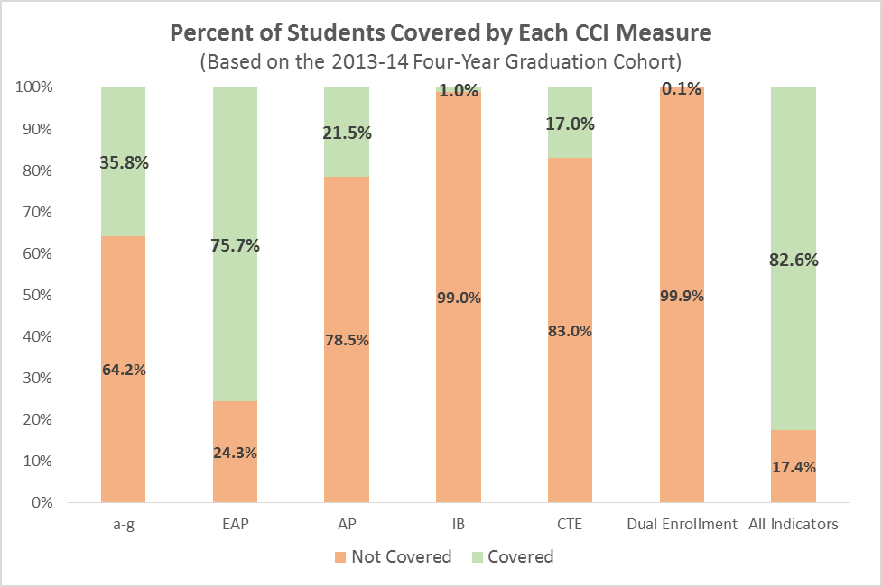
Total number of students in the 2013–14 four-year graduation cohort: 492,971

Note that 17.4 percent of all students in the 2013–14 four-year graduation cohort were not covered in any of the CCI measures.

http://www.epiconline.org/
https://cew.georgetown.edu/wp-content/uploads/2014/11/Recovery2020.ES_.Web_.pdf
[Note: Invalid link removed.]
http://www.ccrscenter.org/sites/default/files/CCRS%20Defintions%20Brief_REV_1.pdf
http://education.ucdavis.edu/sites/main/files/file-attachments/kurlaenderjacksonpsaa9-6-13_presentation-distribute.pdf
https://edpolicy.stanford.edu/sites/default/files/publications/recognizing-college-and-career-readiness-california-school-accountability-system_1.pdf
http://edpolicyinca.org/sites/default/files/pace%20eap%20talk%203-13-15.pdf

