California Department of Education
Executive Office
SBE-002 (REV. 01/2011)

memorandum

Date: | July 15, 2013

TO: | MEMBERS, State Board of Education

FROM: | TOM TORLAKSON, State Superintendent of Public Instruction

SUBJECT: | California Quality Professional Learning Standards report based upon recommendations in Greatness by Design, the Educator Excellence Task Force report sponsored by the California Department of Education (CDE) and the Commission on Teacher Credentialing (CTC).

Summary of Key Issues

Greatness by Design (GBD): Supporting Outstanding Teaching to Sustain a Golden State, the Educator Excellence Task Force report sponsored by the California Department of Education (CDE) and the Commission on Teacher Credentialing (CTC) identifies professional learning standards as a cornerstone of California’s professional learning system. It is intended that the California Quality Professional Learning Standards (QPLS), based on GBD, will be included in the curriculum frameworks that are currently being developed to guide professional learning in the planning, development, and implementation of curriculum standards in each county, district, school and educator.

The draft of the QPLS (available at the California Comprehensive Center at WestEd Web site***) will be sent out from July 29 through August 9, 2013 for final review and comment to the State Consortium on Educator Excellence in California. The final report will be posted on this same website in September 2013. Attached is the CDE Timeline of California Quality Professional Learning Standards Development and Adoption Process, which explains the process CDE, CTC, and WestEd have undertaken to ensure the proper deployment of this proposal. Lastly, there is a List of Stakeholder Groups (Attachment 2) that received Draft One for Comment.

*** [Note: The hyperlink from the California Comprehensive Center at WestEd Web site is no longer applicable and has been removed as of March 2021. Contact the SBE Office for more information.]

Background

The CDE and the CTC convened the California Educator Excellence Task Force, which published the report Greatness by Design: Supporting Outstanding Teaching to Sustain a Golden State. In partial fulfillment of the GBD recommendations outlined in Chapter 5 (“Opportunities for Professional Learning”), the CDE convened a group of educators from across the state, the Core Design Team (CDT), to guide the development of the QPLS.

The CDT also researched professional learning standards from other states, districts, and professional organizations, particularly Learning Forward’s Standards for Professional Learning (2011). The California Standards for the Teaching Profession (CSTP) (California Commission on Teacher Credentialing, 2009) and the California Professional Standards for Education Leaders (CPSEL) (California School Leadership Academy at WestEd & Association of California School Administrators, 2000) were used as reference points, as were expectations for educators related to implementing the Common Core State Standards and the English Language Development Standards. A selection of research about effective professional learning, especially California-based studies and research was reviewed. In drafting the QPLS, the CDT continually referenced the California context, ensuring a focus on the state’s diverse student population.

The QPLS are program standards designed to be useful to all persons connected to increasing educator capacity–including teachers, principals, district, county, state education agency staff, institutes of higher education, professional learning, technical assistance providers and policymakers. These standards help to create a coherent set of professional learning policies and activities that span the career continuum of an educator, improve educators’ knowledge, skills, and dispositions; and, ultimately, increase student learning results. The standards are intended to help users contextualize their own goals, plans, and evaluations when making decisions about how to create and/or improve professional learning in their own systems. These standards are in no way intended to replace professional personnel standards such as the CSTP and CPSEL for individual educators. Instead, the QPLS describe the system of quality learning experiences that, if well implemented, will benefit educators focused on increasing their professional capacity and performance.

The development of the QPLS provides educators, policymakers, education officials and other stakeholders with a shared expectation of what professional learning is and how it could be supported.

Attachment(s)

Attachment 1: CDE Timeline of California Quality Professional Learning Standards
Development and Adoption Process (1 Page).

Attachment 2: List of Stakeholder Groups that Received Draft One for Comment
(2 Pages).

Timeline for the Development and Adoption of the California Quality Professional Learning Standards

The information provided below outlines the general development process and timeline for California Quality Professional Learning Standards (QPLS). The program standards have been through a single round of review with multiple stakeholder groups. Comments were collected and analyzed for commonalities. Comments consistent with the purposes and parameters of the standards were incorporated into the standards.

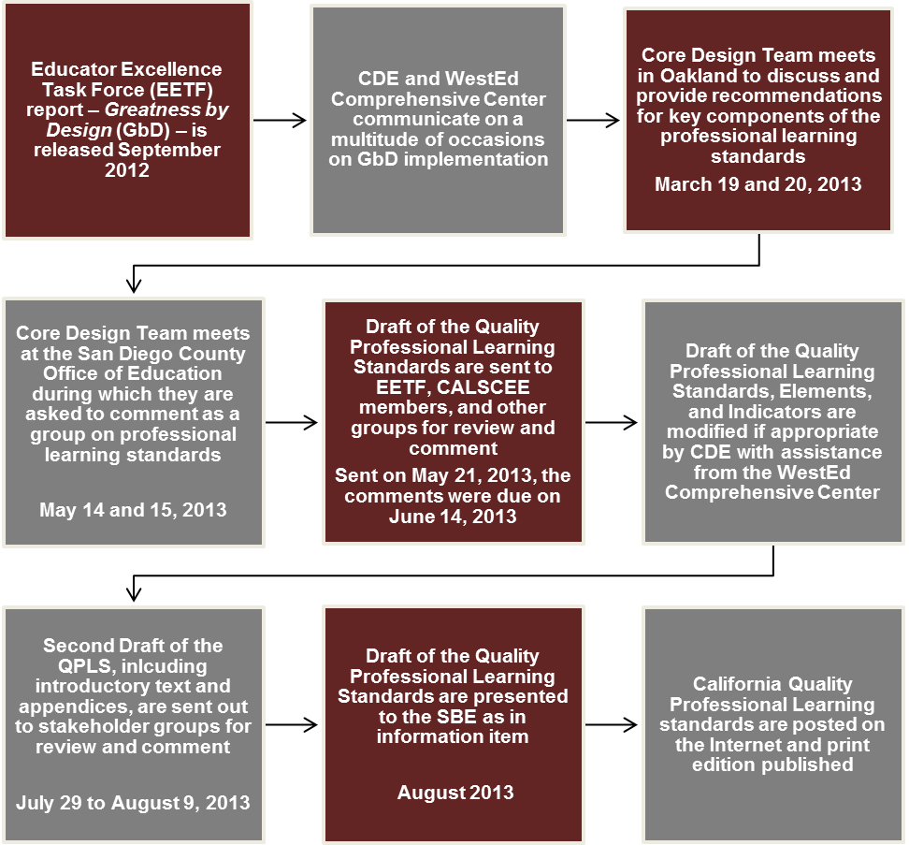
List of Stakeholder Groups that Received Draft One for Comment

State Agencies/Legislature

CA Commission on Teacher Credentialing
CA Department of Education
CA State Assembly
CA State Board of Education
CA State Senate

Associations/Advocacy Groups

California School Boards Association
CA County Superintendents Educational Services Association
Curriculum and Instruction Steering Committee (CISC)
CISC Teacher Development Subcommittee
CISC Leadership Subcommittee
BTSA Cluster Region Directors
Madera COE
Tehama COE
El Dorado COE
Ventura COE
Stanislaus COE
San Diego COE
CA Parent Teacher Association
Public Advocates
California Teachers Association
California Federation of Teachers
Association of CA School Administrators
PICO
CA Charter Schools Association
Los Angeles Chamber of Commerce
Association of Independent CA Colleges and Universities
CA Advisory Commission on Special Education
Californian’s Together & CA Association for Bilingual Education

Schools/School Districts

Folsom Cordova USD
Los Angeles USD
San Francisco USD
Newark USD
Compton USD
ABC USD
Vallejo City SD
Sacramento City USD
Fresno USD
Yuba City USD
Emery SD
Oakland USD
Long Beach USD
North Cow Creek SD
Galt Union Elementary SD
King City USD

Institutions of Higher Education (IHE)

University of San Diego
University of CA, Davis
University of CA, San Diego
University of CA, Santa Barbara
University of CA, Berkeley
University of CA, Office of the President
CA Subject Matter Projects
Schools of Education
Teachers College of San Joaquin
Stanford University
CSU Dominguez Hills
Loyola Marymount University
San Diego State University
Mira Costa College
University of San Francisco
CA State University Chancellor’s Office
Deans of Education
Improving Teacher Quality State Grants Projects (IHEs, COEs, LEAs)

Others

Packard Foundation
Stuart Foundation
New Teacher Center
The Glen Price Group
Reach Institute
Pivot Learning Partners
WestEd
K12 Alliance at WestEd

