California Department of Education  Executive Office  SBE-002 (REV. 01/2011) | ssssb-sed-dec14item01

memorandum

Date: | November 14, 2014

TO: | MEMBERS, State Board of Education

FROM: | TOM TORLAKSON, State Superintendent of Public Instruction

SUBJECT: | Update on California’s 2014 Individuals with Disabilities Education Act Compliance Determination Appeal

Summary of Key Issues

California Appeal of Determination

On September 15, 2014, staff from the California Department of Education, the California State Board of Education, and 11 members of a California Coalition for Adequate Special Education Funding met with Michael K. Yudin, Acting Assistant Secretary, Office of Special Education and Rehabilitative Services; and Office of Special Education Program (OSEP) staff Melody Musgrove, Director; Ruth Ryder, Deputy Director; Gregg Corr, Director, Division of Monitoring and State Improvement Planning; Larry Ringer, Associate Director, Division of Monitoring and State Improvement Planning; and Nancy Deutsch, Office of the General Counsel, to appeal the OSEP determination of “Needs Intervention” for California’s special education programs. In support of our appeal, we had letters from California’s Senators and from the Council of Chief State School Officers.

We asserted that OSEP had not used the “totality of the State’s data and information” as it stated in numerous documents. In fact, we asserted that the results portion of the determination was based solely on two broad measures: statewide assessment data and the National Assessment of Educational Progress (NAEP). We challenged the use of these items based on problems with the methodology employed by OSEP.

- For statewide assessments, students who took the alternate or modified assessments were either not included or included improperly.
- NAEP is not a valid measure for the purposes utilized by OSEP.
- In its application of NAEP scoring on participation, OSEP failed to note that the lack of accommodations provided in the NAEP assessment prohibited potentially 36 percent of students with disabilities in California from participating, thereby making measures of participation invalid.
- OSEP failed to note that NAEP stated that California was “not significantly different from the … goal of 85 percent” participation. Adjusting for this one factor alone would change California’s determination.
- We also pointed out the imbalance in the Compliance versus the Results Determinations columns. Essentially, OSEP undervalued compliance by averaging the two measures before making the overall determination.
Further, we challenged OSEP for its lack of adherence to U.S. Department of Education’s (ED) Core Principles:
- “Core Principle 1. The Results Driven Accountability (RDA) system is being developed in partnership with our stakeholders.”

- “Core Principle 2. The RDA system is transparent and understandable to States and the general public, especially individuals with disabilities and their families. ”

- “Core Principle 3. The RDA system drives improved outcomes for all children and youth with disabilities regardless of their age, disability, race/ethnicity, language, gender, socioeconomic status, or location.”

Our feedback and self-assessment of the hearing was that we effectively presented all the salient points on both technical and procedural grounds. We agreed to allow time for OSEP to produce all the documentation responsive to our Freedom of Information Act (FOIA) request related to this determination before providing us the final response so that we can further analyze the methods used by OSEP and possibly amend our appeal, if warranted.

Attachment(s)

Attachment 1: Handout Presented at OSEP Appeal (18 Pages)

Attachment 2: PowerPoint Presentation for OSEP Appeal (15 Pages)

In Person Appeal Hearing

Purpose of this Meeting

California has been determined by the Office of Special Education Programs (OSEP) to “need intervention.” California believes that this determination was made based on errors in the selection and application of key criteria. This presentation will outline those specific areas, some of which were presented in our earlier document requesting this hearing, and others that are relevant. In addition, we will present some general concerns and offer specific recommendations.

Totality of Information

CA is concerned regarding the errors and discrepancies in the published information provided. In the letter to State Superintendent of Public Instruction, Tom Torlakson, OSEP stated: “This determination is based on the totality of the State’s data and information, including the Federal fiscal year (FFY) 2012 Annual Performance Plan (APR) and revised State Performance Plan (SPP), other State-reported data, and other publicly available information.” This statement is repeated in the OSEP document titled, “How the Department Made Determinations under Section 616(d) of the Individuals with Disabilities Education Act in 2014: Part B.”

We do not find the above statement to be true. While the compliance portion of the determination is based upon well-defined, long known compliance indicators that are annually reported in the SPP/APR, the “results-driven accountability” (“RDA”) measures use only participation rates and performance scores for statewide assessment, and for the National Assessment of Educational Progress (NAEP). There are a substantial number of additional indicators and measures that are included in the SPP/APR, and that are included in the OSEP data tables provided as part of the determination documents, that OSEP did not include in its determination. These critical indicators better comprise “the totality of the State’s data and information” and will be addressed.
In addition, we object to the use of NAEP generally. California believes that the National Assessment of Educational Progress Authorization Act prohibits the use of the National Assessment of Educational Progress (NAEP) for the purposes for which OSEP has used it. The prohibition at Section 303 (4) (1) states generally that “the use of assessment items and data on any assessment authorized under this section by an agent or agents of the Federal Government to rank, compare, or otherwise evaluate . . . is prohibited.” Further, on NAEP’s own Web page: Important Aspects of No Child Left Behind Relevant to NAEP at http://nces.ed.gov/nationsreportcard/nclb.asp, it clearly states: “There will be no rewards or sanctions to states, local education agencies, or schools based on state NAEP results.”
Specific Errors: Due to the following errors, we believe California has been unfairly and erroneously labeled “Needs Intervention.”

NAEP: The National Center for Education Statistics (NCES) states in their guidance and documentation that California (CA) meets the inclusion rate goal of 85 percent.

  - On page six of the NCES 2013 mathematics assessment report card, a footnote includes California as part of the group that states: “The state/jurisdictions [California] inclusion rate is higher than or not significantly different from the national assessment governing board goal of 85 percent.” We believe that this is a more accurate portrayal of CA’s participation. OSEP’s oversight of this critical footnote negatively affects only CA. The appropriate application of the standard error as indicated in the NCES document would result in California earning a score of +1 point for this element and would change the CA determination to Needs Assistance.

  - CA strives to have full participation of its students in all assessments. The published inclusion rate value in the NCES 2013 mathematics assessment report card is due to factors that are beyond the scope of CA to change. CA does not exclude students from NAEP participation. Students do not participate in NAEP due in large part to the lack of accommodations offered by NAEP.

    - The NCES does not permit potentially 89,000 CA students (16 percent), and possibly as many as 190,000 CA students (36 percent), to take NAEP with necessary accommodations identified due to NAEP’s accommodation rules. In fact, NAEP specifically does not allow 13 of the 23 accommodations needed by CA students to be used during its administration. (See Chart A).

    - The NAEP rules simply do not allow for these students’ participation. OSEP did not account for this in their results calculations. Appropriately accounting for the NAEP exclusions of CA students with disabilities would change CA’s determination to Needs Assistance.

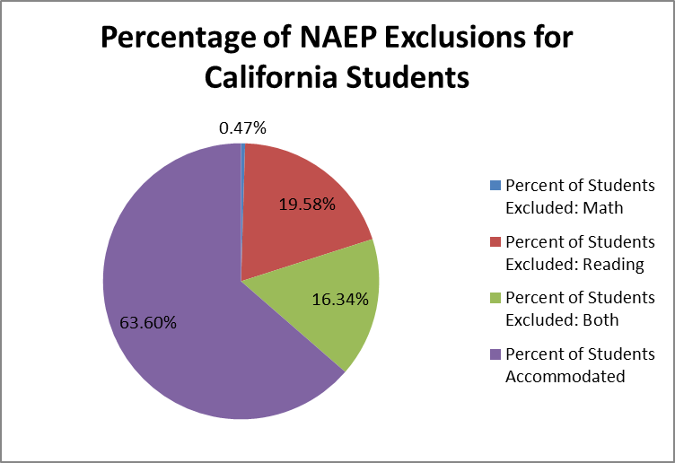

- OSEP may have used an incorrect table which includes students with Section 504 plans

    - It appears that OSEP is using the tables from pages 13 and 14 of the NCES mathematics tables and pages 14 and 15 of the reading tables. However, NCES notes that these data include students “identified as having either an Individualized Education Program or (emphasis added) protection under Section 504 of the Rehabilitation Act.” Students qualifying under Section 504 are not receiving services under the Individuals with Disabilities Education Act (IDEA), but are presumably included in this total by NCES because they may be allowed some kind of test accommodations. Notably, the table on page 6 of the NCES mathematics document, which finds the CDE largely in compliance with the recommendation to test at least 85 percent of students with disabilities, does not include students protected under Section 504. The inclusion of Section 504 students in the State’s exclusion rates who are excluded by the NAEP’s own rules misrepresents the number of students with disabilities served under IDEA, and unjustly penalizes CA.

- The NAEP sample size for students with disabilities in California is inadequate.

  - Due to NAEP’s inability to accommodate students in their sampling methodology, the resulting N size of ~590 for math and ~660 for English/Language Arts (ELA) cannot adequately represent the totality of approximately 760,000 students with disabilities in California.

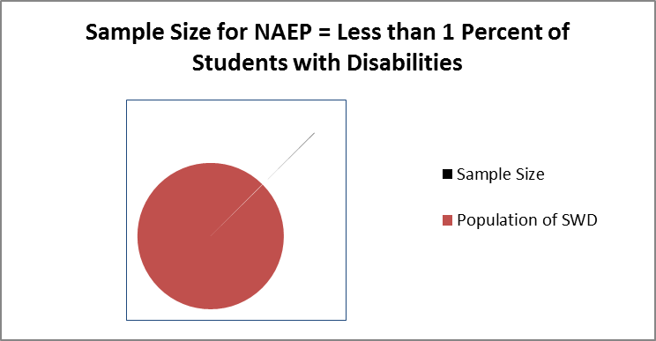

- NAEP weighting is overemphasized

- NAEP Accounts for 8 of the 12 results elements. We have already indicated that 4 of those 8 are not representative of all students with disabilities in California. Again, this is due to the lack of accommodations in the NAEP sampling, not because of decisions made by California’s schools and LEAs.

- In the Results Matrix, participation by 4th and 8th graders in statewide assessments was combined, but those grades were separated out on NAEP yielding twice the weight to NAEP participation as compared to participation on statewide assessments.

- Additionally, the federal register notice of Wednesday, March 26, 2014, states that, “relevant data reported by States and other publicly available data will be reflected in the matrices, with each data element receiving a score between zero and two and then combining all of the points from both matrices.” This would have been a more equitable means of scoring. Yet, in the final metric, for participation on the NAEP, participation was scored either -1 or +1. We fail to understand the logic behind this departure from the notice and why it is used to unduly weight the NAEP participation.

Participation on Statewide Assessments

- Historically, in OSEP’s responses to CA’s SPP/APR submission, the participation rate for students with disabilities published in the APR was acceptable. In previous years CA has not had any negative feedback pertaining to its previous APR submissions for this Indicator, and in the most recent response table specifically, there was no “Required Action” for Indicator 3b, “Proficiency rate for children with Individualized Education Programs (IEPs) against grade level, modified and alternate academic achievement standards” in the calculation of the participation rate for students with disabilities. California’s participation rate on statewide assessments has been over 97 percent on English/Language Arts and over 98 percent on Math for the past three years.

- CA treats all students equally, those that take the general assessment as directed under the Elementary and Secondary Education Act (ESEA) as well as those that, due to the nature of their disability, take the alternate or modified assessment as permitted under the IDEA. OSEP’s apparent sole use of the ESEA standard for general assessments, excluding those who take modified or alternate assessments, treats these students unequally. We will appreciate seeing the actual calculations used to arrive at these numbers, if they did in fact include alternate assessments. This essentially punishes IEP decisions made in accordance with 34 CFR 300.320 (a) (6) and implies that such teams are making the “wrong” decision.

  - In Section 300.320, the definition of individualized education program, it states:
    - “(a) General. As used in this part, the term individualized education program or IEP means a written statement for each child with a disability that is developed, reviewed, and revised in a meeting in accordance with Sec. 300.320 through 300.324, and that must include--
    - (6) (i) A statement of any individual appropriate accommodations that are necessary to measure the academic achievement and functional performance of the child on State and districtwide assessments consistent with section 612(a)(16) of the Act; and
    - (ii) If the IEP Team determines that the child must take an alternate assessment instead of a particular regular State or districtwide assessment of student achievement, a statement of why--
    - (A) The child cannot participate in the regular assessment; and…”

- CA believes in the authority of the IEP team to render such decisions, and that aggregating those individual decisions to make a state determination is improper and discriminatory.

- In addition, the limitation on using only the 1 percent of students with disabilities whose scores are used for accountability purposes is problematic. ESEA regulations, not IDEA requirements, impose that 1 percent cap for purposes of accountability. We clearly understand the limitations of reporting more than one percent of students as proficient for those that take the alternate assessment, but this does not prohibit those students from participating in the assessment. Limiting the use of these students’ scores when these alternate assessments are clearly permitted under IDEA creates another unreasonable and arbitrary restriction

Requested Action

- Based on information provided in the original request for a hearing and the information presented here, CA’s determination should be changed. Based on the evidence presented above, this could be accomplished by any of the following means:

- Remove the NAEP participation rate calculations from the Results Matrix due to NAEP’s failure to fully accommodate CA’s students with disabilities. Adjusting the Results Matrix appropriately based on this information would yield a Results Matrix score of 6 of 12 possible points (50 percent). When properly combined with the Compliance Matrix, the Determination score would be 27/34 possible points (79 percent). This adjustment would place CA in the “Needs Assistance” range.

Needs Assistance

- Correct the scoring of NAEP participation rate in 4th grade math using NAEP’s own arguments. This would change the Results Matrix score from 3 of 20 possible points (15 percent) to 5 of 20 possible points (25 percent). Such correction would properly yield a combined determination score of 26/42 possible points (62 percent). This correction would place CA in the “Needs Assistance” range.

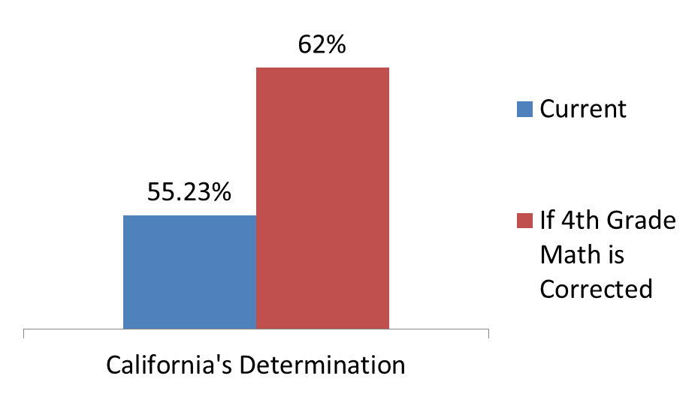
Needs Assistance

  - Alternately, ED should eliminate the NAEP component of the Results Matrix entirely. This would change the scoring for the results section from 3 of 20 possible points (15 percent) to 5 of 8 possible points (63 percent). The addition of the results matrix score to the compliance matrix score would properly yield a determination score of 26/30 (87 percent). This would place CA in the “Meets Requirements” range.

- CA also requests that this year’s determinations be used for “informational purposes only,” not as the baseline for future determinations. CA believes that this should be the case for any new determination until States have had proper opportunity to review new metrics and prepare accordingly.

Meets Requirements

- The Federal Register notice stated that the final determination score would result from “combining all of the points from both [the results and compliance] matrices” and that “[u]sing the cumulative possible number of points from both matrices as the denominator, and using the total number of actual points the State received in the scoring under the individual factors as the numerator, the State’s 2014 determination will be based on the percentage score from both matrices.” However, the final scoring matrix which ED used to make the 2014 determinations was not scored this way. Instead, the final State RDA percentages were calculated by adding 50 percent of the State’s Results Performance Percentage and 50 percent of the State’s Compliance Performance Percentage (see ED’s determinations document, page 7). This is essentially averaging averages, a basic mathematical error. The method originally suggested in the Federal Register should be adopted instead, as various States have different numbers of performance indicators. California’s score should be adjusted accordingly.

Policy Error: California supports the concept of “Results Driven Accountability,” but has significant concerns about its implementation and adherence to ED’s Core Principles

CA believes that the focus of our work and that of all education personnel should be on improving outcomes for all students, including those infants, toddlers, children, and youth with disabilities. CA also supports ED’s Core Principles of partnership, transparency, and improved outcomes and has demonstrated that it can live up to those principles. CA has demonstrated that it can achieve any target that is set in advance and that though our actions and oversight we can influence progress towards the target. This is evidenced, in part, by our excellent scores in the compliance matrix. We can do this because we have a powerful relationship with our stakeholders, and strive to make our process transparent and inclusive. Results for students with disabilities on the totality of measures indicate that outcomes for students are improving.

ED’s Core Principles do not appear to align with the actions OSEP has taken in developing the RDA. These actions are described below.

- “Core Principle 1. The RDA system is being developed in partnership with our stakeholders.”

    - Although a Request for Information was published, the determinations document states that data used in the determinations was captured on April 16th, well before input regarding what data OSEP should use was completed, indicating that the agency had already decided what data it would use prior to receiving stakeholder input.

    - When OSEP received stakeholder input, stakeholder recommendations or concerns were ignored. For example, even in the report ED requested from the NCEO regarding the use of NAEP data, the center asserted that the NAEP “does not provide data that could be used to indicate the performance of students with disabilities, but it does provide data that can be used to indicate the relative difficulty of each state’s general assessment.

    - The National Association of State Directors of Special Education (see attached Comment 1), submitted comments on behalf of all the state directors of special education strongly advising against the use of NAEP and offering alternative measures that would be more representative of data appropriate to measure results.

- “Core Principle 2. The RDA system is transparent and understandable to States and the general public, especially individuals with disabilities and their families.”

- Both the scoring for the results components and the amount by which the results and compliance components are weighted differ significantly from the outlines originally provided in the March 2014 Federal Register notice. The original Federal Register notice indicated that, within the results matrix, “each data element [would receive] a score between zero and two.” Instead, four of the results components, those relating to exclusion from NAEP testing, are scored on a scale between -1 and 2. This change has significant impact on the overall determination scores.

- OSEP failed to clearly articulate that NAEP was being considered as the primary measure of State performance under RDA indicators. The only reference in any published document that we have so far received states, “we are considering using the following results data in making determinations, including examining a State’s progress over time:

- For Part B, data related to:

- Participation in and proficiency on assessments (reported publicly through either statewide assessments or [emphasis added] the National Assessment of Educational Progress) in reading/language arts and math,

- Rates of students graduating with a regular diploma and/or

- Post school outcomes.”

Given historical reporting and the substantial input provided, the use of statewide assessment data was anticipated; the use of NAEP was not.

- We are also concerned regarding the lack of timely notice, along with the errors and discrepancies in the published information provided. Notice of proposed measures was not provided in time to verify validity of the measures. It is also important to be able to work with stakeholders regarding understanding of such measures and to be prepared to speak knowledgeably about those results. This brief timeline is an indication of the lack of timeliness in notice.

- On June 23, 2014, CA was notified of the OSEPs determination for CA. This notice consisted of a series of teleconferences; the full determinations were released only hours later.

- The lack of notice regarding the scoring metric meant that the State had no opportunity to encourage better participation in the NAEP or even to prepare a comprehensive and data-driven response before media inquiries began.

- “Core Principle 3. The RDA system drives improved outcomes for all children and youth with disabilities regardless of their age, disability, race/ethnicity, language, gender, socioeconomic status, or location.”

    - We are concerned that in the determinations made for CA not every student with disabilities was included. The method for determining participation on statewide assessments excludes students who do not take the regular assessment, thereby eliminating students who participated in either a modified or alternate assessment. A footnote on page 4 of ED’s determinations document states that its ultimate goal is “to ensure that all Children with Disabilities (CWD) demonstrate proficient or advanced mastery of challenging subject matter.” It is difficult to imagine how the ED expects many CWD to demonstrate that mastery without the ability to incorporate modified assessments and alternate standards and/or assessments, where appropriate.

    - California has found that by including all students in all assessments, we are not only showing improved rates of performances for all students, but also CWD are closing the achievement gap.

  - Suggestions: OSEP should include all students who take all types of assessments in their determinations. Further, ED should limit the use of their test performance measure to those valid tests that are designed for accountability and solely test student performance on content standards.

If the use of NAEP remains unchanged, and ED remains unclear what the next measure will be, in absence of that clarity, states such as CA have no target so shoot for. As noted above, with such clarity and time to address the relevant measures used, the determinations next year will again perpetuate the misrepresentations of CA’s progress in serving CWDs.

Final concern: We simply do not believe that this determination is reflective of CA and the progress our students are making. This does not represent the progress of students with disabilities in CA.

- OSEP states that they used the totality of the information they have about a state. We find that much information that provides a more accurate view of CA is not included. As noted in the following displays, results for students with disabilities are improving and those corollary measures of improved conditions leading to improved results are positive.

- Graduation rates are steadily increasing.

- Suspension rates have been significantly reduced.

- Parents report high levels of engagement.

- English/language arts proficiency rates are increasing and the achievement gap between students with disabilities is decreasing.

- Math proficiency rates continue to generally increase and the math achievement gap is slowly closing.

- The following graphs demonstrate these changes:
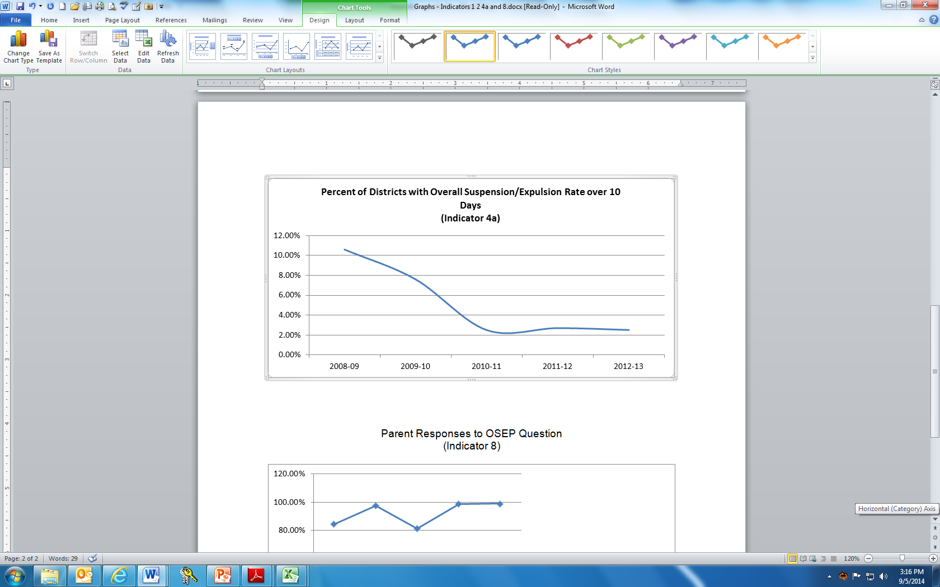
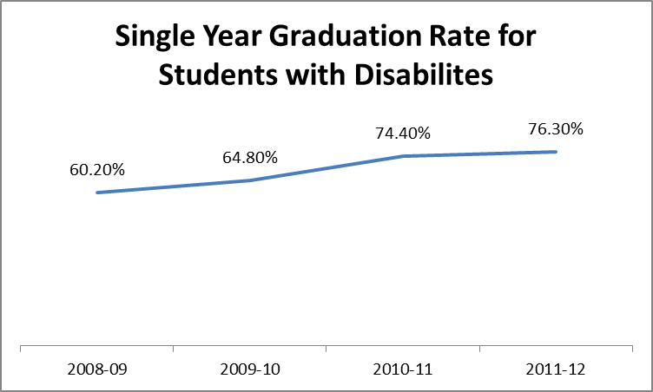

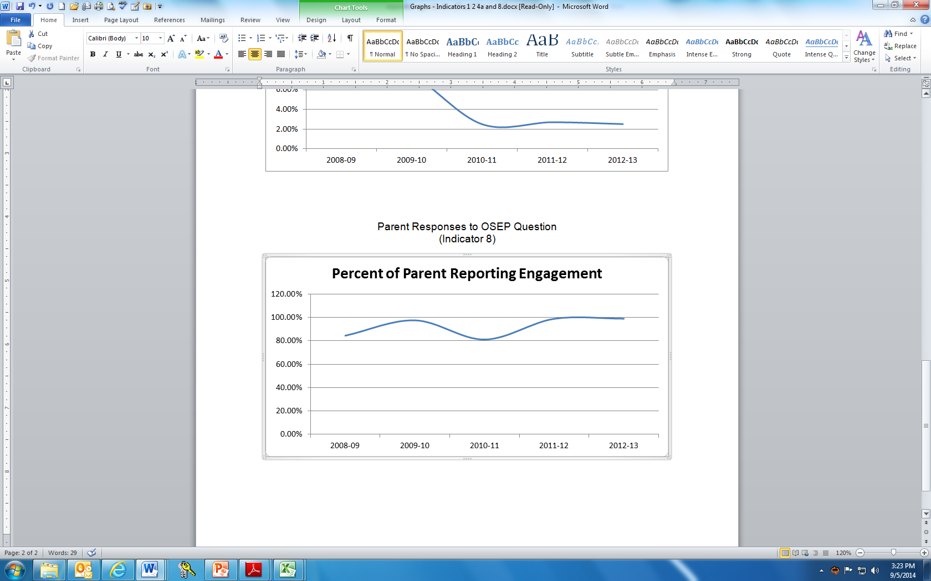
Percent of Parents Reporting Engagement

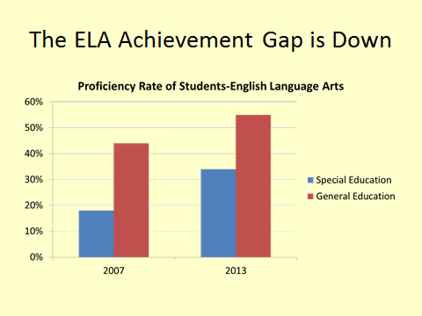
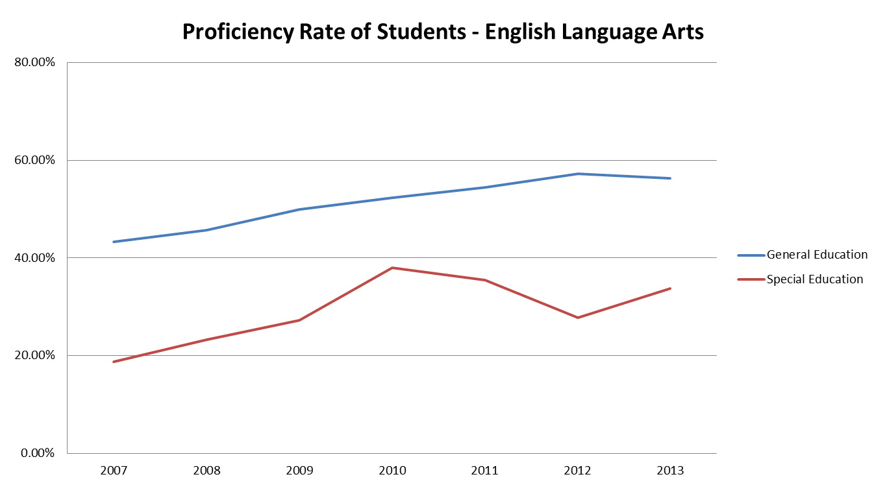


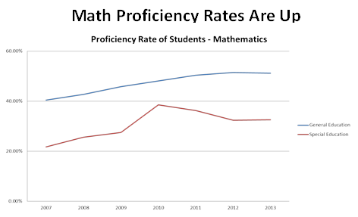

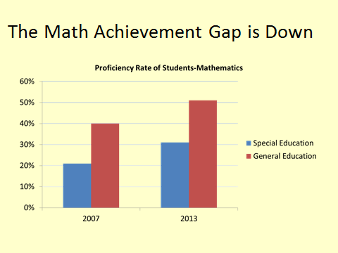

California remains committed to working to improve results for all its students. We suggest that the above measures, along with others, such as post school outcomes and diploma receipt, may more accurately reflect attainment of those improved results.

OSEP has stated that it “will use results data and other information about a State to determine the appropriate intensity, focus, and nature of the oversight and support that each State will receive as part of RDA. In providing differentiated support, OSEP will consider each State’s need in relation to the development and implementation of its SSIP.” We look forward to a more transparent and enhanced partnership in designing and implementing differentiated monitoring and support for CA.
Chart A – Student Accommodations Not Allowed During NAEP Administration: Students Excluded
Accommodation Needed | Count | Math Not Allowed | Reading Not Allowed | Students Excluded Math | Students Excluded Reading
Total Special Ed Student Count in STAR File | 528,475 | -- | -- | 88,863 | 189,869
Student had supervised breaks | 118,372 | -- | -- | 0 | 0
Student heard test examiner read test questions or text in Writing Prompt aloud (audio CD presentation not used). | 102,205 | -- | 1 | 0 | 102,205
Test was administered at the most beneficial time of the day for the student | 43,801 | 1 | 1 | 43,801 | 43,801
Student used an unlisted accommodation | 26,917 | -- | -- | 0 | 0
Student tested over more than one day | 25,496 | 1 | 1 | 25,496 | 25,496
Student marked in test booklet and responses were transferred | 15,112 | 1 | 1 | 15,112 | 15,112
Student used a calculator | 5,215 | -- | -- | 0 | 0
Student used large print test | 3,447 | -- | -- | 0 | 0
Student used math manipulatives | 2,150 | 1 | -- | 2,150 | 0
Test administrator used Manually Coded English or American Sign Language to present test questions or any text in Writing Prompt and Response Booklet to student. | 1,292 | -- | 1 | 0 | 1,292
Student dictated responses to a scribe | 1,268 | -- | -- | 0 | 0
Student used assistive device that did not interfere with the independent work of the student. | 1,186 | -- | -- | 0 | 0
Test was administered at home or in a hospital | 889 | 1 | 1 | 889 | 889
Student used word processing software with spell and grammatical check tools turned off | 829 | -- | -- | 0 | 0
Student used a dictionary | 501 | 1 | 1 | 501 | 501
Student used an unlisted modification | 488 | 1 | 1 | 488 | 488
Student used Braille test | 476 | -- | -- | 0 | 0
Student used an arithmetic table | 341 | 1 | -- | 341 | 0
Student dictated responses to a scribe. The scribe provided all spelling and language conventions. | 33 | 1 | 1 | 33 | 33
Student used word processing software with spell and grammar check tools enabled. | 33 | 1 | 1 | 33 | 33
Student used assistive device that interfered with the independent work of the student. | 19 | 1 | 1 | 19 | 19


Comment 1
National Association of State Directors of Special Education, Inc.

225 Reinekers Lane, Suite 420, Alexandria, VA 22314
Tel: 703/519-3800 Fax: 703/519-3808 www.nasdse.org

April 25, 2014

Larry Ringer
Office of Special Education Programs
U.S. Department of Education
400 Maryland Avenue, SW
Room 4032, Potomac Center Plaza
Washington, DC 20202-2600

RE: Docket No.: ED-2013-OSERS-0150
Dear Larry:

On behalf of the National Association of State Directors of Special Education (NASDSE), the national nonprofit organization that represents the state directors of special education in the states, District of Columbia, Department of Defense Education Agency, federal territories and the Freely Associated States, I am submitting these comments in response to the above-referenced Docket Number.

As you know, NASDSE’s members have been very supportive of OSEP’s Results Driven Accountability (RDA) initiative because they believe that the focus of their work and that of all education personnel should be on improving outcomes for all students, including those infants, toddlers, children and youth with disabilities.

Our comments below focus first on data to consider in developing a Results Matrix and then on the specific questions raised in this RFI.

Data to Consider in Developing a Results Matrix for purposes of Determinations

- Since the Individuals with Disabilities Education Act (IDEA) was reauthorized in 2004, determinations made by the Office of Special Education Programs (OSEP) have focused on the compliance indicators in the State Performance Plan/Annual Performance Report (SPP/APR). Because of the importance of the APR in making determinations and the amount of effort by states to report on the Part B and C indicators, this is where the focus of the states’ work has been.

- While NASDSE members are in agreement that there needs to be more focus on the results indicators, we are concerned about bringing in other criteria (excluding Indicators C-11 and B-17) for making determinations. NASDSE supports using only data gathered for the indicators of the SPP/APR for the Results Matrix.

- We are opposed to using NAEP scores because historically, students with disabilities have been excluded from NAEP and while efforts over the past few years have been made to include students with disabilities, their overall participation in NAEP is low. Therefore, we believe the use of NAEP scores would not be an accurate reflection of how well students with disabilities are doing academically. Further, states are in the process of transitioning to the Common Core and Common Core assessments and the NAEP has not been transfigured into reflecting the new Common Core. Therefore, for at least several more years, the NAEP will not reflect what students are learning in the classroom. For these reasons, NASDSE does not recommend the use of NAEP in the Results Matrix.

- Overall, NASDSE is opposed to the use of data that would rank states on the basis of their performance indicators. NASDSE believes that it is important for OSEP to evaluate each state’s performance on an individual basis because states are starting at different places, which should impact the progress they make in improving outcomes.

Responses to Questions in the Request for Information

- How should the Department use results data in making determinations under Part B?

NASDSE supports the use of state assessment data and graduation data. However, we oppose using post-school outcome data for the purpose of making determinations. While NASDSE believes that Indicator 14 is a useful tool for evaluating how well students are doing once they leave the IDEA ‘system,’ there are several flaws with the use of this measurement for making determinations. First, as comparable post-school outcome data for students without disabilities is not currently being collected by states or the U.S. Department of Education, there is no basis for comparing the data gathered under Indicator 14 with students without disabilities. Thus, if a state (or a locale) is experiencing particularly high rates of unemployment, the unemployment rate for students with disabilities might conceivably be comparable to that of young adults in the community without disabilities. Second, no matter how good the education and transition planning is for youth, there are potentially many factors that could intervene post-graduation to affect a student’s post-school outcomes. To name just a few: the death of an immediate family member; serious health concerns or an accident for the young adult; drug abuse; family homelessness; and mental health issues that far too often affect young adults. Any of these issues could derail a successful transition to post-school outcomes for a young adult, whether or not the individual has a disability.

NASDSE recommends putting the emphasis for outcomes on those indicators where targets and progress can be clearly measured – graduation and dropout rates, assessments, suspensions and expulsions and LRE placements.

(3) Are there any additional or different types of results data that the Department should/could consider using the IDEA Part B determinations process?

It is important for the Department to keep in mind the actions states are presently taking under their ESEA waivers and the ESEA statute to improve outcomes for all students, including students with disabilities. NASDSE is in agreement with comments made the Council of Chief State School Officers (CCSSO) that as OSEP moves forward with its RDA initiative, it closely aligns this work with the accountability systems developed by states under ESEA waivers or the ESEA statute.

In addition, NASDSE urges OSEP not to increase either the reporting or overall burden on states under IDEA. We welcome OSEP’s increased involvement with the Office of Elementary and Secondary Education (OESE) in its monitoring and hope that OSEP recognizes that state special education personnel are also more involved in the ESEA outcomes and accountability work being undertaken by states. NASDSE believes that this work should be aligned to the maximum extent possible.

Again, NASDSE thanks you for this opportunity to provide input. If you have any questions, please do not hesitate to contact me at bill.east@nasdse.org or NASDSE’s deputy executive director, Nancy Reder, at nancy.reder@nasdse.org.

Sincerely,


Theron (Bill) East, Jr., Ed.D.
Executive Director

