California Workforce Pathways Joint Advisory Committee

cwpjac-july25item01

Page 1 of 2

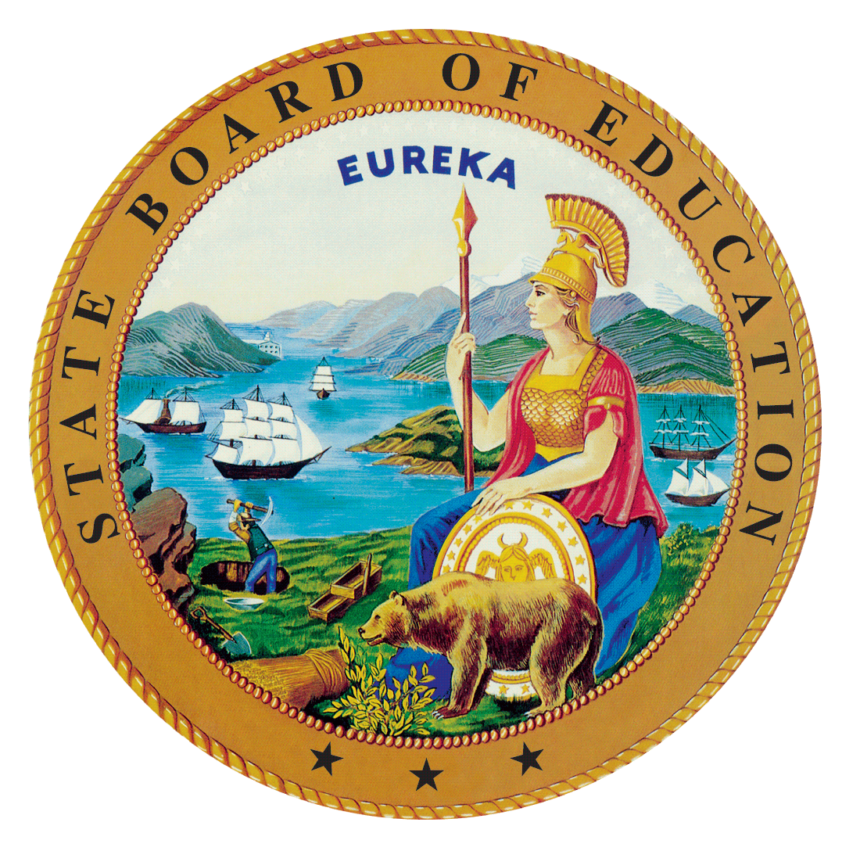  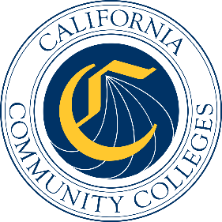

# California Workforce Pathways Joint Advisory Committee July 11, 2025 Agenda Item 01

Posted by the California Department of Education

## Subject

CALIFORNIA WORKFORCE PATHWAYS JOINT ADVISORY COMMITTEE PROJECTS AND PRIORITIES.

Including, but not limited to, future meeting plans; agenda items; Advisory Committee appointments and direction to staff; Committee policy; approval of minutes; Committee Chair and liaison reports; Department staffing updates; and other matters of interest.

## Type of Action

Information, Action

## Summary of the Issue(s)

1. California Workforces Pathways Joint Advisory Committee (CWPJAC) Draft Preliminary Report of Actions/Minutes for the November 25, 2025, meeting
2. Committee Member reports
3. Department Updates:
   1. California Department of Education (CDE)
   2. California Community Colleges Chancellor’s Office (CCCCO)
   3. State Board of Education (SBE)

## Recommendation

The SBE, the CDE, and the CCCCO staff jointly recommend that the CWPJAC review and approve the November 25, 2024, Preliminary Report of Actions/Draft Minutes (Attachment 1).

## Brief History of Key Issues

The CWPJAC addresses systems alignment policies specific to career pathways within the context of state and federal investments, furthering California’s policy objectives regarding workforce pathways in the state’s regional economies.

## Summary of Previous California Workforce Pathways Joint Advisory Committee Discussion(s) and Action(s)

This is a standing Agenda Item which allows the CWPJAC members to review and approve the Preliminary Report of Actions/Draft Minutes for the previous CWPJAC meeting and any other topics necessary to run the CWPJAC.

## Attachment(s)

**Attachment 1:** Preliminary Report of Action/Draft Minutes (3 pages)