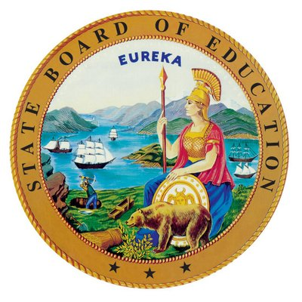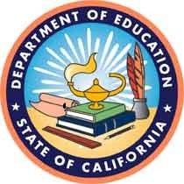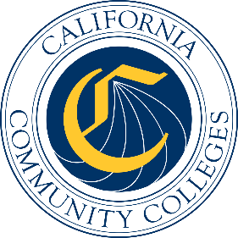

California Workforce Pathways
Joint Advisory Committee
September 11, 2026
Agenda Item 05

Subject
Career Technical Education Model Curriculum Standards Update

Type of Action
Information

Summary of the Issue(s)
The California Department of Education (CDE) is modernizing the Career Technical Education (CTE) Model Curriculum Standards (MCS) by adopting the Advance CTE National Career Clusters® Framework as the organizational structure for California's CTE system. This approach establishes a common statewide framework that strengthens alignment among education, workforce development, labor, and industry while preserving California's ability to design career pathways that reflect the state's economy, workforce priorities, and regional labor market needs.
This common framework creates an opportunity to align K-14 education and apprenticeship systems around a shared language of workforce preparation. The California Division of Apprenticeship Standards (DAS) has also adopted the Career Clusters Framework to organize registered apprenticeship pathways, creating stronger connections between CTE, pre-apprenticeship, registered apprenticeship, and employment. Using the same organizational framework allows educators, employers, labor organizations, and apprenticeship sponsors to more clearly identify pathway connections, align competencies, and support seamless learner transitions between systems.
CDE has taken a phased approach to this work:
- In November of 2025, The State Board of Education (SBE) adopted the MCS for the first phase which included the following Career Clusters: Arts, Entertainment, and Design, Management and Entrepreneurship, and Marketing and Sales.
- In November 2026, CDE will present the proposed CA CTE Framework for adoption inclusive of the new pathway structure across all fourteen Career Clusters. (Attachment 1: Proposed California CTE Framework: Pathways and Pathway Crosswalk)
- In November 2026, CDE will submit the MCS for an additional five Career Clusters for approval. The five Career Clusters in phase 2 include: Education, Energy and Natural Resources, Financial Services, Hospitality, Events, and Tourism, Public Safety and Services.
- Phase three includes six Career Clusters which will be developed over the next six months and presented for adoption no later than November 2027.
- CDE will be working diligently with the California Commission on Teacher Credentialing and our CALPADs data team to support a smooth transition to the new framework.
- CDE will also be preparing a strategic roll-out that includes professional development and technical assistance for LEAs during the transition in partnership with WestEd.
The revised Career Technical Education Model Curriculum Standards (MCS) have been developed in alignment with the National Career Clusters® Framework through a comprehensive, industry-led process involving employers, labor organizations, educators, postsecondary institutions, workforce partners, and state agencies. Standards Development Committees and pathway-specific workgroups identified the knowledge, skills, and competencies that learners need to successfully transition into employment, postsecondary education, registered apprenticeship, and lifelong career advancement. Rather than simply updating existing standards, California has developed a universal Industry Skills Framework that identifies foundational and technical competencies recognized across education and workforce systems. Organized within the National Career Clusters Framework, California-defined pathways provide the flexibility to address state-specific industries, occupations, and emerging technologies while maintaining a consistent structure that can be shared across partners.
The development of the MCS and modernized framework has also been informed through ongoing collaboration, advisement, and support from leaders across partner agencies including the Community Colleges Chancellor’s Office (CCCCO), California Workforce Development Board (CWDB), Labor and Workforce Development Agency (LWDA), Division of Apprenticeship Standards (DAS), Academic Senate for California Community Colleges (ASCCC), and the Mapping Articulated Pathways Initiative (MAP). Together, these efforts advance a statewide vision for a more integrated talent development system by identifying credentials of value, promoting common terminology, coordinated pathway design for dual enrollment, work-based learning, youth apprenticeship, and stronger alignment between education and workforce investments. The framework supports regional collaboration while providing consistency across agencies responsible for preparing California's future workforce.
Formally adopting a shared Career Cluster structure across CDE and the DAS establishes the foundation for a connected CTE and workforce system. It supports the development of apprenticeship-aligned programs of study, advances dual enrollment opportunities, identifies industry-recognized credentials, and leads to competency-based pathways that prepare learners for high-skill, high-wage, and high-demand careers.
Building upon the collaborative development of California's MCS and the adoption of the National Career Clusters® Framework by both CDE and DAS, the next phase of this work is to align K–14 Career Technical Education programs within the modernized statewide framework. This effort would establish coherent career pathways, improve articulation across K-12 and postsecondary systems, strengthen work-based learning and youth apprenticeship opportunities, and create seamless transitions from education to employment. Advancing this alignment will support the goals of the Master Plan for Career Education while creating a coordinated talent development system that better serves learners, employers, and California's economy.
CDE will present the new proposed CA CTE Framework to the California Workforce Pathways Joint Advisory Committee, provide an update on the development timeline, and share the cross-agency CTE and apprenticeship alignment work with partners from CCCCO and DAS.

Brief History of Key Issues
Background Context
California's Master Plan for Career Education and the State Superintendent of Public Instruction's (SSPI) initiatives have prioritized systems alignment and career readiness. Adopting the national framework will improve transparency and access for all students in California. CDE has completed the new CA framework design as well as the first two phases of the CTE MCS development.
CDE spent the last eight months convening cross-agency partners, employers, labor, CTE educators and faculty, and subject matter experts to design a modern CTE Framework that is reflective of California’s workforce needs. The modernized Framework will ensure California's CTE programs stay current, skills-based, and flexible.
Central to this process was the systems alignment that occurred due to extensive cross-agency collaboration. In addition to the participation by postsecondary and workforce partner agencies, several state employers participated actively in the process including California Department of Human Resource, California Apprenticeship Council, California Air Resources Board, State Water Resources Board, California Department of Transportation, California State Transportation Agency, California Department of Social Services, the Energy Commission, and California Municipal Utilities Association.
The MCS update is grounded in a comprehensive, stakeholder-engaged approach that prioritizes input from employers, labor, and California's CTE educators at every stage. This ensures that the framework not only aligns with national expectations but also reflects the practical needs of those delivering CTE instruction across the state.
The revised MCS will emphasize emerging technologies, occupational alignment, and industry-driven guidance preparing students for career and college opportunities. By aligning California's standards with national frameworks and contemporary workforce needs, the updated MCS will ensure our CTE programs remain competitive and relevant in preparing students for both immediate employment and continued educational advancement.
A component of this update is planned collaboration among the core leadership of the California Longitudinal Pupil Achievement Data System (CALPADS) team and the California Commission on Teacher Credentialing. These teams working together will ensure that information systems and processes remain consistent with the new standards as they are adopted. The plan to update MCS was shared with the California State Board of Education (SBE) in June 2025 via a Memo. The SBE Memo is available for viewing on the CDE SBE web page at https://www.cde.ca.gov/be/pn/im/infomemojun2025.asp.
Approach and Areas of Focus
The broad intent of updating the MCS is to provide integration and direction to current state, regional, and local level CTE work that are relevant for stakeholders, particularly students and employers, as the system's ultimate beneficiaries. The scope of this work is organized into three key areas with equity and access being foundational threads throughout:
- Workforce supply that meets demand: industry interactions and partnerships, in-demand skills and clusters, labor market alignment
- Delivery systems: competency-based education, emerging technologies integration, experiential/work-based learning, curriculum alignment
- Systems alignment: dual enrollment, teacher preparation, credentialing, career pathways coordination
The following cross-cutting themes further support the key areas above:
- Career Pathway Integration
- Dual Enrollment
- CTE Teacher Preparation Pipeline
Framework Principles
The update will ground programs in the context of education and workforce development priorities, including Career Education and the Future of Work initiative. The CDE will continue to draw on resources such as the Federal Strengthening Career and Technical Education for the 21st Century Act (Perkins V) and stakeholder input to ensure the standards reflect the diverse needs of California's education landscape.
Next Steps
This collaboration between CDE, CALPADS, and the California Commission on Teacher Credentialing will:
- Ensure CTE pathways and course sequences are thoughtfully mapped to the 14 career cluster frameworks
- Foster alignment between CTE pathways, course sequences, and broader state initiatives
- Promote integration of teacher credentialing to inform educator preparation and program development
Implementation Approach
A comprehensive implementation approach will be utilized to support adoption of the updated Model Curriculum Standards and Framework. Stakeholder input will guide every step of the update, ensuring programs reflect real-world needs and classroom realities.
This update represents a timely reflection of the vision set forth in the Governor's Master Plan for Career Education and the SSPI’s CTE Initiatives, ensuring all of California's TK–12 CTE teachers are provided with updated instructional guidance and that students are well-prepared for the evolving world of work.

Attachment
- Attachment 1: Proposed California CTE Framework: Pathways and Pathway Crosswalk (7 pages).

“Emerging Sectors, Responsive Career Pathways: Bridging Education and Industry” "https://careertech.org/wp-content/uploads/2025/06/NSrn_Emerging_Sectors_Responsive_Career_Pathways.pdf
“Putting LMI in the Right Hands” https://careertech.org/wp-content/uploads/2023/01/Putting_LMI_in_the_Right_Hands_2017.pdf

