


Making Meaning of the California Mathematics and ELA/ELD Frameworks
Helpful Tools for Every Audience
The State of California, along with an ever-growing field of dedicated stakeholders, seeks to continue the support of county offices, districts, schools, teachers, and families with continuous improvement and an overall focus of implementing the California Standards.
California’s Mathematics Framework (November, 2013) and English Language Art/English Language Development (ELA/ELD) Framework (July, 2014) have provided educators with comprehensive resources to implement the California Standards across the grade levels. Each framework provides a clear and organized presentation on how to teach the standards and gives educators a rich bank of resources to access during planning and teaching.
If the California Standards are the “what” of classroom instruction, then the California Curriculum Frameworks provide critical guidance on the “how” of teaching. The frameworks provide educators with a context for implementing the standards – they address how all students in California public schools can best meet those standards.
A series of Brochures for parents/community members outline the standards at each grade level; and Executive Summaries have been created to provide a window into the Curriculum Frameworks as educators look for resources and guidance as they develop curriculum and instruction, plan professional learning experiences, adopt materials, and improve assessment and accountability.
Brochures
https://www.scoe.net/divisions/ed_services/curriculum/castandards
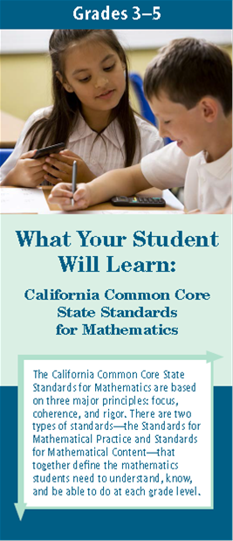
California educators have done an effective job of communicating the importance of the California Standards to our many audiences, creating an atmosphere of trust and paving the way for smooth transitions. As we continue to respond to requests from the field for additional resources, a series of ELA/ELD and mathematics brochures have been created to further help California’s educators communicate with parents, families, and community/business groups about the California Standards.
A few examples of the ways these brochures are being used in California districts and schools are:
- Featuring them on district/school websites
- Distributing samples using social media with references back to CDE websites for more information
- Making copies for classroom teachers for distribution and explanation at important school events like Back-to-School Night, Parent Teacher Conferences, and/or Open House
- Working with parent leadership groups such as the PTA, PTC, School Site Council (SSC), and English Language Advisory Council (ELAC) and asking for their support in further distribution/explanation
- Making copies available at local hubs where parents, families, and the entire community can easily access them
- Working with business/community leaders to distribute the brochures as a way to help explain the depth of the California Standards

Executive Summaries
https://www.scoe.net/divisions/ed_services/curriculum/castandards
Responding to feedback from educational leaders, the executive summaries provide an overview of each curriculum framework and provide valuable pathways for deeper study and implementation of the full documents. The ELA/ELD (http://www.scoe.net/castandards/Documents/summary_ela-eld_framework.pdf) and Mathematics (http://www.scoe.net/castandards/Documents/summary_math_framework.pdf) executive summaries are a response to this feedback and are recommended for distribution to stakeholders across your organization.
A few examples of ways these summaries are being used in California schools are:
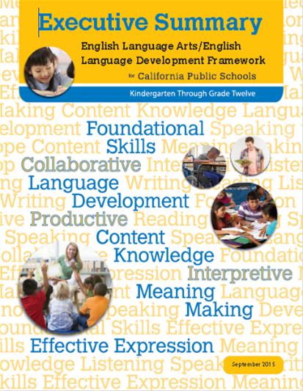
- School site administrators and teachers review and discuss the executive summaries together to establish a shared vision for instruction and learning – this review should be a jumping-off point for a deeper study of the Curriculum Frameworks
- In Professional Learning Communities, teachers study expectations for the grades or courses above and below their own. Collaboration, including vertical teaming, allows for ongoing conversations and planning regarding the scope and sequence of the California Standards
- Teachers read the “Additional Support” section (pages 28-33) in the Mathematics Executive Summary. Teams select a section they will read and report on from the full Mathematics Framework
- Teachers read the “Topic-Specific Guidance” section (pages 27-30) in the ELA/ELD Executive Summary and select chapters from the full ELA/ELD Framework for further group study and discussion
- Leadership teams consider the Executive Summaries and decide which sections would be most applicable for deeper study in the comprehensive Framework with all staff
- Staff uses as a jumping-off point for textbook adoption before digging into the full framework
Curriculum Frameworks
http://www.cde.ca.gov/ci/cr/cf/allfwks.asp
The curriculum frameworks provide guidance to educators as they look to deepen implementation of the California Standards. The standards call for a deeper depth of knowledge and understanding from students and educators alike, requiring instruction to be more sensitive to the needs of students. The frameworks provide new instructional strategies and approaches: supports to close the achievement gaps for our students with the greatest needs, use of technology/tools/instructional resources, course sequence possibilities, and inclusion of English learners into all classrooms.
The Curriculum Frameworks are being used across the state by teachers and other educators in a variety of ways—a few of these include:
- Developing a deeper understanding of the instructional shifts using the Circles of Implementation (explained in chapter 2 of the ELA/ELD Framework) and the Standards for Mathematical Practice (discussed in the overview of the Mathematics Framework)
- Examining the interrelationship between the ELA/literacy standards and the English language development standards (including both integrated and designated ELD instruction) and the essential elements of each set of standards as outlined in chapter 1 of the ELA/ELD Framework
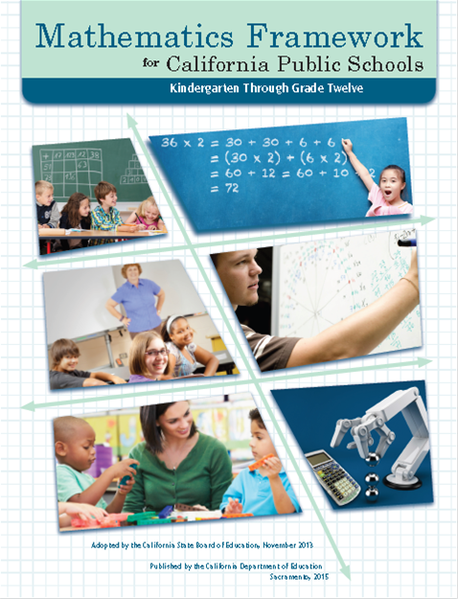
- Utilizing the vignettes and snapshots in the grade-level chapters of the ELA/ELD Framework and the example problems in the grade-level and course-level chapters of the Mathematics Framework to support professional learning about the California standards
- Comparing and contrasting lessons/examples from the curriculum frameworks with teachers’ own. How does the rigor of the teaching/learning match up?
- Supporting literacy across content areas and interdisciplinary instruction by focusing on the relationships and convergences of mathematics, science, and English language arts practices illustrated on page 62 of the ELA/ELD Framework
- Ensuring the necessary supports are in place for all students to succeed by employing the guidance in chapter 9, Access and Equity in the ELA/ELD Framework and the Universal Access chapter in the Mathematics Framework
- Utilizing the chapters on instructional materials in both frameworks to guide local adoptions of standards-aligned instructional resources for students in kindergarten through grade twelve

Opportunities for use of the Brochures, Executive Summaries, and Curriculum Frameworks extend well beyond these ideas and should be tailored to the needs of each organization. The end-goal for the Curriculum Frameworks and associated resources is to assist educators to make greater meaning of the California Standards and facilitate their effective implementation in classrooms to improve student success. Day-to-day curriculum support can be found in the SBE-adopted programs for mathematics (http://www.cde.ca.gov/ci/ma/im/sbeadopted2014mathprgms.asp) and ELA/ELD (http://www.cde.ca.gov/ci/rl/im/sbeadoptedelaeldprogs.asp). We are confident your teachers, administrators, and other stakeholders will find all of these resources useful.

California Department of Education
April 21, 2016

