This document is part of the larger Mathematics Framework Communication Toolkit. For more resources, visit the [Mathematics Framework web page](https://www.cde.ca.gov/ci/ma/cf/).

# Mathematics Framework Social Media Post for LEAs #3

## Instructions for LEAs

* Save the embedded image (right click, save as picture) and add your school or district logo to the white banner at the bottom before posting.
* Edit the post to include your local information.
* Use alt text for the image when posting.

## Post Content

The ***[insert school, district, charter, or county name]*** is excited to see the new *Mathematics Framework for California Public Schools, Kindergarten through Grade Twelve* (*Mathematics Framework*) in action in our ***[school/district/charter school/county]!***

The *Mathematics Framework* organizes instruction at each grade level into Big Ideas. This allows our teachers to guide students in connecting mathematical concepts within and across grade levels.

The *Mathematics Framework’s* instructional approach connects learning to the “real world” through authentic examples and use of data, which will help prepare our students for an increasingly data-driven world.

#MathFramework #CaliforniaEducation #TeachingMath #MathTeachers #StudentSuccess #NewRelease #MathEducation #TeachingStrategies #Educators

### Alt Text for Images When Posting

The new Mathematics Framework for California Public Schools, Kindergarten through Grade Twelve connects learning to the real world. This will help prepare our students for an increasingly data-driven world.

## Rectangle Image

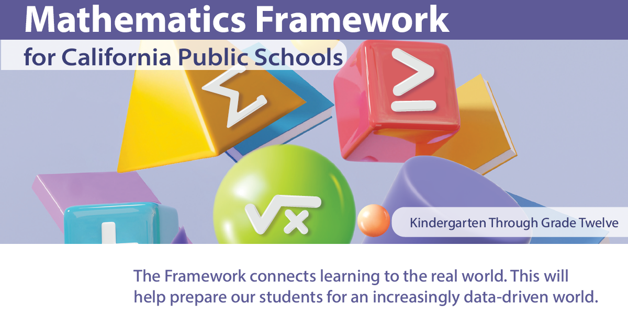

## Square Image

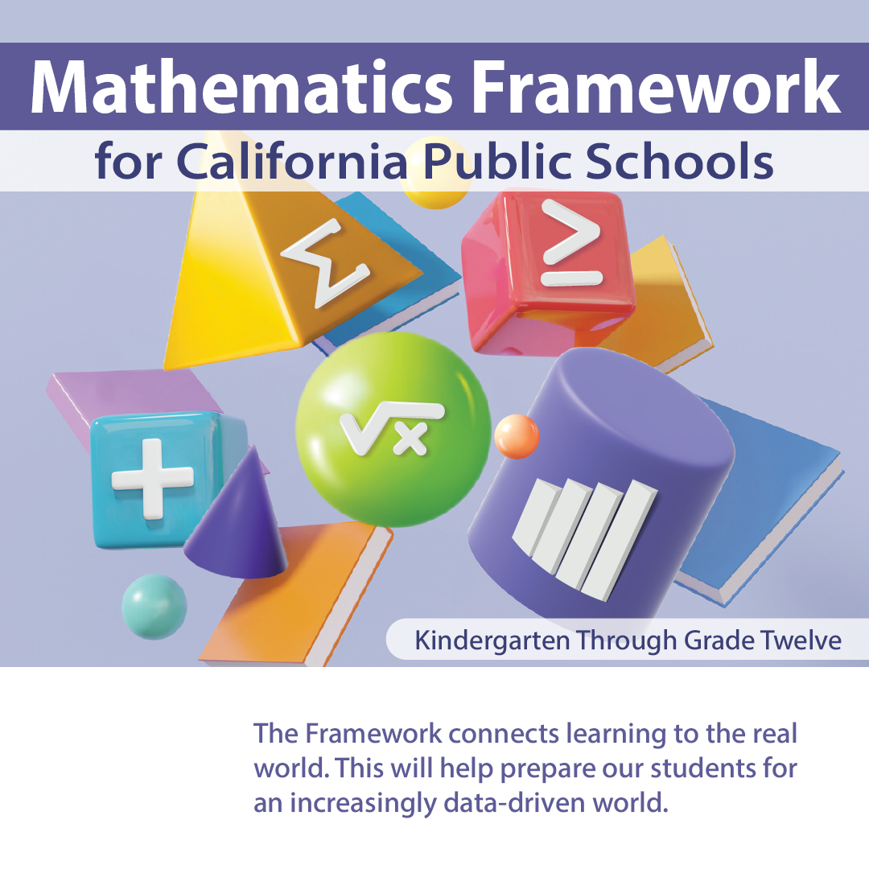

California Department of Education, August 2025