CALIFORNIA DEPARTMENT OF EDUCATION
Updated December 2011
Curriculum Framework Development Process
This chart shows the major steps of the curriculum framework development process.

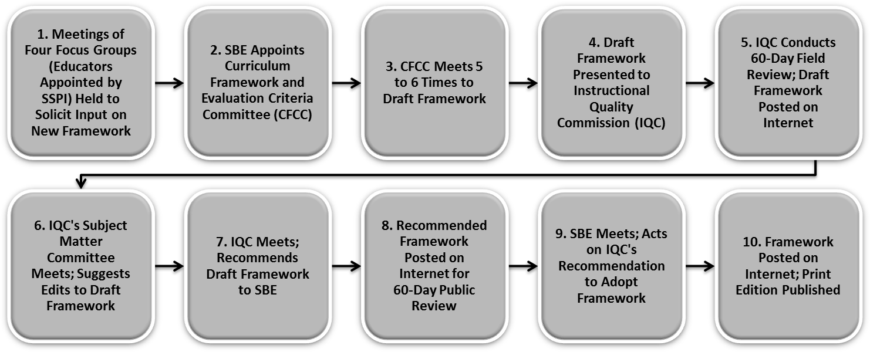
All meetings are open to the public.

