Mathematics Framework
Adopted by the State Board of Education on July 12, 2023
Page 1 of 63

Mathematics Framework
Chapter 12: Mathematics Assessment in the 21st Century

Mathematics Framework Chapter 12: Mathematics Assessment in the 21st Century 1
Introduction 2
Broadening Assessment Practices 3
Two Types of Assessment: Formative and Summative 9
Formative Assessment 16
Formative Assessment Lessons 17
Rubrics 19
Re-engagement Lessons 31
Teacher Diagnostic Comments 32
Self- and Peer Assessment 35
Mastery-Based Approaches to Assessment 38
Effective Assessment Strategies for English Learners 47
Summative Assessment 49
Retaking Assignments and Tests 51
Portfolios 53
The Smarter Balanced Assessment System and the CAASPP 56
Interim Assessments 59
Conclusion 60
Long Descriptions for Chapter 12 60

Introduction
In California, as nationwide, mathematics assessment is in transition, shifting from rote tests of fact-based skills to multidimensional measures of procedural skills, problem-solving capacity, and evidence-based reasoning. The shift reflects a growing alignment between how mathematics is being taught and how it is being tested—in turn reflecting shifting classroom, school, district, and state priorities. This chapter discusses California’s evolving comprehensive assessment system, describing in detail the system’s two primary forms of math assessments—formative and summative—and how they relate to math instruction and learning. It encourages educators, administrators, and policymakers to focus on assessment that engages students in continuous improvement efforts by using mastery-based approaches—notably, by assessing with rubrics and using self, peer, and teacher feedback. Such an approach reflects the important goal of achieving conceptual understanding, problem-solving capacity, and procedural fluency. It also promises to maximize the amount of learning each child is capable of while minimizing the sociocultural effects of narrow testing.

Broadening Assessment Practices
Assessment is a critical step in the teaching and learning process for students, teachers, administrators, and parents. It is a “systematic collection and analysis of information to improve student learning” (Stassen et al., 2001, 5). As increasingly modern assessments continue to replace traditional tests, all educational assessment should share a common purpose: collecting evidence to enhance student learning and to support students’ development of positive mathematics identities (Aguirre, Mayfield-Ingram, and Martin, 2013). As mentioned in chapter 2, mathematical identities are connected to student culture, language, and experiences.
Important mathematics learning often can be demonstrated through many forms of communication, such as speaking, drawing, writing, and model building, integrating mathematical content and practices. Practices should include appropriate assessment design elements for a variety of learners, including English learners and students in multilingual programs. (For more information, see the section “Effective Assessment Strategies for English Learners,” below.) It has long been the practice in mathematics classrooms to assess students’ mathematics achievement through narrow tests of procedural knowledge. The California Assessment of Student Performance and Progress (CAASPP) has instead been designed to assess students in responsive and multifaceted ways, capturing their reasoning and problem solving. Reflecting this shift in approach, many colleges, including all University of California campuses, have now eliminated SAT or ACT scores from the admissions process.
Measurements of learning that are most helpful are those that assess students’ breadth of knowledge and understanding of mathematical content and practices and that require students to reason and solve problems. Recommendations for equitable teaching and assessing, with clear links between the pursuit of equity and the ways teachers assess students, can be found in Feldman (2019) and DeSilva (2020). This chapter sets out an approach that includes the principle that assessment design elements should be inclusive of considerations for all students, including culturally and linguistically diverse learners and students in multilingual programs.
A particularly damaging assessment practice to avoid is the use of timed tests to assess speed of mathematical fact retention, as such tests have been found to prompt mathematics anxiety (Engle, 2002). When anxious, the working memory—the part of the brain needed for reproducing mathematics facts—is compromised (Beilock, 2011). Math anxiety has been recorded in students as young as five years old (Ramirez et al., 2013), and work by Engle, Beilock, and others suggests that the still-common practice of timed mathematics tests may be a contributing factor to this distressing, sometimes life-long condition. Perhaps for this reason, other researchers have found that students who were more frequently exposed to timed testing demonstrated slower progress toward automaticity with their facts than their counterparts who were not tested in this way (Henry and Brown, 2008). Alternative activities can be used that develop mathematics fact fluency through engaging, conceptual visual activities instead of anxiety-producing speed tests. Inflexible, narrow methods of assessing mathematical competence also disadvantage students with learning differences. The framework of Universal Design for Learning (UDL) explicitly calls for multidimensional assessment practices (Meyer et al., 2014). In mathematics, assessments should be flexible, allowing for multiple means of expression, such as talking, writing words, drawing, using manipulatives, or typing responses. They should also provide actionable feedback to students (Lambert, 2020). Moreover, they should assess an integrated approach of mathematical content and practices. For multilingual learners, teachers can intentionally plan for multiple means of expression based on language proficiency levels and allow opportunities for students to show their understanding in their own language. The Smarter Balanced CAASPP assessment is available in Spanish in a “stacked version” showing the questions in both languages (CDE, n.d.).
Chapters 6, 7, and 8 set out an approach to mathematics teaching through big ideas that integrates mathematical content and practices. These chapters contain many ideas for tasks that focus on big ideas throughout the grades, from transitional kindergarten through grade twelve. Assessments should match the focus on Big Ideas, with students receiving opportunities to share conceptual thinking, reasoning, and with student work assessed with rubrics as set out in this chapter.
Figure 12.1 shows the Big Ideas for grade three followed by a rubric that focuses on the Big Ideas and mathematical practices. (See also appendix A for Big Ideas for transitional kindergarten through grade ten.)
Figure 12.1 Big Idea Network Map for Grade Three
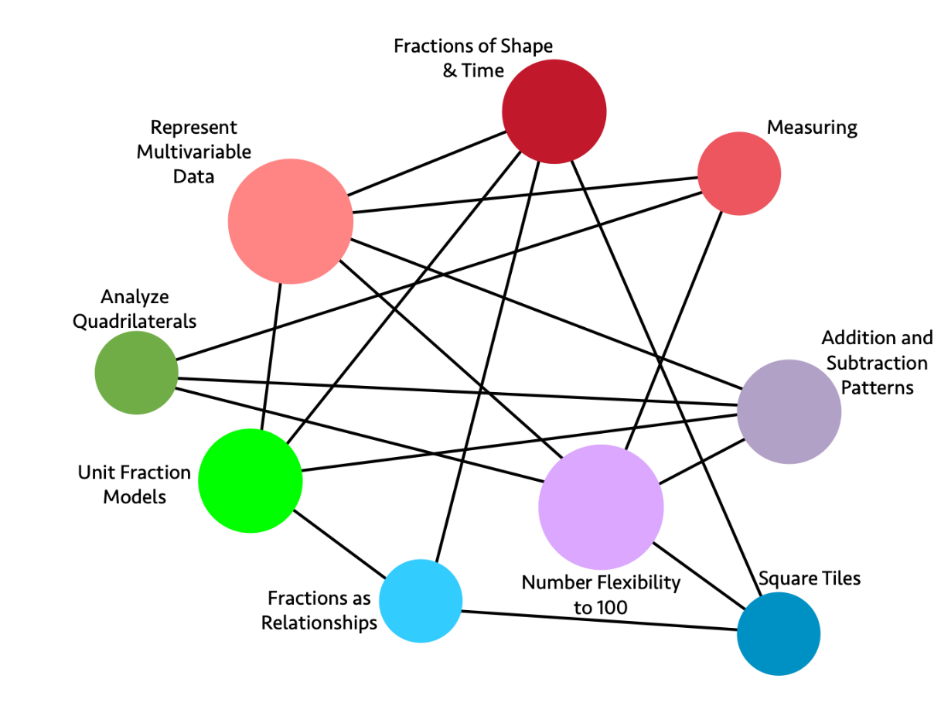
Long description for figure 12.1
Sample Rubric for Grade Three: Assessing Big Ideas and Mathematical Practices
The rubric below gives an overview of the Big Ideas for grade three. It connects the Drivers of Investigation (DIs) to both the Big Ideas and the standards for mathematical practice (SMPs). Periodically and throughout the school year, teachers can use a rubric like this to assess and give feedback to students around their strengths and areas for growth. The teacher notes those indicators for which the student has shown understanding and those indicators the student should focus on to further student learning. The final two columns are meant to be filled in by the teacher.
Considerations for the final two columns to be completed by the teacher (TBT):
- Student Strength: What does the student understand in terms of this standard? What linguistic and cultural assets possessed by the students can I tap into to support all students, including those on the road to English proficiency, in their mastery of the content?
- Student Area for Growth: What should the student focus on to strengthen their understanding of this standard?
Content Connections | Big ideas | Mathematical  Practice Standards | Indicators: The student... | Student Strength | Student area for Growth
Reasoning with Data | Represent Multivariate Data | SMP.1: Make sense of problems and persevere in solving them.  SMP.4: Model with mathematics.  SMP.6: Attend to precision. | -Interprets appropriate meaning from graphs  -Strategically organizes multivariable data  -Creates graphs that clearly communicate information from data | TBT | TBT
Reasoning with Data | Fractions of Shape and Time | SMP.4: Model with mathematics.  SMP.5: Use appropriate tools strategically.  SMP.6: Attend to precision. | -Creates data visualizations that clearly capture and communicate about data collected over time | TBT | TBT
Exploring Changing Quantities | Patterns in Four Operations | SMP.3: Construct viable arguments and critique the reasoning of others.  SMP.5: Use appropriate tools strategically.  SMP.7: Look for and make use of structure. | -Computes sums and differences within 1000  -Justifies solutions using appropriate tools or models  -Constructs arguments with clear reasoning to support solutions | TBT | TBT
Exploring Changing Quantities | Number Flexibility to 100 for All Four Operations | SMP.3: Construct viable arguments and critique the reasoning of others.  SMP.4: Model with mathematics.  SMP.5: Use appropriate tools strategically. | -Computes products and quotients within 100  -Justifies solutions using appropriate tools or models  -Constructs arguments with clear reasoning to support solutions | TBT | TBT
Taking Wholes Apart, Putting Parts Together | Square Tiles | SMP.2: Reason abstractly and quantitatively.  SMP.5: Use appropriate tools strategically. | -Measures area using square tiles as tools  -Connects the area of individual square tiles to area of entire shape’s area using fractions | TBT | TBT
Taking Wholes Apart, Putting Parts Together | Fractions of Shape and Time | SMP.2: Reason abstractly and quantitatively.  SMP.4: Model with mathematics.  SMP.7: Look for and make use of structure. | -Collects and organizes multivariable data in relationship to time  -Creates connections that highlight the relationship between measures of time including minutes, quarter, and half hours | TBT | TBT
Taking Wholes Apart, Putting Parts Together | Fractions as Relationships | SMP.2: Reason abstractly and quantitatively.  SMP.7: Look for and make use of structure. | -Interprets the relationship between the numerator and denominator of fractions, especially in context  -Recognizes and connects equivalent fractions to one another | TBT | TBT
Taking Wholes Apart, Putting Parts Together | Unit Fraction Models | SMP.3: Construct viable arguments and critique the reasoning of others.  SMP.4: Model with mathematics. | -Uses visual models to compare unit fractions  -Justifies arguments about unit fractions using visual models | TBT | TBT
Discovering Shape and Space | Analyze Quadrilaterals | SMP.2: Reason abstractly and quantitatively.  SMP.4: Model with mathematics. | -Compares quadrilaterals based on various features  -Investigates how area and perimeter change when side lengths change  -Solves real world problems involving area and perimeter of quadrilaterals through modeling | TBT | TBT
Discovering Shape and Space | Fractions as Relationships | SMP.2: Reason abstractly and quantitatively.  SMP.4: Model with mathematics. | -Creates visual representations that model fractions  -Justifies how a model represents a fractional quantity by relating the numerator, denominator, and visual | TBT | TBT
Discovering Shape and Space | Unit Fraction Models | SMP3: Construct viable arguments and critique the reasoning of others.  SMP4: Model with mathematics. | -Uses visual models to compare unit fractions by attending to differences in scale  -Justifies arguments about unit fractions using visual models | TBT | TBT
Source: California Department of Education (CDE), 2021, 158–160.

Two Types of Assessment: Formative and Summative
There are two general types of assessment, formative and summative.
Formative assessment, commonly referred to as assessment for learning, has the goal of providing in-process information to teachers and students with regard to learning. The following definition of formative assessment comes from the English Language Arts/English Language Development Framework (ELA/ELD Framework, CDE, 2014):
Formative assessment is a process teachers and students use during instruction that provides feedback to adjust ongoing teaching moves and learning tactics. It is not a tool or an event, nor a bank of test items or performance tasks. Well‐supported by research evidence, it improves students’ learning in time to achieve intended instructional outcomes.
The ELA/ELD Framework includes important considerations for English learners and all students in multilingual programs. (For more on supporting English learners, see the section “Effective Assessment Strategies for English Learners,” below.) Key features include:
- Clear lesson-learning goals and success criteria, so students understand what they’re aiming for.
- Evidence of learning gathered during lessons to determine where students are relative to goals.
- A pedagogical response to evidence, including descriptive feedback that supports learning by helping students answer: Where am I going? Where am I now? What are my next steps?
- Peer and self‐assessment to strengthen students’ learning, efficacy, confidence, and autonomy.
- A collaborative classroom culture where students and teachers are partners in learning.
From Linquanti (2014, 2).
Ongoing research and evidence on formative assessment illustrates how it improves students’ learning in time to achieve intended instructional outcomes (CDE, 2014). The CAASPP system encompasses both formative and summative assessment resources and reflects the work of the Smarter Balanced Assessment Consortium, which further defines formative assessment in the context of the system (Regents of the University of California, 2021).
Summative assessment, commonly referred to as assessment of learning, has the goal of collecting information on a student’s achievement after learning has occurred. Summative assessment measures include classroom, interim, or benchmark assessments and large-scale summative measures, such as the CAASPP or SAT.
Summative assessments help determine whether students have attained a certain level of competency after a more or less extended period of instruction and learning, such as the end of a unit (which may last several weeks), the end of a quarter, or annually (National Research Council [NRC], 2001).
Regardless of the type or purpose of an assessment, teachers should keep in mind that the UDL principles call for students to be provided multiple means of action and expression. This could be as simple as allowing students the option to talk through their solution by pointing and verbalizing (instead of requiring writing), or using arrows and circles to highlight particular pieces of evidence in their solution rather than repeating statements in their explanation. Providing a variety of ways for students to showcase what they can do and what they know is especially important in mathematics assessments, and particularly important for English learners and for students who are traditionally marginalized. Aligning assessment with one or more UDL principles can better inform the teacher of what students are learning. Multiple means of representation, whether used to inform formative assessment of daily progress or as a summative display of enduring mathematical understanding, can create a complex and diverse mosaic of student achievement.
An underlying question for teachers as they design, implement, and adapt assessments to be effective for all students is: How can students demonstrate what they know in a variety of ways? Increased use of distance learning during the pandemic has prompted a shift in assessment practices, which has distinct benefits for students being able to show their understanding in alternative ways. For example, students can video-record their thinking related to a task or they can post answers in a live chat or anonymous poll. By considering and planning for the variety of ways in which students can demonstrate their skills and knowledge, teachers can better gain information on what students succeed in doing and where their challenges are.
The main differences between formative and summative assessment are outlined in Figure 12.2, which comes from the ELA/ELD Framework.
Figure 12.2 Key Dimensions of Assessment for Learning and Assessment of Learning: A Process of Reasoning from Evidence to Inform Teaching and Learning
Dimension | Assessment for learning | Assessment of learning 1 | Assessment of learning 2
Method | Formative Assessment Process | Classroom Summative/ Interim/Benchmark  Assessment* | Large-Scale Summative Assessment
Main Purpose | Assist immediate learning (in the moment) | Measure student achievement or progress (may also inform future teaching and learning) | Evaluate educational programs and measure multiyear progress
Focus | Teaching and learning | Measurement | Accountability
Locus | Individual student and classroom learning | Grade level/ department/school | School/district/state
Priority for Instruction | High | Medium | Low
Proximity to learning | In-the-midst | Middle-distance | Distant
Timing | During immediate instruction or sequence of lessons | After teaching-learning cycle → between units/periodic | End of year/course
Participants | Teacher and Student (T-S / S-S / Self) | Student (may later include T-S in conference) | Student
Adapted from Linquanti (2014).
*Assessment of learning may also be used for formative purposes if assessment evidence is used to shape future instruction. Such assessments include weekly quizzes; curriculum embedded within-unit tasks (e.g., oral presentations, writing projects, portfolios) or end-of-unit/culminating tasks; monthly writing samples; reading assessments (e.g., oral reading observation, periodic foundational skills assessments); and student reflections/self-assessments (e.g., rubric self-rating).
Source: CDE, 2014, Chapter 8.
The different purposes of assessment cycles are set out in figure 12.3, from the ELA/ELD Framework.
Figure 12.3 Different Purposes of Assessment Cycles
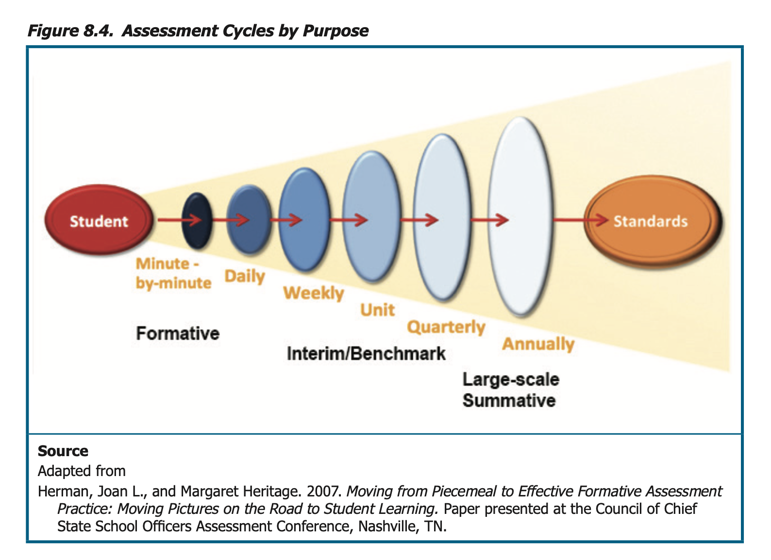
Long description of figure 12.3
These purposes are further exemplified in figures 12.4 through 12.6.
Figure 12.4 Short-Cycle Formative Assessment Table from the ELA/ELD Framework
Short Cycle | Methods | Information | Uses/Actions
Minute-by-minute | - Observation  - Questions (teachers and students)  - Instructional tasks  - Student discussions  - Written work/representations | - Students’ current learning status, relative difficulties and misunderstandings, emerging or partially formed ideas, full understanding | - Keep going, stop and find out more, provide oral feedback to individuals, adjust instructional moves in relation to student learning status (e.g., act on “teachable moments”)
Daily Lesson | Planned and placed strategically in the lesson:  - Observation  - Questions (teachers and students)  - Instructional tasks  - Student discussions  - Written work/representations  - Student self-reflection (e.g., quick write) | - Students’ current learning status, relative difficulties and misunderstandings, emerging or partially formed ideas, full understanding | - Continue with planned instruction  - Instructional adjustments in this or the next lesson  - Find out more  - Feedback to class or individual students (oral or written)
Week | - Student discussions and work products  - Student self-reflection (e.g., journaling) | - Students’ current learning status relative to lesson learning goals (e.g., have students met the goals/are they nearly there?) | - Instructional planning for start of new week  - Feedback to students (oral or written)
Figure 12.5 Medium-Cycle Assessment Table from the ELA/ELD Framework
Medium Cycle | Methods | Information | Uses/Actions
End-of-Unit/ Project | - Student work artifacts (e.g., portfolio, writing project, oral presentation)  - Use of rubrics  - Student self-reflection (e.g., short survey)  - Other classroom summative assessments designed by teacher(s) | - Status of student learning relative to unit learning goals | - Grading  - Reporting  - Teacher reflection on effectiveness of planning and instruction  - Teacher grade level/departmental discussions of student work
Quarterly/  Interim/ Benchmark | - Portfolio  - Oral reading observation  - Test | - Status of achievement of intermediate goals toward meeting standards (results aggregated and disaggregated) | - Making within-year instructional decisions  - Monitoring, reporting; grading; same-year adjustments to curriculum programs  - Teacher reflection on effectiveness of planning and instruction  - Readjusting professional learning priorities and resource decisions
Figure 12.6 Long-Cycle Assessment Table from the ELA/ELD Framework
Long Cycle | Methods | Information | Uses/Actions
Annual | - Smarter Balanced Summative Assessment  - English Learner Proficiency Assessment for California (ELPAC)  - Portfolio  - District-/school- created test | Status of student achievement with respect to standards (results aggregated and disaggregated) | - Judging students’ overall learning  - Gauging student, school, district, and state year-to-year progress  - Monitoring, reporting, and accountability  - Classification and placement (e.g., English learners)  - Certification  - Adjustments to following year’s instruction, curriculum, programs  - Final grades  - Professional learning prioritization and resource decisions  - Teacher reflection (individual/grade level/department) on overall effectiveness of planning and instruction
Source: CDE, 2014, Chapter 8.
Note: The California English Language Development Test (CELDT) was replaced by the ELPAC on July 1, 2018.

Formative Assessment
Formative assessment is the collection of evidence to provide day-to-day feedback to students and teachers so that teachers can adapt their instruction and students become self-aware learners who take responsibility for their learning. Formative assessment is typically classroom based and in sync with instruction, such as analyzing classroom conversations or doing over-the-shoulder observations of students’ diagrams, work, questions, and conversations.
A central goal of formative assessment is encouragement of students to take responsibility for their learning. When teachers communicate to students where they are now, where they need to be, and ways to close the gap between the two places, they provide valuable information to students that enhances their learning. Figure 12.7, taken from Principles to Actions (NCTM, 2014, 56), provides helpful insight into specific teacher and student actions in a formative assessment setting.
Figure 12.7 Elicit and Use Evidence of Student Thinking: Teacher and Student Actions
What are teachers doing? | What are students doing?
- Identifying what counts as evidence of student progress toward mathematics learning goals  - Eliciting and gathering evidence of student understanding at strategic points during instruction  - Interpreting student thinking to assess mathematical understanding, reasoning, and methods  - Making in-the-moment decisions on how to respond to students with questions and prompts that probe, scaffold, and extend  - Reflecting on evidence of student learning to inform the planning of next instructional steps | - Revealing their mathematical understanding, reasoning, and methods in written work and classroom discourse  - Reflecting on mistakes and misconceptions to improve their mathematical understanding  - Asking questions of their peers, responding to questions from their peers, and giving suggestions to support the learning of their classmates  - Assessing and monitoring their own progress toward mathematics learning goals and identifying areas in which they need to improve

Formative Assessment Lessons
One of the strengths of formative assessment is the flexibility that it affords a classroom teacher, both in timing and approach. Indeed, one can argue that there are myriad possibilities for teachers to conduct formative assessment throughout a lesson, such as monitoring the types of questions students ask, the responses students share to questions, and the quality of content in peer conversations. And—though much of this may be unplanned—when formative assessment is intentionally included in a daily lesson plan, the data and analysis are even more effective.
Formative assessment involves teachers noticing and making sense of student thinking (Carpenter et al., 2014; Fernandes, Crespo, and Civil, 2017). The NCTM Principles to Actions state that “[e]ffective teaching of mathematics uses evidence of student thinking to assess progress toward mathematical understanding and to adjust instruction continually in ways that support and extend learning” (NCTM, 2014). Complex Instruction is a pedagogical approach that provides an example of the ways student discussions can provide teachers with formative assessment. Complex Instruction centers upon three principles for creating equity in heterogeneous classrooms through groupwork (Cohen and Lotan, 2014):
- Students developing responsibility for each other. This includes serving as academic and linguistic resources for one another (Cabana, Shreve, and Woodbury, 2014).
- Students working together to complete tasks (Cohen and Lotan, 2014). To realize this principle, teachers must manage equal participation in groups by valuing and highlighting a wide range of abilities and attending to issues of status among students (Cohen and Lotan, 2014; Tsu, Lotan, and Cossey, 2014). During groupwork, the teacher looks for opportunities to elevate students by highlighting their abilities and contributions to the group, which is referred to as “assigning competence” (Boaler and Staples, 2014). This principle recognizes the fact that group interactions often create status differences between students—and when teachers perceive that a student has become “low status” in a group, they intervene by publicly praising a mathematical contribution the student has made.
- Implementation of multidimensional, group-worthy tasks, which are challenging, open-ended, and require a range of ways of working. This principle underlies the other two (Banks, 2014; Cohen and Lotan, 1997; LaMar, Leshin, and Boaler, 2020). As teachers work to manage heterogeneous groupwork and assign competence, they will encounter opportunities to listen to student thinking and to assess formatively. Teachers are encouraged to plan for student groupings or pairings with language proficiencies in mind. Groupings should be flexible and purposeful and should not be formed exclusively by proficiency levels, as this can create in-class tracking. English learners need opportunities to interact with peers who are native speakers of English and to be provided access to language models and authentic opportunities to use their developing language skills.
In the vignette, A Teacher Tries a New Assessment Approach a veteran teacher of diverse groups of students reads about assessment for learning and decides to use his summative assessments formatively by incorporating them into his teaching.

Rubrics
Although rubrics are often used by teachers as a tool to evaluate summative work and identify more reliable scores when grading student work, rubrics lend themselves to the formative assessment process because they can provide students with a clear set of expectations to achieve as they learn, and ultimately serve as success criteria for summative assessments. Rubrics help students, parents, and teachers identify what high-quality work is. Students can judge their own work and accept more responsibility for the final product. Parents have a clear understanding of what is expected for tasks, which helps them understand what it takes to meet or exceed a standard and what further learning needs to take place.
A rubric can provide parameters for the mathematics that students are learning and can enable them to develop self-awareness and reflect on their own progress. It is not uncommon for students to carefully answer questions in lessons but experience difficulty when connecting their learning to the broader mathematical landscape. Using a rubric enables students to assess their own learning as well as that of their peers; it also allows the teacher to provide comments to guide students in making important connections to other areas of their mathematical knowledge. In creating rubrics, teachers should be mindful of the variety of ways in which students can demonstrate their knowledge. Rubrics that are outcomes-based, as opposed to skill-specific, can provide multiple modes of engagement for students during instruction and encourage teachers to develop multiple options for students to showcase their skills and knowledge. For example, teachers can provide colored tape so students can make tape diagrams rather than drawing each section of tape and shading. Or teachers can use a camera to take a sequence of images to document students’ work while using manipulatives, such as integer chips, to solve a problem, thus sparing students from otherwise rote activities like copying and drawing. When utilizing rubrics, it is important to provide English learners with scaffolds and strategies to ensure that all students understand and can interact with the rubric.
As seen in the rubric examples provided below, the criteria can focus on the mathematical practices, mathematical content, or both. The following two rubrics, created at the Stanford Center for Assessment Learning and Equity (SCALE), communicate the mathematical practices in a form that students can use to monitor their own progress and learning (Dieckmann and Kokka, 2016).
Figure 12.8 Rubric for Student Self-Monitoring of Progress and Learning
Practice | Not Yet | Approaches | Achieves | Masters
Make sense of problems and persevere in solving them | - I need assistance from my teacher to understand what the problem or question asks me to do.  - I am unsure how to connect this problem or question to what I already know.  - I am still working to organize the information in this problem or question. | - I have a partial understanding of what a problem or question asks me to do. I am working on this to make the connection stronger.  - I show partial connection between this question and what I already know. I am working on this to make the connection stronger.  - I organized some of the information in this question or problem but missed some important information. | - I explain questions and problems in my own words.  - I relate questions and problems to similar things I have seen before.  - I organize given information before attempting to solve. I check to make sure that my final solution makes sense and is reasonable. | - Achieves, and also: My work includes a reflection of how I monitored myself while I was working and adjusted my plan when necessary.
Reason abstractly and quantitatively | - I am still working to translate between my math work (symbols, calculations) and real-world situations. I currently do this with the assistance of my teacher. | - I show and explain what some of my math work (symbols, calculations) means in real-life contexts. | - I show and explain what all or most of my math work (symbols, calculations) means in real-life contexts.  - I pay attention to the meaning of quantities, not just how to compute them. | - Achieves, and also: I describe my solution and any limitations in terms of the real-world context described within the problem.
The following is a sample math performance assessment rubric for teacher use, grades nine through twelve:
Math Performance Assessment Rubric (Grades Nine through Twelve)
Assessing: The ability to reason, solve problems, develop sound arguments or decisions, and create new ideas by using appropriate sources and applying the knowledge and skills of a discipline.
Criteria: Problem Solving
What is the evidence that the student understands the problem and the mathematical strategies that can be used to arrive at a solution?
Measurement: Emerging
- Does not provide a model
- Ignores given constraints
- Uses few, if any, problem-solving strategies
Measurement: Developing
- Creates a limited model to simplify a complicated situation
- Attends to some of the given constraints
- Uses inappropriate or inefficient problem-solving strategies
Measurement: Proficient
- Creates a model to simplify a complicated situation
- Analyzes all given constraints, goals, and definitions
- Uses appropriate problem-solving strategies
Measurement: Advanced
- Creates a model to simplify a complicated situation and identifies limitations of the model
- Analyzes all given constraints, goals, and definitions and implied assumptions
- Uses novel problem-solving strategies and/or strategic use of tools
Criteria: Reasoning and Proof
What is the evidence that the student can apply mathematical reasoning/procedures in an accurate and complete manner?
Measurement: Emerging
- Provides incorrect solutions without justifications
- Results are not interpreted in terms of context
Measurement: Developing
- Provides partially correct solutions or correct solutions without logic or justification
- Results are interpreted partially or incorrectly in terms of context
Measurement: Proficient
- Constructs a logical, correct, complete solution
- Results are interpreted correctly in terms of context
Measurement: Advanced
- Constructs a logical, correct, complete solution with justifications
- Interprets results correctly in terms of context, indicating the domain to which a solution applies
- Monitors for reasonableness, identifies sources of error, and adapts approximately
Criteria: Connections
What is the evidence that the student understands the relationships between the concepts, procedures, and/or real-world applications inherent in the problem?
Measurement: Emerging
- Little or no evidence of applying previous math knowledge to the given problem
Measurement: Developing
- Applies previous math knowledge to the given problem but may include reasoning or procedural errors
Measurement: Proficient
- Applies and extends previous math knowledge correctly to the given problem
Measurement: Advanced
- Applies and extends previous math knowledge correctly to the given problem and makes appropriate use of derived results
- Identifies and generalizes the underlying structures of the given problem to other seemingly unrelated problems or applications
Criteria: Communication and Representation
What is the evidence that the student can communicate mathematical ideas to others?
Measurement: Emerging
- Uses representations (diagrams, tables, graphs, formulas) in ways that confuse the audience
- Uses incorrect definitions or inaccurate representations
Measurement: Developing
- Uses correct representations (diagrams, tables, graphs, formulas) but does not help the audience follow the chain of reasoning; extraneous representations may be included
- Uses imprecise definitions or incomplete representations with missing units of measure or labeled axes
Measurement: Proficient
- Uses multiple representations (diagrams, tables, graphs, formulas) to help the audience follow the chain of reasoning
- With few exceptions, uses precise definitions and accurate representations, including units of measure and labeled axes
Measurement: Advanced
- Uses multiple representations (diagrams, tables, graphs, formulas) and key explanations to enhance the audience’s understanding of the solution; only relevant representations are included
- Uses precise definitions and accurate representations including units of measure and labeled axes; uses formal notation
(SCALE et al., 2013).
Jill Gough and Jennifer Wilson (2014) offer another mathematical practice rubric that communicates outcomes in language written for students. An example of SMP.1 is shown in figure 12.9.
Figure 12.9 Sample Mathematical Practice Rubric for SMP.1
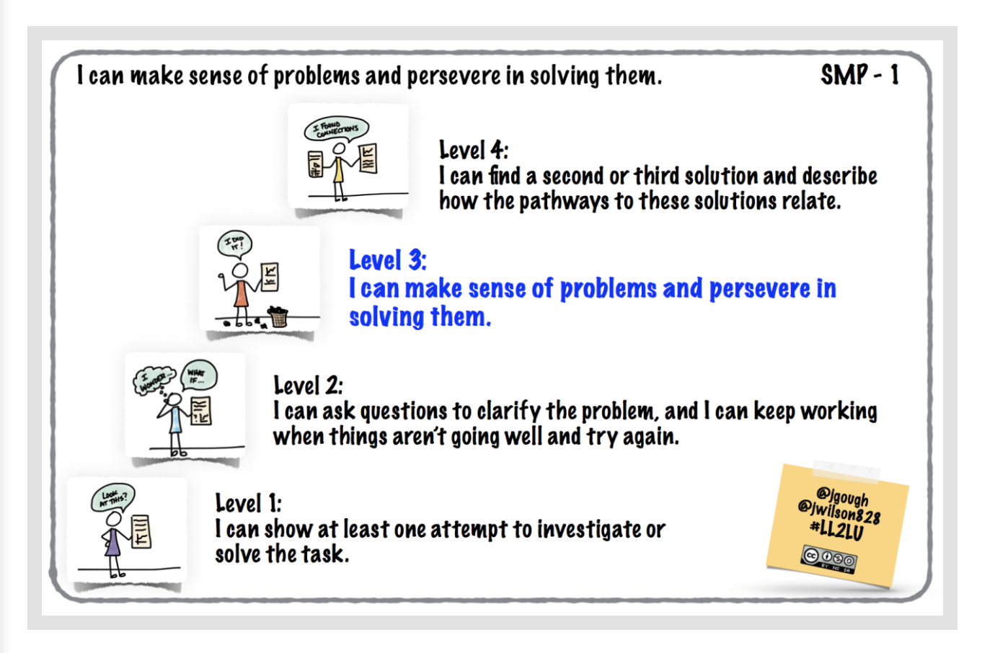Long description of figure 12.9
Source: Gough and Wilson, 2014.
The following rubric from the 2013 Mathematics Framework provides criteria based on a Smarter Balanced sample performance task and scoring rubric.
Performance Task
Part A
Ana is saving to buy a bicycle that costs $135. She has saved $98 and wants to know how much more money she needs to buy the bicycle.
The equation 135 = x + 98 models this situation, where x represents the additional amount of money Ana needs to buy the bicycle.
- When substituting for x, which value(s), if any, from the set {0, 37, 08, 135, 233} will make the equation true?
- Explain what this means in terms of the amount of money needed and the cost of the bicycle.
Part B
Ana considered buying the $135 bicycle, but then she decided to shop for a different bicycle. She knows the other bicycle she likes will cost more than $150.
This situation can be modeled by the following inequality: x + 98 > 150
- Which values, if any, from –250 to 250 will make the inequality true? If more than one value makes the inequality true, identify the least and greatest values that make the inequality true.
- Explain what this means in terms of the amount of money needed and the cost of the bicycle.
Sample Top-Score Response
Part A
- The only value in the given set that makes the equation true is 37. This means that Ana will need exactly $37 more to buy the bicycle.
Part B
- The values from 53 to 250 will make the inequality true. This means that Ana will need from $53 to $250 to buy the bicycle.
Scoring Rubric
Responses to this item will receive 0–3 points, based on the following descriptions:
3 points: The student shows a thorough understanding of equations and inequalities in a contextual scenario, as well as a thorough understanding of substituting values into equations and inequalities to verify whether they satisfy the equation or inequality. The student offers a correct interpretation of the equality and the inequality in the correct context of the problem. The student correctly states that 37 will satisfy the equation and that the values from 53 to 250 will satisfy the inequality.
2 points: The student shows a thorough understanding of substituting values into equations and inequalities to verify whether they satisfy the equation or inequality but limited understanding of equations or inequalities in a contextual scenario. The student correctly states that 37 will satisfy the equation and that the values from 53 to 250 will satisfy the inequality, but the student offers an incorrect interpretation of the equality or the inequality in the context of the problem.
1 point: The student shows a limited understanding of substituting values into equations and inequalities to verify whether they satisfy the equation or inequality and demonstrates a limited understanding of equations and inequalities in a contextual scenario. The student correctly states that 37 will satisfy the equation, does not state that the values from 53 to 250 will satisfy the inequality, and offers incorrect interpretations of the equality and the inequality in the context of the problem. OR The student correctly states that the values from 53 to 250 will satisfy the inequality, does not state that 37 satisfies the equation, and offers incorrect interpretations of the equality and the inequality in the context of the problem.
0 points: The student shows little or no understanding of equations and inequalities in a contextual scenario and little or no understanding of substituting values into equations and inequalities to verify whether they satisfy the equation or inequality. The student offers incorrect interpretations of the equality and the inequality in the context of the problem, does not state that 37 satisfies the equation, and does not state the values from 53 to 250 will satisfy the equation.
An engaging mathematics vignette, Mathematical Thinking for Early Elementary,—provided in the Science Framework (CDE, 2018)—focuses on a task that draws from mathematical and scientific understanding. The vignette describes the task, which is accompanied by a rubric that the teacher, Mr. A, used to assess the students’ work.
Some teachers choose to give rubrics to students based around one mathematical area or standard. These are sometimes referred to as single-point rubrics, an example of which is in figure 12.10 below.
Figure 12.10 Single-Point Rubric Example
Ways I could improve | Criteria | I have shown this in:
[blank] | I approach problems in different ways—using drawings, words, and color coding to connect ideas. | [blank]
[blank] | [blank] | [blank]
[blank] | [blank] | [blank]
Source: Gonzalez, 2015.
Single-point rubrics provide a way for teachers to focus on something important and to give diagnostic comments and diagnostic teacher feedback (see next section) on a particularly important area of work.
Examples of single-point rubrics that promote reflection and measure creativity (grade six) and communication (grade seven), from Audrey Mendivil, are shown in figure 12.11 through 12.14 below.
Figure 12.11 Creativity Rubric Part One—Creative Thought
Something to work on | Criteria | Area of strength
[blank] | I created ideas and shared them. | [blank]
[blank] | I developed new ideas using both previous and new knowledge. | [blank]
[blank] | I reflected on my ideas and incorporated changes to improve my work. | [blank]
Figure 12.12 Creativity Rubric Part Two—Work Creatively with Others
Something to work on | Criteria | Area of strength
[blank] | I developed, implemented, and communicated new ideas to others effectively. | [blank]
[blank] | I listened to diverse views and incorporated these ideas in my work. | [blank]
[blank] | I demonstrated creativity and was realistic about the limits of the situation. | [blank]
[blank] | I attempted or experimented as part of the path to success, including times when I failed or made a mistake. | [blank]
Figure 12.13 Creativity Rubric Part Three—Implement Innovation
Something to work on | Criteria | Area of strength
[blank] | I applied creative ideas to make a real and useful contribution to the work. | [blank]
Figure 12.14 Reflection Rubric
Feedback  for improvement | Criteria  Standards for this task | Evidence  of meeting or exceeding standard
[blank] | Criteria #1  My description includes my process for identifying and generating equivalent expressions and has accurately represented what equivalent means. | [blank]
[blank] | Criteria #2  My description references the connection between algebraic expressions and generalizing the pattern’s growth, including that the expressions should match the way I see the pattern growing. | [blank]
[blank] | Criteria #3  My description cites specific examples of creating my own expression and my understanding of patterns’ growth in relation to creating an expression AND of providing specific critique/feedback to another student (ex: TAG protocol—i.e., Tell what you like, Ask a question, Give a suggestion). | [blank]
[blank] | Criteria #4  My description includes ways I have become more precise with language, including at least one specific example of how I improved my use of language that then helped me to better communicate my ideas. | [blank]

Re-engagement Lessons
When students do not reveal understanding in their classroom assessments, an ideal approach to help those students and the rest of the class is to re-engage them in the ideas. This supports students who did not understand and helps those who did by offering opportunities for deepened understanding. The Silicon Valley Mathematics Initiative has offered a process and a set of resources that have been used with considerable success for many years (e.g., MAC and CAASP, 2015). The process starts with a performance task. Teachers then analyze student work before moving to a re-engagement lesson based on student thinking and levels of understanding. Based upon their analysis, teachers can focus on specific learning goals to meet their students where they are. By using the students’ own work and reasoning, teachers can design prompts for students to critique each other’s mathematical thinking, promote cognitive dilemmas, and address misconceptions or errors. The re-engagement lessons are taught to the entire class to deepen mathematical conceptions, promote emerging understandings, and address unfinished learning.
If students appear to have understood content before it is taught or at an early stage, they will be helped by teachers providing additional opportunities for productive struggle and opportunities for deeper, more innovative problem solving through investigative tasks. All students in a class can be given opportunities for appropriate struggle and challenge if open-ended investigative tasks are used.

Teacher Diagnostic Comments
Assessment for learning communicates to students where they are in their mathematical pathway and, often, how they may move forward. One way to communicate feedback is by sharing grades students have earned, but grades do not give feedback to students about ways to improve. Teacher diagnostic comments are specific comments designed to elicit cognitive skill and strategy development about a topic. They allow teachers to share with students their knowledge of ways to improve or build upon their thinking. Diagnostic comments differ from general feedback in that they direct students to reflect on the choices students made while solving a problem in order to elevate their understanding. This presents an opportunity to leverage English learner scaffolds and strategies to ensure that English learners understand the feedback being provided.
Different researchers have compared the impact of grades versus diagnostic feedback. Elawar and Corno, for example, contrasted the ways students responded to mathematics homework in sixth grade, with half of the students receiving grades and the other half receiving diagnostic comments without a grade (Elawar and Corno, 1985). The students receiving comments learned twice as fast as the control group, the achievement gap between male and female students disappeared, and student attitudes improved.
Teachers may express concern about the extra time that diagnostic feedback requires, but diagnostic comments remain effective even if given only occasionally, instead of frequent grading of classwork or homework, because they provide students with insights that can propel them onto paths of higher achievement. Many learning management systems (LMSs) allow teachers to give students verbal feedback on their work. The example of student work in figure 12.15 comes from the Interactive Mathematics Program (IMP): The High Dive Problem (Heuer, 2008). The teacher’s comments, in green, are an example of diagnostic comments—some of which are encouraging, some questioning, and some guiding (Boaler, Dance, and Woodbury, 2018).
Figure 12.15 Sample Diagnostic Comments for High Dive Checkpoint 1
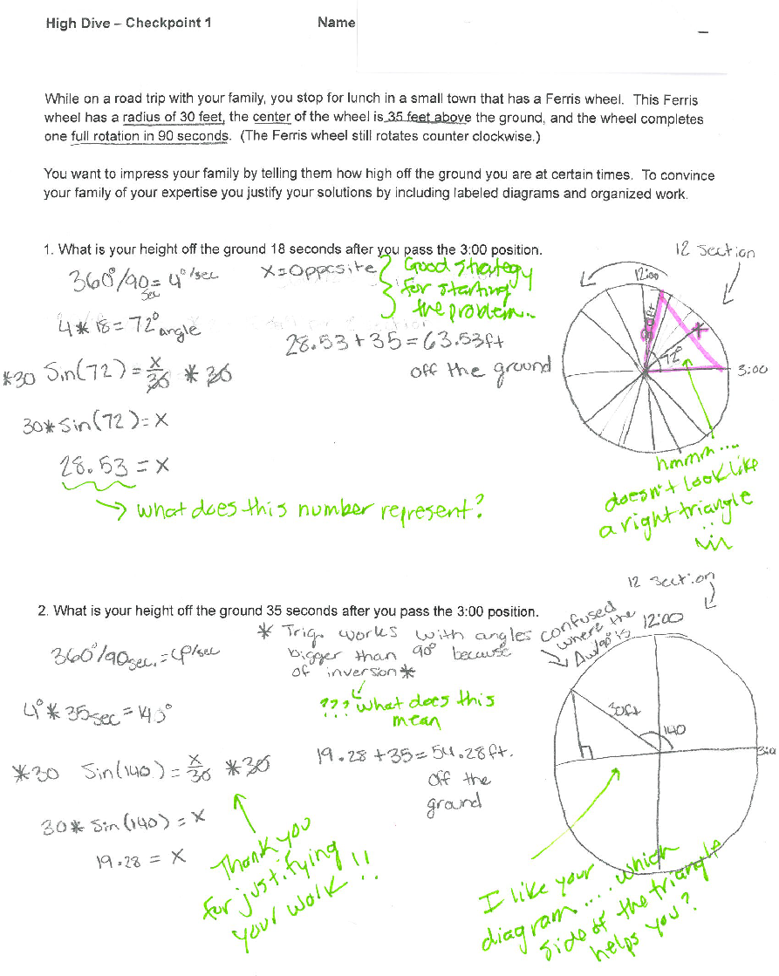
Long description of figure 12.15

Self- and Peer Assessment
The two main strategies for helping students become aware of the mathematics they are learning and their broader learning pathways are self- and peer assessment. In self-assessment, students are given clear statements of the mathematical content and practices they are learning, which they use to think about what they have learned and what they still need to work on. The statements could communicate mathematics content such as, “I understand the difference between mean and median and when each should be used,” as well as mathematical practices, such as, “I have learned to persist with problems and keep going even when they are difficult.” If students start each unit of work with clear statements about the mathematics they are going to learn, they begin to focus on the bigger landscape of their learning journeys; they learn what is important as well as what they need to work on to improve. Studies have found benefits to having students rate their understanding of their work through self-assessment. Such benefits include:
    - Students understand what they need to do to be successful. They start to see the work being asked of them in terms of smaller goals that need to be achieved in moving toward a broader learning goal. This allows them to manage and control the work for themselves; to become independent learners.
    - Following the use of simple strategies like “traffic light” icons (where students label their work green, yellow, or red according to whether they think they have good, partial, or little understanding), students can then be paired with others and asked to justify their self-assessments. Linking self-assessment to peer assessment in this way can support students to develop general mathematical communication skills as well as the skills and detachment needed for effective self-assessment.
    - Students’ self-assessments of their understanding can also be used to inform future teaching, with student feedback indicating in which areas a teacher needs to spend more time.
Self-assessment can be developed at different degrees of granularity. Teachers might conduct a mathematics lesson or show students the mathematics across a longer period of time, such as a unit, term, or semester. In addition to understanding the criteria, students need time to reflect upon their learning. These moments can be built into plans during a lesson, at the end of the period, or even at home after considerable time to process.
Figure 12.16 presents a self-assessment example that focuses on mathematical practices. It is followed by an example of algebra content self-assessment.
Figure 12.16 Self-Assessment Example that Focuses on Mathematical Practices
Standard for Mathematical Practice | Student-Friendly Language
- Make sense of problems and persevere in solving them. | I can try many times to understand and solve a math problem.
- Reason abstractly and quantitatively. | I can think about the math problem in my head first.
- Construct viable arguments and critique the reasoning of others. | I can make a plan, called a strategy, to solve the problem and discuss other students’ strategies too.
- Model with mathematics. | I can use math symbols and numbers to solve a problem.
- Use appropriate tools strategically. | I can use math tools, pictures, drawings, and objects to solve the problem.
- Attend to precision. | I can check to see if my strategy and calculations are correct.
- Look for and make use of structure. | I can use what I already know about math to solve the problem.
- Look for and express regularity in repeated reasoning. | I can use a strategy that I used to solve another math problem.
Source: Rhode Island Department of Education, n.d.
The following example is an algebra content self-assessment (Boaler, 2016):
Algebra I Self-Assessment
Unit 1—Linear Equations and Inequalities
- I can solve a linear equation in one variable.
- I can solve a linear inequality in one variable.
- I can solve formulas for a specified variable.
- I can solve an absolute value equation in one variable.
- I can solve and graph a compound inequality in one variable.
- I can solve an absolute value inequality in one variable.
Unit 2—Representing Relationships Mathematically
- I can use and interpret units when solving formulas.
- I can perform unit conversions.
- I can identify parts of an expression.
- I can write the equation or inequality in one variable that best models the problem.
- I can write the equation in two variables that best model the problem.
- I can state the appropriate values that could be substituted into an equation and defend my choice.
- I can interpret solutions in the context of the situation modeled and decide if they are reasonable.
- I can graph equations on coordinate axes with appropriate labels and scales.
- I can verify that any point on a graph will result in a true equation when their coordinates are substituted into the equation.
- I can compare properties of two functions graphically, in table form, and algebraically.
Unit 3—Understanding Functions
- I can determine if a graph, table, or set of ordered pairs represents a function.
- I can decode function notation and explain how the output of a function is matched to its input.
- I can convert a list of numbers (a sequence) into a function by making the whole numbers the inputs and the elements of the sequence the outputs.
Peer assessment is similar to self-assessment, as it also involves giving students clear criteria for assessment, but they use it to assess each other’s work rather than their own. When students assess each other’s work, they gain additional opportunities to become aware of the mathematics they are learning and need to learn. Peer assessment has been shown to be highly effective, in part because students are often much more open to hearing criticism or a suggestion for change from another student, and peers usually communicate in ways that are easily understood by each other (Black et al., 2002). This kind of collaboration allows students to internalize the evaluative criteria and engage in a learning process that relies on speaking and thinking like a mathematician.
One method of peer assessment is called “Two Stars and a Wish.” Students are asked to look at their peers’ work and, with or without criteria, to select two things done well and one area to improve on. (For lesson plans that embed formative assessment strategies like Two Stars and a Wish, go to Tools for Teachers (n.d.), which includes more than 40 formative assessment strategies as teacher resources.) When students are given information that communicates clearly what they are learning and they are asked, at frequent intervals, to reflect on their learning, they develop responsibility for their own learning.

Mastery-Based Approaches to Assessment
Mastery-based grading describes a form of grading that focuses on mastery of ideas rather than on points or scores. This approach is sometimes referred to as standards-based grading, and although it refers to standards, it does not have to focus on specific standards. It could, instead, use cluster headings, which are more akin to the Content Connections and Big Ideas approach of this framework. (The big ideas are set out in the grade-band chapters, chapters 6, 7, and 8 and in appendix A. The assessments that go with them are found in the California Digital Learning Integration and Standards Guidance). The important feature of this approach is that it communicates the mathematics that students are learning, and students receive feedback on the mathematics they have learned or are learning, rather than a score. This helps students view their learning as a process that they can improve on over time rather than a score or a grade that they often perceive as a measure of their worth. The following is a good example of a rubric that sets out the mathematics for students—not by standards but by mathematical ideas—from the Robert F. Kennedy UCLA Community School.

Grade 8 Math Syllabus: Core Connections, Course 3
Ms. Lee-Ortiz, Room L212, UCLA-CS

Introduction
Each day in this class, students will be using problem-solving strategies, questioning, investigating, analyzing critically, gathering and constructing evidence, and communicating rigorous arguments justifying their thinking. Under teacher guidance, students learn in collaboration with others while sharing information, expertise, and ideas. This course helps students build on the Course 2 concepts from last year in order to develop multiple strategies to solve problems and to recognize the connections between concepts.

Mastery Learning and Grading
Grades will be determined based on demonstration of content knowledge, specified as Learning Targets:
Number | Learning Target
1 | I know that there are numbers that are not rational and approximate them by rational numbers.
2 | I can work with radicals and integer exponents.
3 | I demonstrate understanding of the connections between proportional relationships, lines, and linear equations.
4 | I can analyze and solve linear equations and pairs of simultaneous linear equations.
5 | I can define, evaluate, and compare functions.
6 | I can use functions to model relationships between quantities.
7 | I can demonstrate understanding of congruence and similarity using physical models, transparencies, or geometry software.
8 | I can understand and apply the Pythagorean Theorem.
9 | I can solve real-world and mathematical problems involving volumes of cylinders, cones, and spheres.
10 | I can investigate patterns of association in bivariate data.
Grades will NOT be based on percentages or averages but instead will be determined holistically. Grades will support the learning process and support student success. This is called mastery learning and grading. Rubrics, checklists, and scoring guides will be used to provide regular feedback so that students can improve and focus on learning the content. Students will have time as well as multiple opportunities to demonstrate mastery of the Learning Targets. It is not expected that you master a Learning Target the first time you learn it. The focus should be on showing growth and heading toward mastery. I will work alongside you to reach that goal. Let’s maintain a growth mindset!
Mastery-based grading is a way to bring some of the very valuable aspects of formative assessment into summative assessments. This method of assessment shifts the focus from a fixed measure based on a score or a test result to a reflection of the mathematics students are working toward. Mastery-based grading breaks content into Learning Targets, each of which is a teachable concept for which students may demonstrate proficiency. Instead of receiving partial credit for incorrect responses, students are provided feedback and the opportunity to reassess standards they do not meet in their first attempt. Teachers can then track and provide feedback based on students’ work in relation to each Learning Target.
Included below is text from a standards-based report card. To view the full image, access the source information. The criteria are designed to be evaluated intentionally at specific points in the duration of the course (i.e., trimester or quarter).
A kindergarten example:

Kindergarten Mathematics
Number and Operations in Base-10
- I work with numbers 11–19 to show 10 ones and some further ones.
Measurement and Data
- I describe, compare, and classify objects and count the number in each category.
Geometry
- I identify and describe flat and 3D shapes.
- I compare, create, and compose shapes.
Source: ISBR, n.d.
The following example is adapted from the Saddleback Valley Unified School District:

Grade 6 Mathematics
Ratios and Proportional Relationships
- Understands ratio concepts and uses ratio reasoning to solve problems
The Number System
- Applies and extends previous understandings of multiplication and division to divide fractions by fractions
- Applies and extends previous understandings of numbers to the system of rational numbers
Expressions and Equations
- Applies and extends previous understandings of arithmetic to algebraic expressions
- Understands ratio concepts and uses ratio reasoning to solve problems
- Solves one-variable equations and inequalities
- Represents and analyzes quantitative relationships between dependent and independent variables
Geometry
- Solves real-world and mathematical problems involving area, surface area, and volume
Statistics and Probability
- Develops understanding of statistical variability
- Summarizes and describes distributions
The following example is adapted from the Saddleback Valley Unified School District:

Grade 2 Mathematics
Operations and Algebraic Thinking
- Represents and solves problems involving addition and subtraction
- Adds and subtracts fluently within 20
- Works with equal groups of objects to gain foundations for multiplication
Numbers and Operations in Base-10
- Understands and applies place-value concepts
- Uses place-value understanding and properties of operations to add and subtract
Measurement and Data
- Measures and estimates lengths in standard units
- Relates addition and subtraction to length
- Works with time and money
- Represents and interprets data
Geometry
- Reasons with shapes and their attributes
The following example is adapted from the David Douglas School District, n.d.:

Grade 4 Mathematics
- Read, write, compare, and round decimals to thousandths. Convert metric measurements. NBT.3, NBT.1-4, MD.1
- Fluently multiply multi-digit whole numbers using the standard algorithm. Convert customary measurements. NBT.5, MD.1
- Solve multi-digit (up to four-digit by two-digit) whole number division problems using various strategies. NBT.6
- Add, subtract, multiply, and divide decimals to the hundredths place using various strategies. NBT.7
- Solve real-world and mathematical problems involving addition and subtraction of fractions including unlike denominators. Make line plots with fractional units. NF.2, NF.1, MD.2
- Solve real-world and mathematical problems involving multiplication of fractions and mixed numbers, including area of rectangles. NF.6, NF.4, NF.5
- Solve real-world and mathematical problems involving division of fractions by whole numbers (1/4 ÷ 7) and division of whole numbers by fractions (3 ÷ 1/2). Interpret a fraction as division. NF.7, NF.3
- Solve real-world and mathematical problems involving volume by using addition and multiplication strategies and applying the formulas. MD.5, MD.3-5
- Solve real-world and mathematical problems by graphing points, including numeral patterns, on the coordinate plane. G.2, G.1, OA.3
The following example is adapted from the Loma Prieta Joint Union School District, n.d.:

Grade 4 Mathematics
Operations and Algebraic Thinking
- Use Operations with Whole Numbers to Solve Problems
- Gain Familiarity with Factors and Multiples
- Generalize and Analyze Problems
Number and Operation Base-10
- Understand Place Value for Multi-Digit Whole Numbers
- Use Place Value Understanding and Properties of Operations to Perform Multi-Digit Arithmetic
Number Operations and Fractions
- Understanding of Fraction Equivalence and Ordering
- Build Fractions from Unit Fractions
- Understand Decimal Notation for Fractions
Measurement Data
- Solve Problems Involving Measurement and Conversion
- Represent and Interpret Data
Geometry
- Draw, Identify, and Utilize Lines and Angles
The following example is from University High School:
Semester 1 Learning Targets
Learning Target (LT) | Description*
LT 1 | Function Characteristics: I can identify, describe, compare, and analyze functions and/or their characteristics and use them to model situations/create functions.
LT 2 | Linear Functions: I can use, create, describe, and analyze linear functions using different representations.
LT 3 | Piecewise Functions: I can use, create, describe, and analyze piecewise functions using different representations.
LT 4 | Exponential Functions: I can use, create, and analyze exponential functions using different representations.
LT 5 | Logarithmic Functions: I can prove laws of logarithms and use the definition and properties of logarithms to translate between logarithms in any base and simplify logarithmic expressions.
LT 6 | Quadratic Functions: I can use, create, and analyze quadratic functions using different representations.
LT 7 | Sequence and Series: I can analyze arithmetic, geometric, and recursive sequences and series and use different representations to solve problems.
LT 8 | Eight Mathematical Practices: I can demonstrate eight mathematical standards.
LT 9 | Participation, Engagement, & Organization: I can participate and engage in class/group discussion and problem solving synchronously and asynchronously.
LT 10 | Agency, Ownership, & Identity: I can take ownership over my own learning and develop positive identity as a thinker and a learner of mathematics through reflection, self-determination, and grit.
*Learning Topics 1–7 are considered Academic Learning Targets.
Mastery-based grading can be reported to districts, parents, and others in the form of the clusters achieved and not associated with letter grades. Alternatively, teachers can develop structures and methods that turn mastery-based grading results into letter grades if required. These systems could be tied to the percentage of standards mastered, the number of standards at different levels, or mastery of key learning outcomes and some amounts of additional material.
The following is an example from the Robert F. Kennedy UCLA Community School, Grade Eight:
Mastery Rubric
Level | Description
4 – Mastery | You have demonstrated complete and detailed understanding of the Learning Target and can apply it to new problems.
3 – Proficiency | You have a firm grasp of the Learning Target and have demonstrated understanding of the concepts involved but may be inconsistent or may have minor misunderstandings and errors.
2 – Basic | You have demonstrated some conceptual understanding of the Learning Target but still have some confusion of key ideas or make errors more than occasionally.
1 – Beginning | You have demonstrated little or unclear understanding or have multiple misunderstandings about the Learning Target.
0 – Not yet | You have not attempted this Learning Target yet or have not turned in work for this Learning Target to be assessed.
Figure 12.17 presents the cycle for mastery learning.
Figure 12.17 Cycle for Mastery Learning
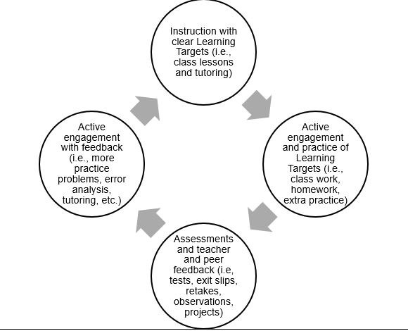
Long description for figure 12.17
Students learn at different rates and in different ways, so grades will be based on learning over time after many opportunities for practice with feedback. Final grades will be determined on the achievement, consistency, and improvement of mastering the Learning Targets evidenced by assessments and work submitted, such as tests, exit slips, teacher observations, and projects.
Figure 12.18 presents a final academic grade rubric for mastery learning.
Figure 12.18 Final Academic Grade Rubric for Mastery Learning
Grade | Description
A | Demonstrate mostly Mastery (4) level in Learning Targets and nothing less than a 3 in the other Learning Targets
B | Demonstrate at least Proficiency (3) level in most Learning Targets and nothing less than a 2 in the other Learning Targets
C | Demonstrate at least Basic Understanding (2) level in all the Learning Targets
D | Demonstrate at least Beginning (1) level in all Learning Targets
F | Demonstrate that few or none of the Learning Targets are achieved with at least a Beginning (1) level
One key benefit of using mastery-based grading is that it includes a lot more information on what students actually know. When it includes opportunities for reassessment, and students work with feedback to improve their results, it also encourages important growth-mindset messages. Researchers have considered parents’ responses to a shift to mastery-based grading, finding that parents are supportive of standards-based grading as an alternative to traditional grading (Swan, Guskey, and Jung, 2014). Mastery-based report cards may contain the language of cluster headings or standards and may need explanations for parents to understand their child’s strengths and challenges. Building knowledge or simplifying the meaning of the language could accompany feedback given to parents. Research studies have shown that mastery-based grading also improves student engagement and achievement (Iamarino, 2014; Selbach-Allen et al., 2020; Townsley et al., 2016).
On a final note, since mastery-based grading is based on students meeting learning targets, grade reports function differently. Test and quiz scores, for example, are often averaged and translated to letter grades in a traditional system, whereas in a mastery-based system, mastery of topics is evidenced and communicated over time and in multiple ways. At early points in the year, it should not be expected that students would have mastered all, or even a significant number, of Learning Targets, and grade reports would reflect this progression. Schools should provide clear and consistent messaging regarding mastery-based grading systems to help parents and students understand report cards.
In traditional grading systems, points are often offered for participation, attendance, behavior, and homework completion. These measures often bring inequity into the grading system as students’ outside circumstances impact these aspects of their grade. The final grade becomes more about behaviors than learning. While mastery-based grading is not a panacea to fix inequities in assessments, it ensures grades and assessment relate to demonstrated knowledge rather than behaviors that may not reflect a student’s actual learning.

Effective Assessment Strategies for English Learners
Because the language and content of mathematics are interdependent, effective assessment calls for teachers to formatively assess students’ use of language in the context of mathematical reasoning over time. At the outset of a unit, students would likely use more exploratory language, including everyday language; over the course of the unit, students would add to their repertoire the more standard, less ambiguous form of mathematical conventions and agreements. One of several mathematical language routines that has been developed is called “Collect and Display” (Zwiers et al., 2017, 11), where teachers listen to students’ use of language, then they display the collection of terms they heard. This then becomes a useful language resource for the class as it shows the development of language over time.
Teachers should also provide rubrics, including a discussion of key academic vocabulary, so that the criteria for success are clear to students. Because rubrics can be used to conduct self- and peer assessments (in addition to assessment by the teacher), it can be useful for teachers to provide language instruction, including frames for collaborative criteria chats, if key terms are expected in students’ explanations.
For culminating assessments, teachers should do an analysis of the language demands prior to administering the assessments, as well as backward planning, guided by the following questions:
- What opportunities are provided for students to explain and elaborate their reasoning?
- Prior to the assessment, have students had sufficient opportunities to practice using the kind of language that is expected to demonstrate their mathematical reasoning?
- Have students received feedback and a chance to apply that feedback to their work?
Example:
In a unit test, suppose students are asked to explain how they know that a linear system of equations has no solutions. Throughout the instructional unit, students should have opportunities to generate and refine such explanations, working on specific cases but also building up to the language of generalization over time. Students should examine examples of explanations that include visuals of parallel lines, along with a focus on the slopes of the given lines in this case. Using language for complex ideas is an attainable goal for English learners, but only if there is thoughtful planning and support throughout the instruction.
Feedback on student explanations on assessments should follow the same principles of high-quality feedback for English learners—that is, feedback should acknowledge what was done correctly, ask clarifying questions, and give students an opportunity to revise their work.
As teachers continue to collect formative data about students’ language, they can act on that data by assessing growth over time, adjust instruction, and consider possible flexible groupings to provide more targeted support.
Teachers may consider the following assessment modifications appropriate for linguistically and culturally diverse English learners in the process of acquiring English:
- Allow verbal answers rather than requiring writing, or provide some combination.
- Consider chunking longer assessments into smaller parts.
- Enlist a qualified bilingual professional to help provide multiple means of assessments and support formative and summative assessment.
- Consider group assessments as a means for English learners to demonstrate progress.
- Allow students to give responses in multiple formats and with the support of manipulatives.
- Accept responses in the students’ native language if translation support systems exist in the school.
- Allow culturally and linguistically diverse English learners to use bilingual dictionaries or translation software to support their language learning.

Summative Assessment
Summative assessment is assessment of learning. Summative assessments typically occur at the end of a learning cycle in order to ascertain students’ acquisition of knowledge and skills in the subject. On a classroom level, exams, quizzes, worksheets, and homework have traditionally been used as summative measures of learning for particular units or chapters. Summative assessments have the potential to be anxiety-inducing for students, so some best practices should be implemented to minimize damaging effects. The Poorvu Center at Yale has compiled the list of best practices shown in figure 12.19.
Figure 12.19 Best Practices for Summative Assessments
Practice | Explanation
Use a Rubric or Table of Specifications | Instructors can use a rubric to lay out expected performance criteria for a range of grades. Rubrics will describe what an ideal assignment looks like and will “summarize” expected performance at the beginning of the term, providing students with a trajectory and sense of completion.
Design Clear, Effective Questions | If designing essay questions, instructors can ensure that questions meet criteria while allowing students the freedom to express their knowledge creatively and in ways that honor how they digested, constructed, or mastered meaning.
Assess Comprehensiveness | Effective summative assessments provide an opportunity for students to consider the totality of a course’s content, making broad connections, demonstrating synthesized skills, and exploring deeper concepts that drive or found a course’s ideas and content.
Make Parameters Clear | When approaching a final assessment, instructors can ensure that parameters are well defined (e.g., length of assessment, depth of response, time and date, grading standards); knowledge assessed relates clearly to content covered in the course; and students with disabilities are provided required space and support.
Consider Blind Grading | Instructors may wish to know whose work they grade in order to provide feedback that speaks to a student’s term-long trajectory. If instructors wish to provide truly unbiased summative assessment, they can also consider blind grading. This process is explained, with examples, by the Yale Poorvu Center for Teaching and Learning.
Source: Poorvu Center for Teaching and Learning, Yale University
One of the problems with a classroom approach based upon frequent grading is that teachers are using summative measures hoping they will have a formative effect and impact learning. One alternative to this approach is standards-based grading, which can be used in ways that support formative and summative assessment.
Examples of summative questions from primary, upper elementary, middle school, and high school are given below.
Summative Assessment Questions
Primary:
- You have a collection of five objects and your friend gives you six more. How many do you have and how do you know? Explain your reasoning using words, pictures, and numbers.
Upper Elementary:
- You have a 48-foot-long fence made up of 4-foot panels. How many 4-foot panels are there? How do you know? Write a number sentence showing the calculation needed for this question. Fully explain how your number sentence models this situation.
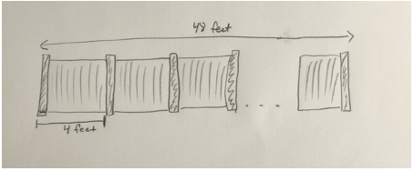
Middle School:
- A point is located at –17 on a number line. If you add 8 to –17 and move the point, where will it be located? Draw the number line showing the movement and write a number sentence that represents the movement of the point. What whole number is between the two points? Make a convincing argument proving how you know. Explain your reasoning fully.
High School:
- F(x) = 3x + 2, where the domain is the interval [0,7]. Graph the function and include a table of values showing the ordered pairs for integer values of x. Write a story that might be modeled by this function. Explain how the function models your story.

Retaking Assignments and Tests
Assignments and tests that occur frequently can still provide a valuable learning experience for students when they are not seen as the end to a learning cycle. Some teachers believe that others retaking work is not fair practice, believing students may go away and learn on their own what they need to improve their grade, but such efforts are, at their core, about learning, and should be valued. Allowing students to retake work sends an important growth-mindset message and encourages further learning. Just as career mathematicians constantly revise their work and conjectures, students should be allowed the same fluidity in their own learning process. See the snapshot Retaking Tests, below, for an example of how retaking a test can enable further learning. Allowing students to resubmit any work or test is the ultimate growth-mindset message, focusing assessment upon learning rather than performance.

Snapshot: Retaking Tests
Kaj has noticed that, for some of her students, the unit tests are anxiety-inducing—both in the taking of the tests and in receiving potentially low scores a few days later. In talking with an English language arts/literacy (ELA) peer teacher, the subject of testing came up, and her peer pointed out that drafts and revisions are the norm in ELA. Kaj wondered if embedding a revision cycle into the testing could help her students with test anxiety and with long-term retention.
For her next unit test, she announces to the class that they will have the opportunity to revise their work on any items on which they lose significant points. In the week before the test, she overhears some of her students mentioning that they might “wing it” since they can just retake items later. She decided that a few rules were needed: When taking the test, an attempt must be made and an answer found on all problems. In addition, a revision includes three components: a correct solution with all steps shown, an annotated version of the original work with explanation of what was overlooked or missed, and a citation of the resource used, such as page number or class notes.
On testing day, she noticed that students who typically struggled seemed to be writing more and leaving fewer questions unanswered. During grading she was careful to give written feedback (see earlier “Diagnostic Comments” section) that was both positive and constructive so students were more inclined to revise their work, if possible, rather than scrapping it entirely. As the revisions came in, Kaj was heartened to see that her students improved upon their work considerably, and their scores reflected this improvement. She also noticed that, for many of her students, the revision process enabled better long-term retention. As Kaj made further changes to the system, as well as instituting a peer checking system, she was able to address the extra grading time for herself as well as some of the complaints about fairness she overheard from a few parents. For the next year, she planned on including good study practices in the lead-up to a test and having her students talk with a classmate to help identify which topics were most difficult for them. Overall, she felt that developing these types of reflection, self-awareness, and anticipation skills in her students will bode well for them with future learning experiences.
(end snapshot)

Portfolios
Perhaps the most comprehensive way to assess student learning is through a portfolio—a collection of work that communicates students’ activities over a length of time. It could include project work, photographs, audio samples, letters, digital artifacts, and other records of mathematical work. Portfolios allow students to choose and assemble their best work, selecting the contents and reflecting on the reasons for their inclusion. Portfolios are particularly appropriate ways of assessing data science projects. Students should have the option of demonstrating their knowledge of math concepts through the use of their home language.
Portfolios can be scored using well-developed rubrics or criteria. They can provide value when used as a way of communicating student progress to parents. Ideally, they tell a story of student growth in learning the content and practices of mathematics. The detail can help parents support their students’ learning and expand collaboration between schools and families. In distance learning settings, portfolios can provide a powerful means for students to demonstrate understanding and knowledge and can be easily compiled with the use of technology.
Examples of Pre-K Mathematics Portfolios (Prekinders, n.d.) and figures 12.20 through 12.23 provide examples of tasks a kindergarten teacher included in her student portfolio.
Figure 12.20 One-to-One Correspondence: Stamp Bingo Dot Markers in Squares
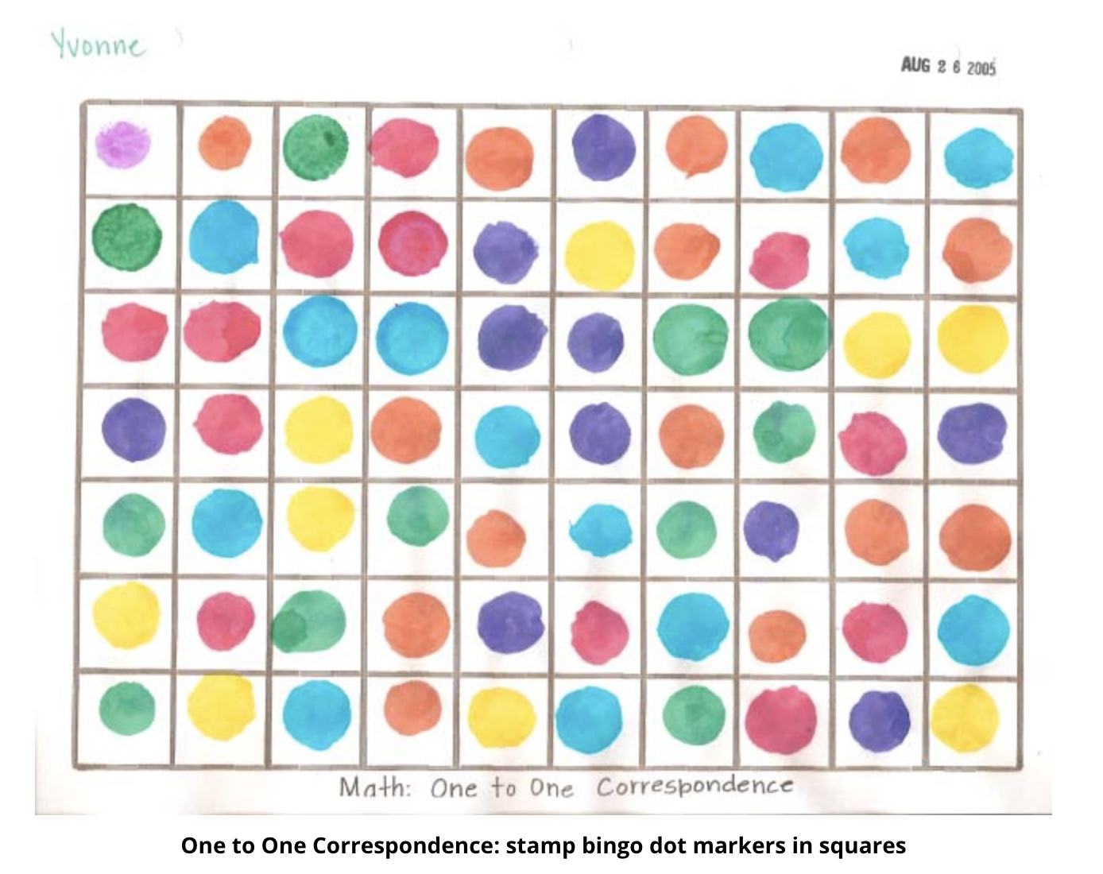
Figure 12.21 One-to-One Correspondence with Rubber Stamps
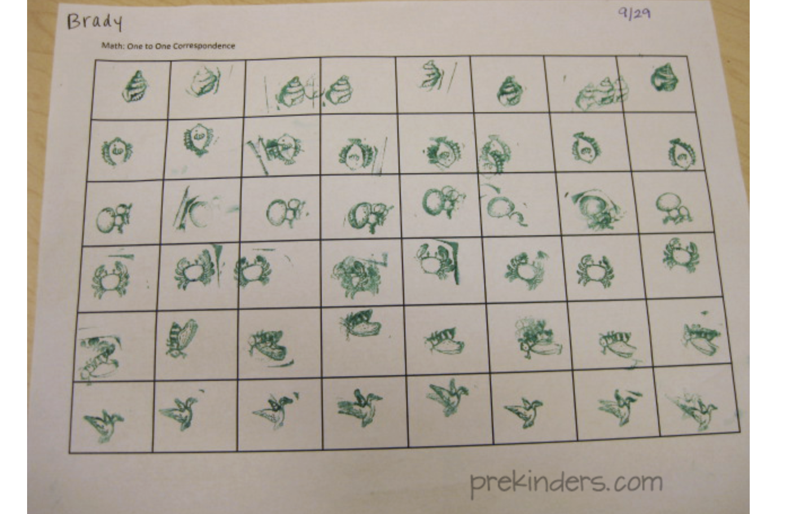
Figure 12.22 Representing Numbers with Drawing
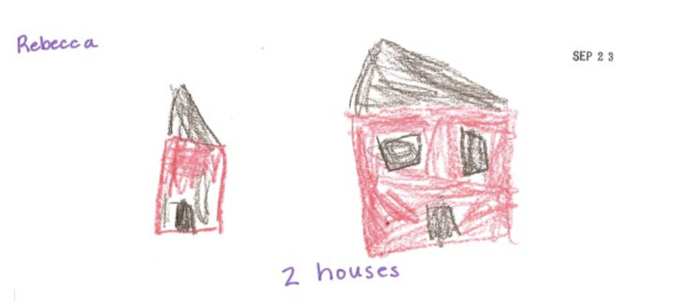
Figure 12.23 Sorting Paper Cutouts by Color
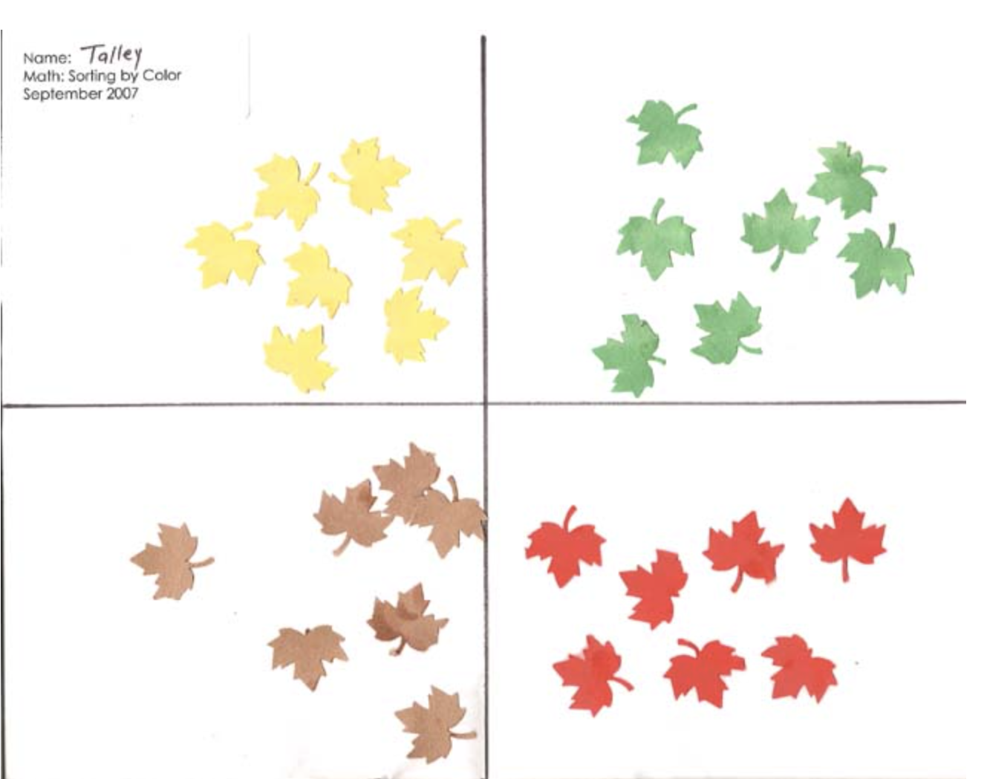

The Smarter Balanced Assessment System and the CAASPP
California’s statewide assessment program, known as the California Assessment of Student Performance and Progress (CAASPP), comprises various assessments, including the Smarter Balanced system of assessments for mathematics and English language arts/literacy. The summative assessment for mathematics is designed to measure students’ and schools’ progress toward meeting the goals of the CA CCSSM for grades three through eight and in grade eleven.
The Smarter Balanced assessments, which are untimed and include items and tasks in many formats, require students to think critically, solve problems, and show a greater depth of knowledge. The Smarter Balanced assessments provide a full range of assessment resources for all students, including those who are English learners and students with disabilities. These resources ensure that the assessment meets the needs of all students. The Smarter Balanced summative assessment in mathematics is available in Spanish using a tool that allows students to toggle the preferred language of the testing interface between English and Spanish. The CAASPP summative assessments are available in Spanish in a stacked version, showing the questions/problems in English and Spanish. Districts and schools can designate which students should be given this form of the assessment and complete the appropriate documentation required.
In measuring students’ and schools’ progress toward meeting the CA CCSSM, there are three key aspects of the CAASPP:
- Computer-based testing. All schools with eligible students in grades three through eight and eleven are required to administer the test electronically. Computer-based testing allows for smoother test administration, faster reporting of results, and the utilization of computer-adaptive testing.
- Computer-adaptive testing. The Smarter Balanced assessments use a system that monitors students’ progress as they take the assessment and presents the student with harder or easier problems depending on the student’s performance on the current item. In this way, the computer system can adjust to more accurately assess the student’s knowledge and skills.
- Varied item types. The Smarter Balanced tests allow for a variety of types of items that are each intended to measure different learning outcomes. For instance, a selected response item may have two correct choices out of four; a student who selects only one of those correct items would indicate a different understanding of a concept than a student who selects both of the correct responses. Constructed-response questions are featured, as well as performance tasks (which include extended-response questions) that measure students’ abilities to solve problems and use mathematics in context, thereby measuring students’ progress toward employing the mathematical practice standards and demonstrating their knowledge of mathematics content. Finally, the assessments feature technology-enhanced items that aim to provide evidence of mathematical practices. These items utilize the technology of the online test format to provide an item type not possible in paper pencil assessment. They are aligned with the four claims shown in Figure 12.24.
Figure 12.24 Smarter Balanced Assessment Consortium, Four Claims
Claim | Explanation
Claim 1 | Concepts and Procedures: Students can explain and apply mathematical concepts and interpret and carry out mathematical procedures with precision and fluency.  This claim addresses procedural skills and the conceptual understanding on which the development of skills depends. It uses the cluster headings in the CA CCSSM as the targets of assessment for generating evidence for the claim. It is important to assess students’ knowledge of how concepts are linked and why mathematical procedures work the way they do. Central to understanding this claim is making the connection to elements of these mathematical practices as stated in the CA CCSSM: SMP.5, 6, 7, and 8.
Claim 2 | Problem Solving: Students can solve a range of complex, well-posed problems in pure and applied mathematics, making productive use of knowledge and problem-solving strategies.  Assessment items and tasks focused on Claim 2 include problems in pure mathematics and problems set in context. Problems are presented as items and tasks that are well posed (i.e., problem formulation is not necessary) and for which a solution path is not immediately obvious. These problems require students to construct their own solution pathway rather than follow a solution pathway that has been provided for them. Such problems are therefore unstructured, and students will need to select appropriate conceptual and physical tools to solve them.
Claim 3 | Communicating Reasoning: Students can clearly and precisely construct viable arguments to support their own reasoning and to critique the reasoning of others.  Claim 3 refers to a recurring theme in the CA CCSSM content and practice standards: the ability to construct and present a clear, logical, and convincing argument. For older students this may take the form of a rigorous deductive proof based on clearly stated axioms. For younger students this will involve justifications that are less formal. Assessment tasks that address this claim typically present a claim and ask students to provide a justification or counterexample.
Claim 4 | Modeling and Data Analysis: Students can analyze complex, real-world scenarios and can construct and use mathematical models to interpret and solve problems.  Modeling is the bridge between “school math” and “the real world”—a bridge that has been missing from many mathematics curricula and assessments. Modeling is the twin of mathematical literacy, which is the focus of international comparison tests in mathematics given by the Programme for International Student Assessment (PISA). The CA CCSSM feature modeling as both a mathematical practice at all grade levels and as a content focus in higher mathematics courses.

Interim Assessments
Interim assessments allow teachers to check students’ progress at mastering specific concepts at strategic points throughout the year. Teachers can use this information to support their instruction and help students meet the challenge of college- and career-ready standards. A variety of interim assessments are used by teachers, such as cumulative mid-quarter or quarter assessments, which provide opportunities for students to demonstrate understanding about topics from prior weeks or months. Collectively, Smarter Balanced interim assessments provide teachers with an array of useful formative assessment options tailored to the standards that students are learning.
Smarter Balanced offers the following interim assessments:
- Interim Comprehensive Assessments (ICAs) that test the same content and report scores on the same scale as the summative assessments.
- Interim Assessment Blocks (IABs) that focus on smaller sets of related concepts and provide more detailed information for instructional purposes.
- Focused IABs that assess no more than three assessment targets to provide educators with a finer-grained understanding of student learning.
The Smarter Balanced interim assessments can be used by teachers at any time before, during, and after instruction in a standardized or nonstandardized administration. Examples of interim assessment flexibility include the following:
- Teachers can administer the interim assessments as an end-of-unit summative, "traditional" assessment of learning.
- Teachers can display and discuss interim assessment items with students as a formative assessment during instruction to clarify learning.
- Teachers can analyze individual and group responses in the reporting system and plan instructional next steps accordingly.

Conclusion
Assessment in mathematics is in a period of transition, from tests of fact-based skills to multifaceted measures of sense-making, reasoning, and problem-solving. In other words, alignment is growing between how mathematics is being taught and how it is being tested. A comprehensive system of assessment should provide all educational partners with the levels of detail they need to make informed decisions. Educators, administrators, and policymakers should focus on assessment that engages students in continuous improvement efforts by using mastery-based approaches—assessing with rubrics, self, peer, and teacher feedback. This approach reflects the important goal of achieving conceptual understanding, problem-solving capacity, and procedural fluency. It also maximizes the amount of learning each child is capable of while minimizing the sociocultural effects of narrow testing.
In California, all teachers strive to ensure every child has an equitable opportunity to succeed. Teachers of mathematics can work to ensure that all students receive the attention, respect, and resources they need to achieve success. At the most fundamental level, each educational partner has an important role in supporting classroom teachers’ use of assessment in making the critical minute-by-minute decisions that afford better learning for all students in their care. All educational partners working collaboratively within a system of assessment should ensure that all students in California have access to the rich mathematical ideas and practices set forth in the CA CCSSM.

Long Descriptions for Chapter 12

Figure 12.1 Big Idea Network Map for Grade Three
The graphic illustrates the connections and relationships of some third-grade mathematics concepts. Direct connections include the following:
- Fractions of Shape & Time directly connects to: Square Tiles, Fractions as Relationships, Unit Fractions Models, Represent Multivariable Data
- Measuring directly connects to: Number Flexibility to 100, Analyze Quadrilaterals, Represent Multivariable Data
- Addition and Subtraction Patterns directly connects to: Number Flexibility to 100, Unit Fraction Models, Analyze Quadrilaterals, Represent Multivariable Data
- Square Tiles directly connects to: Fractions as Relationships, Number Flexibility to 100, Fractions of Shape & Time
- Fractions as Relationships directly connects to: Square Tiles, Fractions of Shape & Time, Unit Fraction Models
- Unit Fraction Models directly connects to: Fractions as Relationships, Addition and Subtraction Patterns, Fractions of Shape & Time, Represent Multivariable Data
- Analyze Quadrilaterals directly connects to: Number Flexibility to 100, Addition and Subtraction Patterns, Measuring
- Represent Multivariable Data directly connects to: Unit Fraction Models, Number Flexibility to 100, Addition and Subtraction Patterns, Measuring, Fractions of Shape & Time
- Number Flexibility to 100 directly connects to: Square Tiles, Analyze Quadrilaterals, Represent Multivariable Data, Measuring, Addition and Subtraction Patterns. Return to figure 12.1 graphic

Figure 12.3 Different Purposes of Assessment Cycles
This image shows the different types of assessments in relation to one another. From left to right the “Student” right arrow points to “Short cycle assessments”: Minute-by-minute; Daily; Weekly; Right arrow to “Medium cycle assessments”: Unit and Quarterly; right arrow to “long-cycle assessments”: Annually; right arrow to “Standards.” Source: adapted from Herman, Joan L., and Margaret Heritage. 2007. Moving from Piecemeal to Effective Formative Assessment Practice: Moving Pictures on the Road to Student Learning. Paper presented at the Council of Chief State School Officers Assessment Conference, Nashville, TN. Return to figure 12.3 graphic

Figure 12.9 Sample Mathematical Practice Rubric for SMP.1
Indicating four levels of student proficiency in SMP. 1: Make sense of problems and persevere in solving them.
- Level 1 is “I can show at least one attempt to investigate or solve the task.
- Level 2 is “I can ask questions and clarify the problem and I can keep working when things aren’t going well and try again.”
- Level 3 is “I can make sense of problems and persevere in solving them” (standard reached)
- Level 4 is “I can find a second or third solution and describe how the pathways to the solutions relate.”
Return to figure 12.9 graphic

Figure 12.15 Sample Diagnostic Comments for High Dive Checkpoint 1
The image shows a mathematical task with both student work and teacher diagnostic comments in green. The task set up provides information about the radius of a Ferris wheel, the height above ground of the center of the Ferris wheel, and the time it takes to complete one full rotation of the Ferris wheel. The task asks students to describe how high off the ground a rider (“you”) would be at certain times. Problem one asks, “What is your height off the ground 18 seconds after you pass the 3:00 position.” The student work shows that they begin the problem by calculating how many degrees the wheel rotates each second and determining where the wheel would be in its rotation at 18 seconds. Teacher comments that this initial work is a “good strategy for solving the problem.” The student uses trigonometry to find x and uses x to determine an answer to the question. Pointing to x, the teacher asks, “What does this number represent?” The teachers also notes on the students’ drawing of the Ferris wheel that a drawn triangle “doesn’t look like a right triangle,” subtly questioning the formula the student selected to use to make the calculations.
Problem two asks, “What is your height off the ground 35 seconds after you pass the 3:00 position.” To the student note that “trigonometry works with angles bigger than 90 degrees because of inversion;” the teacher wonders “what does this mean?” In response to the student calculations, the teacher comments “Thank you for justifying your work!!” In response to the students’ drawing of the Ferris wheel showing a right triangle with one side length labeled and one angle measurement, the teacher comments, “I like your diagram.... Which side of the triangle helps you?” Return to figure 12.15 graphic

Figure 12.17 Cycles for Mastery Learning
Cycles for Mastery Learning process graphic shows how teachers move from instruction with clear learning targets (i.e., class lessons and tutoring), to active engagement and practice of the learning targets (i.e., class work, homework, extra practice), to assessments and teacher and peer feedback (i.e., tests, exit slips, retakes, observations, projects), to active engagement with feedback (i.e., more practice, problems, error analysis, tutoring, etc.) Return to figure 12.17 graphic
California Department of Education, October 2023

