This document is part of the larger Mathematics Framework Communication Toolkit. For more resources, visit the [Mathematics Framework web page](https://www.cde.ca.gov/ci/ma/cf/).

# Mathematics Framework Social Media Post for LEAs #1

## Instructions for LEAs

* Save the embedded image (right click, save as picture) and add your school or district logo to the white banner at the bottom before posting.
* Edit the post to include your local information.
* Use alt text for the image when posting.

## Post Content

***[Insert school, district, charter, or county name]*** is thrilled to announce that we have started to use the updated *Mathematics Framework for California Public Schools* (*Mathematics Framework*). The *Mathematics Framework* supports more equitable outcomes for all students!

While the Common Core State Standards for Mathematics remain the same, the 2023 *Mathematics Framework* was written to provide implementation guidance grounded in research and reflecting best practices across the globe.

The new *Mathematics Framework* will help our teachers and staff provide equitable and enriching mathematics instruction while ensuring the deep mathematics understandings needed for success in college, career, and civic life.

If you have any questions about the *Mathematics Framework*, contact ***[insert contact information here].***

#MathFramework #CaliforniaEducation #TeachingMath #MathTeachers #StudentSuccess #NewRelease #MathEducation #TeachingStrategies #Educators

### Alt Text for Images When Posting

The new Mathematics Framework for California Public Schools, Kindergarten through Grade Twelve, is designed to support equitable outcomes for all students in mathematics!

## Rectangle Image

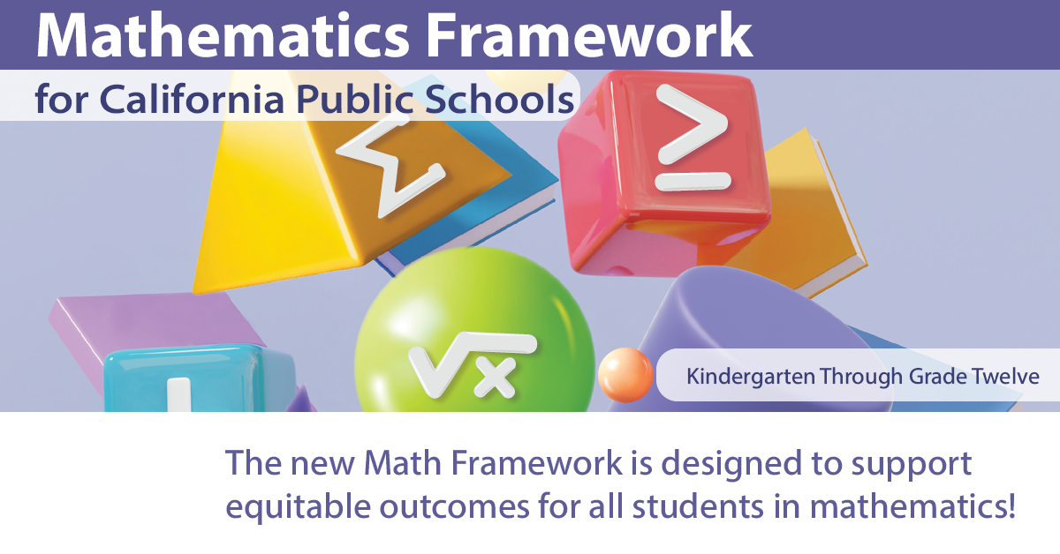

## Square Image

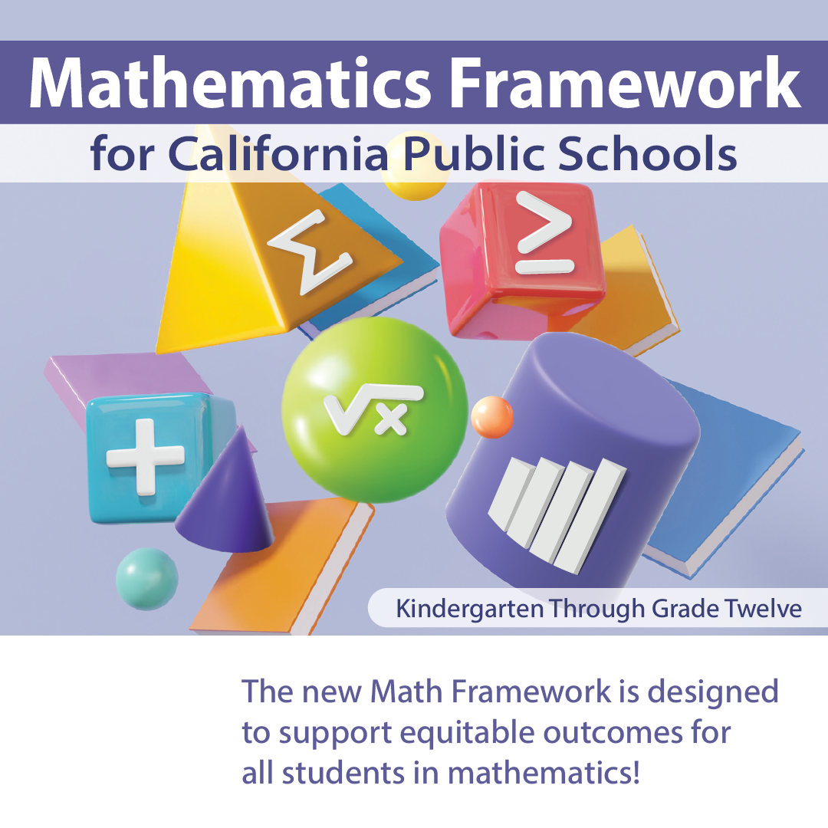

California Department of Education, August 2025