This document is part of the larger Mathematics Framework Communication Toolkit. For more resources, visit the [Mathematics Framework web page](https://www.cde.ca.gov/ci/ma/cf/).

# Mathematics Framework Social Media Post for LEAs #2

## Instructions for LEAs

* Save the embedded image (right click, save as picture) and add your school or district logo to the white banner at the bottom before posting.
* Edit the post to include your local information.
* Use alt text for the image when posting.

## Post Content

The ***[insert school, district, charter, or county name]*** is excited to be exploring California’s new *Mathematics Framework for California Public Schools, Kindergarten through Grade Twelve* (*Mathematics Framework*)!

**For all grades, the *Mathematics Framework* provides valuable insights into:**

* Development of Number Sense
* Standards for Mathematical Practice
* Data Literacy
* Content Connections

The *Mathematics Framework* guides educators in planning instruction around major mathematical concepts, or Big Ideas, and supports offering students multiple opportunities to develop depth of understanding and mastery of the standards.

This approach engages students and prepares them for success beyond the classroom, equipping them with essential skills for future careers and challenges. College-bound students will leave high school fully prepared for higher level mathematics in all fields of study.

The new *Mathematics Framework* will help our teachers and staff provide equitable and enriching mathematics instruction.

#MathFramework #CaliforniaEducation #TeachingMath #MathTeachers #StudentSuccess #NewRelease #MathEducation #TeachingStrategies #Educators

### Alt Text for Images When Posting

The new Mathematics Framework for California Public Schools, Kindergarten through Grade Twelve, guides educators in planning instruction around major mathematics concepts, or Big Ideas.

## Rectangle Image

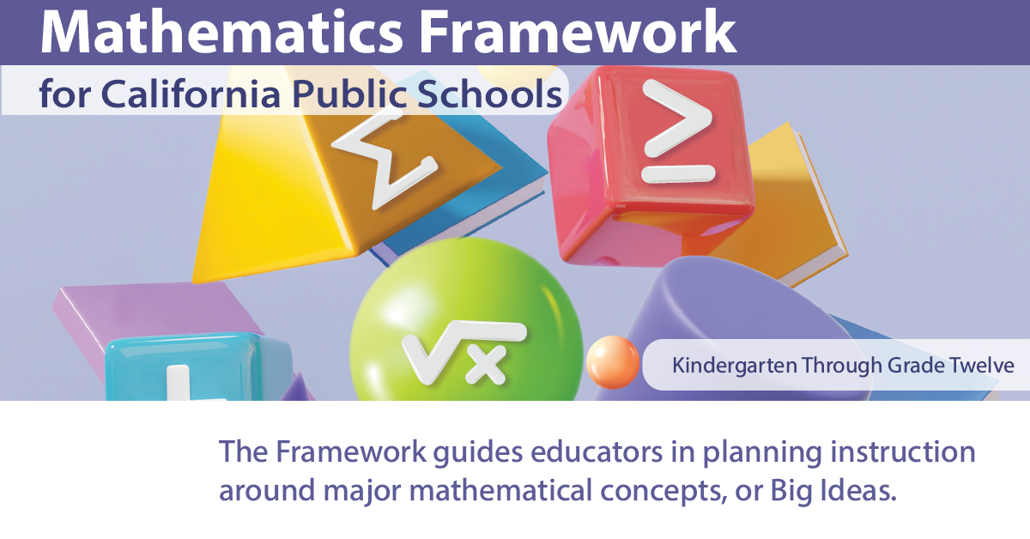

## Square Image

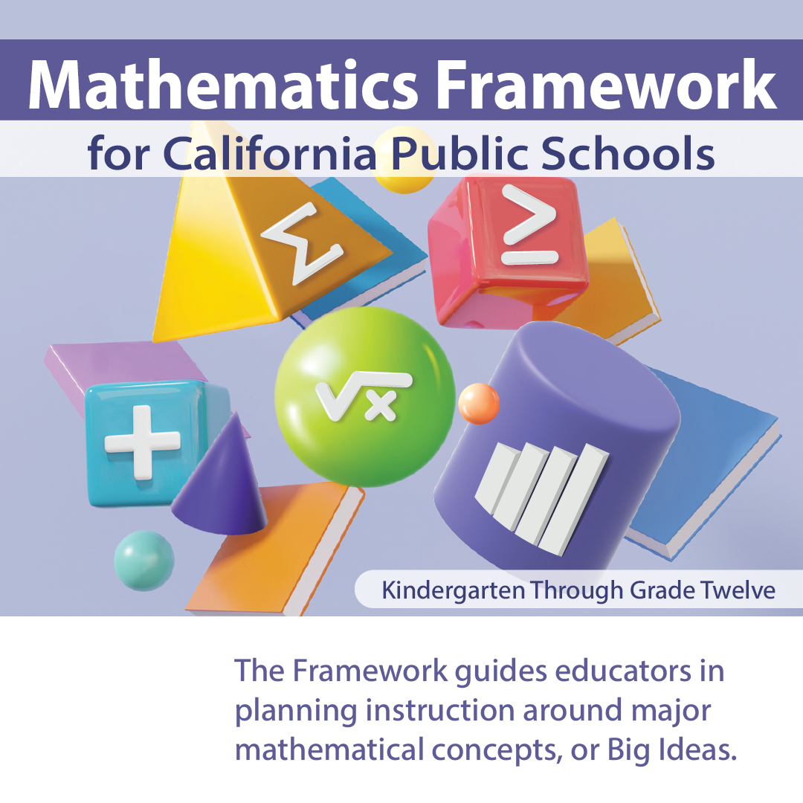

California Department of Education, August 2025