Consolidated Application and Reporting System

LEA User Guide

11/19/2015



California Department of Education
Table of Contents

Consolidated Application and Reporting System Overview 4
Consolidated Application and Reporting System Objective 4
Guide Objective 4
Using the Guide 4
Additional Help 5
Additional Information 5
Centralized Authentication System Access 5
New User Registration 5
Association Type 6
User Information 7
Security Questions 8
Forgot Password 10
Update Password and Personal Information 13
Consolidated Application and Reporting System Access 15
User Access 15
User Roles and Permission 15
Logon to Consolidated Application and Reporting System 16
If You Forgot Your Password 17
District or School Information 17
Navigation 17
Header 17
Switch Local Educational Agency 18
Tabs 18
Data Collection Cycle 19
Deadline Date 20
Review Period 20
Close Date 20
Data Collection Status 21
Tabs 21
Home Tab 21
Data Collection Display List 22
Notices 23
Data Entry Forms Tab 23
Filters 24
Certification Preview Tab 24
Message Types and Severity Levels 26
Certify Data Tab 26
Certification of Assurances 26
Certification of Data 27
Reports Tab 29
Filters 31
Users Tab 31
Add a User 32
Adding CDE Program Staff 34
Edit a User 34
Contacts Tab 35
Assign Program Contact 36
Non-User Contacts 37
Frequently Asked Questions (FAQ) Tab 37
Data Entry Forms 37
Program Information 39
Data Entry Instructions 39
Saving Draft Data 39
Error and Warning Levels 40
Required Data or Parameters 40
Business Rules Enforced by the System 42
Certification Dependency 42
Download Schools Template / Upload Schools File 43
Things to know: 45
Error Messages 46
Add a School 47
Districts Without Attendance Area Nonprofit Private Schools 47
How to Add a School 48
How to Remove a School 49
Appendix A - Generic Process Flow 51
Appendix B - Glossary 52

Consolidated Application and Reporting System Overview

Consolidated Application and Reporting System Objective

The Consolidated Application (ConApp) is used by the California Department of Education (CDE) to distribute categorical funds from various state and federal programs to county offices, school districts, and direct-funded charter schools throughout California.

Local Educational Agencies (LEA) use the Consolidated Application and Reporting System (CARS) to electronically apply for, manage, report and provide assurances that the district will comply with the legal requirements related to specific formulas driven by state and/or federal categorical programs. The system is also used by the CDE categorical program staff and fiscal services to collect financial and participation data to ensure compliance to state and federal regulation and guidance in the use of the funds.

Guide Objective

The objective of this guide is to provide CARS users with the knowledge and understanding needed to navigate efficiently through CARS and to enter or view data.

The guide is designed to help:

- Navigate the system
- Enter and certify data collections
- Generate reports or extracts of submitted data
- Manage user access to the system

The guide is partitioned into sections relevant to the user and the user’s roles.

This guide will not provide categorical program guidance or information to complete data collections beyond how to navigate to and enter the data into the system. Guidance and instructions are provided in separate documents.

Using the Guide

This guide is designed for users who have a basic understanding of the business requirements, terminology, and statutes related to categorical programs.

The guide also assumes the user is familiar with basic computer functions and their internet browser’s functionality.

At the end of each section of the guide is a link to the Table of Contents. To return to the Table of Contents press the Ctrl key, then click on Return to Table of Contents.

Additional Help

For specific questions or problems related to the system, additional help is available from the CARS staff at the ConApp Support Desk. Support can be requested by:

- Emailing conappsupport@cde.ca.gov

- Calling the ConApp Support Desk telephone number at 916-319-0297.

Please note: Non-system related categorical program questions should be directed to the responsible CDE program contact reflected in the lower right-hand corner of each data entry form within CARS.

Additional Information

Additional information about the ConApp, program profiles and related links can be found on the CDE ConApp Web page at http://www.cde.ca.gov/fg/aa/co/.

Return to Table of Contents

Centralized Authentication System Access

In the new Centralized Authentication System (CAS), users self-register new user accounts, and update existing user accounts, for the purpose of establishing login data to gain online access to various systems of the California Department of Education (CDE). In order to access the CDE’s Consolidated Application and Reporting System (CARS), a user must have a username and password. In order to obtain a username and password, a user must register in CAS. CAS is a separate system from CARS, although within both systems are links to the other.

Link to CAS
https://www3.cde.ca.gov/cdeauthentication/logon.aspx?programabbr=CARS

Links to CAS can also be found on the CARS Logon page at:
https://www3.cde.ca.gov/CARS/app/logon.aspx

New User Registration

New Registration is one of the CAS User Links found on the CARS Logon page (from the CAS Logon page, the link is named New User Registration). Select the New Registration link to get started.

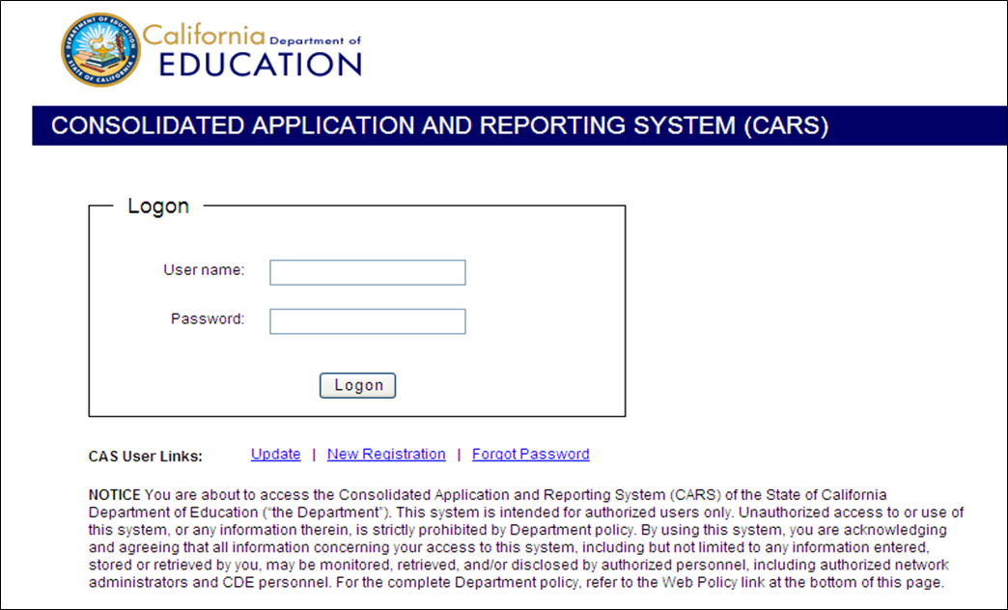

After selecting the New Registration link on the CARS Logon page, the user is directed to the CAS Registration page.

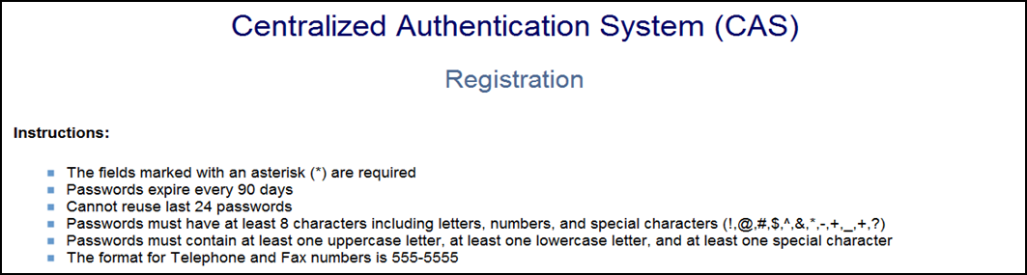

Add the new user’s information to the three sections of the Registration page: Association Type; User Information; and Security Questions.

Association Type

The Association Type provides information about the LEA with which the user is affiliated.

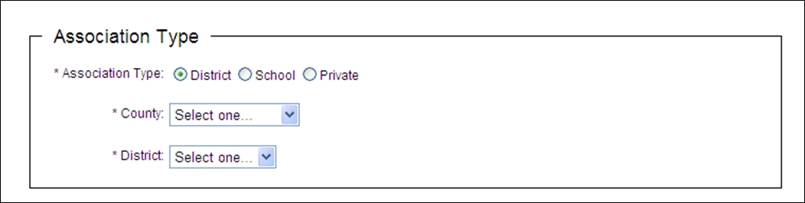

Select the most appropriate association type. Choosing the District or School radio button will lead to related drop down boxes, which will allow the user to drill down to applicable selections. If the Private radio button is selected, the user will have to provide information about the organization they represent.

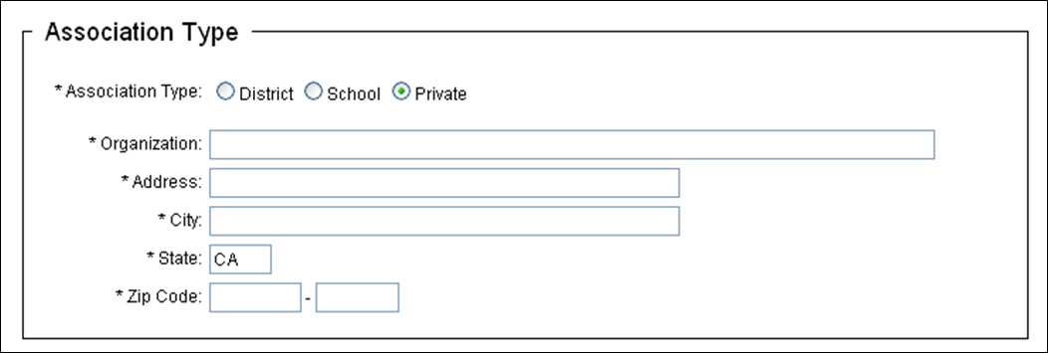

Important Note: The Association Type selected during registration is relevant in the CAS system, but is not used by CARS.

User Information

User Information provides data about the user and allows the user to create a username and password.

ntion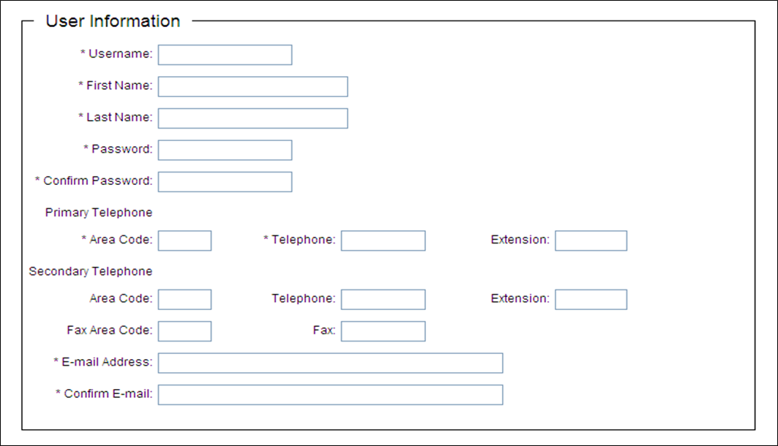

When completing this section, the system will enforce the following:

- The username must be unique to the system. (Error message: Username already exists. Select another Username.)

- The fields marked with an asterisk (*) are required.

- Passwords expire every 90 days.

- Cannot reuse any of the user’s previous 24 passwords. (Error message: The new password you submitted has been used by you before. Select another password.)

- Passwords must have at least 8 characters and must contain at least one upper case letter; one lower case letter; and one allowable special character (!@#$%^&*+=_?). Passwords can also include numbers.

- The format for Telephone and Fax numbers is 555-5555.

Important Notes:

- Make a note of the user’s password. CARS Support does not have visibility to passwords and so cannot provide users with that information. If a password is forgotten, the user must go through the Forgot Password process described later in this guide.

- It is strongly recommended that a user’s individual email address be used as contact, as opposed to a general department or organization-wide email address.

Security Questions

Security Questions are used to validate the user’s identity for password resets. The system requires the user to select two questions from among several choices, and provide answers.

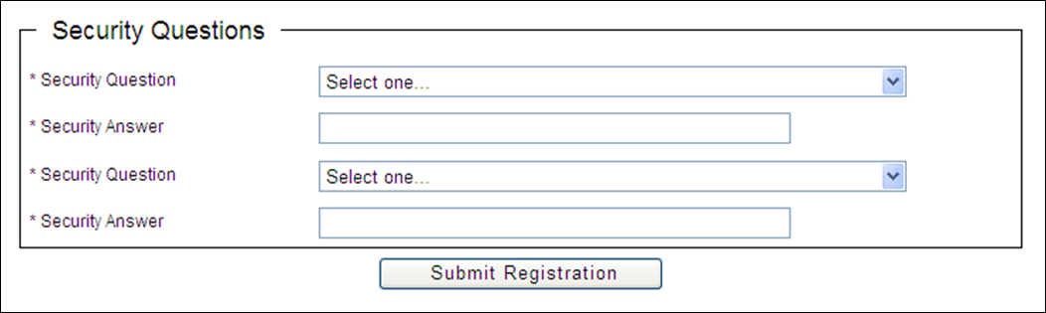

Important Note: Make a note of security questions and answers; CARS Support does not have access to either.

When all sections have been completed, select the Submit Registration button. If the user’s registration information is accepted by the system, a confirmation message will display on the screen, and a confirmation email will be sent to the email address provided.

Example screen confirmation:
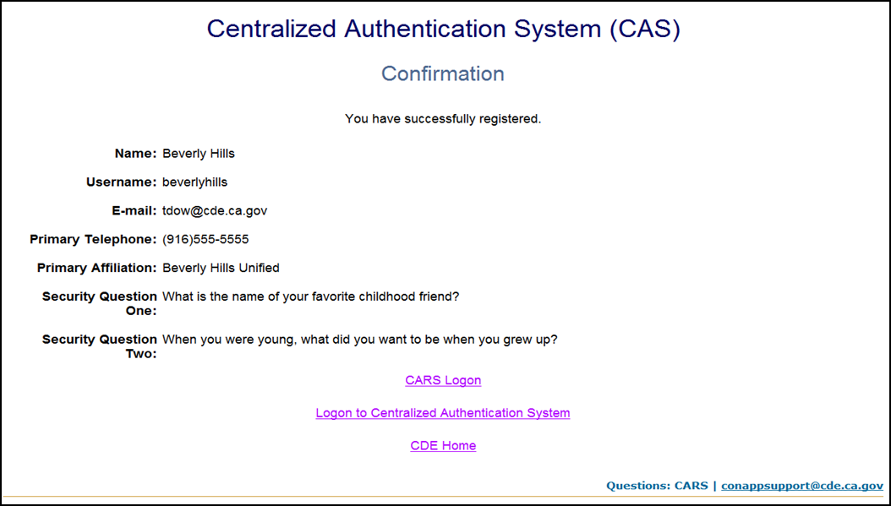

Example email confirmation:
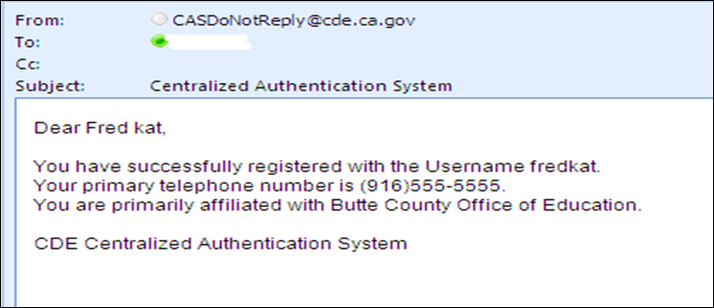

Important Notes:

- Only register once. Even if the user is associated with multiple LEAs, do not register more than once, or create separate usernames for different LEAs.

- After CAS registration is complete, the user should contact their LEA’s User Administrator to request their username be linked to the LEA. The user can be associated with multiple LEAs. The user should contact each User Administrator of each LEA to which the user wants CARS access.

- If the LEA doesn’t have a CARS user with the assigned role of User Administrator or if the User Administrator on record is no longer with the LEA then the Superintendent (or if LEA is a direct funded charter then it might be the Executive Director, CEO, etc.) must send an email to conappsupport@cde.ca.gov. In the email, the Superintendent should note their name and title, the LEA name and CDS code, and state the name, contact information (phone number; email address), and exact CAS username of the individual who will be the new User Administrator for the LEA.

- After registering or resetting a password in CAS, the user should wait 1-5 minutes before attempting to logon to CARS. This allows time for the CAS data to be forwarded to the CARS database.

- If you are using a browser other than Microsoft Internet Explorer and repeatedly receive a “logon data is invalid” message, close your browser and logon using Microsoft Internet Explorer.

Reminder: CAS is a separate system from CARS. Once registration or changes have been completed in CAS, if the user wants to go to CARS, the user must logon to CARS as a separate action.

Forgot Password

If you typically have the computer “remember” your password, be sure to clear your cache and previously saved passwords before you reset your password.

If a password is forgotten, a new password can be created. The user can select Forgot Password in the CAS User Links section of the CARS Logon page, and be directed to the appropriate CAS page.

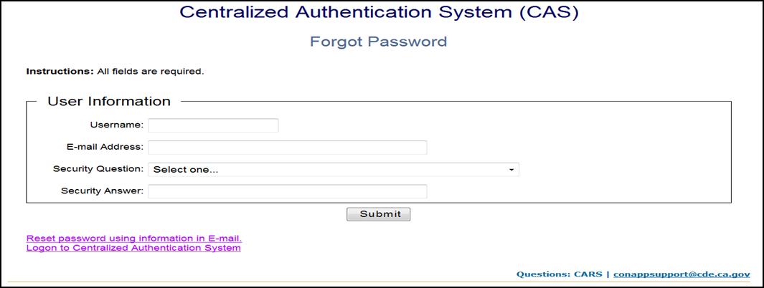

On the Forgot Password page, enter username and email address, being sure the email address entered matches the email address the user already has on file in CAS. Choose one of the two security questions and answers that the user previously chose when the username was registered, then select the Submit button. If the user cannot remember the preselected questions and answers, then we suggest the user try to answer any of the other security questions until all available options are exhausted. Once a correct security question/answer combination is submitted, the system will advise the user that an email containing information to create a new password will be sent to the email address provided. If the user cannot answer any of the security questions correctly, then the user must register a new username.

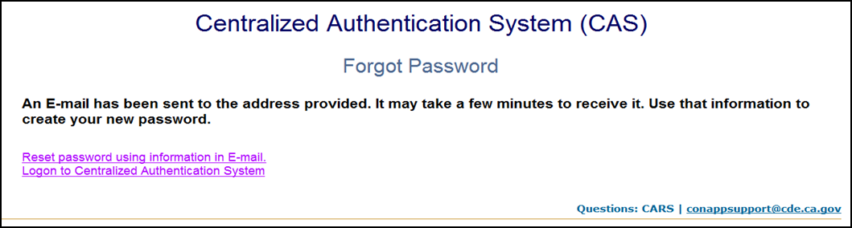

The email sent from CASDoNotReply@cde.ca.gov will contain a Temporary UserID and a Web link, both of which will be needed to reset the password.

Example email:
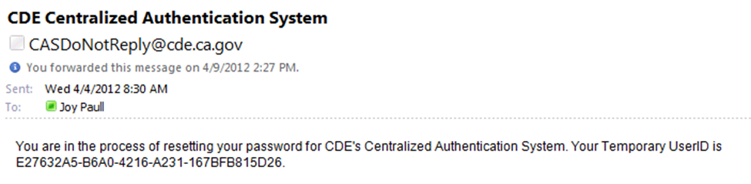

To complete the Forgot Password process:

- Copy the Temporary UserID that appears in the email, but do not copy the period at the end of the sentence.

- Select the Web link provided in the email, and be directed to the appropriate CAS page.

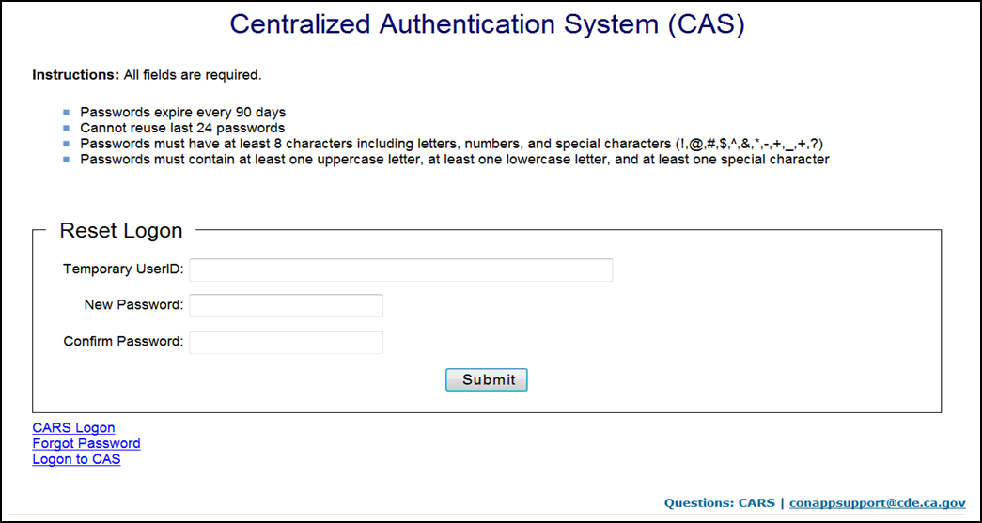

- Paste the Temporary UserID into the Temporary UserID field that appears on the screen.

- Enter a new password and confirm it, following the password requirements previously mentioned in this guide.

- Select the Submit button, then receive a confirmation.

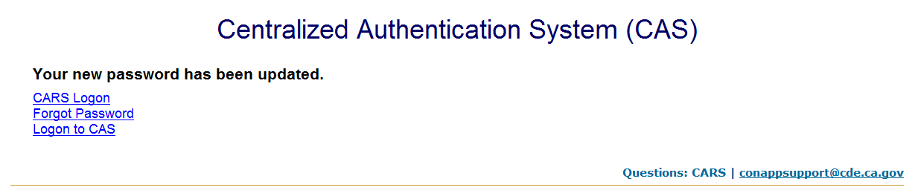

Important notes:

- The Temporary UserID is good for only three hours and can be used just once within that timeframe. If you do not complete all of the Forgot Password steps within three hours of receiving the Temporary UserID, then you will have to restart that process. If you request more than one Temporary UserID, only the most recent one will be valid, even if you did not use the older one(s).

- The user should wait 1-5 minutes between resetting a password and attempting to logon to CARS. This allows time for the CAS data to be forwarded to the CARS database.

Reminders:

- Make a note of the user’s new password and security questions/answers. CARS Support does not have visibility to passwords or security questions/answers and so cannot provide users with that information.

- If the user cannot answer any of the security questions correctly, then the user must register a new username (which must be different from the old username by at least one character) by following instructions in the New User Registration section of this guide.

- CAS is a separate system from CARS. Once registration or changes have been completed in CAS, if the user wants to go to CARS, the user must logon to CARS as a separate action.

- If you are using a browser other than Microsoft Internet Explorer and repeatedly receive a “logon data is invalid” message, close your browser and logon using Microsoft Internet Explorer.

Update Password and Personal Information

To update password and/or personal information, from the CARS Logon page the user may select the Update link. The user will be directed to the CAS Logon page.

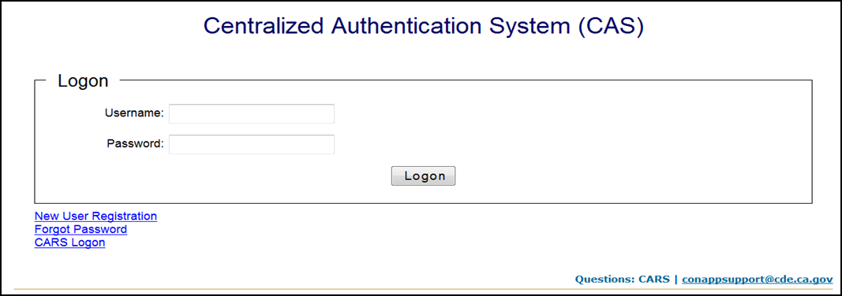

The user will need to log-on to CAS with current user name and password, after which the user will be directed to the CAS Main Menu where one of the update options can be selected.

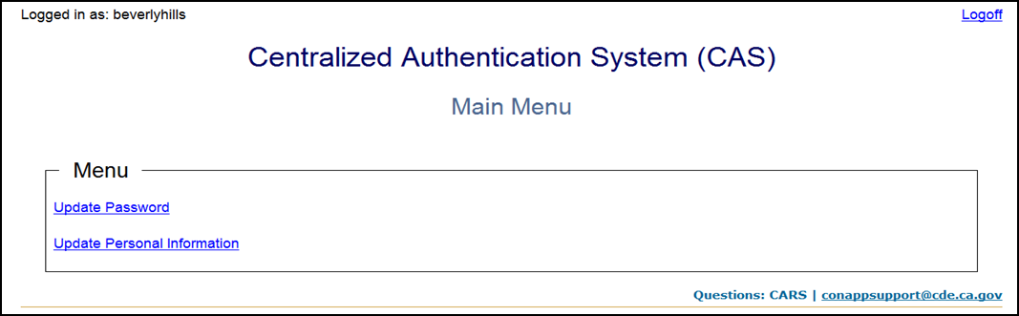

When updating password and/or personal information, remember to adhere to content, format and field requirements as explained in the New User Registration section of this guide.

Reminders:

- If a password has been updated, make a note of the new password. CARS Support does not have visibility to passwords and so cannot provide users with that information. If a password is forgotten, the user must go through the Forgot Password process.

- If you typically have the computer “remember” your password, be sure to clear your cache and previously saved passwords before you reset your password.

- CAS is a separate system from CARS. Once registration or changes have been completed in CAS, if the user wants to go to CARS, the user must logon to CARS as a separate action.

- The user should wait 1-5 minutes between resetting a password and attempting to logon to CARS. This allows time for the CAS data to be forwarded to the CARS database.

If you are using a browser other than Microsoft Internet Explorer and repeatedly receive a “logon data is invalid” message, close your browser and logon using Microsoft Internet Explorer.

Return to Table of Contents

Consolidated Application and Reporting System Access

The CARS is available from the CDE CARS Web page at http://www.cde.ca.gov/fg/aa/co/cars.asp. To access the system, the user must have a user name and password.

The CARS is intended for authorized users only. Unauthorized access to, or use of this system, or any information therein, is strictly prohibited by CDE policy. By using the system, the user is acknowledging and agreeing that all information concerning access to the system, including but not limited to any information entered, stored or retrieved, may be monitored, retrieved, and/or disclosed by authorized personnel, including authorized network administrators and CDE personnel.

For the complete CDE Web Policy the user can click on Web Policy displayed at the bottom of every screen, or on the CDE Web Policy Web page at http://www.cde.ca.gov/re/di/ws/webpolicy.asp.

User Access

The CARS Logon page allows an authorized user, who has been added to the system by a CDE or LEA User Administrator, to logon to CARS. The role(s) assigned to users determines the level of access and functions the user has permission to perform.

Important Note: A user’s access and role is LEA specific. The user must work with each separate LEA to gain access to each separate LEA’s information in CARS.

User Roles and Permission

User roles and system access levels are set according to the CDE specifications. The assigned role determines what functions the user has permission to perform.

A role is a name given to a set of permissions. Permissions are a set of related tasks or functional areas with the system the user is permitted to perform or view. A user may be assigned one or more roles.

Role | Definition | Permissions
LEA Authorized Representative | The LEA superintendent or their designated person responsible for certifying the legal assurance. Also responsible for certifying and submitting data collections. | - The ability to certify the LEA will comply with state and federal legal assurance and compliance requirements.  - The ability to certify one or more LEA data collections to CDE as official data.  - The ability to add, edit and save draft data.  - The ability to download and upload school data.  - The ability to view LEA certified data.  - The ability to view LEA saved draft data.
LEA Data Entry Representative | A user who has the ability to enter and save draft data. | - The ability to add, edit and save draft data.  - The ability to download and upload school data.  - The ability to view LEA certified data.  - The ability to view LEA saved draft data.
LEA General Staff | LEA site user who has an interest in LEA consolidated application information. | - The ability to view LEA certified data.  - The ability to view LEA saved draft data.
LEA User Administrator | A user who is responsible for managing user access and roles. | - The ability to view LEA certified or draft data.  - The ability to access the User Management Tool which allows the user to grant CARS access to other users, and assign or remove roles to those users.

Logon to Consolidated Application and Reporting System

The user must logon to CARS before each session. The Web page will automatically prompt for a user name and password.

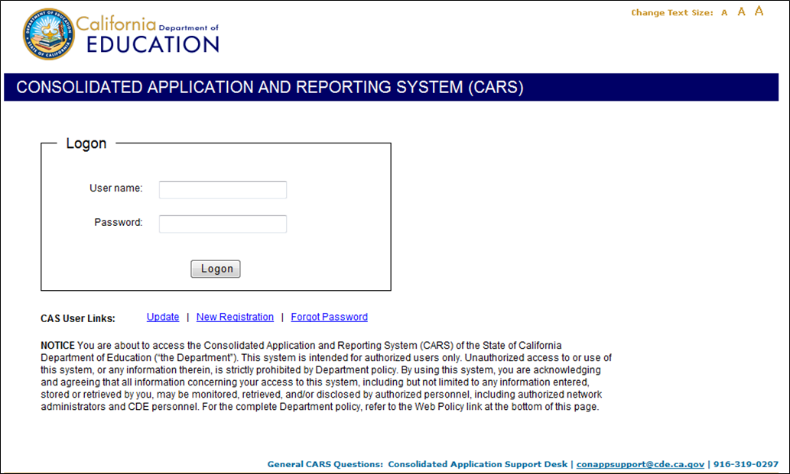

Upon successful logon, if the user is associated with just one LEA, the user will be taken to that LEA’s CARS Home tab. If the user is associated with multiple LEAs, the user will be prompted to Select LEA.

Important Note: The system will automatically log the user off after one hour of inactivity.

If You Forgot Your Password

If a password is forgotten, from the CARS logon screen, click on the “Forgot password” link then follow the instructions provided in the CAS Forgot Password section of this document.

Return to Table of Contents

District or School Information

Information about all California public schools, private schools, school districts, and county offices of education, including district type, status, funding type and school lists, is sourced from the County-District-School (CDS) data file.

A LEA must be active in CDS in order to have access to CARS. Once active, the LEA district type and funding type drive some data collection submissions. An example is: If the LEA is a direct funded charter, the LEA will not be able to apply for funding, view or submit Economic Impact Aid data.

If a change is needed to a LEA’s district type, status, funding type or school list, it cannot be made in CARS; rather, it must be made by the LEA’s authorized CDS Coordinator via the CDS Online Public Update for Schools (OPUS) web application.

Navigation

The CARS is an online system. Except during Site Maintenance, the system is up and available to the user at all times.

The CARS navigation includes subject tabs and hotlinks to specific open items. The browser forward and back arrows are supported in CARS. However, they are not recommended for use during data entry.

Important Note: The system will automatically log the user off after one hour of inactivity.

CARS is designed to be compatible with multiple web browsers including but not limited to:

- Microsoft Explore
- Firefox Mozilla
- Apple Safari

The system has been tested on the three browsers listed above.

Header

The Header displays on all screens and all tabs and includes general information about the LEA, including: the LEA’s full name, 14 character CDS code, and the logon user name.

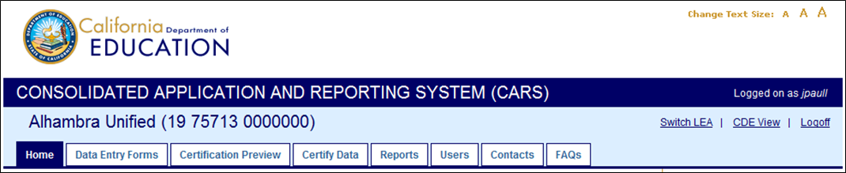
Header
Tabs

To exit the system, click on Logoff; the system will return to the Logon screen.

Switch Local Educational Agency

If a user is associated with more than one LEA, the header will also display Switch LEA in the upper right-hand corner. To change from one LEA view to another, click on the Switch LEA link, then select a LEA from the drop down list.

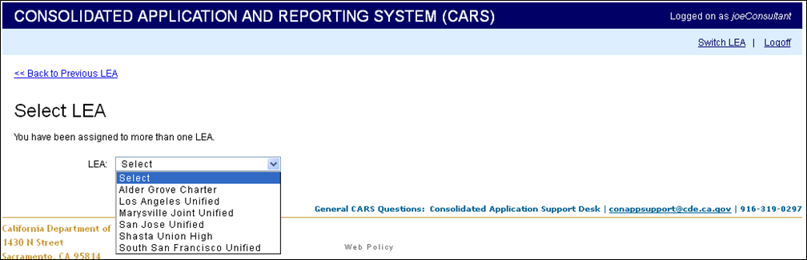

Users will only be allowed to access LEAs that they have been associated with by each LEA’s User Administrator.

Tabs

Tabs for each of the CARS interfaces are found across the top of the header. The tabs are:

Home – Includes all open data collections that require action or have a future deadline date.

Data Entry Forms – Includes all open data collections. User is able to filter data collections.

Certification Preview – Displays all data collections that are ready to be certified, have a status of draft or certified-obsolete, or are certified. It allows the user to view data collection certification dependency and error messages.

Certify Data – Displays all data collections that are ready to be certified, have a status of draft or certified-obsolete, or are certified. It allows a user to certify one or more data collections.

Reports – Includes all open and closed data collection reports. User is able to filter by year, program and submission status.

Users – Allows a LEA User Administrator to manage user access and assign roles.

Contacts – Allows the LEA to identify individuals assigned to key contact types such as Homeless or Foster Youth.

The tab for an area will be active if the user has permissions, based on their access role, to use that interface. Each tab allows the user to view or perform specific functions. Below is a matrix of tabs available by LEA user role:

Tab | Authorized Representative | Data Entry Representative | General Staff | User Administrator
Home | X | X | X | X
Data Entry Forms | X | X | N/A | N/A
Certification Preview | X | X | X | X
Certify Data | X | N/A | N/A | N/A
Reports | X | X | X | X
Users | N/A | N/A | N/A | X
Contacts | X | X | N/A | X
FAQs | X | X | X | X

To select a tab, click on the tab name. The header will not change when a tab is selected.

More information about each tab is provided in the Tabs section of this document.

Return to Table of Contents

Data Collection Cycle

Data collections are typically released as a group on a set schedule. A Spring Release will be available in May and a Winter Release will be available in January. When the system is released, the data collections are open for data entry.

The cycle consists of release for data entry, review by CDE program staff, closed to changes, and access via reports.

The matrix below provides the data collections that will be displayed on each tab based on the data collection’s status over time:

Tab | From initial release up to deadline date. | From deadline date to close date. | After close date.
Home | Data collections with a status of None, Draft or Certified. | Data collections with a status of None or Draft. | N/A
Data Entry Forms | Data collections with a status of None, Draft or Certified. | Data collections with a status of None, Draft or Certified. | N/A
Certification Preview | Data collections with a status of Draft or Certified-Obsolete. | Data collections with a status of Draft or Certified-Obsolete. | N/A
Certify Data | Data collections with a status of Draft or Certified-Obsolete. | Data collections with a status of Draft or Certified-Obsolete. | N/A
Reports | Data collections with a status of Draft or Certified-Obsolete. | Data collections with a status of Draft or Certified-Obsolete. | Data collections with a status of Certified or Certified-Obsolete.

Deadline Date

The deadline is the published due date for the data collection. It is important that the LEA is aware of each data collection’s deadline. In most cases, the deadline for a group of data collections released together will be the same, however there may be exceptions.

It is important that the LEA certify all data collections by the deadline date. Deadlines are set so that the CDE can meet its state and federal reporting requirements. The CDE will not use draft data for state and federal reporting. If data has not been certified by the LEA, the CDE will report zero or missing values for that LEA.

Once a data collection’s deadline is past, certified data collections will not display on the LEA Home page.

Review Period

Once a deadline is past, data collections go into a review period. Several things may occur during the review period:

- CARS support staff and CDE program staff will begin expediting uncertified data collections.
- CDE program staff will begin reviewing certified data collections for validity and compliance.
- Certified data will be used for state and federal reporting.

The review period is data collection specific and the length of time is defined by CDE program staff. The review period is not published.

Data collections with a status of “None” or “Draft” will continue to display on the LEA Home tab. All data collections, regardless of status will continue to display on the LEA Data Entry Forms tab until the close date.

Close Date

The close date is data collection specific and is not published. Once the data collection has closed it cannot be accessed for data entry. Certified data will be available in Reports.

At the end of the review period, the data collection will be closed. Once a data collection is closed, the data collection cannot be modified and all draft data is deleted from the database. Certified data can be accessed via the Reports tab. If a data collection was certified then modified, but not re-certified, the data collection will revert back to its last certified state.

Data Collection Status

The status for each data collection is displayed. This is an “at a glance” status. There are four statuses:

- None: No data have been entered or saved.

- Draft: At least one data element has been entered and saved. Saved data could be incomplete or contain warnings. Draft data is not viewable by CDE program staff.

- Certified: All applicable data elements have been entered, the data collection is error free and the data collection has been certified by an Authorized Representative. Certified data is viewable by CDE program staff.

- Certified-Obsolete: If a change is made to a data collection with downstream data dependency and is certified, if a business rule or calculation is “broken” in a certified dependent data collection, its status will change to Certified-Obsolete. This informs the user that additional action is required.

It is important that the LEA is aware that if a certified data collection is modified and those modifications are saved, the status of the data collection will change from Certified to Draft. The new data entered is not viewable by CDE program staff until it is error free and re-certified.

Return to Table of Contents

Tabs

The Tabs in the CARS have specific functionality. The sections below provide details as to the functionality and how to use each one.

Home Tab

The Home tab is the landing screen after logging on as a specific LEA. The data collections listed on the Home tab are those that are currently open and require action by the LEA.
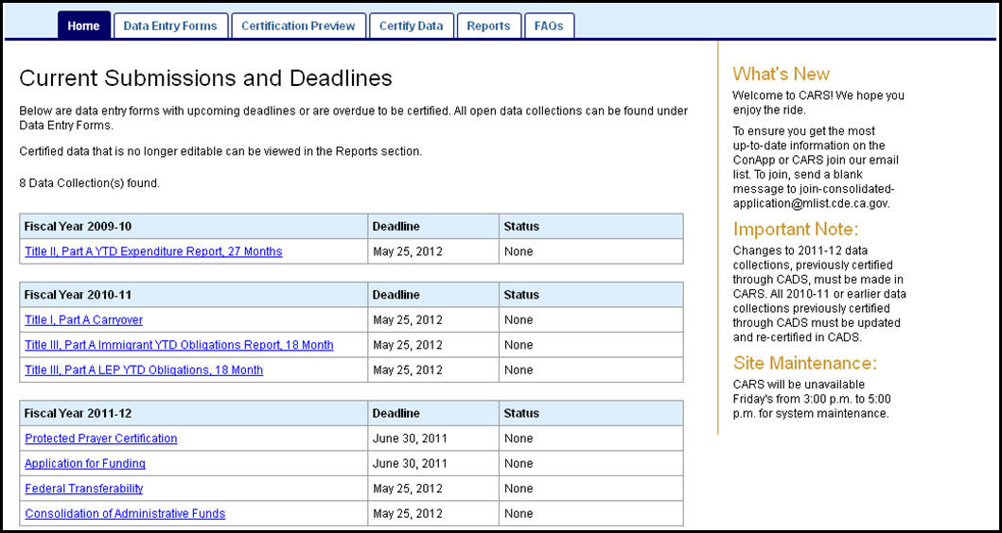
Data Collections
Notices

The Home tab will display the current data collections open for submission, each data collection’s Deadline, and its current Status. Data collections are grouped by Fiscal Year.

Note: The data collections are listed in the order in which the LEA should complete them. It is important that the LEA complete the forms in the appropriate order to ensure data flows appropriately from a source data collection to a dependent data collection.

To view a specific data entry form, click on the data collection name. The system will automatically move to the Data Entry Forms tab and open the selected data entry form.

Clicking on the Return to List button in any data entry form will return the user to the Home tab.

Data Collection Display List

Data collections open for submission will be listed under the Current Submissions and Deadlines title.

The list of data collections displayed is dependent on LEA district type, eligibility lists and decisions made by the user. An example of each:

- District Type: The Title I, Part A Nonprofit Private School Participation and the Other Elementary and Secondary Education Act (ESEA) Nonprofit Private School Participation data collections include nonprofit private schools within a district’s attendance area. If the district type is a County Office of Education (COE), the Title I, Part A Nonprofit Private School Participation and the Other ESEA Nonprofit Private School Participation data collections will never display as there is not an “attendance area” associated with a COE. (Note: We use the term “Relevancy” to describe that the system only displays items that are relevant.)

- Eligibility: Eligibility for Title VI, Part B Rural Education Achievement Program (REAP) is dependent on the LEA meeting the Rural and Low-Income School Program (RLIS) and the Small, Rural School Achievement Program (SRSA) criteria. CDE Title VI, Part B program staff provides a list of eligible LEAs as source data. If an LEA is not eligible based on program criteria, the LEA will not see the option to apply for those funds or the prompt to submit any data collections associated with the program.

- Decisions Made: If an eligible LEA elects to apply for Title I, Part A funds, after the Application for Funds is saved, the LEA will be prompted to submit two additional data collections: Title I, Part A Nonprofit Private School Participation and Title I, Part A School Allocation Plan.

If the deadline date has passed, and the data collection is certified, it will not display on the Home tab. During the review period certified data collections are still accessible in the Data Entry Forms tab.

Notices

Various notices (sometimes referred to as snippets), such as “What’s New,” “Important Notes” and “Site Maintenance,” are included to the right of the Home tab. These notices are used to communicate information such as a new release, known or resolved issues, or changes to the system.

Return to Table of Contents

Data Entry Forms Tab

All data entry forms can be accessed by clicking on the Data Entry Forms tab. All open forms are grouped by fiscal year. The Deadline and Status for each data collection is listed.

Note: The data collections are listed in the order in which the LEA should complete them. It is important that the LEA complete the forms in the appropriate order to ensure data collections, where they depend on data from another data collection, reflect the most current information.

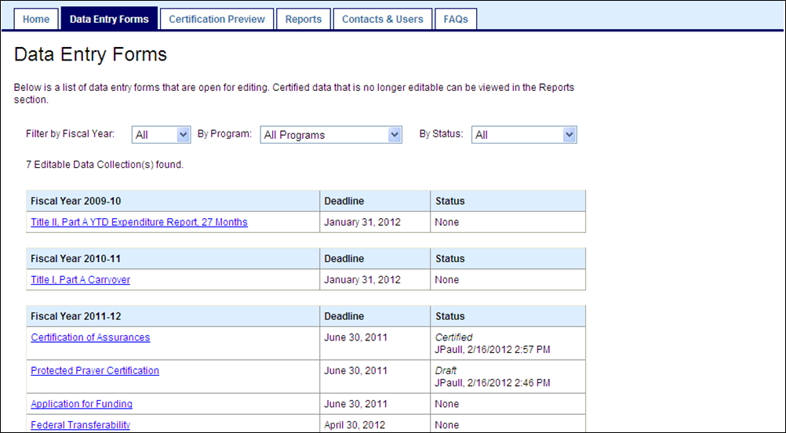

To open a data collection data entry form click on the collection name under the appropriate fiscal year. Data collections are listed in the order they should be completed.

Filters

Multiple fiscal years with numerous data collections may be release simultaneously. Filters are provided to allow you to narrow the selection to relevant data collections.

- Fiscal Year: All data collections that are open for a specific fiscal year are displayed.

- Program: All data collections for a specific categorical program are displayed.

- Status: All data collections with a specific status are displayed.

Return to Table of Contents

Certification Preview Tab

The Certification Preview tab allows users to verify whether or not any messages are associated with a data collection with a status of draft or certified-obsolete.

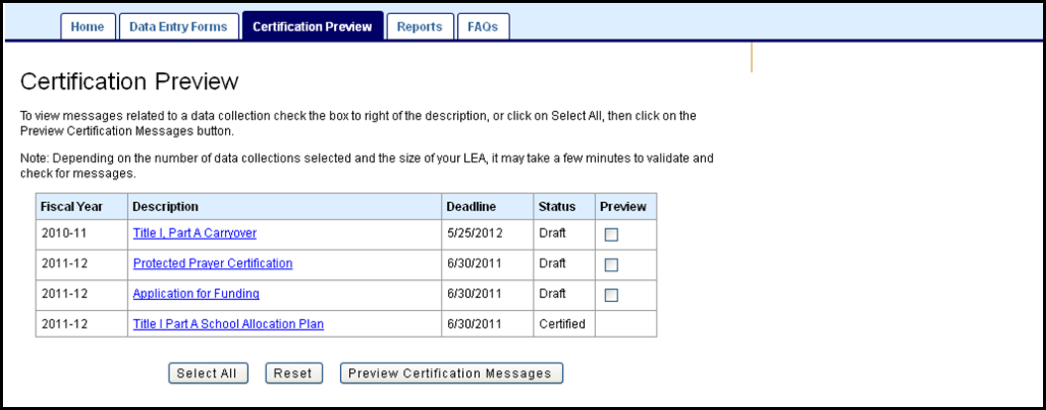

To view any messages associated with a data collection, click the data collection Preview box, then click on Preview Certification Messages. The system will display the certification readiness of the data collection and any messages associated with the data collection.

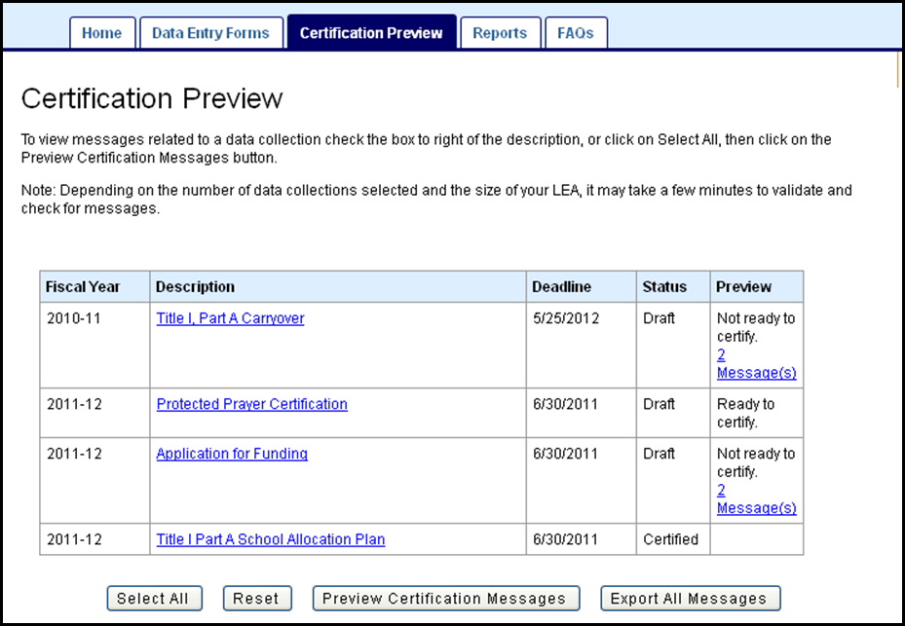

To view the messages, click on the message link.

The message, severity and description will be displayed.

To view all messages click on the Export All Messages button. The messages are exported as an Excel spreadsheet.

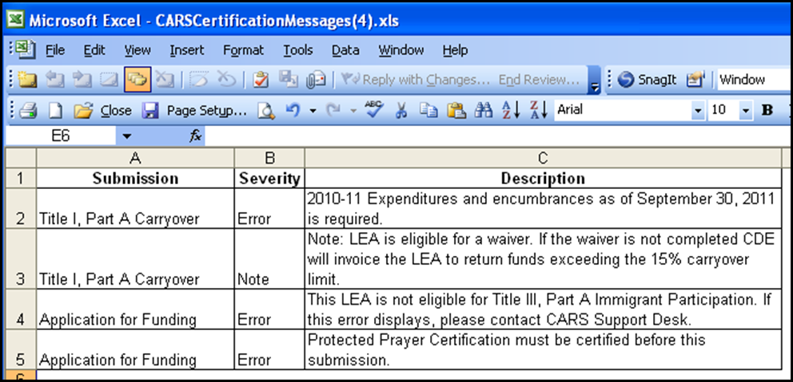

Message Types and Severity Levels

Message types and severity vary. Message types include:

Business rules: Data entered in the form does not meet the categorical program’s requirements. An example is the dollar amount entered cannot exceed a program specified percentage. Some business rules will not prevent a data collection from being certified.

Validation rules: Data entered in the form does not meet a system validation rule. An example is a school does not meet the allowable criteria for the exception code that was entered. All validation rules will prevent a data collection from being certified.

Certification rules: The data collection has one or more data dependencies requiring specific data collections to be certified first.

If business rule or validation errors are displayed, to correct them, click on the data collection name and the system will automatically move to the Data Entry Forms tab and open the selected data entry form.

If the data collection is error free, “Ready to certify” will be displayed in the Preview column.

Ready to certify does not necessarily mean the data entered is complete or correct. It means the data collection is currently error free as defined by the business and validation rules.

Return to Table of Contents

Certify Data Tab

Visibility to and the ability to certify draft data as official is only available to a user with the role of Authorized Representative. The Certify Data tab allows the certification of legal assurances as well as certifies data.

Certification of Assurances

Submission of the Certification of Assurance is associated with the fiscal year Application for Funding. A complete list of legal and program assurances for the fiscal year can be viewed by clicking on the “Program Information” link located in the upper right-hand corner of the Certification of Assurances form. All Legal Assurances can also be found on the CDE Legal Assurances Web page.

Once opened, before any data collections can be certified, the Authorized Representative must complete and certify the Certification of Assurance for the fiscal year.

Once submitted, the certified Certification of Assurances will be displayed as a data collection and can be edited and re-certified by an Authorized Representative.

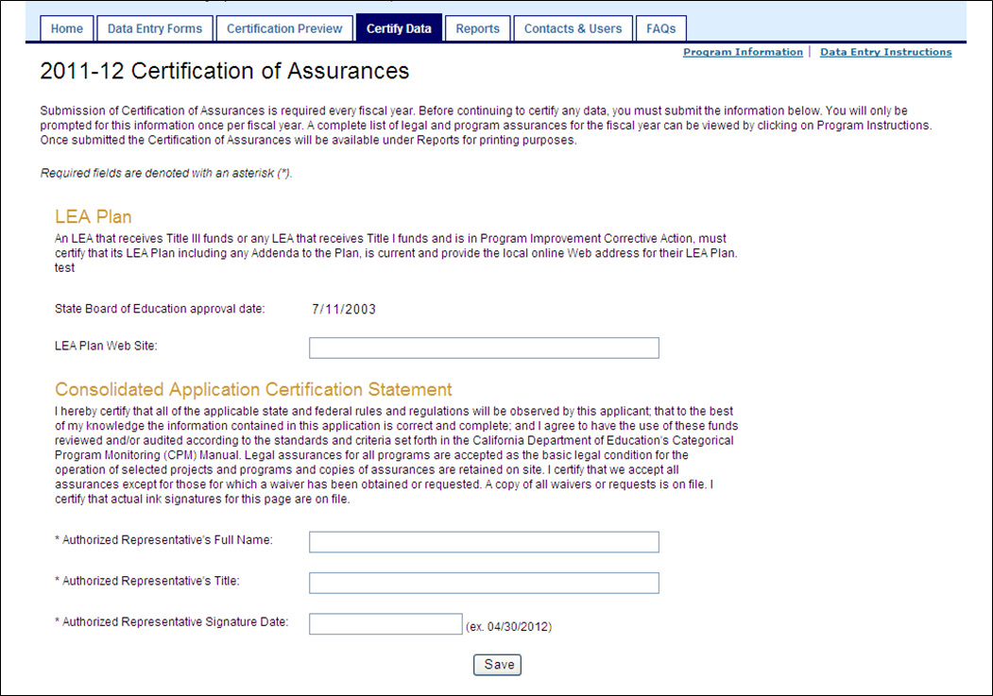

Certification of Data

A data collection will remain in a draft status until an Authorized Representative certifies the data. Certified, also known as official, data is visible to CDE program staff and may be used for public, state and federal reporting.

Data cannot be certified until the Certification of Assurances has been certified for the year. Once the Certification of Assurances is certified, a list of data collections will be displayed on the Certify Data tab.

To certify a data collection, click the check box on the right, then click Certify Submission on the bottom of the screen. Alternatively, all data collections can be certified at once by clicking on the Select All button.

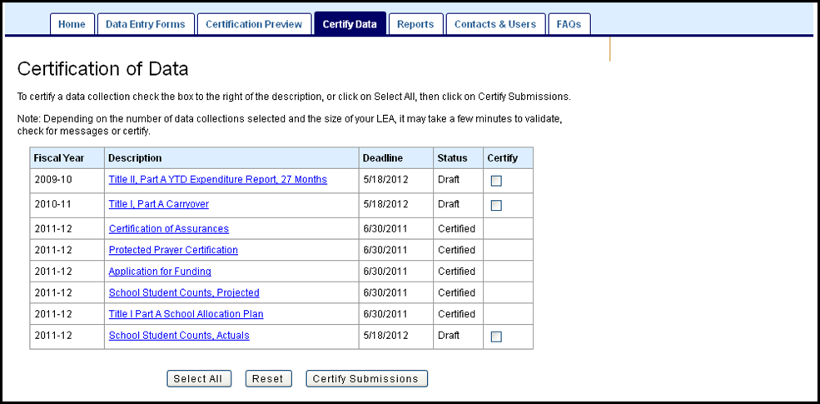

If there are any outstanding errors, the system will not allow the data collection to be certified. The system will display all of the errors associated with the data collection as messages.

To view the messages, either click on the message link associated with the data collection, or to view error messages for all data collections, click on the Export All Messages button.

All errors must be resolved before the system can successfully certify the data collection.

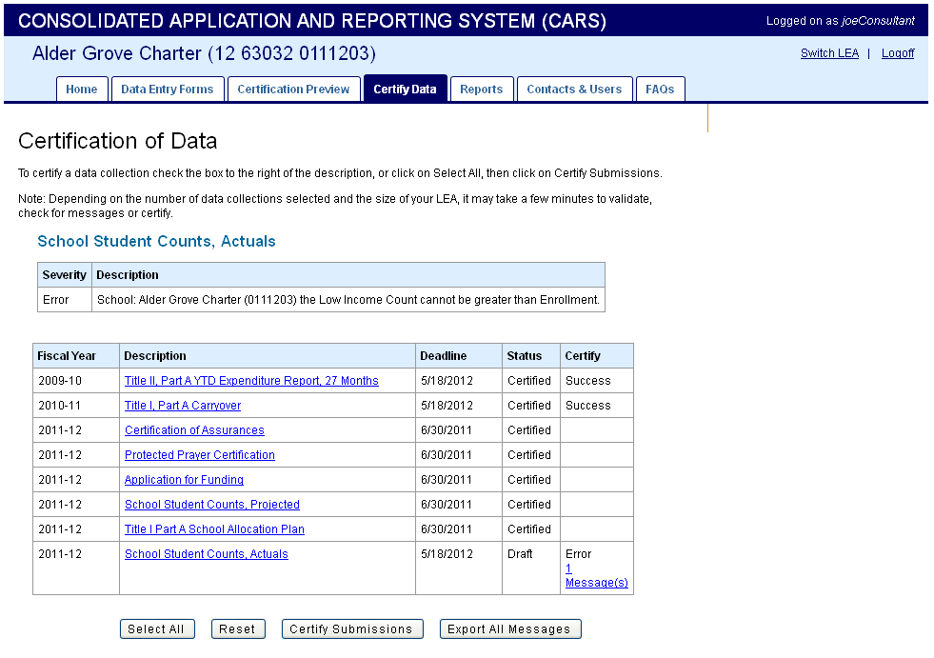

It is important to certify all draft data before the published deadline date. Once a final close date has passed all draft data will be removed from the database.

Return to Table of Contents

Reports Tab

The Reports tab allows the user to see the District Level and School Level Reports for their LEA. Both the District and School Level will show the status of each report and the date and time of the last change. Reports are fiscal year specific; the default displayed is always the current fiscal year. Use the Filter by Fiscal Year to view / print prior year reports.

To view a District level report, select one or more data collections by checking the Select box, or click on the Select All button, then click on the Get District Report button.

To view a School level report, select a single data collection then click on the Get School Report button. Only one school level report can be selected and generated at a time.

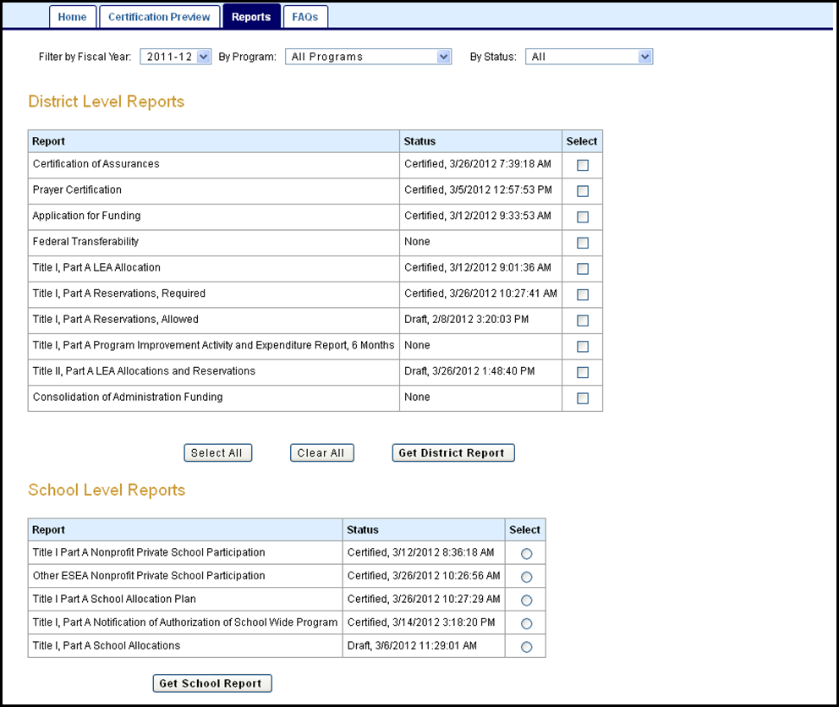

The report will be presented in a PDF file. The file name is automatically assigned the last data collection selected. The user must have Adobe Reader installed on their computer.

Example report:

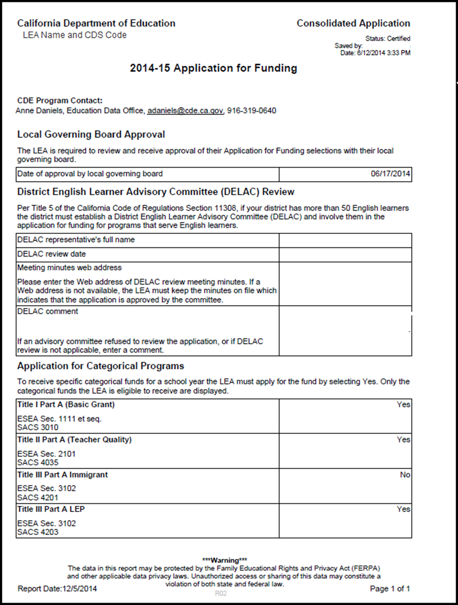
The system will not print a report; once the PDF file is created the user can print the report in Adobe Reader.

Filters

The system allows the user to narrow, or filter, the report selections to a specific fiscal year, program or status.

To filter the list, make a selection from one or more of the drop down selections. The system will not allow the user to select multiple items from the drop down list.

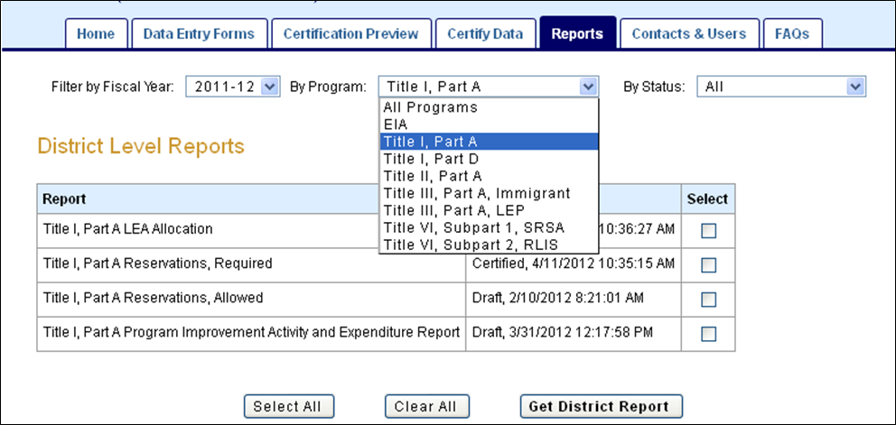

Return to Table of Contents

Users Tab

Through the Users tab, the LEA can manage their LEA’s user access to CARS. This tab is only available to users who have the role of User Administrator.

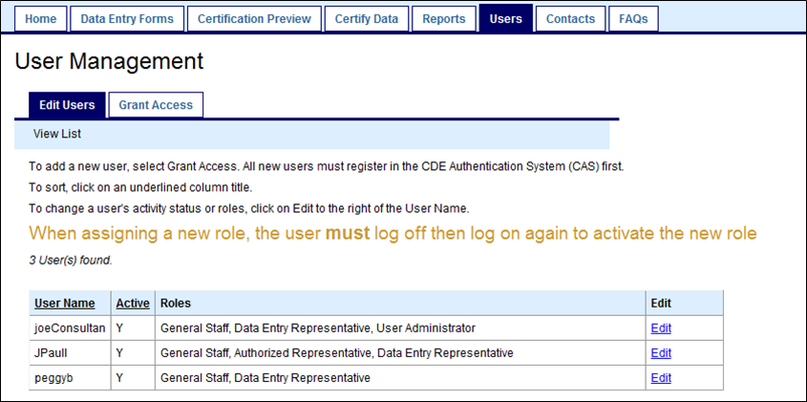

Add a User

The Grant Access tab allows the LEA User Administrator to add a user to CARS. Prior to being given access to CARS, the user must first be registered in CAS. The LEA User Administrator must be advised of the exact user name that the user created in CAS.

To add a new user, the LEA User Administrator must click on the Grant Access tab, enter in the exact user name, and click on the Search button.

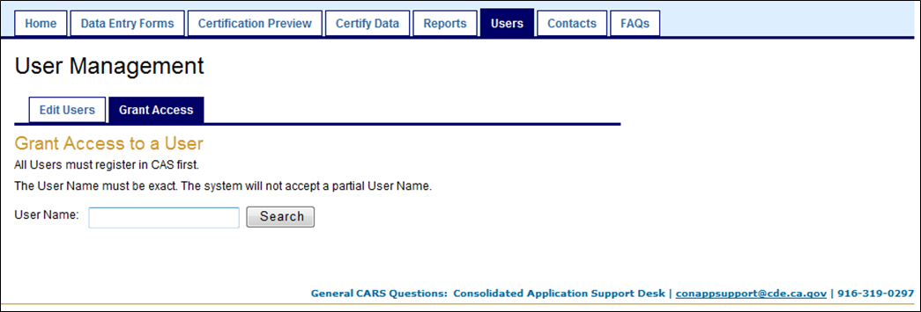

Next, validate the user’s contact information. After the contact information has been validated, click the Save button.

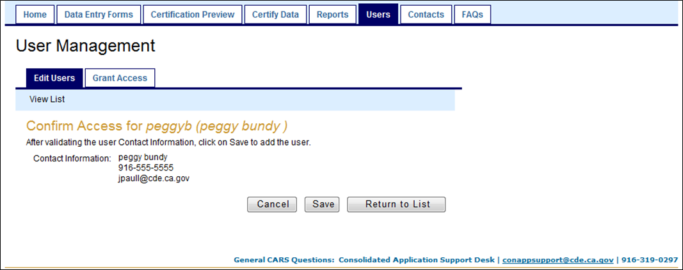

The system will automatically go to the Edit Users tab. Here a message in red font will say that the user access was granted and additional authorization can be added below.

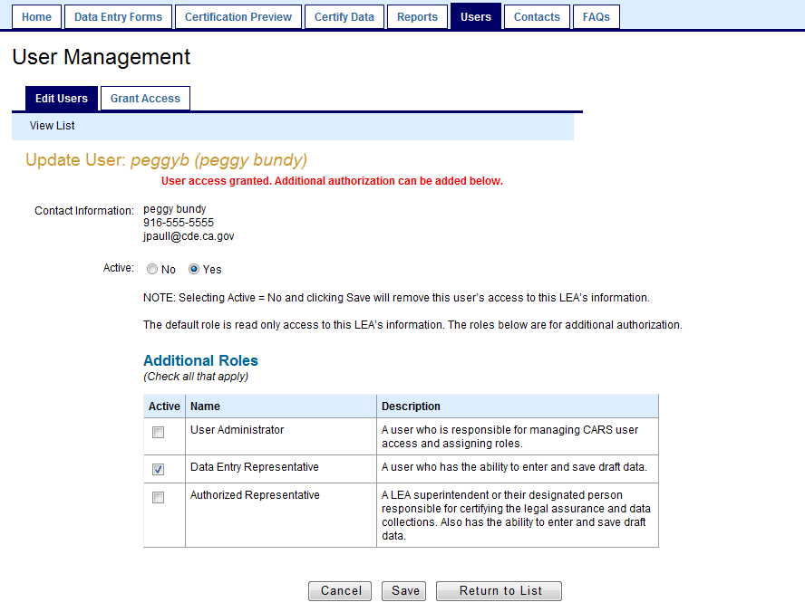

Make sure that the radio button in the Active section is marked Yes. The default role that is assigned to the user is General Staff, or read only. Additional roles do not have to be assigned, but should be reviewed to determine if any more are appropriate for the particular user. Click the Save button.

A message in red font will say Success, indicating that the user was successfully added to CARS.

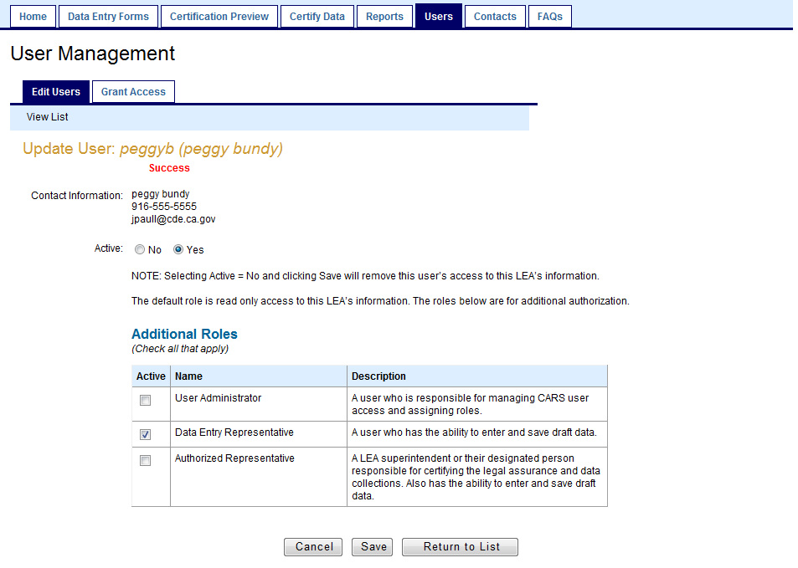

Click on the Return to List button or the View List link to view the user list. The new user added will display with their Active status and Roles.

Important Note: If the LEA User Administrator is correctly adding the user and has received Success messages throughout the process, yet the user is not displayed on their User List, contact the ConApp Support Desk and ask the support staff to check the CDE level activity status. If the user is Inactive at the CDE level, the LEA will be able to add the user to their site, however the user will not be displayed on their user list.

Adding CDE Program Staff

It may be necessary for the LEA User Administrator to add CDE program staff as users in order for them to provide program or technical support. The steps to add CDE Program Staff as General Staff, or read only, users are the same as above.

Important Note: No additional roles should be assigned to CDE program staff other than the default of General Staff, or read only. If additional roles are assigned to CDE program staff, the ConApp Support Staff will remove the roles without notice to the LEA.

Edit a User

To inactivate or change the role(s) of a user, from the Edit Users sub-tab click Edit to the right of the User Name.

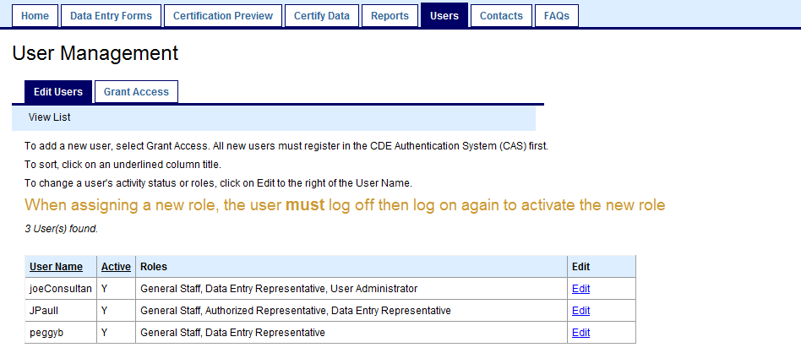

To inactivate a user, click the No radio button. To change the user’s role(s), add or remove checks from Roles. Once the edits have been made, click the Save button. A message in red font will say Success, indicating that the user’s information was successfully edited in the CARS.

Note: After a role has been added, the user will have to log out, then back into CARS to activate the new role.

Return to Table of Contents

Contacts Tab

To assist CDE communications and the CARS/ConApp support staff, and to meet categorical compliance requirements, the LEA must provide Program Contacts. Required contacts are: ConApp Coordinator, Homeless and Foster Youth.
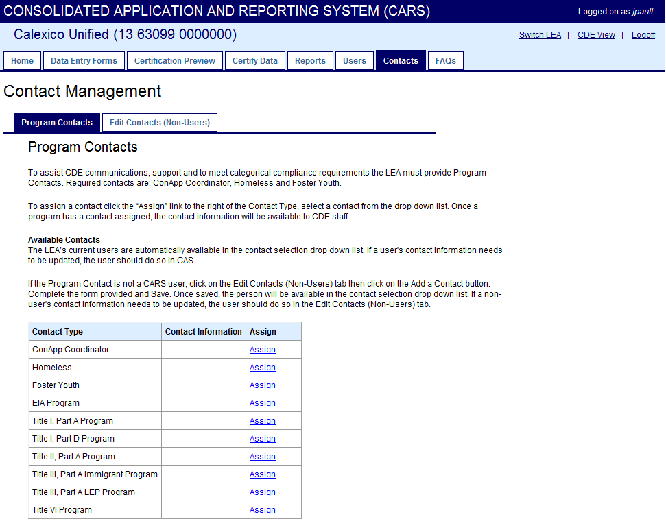

Assign Program Contact

To assign a contact, under the Program Contacts sub-tab click the “Assign” link to the right of the Contact Type. Select a contact from the drop down list below to associate it with this program.

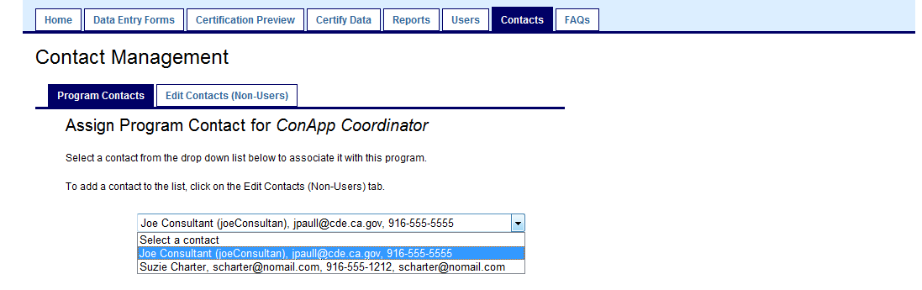

All CARS users are automatically included in the drop down list. If the contact is not a CARS user (non-user) the Contact will have to be created before it can be assigned (see below).

Important Note: If a CARS user's contact information needs to be updated, the user must make the change in CAS. User information cannot be changed in CARS.

Non-User Contacts

If the Program Contact is not a CARS user, click on the Edit Contacts (Non-Users) tab, then click on the Add a Contact button. Complete the form provided and Save. Once saved, the person will be available in the contact selection drop down list. If a non-user's contact information needs to be updated, it should be done in the Edit Contacts (Non-Users) tab, then click on Edit.

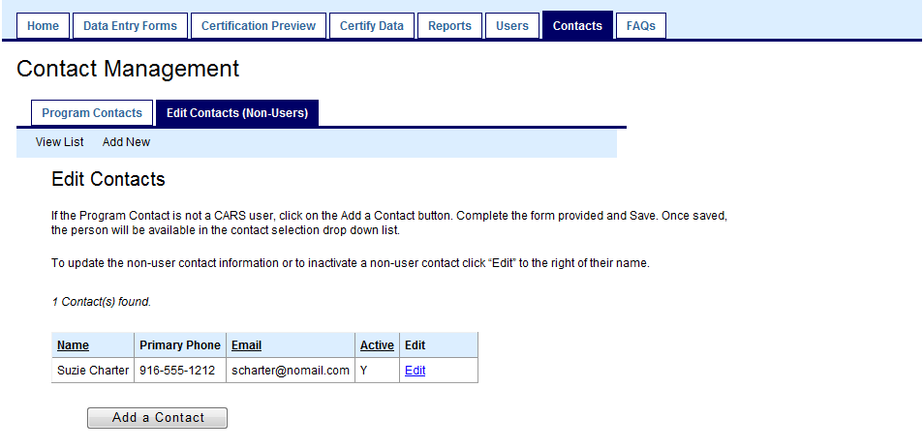

Return to Table of Contents

Frequently Asked Questions (FAQ) Tab

Clicking on the FAQ tab will open a browser window or tab linked to the CDE CARS FAQ Web page http://www.cde.ca.gov/fg/aa/co/cafaqs.asp.

Return to Table of Contents

Data Entry Forms

Data entry forms are used to collect fiscal year and categorical program specific application, financial or participation data from the LEA. The Data Entry Forms tab is available to all users with the role of Data Entry Representative. Only users with the role of Authorized Representative or Data Entry Representative will have the ability to save data. Users with the role of General Staff can access open data collections from the Home tab links.

If the user has read only access each form will display the following message:

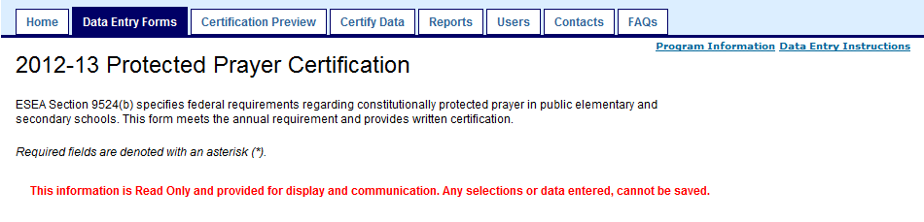

The Save button is also removed from the data entry form.

A data entry form can be accessed from any list by clicking on the data collection description under the applicable fiscal year.

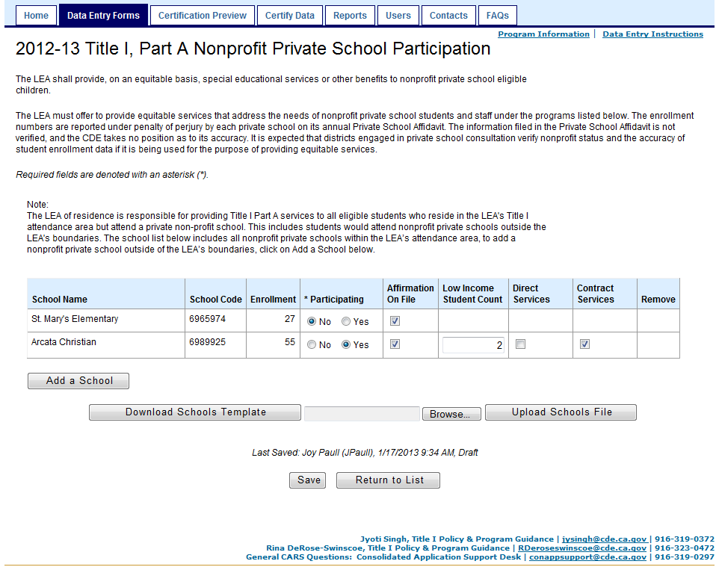
Data Entry Form Example

Each data entry form includes the following items:

- A link to Program Information (located in the upper right hand corner).

- A link to Data Entry Instructions (located in the upper right hand corner).

- Email and telephone information for the CDE categorical program staff designated as the data collection’s primary and secondary contacts (located in the lower right hand corner). Note: The program staff email address is not a hyperlink.

- A Return to List button to return to the data collection list (located at the bottom of the form). Note: The Return to List button will always return the user to the Submissions and Deadlines list on the Home tab.

Program Information

Clicking on the Program Information link will open a new browser window or tab. The link will direct the user to information provided by CDE’s program contact or to the applicable link within the ConApp Program Guidance. The type and level of information displayed will vary depending on the categorical program or data collection’s needs.

All Program Guidance can be found within the CDE ConApp Web page at: http://www.cde.ca.gov/fg/aa/co/.

Data Entry Instructions

Clicking on Data Entry Instructions will open a new browser window or tab. The instructions provide form specific information:

- Purpose statement
- Data collection specific guidance
- CDE Program Staff Contact
- Preloaded data information, if applicable
- Step-by-step procedures to complete the form
- Form specific error messages and how to resolve the error

All data entry instructions can be found within the CDE ConApp Web page at: http://www.cde.ca.gov/fg/aa/co/.

Saving Draft Data

A user with a role of Data Entry Representative or Authorized Representative will have the ability to save data entered into a data entry form.

After clicking on the Save button, the screen will display “Data saved successfully as a draft” if the data was successfully saved to the database.

Do not move to another tab, click on Return to List, or use the browser forward or back arrows until after all data entered has been saved. Otherwise all data previously entered will be lost.

Once a data entry form has been saved, the data collection status will change to Draft.

Important Note: In order for data to be successfully saved all required fields must be completed.

As long as all required fields are completed, CARS will allow partial or incomplete forms to be saved successfully to the database. CARS will also allow data with warnings associated with it to be saved.

If a form is certified, the following message displays in red font: “Note: Your LEA has previously certified this data collection as official. One or more other data collection(s) are dependent on this data collection. Please be aware if a change is saved and certified, it may cause a dependent data collection to become obsolete and your LEA may have to revise and resubmit those data collection(s). Refer to CARS Instructions for details on dependencies.”

If a change is made to a certified data entry form, the status will change from certified to draft. If applicable, the data collection must be re-certified. Currently the system is not able to revert back to the last certified version.

If a data collection was previously certified, and a change is saved, the status will change from certified to draft. The data collection must be re-certified to be considered official data. Also, if the change(s) made to a certified data collection would cause data in a dependent data collection to fail a data edit check, the dependent data collection’s status will be changed to certified-obsolete and the LEA will need to open the dependent data collection to resolve all errors and re-certify. Refer to the Certification Dependency Management section for more information about dependencies, certification, and the certified-obsolete status.

Error and Warning Levels

A warning or error message will be displayed if any of the following are true:

- Required data and parameters are not met

- A business rule enforced by the system is not met

- A certification dependency exists

- A business rule applies, but is not enforced by the system; these messages are displayed as a note when the form is saved

The severity and impact of a warning or error is dependent on whether it is displayed in a data entry form or the Certification Preview and Certify Data tabs.

Required Data or Parameters

There are three types of errors related to required data or parameters:

- The field is required and cannot be blank or null. These are flagged with an asterisk (*). If not entered the system will not allow the form to be saved.

- The field is enforced by required parameters such as a minimum and maximum date range or numeric value.

- The display of the field is dependent on specific conditions; if those conditions are met, the field is required and cannot be blank or null.

The screen below displays an example where each required data error is true.

- Title I, Part A Application Flag is required: The field is required and cannot be blank or null. It is flagged with an asterisk (*).

- Local Governing Board Approval Date cannot be beyond July 31, or if today’s date is after July 31 greater than today’s date.

- Title III, Part A Immigrant Participation selection is missing. Either Yes or No must be selected: The display of the field is dependent on meeting the eligibility conditions. Since the LEA is eligible, the field is required and cannot be blank or null.

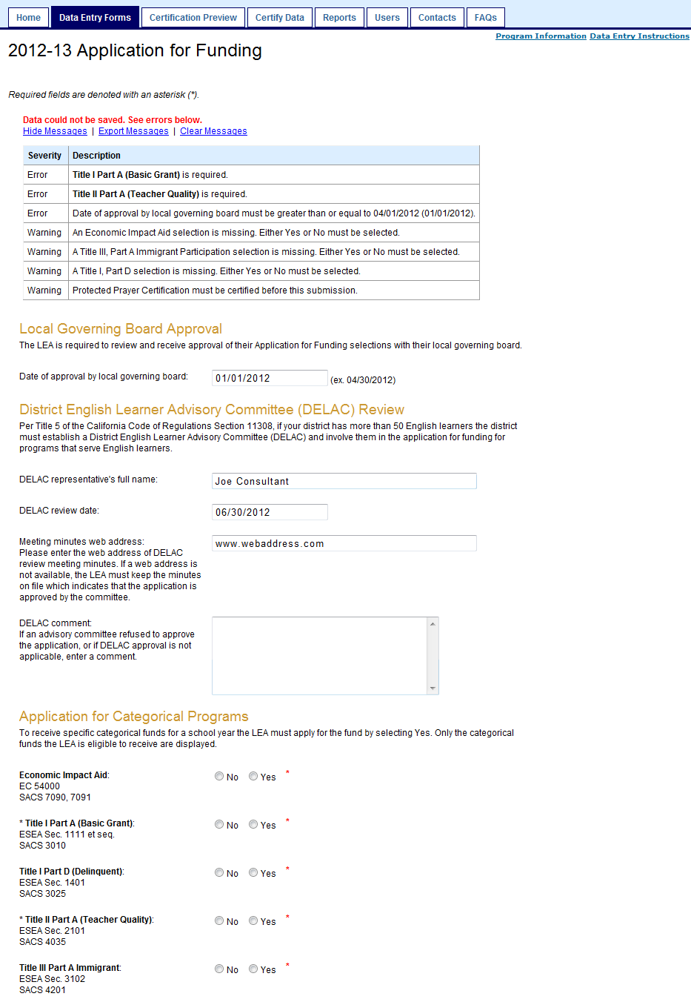

Required data or parameter errors must be corrected before any of the data entered can be saved.

Business Rules Enforced by the System

CARS will enforce business rules, as defined by CDE program staff, to support the reporting of or to enforce the compliance of state and federal requirements.

CARS will allow a user to save draft data that does not meet defined business rules or is incomplete. The system will display warning messages associated with the business rule(s) and/or missing data.

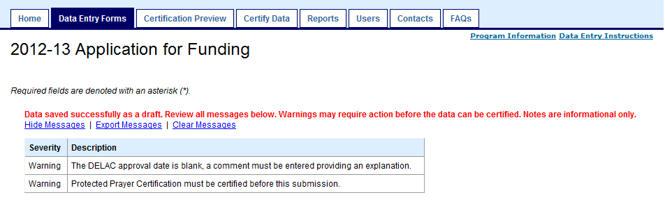

Even if the data does not pass the data validation checks, it can be saved, but all warnings related to the business rules and incomplete data must be resolved before the data can be certified.

- Tip: Clear all data related warnings on a data collection before proceeding to the next data collection in a dependency pathway. All errors must be cleared before the data collection can be certified.

Once data is entered, it is important to click the Save button before continuing to another data entry form or tab. Otherwise your data will not be saved. After clicking Save, the system checks the data to see whether it passes data validation checks.

Certification Dependency

When a data dependency exists between two data collections, the source data collection must be certified before the dependent data collection. The system will display a warning message advising the user of certification dependencies if the source data collection form is optional and is not already certified when the dependent data collection form is saved.

“Must be certified before this submission” messages will prevent a dependent data collection from successfully certifying if the source data collection is not already certified.

Similarly, the system will display a warning message when a source data collection form, that was previously certified, is saved and a data dependency exists.

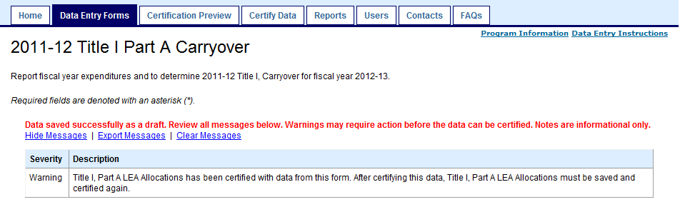

In the Certification Preview or Certify Data tabs, if the source data collection form is required and is not already certified an error message will display advising the user of the certification dependency.

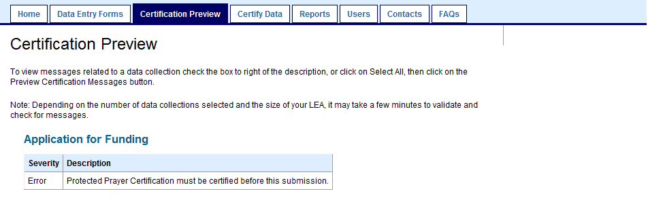

Return to Table of Contents

Download Schools Template / Upload Schools File

All school level data collections can be downloaded to an Excel spreadsheet, the data modified, then uploaded back to the data collection data entry form.

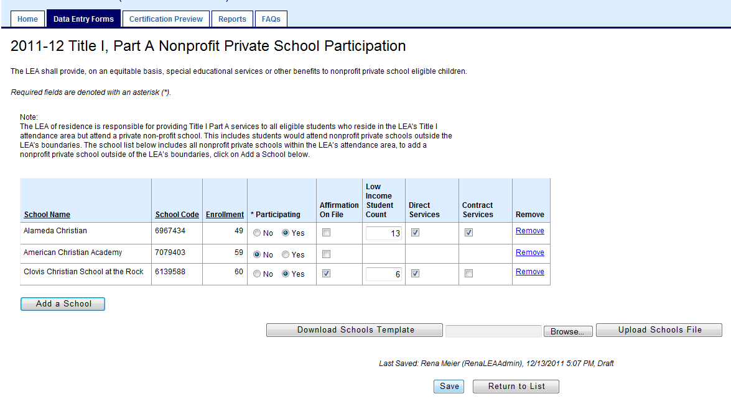

- Click the Download Schools Template button. The File Download screen will be displayed.

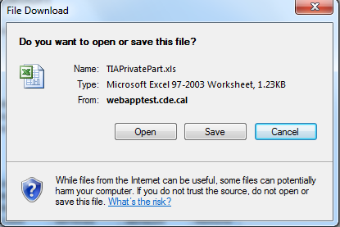

- Select Open in File Download screen. The template data file will open in Excel format.

Note: If a box is displayed on the screen, asking the user to confirm that the file has not been corrupted, click the Yes button.

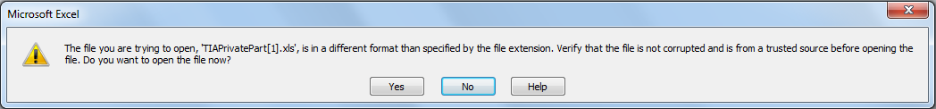

- Make any necessary data changes and save the file using the Save As option.

Note: If you use Save instead of Save As, the file may not be saved in the proper format and you will not be able to upload the file.

- Navigate to the folder where you want to save the file.

- Enter a file name, select the Excel 97-2003 Workbook (*.xls) file type (default is Web page .html) and click the Save button.

Important Note: At this time CARS will only access “.xls” type files.

- Close the Excel file.

- Click the Browse button on the data collection screen and select the file you want to upload.

- Click the Upload Schools File button on the data collection screen.

- If the upload is successful, the following message will be displayed at the top of the form:

“Data has been uploaded in this data collection form. Click the Save button to store draft data.”

Note: If there are problems with the upload, the following error message will be displayed at the bottom of the page above the Upload Schools File button:

“Uploaded file contained no data or was not a properly formatted Excel file.”

Things to know:

- The files are full replacement.

- If a school is missing no error is given, the existing data displayed in the grid remains the same.

- If the LEA changes non-user entered column data, the system does not recognize those changes. Example: if a school’s low income student count in the Title I, Part A School Allocations downloaded file is changed, the system will not change the number when it uploads. That change must occur in School Student Counts, Actuals.

- If a field is numeric and the LEA enters alpha characters, and no error is given. Any previously entered values are deleted.

- If it is a data entry column, the system will accept calculated values from the spreadsheet. Example: cell value equals "=234 + 230", system will load 464 or " =12457000/(SUM(D2:D54))" the system will load the result.

- If a valid, non-attendance area school is added to any file, the system ignores the record, and no error is given. The exception to this is Title I, Part A Nonprofit Private School Participation; this data collection will accept a non-attendance area nonprofit private school added to the spreadsheet.

- For Title I, Part A Nonprofit Private School Participation, if a non-attendance area nonprofit private school (previously added to the schools list) is removed from the spreadsheet, the system will clear all data for that school after the file is uploaded but it will not remove the school from the form grid. The LEA will have to manually remove the school.

- Y / N (Yes / No) values must be capitals or the system will not accept the record.

- No matter the number of rows, with the full replacement, if one row fails nothing will load.

- For Title I, Part A Nonprofit Private School Participation, if a public school is added the following message appears:

“Data has been uploaded into this data collection form. Click the Save button to store the draft data. The batch file included the school listed below. The school does not meet the requirements for this data collection and will not be loaded. If you feel this is incorrect, please contact the CARS Support Desk.”

Note: The file will successfully upload, ignoring the invalid item(s).

Error Messages

Below are descriptions and examples of each error message type. Error messages when uploading are not very user friendly:

Example message:

Severity | Description
Error | Invalid School Code for this LEA. (093999) Row #1
Error | Invalid number of columns found in data file Expected number of columns = 20. Total columns in file = 7
Error | Invalid value for "Affirmation On File" in row #6 Expected value: Y or N. Actual value: y

The row number is the row in the spreadsheet.

Error Message | Description
Check for invalid values in DATE type columns. | Invalid data type for value. DATE type was expected. (<ACTUAL VALUE SUBMITTED BY USER>) Row #<ROW NUMBER>  - Invalid data type for value. DATE type was expected. (4) Row #2  - Invalid data type for value. DATE type was expected. (feb) Row #6
Check for invalid values in INTEGER type columns. | Invalid data type for value. INTEGER type was expected. (<ACTUAL VALUE SUBMITTED BY USER>) Row #<ROW NUMBER>  - Invalid data type for value. INTEGER type was expected. (p20) Row #4  - Invalid data type for value. INTEGER type was expected. (zzz) Row #1
Check for data rows that contain a fewer number of columns than what is expected for the data collection. | Invalid number of columns found in data file. Expected number of columns = <EXPECTED # OF COLUMNS>. Total columns in file = <ACTUAL COLUMN COUNT SUBMITTED BY USER>  - Invalid number of columns found in data file. Expected number of columns = 15. Total columns in file = 12  - Invalid number of columns found in data file. Expected number of columns = 9. Total columns in file = 8
Check for rows with invalid school codes (school codes that do not exist in CDS database). | Invalid School Code for this LEA. (<SCHOOL CODE SUBMITTED BY USER>) Row #<ROW NUMBER>  - Invalid School Code for this LEA. (9999999) Row #6  - Invalid School Code for this LEA. (9999999) Row #6
Check for invalid values in fields. Display Field Name as part of message. | Invalid value for "<FIELD NAME>" in row #<ROW NUMBER> Expected value: Y or N. Actual value: <ACTUAL VALUE SUBMITTED BY USER>  - Invalid value for "Fund Flag" in row #5 Expected value: Y or N. Actual value: y  - Invalid value for "Participating" in row #0 Expected value: Y or N. Actual value: Participating
Check for values with invalid lengths (length greater than maximum of 300). | Value length > MAX length (<LENGTH OF VALUE SUBMITTED BY USER>) Row #<ROW NUMBER>  - Value length > MAX length. (251) Row #1  - Value length > MAX length. (307) Row #1
Check for invalid format of the batch upload file. | Uploaded file contained no data or was not a properly formatted Excel file.
The batch file included the school listed below. The school does not meet the requirements for this data collection and will not be loaded. If you feel this is incorrect, please contact the CARS Support Desk. | Example:
  School Name | School Code
  John C. Kimball High | 0119040

Return to Table of Contents

Add a School

Two data collections, Title I, Part A Nonprofit Private School Participation and Other ESEA Nonprofit Private School Participation, have the option to add non-attendance area nonprofit private schools to their existing list of attendance area nonprofit private schools. Any non-attendance area schools to be added to the list must already exist and be active in the CDS database.

The Add a School button shows up in Title I, Part A Nonprofit Private School Participation data collection form for LEAs that have elected to participate in Title I, Part A. The Add a School button shows up in Other ESEA Nonprofit Private School Participation data collection form for non-unified LEAs, if the LEAs have elected to participate in Title II, Part A.

The forms and this process do not apply to county offices of education or direct funded charters.

Districts Without Attendance Area Nonprofit Private Schools

If a district does not have any attendance area nonprofit private schools within its boundaries, and therefore a list of schools does not prepopulate into the form, in order to gain access to the Add a School button the LEA must first designate that they want to add non-attendance area schools by changing the form’s default flag from No to Yes. After setting the flag to Yes, the Add a School button will be displayed with the column headers of the school list.

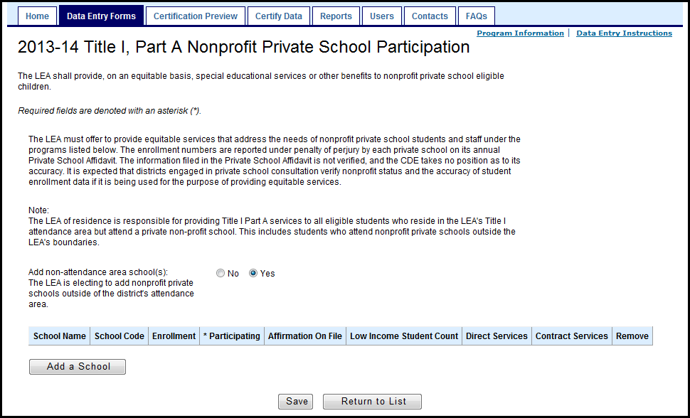

How to Add a School

A non-attendance area nonprofit private school can be added to the forms by either clicking on the Add a School button or by adding a valid school to the Upload Schools File.

To add a school via the Add a School button:

- Within the form, click on the Add a School button.

- Search for a school by entering either all or part of the school name or CDS Code.

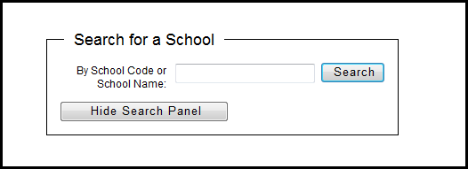

- From the results list, Select a school.

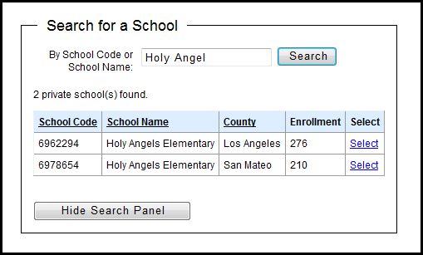

- The school will be added to the school list.

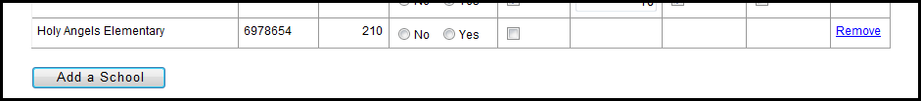

To add a school via the Upload Schools File button:

- Within the form, the option to click on the Download Schools Template button will be available if there is already at least one school displaying in the list; select this button.

- Add the school to the spreadsheet. Note: the only required field is the CDS School Code.

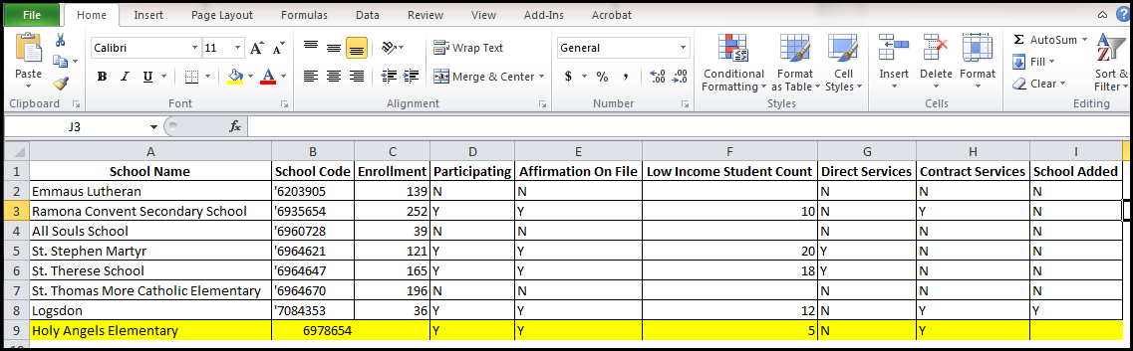

- Save the spreadsheet with a .xls file extension.

- Click on the Browse button. Find, click on and open the saved file.

- Click on the Upload Schools File button. You should receive the following message: Data has been uploaded into this data collection form. Click the Save button to store the draft data.

How to Remove a School

To remove a school, click on the Remove hyperlink, then save the form.

Note: After clicking on the Remove hyperlink, the school is removed from the form’s displayed list, but it is not removed from the database until after the form is saved.

Return to Table of Contents

Appendix A - Generic Process Flow

The diagram below is a generic work flow using the tabs available to a LEA as defined by the user’s role.

Appendix B - Glossary

Term | Definition
Business Rule | A system validation rule that enforces a business or categorical program requirement.
Certification Dependency | A list of which data collections must be certified with or before the data collection.
Certified | Error free data that an authorized representative of the LEA has flagged as official. A data collection status.
Certified-Obsolete | A data collection status automatically set by the system. The status changes when the initial data collection status is certified and a source data collection has been modified and certified causing a data dependency validation rule to fail.
Close | The date a data collection is closed to new submissions.
Data Collection | A logical group of individual data items collected and submitted as a collection. A group of related data elements displayed.
Data Collection Dependency | A list of which data collections should be completed before entering data on a particular data collection.
Data Dependency | The completion of a data collection is dependent on data from a source data collection
Data Dependency Path | Data dependencies may follow a path linking multiple data collections together. The data collections are linked by a flow, or path, of data. An example would be Title I Part A LEA Allocations to Reservations-Required to Reservations-Allowed to School Allocations.
Data Element | A collected data item or field.
Data Entry Form | A method to collect specific categorical program data or data elements.
Deadline | Defined by CDE program staff, the date a certified data collection is due.
Dependent Data Collection | A dependent data collection has a data or certification dependency on one or more data collections. Example: Title I Part A Reservations-Required is dependent on LEA Allocations, as source data collection.
District Type | Structure of a LEA used to determine eligibility and reporting requirements. Types include district, county office of education and direct funded charter.
Draft | A data collection status. Preliminary data that has been saved by the LEA. Data may be incomplete or contain warnings or errors.
Error | A business rule or system requirement that has not be been met. An error may prevent saving data at the time it is entered or certifying draft data.
Full File Replacement | Pertains to uploading school level data. All school level data, or records, must be uploaded versus uploading partial data, or a single record.
Funding Type | The term applies to how a charter school is funded by the state. Types include direct and local.
Hide / Show Functionality | Data entry form displays based on eligibility criteria or decision made by the user.
Migrated Data | For the initial release of CARS, 2011–12 ConApp Part I data was extracted from the CADS database and mapped and imported into CARS data collections.
Official Data | Data certified by the LEA. It may be used by CDE for state and federal reporting.
Program Staff | CDE personnel that provide categorical program business expertise and support.
Relevancy | Data elements or data collections that pertain to a LEA based on LEA structure, business rules or decision made.
Review Period | An unpublished period of time after the deadline date used by CDE to expedite outstanding data collections or to validate certified data. The review period is data collection specific and as such may vary in length.
Role | The name assigned to a group of system permissions. Examples include: Data Entry Representative and Authorized Representative.
Role (system) Permission | The unique views or functionality assigned to a role. Examples are the ability to certify a data collection, the ability to edit data, or the ability to view draft data.
Source Data | Data provided by another system, group, or person. Examples include: CSD, or an eligibility or exception list provided by CDE program staff.
Source Data Collection | A data collection that has one or more data collections with either a data or certification dependency on it. Example: Title I Part A LEA Allocations is a source data collection to Reservations-Required, which is a dependent data collection.
User Role | A role assigned to a specific user. The role has specific permissions assigned to it. Examples include: Authorized Representative, Data Entry Representative and LEA General Staff.
Validation Rule | A system rule that is used to enforce data integrity or business rules.
Warning | A business rule that has not been met at the time the data is entered. A warning will allow data to be saved as draft but may not allow a data collections to be certified.

Return to Table of Contents

