FISCAL YEAR 2020-21
Principal Apportionment
Data Collection and Tax Software
Version 20.00

INSTALLATION GUIDE
October 2020
California Department of Education
School Fiscal Services Division
1430 N Street
Sacramento, CA 95814

Table of Contents
Introduction 1
System Requirements 1
Document Conventions 1
Software Installation 3
Downloading and Installing the Software from the Internet 3
Downloading from Internet Explorer 3
Installing the Software 3
Setting Compatibility Mode 9

Table of Figures
Figure 1: InstallShield Wizard Window 4
Figure 2: Windows Installer Window 4
Figure 3: Welcome Window 5
Figure 4: Customer Information Window 5
Figure 5: Destination Folder Program Window 6
Figure 6: Database Folder Program Window 6
Figure 7: Install Program Window 7
Figure 8: Installation Progress Window 7
Figure 9: Installation Completed Successfully Window 8
Figure 10: Compatibility Mode Window 9

Introduction
This document is the Installation Guide for the California Department of Education (CDE) Principal Apportionment software, and it covers installation of the data collection and tax software packages. Understanding basic Windows functions and procedures, such as clicking, double clicking, right clicking, etc., will assist you in installing and using the software.
This Installation Guide is designed to be common to the Tax Software and the Principal Apportionment Data Collection (PADC) Software. The steps involved with installing the two separate packages are the same, with the exception of the self-extracting executable download and install files. For example, the Tax Software begins with tax2020vxxxx.exe file, and the PADC Software begins with the padc2020vxxxx.exe file.
Note: If you install the PADC Software package, it is not necessary to separately install the Tax Software package. County offices of education should install the PADC Software package. However, because First Principal taxes are due to CDE before the release of the PADC Software, some county offices may choose to install the Tax Software package as well. County auditors should install the Tax software package. School districts and charter schools should install the PADC Software package to submit attendance and other data to their county office of education.
For instructions on using the software packages, please refer to the user guides and/or the reporting instructions which can be found on the CDE Software & Forms web page at https://www.cde.ca.gov/fg/sf/. Select the appropriate software package and fiscal year.

System Requirements
The installation of the Principal Apportionment Software requires approximately 10–40 MB of hard disk space on a Windows based PC.

Document Conventions
This document uses the following conventions to describe functions and procedures in the software:

Window
Names
Commands
Image Names
Important Notes
The names of windows, screens, and dialogue boxes use title case, such as:
Save As window
User Information screen
Commands are operations you must follow in order to perform certain functions in the software. Bold face font is used, such as:
Select Print from the File menu
Click the OK button
Images, or pictures, are described as Figures and use Italic face font, such as:
Figure 1: Diagram of the data process.
Notes include important statements regarding steps you may need to take. They are highlighted in gray, with a black border on the top and bottom, such as:
Note: Important note here

Software Installation
This section describes software installation in Windows from the internet.

Downloading and Installing the Software from the Internet
The latest versions of the software are available on the CDE Software & Forms web page at https://www.cde.ca.gov/fg/sf/.
Note: Depending on the browser used, the downloading instructions may be different than described below.

Downloading from Internet Explorer
- Navigate to the CDE Software & Forms web page at https://www.cde.ca.gov/fg/sf/.
- Select either Tax Collection or Principal Apportionment Data Collection.
- Select the Fiscal Year.
- Click on the tax2020vxxxx.exe or padc2020vxxxx.exe file.
Note: To download the PADC Software click on the appropriate links, then the padc2020vxxxx.exe file, respectively. The various setup windows and dialog boxes will be specific to the software you are installing.
- A dialog box will display asking if you want to run or save the file.
- If you want to run the file, select Run and the installation process will begin.
- If you want to save the file, select Save to save the file to the default folder or select Save As to save the file to a specific folder. (For example, you might save your file to the Desktop so you may quickly find it.)
Note: Be sure you have closed all other applications.

Installing the Software
- Locate the downloaded file (ex. tax2020vxxxx.exe or padc2020vxxxx.exe) and double-click on it to start the installation process.
- The InstallShield Wizard window displays (Figure 1).
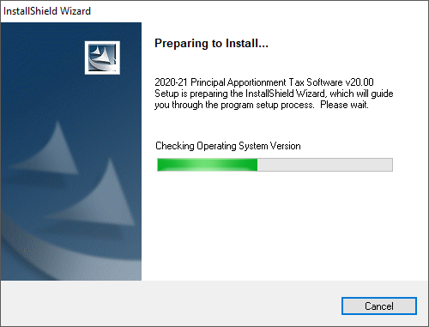
Figure 1: InstallShield Wizard Window
- The Windows Installer window displays (Figure 2).
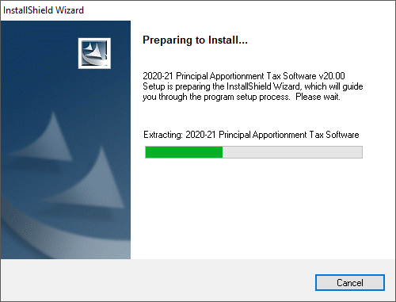
Figure 2: Windows Installer Window

- The Welcome window displays (Figure 3).
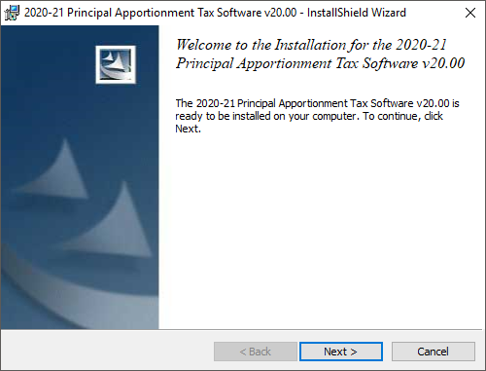
Figure 3: Welcome Window
- Click the Next button. The Customer Information window displays (Figure 4).
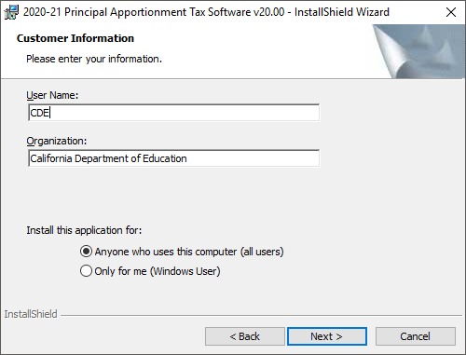
Figure 4: Customer Information Window

- Click the Next button. The Destination Folder Program window displays (Figure 5).
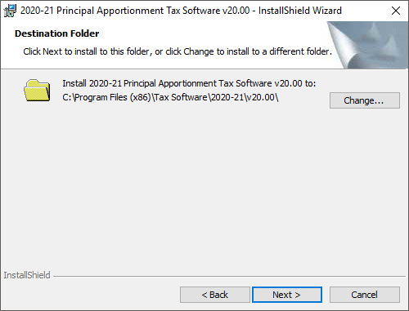
Figure 5: Destination Folder Program Window
Note: Accept the default location for the Destination Folder.
- Click the Next button. The Database Folder Program window displays
(Figure 6).
Note: Accept the default location for the Database Folder.
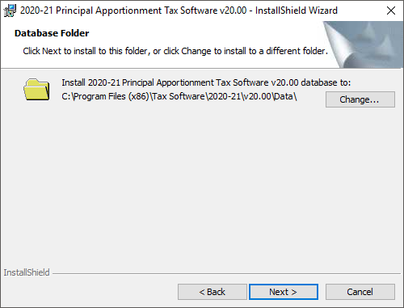
Figure 6: Database Folder Program Window
- Click the Next button. The Ready to Install the Program window displays (Figure 7).
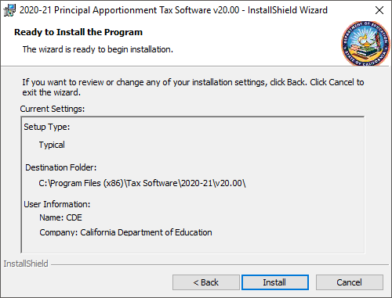
Figure 7: Install Program Window
- Click Install. The progress meter displays the installation status (Figure 8).
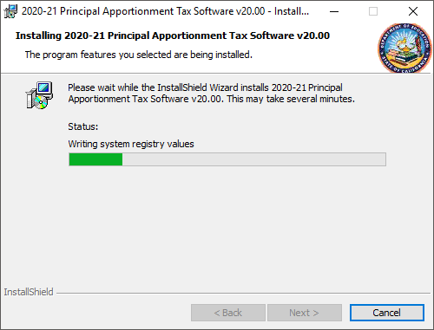
Figure 8: Installation Progress Window
- When the installation is complete, the Installation Completed window displays (Figure 9).
The dialog box shows that the software installed successfully.
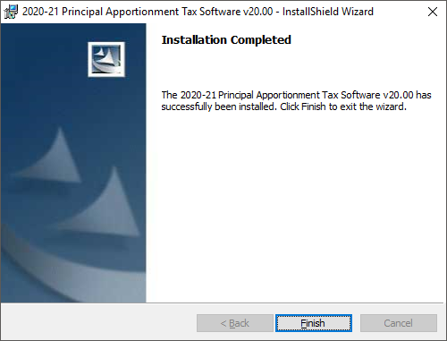Figure 9: Installation Completed Successfully Window
- Click Finish.
Note: You may be asked to restart your computer. Click Yes. After the computer restarts, you can start using the software.

Setting Compatibility Mode
After installing the PADC Software or Tax Software, right click on the shortcut on your desktop to set the compatibility mode to Windows XP (Service Pack 3) as shown in Figure 10. If you are using Windows XP your system should already be set to Windows XP. However, if you are using Windows 7, Windows 8, or Windows 10 we strongly recommend you run the software in this mode to alleviate errors caused by compatibility issues between Windows 7, Windows 8, or Windows 10, and the software.
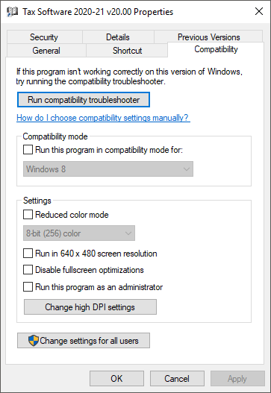
Figure 10: Compatibility Mode Window

