California Department of Education

Revised May 6, 2025

# Physical Education High School Site Plan: Sample Design A

[Small School Site Guidelines](https://www.cde.ca.gov/ls/fa/smallschoolsite.asp)

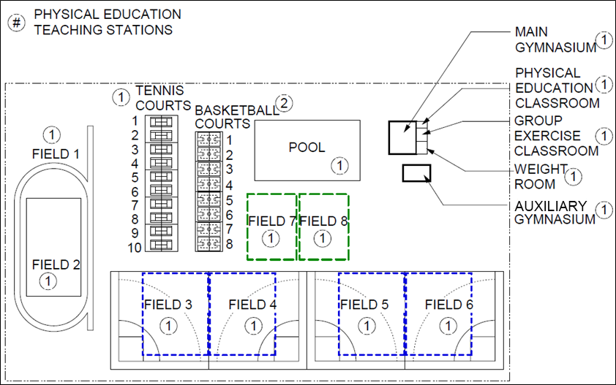

## Full Text Description

The image above displays a rectangular design of a Physical Education High School Site Plan. A legend includes one item:

* # - Physical Education Teaching Stations

All the items displayed in the image are physical education teaching stations.

On the very left of the image are two fields labeled Field 1 and Field 2. Field 2 is surrounded by what appears to be a track. Field 1 is above Field 2.   
  
To the right of Field 1 are 10 Tennis Courts. To the right of these tennis courts there are 8 basketball courts. To the right of these basketball courts there is a large pool and two more fields, labeled field 7 and field 8. Field 7 and field 8 are located below the pool and are side by side. To the right of the pool is the main gymnasium which contains a physical education classroom, a group exercise room, and a weight room. Adjacent to the main gymnasium, below and a little to the right, is an auxiliary gymnasium.

To the right of Field 2, which is located on the bottom left side of the image, are what appear to be 4 baseball/softball fields labeled field 3, 4, 5 and 6. These fields span across the lower portion of the image and are side by side. Field 3 and 4 are below the tennis and basketball courts and adjacent to Field 7 and field 5 and 6 are adjacent to Field 8 and below the auxiliary gymnasium.