# Small School Site Conceptual Site Plan

[Small School Site Guidelines](https://www.cde.ca.gov/ls/fa/smallschoolsite.asp)

A conceptual design of a middle school with 725 students and 4.0 usable acres. 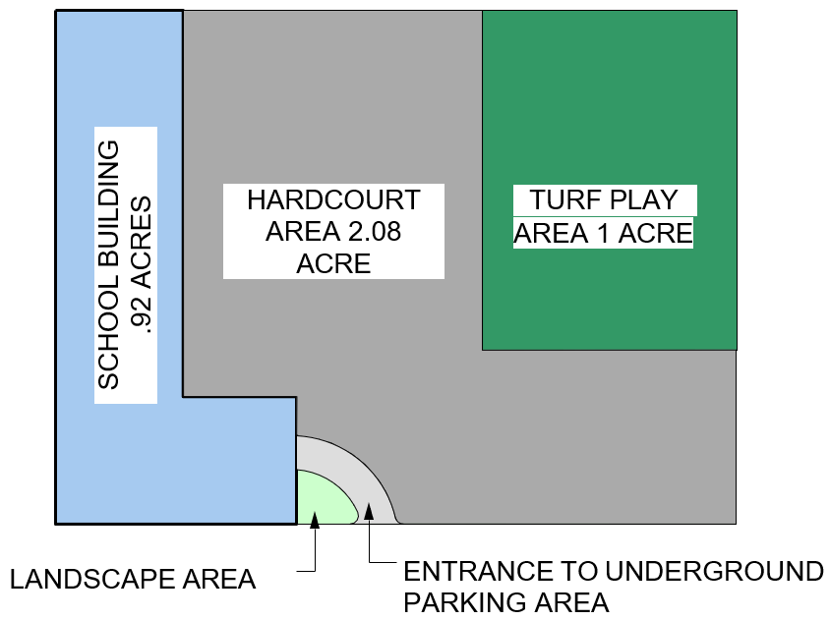

## Full Text Description

A rectangular image displaying a conceptual design of a middle school with 725 students and 4.0 usable acres. On the left is a school building that is .92 acres. To the right of the school building is a hardcourt area that is 2.08 acres. To the right of the hardcourt area is a turf play area that is 1 acre. In the bottom middle area of the image is a small landscape area. To the right of this landscape area is an entrance to an underground parking area. underground.