California Department of Education
Revised May 6, 2025

Physical Education Elementary School Site Plan:
Sample Design A
Small School Site Guidelines
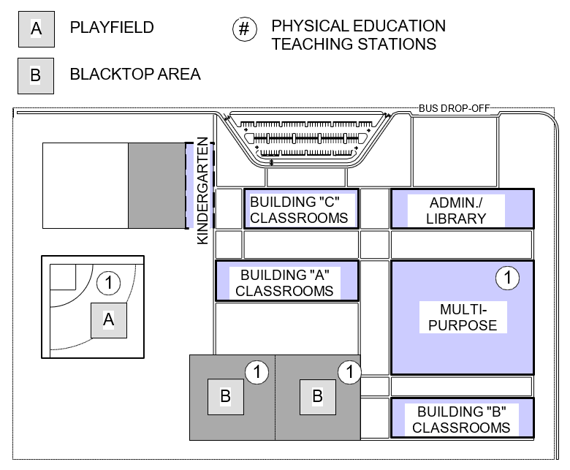

Full Text Description
This image above displays a rectangular design of a Physical Education Elementary School Plan. A legend includes the following items:
- (A) Playfield
- (B) Blacktop Area
- (#) Physical Education Teaching Stations
At the top center of the design is a parking lot, and to the right of this, an area marked for “Bus Drop Off”. To describe the rest of the image it will be categorized into three levels:
- Upper
- Middle
- Lower
The Upper left area of the design includes a building labeled “Kindergarten”. The upper middle area is a building labeled “Building “C” Classrooms. The upper right building is labeled Admin./Library.
The middle-left area appears to be a baseball/softball field labeled (A)(1) which means it is used as a playfield and physical education teaching station. The middle center is a building labeled “Building “A” Classrooms”. The middle right building is labeled “Multi-Purpose (1)”, which means it used as a physical education teaching station.
The Lower left area does not contain anything. The lower middle area contains two buildings labeled (B)(1) which means the buildings are used as a black top area and a physical education teaching station. The lower right area contains a building labeled “Building “B” Classrooms”.

