California Department of Education

Revised May 6, 2025

# Physical Education High School Site Plan: Sample Design B

[Small School Site Guidelines](https://www.cde.ca.gov/ls/fa/smallschoolsite.asp)

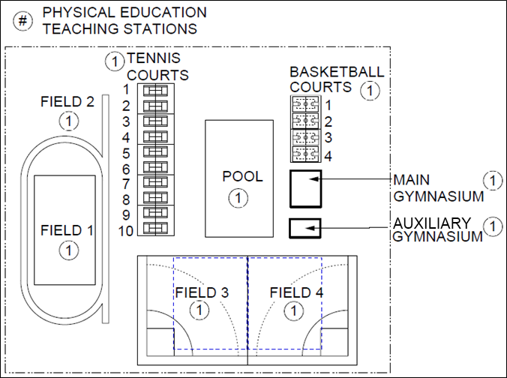

## Full Text Description

The image above displays a rectangular design of a Physical Education High School Site Plan. A legend includes one item:

* # - Physical Education Teaching Stations

All the items displayed in the image are physical education teaching stations.

On the very left of the image are two fields labeled Field 1 and Field 2. Field 2 is surrounded by what appears to be a track. Field 1 is above Field 2.   
  
To the right of Field 1 there are 10 tennis courts. To the right of the tennis courts is a large pool. To the right of the pool there are 4 basketball courts, the main gymnasium, and an auxiliary gymnasium. The lower portion of the image contains Field 3 and Field 4 which appear to be baseball/softball fields. These fields are located under the tennis courts, pool, and auxiliary gymnasium. To the left of Field 3 is the lower portion of Field 1.