ESSA Policy Option Factsheet: Accountability and Continuous Improvement

The Every Student Succeeds Act (ESSA) requires states to establish long-term goals for students and identify the lowest performing schools in the state for additional supports. To inform State Board of Education (SBE) decision-making, the California Department of Education is gathering information from diverse Californians regarding how to address these requirements; specifically:

- Given the color-based structure of the Dashboard, what would help your local districts and schools measure progress?

- When identifying the lowest 5 percent of schools, potentially schools with red and/or orange for all indicators will be eligible for support. What should the State consider in determining the rest of the eligible schools?

Background Information

California is at the forefront nationally in using multiple measures of student success for district and school accountability. Based on the Local Control Funding Formula (LCFF), which was passed in 2013, California’s new accountability system provides a more complete picture of how schools are meeting the needs of the students they serve.

LCFF also requires that the SBE adopt a new accountability tool, called evaluation rubrics, which consider all LCFF priority areas. The new accountability system is fully operational in 2017–18. In contrast to the performance targets that were in place under No Child Left Behind, the State Board approved realistic performance standards that take into account the present range of performance statewide and incorporate improvement as part of a district’s or school’s overall performance.
Educators, parents, and stakeholders will be able to track school and district progress on the concise set of measures included in the new accountability tool through a new online system called the California School Dashboard. Like a dashboard, it will provide information on a concise set of measures critical to student performance.
The Dashboard will include a set of easy-to-use reports that will help parents, educators, and the public evaluate schools and districts, identify strengths and weaknesses, and allow targeted assistance to be given to districts and schools that need extra help. It will greatly assist efforts to improve equity by identifying student groups that may be struggling on one or more state measures.
Some of the indicators included in the new accountability tool apply uniformly across the state and show performance of all students and student groups at the local educational agency (LEA) and school levels. These are called “state indicators” and include:

- Student test scores for English Language Arts and mathematics (called the “Academic Indicator”),
- College and career readiness (called the “College/Career Indicator”),
- Proficiency for English learners (called the “English Learner Progress Indicator”),
- Graduation rates,
- Chronic absenteeism, and
- Suspension rates.

For each of the state indicators, LEAs and schools will receive one of five color-coded performance levels, which are based on how current performance (Status) compares to past performance (Change). There are five possible ranges for Status and five possible ranges for Change. This results in a five-by-five grid (resulting in 25 results) for each indicator. LEAs, schools, and student groups receive one of the five color-coded performance levels based on the combination of their Status and Change.

Figure 1 provides an example of how the five-by-five reference chart is used to determine performance. The chart displays how a school with “High” for Status and “Increased” for Change will receive an overall performance level of Green.

Figure 1. Example Reference Chart
Change

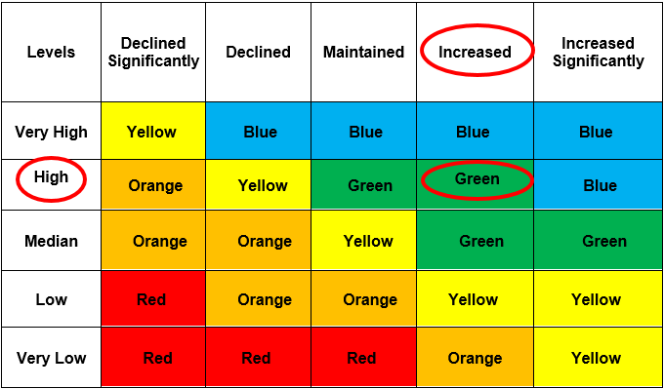

Status

Relevant Sections of Every Student Succeeds Act Statutes

Long-Term Goals Statute

Section 1111(c)(4)(A) of ESSA requires that the state plan:

(A) ESTABLISHMENT OF LONG-TERM GOALS.—Establish ambitious State-designed long-term goals, which shall include measurements of interim progress toward meeting such goals—
(i) for all students and separately for each subgroup of students in the State—
(I) for, at a minimum, improved—
(aa) academic achievement, as measured by proficiency on the annual assessments [for English and mathematics]; and
(bb) high school graduation rates, including—
(AA) the four-year adjusted cohort graduation rate; and
(BB) at the State’s discretion, the extended-year adjusted cohort graduation rate, except that the State shall set a more rigorous long-term goal for such graduation rate, as compared to the long-term goal set for the four-year adjusted cohort graduation rate;
(II) for which the term set by the State for such goals is the same multi-year length of time for all students and for each subgroup of students in the State; and
(III) that, for subgroups of students who are behind on the measures described in items (aa) and (bb) of subclause (I), take into account the improvement necessary on such measures to make significant progress in closing statewide proficiency and graduation rate gaps; and
(ii) for English learners, for increases in the percentage of such students making progress in achieving English language proficiency, as defined by the State and measured by the [English language development assessment], within a State-determined timeline.

Identifying Schools for Comprehensive and Targeted Support Statute

Section 1111(c)(4) requires that the State Plan:

“(C) ANNUAL MEANINGFUL DIFFERENTIATION.—Establish a system of meaningfully differentiating, on an annual basis, all public schools in the State, which shall—

“(i) be based on all indicators in the State’s accountability system under subparagraph (B), for all students and for each of subgroup of students, consistent with the requirements of such subparagraph;
“(ii) with respect to the indicators described in clauses (i) through (iv) of subparagraph (B) afford—
“(I) substantial weight to each such indicator; and
“(II) in the aggregate, much greater weight than is afforded to the indicator or indicators utilized by the State and described in subparagraph (B)(v), in the aggregate; and
“(iii) include differentiation of any such school in which any subgroup of students is consistently underperforming, as determined by the State, based on all indicators under subparagraph (B) and the system established under this subparagraph.

Section 1111(c)(4) further requires that the State Plan:

“(D) IDENTIFICATION OF SCHOOLS.—Based on the system of meaningful differentiation described in subparagraph (C), establish a State-determined methodology to identify—
“(i) beginning with school year 2017–2018, and at least once every three school years thereafter, one statewide category of schools for comprehensive support and improvement, as described in subsection (d)(1), which shall include—
“(I) not less than the lowest-performing 5 percent of all schools receiving funds under this part in the State;
“(II) all public high schools in the State failing to graduate one third or more of their students; and
“(III) public schools in the State described under subsection (d)(3)(A)(i)(II); and
“(ii) at the discretion of the State, additional statewide categories of schools.

ESSA Policy Option Factsheet: Accountability and Continuous Improvement
California Department of Education | February 2017 | Page 5

