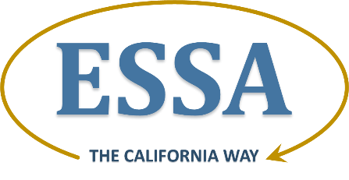

Section 2: Consultation and Coordination

State Plan Requirement: 2.1 Timely and Meaningful Consultation

Each SEA [state educational agency] must engage in timely and meaningful consultation with stakeholders in developing its consolidated State plan, consistent with §§ 299.13 (b) and 299.15 (a). The stakeholders must include the following individuals and entities and reflect the geographic diversity of the State: the Governor or appropriate officials from the Governor’s office; members of the State legislature; members of the State board of education, if applicable; LEAs, including LEAs in rural areas; representatives of Indian tribes located in the State; teachers, principals, other school leaders, paraprofessionals, specialized instructional support personnel, and organizations representing such individuals; charter school leaders, if applicable; parents and families; community-based organizations; civil rights organizations, including those representing students with disabilities, English learners, and other historically underserved students; institutions of higher education (IHEs); employers; and the public.

Prompt: Public Notice

- Provide evidence of the public notice that the SEA provided in compliance with the requirements under §200.21(b)(1)-(3), of the SEA’s processes and procedures for developing and adopting its consolidated State plan.

California’s Response

Below you will find evidence of the public notice the state educational agency (SEA) provided of the SEA’s processes and procedures for developing and adopting its ESSA Consolidated State Plan (State Plan) aligned to the phases of California’s Stakeholder Engagement Plan.

STAKEHOLDER ENGAGEMENT PLAN: Providing Public Notice

Throughout the ESSA State Plan Development Process

State Board of Education Meetings
The California State Board of Education (SBE) meets every other month in publicly noticed, webcasted meetings. Since the passage of the ESSA in December 2015, the SBE has been presented regular updates on the Every Student Succeeds Act (ESSA) and asked to take action as members deem necessary.

The timeline to develop and adopt the State Plan was presented to the SBE and the public at the following SBE meetings:

- March 2016
- May 2016
- September 2016
- November 2016

SBE meeting agendas and public notices are available on the SBE Current & Past Agendas Web page at http://www.cde.ca.gov/be/ag/ag/index.asp. As noted in each SBE meeting agenda, members of the public requiring translation services or a reasonable accommodation in order to access materials before the SBE may request assistance by contacting the SBE Office. SBE meeting agenda items related to the development and adoption of the State Plan are available on the California Department of Education (CDE) Web site at http://www.cde.ca.gov/re/es/sbeitems.asp.

California Practitioners Advisory Group Meetings
The California Practitioners Advisory Group (CPAG) is California’s Title I Committee of Practitioners. During the development of the State Plan, CPAG members have participated and will participate in at least seven public meetings:

- April 13–14, 2016
- June 22, 2016
- September 29, 2016
- October 13, 2016
- December 7, 2016
- February 9, 2017
- April 4, 2017
- Week of April 24, 2017 (meeting date to be determined)

In each of these meetings, the CPAG provides input on the practical implications of decisions before the SBE related to California’s accountability system and the State Plan.

CPAG public meeting notices, agendas, and minutes are available at http://www.cde.ca.gov/be/cc/cp/cpag2016agendas.asp. All CPAG meetings are open to the public and webcasted, and members of the public may comment on matters under discussion in person or via written correspondence. As noted in each CPAG meeting agenda, members of the public requiring translation services or a reasonable accommodation in order to access materials before the CPAG may request assistance by contacting the CDE. More information about the CPAG is available on the CDE CPAG Web page at http://www.cde.ca.gov/be/cc/cp/.

Phase I: What Californians Want for Their Schools

The first phase of stakeholder engagement addressed three distinct goals: 1) ensure stakeholders have timely access to important information about ESSA; 2) gather and respond to questions regarding ESSA; and 3) gather input from stakeholders about what they would like to see in the State Plan and the best ways for the State to sustain their engagement in the plan development process. Results of the outreach conducted in Phase I are explained in more detail under the Outreach and Input Section of this draft State Plan. Below you will find information about all of the activities the State engaged in during Phase I to provide public notice of the process and procedures for developing the State Plan, in addition to SBE and CPAG meetings.

California ESSA Webinar for Education Stakeholders and Public
On May 26, 2016, and June 1, 2016, CDE staff, with support from the California Comprehensive Center, presented a brief overview of the ESSA and the process and timeline to develop a State Plan. These webinars were promoted through the CDE ESSA State Plan Development Opportunities Web page at http://www.cde.ca.gov/re/es/essaopptopart.asp and the ESSA Update listserv, an archive of which is available at http://www.cde.ca.gov/re/es/essaupdate.asp. Materials from the webinar and a recording of one of the webinars is available on the ESSA State Plan Development Opportunities Web page.

ESSA Regional Stakeholder Meetings
In Phase I of the California ESSA Stakeholder Engagement Plan, the CDE and several county offices of education (COEs) across the state partnered to host a series of regional stakeholder meetings to provide an overview of the ESSA and an update on the development of the State Plan and to consult with stakeholders regarding what should be included in the State Plan.

Specific COEs representing the geographic diversity of the state were invited to host regional stakeholder meetings. The map and table below display the locations of the six regional stakeholder meetings in Phase I.

Figure 1: Map of ESSA Regional Stakeholder Meetings - Phase I
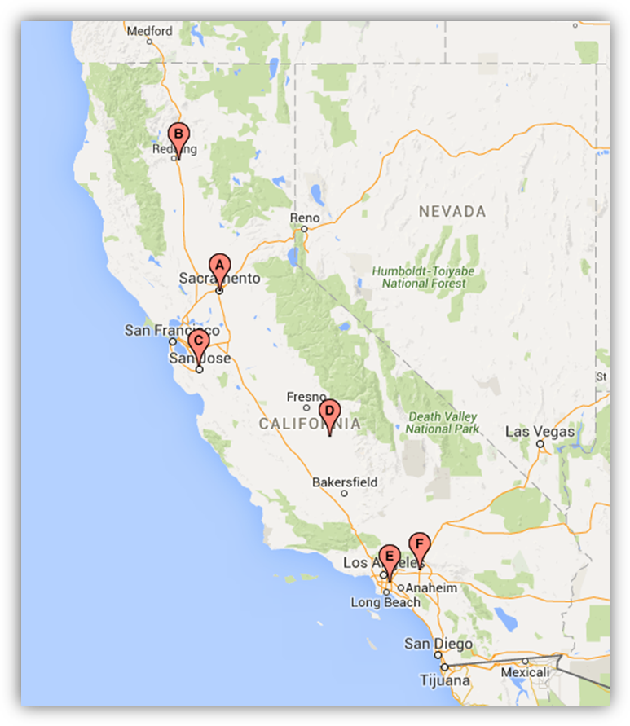
Table 1: Locations of ESSA Regional Stakeholder Meetings – Phase I

 | Date/Time | Location
A | June 16  1–4 p.m. | California Department of Education  1430 N Street, Room 1101  Sacramento, CA 95814
B | June 20  1–4 p.m. | Shasta County Office of Education  2985 Innsbruck Dr.  Redding, CA 96002
C | June 23  1–4 p.m. | Santa Clara County Office of Education  San Jose/Eastside Room  1290 Ridder Park Drive  San Jose, CA 95131-2304
D | June 27  1–4 p.m. | Tulare County Office of Education  6200 S. Mooney Blvd.  Visalia, CA 93278  Redwood Rooms C-F
E | June 28  1–4 p.m. | Los Angeles County Office of Education  9300 Imperial Hwy - EC 281  Downey, CA 90242
F | July 8  1–4 p.m. | Etiwanda Gardens  7576 Etiwanda Ave  Etiwanda, CA 91739

In addition to the events being locally promoted by the host COEs, the CDE utilized its ESSA State Plan Development Opportunities Webpage, ESSA Update listserv (http://www.cde.ca.gov/re/es/essaupdate.asp), the CDE Facebook (https://www.facebook.com/CAEducation), and the CDE Twitter (https://twitter.com/cadepted) to promote the events.

Targeted Consultation
In order to ensure California consults with all of the required stakeholders and any interested stakeholder in a manner that is adapted to the needs of specific audiences, CDE staff presented information about the State Plan development and adoption processes and procedures at the following meetings and events:

- March 16, 2016 – Policy Work Group Input Session

- March 18, 2016 – State and Federal Programs Directors’ Meeting

- March 25, 2016 – Listening Session with Deputy Assistant Secretary Ary Amerikaner from the U.S. Department of Education and stakeholder representatives

- April 15, 2016 – State and Federal Programs Directors’ Meeting

- May 5, 2016 – Education Coalition and Equity Coalition

- May 18, 2016 – Regional Assessment Network

- May 19, 2016 – Bilingual Coordinators Meeting

- May 20, 2016 – State and Federal Programs Directors’ Meeting

- May 24, 2016 – Alameda County Office of Education ESSA Workshop

- June 2, 2016 – Contra Costa County Office of Education ESSA Workshop

- June 17, 2016 – Policy Work Group Meeting

- June 17, 2016 – State and Federal Programs Directors’ Meeting

- June 23, 2016 – Educator Equity Plan Meeting (included representatives from diverse equity groups)

- August 10, 2016 – California Advisory Commission on Special Education Meeting

- August 12, 2016 – American Indian Oversight Committee Meeting

- August 19, 2016 – State and Federal Programs Directors’ Meeting

- August 24, 2016 – California Private School Advisory Committee

- September 1, 2016 – Migrant Education Program Directors Meeting

- September 16, 2016 – Bilingual Coordinators Network Meeting

- September 16, 2016 – State and Federal Programs Directors’ Meeting

- September 19, 2016 – Early Education and ESSA Meeting

- September 19, 2016 – SBE, CDE, California Commission on Teacher Credentialing, California Subject Matter Project, California Collaborative on Education Excellence, and California County Superintendents Educational Services Association Cross-State Agency ESSA Meeting

- September 23, 2016 – California Federation of Teachers Early Childhood/TK–12 Division Council Meeting

- September 26, 2016 – Marin County Office of Education ESSA Workshop

- October 4, 2016 – Small School Districts Association Meeting, Siskiyou County

- October 5, 2016 – Riverside County Office of Education ESSA Workshop

- October 12, 2016 – California Credential Analysts and Counselors Conference

- October 13, 2016 – California Association of Administrators of State and Federal Education Programs Institute

- October 18, 2016 – Association of California School Administrators Webinar

- October 20, 2016 – Small School Districts Association Meeting, Merced County

Phases II, III, and IV: Engagement and Public Comment
on ESSA State Plan Drafts

The goal of Phases II, III, and IV of California’s ESSA Stakeholder Engagement Plan is to present drafts of the ESSA State Plan to stakeholders and gather their feedback on those drafts in order to refine the State Plan and ensure it reflects the voices of diverse Californians. Each of these phases will begin with the availability of a new draft of the State Plan, webinars explaining the contents of the draft, a toolkit for local stakeholder engagement, and a survey to collect public comment on the draft.

Regional Stakeholder Meetings
Phase IV of stakeholder engagement will include the required 30-day public comment period on the final draft of the State Plan and will also include regional stakeholder meetings throughout the state and online to explain the contents of the final plan and encourage engagement in the public comment process. Participants in these regional meetings will be able to request translation services and reasonable accommodations.

Below is a timeline that displays when each draft of the State Plan will be made available for public comment, including the final draft and the 30-day public comment period.

Table 2: Stakeholder Engagement Phases

Date | Activity
November 10–December 2, 2016 | Phase II: First draft made available for public comment
January 20–February 10, 2017 | Phase III: Second draft made available for public comment
March 17–April 17, 2017 | Phase IV: Third and final draft made available for 30-day public comment period

Phase V and Beyond: Implementation of the ESSA State Plan

Once the State Plan is approved, California will engage in statewide activities to inform the public about how the plan will impact education in our state. Public engagement activities and a continuous improvement process will be built into every ESSA program so that California can annually reflect on the progress of these programs with the public and make any necessary refinements to the programs and our State Plan.

Prompt: Outreach and Input

- For each of the four components of the consolidated State plan listed below, describe how the SEA:

- Conducted outreach to and solicited input from the individuals and entities listed above during the design and development of the SEA’s plans to implement the programs that the SEA has indicated it will include in its consolidated State plan; and following the completion of the consolidated State plan by making the plan available for public comment for a period of not less than 30 days prior to submission to the Department for review and approval.

- Took into account the consultation and public comment, including how the SEA addressed the concerns and issues raised through consultation and public comment and any changes the SEA made as a result of consultation and public comment.

California’s Response

As this is the first draft of California’s ESSA Consolidated State Plan, it will describe the outreach that has taken place to date and how it has and will inform the drafts of the ESSA State Plan. This first draft also describes what the SEA plans to do in the forthcoming phases of stakeholder engagement around the subsequent drafts of the State Plan. This section will be updated in the final draft.

Challenging Academic Standards and Academic Assessments

Stakeholder Engagement Prior to ESSA State Plan Development

The challenging academic standards ESSA requires states to adopt were adopted in California prior to the ESSA being signed into law. The SEA engaged in extensive and rigorous public processes to review and amend, as necessary, each set of standards. For detailed information about the development and adoption of the ESSA-required academic standards, please visit the links below.

Common Core State Standards for Mathematics and English Language Arts and Literacy in History-Social Studies, Science and Technical Subjects, 2010 | http://www.cde.ca.gov/re/cc/ccssadoptprocess.asp
Next Generation Science Standards , 2013 | http://www.cde.ca.gov/pd/ca/sc/ngsshistory.asp [broken link removed]

The California Assessment of Student Performance and Progress (CAASPP) is extensively vetted by education stakeholders. Smarter Balanced mathematics and English language arts/literacy assessments undergo public processes to develop and refine items, ensure ease of use by all users, set achievement levels, and provide technical reports. These processes include regular stakeholder meetings, surveys, focus groups, workshops, and pilot and field testing. Using similar public processes, the CDE is currently developing an assessment based on the state-adopted Next Generation Science Standards, which is scheduled to be fully operation by the 2018–19 school year. For detailed information regarding the development of ESSA-required assessments, please visit the links below.

Smarter Balanced Assessments for Mathematics and English Language Arts | http://www.cde.ca.gov/ta/tg/sa/index.asp
California Science Assessments | http://www.cde.ca.gov/ta/tg/ca/caasppscience.asp

Stakeholder Engagement During Design and Development of State Plan
The Challenging Academic Standards and Academic Assessments section of California’s Consolidated State Plan is being made available for public comment in the first draft of the State Plan. This first draft will be presented to the California Practitioners Advisory Group (CPAG) (described above) at its October 13, 2016 meeting, and to the State Board of Education (SBE) at its November 2–3, 2016 meeting. After these publicly noticed meetings, the first draft will be made available for public comment November 10–December 2, 2016. CDE staff will review and analyze the public comments for this section for possible revisions in the final draft of the State Plan.

Accountability and Support for Schools

Stakeholder Engagement Prior to ESSA State Plan Development
It is important to note that California has been engaged in developing a State accountability and continuous improvement system since the 2013 transition to California’s new school funding system known as the Local Control Funding Formula. An important goal for this initiative is to create a single and coherent local, state, and federal system, addressing persistent feedback from education stakeholders to streamline the system and avoid duplicative processes and procedures.

With the passage of ESSA in December 2015, the SBE seized the opportunity to incorporate elements of ESSA accountability into the emerging state accountability and continuous improvement system. Existing stakeholder groups and networks were and continue to be consulted about ESSA accountability requirements and how they will fit into the single and coherent system. The California ESSA State Plan is designed to complement the work well underway in the state that has years of stakeholder support behind it.

Stakeholder Engagement During Design and Development of State Plan
Since the passage of ESSA, California has conducted outreach to and solicited input from a variety of individuals and organizations regarding ESSA accountability.

In May 2016, the State Superintendent of Public Instruction’s Advisory Task Force on Accountability and Continuous Improvement published the report entitled Preparing All Students for College, Career, Life, and Leadership in the 21st Century. The task force included teachers, parents, students, administrators, school board members, institutions of higher education representatives, researchers, philanthropic representatives, and business representatives. The report considers the state’s emerging accountability system and the provisions of ESSA to provide recommendations for an accountability and continuous improvement system that is rooted in performance, equity, and improvement.

Other important activities have focused on the development of the LCFF Evaluation Rubrics. The evaluation rubrics assist LEAs, and those providing technical assistance to LEAs, to evaluate strengths, weaknesses, and areas that require improvement based on data from multiple state and local indicators, and, on the basis of this evaluation, connect the LEA to practices and resources that result in meaningful improvement of student-level outcomes. The LCFF Evaluation Rubrics include the ESSA-required indicators.

Stakeholders have been and continue to be integrally involved in the development of the LCFF evaluation rubrics system, including reviewing data methodologies and simulations, reviewing indicator cut scores and distributions, providing input regarding the identification of schools and districts for technical assistance and support, and providing feedback regarding the system’s user-interface. California is currently working with the following groups to gather stakeholder feedback:

- CPAG: As noted above, the CPAG is an advisory committee to the SBE and also serves as the State’s Title I committee of practitioners. The CPAG has and will continue to provide input regarding accountability to the SBE throughout the State Plan development process.

- Equity and Policy Stakeholder Input Working Group: This group, which includes representatives from statewide professional associations and community based organizations, provides feedback to the CDE and SBE regarding LCFF implementation and accountability.

- User Acceptance Testing Group: This group consists of representatives from over 30 LEAs, including county offices of education, school districts, and charter schools. It provides feedback to the CDE and SBE regarding the LCFF Evaluation Rubrics and their relevance, usefulness, and applicability to support local planning and evaluation of performance relative to State priorities.

- Technical Design Group: This is a group of experts in psychometric theory and education research that provides recommendations to the CDE on matters related to the state and federal accountability system.

- English Learner Indicator Work Group: This group is comprised of individuals with English learner (EL) program expertise and EL data expertise with representatives from the county and district levels as well as representatives from stakeholder groups. It is tasked with creating a composite measure for the English Learner Indicator that includes English acquisition, reclassification rates, and long-term EL rates.

- School Conditions and Climate Work Group: This group consists of members with expertise in education measurement and school conditions/climate. It is tasked with reviewing existing school climate measurement approaches, tools, resources, and surveys that measure aspects of school conditions and climate and present recommendations to CDE regarding the school climate State priority indicator.

During Phase I of stakeholder engagement, described above, CDE staff also gathered feedback from stakeholders regarding the accountability system. These comments have been summarized by the Comprehensive Center at WestEd in the ESSA Stakeholder Engagement – Phase I Report available at http://www.cde.ca.gov/be/pn/im/documents/memo-exec-essa-aug16item02.doc. This feedback will be taken into account as California develops this section of the plan.

The Accountability and Support for Schools section of California’s State Plan will be made available for public comment in a subsequent draft of the State Plan. CDE staff will review and analyze the public comments on this section for possible revisions in the final draft of the State Plan.

Supporting Excellent Educators

Stakeholder Engagement Prior to ESSA State Plan Development
Stakeholder engagement regarding supporting excellent educators in California is a continuous process. ESSA-related stakeholder engagement cannot be discussed without first recognizing the work the State has engaged in prior to the ESSA and how it impacts the State’s implementation of the ESSA.

California Commission on Teacher Credentialing (CTC): The purpose of the CTC is to ensure integrity, relevance, and high quality in the preparation and discipline of the educators who serve all California’s diverse students. The CTC is an agency in the Executive Branch of the California State Government. The Governor-appointed commissioners consist of six classroom teachers, one school administrator, one school board member, one school counselor or services credential holder, one higher education faculty member from an institution for teacher education, and four public members. The CTC meets every other month in publicly noticed meetings where members of the public are welcome to comment on matters before the CTC, and, as a state standards board, regularly engages the public in its processes and procedures. The CTC’s work as influenced by stakeholders is an integral piece of the Supporting Excellent Educators section of the ESSA State Plan.

Greatness by Design: Since 2012, much of California’s work to improve educator excellence has been grounded in Greatness by Design: Supporting Outstanding Teaching to Sustain a Golden State (GbD), a report from the California Educator Excellence Task Force (EETF). The EETF was comprised of more than 50 education stakeholders—including parents, K–12 educators, postsecondary educators, researchers, and community leaders—and was charged with drafting recommended actions that could be woven together into a coherent system that would produce exceptional teachers and principals. More information regarding the EETF and GbD is available on the CDE EETF Web page at http://www.cde.ca.gov/eo/in/ee.asp. The GbD recommendations address a wide range of education issues in California, focusing broadly on recruitment, preparation, induction, professional learning, evaluation, and leadership. Implementation of many of the GbD recommendations is well underway and will provide much of the focus for the Supporting Excellent Educators section of the ESSA State Plan.

California State Plan to Ensure Equitable Access to Excellent Educators, July 2015: California submitted to the U.S. Department of Education its plan of current and future work related to gaps in equitable access to excellent educators for all students in July 2015. This document details a theory of action and progress toward achieving equitable access to excellent teachers and leaders for all students. CDE, SBE, and CTC staff had the opportunity to engage with stakeholders regarding equitable access to excellent educators on three separate occasions prior to the submission of this plan. Parents, teachers, administrators, community members, policymakers and representatives from school districts, civil rights groups, and institutions of higher education participated in these meetings. Since many of the requirements of the Educator Equity Plan have been retained under ESSA, the basis of the 2015 Educator Equity Plan will help to inform the Supporting Excellent Educators section of the ESSA State Plan to guarantee continuity of strategies to ensure low-income and minority students in Title I schools have equitable access to excellent educators.

Stakeholder Engagement During Design and Development of State Plan
Between December 2015 and June 2016, the CDE conducted six stakeholder events with facilitation support from the California Comprehensive Center. These events were held to gather input on the root causes identified in the 2015 Educator Equity Plan and the strategies being used by the State to address these root causes. Combined, there were a total of 169 individual stakeholder participants. Parents, teachers, administrators, community members, policymakers and representatives from school districts, civil rights groups, and institutions of higher education participated in these meetings. The feedback from stakeholders gathered at these meetings will greatly inform the Supporting Excellent Educators section of the ESSA State Plan.

During Phase I of stakeholder engagement, described above, CDE staff also gathered feedback from stakeholders regarding educator excellence. These comments have been summarized by the Comprehensive Center at WestEd in the ESSA Stakeholder Engagement – Phase I Report available at http://www.cde.ca.gov/be/pn/im/documents/memo-exec-essa-aug16item02.doc. This feedback will be taken into account as California develops this section of the plan.

The Supporting Excellent Educators section of California’s State Plan will be made available for public comment in a subsequent draft of the plan. CDE staff will review and analyze the public comments on this section for possible revisions in the final draft of the State Plan.

Supporting All Students

Stakeholder Engagement Prior to ESSA State Plan Development
There is an integral document that provides California its Education North Star, A Blueprint for Great Schools: Version 2.0. State Superintendent Torlakson convened 29 stakeholders representing teachers, district and site administrators, business, higher education, school boards, early education, legislators, philanthropists, and community organizations to develop an action plan to guide the State as it continues its momentum to implement California’s academic standards and new funding system, and address important concerns such as the achievement gap and teacher shortage.

The Blueprint defined five strategic priority areas on which the State should focus: California Standards, teaching and leading excellence, student success, continuous improvement and accountability systems, and systems change and supports for strategic priorities. The Blueprint further defined guiding principles that provide a lens for addressing the strategic priority areas: meaningful learning, whole child, community engagement, collaboration and coherence, creativity and flexibility, transparency, multiple measures, trust and responsibility, reciprocity and subsidiarity, and equity.

As California develops the Supporting All Students section of the State Plan, the strategic priority areas and guiding principles will continue to provide California’s Education North Star.

Stakeholder Engagement During Design and Development of State Plan
During Phase I of stakeholder engagement, described above, CDE staff gathered feedback from stakeholders regarding the how the State can support schools to support the needs of all students and how the State can ensure that all students have equitable access to a well-rounded education and rigorous coursework across the curriculum. These comments have been summarized by the Comprehensive Center at WestEd in the ESSA Stakeholder Engagement – Phase I Report available at http://www.cde.ca.gov/be/pn/im/documents/memo-exec-essa-aug16item02.doc. This feedback will be taken into account as California develops this section of the plan.

The Supporting All Students section of California’s State Plan will be made available for public comment in the third draft of the plan. The third draft will be presented to the CPAG at its February 9, 2017 meeting, and to the SBE at its March 8–9, 2017 meeting.

Stakeholder Engagement Following Completion of State Plan

The final draft of the State Plan will be made available for the 30-day public comment period March 17–April 17, 2017. Public comments will then be presented to the California Practitioners Advisory Group for recommendations about how public comments should be incorporated into the final State Plan. The final State Plan, scheduled to be presented to the SBE at its May 2017 meeting, will include a description about how California took into account the consultation and public comment, including how the State addressed the concerns and issues raised through consultation and public comment and any changes the State made as a result of consultation and public comment.

Ensuring Engagement with Diverse Californians

California is a large and diverse state and the SEA is committed to hearing from as many stakeholders as possible in the development of the State Plan. As noted above, in Phase I of stakeholder engagement, the State engaged in public state board and advisory group meetings, webinars, regional stakeholder meetings, a stakeholder survey, and targeted consultation. Along the way, California has noted which stakeholders have been consulted with that meet the ESSA State Plan requirements. Below is a chart that displays which stakeholders contributed input through each Phase I activity.
Chart 1: Engagement with Stakeholders Required by ESSA

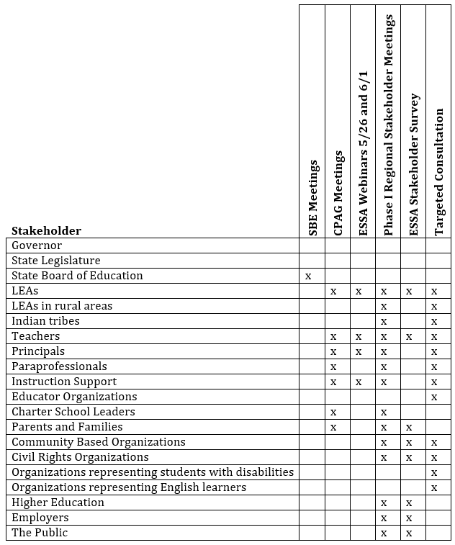

This information has helped the State plan for the next phases of stakeholder engagement. While a good number and variety of stakeholders engaged in Phase I activities, California plans employ two new strategies to engage greater numbers of diverse stakeholders in Phases II through IV.

First, CDE will develop a toolkit of engagement resources that can be used at the local level—school sites, community meetings, special interest groups, etc.—that will provide all of the information stakeholders need in order to review the ESSA State Plan and provide feedback to the SEA. The toolkit will include presentations that provide background information about ESSA, videos that provide overviews of the State Plan development timeline and each section of each draft of the State Plan, and information about how stakeholders can provide feedback during the public comment periods.

Second, CDE will seek out organizations to partner with to provide webinars to specific audiences such as student, parent, teacher, administrator, and school board organizations and associations. This will help the SEA communicate what the ESSA State Plan means for specific stakeholders so that they may provide feedback on the issues and concerns that are most important to them.

During future phases of engagement, the SEA will also consult with the Governor’s Office and members of the State Legislature to gather their feedback on the drafts of the State Plan.

State Plan Requirement: 2.2 Coordination

Each SEA must coordinate its plans for administering the included programs and other programs, consistent with §299.15 (b). The programs must include the following: other programs authorized under the ESEA, as amended by the ESSA; the Individuals with Disabilities Education Act; the Rehabilitation Act; the Carl D. Perkins Career and Technical Education Act of 2006; the Workforce Innovation and Opportunity Act; the Head Start Act; the Child Care and Development Block Grant Act of 1990; the Education Sciences Reform Act of 2002; the Education Technical Assistance Act of 2002; the National Assessment of Educational Progress Authorization Act; and the Adult Education and Family Literacy Act.

Prompt: Plan Coordination

- Describe how the SEA is coordinating its plans for administering the programs under this consolidated application and the programs listed above.

California’s Response

The SEA will identify and convene each of the program directors at the state level for each of the ESSA programs and the other federal programs listed above. These directors will review each draft of the ESSA State Plan and identify any areas where plans conflict or where plans can be aligned and leveraged to increase coherence in the education system. These state level directors will also work closely with their contacts at the county and district levels to consider the practical implications of plan alignment.

FIRST DRAFT: California ESSA Consolidated State Plan | Consultation and Coordination
California Department of Education | November 2016 | Page 19

According to sign in sheets, representatives from the following organizations attended this event: Public Advocates, Association of California School Administrators, Early Edge California, California School Boards Association, California Legislative Analyst’s Office, WestEd, California Collaborative for Educational Excellence, Kids Alliance, COEs, districts, Education Trust-West, Youth Law, Fight Crime: Invest in Kids, California Forward Action Fund, California Senate, Families in Schools, California County Superintendents Educational Services Association, Capitol Advisors, Fiscal Crisis & Management Assistance Team, Charter Schools Development Center, California Parent Teacher Association, California Department of Finance, California Endowment, California Budget & Policy Center, ACLU, California Governor’s Office, California Teachers Association, EdVoice, and Children Now.
The following organizations are represented in the Education Coalition and Equity Coalition: Children Now, ACLU, Inland Congregations United for Change – PICO, Public Advocates, Parent Network, Californians for Justice, California Budget & Policy Center, Families in Schools, EdVoice, Education Trust-West, PICO California, Oakland Community Organizations – PICO, Advancement Project, Californians Together, Contra Costa Interfaith Supporting Community Organization, Fight Crime: Invest in Kids, and Youth Law.

