EVERY STUDENT SUCCEEDS ACT: PLAN SECTION SUMMARY

Title I, Part A: Accountability

Purposes of the Program

The purpose of Title I, Part A is to provide all children the opportunity to receive an equitable, high-quality education, and to close educational achievement gaps. Under Title I, Part A, California provides funds to districts and schools with low income families. The funds are intended to help students meet state academic content standards.

California’s accountability system helps everyone to know how well schools and districts are doing in meeting the needs of their students.

ESSA State Plan Requirement: Describe how the state accountability system will identify the lowest-performing five percent of Title I funded schools in need of support based on low overall school performance (comprehensive support) or based on consistent underperformance of student groups (targeted support). Describe how the approach will provide much greater weight, in the aggregate, to the indicators related to academics than the other indicator(s).
Three options for identifying the lowest-performing five percent of Title I schools have been presented to the State Board of Education. All three options use performance levels, which are represented by colors, with red representing the lowest performance level and blue representing the highest performance level. Schools receive a performance color for each state indicator.
- Option 1 will identify at least five percent of Title I schools based on the schools’ performance on all their indicators. All schools that show Red (indicating the lowest performance level) for each applicable indicator would be identified first. The next schools to be identified would be those showing all Red and one Orange indicator. This process would continue until at least 5 percent of schools are identified.

- Option 2 is similar to Option 1, but provides more or less weighting to one or more indicators. For example, if one or more indicators is thought to be more important, they could be counted twice as much in deciding which schools to identify for support. Or if an indicator is thought to be less important, it could be counted half as much.

- Option 3 arranges the state indicators in order of importance. For example, English language arts and mathematics could be ordered first, with the English Language Progress Indicator second, and suspension rate third. All schools that have low performance in academics, that would be the English language arts and mathematics assessment, would be identified first. If less than 5 percent of schools are identified with this state indicator, school performance on the English Language Progress Indicator would be used to continue the identification process. If 5 percent of schools are identified using the academic and English Language Progress Indicator state indicators, the suspension rate would not be taken into consideration.

By design, the state accountability system, known as the California Model, has only one non-academic indicator, suspension rate. There are three state academic indicators for elementary and middle schools: English language arts and mathematics assessment results, English Learner Progress in English language acquisition, and chronic absenteeism. For high schools, the three state indicators are College/Career (which includes English Language Arts and mathematics assessment results), English Learner Progress in English language acquisition, and Graduation Rate. Therefore, the California Model meets the federal requirement that greater weight be given to academic indicators in identifying schools for support.
ESSA State Plan Requirement: Describe how the 95 percent participation rate can be factored into the accountability system.
The California State Plan proposes to report whether schools met the 95 percent participation requirement based on a unique symbol. For example, a color coded image or icon specific to participation rate could be displayed. California also proposes to offer assistance to schools that do not meet that participation rate through the statewide system of support.
ESSA State Plan Requirement: Describe how ambitious long-term goals, which include measurements of interim progress toward meeting the goals for all students and separately for each student group, will be established for academic achievement, graduation rate, and progress toward achieving English language proficiency for English learners. Demonstrate how these goals set the same timeline for all students and each student group to achieve the long-term goal; take into account the improvement necessary to make significant progress in closing the achievement gaps for student groups on assessments and graduation rate; and reflect increases in the percentage of English learner students making progress in achieving English language proficiency.
The current performance levels or colors were established using a grading curve. The State Board of Education expects to reset the performance levels for state indicators every five to seven years. Accordingly, the plan is recommending that the same 5-7 year timeline for reaching the goals be aligned with the timeline for resetting the performance levels.
California proposes to set the long-term goals using the 5x5 colored grid, which includes a range of scores within each of the 25 results on the grid. As a starting point for public feedback, the box for High (Status) on the grid and the Maintained (Change) box on the grid are identified as a potential goal.

In the example below, the green box outlined in orange (High Status level, Maintained Change level) is the proposed long-term goal. All boxes above and to the right of the long-term goal (4 Blue boxes and 1 green box) have exceeded the goal. The State Board of Education will need to decide whether the Green box in the first row would meet the long-term goal (for example, Very High/Declined). 27.2 percent of schools currently meet this proposed goal, making the goal ambitious.

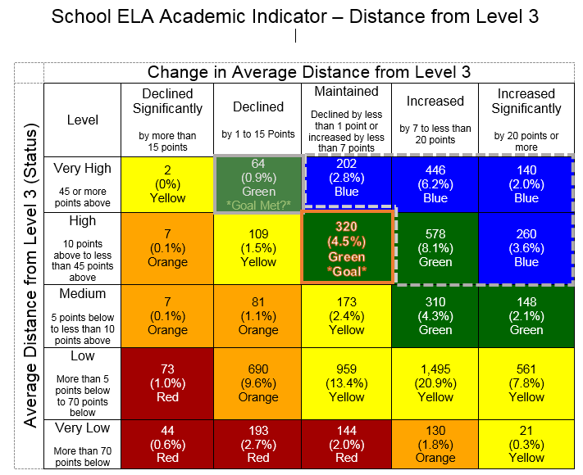

California proposes that all student groups have the same long-term goal as the school. Student groups starting in lower performance colors (for example, Red or Orange) will need to make greater improvement over time to reach the long-term goal within the timeline. The ability for districts and schools to determine interim progress goals, including for student groups with lower performance colors, is built into the California Model.

California Department of Education | May 2017 | Page 3

