CALIFORNIA’S EVERY STUDENT SUCCEEDS ACT CONSOLIDATED STATE PLAN

- Title II, Part A: Supporting Effective Instruction

The purpose of this program is to provide grants to states and subgrants to local educational agencies (LEAs) to:

- Increase student achievement consistent with the challenging state academic standards;

- Improve the quality and effectiveness of teachers, principals, and other school leaders;

- Increase the number of teachers, principals, and other school leaders who are effective in improving student academic achievement in schools; and

- Provide low-income and minority students greater access to effective teachers, principals, and other school leaders.
Under Title II, Part A, 95 percent of the state grant is subgranted to LEAs. The remaining 5 percent is used for administration and state-level activities. These funds are provided to States and LEAs based on a formula that considers the population and level of poverty. The California Department of Education (CDE) anticipates that California will receive $252 million in Title II, Part A funds in 2017–18. Of this amount, $239.4 million will be subgranted to LEAs, and the remaining $12.6 million will be dedicated to administrative and state-level activities. The ESSA provides California with an opportunity to reserve 3 percent of the Title II, Part A LEA subgrant allocation for activities for principals or other school leaders. Based on the estimate of $252 million, this represents $7,182,000. Allowable uses of Title II, Part A funds are described in sections 2101(c) and 2103 of the ESSA. In 2016–17 under the No Child Left Behind Act, 1,250 districts and direct-funded charter schools received Title II, Part A funds.

  - Use of Funds (ESEA section 2101(d)(2)(A) and (D)): Describe how the State educational agency will use Title II, Part A funds received under Title II, Part A for State-level activities described in section 2101(c), including how the activities are expected to improve student achievement.

Note: Since 2010, California has been steadily supporting the transition to new standards for English language arts (ELA)/literacy, mathematics, English language development (ELD) and science. The State Board of Education (SBE) has updated the curriculum frameworks for each of these sets of standards and has also updated the curriculum framework for the history/social science standards.

Successful implementation of standards requires strong instructional leadership in every school and well-prepared teachers in every classroom. In order for any standards-based system to be successful, educators must possess a thorough understanding of what students are expected to know and be able to do, as well as an array of instructional strategies designed to support every student in meeting those expectations. California must continue to build the instructional capacity of its teachers and leaders to improve educational outcomes for its students.

In keeping with California’s deep commitment to educational equity, Title II, Part A resources will be used to build the capacity of California educators to successfully implement state academic content standards while emphasizing the importance of meeting the specific, and often multiple, learning needs of diverse students, including, but not limited to, English learners, students with disabilities, foster youth, and
low-income students. Consistent with California’s theory of action and commitment to continuous improvement, state-level activities will be designed collaboratively by the CDE, SBE, California Collaborative for Educational Excellence (CCEE), county offices of Education (COEs), California Commission on Teacher Credentialing (CTC), California Subject Matter Project (CSMP), and other entities as appropriate; informed by California School Dashboard data; and updated as necessary to flexibly address emerging statewide needs as they are identified. Key activities are described below.

Implementation of State Academic Content Standards: Currently, the CDE, SBE, and COEs are working in collaboration with other state, regional, and local partners to support the implementation of state academic content standards. The Standards Implementation Steering Committee, Collaboration Committees, and Communities of Practice support standards implementation through collaborative and coordinated efforts at the state, regional, and local levels in the areas of curriculum, instruction, and professional learning.

California will build upon this work using Title II, Part A funds and funds available through related programs to support the dissemination and implementation of SBE adopted standards and frameworks, deploying a variety of strategies to provide professional learning opportunities for educators to support student achievement. Activities will be designed to address specific areas of need identified through the California School Dashboard, review of LEA Local Control and Accountability Plans (LCAPs) and LCAP Addenda, and surveys. These data points will be reviewed regularly and activities updated as necessary to support continuous improvement.

Support for School Leaders: To promote high-quality instruction and instructional leadership, California plans to leverage the optional 3 percent Title II, Part A LEA subgrant reservation to incorporate into the emerging statewide system of support resources and activities that will focus on developing and providing professional learning and other systems of support for principals and other school leaders. The initiative will emphasize the development of culturally competent leaders and leadership teams to guide and support teachers/staff in engaging students in differentiated teaching and learning so that all students graduate ready for success in college and careers.

Activities may include approaches and methods to collect and analyze data related to student achievement and well-being and educator workforce equitable distribution and labor-management collaboration; strategies to implement cycles of continuous improvement, based on data in making evidence-based decisions to solve problems of practice; engagement of K–12 principals and other school leaders, achieved through collegially selected topics of high interest (e.g., development of cultural competency and access to instructional resources) and professional learning opportunities; and strategies that establish and support distributed or shared leadership at the school site that include teacher leaders along with site administrators in communities of practice, supportive infrastructure, and adequate time for the work to unfold.

Equitable services: Title II, Part A funds will also be used to provide state-wide professional development activities to California’s nonprofit private school teachers and administrators based on a proportional share and on an equitable basis of Title II, Part A funding for state-level activities. The CDE consults with a diverse body of current practitioners from private schools and private school networks across the state that represent the broadly inclusive needs and interests of California’s nonprofit, private school students to conduct and analyze needs assessments and collaboratively design these statewide professional learning activities.

Administration and technical assistance: Title II, Part A funds will be used to support CDE staff who distribute, monitor, and provide technical assistance regarding appropriate use of local Title II funds.

  - Use of Funds to Improve Equitable Access to Teachers in Title I, Part A Schools (ESEA section 2101(d)(2)(E)): If an SEA plans to use Title II, Part A funds to improve equitable access to effective teachers, consistent with ESEA section 1111(g)(1)(B), describe how such funds will be used for this purpose.

Title II, Part A funds will be used to collect and evaluate pertinent data, and then report on equitable access to teachers in schools that receive Title I, Part A funds. Consistent with California’s commitments to equity, continuous improvement, and local control, the state will incorporate resources and supports for LEA efforts to address issues regarding educator equity into the statewide system of support, and may use Title II, Part A funds for this purpose. Specific strategies will be developed within the context of the emerging statewide system of support.

  - System of Certification and Licensing (ESEA section 2101(d)(2)(B)): Describe the State’s system of certification and licensing of teachers, principals, or other school leaders.

The CTC operates as an independent standards board and works in conjunction with the CDE to serve California’s teachers. The CTC is statutorily responsible for the design, development, and implementation of standards that govern educator preparation for the public schools of California and for the licensing and credentialing of professional educators in California.

The CTC is responsible for issuing any and all licenses required by law to serve in an instructional, administrative, service, or counseling position in the public schools in California. Education Code Section 44225 requires the CTC to award the following types of credentials to applicants whose preparation and competence satisfy its standards: basic teaching credentials for teaching in kindergarten, or any of grades 1 to 12 inclusive; credentials for teaching adult education classes and vocational education classes; credentials for teaching specialties, including bilingual education, early childhood education, and special education; and credentials for school services, such as administrators, school counselors, speech language therapists, audiologists, school psychologists, library media teachers, supervisors of attendance, and school nurses.

California teachers and administrators are required to participate in a two-year induction program in order to clear their preliminary credentials and become fully licensed. The CTC is responsible for both developing induction program standards and approving educator induction programs. The California Standards for the Teaching Profession serve as the basis for teacher induction programs. Strong and effective mentoring is one of the primary factors contributing to teacher retention and classroom performance and is the most important aspect of induction. Teacher induction programs emphasize meeting the new teacher’s immediate needs and supporting long-term teacher growth through ongoing reflection on and analysis of practice. More information regarding teacher induction is available on the CTC Elementary/Multiple Subjects Credentials Web page at http://www.ctc.ca.gov/help/MS/renewal.html.

The California Professional Standards for Education Leaders serve as the basis for administrator induction programs. The heart of the clear credential program for administrators is a coaching-based professional induction process contextualized through the job the administrator currently holds while still continuing to develop candidates for future leadership positions. This new structure is designed to provide the best career preparation for effective leadership in California's 21st century schools. More information regarding administrator induction is available on the CTC Clear Administrative Services Credential Web page at http://www.ctc.ca.gov/educator-prep/clear-asc%5Cdefault.html.

  - Improving Skills of Educators (ESEA section 2101(d)(2)(J)): Describe how the SEA will improve the skills of teachers, principals, or other school leaders in order to enable them to identify students with specific learning needs, particularly children with disabilities, English learners, students who are gifted and talented, and students with low literacy levels, and provide instruction based on the needs of such students.

California’s curriculum frameworks serve as the cornerstone for the state’s efforts to improve the skills of teachers, principals, and other school leaders to address the specific learning needs of students and improve student outcomes. The SBE-adopted frameworks provide guidance to K–12 educators for implementing California’s academic content standards by outlining the scope and sequence of the learning trajectory across grade levels. They contain guidance on content and pedagogy, access and equity, and strategies for professional learning and leadership. Figure 2 below, a screenshot from the English language arts/English language develop (ELA/ELD) framework’s “Access and Equity” chapter, illustrates California’s commitment to meeting the needs of all of its diverse students, including children with disabilities, English learners, students who are gifted and talented, and students with low literacy levels.

Figure 2. Chapter at a Glance of “Chapter 9: Access and Equity” of the English Language Arts/English Language Development Framework for California Public Schools Kindergarten Through Grade Twelve, p. 879
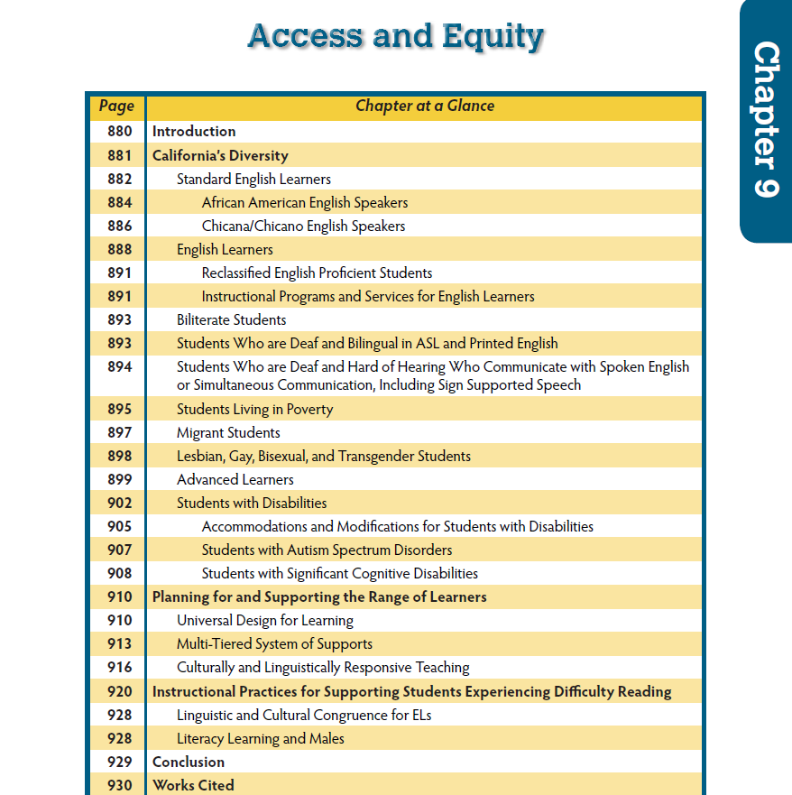

Frameworks inform educator professional learning across the career continuum; they are used in educator preparation and induction programs and in the professional learning activities of in-service educators. Dissemination of the frameworks is the primary objective of the statewide standards implementation work described in section D.1 above. The frameworks also include evaluation criteria for instructional materials, encouraging publishers to develop classroom resources that support framework content. Instructional materials approved by the SBE must meet the criteria described in the frameworks.

The California English Language Development Standards (CA ELD Standards) are designed to guide instruction so that English learners develop sufficient language to gain access to and engage in academic subjects, achieve in grade-level academic content, and meet state academic standards for college and career readiness. The CA ELD Standards were adopted in 2012 and are correlated to the ELA standards that were adopted in 2010. California is first in the nation to produce an integrated ELA/ELD curriculum framework and all subsequently adopted frameworks now include the integration of ELD.

Further, to ensure that students with disabilities are served more effectively regardless of setting, California is undertaking substantial revisions to its teacher preparation standards and programs. The CTC has engaged a stakeholder group to redesign program standards for both special educators and general education teachers. This redesign is based on the concept of cross-training, and will include increased preparation for general education teachers in serving students with disabilities. California recognizes that most students with disabilities receive much of their instruction in general education classrooms, so it is critical that general educators are better prepared to address the needs of the students with disabilities they serve.

Concurrently, special education program standards will be revised to include additional preparation to serve general education students, resulting in a broadened credential authorization that will allow special educators to serve general education students. As a result, special education expertise will be available through intervention and remediation activities to assist general education students who are struggling to overcome barriers to improved academic performance. These efforts to recognize the needs of students with disabilities in general education classrooms, and the challenges of the teachers who serve them, were inspired by the groundbreaking work of California’s Statewide Special Education Task Force and their summary report, “One System: Reforming Education to Serve All Students,” available at http://www.smcoe.org/about-smcoe/statewide-special-education-task-force/.

California’s accountability and continuous improvement system based on the Local Control Funding Formula (LCFF) provides LEAs with information and tools to identify areas where specific groups of students may need additional support. Performance data on a variety of state priorities is reported to the public through the California School Dashboard. LEAs can use this information to identify local educator professional learning needs, develop strategies, set goals, and resource these activities appropriately. The statewide system of support, a multi-leveled system that includes the standards implementation and support for school leaders activities described in Section D.1 above, will provide resources and assistance to schools and districts as they work to address locally-determined professional learning needs of educators.

  - Data and Consultation (ESEA section 2101(d)(2)(K)): Describe how the State will use data and ongoing consultation as described in ESEA section 2101(d)(3) to continually update and improve the activities supported under Title II, Part A.

Data and consultation are at the heart of California’s school funding system. At the local level, LCAPs are updated annually, allowing for local evaluation of programs and activities and realignment of resources that is responsive to the evolving needs of educators, students, and the district community.

Supplementing the LCAP development process with its requirements for community engagement, LEAs must complete the LCAP Addendum, which is the mechanism by which LEAs address the local planning requirements of the ESSA. Specifically, LEAs must describe programs and activities they will engage in using their Title II, Part A funds. Therefore, the expenditure of these funds is planned for in consultation with the local school community.

State-level activities will also be continuously evaluated and improved through data analysis and consultation. In reviewing LCAP Addenda, analyzing statewide Dashboard data annually, and consulting with state system of support partners, the state will prioritize state-level activities under Title II, Part A to address areas of greatest need. Systematic coordination with other state and federal programs will reduce redundancies and ensure the greatest impact at the local level.

  - Teacher Preparation (ESEA section 2101(d)(2)(M)): Describe the actions the State may take to improve preparation programs and strengthen support for teachers, principals, or other school leaders based on the needs of the State, as identified by the SEA.

California does not plan to utilize Title II, Part A funds to improve preparation programs. Investments to strengthen supports for educators will be made within California’s state system of support as described above.

DRAFT California ESSA State Plan: Title II, Part A: Supporting Effective Instruction
May 2017 | Page 7
California Department of Education | State Board of Education

Available at http://www.cde.ca.gov/ci/rl/cf/elaeldfrmwrksbeadopted.asp.

