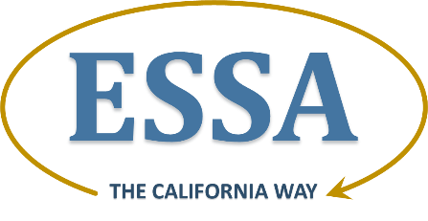
Section 6: Supporting All Students
Program-Specific Requirements

State Plan Requirement: 6.3 Program-Specific Requirements

Prompt: C. Title III, Part A: Language Instruction for English Learners and Immigrant Students: Entrance and Exit Procedures for English Learners

- Describe the SEA’s standardized entrance and exit procedures for English learners consistent with section 3113(b)(2), as amended by ESSA. These procedures must include valid, reliable, and objective criteria that are applied consistently across the State. At a minimum, the standardized exit procedures must:

    - Include a score of proficient on the state’s annual English language proficiency assessment;

    - Be the same as used for exiting students from the English learner subgroup for Title I reporting and accountability purposes;

    - Not include performance on an academic content assessment; and

    - Be consistent with Federal civil rights obligations.

California’s Response

The statewide California entrance procedures ensure that all students who may be English learners are assessed for such status using a valid and reliable instrument within 30 days after enrollment in a school in the state. California will replace the California English Language Development Test (CELDT) with the English Language Proficiency Assessments for California (ELPAC) as the state’s English language proficiency (ELP) assessment in the 2018–19 school year.

Pursuant to Education Code (EC) Section 313, the current standardized reclassification procedures for English learners are as follows and in accordance with the California Code of Regulations, Title 5, Section 11303:

- Assessment of English language proficiency using the state test of English language development; and

- Teacher evaluation inclusive of a review of the student’s curriculum mastery; and

- Parent opinion and consultation, inclusive of a review of student data, and at which time the parent is provided opportunity to opine and question; and

- Comparison of student performance in basic skills against an empirically established range of performance in basic skills based on the performance of English proficient students of the same age.

The CDE is planning to initiate a conversation with the State Legislature to remove Item 4 for the 2018–19 school year once the ELPAC is fully operational.

California ensures that standardized procedures are used for exiting students from the English learner subgroup as are used for Title I reporting and accountability purposes. The ELPAC summative assessment will occur as an operational assessment statewide in spring 2018. To ensure the exit from EL status is valid and reliable, a cut-score validation study will be conducted based on data received from the ELPAC summative assessment.

FIRST DRAFT: California ESSA Consolidated State Plan | Title III, Part A: Entrance and Exit Procedures for English Learners | California Department of Education | November 2016
Page 2

