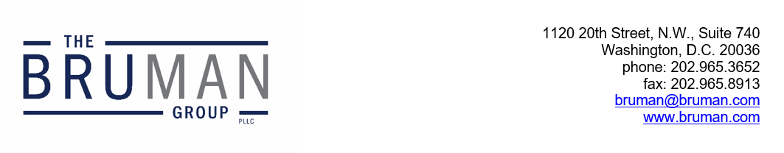

The Federal Update for June 21, 2024

From: Michael Brustein, Julia Martin, Steven Spillan, Kelly Christiansen
Re: Federal Update
Date: June 21, 2024
News 1
Second Federal Judge Blocks Title IX Rule 1
SCOTUS To Hear Case on E-Rate Program 2
Reports 2
GAO Issues Report on Identification of English Learners 2

News

Second Federal Judge Blocks Title IX Rule
A federal judge in the Eastern District of Kentucky has issued an order which prohibits the U.S. Department of Education from enforcing its new Title IX rule in a number of plaintiff States. In his ruling, Judge Danny Reeves wrote that “Title IX’s text, coupled with the legislative history discussed at the beginning at this opinion, leaves little doubt that Title IX’s drafters meant ‘male’ and ‘female’ when they wrote ‘on the basis of sex.’”
The order also suggests that the rule would conflict with parents’ rights to direct their children, or free speech rights if students and teachers are required to use pronouns aligning with a student’s gender identity and “convey a particular message that may contradict moral or religious values.” He also expressed concern that “[s]chool personnel would be forced to improperly insert themselves into constitutionally protected family affairs,” arguing that “this undermines a meaningful role for parents if the child decides his or her biological gender is not preferential.” Finally, he suggested that the rule was too vague in defining many terms, including what constitutes harassment that is “objectively offensive.”
The injunction blocks the rule from taking effect in Virginia, Kentucky, Tennessee, Indiana, Ohio, and West Virginia on its scheduled implementation date of August 1st. Last week, a federal judge in Louisiana temporarily blocked the rule from taking effect in Louisiana, Mississippi, Montana, and Idaho while that case proceeds, and there are five more lawsuits by States pending in federal courts. However, if a higher court overturns the decision on appeal or the U.S. Department of Education prevails in other States after August 1st, recipients could be required to implement the new rule with immediate effect.
Author: JCM

SCOTUS To Hear Case on E-Rate Program
The U.S. Supreme Court has agreed to take up a case next term to determine whether the E-Rate program, which provides discounted telecommunications and internet services to eligible schools and libraries, is subject to the False Claims Act. Under the False Claims Act, individuals or entities that have defrauded the federal government are liable for damages.
The case, Wisconsin Bell Inc. v. United States ex rel. Heath, hinges on whether action can be taken under the False Claims Act with respect to E-Rate funds, due to its complicated funding structure. E-Rate is overseen by the federal government through the Federal Communications Commission (FCC) but administered by the Universal Service Administrative Corporation and funded through contributions from private telecommunications companies. In the case appealed to the Supreme Court, an individual working for the FCC submitted a whistleblower claim that a particular telecommunications company was charging schools and libraries more than the E-Rate program permits in violation of the law. Circuit courts are split on whether the False Claims Act applies to E-Rate funding and would allow the FCC to recoup funds through the Act. In the case appealed to the Supreme Court, the U.S. 7th Circuit Court of Appeals determined that reimbursements under the E-Rate program are subject to the False Claims Act.
The Supreme Court will hear the case during its term that begins in October 2024.
Resources:
Naaz Modan, “Supreme Court to hear FCC E-rate case on school reimbursements,” K-12 Dive, June 18, 2024.
Author: KSC

Reports

GAO Issues Report on Identification of English Learners
The Government Accountability Office (GAO) issued a report this week that includes an analysis of how States and school districts identify English learners, including those with disabilities, for language services.
Districts are required to identify English learners, including English learners with disabilities, enrolled in the district’s schools, which is typically achieved by having families enrolling new students complete a language survey. Based on the survey results, districts then request that students complete an English language proficiency screening to determine whether services are needed and what types or level of services may be required. Investigations a few years ago conducted by the U.S. Departments of Education (ED) and Justice indicated that some States were not identifying all English learners through their identification processes. Following those investigations, ED released three questions that States should include on home language surveys in order to meet federal requirements, though additional questions can also be included.
As the basis for the report, GAO surveyed all 50 States on their English learner identification process, as well as how States ensure all English learners are identified. GAO found that 48 States use the ED-approved questions for home language surveys but that 40 of those States either modified the questions and/or added questions to the surveys. In addition, when asked about whether States have assessed the quality of their identification systems, 32 States reported that they had, primarily through reviewing their policies and procedures, as well as any federal guidelines on identification of English learners. Finally, 41 States said that they provided assistance to school districts in identifying English learners with disabilities within the last three years, which included publishing guidance and providing instructional support, among other types of assistance.
The full GAO report on identifying English learners is available here.
Author: KSC
The Federal Update has been prepared to inform The Bruman Group, PLLC’s legislative clients of recent events in federal education legislation and/or administrative law. It is not intended as legal advice, should not serve as the basis for decision-making in specific situations, and does not create an attorney-client relationship between The Bruman Group, PLLC and the reader.
© The Bruman Group, PLLC 2024
Contributors: Julia Martin, Kelly Christiansen
Posted by the California Department of Education, June 2024

