

CA Early Childhood Inclusion Support
Winter 2025 Newsletter
California Department of Education
December 11, 2025

Inspiration Highlight
The Purple Tree Cafe empowers people with disabilities by offering community-based, integrated employment at competitive wages. Through food, art, and music, the café fosters inclusive connections while selling vegan, wheat-free baked goods, and organic beverages at local markets, events, and its University of California, Davis storefront. Click on the link to find out more and watch a short video about the Purple Tree Café (Video; 10:24).

Early Learning and Care Inclusion News

Congratulations to our Early Education Division (EED) Director, Stephen Propheter, who has been appointed by Governor Gavin Newsom to the Early Childhood Policy Council. View the announcement at Governor Newsom announces appointments 10.28.25 (www.gov.ca.gov).

Inclusion Spotlight
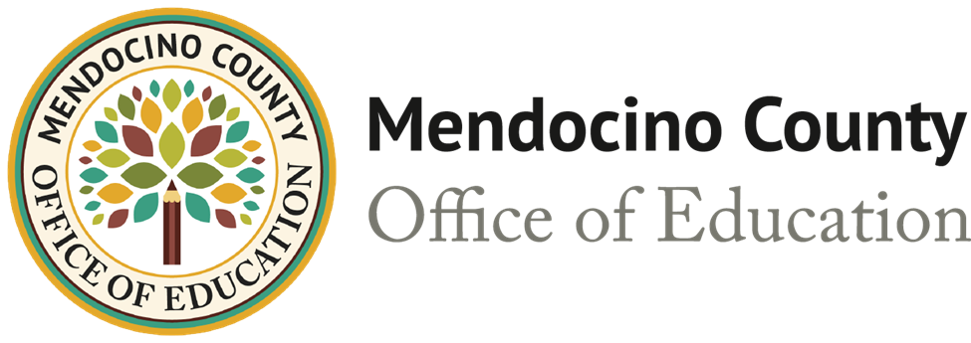

Redwood Preschool: Cultivating Inclusion and Belonging in Mendocino County
In the heart of Mendocino County, Redwood Preschool is redefining what it means to belong. With a mission rooted in empathy, respect, and community, this early childhood program is leading the way in inclusive education—where every child, regardless of ability, is welcomed, supported, and celebrated.

A Vision of Inclusion from the Start
At Redwood Preschool, inclusion is not just a practice – it is a mindset. The team believes that all children deserve to be full members of a learning community. “We emphasize that every child is unique,” says the staff, “and that these differences are strengths that enrich our classroom.” Through strong relationships, responsive teaching, and a culture of respect, the program helps children and families embrace diversity from the earliest years.

Defining and Measuring Success
Inclusion at Redwood means more than physical presence – it is about meaningful participation. Success is measured by how actively children engage in classroom routines, build relationships, and grow in independence, communication, and social-emotional skills. Equally important is the development of empathy and mutual support among peers, creating a classroom culture where every learner is valued.

A Unified Model of Support
Redwood Preschool blends the district’s Special Education Preschool program with the State Preschool program, creating a unified, co-taught classroom. This model ensures that all children, neurotypical and neurodivergent, learn and grow together. Supports are embedded within the natural classroom environment, with specialists and educators collaborating to scaffold learning and model inclusive strategies.
For children with more complex needs, flexible options like quieter spaces or targeted support are available, always guided by the child’s comfort and learning goals. “We regularly talk about how everyone learns, moves, and communicates in different ways,” the team explains. “Differences are expected, respected, and celebrated.”

Teaching Through Collaboration
The teaching model at Redwood is grounded in co-teaching and embedded instruction. Educators work side-by-side to support all students in developing meaningful skills through everyday experiences. This collaborative approach ensures that every child can participate fully and confidently in classroom life.
The program also benefits from partnerships with the Mendocino County Office of Education (COE) and the Inclusive Early Education Expansion Program grant, in collaboration with the California Teaching Pyramid, further strengthening its inclusive practices.

Family Partnerships and Community Connection
Redwood Preschool places a high value on family engagement. From daily drop-off conversations to monthly newsletters and online updates, families are kept informed and involved. “We’re proud of the strong, ongoing partnerships we’ve built with families,” the staff shares. “These connections help ensure that families feel included and connected to their child’s preschool experience.”

Overcoming Barriers, Building Culture
Blending multiple preschool programs into one inclusive model came with challenges. The team prioritized building a unified staff culture committed to inclusion and sought administrative support for ongoing professional development. This investment in training and collaboration has paid off, creating a strong foundation for inclusive practices.

A Journey Rooted in Belonging
For Redwood Preschool, inclusion is not a destination; it’s a journey. “Inclusion is not a place,” the team emphasizes. “It’s a mindset. It’s about fostering belonging, respect, and opportunity throughout all classroom experiences.”
As they continue to grow and evolve, Redwood Preschool remains a shining example of what is possible when educators, families, and communities come together to create a space where every child is seen, supported, and celebrated.
Check out their awesome environments for their students below:
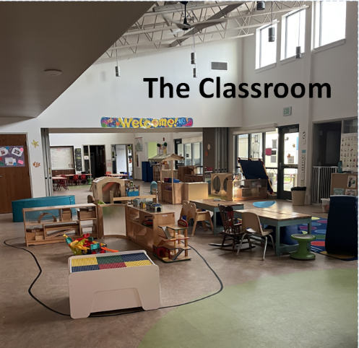
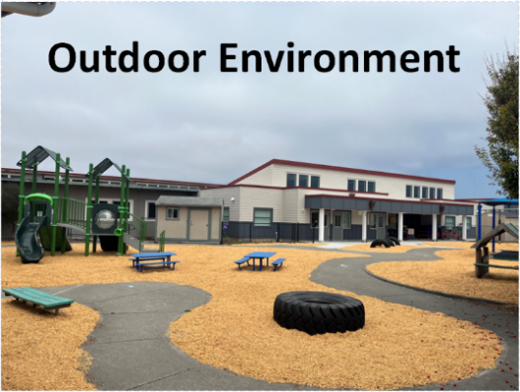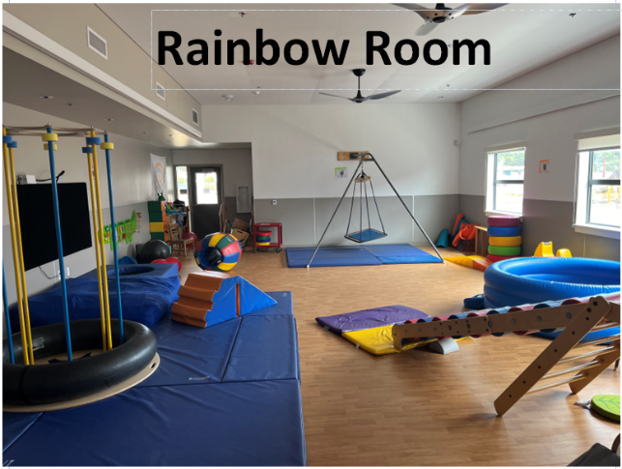

Transitions

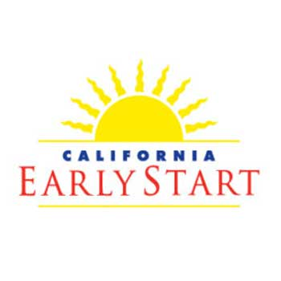
California Early Start
The Early Start program is California’s early intervention program for infants and toddlers with developmental delays or at risk of having a developmental disability and their families. Early Start services are available statewide and are provided in a coordinated, family-centered system.
The Story of Max (Early Head Start) and Max Turns 3 (Early Head Start)

High-Quality Individualized Education Programs

The following family resources can be found on the High Quality Individualized Education Programs (IEPs) web page:
- Planning For Transition: Part C to Part B of IDEA Transition Checklist in English and in Spanish.
- Understanding the Difference between Individualized Family Service Plans and IEPs in English and in Spanish.
- Resources for Families - Before, During & After the IEP

Social Emotional Resource Highlight

Inclusive Early Education Resources
In an effort to uplift high-quality inclusive early education, the EED at the California Department of Education (CDE), in collaboration with the Impact Inclusion Workgroup, has developed a resource matrix to support providers, administrators, and parents with information to help support increased access to children with disabilities in inclusive programs. Visit the CDE Inclusive Early Education Resources web page for more information.

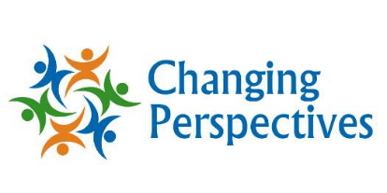
Changing Perspectives
The Changing Perspectives web page provides support to all members of an educational community to foster social-emotional learning and cultivate inclusive and equitable learning environments for all students.
One resource area to highlight is their family workshops page that includes support for learning beyond the classroom or program by providing parents and caregivers with insights and strategies they can use at home. As part of their comprehensive holistic model, the family workshops can be conveniently delivered either virtually or in-person. Workshop content is carefully tailored in collaboration with the school and/or organization to bridge the gap between school and home learning effectively.
Find out how the family workshops strengthen school-home partnerships. Click the link below:
How Family Workshops Strengthen School-Home Partnerships – Educator Testimonials (Video; 3:35)

Upcoming Events and Learning Opportunities
- Cal-TASH 43rd Annual Conference: February 27–28, 2026. Sacramento, California. Building Bridges, Breaking Barriers (Cal-TASH). TASH works to advance inclusive communities through advocacy, research, professional development, policy, and information and resources for parents, families and self-advocates.
- Beginning Together 2025–26 Inclusion Webinar Series: March 3, 2026. Virtual. Beginning Together will host a webinar on inclusion titled Building Relationships Across Teams: Connections and Continuity. Following the webinar, participants will be invited to a ninety-minute virtual small group session called “Collaborative Conversations: Follow-up to Inclusion Webinars and Support on Inclusion.” These sessions are designed to facilitate conversations with others in similar roles to discuss specific areas of interest or concern in relation to supporting inclusion and will be facilitated by a Beginning Together trainer who can provide technical assistance, additional information, and resources. Visit Beginning Together’s webinar page to learn more and register.
- Beginning Together – Inclusion Facilitator Institute 2026: March 2026. Virtual. This Institute will host Training-of-Trainers virtual sessions offered as a combination of synchronous and asynchronous virtual activities on Thursday afternoons. There will also be opportunities for teams to plan how they will use the training and facilitation activities in their communities. Beginning Together Institute for Inclusion Facilitators is designed for those who train early childhood staff including childcare providers, educators, and assistants on the benefits and basics of inclusive practice. Synchronous meetings and trainings will be held from noon to 4 p.m. on the following Thursdays: March 5, 12, 19, 26, and April 2, 2026. Additional online activities, requiring between two to four hours each week, will be offered to complete on your own timeline. Visit the Beginning Together ~ Inclusion Facilitator Institute 2026 web page for more information and to apply.
- Inclusion Academy Supports District and Sacramento County Office of Education (SCOE) Departments: Ongoing. Virtual. Put on by Supporting Innovative Practices (SIP) along with SCOE. School districts, charter schools, Special Education Local Plans (SELPAs), and other COEs interested in receiving training should email scoleman@scoe.net. For more information, visit the SCOE Inclusion Academy Supports Districts and SCOE Departments web page.
- SIP 5th Annual Virtual Conference: May 2026. Virtual. More information coming soon. Keep checking the Supporting Innovative Practices web page for more information.
- CalECSE’s 2025–26 Community of Practice (CoP): Dates and times vary. This is a statewide opportunity to connect with other professionals, learn together, and improve outcomes for young children with disabilities (ages birth to five) and their families. Dates and times for your region’s meetings can be found on the CalECSE COP web page.
- Desired Results Access Project Upcoming Events: February 2, 2026, at 3 p.m. Pacific Standard Time (PST) (Virtual). Desired Results (DR) Access is excited to collaborate with CalECSE, the High Quality IEP Project, and CalBloom to present an engaging virtual series: “From Assessment to Action (Napa COE).” This series guides participants through understanding assessment reports, writing present levels, planning instruction, and ultimately turning data into meaningful action.
- Early Childhood Investigations Webinars:
  - Foundations of Social-Emotional Development in a Post-Pandemic, Digital World (Early Childhood Investigations Webinars): January 7, 2026, 11 a.m. to 12:30 p.m. PST presented by Brian Puerling, Early Childhood Expert, Advocate, and Author.
  - From Overwhelmed to Joyful: Caring for Children and Yourself with Intention (Early Childhood Investigations Webinar): January 8, 2026, 11 a.m. to 12:30 p.m. PST presented by Christina Fecio, Education Consultant.
  - Is it Stress or Trauma? How We Can Support Children in School (Early Childhood Investigations Webinars): January 28, 2026, 11 a.m. to 12:30 p.m. PST by Dr. Sharon Bacharach, Associate Director of Early Childhood Education Degree Programs.
  - Beyond Behavior: Understanding Attention-Seeking in Young Children (Early Childhood Investigations Webinars): February 6, 2026, 11 a.m. to 12:30 p.m. PST presented by Shelby Secoura, Registered Early Childhood Educator.

In case you missed it
SELPA IMPACT: Celebrating 50 years of IDEA: A Parent’s Perspective (SELPA) newsletter published by SELPA Administrators of California.
Brookes Publishing: Brookes publishing presents the Second Edition of The Preschool Inclusion Toolbox – How to Build and Lead a High-Quality Program (Brookes Publishing). Written by top inclusion experts and updated with timely new topics and tools, this book will help leaders develop program-level policies for implementing and sustaining full-scale preschool inclusion. This toolbox of ready-to-use guidance is perfect for use as a self-directed professional learning resource or as a textbook in early childhood administration courses.
Infant-Toddler Learning and Development Foundations, Second Edition - The California Department of Social Services (CDSS) is pleased to announce the release of the revised California Infant-Toddler Learning and Development Foundations (ITLDF). The revised ITLDF represents part of the CDSS comprehensive effort to strengthen young children’s learning and development through high-quality early care and education. The ITLDF describes the development infants and toddlers often attain during the birth-to-three age period. This second edition of the ITLDF was developed with input from a broad range of interest holders, researchers, and early learning/education providers, and has been aligned with the California Preschool/Transitional Kindergarten Learning Foundations.
The ITLDF can be accessed on the CDSS Publication Page and is available in English, Spanish, Simplified Chinese, and Traditional Chinese.
Coming soon: An interactive website including videos to support the ITLDF, California Early Childhood Online modules, and other resources!


Contact Us
Impact Inclusion Workgroup
Email the workgroup: ImpactInclusionWorkgroup@cde.ca.gov
Email the Inclusive Universal PreKindergarten Office, CDE: InclusionSupport@cde.ca.gov
For information on CDE news related to our P-3 initiative and to ensure you receive updates about future webinars, email "subscribe” to subscribe-cdep3updates@mlist.cde.ca.gov.

