Root Cause Analysis Toolkit

School Improvement and Support Office
Student Achievement and Support Division
California Department of Education
1430 N Street, Suite 6208
Sacramento, CA 95814-5901
916-319-0833
https://www.cde.ca.gov/sp/sw/t1/continuousimprovement.asp
Updated August 2026

Table of Contents

Root Cause Analysis Toolkit 1
Table of Contents 2
Fishbone Generation Protocol 4
Purpose 4
Norms 4
Protocol 4
Interrelationship Digraph Protocol 5
Purpose 5
Norms 5
Protocol 5
Expert Convening Protocol 7
Purpose 7
Roles 7
Norms 7
Protocol 7
Empathy Interview Protocol 10
Purpose 10
Norms 10
Protocol 10
Digging Into Data Protocol 13
Purpose 13
Roles 13
Norms 13
Protocol 13
Process Mapping Protocol 16
Purpose 16
Roles 16
Norms 16
Protocol 16
Driver Diagram Generation Protocol 19
Purpose 19
Norms 19
Some Helpful Definitions 19
Protocol 20

All worksheets adapted from the protocols created by the High Tech High Graduate School of Education Center for Research on Equity and Innovation (http://bit.ly/2DqB4KO).

Fishbone Generation Protocol

Purpose
To arrive at a deeper understanding of the problem (before jumping to solutions).

Norms
- Avoid “Solutionitis”… the goal is to understand the issue, not solve it (yet).
- “Yes and”... the goal is to generate lots of ideas, and not fixate on one.
- Embrace “definitely incomplete; possibly incorrect.”
- Share the air.

Protocol
- Generating our Problem Statement (5–7 min.)
- Using the California School Dashboard as a reference, what is one problem we need to solve? Express the problem in one sentence.
- Initial Brainstorm of Causes (5 min.)
Based on your work digging into the problem (e.g., empathy interviews, expert convening, relevant data, research, etc.) and your own ideas/experiences, individually brainstorm as many causes as you can that might contribute to the problem/issue. Write each cause on a different Post-it. For meaty “big” topics, it can help to ask a chain of “why?”
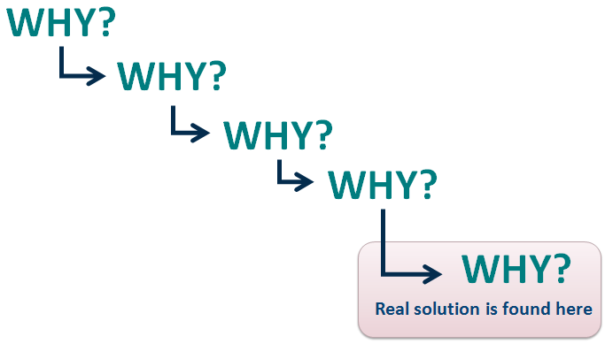
Share and Categorize (15–20 min.)
- Share around:
  - Each person shares one cause contributing to the problem. If others have a similar cause, you can start to group those Post-its together on your Fishbone Diagram.
  - Continue to share your initial brainstorm, building on each other’s ideas and adding new causes that may contribute to the problem.
- Cluster on your Poster: Group related causes together and give each category a title. The data on the Post-its are the details/bones on the Fishbone Diagram.

Fishbone Diagram Example
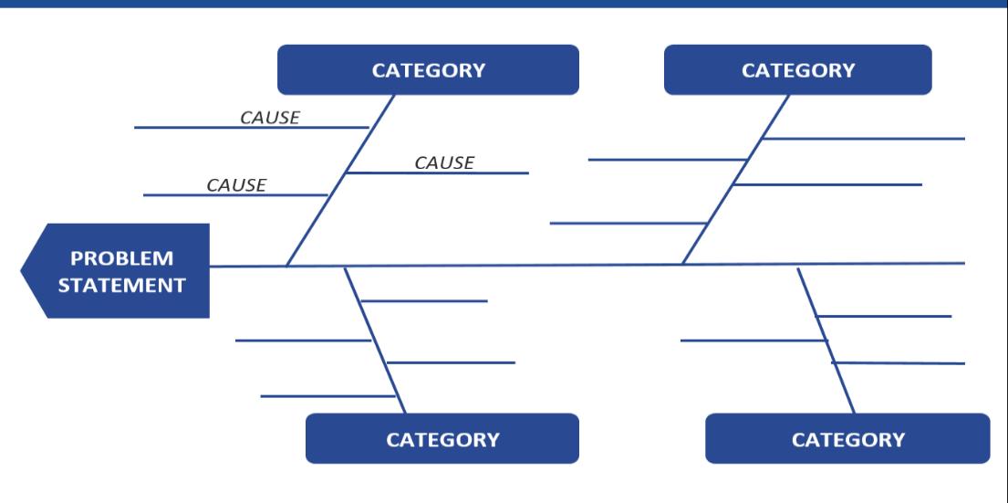
- Post and Reflect (5 min.)
Hang your poster on the wall. Does your diagram capture the root causes you think are important? Anything missing? Then each person gets to vote with one heart and one star:
- High Leverage: Put a heart by the factor, that if addressed, you think would have a significant impact on the problem.
- Practical: Put a star by the factor that is within your control—the factor your team could address with little effort.
- Debrief (5 min.)
- How did we do upholding the norms?
- How might we adjust this protocol in the future?

Interrelationship Digraph Protocol

Purpose
To use this protocol to determine which root causes from the Fishbone Diagram are the most impactful on which to focus.

Norms
- Avoid “Solutionitis”… the goal is to understand the issue, not solve it (yet).
- “Yes and”... the goal is to generate lots of ideas, and not fixate on one.
- Embrace “definitely incomplete; possibly incorrect.”
- Share the air.

Protocol
- Arrange the main root causes from your fishbone in a circle.
- Predict: Which cause do you think is most important?
- Starting with one cause, and for each pair of causes ask yourself:
- Is there a relationship between these two?
- If yes, which causes the other? Draw an arrow from one to the other to show directionality.
  - For example: “Does X cause Y or vice versa?”
- You can decide there is not causal relationship, but you must pick a direction if you do see a relationship.
- Repeat until you have established a relationship (or not) between all the causes.

Interrelationship Digraph Example
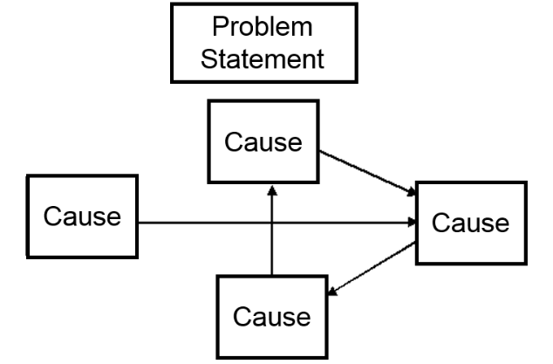
- Tally arrows (out, in) for each cause.
The root causes with the most outgoing lines most impact the problem.
Star the top 1–2 root causes!
Predict which will be the highest priority:

Expert Convening Protocol

Purpose
To learn from people who have relevant expertise and who provide multiple perspectives on the issue a team wants to improve. Ideally, the presenting team should leave with a deeper understanding of the factors contributing to the issue and clear next steps for moving the work forward. The role of the presenting team members is to actively listen and take notes, with one team member facilitating the protocol.

Roles
- Facilitator will guide the group through the protocol and help it uphold the norms, while keeping time.
- Note taker will capture the ideas of the experts as they emerge.
- Experts will share their perspectives on the issue being discussed.

Norms
- “Yes and”...the goal is to explore many ideas, and not fixate on one.
- Seek to understand…ask clarifying and probing questions to dig deeper.
- Share the air…so that all experts are able to contribute their ideas.
- Invite others in.

Protocol
- Overview and Introductions (5 min.)
The facilitator reviews the purpose, protocol, and norms. Participants each take 30 seconds to share their name, role, where they work/study, and one reason this conversation is important to them.
- Clarifying and Probing Questions (5 min.)
Experts ask the presenting team clarifying and probing questions to understand the team’s goal (avoiding advice in disguise such as “Have you thought about…”).
- Reflecting on the Goal and Discussion Questions (5 min.)
Experts write/think about the questions in the Discussion Round (Step 4) and what they would like to contribute to the discussion.
- Discussion Rounds (35 min. total)
Each round begins with each expert briefly sharing their initial thoughts on the question. Experts may choose to pass. Then participants engage in a free-flowing conversation with the time left. The presenting team members are silent and take notes; it may help to have a notetaker capture ideas on poster paper as they emerge.
- Round 1–Reflections (10 min.)
What do we need to think about if we want to achieve this goal?
- Round 2–Resources (10 min.)
Who else is working on this goal and has experienced success? (Who should we talk to? Where should we go? What research should we seek out?)
Or
Who has helped you related to this goal? How?
- Round 3–Change Ideas (10 min.)
What are 1–2 concrete actions you think we should take to achieve our goal? Which actions do you think would have the greatest impact?
- Round 4–Final Word (5 min.)
Any last thoughts? Anything particularly resonating with you?
- Team Reflection (5 min.)
The presenting team member and the note taker reflect on what struck them from the conversation, questions that emerged, and possible next steps. The experts are silent.
- Debrief (5 min.)
All participants reflect on the process using the following questions as a guide:
- Did this protocol help all involved develop a deeper understanding of how to achieve the goal?
- How did this feel? How did we do upholding our norms?
- What changes would we make to the protocol before trying it again?
- After the Protocol (if relevant)
The presenting team meets to revisit and revise their theory of action using the following as a guide:
- Based on the expert convening, what are we learning about the problem we want to address?
- Is there anything missing from our theory of action (i.e., Driver Diagram [see page 17])? Are our drivers necessary and sufficient for moving our goal?
- What new questions are emerging for us?
- What are our next steps?

Empathy Interview Protocol

Purpose
To gain a deeper understanding of a stakeholder’s experience of the issue you are working on.

Norms
- Seek to understand, not confirm.
- Ask once, clearly.
- Ask questions that elicit stories and feelings.
- Probe: “Tell me more…” “What was that like for you?”

Protocol
- Prepare for Interviews (15 min.)
What questions could you ask a student/practitioner/other stakeholder to understand their experience related to your group’s problem/issue, and the factors contributing to it?
- Question Selection/Brainstorm (3 min.)
Individually, review the questions below. Adapt these or generate a few questions of your own.
- Share and Organize (5–10 min.)
As a group, identify/organize your top 5–6 questions. Will they help you understand what makes X challenging, or when Y experiences success
(i.e., the possible root causes you need to address)?
- Predict and Plan (3 min.)
Each person shares one thing they think they will hear. If you are doing the interview with a partner, decide who will interview and who will take notes.
Consider these possible empathy interview questions:
- Tell me about a time when you received feedback on a piece of work that allowed you to improve the quality of that work. Why do you think the feedback was helpful at that moment?
- Tell me about a time when you received feedback on your work that wasn’t helpful.
  - How did that feel?
  - What did you do?
  - Was that hard? Why or why not?
  - What do you wish would have happened?
  - What would have helped?
- What advice would you give another person about X?
- What advice would you give to me about X?
- What do you wish others knew about X?
- If you could describe how you feel about X in one word, what would it be?
- Draw me a picture of what you think about when you hear X…
(Then: Tell me about what you drew.)
- Conduct Interviews (20 min.)
Ask 5 or more interview questions and take notes.
- Q:
N:
- Q:
N:
- Q:
N:
- Q:
N:
- Q:
N:
- Reflect (5 min.)
- Content: What did we hear? What are we learning about the root causes that contribute to the problem?
- Process: Are there questions we wish we would have asked? Are there questions that were particularly helpful? Did we probe effectively?

Digging Into Data Protocol

Purpose
To help a group engage in productive dialogue about data and to build collective capacity to make sense of data relevant to local educational agency improvement. You can use this protocol with multiple small groups, each unpacking a different piece of data, and then sharing out to the group. Or you can use this protocol to have everyone unpack the same piece of data (in this case, modify Phase 3).

Roles
- Facilitator guides the group through the process and ensures that the protocol and norms are upheld.
- Note taker captures notes from the discussion and is prepared to share with the group.

Norms
Data conversations can make people feel vulnerable. A structured dialogue helps maintain safety and focus.
- Share the air…step up, step back, and invite others in.
- Hard on the content, soft on the people.
- Focus on learning, not judging.
- Stick to the protocol.

Protocol
      - Getting Oriented (5 min.)
Participants take 2–3 minutes to individually review the data. The facilitator then leads a quick check-in: Does everyone understand what is being presented?
      - Discussion Rounds (25 min.)
- Round 1: Observations and Celebrations (people may pass or say “ditto”)
  - Each person shares one thing they noticed that they want to celebrate and/or call attention to. During this round it is important to just describe what you see as objectively as possible. Resist the urge to interpret or pose questions.
  - Helpful sentence frame: “I noticed...”
- Round 2: Questions (start with a different person, people may pass or say “ditto”)
  - Each person shares a question that emerges for them from the data.
  - Helpful sentence frame: I wonder...
- Round 3: Hypotheses (facilitator facilitates a discussion)
  - Participants share possible hypotheses or explanations for what they see, trying to identify multiple alternative explanations.
  - Helpful sentence frames: This could be because...Or it could be because...
- Round 4: Next Steps (facilitator facilitates a discussion)
  - Participants share what they might do next given their understanding of the data.
  - Helpful sentence frames: One thing we could do next is...
      - Share out (optional, time varies)
The note taker from each group has 1 minute to share highlights from their group’s discussion of the data. We recommend sharing the following:
- One celebration/noticing
- One question that emerged
- One possible hypothesis
- One next step
(Skip/modify this step if all participants have looked at the same data or if you only have one group.)
      - Debrief (5–7 min.)
The facilitator leads the group in reflecting on this process.
Helpful Guiding Questions:
- What was this process like for you?
- What adjustments would you make?
- How did looking at data influence your understanding of the issue?
- What are we learning about how to package data so that we can engage in productive conversations?
- How might you use this protocol in your work, with your team?
- What data are we craving?

Process Mapping Protocol

Purpose
To better understand the process leading a particular outcome, and identify potential breakdown points where we should focus our improvement efforts.

Roles
- Interviewee: The person being interviewed who can provide a helpful perspective on the process.
- Interviewer/Facilitator: The person who interviews the interviewee, and who facilitates Step 3.
- Process Mappers: One to two people who map the process while listening to the interview.

Norms
- Resist “Solutionitis”… get your map out first, then challenge and ask questions about it.
- Share the Air… step up, step back.
- Seek to Understand, not Confirm.

Protocol
- Identify your Endpoint (5–7 min.)
Before mapping the process, you need to articulate your endpoint (i.e., goal).
- Individually brainstorm (2 min.) possible endpoints for the process you want to map. See if you can express it in one short sentence.
- Share: Each person shares one endpoint until all ideas have been shared.
- Choose one or create a new one (without getting hung up on the perfect wording).
- Create the Map (10–15 min.)
Using the roles above, the interviewer interviews the interviewee to understand the process (i.e., the reality) leading up to that goal, while others map the process on paper.
Helpful questions/sentence frames:
- Start with, “So if X is your goal, where do you begin?”
- Then what?
- Listen for decision points. Is this a decision point? What happens if… (yes)? What happens if… (no)?
- End by asking, “What was most challenging about the process you just described? What changes could we make to address that challenge?”

Process Mapping Example
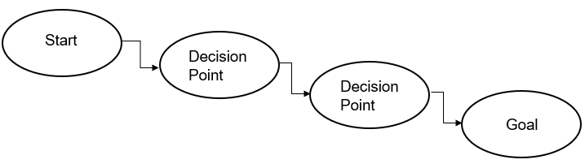
- Interrogating your Map and Identifying Change Ideas (15–20 min.)
The interviewee may no longer be present.
- Share: The rest of the team engages in a discussion about what they heard starting with a share, where each person shares one thing that struck them from the conversation. Looking over the process maps, discuss the following as a group:
  - What are we learning about this process?
  - Was there anything important that we heard that is missing on the process map? (capture it)
- Where/how might this process breakdown, especially for students who may feel disenfranchised or marginalized?
  - Put an X over those places in your map where the process could breakdown.
- What might we do (i.e., change ideas) to improve this process?
  - Write change ideas on your map by the breakdown points.

Driver Diagram Generation Protocol

Purpose
To generate or refine a shared “theory of action” to drive a team’s improvement efforts and achieve the goal.
Note: Driver Diagrams are not intended to be set in stone. Your team’s theory of action should evolve as you learn more about the problem you want to address, the change ideas you are trying, and how best to achieve your goal. Your team is encouraged to revise your Driver Diagram to reflect your most current thinking/focus, and to keep track of versions 1.0, 2.0, etc. so they can reflect on the evolution of your learning.

Norms
- “Yes, and”... the goal is to generate lots of ideas, not fixate on one.
- Embrace “definitely incomplete; possibly incorrect.”
- Share the air.

Some Helpful Definitions
- Goal: What you want to accomplish, for whom, and by when.
- Primary Drivers (the what): What you need to focus on to achieve your goal.
- Secondary Drivers (the where): Where in your system (the existing structures/processes) you should focus your energies to effect the primary driver.
- Change Ideas (the how): What you can try and test/refine.

Driver Diagram Example
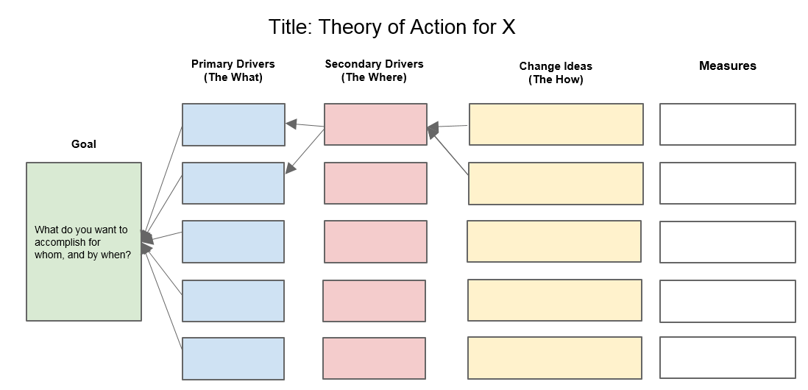

Protocol
- Clarify/Refine our Goal (10 min.)
- Craft/refine the goal statements: What do you want to accomplish, for whom, and by when?
  - Have each person, individually or with a partner, craft a goal statement.
  - Follow this with a whip where each person/partnership shares their goal with the group. Then the group can adopt/adapt from these to create a goal statement everyone feels good about. Write your group’s goal statement on the left side of your poster.
Something to consider:
  - Is your goal measurable? To help ensure your goal is measurable, it can be helpful to ask yourselves this question: “If X was the best it could be, what would it look like?” It can also help to get baseline data related to the issue/gap your team is working on.
- Identify Primary Drivers (20–30 min.)
- Individual (no more than 5 min.): Each person identifies the top 4 drivers (i.e., high leverage areas) they think the team needs to focus on to impact the goal, and writes each driver on a separate index card.
  - Facilitation Move: It can help to think of drivers as X in the following statements: “If we figured out X, we could achieve our goal” or “If we don’t figure out X, it is unlikely we would achieve our goal.”
- Whip and Cluster: Each person shares their favorite driver with the group. If others wrote down a similar driver, group these cards together on the table.
  - Facilitation Move: As your group shares and clusters, it can be helpful to organize the “stacks” with the most cards to the top of the table, and those with the least to the bottom. This gives the group a visual indicator of which drivers might be most important.
- As a group, select 3–5 drivers that you agree are essential for impacting your goal. Write those drivers on your Driver Diagram poster. This is your “theory of action” (i.e., if you could move these drivers, you could achieve your goal).
  - Questions for the team to consider:
          - Is this driver specific enough that we all understand on what to focus?
          - Is this driver impactful enough that it will move the work forward?
          - Is this driver within our locus of control, meaning we can do something about it? (i.e., Poverty is real, but may not be a helpful driver. However, Family Support could be an important driver and signals a way of working with families to reduce the effects of poverty.)
          - Are these drivers necessary and sufficient for achieving our goal?
          - Which driver do we think is our greatest lever for change? (Star this one on your Driver Diagram.)
- Identify Secondary Drivers (if time permits)
If your team has time, you can add secondary drivers to your diagram. Secondary drivers articulate “where” in the system (i.e., on what structures and processes) you can focus your efforts to impact the primary drivers. They can be helpful for focusing the team’s efforts and coming up with more concrete change ideas.
- Generate Change Ideas (15 min.)
  - Individual Brainstorm (3 min.): How might we impact the drivers we identified? What might we try? Where is this happening well already (bright spots), and what are they doing? Write each idea on its own Post-it.
  - Share and Align (10–12 min.): Individuals share their ideas with the group, and post each change idea by the driver they feel it most impacts.
    - Question for the team to consider: What do we notice about the alignment (or lack of) between our change ideas and drivers? (If you have lots of change ideas that don’t align to your existing drivers, this could suggest a new driver is needed. If you have a driver without any change ideas, this driver may not be helpful to your current “theory of action”).
  - Identify high leverage change ideas: As a group, identify 3–5 change ideas that you agree are most impactful, and that you could get moving on quickly. Star these on your Driver Diagram.
- Debrief the Process (5 min.)
Group members discuss the following questions:
- How well did we do with upholding the norms and sticking to the protocol?
- Was this protocol helpful for identifying high leverage drivers and change ideas?
- What worked well about this protocol? What could be improved?

