

Parent Guide for the 2025 California School Dashboard
Prepared by: California Department of Education
November 2025

What Is the California School Dashboard?
The California School Dashboard (or the Dashboard) is an online tool that shows parents and communities how well schools and districts are meeting the needs of all students. It reports performance on both state and local measures. These multiple measures reflect California’s accountability system, which is based on the ten priority areas of the Local Control Funding Formula (LCFF), which are discussed on the State Priority Related Resources web page. Additionally, you will find more information in the Getting to Know the California School Dashboard Flyer (PDF).

State Measures
The state measures are based on information collected statewide and allow parents to compare schools and districts across California.
Seven State Measures:
- Academic (grades three through eight and grade eleven)
  - English language arts/literacy
  - Mathematics
- Chronic Absenteeism (transitional kindergarten through grade eight)
- Suspension Rate (transitional kindergarten through grade twelve)
- English Learner Progress (grades one through twelve)
- Graduation Rate (high school only)
- College/Career (high school only)
- Science (grades five, eight and once in high school, for informational purposes)
You can learn more about each of these indicators in Appendix A: What More Should We Know about the State Measures? or by clicking the Getting to Know the State Measures Flyer (PDF).

Local Measures
Local measures are based on information collected locally by districts, county offices of education, and charter schools. Local measures address:
- Basic Services and Conditions
- Implementation of State Academic Standards
- Parent and Family Engagement
- School Climate Survey
- Access to a Broad Course of Study
The reporting of the local measures on the Dashboard provides the public with important information on an LEA’s progress in each local priority area.
You can learn more from the Getting to Know the Local Measures Flyer (PDF).

Student Groups
The Dashboard reports specific student groups as required in California Education Code Section 52052(a)(2):
Race/Ethnicity:
- Black or African American
- American Indian or Alaska Native
- Asian
- Filipino
- Hispanic or Latino
- Native Hawaiian or Pacific Islander
- White
- Two or More Races
Program Participation:
- English learner (EL)
- Long-Term English Learner (LTEL)
- Socioeconomically Disadvantaged (SED)
- Foster Youth (students whose well-being is the responsibility of a court)
- Student with Disabilities (SWD)
- Homeless

How Is Performance Measured?
Performance on state measures is based on results for both the current and prior years.
For each state measure, schools and districts receive one of five Performance Levels. Each Performance Level is identified by a different color:
Table 1: Performance Levels
Performance Levels
Very High (Blue)
High (Green)
Medium (Yellow)
Low (Orange)
Very Low (Red)
View the How Colors are Determined Flyer (PDF).

How Is Performance Reported on the Dashboard?
On the Dashboard reports, the Performance Levels appear as semi-circle gauges that are divided into color segments: red, orange, yellow, green, and blue. An arrow points to the color that represents the Performance Level for that measure.
Figure 1: Performance Level Gauge
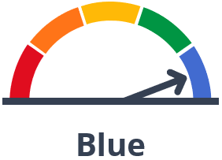
Full Text Description for Figure 1

How to View Performance of a School or District on the 2025 Dashboard
- The Dashboard can be viewed on the California School Dashboard (External Link) web page.
- To see the results for a school or district, type the name into the search bars provided.
Figure 2: Dashboard Home Page
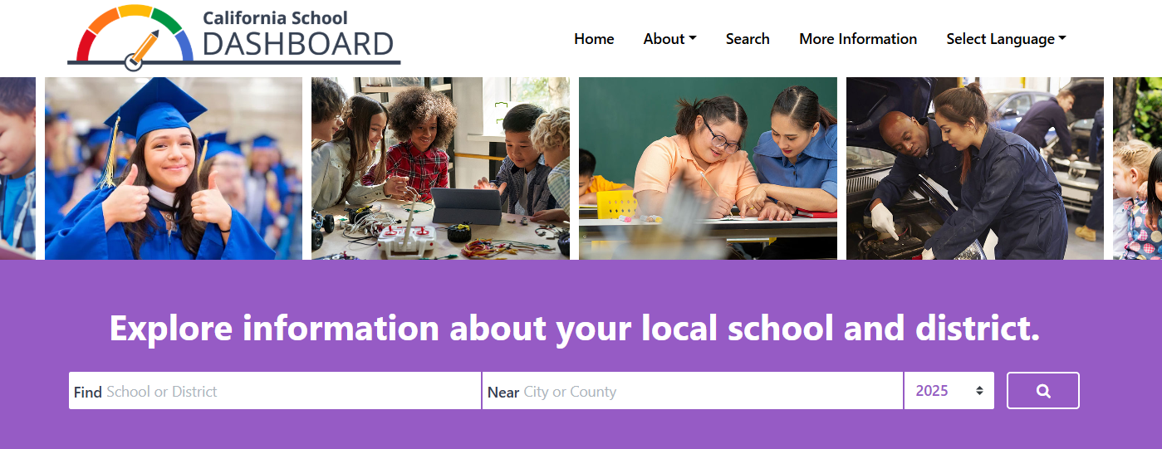
Full Text Description for Figure 2
- Once you select your school or district, you’ll be able to see its performance on state and local measures.
Figure 3: Performance Levels and Local Indicators
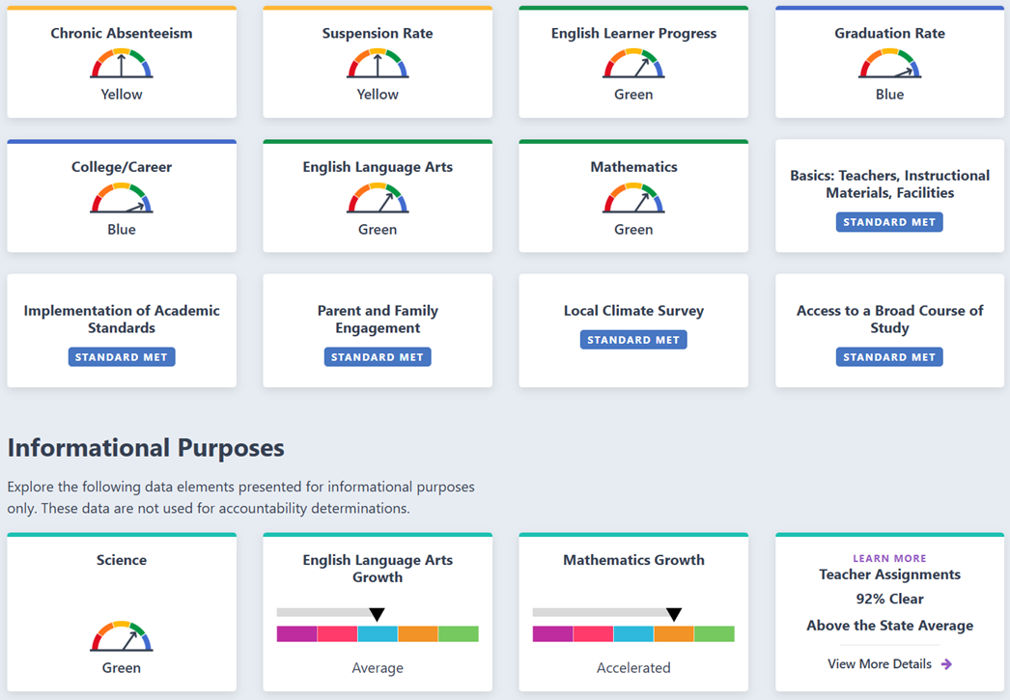
Full Text Description for Figure 3
- Below the at-a-glance view of the school’s or district’s performance, you will find information about the student population.
Figure 4: Student Population Data
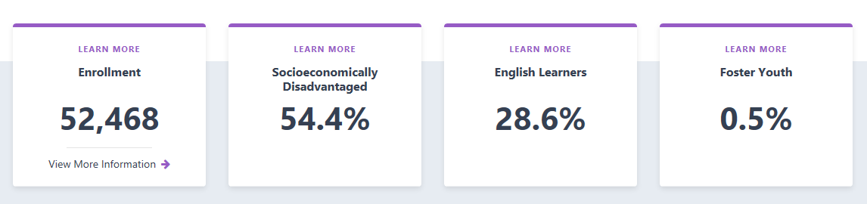
Full Text Description for Figure 4

If you continue to scroll down the page, you’ll find additional data on each measure, such as school or district results for the current year and whether improvement was made from the prior year. The state and local measures are organized into three areas:

- Academic Performance
- Academic Engagement
- Conditions & Climate

Let’s look at the state measures that appear under Academic Performance for our sample district.
Figure 5: State Measures Under Academic Performance
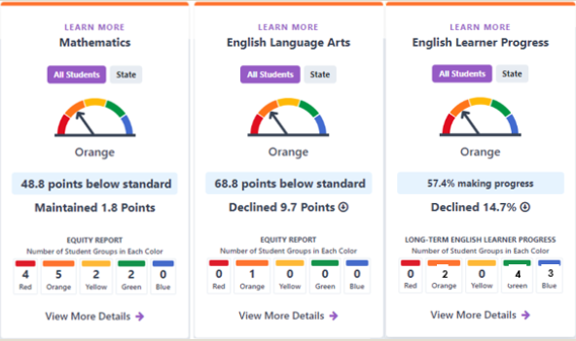
Full text description for Figure 5
The image above represents the district performance of 1.8 points for Mathematics which is 48.8 points below standard. For English Language Arts, there is a decline of 9.7 points from prior year and 68.8 points below standard. Finally, for the English Learner Progress indicator, 57.4 percent of all English learners in the district made progress in obtaining English Language proficiency in 2025. This is a decline of 14.7 percentage points from the prior year.
Notice that you can toggle back and forth between “All Students” and “State,” allowing you to compare student results for your school or district with statewide results.

For additional information view the flyer How to View Performance on the Dashboard (PDF).
- An Equity Report is displayed at the bottom of the card for each state measure. This shows the number of student groups placed in each Performance Level (color) for that measure. Below is the sample district’s Equity Report for English Language Arts.
Figure 6: Sample Equity Report
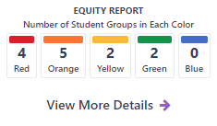
Full Text Description for Figure 6
Looking at the data above, we see that no student group received a Blue color (the highest Performance Level) for Mathematics, and four student groups received a Red color (the lowest Performance Level) for this measure.
For more information view the Exploring the Equity Reports (PDF) flyer.
- If you navigate to the “View More Details” link below the Equity Report, you will be brought to a page that gives detailed information on how student groups performed on that measure. For every measure, student group data are presented in two ways:

- Student Group Details: View the performance color for all student groups at once.
- Explore Groups by Performance Level: Select a color and see which student groups received the color, and why.

Additional Features Utilized by the 2025 Dashboard:
- Learn How to Compare Schools on the Dashboard (PDF).
- View translated flyers through the Translations Tab of the Dashboard Resources web page.
- Frequently Asked Questions (FAQs) page about each of the state indicators
Below are the Student Group Details for Mathematics:

Figure 7: Student Group Details
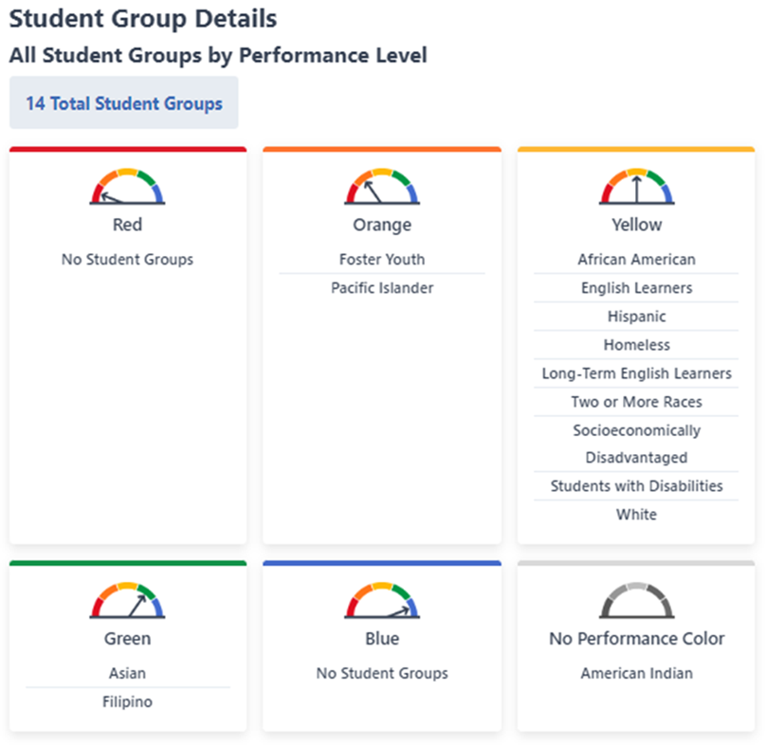
Full text description of Figure 7
In this example, the district has a total of 14 student groups that received a color for this measure. While the Equity Report showed the number of student groups that received each color, the Student Group Details present the specific student groups that received each of the colors.
In the example above, the following student groups received an Orange Performance Level for Mathematics:
- Foster Youth
- Pacific Islander

Figure 8: Explore Groups by Performance Level
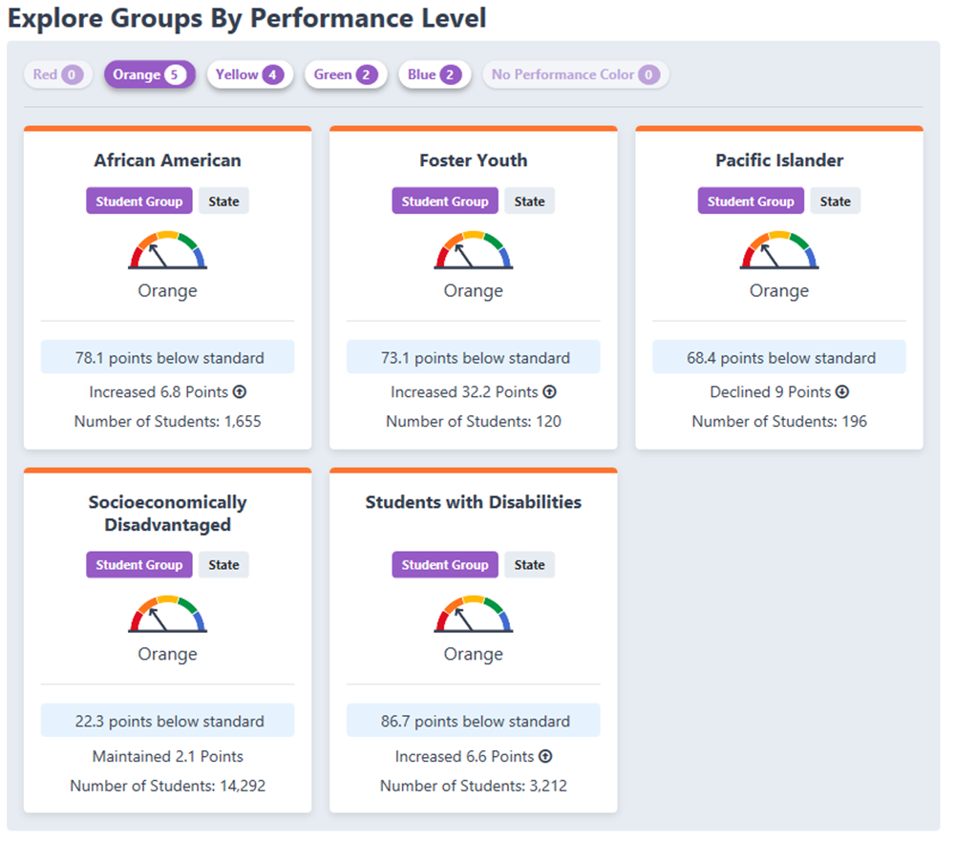
Full text description of Figure 8
If we want to dig even deeper, we can scroll down to Explore Groups by Performance Level, which allows us to select a specific color and view more detailed information on the performance of each student group that received that color.
In the example above, the color Orange has been selected. For each of the student groups that received an Orange for Mathematics, we can see:
- The average distance between the group’s performance and the standard
- How the group’s performance changed from the prior year
- The number of students in the group

Appendix A:

What More Should We Know About the State Measures

Academic: English Language Arts and Mathematics
Academic Performance contains two measures: English Language Arts and mathematics. These measures show how well students are meeting grade-level standards. They are based on student performance on the Smarter Balanced Summative Assessments and the California Alternate Assessments, which are taken each spring by students in grades 3–8 and grade 11. For additional information please visit the On Demand: Academic Indicator (YouTube) and/or review the Notetaking Guide for the Academic Indicator.

Chronic Absenteeism
The Chronic Absenteeism measure shows how many students in grades transitional kindergarten through eight were absent for 10 percent or more of the instructional days they were enrolled to attend. For example, if a student was enrolled to attend 180 instructional days and is absent 18 or more of those days, the student would be considered chronically absent. Students who are chronically absent miss out on important classroom instruction. This information in the Dashboard allows parents and educators to see if chronic absenteeism is a problem at a school or across a district. For additional information please view the On Demand: Chronic Absenteeism Indicator (YouTube) and/or review the Notetaking Guide for the recording.

Suspension Rate
The Suspension Rate measure shows the percent of students in grades transitional kindergarten through grade twelve who were suspended for at least one aggregate full day during the school year. Students who are suspended from school miss out on important classroom instruction. This information in the Dashboard allows parents and educators to see if there is a suspension problem at a school or across a district and whether certain student groups are suspended more than others. (Note: A student is counted only once for this measure even if they have multiple suspensions throughout the year.). For additional information please view the On Demand: Suspension Rate Indicator (YouTube) and/or review the Notetaking Guide: Suspension for the recording.

English Learner Progress
Proficiency in the English language is a first step for students to do well in other subject areas such as reading, writing, math, and science. The English Learner Progress measure looks at the progress that English learner students in grades one through twelve are making toward achieving English language proficiency. Each spring, English learner students take the English Language Proficiency Assessments for California (ELPAC) and/or the Summative Alternative ELPAC (Alt ELPAC), which measures how well they know and understand English. Results from the ELPAC and the Alt ELPAC are used to calculate the English Learner Progress measure. For additional information please view the On Demand: English Learner Progress Indicator (YouTube) and/or review the Notetaking Guide for ELPI.

Graduation Rate
Regardless of whether students go on to college, a high school diploma is the minimum requirement for most entry-level jobs in today’s economy. It represents mastery of foundational skills in mathematics, reading, writing, and the completion of a course of study. The Graduation Rate measure shows the number of students who received a high school diploma at the end of grade twelve. For additional information please view the On Demand: Graduation Rate Indicator (YouTube) and/or review the Notetaking Guide for Graduation Rate.

College/Career Indicator
The College/Career indicator shows how many students graduate from high school better prepared for college or a career. It uses many different measures of college and career preparedness by looking at the courses and work experience students completed in high school or the exams passed. For additional information about how schools help students become prepared for college or a career, please view the following informational flyers:
- Measures of College Readiness and
- Measures of Career Readiness
For additional information please view the On Demand: College/Career Indicator (YouTube) and/or review the Notetaking Guide for CCI.

Science
The Science indicator show how well students are meeting grade-level standards in science. It is based on student performance on the California Science Test (CAST) and the California Alternate Assessments for Science (CAAs) which are taken each spring by students in grades 5, 8 and high school. For additional information please visit the On Demand: Science Indicator (YouTube) and/or review the Notetaking Guide for the Science Indicator.

Appendix B:
Descriptive Text for the Images in this Document

Figure 1: Performance Level Gauge
A picture of an analog gauge meter used on the California School Dashboard. A gauge meter is a half-circle dial that has 5 segments. Each segment represents a different performance level. The colors read from left to right: Red, Orange, Yellow, Green, and Blue. Red represents the lowest performance level while Blue represents the highest performance level. A needle indicates the performance level for the measure.
Return to Figure 1

Figure 2: Dashboard Home Page
The image reflects the Dashboard Homepage. There are two search boxes: (1) Find School or District and (2) Near City or County. The box at the right of the search boxes allows the viewer to toggle for a specific year. The default is set for 2025. The button to the right of the year search box is a magnifying glass.
Return to Figure 2

Figure 3: Performance Levels and Local Indicators
The image is an example display of the performance on state and local indicators for an LEA. The cards showing from left to right:
First Row:
- Chronic Absenteeism: A five-segmented color gauge pointing to the yellow color with the word Yellow underneath the gauge.
- Suspension Rate: A five-segmented color gauge pointing to the yellow color with the word Yellow underneath the gauge.
- English Learner Progress: A five-segmented color gauge pointing to the green color with the word Green underneath the gauge.
- Graduation Rates: A five-segmented color gauge pointing to the blue color with the word Blue underneath the gauge.
Second Row:
- College/Career: A five-segmented color gauge pointing to the blue color with the word Blue underneath the gauge.
- English Language Arts: A five-segmented color gauge pointing to the green color with the word Green underneath the gauge.
- Mathematics: A five-segmented color gauge pointing to the green color with the word Green underneath the gauge.
- Basic Teachers Instructional Materials, Facilities: Local Indicator is Standard Met.
Third Row:
- Implementation of Academic Standards: Local Indicator is Standard Met.
- Parent and Family Engagement: Local Indicator is Standard Met.
- Local Climate Survey: Local Indicator is Standard Met.
- Access to a Broad Course of Study: Local Indicator is Standard Met.
Fourth Row – Informational Purposes:
- Science: A five-segmented color gauge with an arrow pointing to the green color with the word Green underneath the gauge.
- English Language Arts Growth: A five-color segmented bar with an arrow pointing to the blue color section with the word Average underneath the bar.
- Mathematics Growth: A five-color segmented bar with an arrow pointing to the orange color section with the word Accelerated underneath the bar.
- Teacher Assignments: 92% Clear, Above the State Average, below that there is the option to View More Details with a purple arrow next to it.
Return to Figure 3

Figure 4: Student Population Data
A screenshot of what the Student Enrollment Population section looks like on the Dashboard. It gives the total enrollment count followed by the Socioeconomically Disadvantaged, English Learners, and Foster Youth enrollment percentages. In this example, the tabs read from left to right in the following order:
- Enrollment 52,468
- Socioeconomically Disadvantaged 54.4%
- English Learners 28.6%
- Foster Youth 0.5%
The image also includes the text “Learn More” at the top of each tab which can be selected to reveal a detailed definition of enrollment, Socioeconomically Disadvantaged, English Learners, and Foster Youth.
Return to Figure 4

Figure 5: State Measures Under Academic Performance
A screenshot of the 2025 Dashboard under the “Academic Performance” section. This section details how this school performed in English Language Arts, Mathematics, and English Learner Progress. The details of each indicator are included in a card, which reflects the improvement or lack of improvement of student performance from prior to current year, and the number of student groups that received each Performance Level. You can explore deeper by selecting “View More Details” that is located at the bottom of each card. You can also learn more about each indicator by selecting the hyperlinked text “Learn More” found at the top of each indicator card. Finally, you can toggle back and forth between “All Students” and “State,” allowing you to compare student results for your school or district with statewide results. For our example school, here is what each indicator card identifies:
Mathematics – The school received an Orange Performance Level and scored 48.8 points below Standard for the current year. Within the Equity Report that shows the number of students in each level, there are four student groups that received a Red Performance Level, five student groups that received an Orange Performance Level, two student groups that received a Yellow Performance Level, two student groups that received a Green Performance Level, and zero student groups that received a Blue Performance Level.
English Language Arts – The school received an Orange Performance Level and scored 68.8 points below Standard for the current year. Within the Equity Report that shows the number of students in each level, there are zero student groups that received a Red Performance Level, one student group that received an Orange Performance Level, zero student groups that received a Yellow Performance Level, zero student groups that received a Green Performance Level, and zero student groups that received a Blue Performance Level.
English Learner Progress – 57.4% of the school’s English learners made progress toward English language proficiency. Based on the progress level, the school received an Orange Performance Level. Within the Equity Report that shows the number of students in each level, there are zero student groups that received a Red and a Yellow. two student groups received an Orange, four received a Green, and three student groups received a Blue Performance Level.
Return to Figure 5:

Figure 6: Sample Equity Report
Screenshot of the Equity Report that depicts the number of Student Groups in each of the Performance Levels. In this example, from left to right, there are four student groups in the Red Performance Level, five student groups in the Orange Performance Level, two student groups in the Yellow Performance Level, two student groups in the Green Performance Level, and zero student groups in the Blue Performance Level.
Return to Figure 6

Figure 7: Student Group Details
The image shows the Student Group Details section, which indicates how each of the student groups placed in terms of their performance color. In this example, the following student groups are listed under each of the performance colors:
- Red: A five-segmented color gauge with an arrow pointing to the red color with the word Red underneath the gauge. There are no student groups is listed in this card.
- Orange: A five-segmented color gauge with an arrow pointing to the orange color with the word Orange underneath the gauge. The Foster Youth and Pacific Islander student groups are listed in this card.
- Yellow: A five-segmented color gauge with an arrow pointing to the yellow color with the word Yellow underneath the gauge. The African American, English Learners, Hispanic, Homeless, Long-Term English Learners, Two or More Races, Socioeconomically Disadvantaged, Students with Disabilities and White student groups are listed in this card.
- Green: A five-segmented color gauge with an arrow pointing to the green color with the word Green underneath the gauge. The Asian, and Filipino student groups are listed in this card.
- Blue: A five-segmented color gauge with an arrow pointing to the blue color with the word Blue underneath the gauge. There are no student groups listed in this card.
- No Performance Level: A grayed out five-segmented color gauge with the words No Performance Color underneath. The American Indican student groups is listed in this card.
Return to Figure 7

Figure 8: Explore Groups by Performance Level
A screenshot of the “Explore Groups by Performance Level” section, which allows to select a specific Performance Level for an indicator and view detailed information on the performance of each student group that received that color. In this figure, the Performance Level Orange has been selected reflecting a gauge:
- African American: The group has 78.1 points below standard, it has increased by 6.8 points since last year and includes 1,655 students.
- Foster Youth: The group has 73.1 points below standard, it has increased by 32.2 points since last year and includes 120 students.
- Pacific Islander: The group has 68.4 points below standard, it has declined by 9 points since last year and includes 196 students.
- Socioeconomically Disadvantaged: The group has 22.3 points below standard, it has maintained at 2.1 points since last year and includes 14,292 students.
- Students with Disabilities: The group has 86.7 points below standard, it has increased by 6.6 points since last year and includes 3,212 students.
If the viewer is interested in accessing the data for the other Performance Levels, they can select the buttons at the top of the figure from left to right:
- Red has zero student groups which is why the button is grayed out
- Orange has five student groups
- Yellow has four student groups
- Green has two student groups
- Blue has two student groups
- No Performance Level has zero student groups
Return to Figure 8

