2025 Dashboard On Demand Session: Graduation Rate Indicator
California Department of Education | November 2025

Welcome
This Notetaking Guide is a supplementary resource to the 2025 On Demand Session for the Graduation Rate Indicator that is available on the California Department of Education (CDE) Dashboard Communications Toolkit web page at https://www.cde.ca.gov/ta/ac/cm/dashboardtoolkit.asp.

Agenda
- Overview of the California School Dashboard (Dashboard)
- The Graduation Rate Indicator
- Differences Between DataQuest and the Dashboard
- Frequently Asked Questions (FAQs)
- Contacting Us

Overview of the Dashboard
For an overview of the California School Dashboard (Dashboard), please check out the Dashboard 101 On Demand session: https://www.cde.ca.gov/ta/ac/cm/dashboardtoolkit.asp#recordingsnotetakingguide

Graduation Rate Indicator

What is this Indicator?
This indicator represents the percentage of students who graduate high school within a specified timeframe with a standard high school diploma.

Graduation Rate Indicator Formula
The Graduation Rate Indicator on the Dashboard uses a combined four- and five-year graduation rate. This combined rate was approved by the State Board of Education (SBE) in July 2019 to provide additional credit to those LEAs and schools that graduate students in their fifth year.

What is the Combined Graduation Rate?
The rate consists of two sets of students:
- Students in the most current graduating class
- Graduates in five years as part of the prior year graduating class

2025 Dashboard Combined Graduation Rate Formula
The combined four- and five-year graduation rate formula for the 2025 Dashboard is:
- Number of Students in Class of 2025 Who Earned a Regular High School Diploma within four years; and
- Number of Students in Class of 2024 Who Earned a Regular High School Diploma during 2024–25 (i.e., fifth-year graduates).
Divided by
- Total Number of Students in the Class of 2025; and
- Number of Students in Class of 2024 Who Earned a Regular High School Diploma during 2024–25.
The graphic below also identifies the formula:
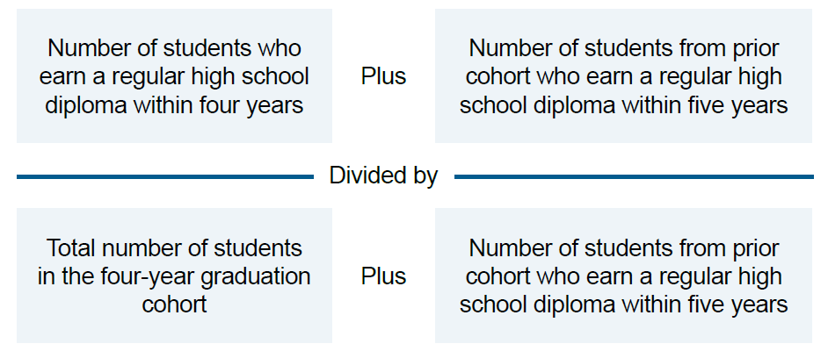

Example of Calculating the Combined Graduation Rate
- For the Class of 2025, there were 95 graduates out of 100 students in the four-year cohort.
- For the Class of 2024, five students graduated in their fifth year (i.e., graduated in 2024–25).
The combined graduation rate is:
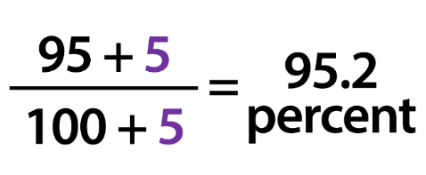

Students in the Graduation Rate
When students first enroll in ninth grade, they become part of the denominator of a four-year graduation rate (i.e., the student becomes a part of a graduating class).
Students included in the denominator of the cohort include those who:
- dropped out during the last four-year period;
- transferred into a school during the last four-year period;
- lost transfers (these are students who exited out of a school as a transfer, but never enrolled in another school by Fall Census Day); and
- transferred to an Adult Education Program or Community College. (Students who transfer to an adult education program or community college during their four or five years of high school without earning a regular high school diploma are included in the cohort [denominator] and counted as other transfers [excluded from the numerator]).
The cohort also includes students who transfer in later during grade nine or during the next three years.
CALPADS Exit codes excluded from the denominator of the cohort:
CALPADS  Exit Category Code | Description
E130 | Died
T180 | Transfer to Private School
T200 | Transfer to a High School Out of California
T240 | Transfer/Emigrated out of the U.S.
T310 | Transfer to a health facility
T370 | Transfer to an Institution with a High School Diploma Program
T460 | Transfer to home school program
One additional consideration for the denominator of the cohort is regarding students with disabilities who receive special education services specifically focused on the student’s transition from secondary education to career and college. Students who are marked with a “Y” in the “Adult Age Students with Disabilities in Transition Status” (field 1.34 from the California Longitudinal Pupil Achievement Data System [CALPADS] Student Enrollment [SENR] file) are also excluded from the denominator of the combined rate.

New for the 2025 Dashboard
Diploma Pathway for Students who Qualify for the California Alternate Assessment
- Students with exceptional needs, who take the CAAs, can graduate from high school through a newly defined diploma pathway (Education Code 51225.31 and 51225.32).
- Students completing this alternative pathway diploma will count towards the LEA’s graduation rate on the Dashboard.
CDE Diploma Pathway for Students who Qualify for the California Alternate Assessment web page: https://www.cde.ca.gov/sp/se/lr/om082523.asp

Who is Counted as a Graduate?
For a student to be counted as a graduate, the student must receive either a regular high school diploma or an alternative pathway diploma through Education Code (EC) 51225.31 and 51225.32.
- Due to the restrictions by the US Department of Education, students earning all other high school equivalency certificates and examinations (that is, Special Education Certificate of Completion, a California High School Equivalency Certificate, an adult education diploma, or pass the California Proficiency Program ) cannot be counted as graduates.

How Are Early Graduates Counted?
Students who graduate high school in less than four years are counted in the original cohort in which they began.
- Example: A grade eleven student graduated early in 2024–25 (after three years). Because the student belongs to the Class of 2026, even though the student receives a diploma a year early, the student will be included in the graduation rate for the Class of 2026.

Graduation Cut Off Date
For a student to be counted as a graduate in the current year, the student must graduate by August 15.
For the 2025 Dashboard:
- Class of 2025 must graduate by August 15, 2025, to be counted as a fourth-year graduate
- Class of 2024 must graduate by August 15, 2025, to be counted as a fifth-year graduate
Keep in mind that summer school students must graduate by August 15 to be counted as a graduate in the current year.

Transfer Students
When students transfer, the last school where a student is enrolled is held accountable for the students’ graduation outcomes.

Graduation Rate Five-by-Five
An LEA, school, or student group’s performance level (color) is determined through the use of a five-by-five colored table that utilizes both the Status level and Change level.
​
Five-by-five tables and cut scores are available for each of the indicators on the 2025 Dashboard Communications Toolkit web page at: https://www.cde.ca.gov/ta/ac/cm/dashboardtoolkit.asp

Five-By-Five Colored Table
Performance Level | Declined Significantly  by 5.1 p.pts or more | Declined  by 1.0 p.pts to 5.0 p.pts | Maintained  declined or increased by 0.9 p.pts or fewer | Increased  by 1.0 p.pts to 4.9 p.pts | Increased Significantly  by 5.0 p.pts or more
Very High  95.0% or greater in Current Year | N/A | Blue | Blue | Blue | Blue
High  90.5% to 94.9% in Current Year | Orange | Yellow | Green | Green | Blue
Medium  80.0% to 90.4% in Current Year | Orange | Orange | Yellow | Green | Green
Low  68.0% to 79.9% in Current Year | Red | Orange | Orange | Yellow | Yellow
Very Low  67.9% or less in Current Year | Red | Red | Red | Red | Red
The SBE has approved one set of cut scores for both Status and Change for the Graduation Rate indicator. These cut scores are used for all districts and schools, including both DASS and charter schools.

Three-by-Five
Select LEAs and schools with small populations are more susceptible to large swings in results from year to year. To account for this, a three-by-five table is applied when the N size is less than 150 at the LEA, school, and student group levels for specific indicators, such as the Graduation Rate Indicator.
The three-by-five table removes both the “Increased Significantly” and “Declined Significantly” Change levels from performance level determinations. Small student populations with less than 150 students in the denominator of the Graduation Rate Indicator will receive only one of three Change levels: Increased, Maintained, and Declined.

Three-By-Five Colored Table
Performance Level | Declined  by 1.0 p.pts to 5.0 p.pts | Maintained  declined or increased by 0.9 p.pts or fewer | Increased  by 1.0 p.pts to 4.9 p.pts
Very High  95.0% or greater in Current Year | Blue | Blue | Blue
High  90.5% to 94.9% in Current Year | Yellow | Green | Green
Medium  80.0% to 90.4% in Current Year | Orange | Yellow | Green
Low  68.0% to 79.9% in Current Year | Orange | Orange | Yellow
Very Low  67.9% or less in Current Year | Red | Red | Red

Graduation Rate Indicator on the Dashboard
Dashboard cards will be the first level of information available to schools and LEAs related to the Graduation Rate Indicator. They show Performance Levels or colors, Status, Change, and the equity report.
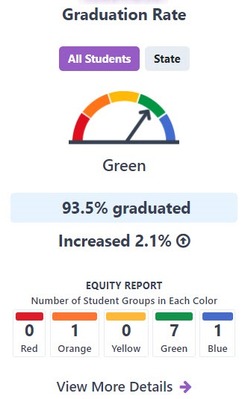
Description of Graduation Rate Dashboard Card
This card reports the results of a school or LEA's Graduation Rate Indicator. The gauge shows five different possible Performance Levels: Red, Orange, Yellow, Green, and Blue. This sample Dashboard card displays a Green Performance Level, or color, with the gauge pointing to the green section and the word "Green" under the gauge. Under the gauge, there is the reporting for Status and Change. In this example, the Status shows a Graduation Rate of 93.5 percent and an increase of 2.1 percentage points from the prior year. Finally, at the bottom of the card, the equity report shares the number of student groups in each Performance Level or color. In this example, no student groups were in Red or Yellow, one group was in Orange, seven were in Green and one in Blue. There is a link to view more details at the base of the card, which provides more specific student group information.

Dashboard Card for 11 to 29 or 11 to 14 Students
A Dashboard card will look different depending on the size of the denominator. If a LEA, School or student group has a small denominator, between 11 to 29 students in the current or prior year, then Only the Graduation Rate status and change is reported on the Dashboard. The exception to this is the Homeless, Foster Youth and Long-term English Learners student groups at the LEA level, which only require 15 or more students in the current and prior year to receive a performance color.
The Dashboard Card for this N-size will display:
- Performance Level (color) graphic greyed out
- Status and Change reported
- Number of students

Dashboard Card for Fewer than 11 Students
If there are fewer than 11 students in the current or prior year, the Dashboard Card will have no data reported to protect students’ privacy.
The Dashboard Card for this N-size will display:
- Performance Level (color) graphic greyed out
- Status and Change not reported
- Number of students

Verify Your Graduation Data Before It is Extracted for Dashboard Use!
LEAs can validate their four-year cohort counts prior to certification using the following two CALPADS Reports:
- 15.1 Cohort Outcome – Counts and Rates for summary results, and
- 15.2 Cohort Outcomes – Student Details to access student-level data
These reports are available year-round and can be reviewed throughout the CALPADS EOY certification window. Further information about these reports is available in the Connecting CALPADS to the Dashboard handbook. This handbook contains print screens to help you navigate through these reports and includes examples and questions to consider prior to certification. The 2024–25 handbook is available at https://www.cde.ca.gov/ta/ac/cm/documents/caldashhandbook25.docx.

DASS One-Year Graduation Rate
Beginning with the 2022 Dashboard, the use of modified methods was no longer allowable due to the U.S. Department of Education’s (ED’s) denial of California’s waiver. Therefore, beginning with the 2022 Dashboard, DASS schools:
- Received the combined four-and five-year graduation rate for the Graduation Rate Indicator (rather than the DASS one-year graduation rate).
However, the waiver denial from the ED affects the requirements under federal law (Every Student Succeeds Act [ESSA]). State law, as provided by the California Education Code Section 52052(d), continues to permit the use of the DASS program and reporting of data separately for alternative schools. Therefore, the CDE will continue to produce and display the DASS one-year graduation rate for informational purposes on both the Dashboard and the School Dashboard Additional Reports (https://www.cde.ca.gov/ta/ac/cm/dbadditionalrpts.asp).

Differences Between Dashboard and DataQuest
Both the Dashboard and DataQuest report data on the graduation rate. However, different rules are used, which may cause differing results. The following identifies the differences:

The Dashboard:
- reports the Combined Four- and Five-Year Graduation Rates;
- excludes charter school data from authorizer’s results; and
- applies the DSEA or the District of Residence rule for Students with Disabilities.

DataQuest:
- reports the Four-Year Cohort Graduation Rates;
- uses filters to include/exclude charter schools’ data from authorizers’ results; and
- does not apply the District of Residence rule. Rather, Students with Disabilities are reported at the District of Attendance.

Frequently Asked Questions

I have a grade eleven student who is graduating this year. When are early graduates included in the graduation rate?
Early grade eleven graduates are included in the graduation rate along with the rest of their class. Therefore, if a grade eleven student graduated this year, then the student will not be included in this year’s graduation rate. The student will be included in next year’s graduation rate along with the rest of the cohort.

Why aren’t students who completed a high school equivalency test counted as a graduate for the combined rate?
The U.S. Department of Education requires that only students who receive a standard high school diploma are counted as graduates. Therefore, students who complete a GED®, HiSET®, the California High School Proficiency Examination [CHSPE], and the Special Education Certificate of Completion) cannot be counted as graduates.

Will students who complete the alternative diploma pathway be included in the graduation rate?
Students with exceptional needs, who entered ninth grade in the 2022–23 school year or later, attending a school district, county office of education, charter school, or state special school can graduate from high school through a newly defined diploma by meeting certain requirements.
Students exiting with this School Completion Status Code within four or five years of their initial ninth grade cohort entry year will be counted as graduates in the Four-Year and Five -Year Adjusted Cohort Graduation Rate for the Dashboard.

Is the DASS One-Year graduation rate used for accountability?
No. Because of the ED’s denial of California’s use of a modified graduation rate, the DASS one-year graduation rate can no longer be used for accountability. Therefore, the combined four- and five-year graduation rate is used to determine Differentiated Assistance at the LEA-level and Comprehensive Support and Improvement/Additional Targeted Support and Improvement at the school-level.

Can I still update my graduation data for the Dashboard even though End-of-Year has closed?
No. The graduation rate data is extracted out of CALPADS immediately after the End-of-Year (EOY) window closes. Therefore, any updates made in CALPADS after the close of EOY will not be incorporated in the Dashboard.

Additional Help with the Graduation Rate Indicator
- The CDE Graduation Rate Indicator web page: https://www.cde.ca.gov/ta/ac/cm/dashboardgrad.asp
- CA School Dashboard Technical Guide:
https://www.cde.ca.gov/ta/ac/cm/dashboardguide.asp
- The CDE School Dashboard Additional Reports web page: https://www6.cde.ca.gov/californiamodel/

Contacting Us
Email the Analysis, Measurement, and Accountability Reporting Division at dashboard@cde.ca.gov.
Follow us on X (formerly Twitter): @CDEDashboard

