California Department of Education
Assessment Development & Administration Division

Summary of 2018-19 State Results for the California Assessment of Student Performance and Progress in English Language Arts/Literacy and Mathematics
Final Submitted October 29, 2019
Educational Testing Service
Contract No. CN140284
This is a blank page.
Contents
Summary 1
Overall Five Year CAASPP Trends 4
Results for CAASPP English Language Arts/Literacy 5
Results for CAASPP Mathematics 9
Performance Differences Among Demographic groups 11
Results for Same Student Cohorts over Five years from 2015 to 2019 41
Results for Local Education Agencies 54
Appendix A. Data Tables for Figures 1 through 14 56
Appendix B. CAASPP English language Arts/Literacy and Mathematics
Achievement Level Percentages by Grade and Year 85
Appendix C. CAASPP Score Distributions for ELA/L and Mathematics 2015 through 2019 96
Appendix D. 2015 to 2019 Performance Trends for Selected Student Groups by Year 126

Summary
The five-year trends from 2015 through 2019 show continuous improvement in student performance in CAASPP English language arts/literacy (ELA/L) and mathematics across the grades. As shown in Figures 1 and 2, the improvement is slight between each year, however, since 2015, average performance has increased 15 to 22 scale score points in the early grades of 3 through 5 and 4 to 16 scale score points in the later grades of 6 through 8 and 11. These reflect a small effect size but the trend continues in a positive direction. Data tables for Figures 1 and 2 are included in Appendix A.
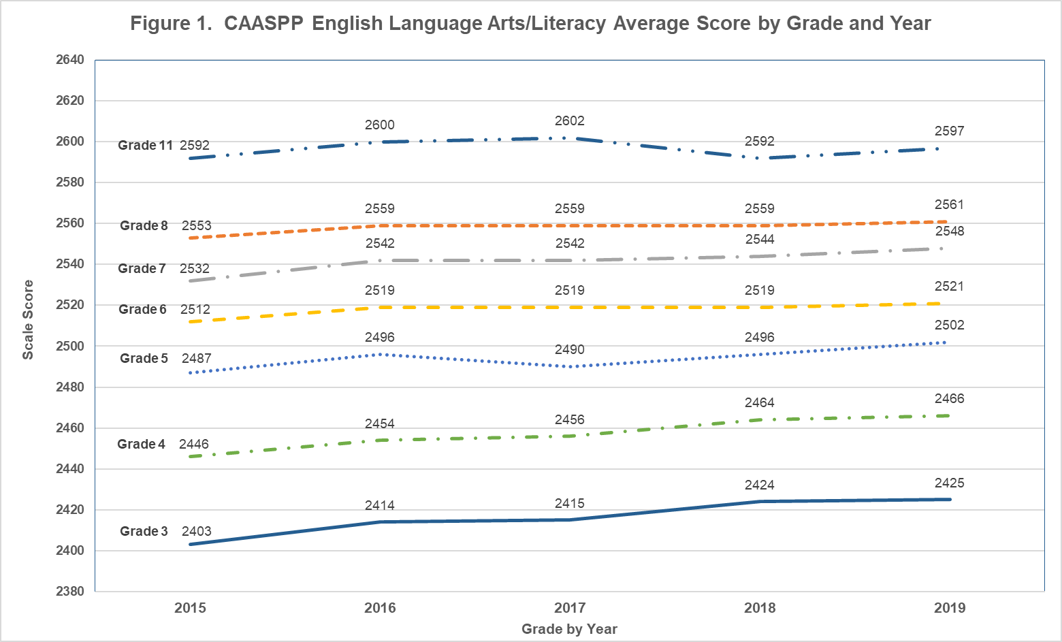
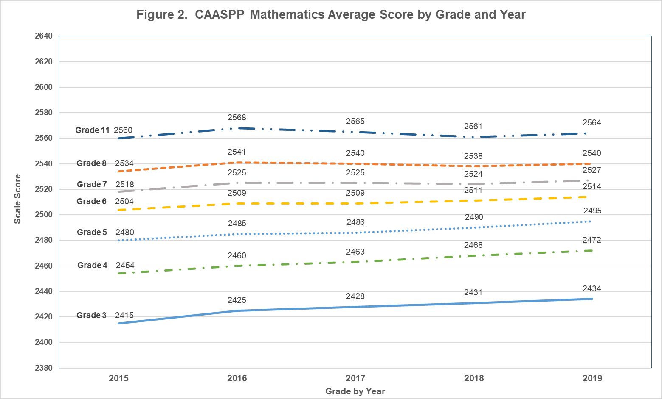

Overall Five Year CAASPP Trends
The percentage of students who met or exceeded standards in ELA/L has increased to just over 50 percent across the grades in 2019. The percentage of students who met or exceeded standards varies more in mathematics from 51 percent in Grade 3 to 32 percent in Grade 11. The percentage of students who met or exceeded standards in mathematics decreases with each higher grade indicating that the standards are more rigorous with each grade in relation to the population of students. This has been a fact since the standards were established in 2015. The percentages of students by Achievement Level for each grade and year are shown in Appendix B.
The percent of students who do not meet standards has also decreased over time in the early grades, however, there is a persistent percentage of students who do not meet standards in the later grades of 7, 8, and 11. These overall trends among the different annual cohorts of students reflect improvement in performance across the entire scale score range in the early grades while the improvement in performance is primarily at the top of the scale score range in the later grades of 7, 8 and 11.
These trends in score distributions by grade are described below for CAASPP ELA/L and mathematics and illustrated in Figures 3 through 6 (data tables are included in Appendix A). The annual score distributions for each grade are shown in Appendix C. Over the five years, the score distributions in the early grades shift across the score range in a positive direction, however, in the later grades, the distributions flatten and spread with slightly more students at both the top of the score range and at the bottom of the score range over the five years.

Results for CAASPP English Language Arts/Literacy
The ELA/L score trends for the early grades 3 through 5 are shown in Figure 3. The mean, median, 25th and 75th percentiles are depicted for each annual grade cohort in relation the achievement level thresholds for the respective grade. These mean and percentile trend lines show that the scores have increased across the score range resulting in more students who met or exceeded standards each year.
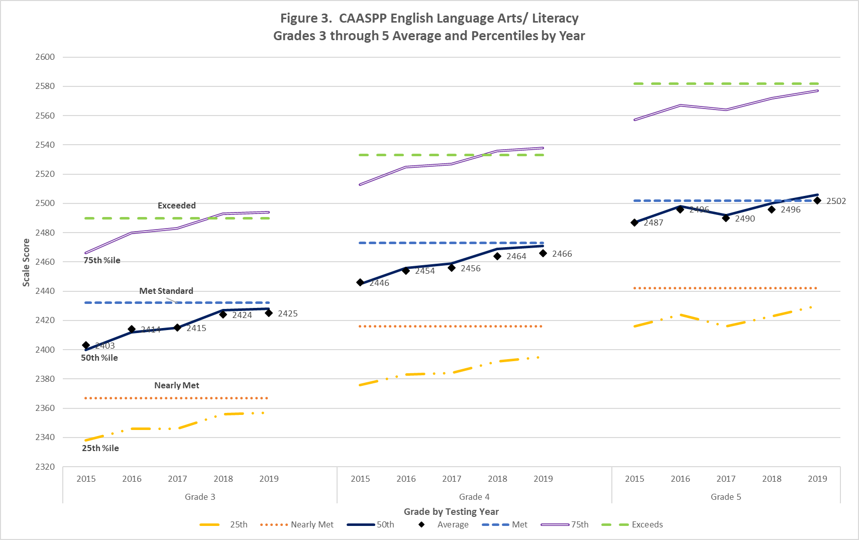

The ELA/L score trends for the later grades 6 through 8 and 11 are shown in Figure 4. The pattern is somewhat different for the later grades as the scale score increases tend to be smaller, particularly after the 2015 increase, and fairly flat in the lower half of the score range. However, the percentage of students who met or exceeded the standards still has increased to almost 50 or more percent.
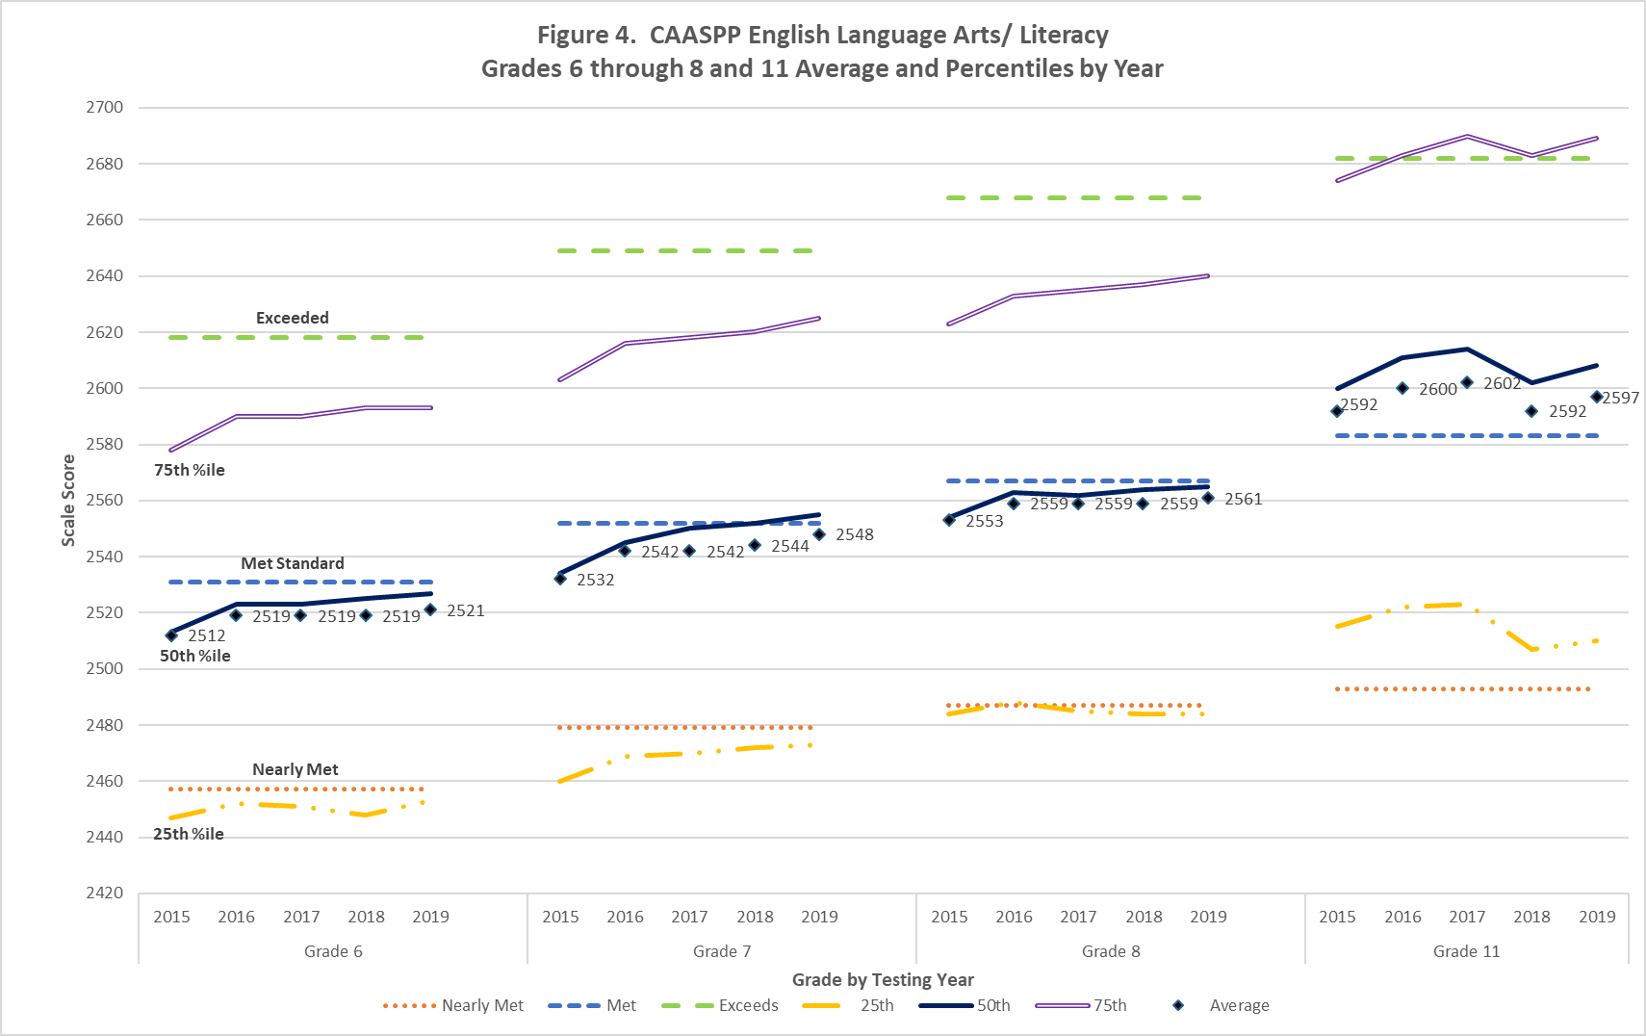

Results for CAASPP Mathematics
The CAASPP mathematics score trends are similar to the ELA/L results across grades as shown in Figure 5 for the early grades and Figure 6 for the later grades. Although the percentage of students who met or exceeded standards for mathematics is not as high except for Grade 3.
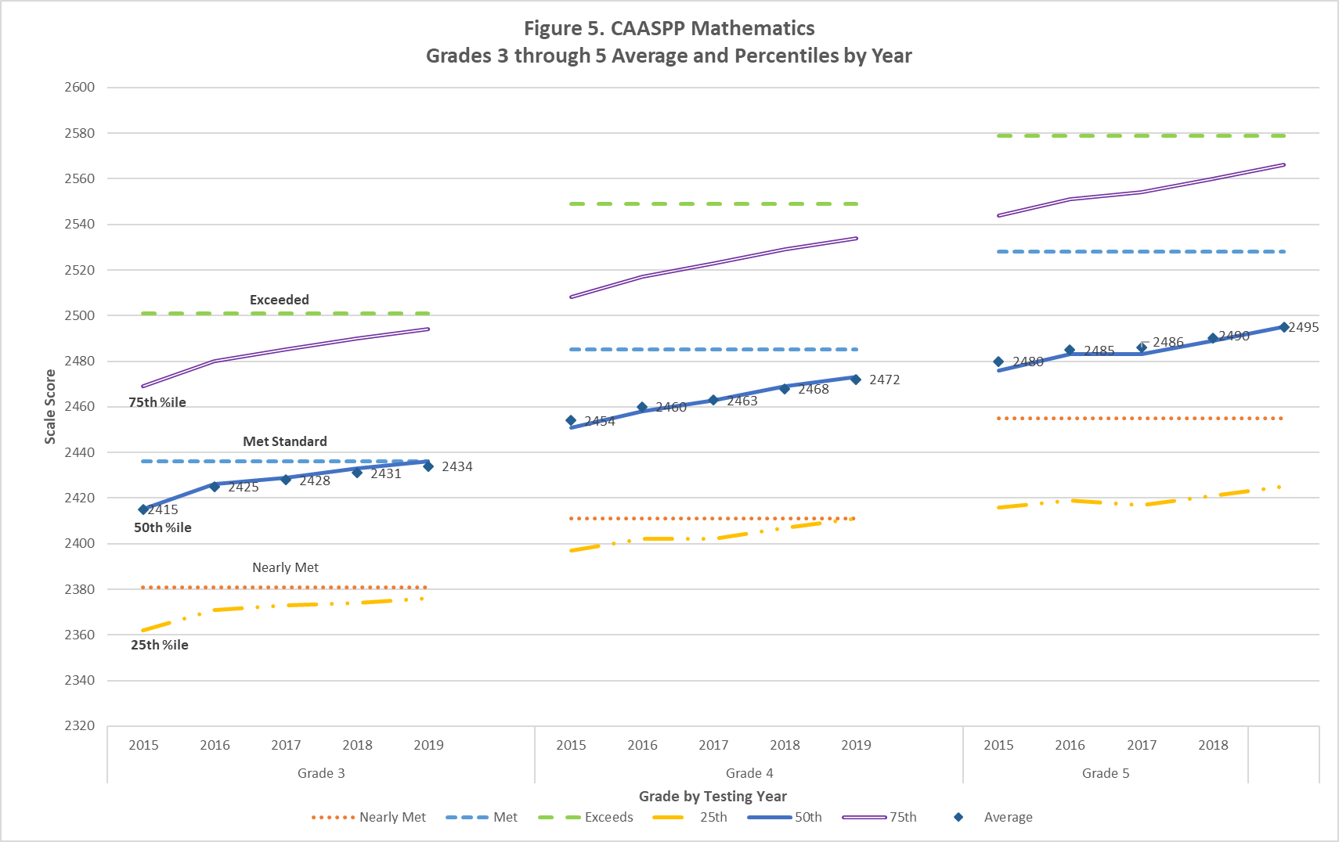

The results in the later grades reflect a similar pattern as the later grades for ELA/L as shown in Figure 6.
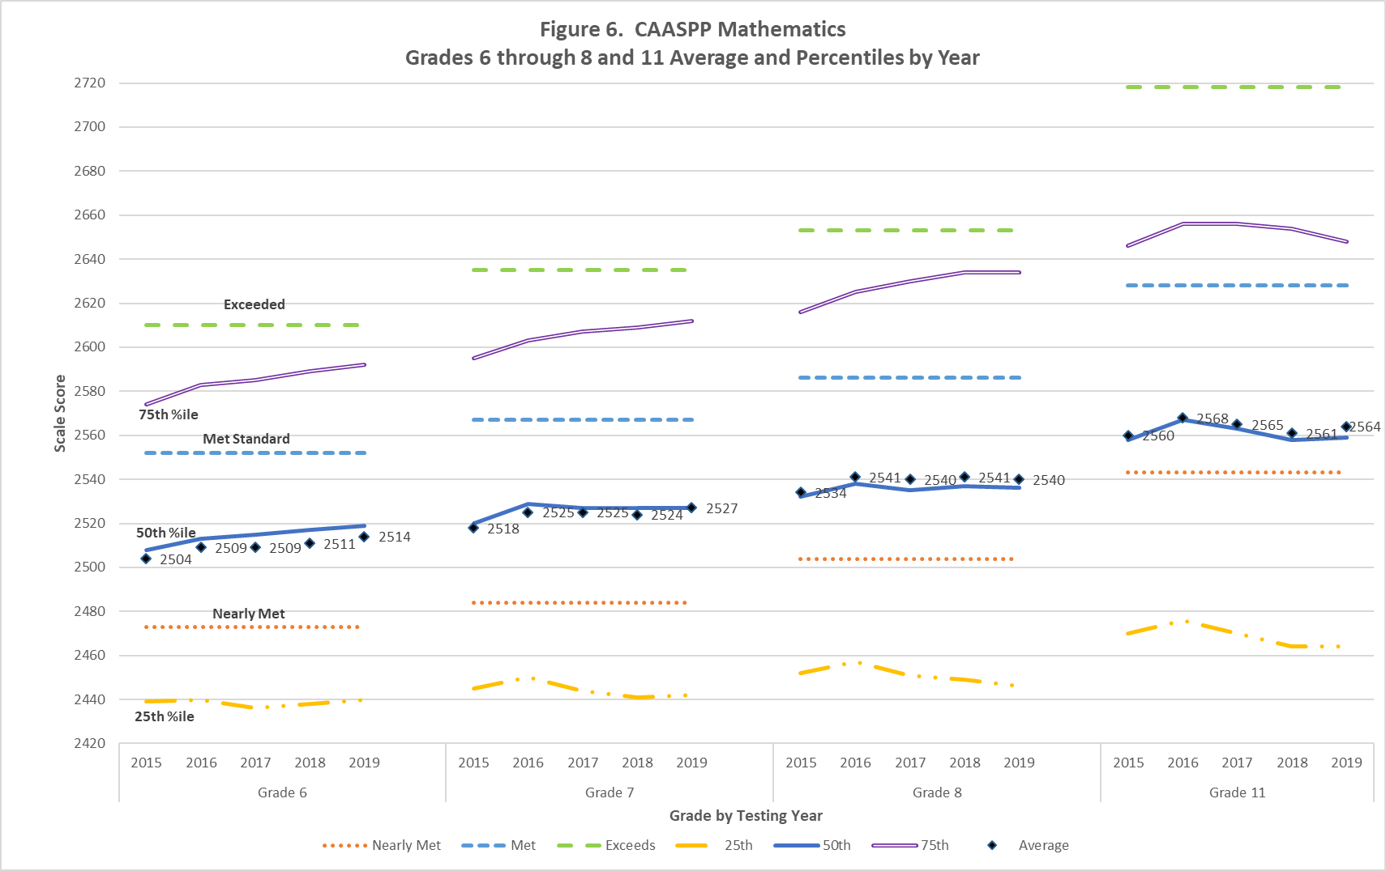

Performance Differences Among Demographic groups
The 2019 results indicate that parity in performance among students from different demographic groups has not been achieved over the five years of CAASPP administrations. While male and female students perform relatively the same across grades in both ELA/L and mathematics, there is still disparity among racial, ethnic, economic, and English language proficiency groups.
For each grade in Figure 7 for ELA/L and Figure 8 for mathematics, the changes in average scale scores from 2015 to 2019 for selected student groups are shown. In the figures, the baseline for each group is their 2015 average score and the box reflects the change in the average score between 2015 and 2019. Larger numbers in the box reflect greater average score increases than smaller numbers. For example, in Grade 3 ELA/L, the Hispanic or Latino groups increased 25 scale score points while the white student groups gained 16 points indicating that the difference between these groups is narrowing from 2015 to 2019.
There have been some positive improvements in reaching parity in group performance. From 2015 to 2019, the performance differences have narrowed between Hispanic and white students and between Ever-English Learner and English only students, particularly in the early grades of 3 through 7. Specific group comparisons of average scale score for each of the five years are shown in Appendix D.

Figure 7a. Average Scale Score Change in ELA/L from 2015 to 2019 for Student Groups for Grade 3

Figure 7b. Average Scale Score Change in ELA/L from 2015 to 2019 for Student Groups for Grade 3

Figure 7c. Average Scale Score Change in ELA/L from 2015 to 2019 for Student Groups for Grade 4

Figure 7d. Average Scale Score Change in ELA/L from 2015 to 2019 for Student Groups for Grade 4

Figure 7e. Average Scale Score Change in ELA/L from 2015 to 2019 for Student Groups for Grade 5

Figure 7f. Average Scale Score Change in ELA/L from 2015 to 2019 for Student Groups for Grade 5

Figure 7g. Average Scale Score Change in ELA/L from 2015 to 2019 for Student Groups for Grade 6

Figure 7h. Average Scale Score Change in ELA/L from 2015 to 2019 for Student Groups for Grade 6
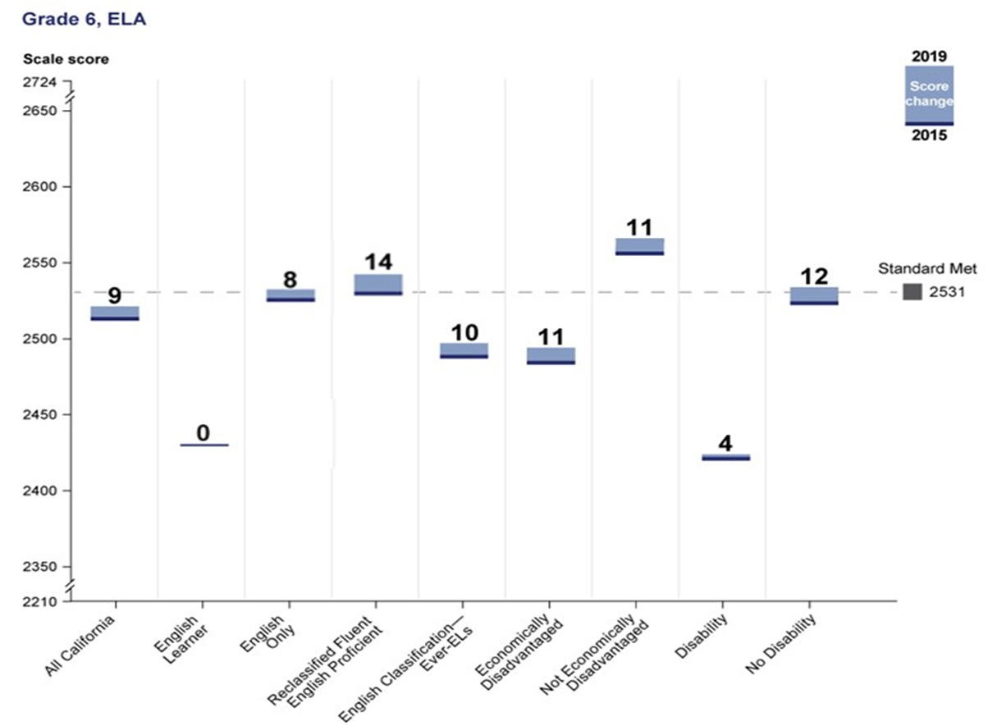
Figure 7i. Average Scale Score Change in ELA/L from 2015 to 2019 for Student Groups for Grade 7

Figure 7j. Average Scale Score Change in ELA/L from 2015 to 2019 for Student Groups for Grade 7

Figure 7k. Average Scale Score Change in ELA/L from 2015 to 2019 for Student Groups for Grade 8
Figure 7l. Average Scale Score Change in ELA/L from 2015 to 2019 for Student Groups for Grade 8
Figure 7m. Average Scale Score Change in ELA/L from 2015 to 2019 for Student Groups for Grade 11

Figure 7n. Average Scale Score Change in ELA/L from 2015 to 2019 for Student Groups for Grade 11

Figure 8a. Average Scale Score Change in Mathematics from 2015 to 2019 for Student Groups for Grade 3

Figure 8b. Average Scale Score Change in Mathematics from 2015 to 2019 for Student Groups for Grade 3

Figure 8c. Average Scale Score Change in Mathematics from 2015 to 2019 for Student Groups for Grade 4
Figure 8d. Average Scale Score Change in Mathematics from 2015 to 2019 for Student Groups for Grade 4
Figure 8e. Average Scale Score Change in Math from 2015 to 2019 for Student Groups for Grade 5

Figure 8f. Average Scale Score Change in Math from 2015 to 2019 for Student Groups for Grade 5

Figure 8g. Average Scale Score Change in Math from 2015 to 2019 for Student Groups for Grade 6
Figure 8h. Average Scale Score Change in Math from 2015 to 2019 for Student Groups for Grade 6

Figure 8i. Average Scale Score Change in Math from 2015 to 2019 for Student Groups for Grade 7

Figure 8j. Average Scale Score Change in Math from 2015 to 2019 for Student Groups for Grade 7

Figure 8k. Average Scale Score Change in Math from 2015 to 2019 for Student Groups for Grade 8
Figure 8l. Average Scale Score Change in Math from 2015 to 2019 for Student Groups for Grade 8

Figure 8m. Average Scale Score Change in Mathematics from 2015 to 2019 for Student Groups for Grade 11
Figure 8n. Average Scale Score Change in Mathematics from 2015 to 2019 for Student Groups for Grade 11

Results for Same Student Cohorts over Five years from 2015 to 2019
Cohorts of students who were matched from 2015 to 2019 were also analyzed to look at score changes over time. Three groups of students who tested in all five academic years were analyzed: 3rd grade to 7th grade, 4th grade to 8th grade, and 7th grade to 11th grade. Figures 9 through 14 show the increases in average scores for various student groups across the vertical scales for ELA/L and mathematics respectively. In these matched cohorts, performance differences in ELA/L also narrowed between Hispanic and white students and between Ever-English Learner and English only students as their grade level increased.

Figure 9a. ELA/L Average Score Increase for Grade 7 from Grade 3 Same Students
Figure 9b. ELA/L Average Score Increase for Grade 7 from Grade 3 Same Students
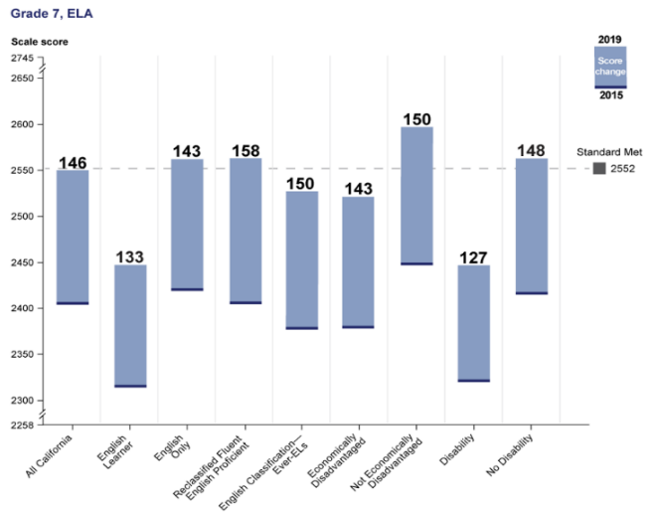
Figure 10a. ELA/L Average Score Increase for Grade 8 from Grade 4 Same Students
Figure 10b. ELA/L Average Score Increase for Grade 8 from Grade 4 Same Students
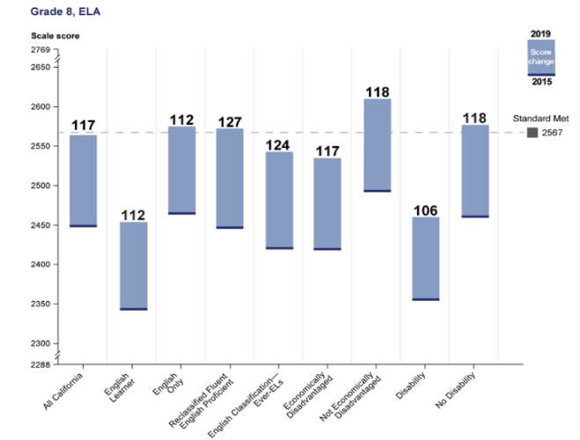
Figure 11a. ELA/L Average Score Increase for Grade 11 from Grade 7 Same Students
Figure 11b. ELA/L Average Score Increase for Grade 11 from Grade 7 Same Students
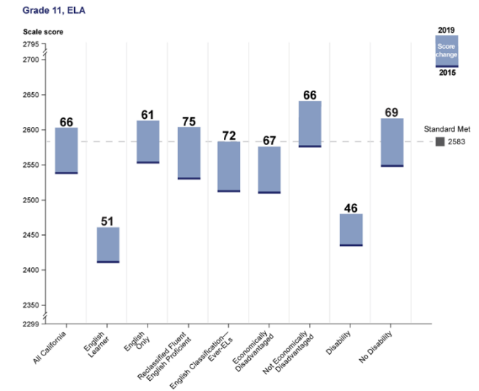
Figure 12a. Math Average Score Increase for Grade 7 from Grade 3 Same Students
Figure 12b. Math Average Score Increase for Grade 7 from Grade 3 Same Students
Figure 13a. Math Average Score Increase for Grade 8 from Grade 4 Same Students
Figure 13b. Math Average Score Increase for Grade 8 from Grade 4 Same Students

Figure 14a. Math Average Score Increase for Grade 11 from Grade 7 Same Students
Figure 14b. Math Average Score Increase for Grade 11 from Grade 7 Same Students

Results for Local Education Agencies
The average performance of several local education agencies (LEA) also increased from 2015 to 2019. The number of LEAs with average scores at or above Standard Met increased 50 percent in ELA/L and 68 percent in mathematics. The number of LEAs and their change in average performance are shown in Tables 1 and 2.
Table 1. Change in LEAs Average Performance from 2015 to 2019 in ELA/L
Grade | Total LEAs | At or above Standard Met | Below Met Standard to Met Standard | Met Standard to below Met Standard | Below Standard Met
Grade 3 | 931 | 195 | 165 | 18 | 553
Grade 4 | 929 | 209 | 146 | 25 | 549
Grade 5 | 945 | 282 | 135 | 21 | 507
Grade 6 | 959 | 229 | 87 | 32 | 611
Grade 7 | 916 | 244 | 141 | 32 | 499
Grade 8 | 905 | 269 | 107 | 45 | 484
Grade 11 | 629 | 291 | 85 | 41 | 212

Table 2. Change in LEAs Average Performance from 2015 to 2019 in Mathematics
Grade | Total LEAs | At or above Standard Met | Below Met Standard to Met Standard | Met Standard to below Met Standard | Below Standard Met
Grade 3 | 932 | 215 | 172 | 30 | 515
Grade 4 | 926 | 169 | 132 | 20 | 605
Grade 5 | 943 | 109 | 79 | 15 | 740
Grade 6 | 959 | 112 | 61 | 20 | 766
Grade 7 | 915 | 131 | 66 | 22 | 696
Grade 8 | 910 | 114 | 67 | 31 | 698
Grade 11 | 627 | 44 | 27 | 9 | 547

Appendix A. Data Tables for Figures 1 through 14

Data table for Figure 1. CAASPP English Language Arts/Literacy Score by Grade and Year
Grade | 2015 | 2016 | 2017 | 2018 | 2019
Grade 3 | 2403 | 2414 | 2415 | 2424 | 2425
Grade 4 | 2446 | 2454 | 2456 | 2464 | 2466
Grade 5 | 2487 | 2496 | 2490 | 2496 | 2502
Grade 6 | 2512 | 2519 | 2519 | 2519 | 2521
Grade 7 | 2532 | 2542 | 2542 | 2544 | 2548
Grade 8 | 2553 | 2559 | 2559 | 2559 | 2561
Grade 11 | 2592 | 2600 | 2602 | 2592 | 2597

Data table for Figure 2. CAASPP Mathematics Score by Grade and Year
Grade | 2015 | 2016 | 2017 | 2018 | 2019
Grade 3 | 2415 | 2425 | 2428 | 2431 | 2434
Grade 4 | 2454 | 2460 | 2463 | 2468 | 2472
Grade 5 | 2480 | 2485 | 2486 | 2490 | 2495
Grade 6 | 2504 | 2509 | 2509 | 2511 | 2514
Grade 7 | 2518 | 2525 | 2525 | 2524 | 2527
Grade 8 | 2534 | 2541 | 2540 | 2538 | 2540
Grade 11 | 2560 | 2568 | 2565 | 2561 | 2564

Grade 3 data table for Figure 3. CAASPP English Language Arts/Literacy
Grades 3 through 5 Average and Percentiles by Year
Data Point | 2015 | 2016 | 2017 | 2018 | 2019
Nearly Met | 2367 | 2367 | 2367 | 2367 | 2367
Met | 2432 | 2432 | 2432 | 2432 | 2432
Exceeds | 2490 | 2490 | 2490 | 2490 | 2490
25th | 2338 | 2346 | 2346 | 2356 | 2357
50th | 2400 | 2412 | 2415 | 2427 | 2428
75th | 2466 | 2480 | 2483 | 2493 | 2494
Average | 2403 | 2414 | 2415 | 2424 | 2425

Grade 4 data table for Figure 3. CAASPP English Language Arts/Literacy
Grades 3 through 5 Average and Percentiles by Year
Data Point | 2015 | 2016 | 2017 | 2018 | 2019
Nearly Met | 2416 | 2416 | 2416 | 2416 | 2416
Met | 2473 | 2473 | 2473 | 2473 | 2473
Exceeds | 2533 | 2533 | 2533 | 2533 | 2533
25th | 2376 | 2383 | 2384 | 2392 | 2395
50th | 2445 | 2456 | 2459 | 2469 | 2471
75th | 2513 | 2525 | 2527 | 2536 | 2538
Average | 2446 | 2454 | 2456 | 2464 | 2466

Grade 5 data table for Figure 3. CAASPP English Language Arts/Literacy
Grades 3 through 5 Average and Percentiles by Year
Data Point | 2015 | 2016 | 2017 | 2018 | 2019
Nearly Met | 2442 | 2442 | 2442 | 2442 | 2442
Met | 2502 | 2502 | 2502 | 2502 | 2502
Exceeds | 2582 | 2582 | 2582 | 2582 | 2582
25th | 2416 | 2424 | 2416 | 2423 | 2430
50th | 2487 | 2498 | 2492 | 2500 | 2506
75th | 2557 | 2567 | 2564 | 2572 | 2577
Average | 2487 | 2496 | 2490 | 2496 | 2502

Grade 6 data table for Figure 4. CAASPP English Language Arts/Literacy
Grades 6 through 8 and 11 Average and Percentiles by Year
Data Point | 2015 | 2016 | 2017 | 2018 | 2019
Nearly Met | 2457 | 2457 | 2457 | 2457 | 2457
Met | 2531 | 2531 | 2531 | 2531 | 2531
Exceeds | 2618 | 2618 | 2618 | 2618 | 2618
25th | 2447 | 2452 | 2451 | 2448 | 2453
50th | 2513 | 2523 | 2523 | 2525 | 2527
75th | 2578 | 2590 | 2590 | 2593 | 2593
Average | 2512 | 2519 | 2519 | 2519 | 2521

Grade 7 data table for Figure 4. CAASPP English Language Arts/Literacy
Grades 6 through 8 and 11 Average and Percentiles by Year
 | 2015 | 2016 | 2017 | 2018 | 2019
Nearly Met | 2479 | 2479 | 2479 | 2479 | 2479
Met | 2552 | 2552 | 2552 | 2552 | 2552
Exceeds | 2649 | 2649 | 2649 | 2649 | 2649
25th | 2460 | 2469 | 2470 | 2472 | 2473
50th | 2534 | 2545 | 2550 | 2552 | 2555
75th | 2603 | 2616 | 2618 | 2620 | 2625
Average | 2532 | 2542 | 2542 | 2544 | 2548

Grade 8 data table for Figure 4. CAASPP English Language Arts/Literacy
Grades 6 through 8 and 11 Average and Percentiles by Year
Data Point | 2015 | 2016 | 2017 | 2018 | 2019
Nearly Met | 2487 | 2487 | 2487 | 2487 | 2487
Met | 2567 | 2567 | 2567 | 2567 | 2567
Exceeds | 2668 | 2668 | 2668 | 2668 | 2668
25th | 2484 | 2488 | 2485 | 2484 | 2484
50th | 2554 | 2563 | 2562 | 2564 | 2565
75th | 2623 | 2633 | 2635 | 2637 | 2640
Average | 2553 | 2559 | 2559 | 2559 | 2561

Grade 11 data table for Figure 4. CAASPP English Language Arts/Literacy
Grades 6 through 8 and 11 Average and Percentiles by Year
Data Point | 2015 | 2016 | 2017 | 2018 | 2019
Nearly Met | 2493 | 2493 | 2493 | 2493 | 2493
Met | 2583 | 2583 | 2583 | 2583 | 2583
Exceeds | 2682 | 2682 | 2682 | 2682 | 2682
25th | 2515 | 2522 | 2523 | 2507 | 2510
50th | 2600 | 2611 | 2614 | 2602 | 2608
75th | 2674 | 2683 | 2690 | 2683 | 2689
Average | 2592 | 2600 | 2602 | 2592 | 2597

Grade 3 data table for Figure 5. CAASPP Mathematics
Grades 3 through 5 Average and Percentiles by Year
Data Point | 2015 | 2016 | 2017 | 2018 | 2019
Nearly Met | 2381 | 2381 | 2381 | 2381 | 2381
Met | 2436 | 2436 | 2436 | 2436 | 2436
Exceeds | 2501 | 2501 | 2501 | 2501 | 2501
25th | 2362 | 2371 | 2373 | 2374 | 2376
50th | 2415 | 2426 | 2429 | 2433 | 2436
75th | 2469 | 2480 | 2485 | 2490 | 2494
Average | 2415 | 2425 | 2428 | 2431 | 2434

Grade 4 data table for Figure 5. CAASPP Mathematics
Grades 3 through 5 Average and Percentiles by Year
Data Point | 2015 | 2016 | 2017 | 2018 | 2019
Nearly Met | 2411 | 2411 | 2411 | 2411 | 2411
Met | 2485 | 2485 | 2485 | 2485 | 2485
Exceeds | 2549 | 2549 | 2549 | 2549 | 2549
25th | 2397 | 2402 | 2402 | 2407 | 2411
50th | 2451 | 2458 | 2463 | 2469 | 2473
75th | 2508 | 2517 | 2523 | 2529 | 2534
Average | 2454 | 2460 | 2463 | 2468 | 2472
Grade 5 data table for Figure 5. CAASPP Mathematics
Grades 3 through 5 Average and Percentiles by Year
Data Point | 2015 | 2016 | 2017 | 2018 | 2019
Nearly Met | 2455 | 2455 | 2455 | 2455 | 2455
Met | 2528 | 2528 | 2528 | 2528 | 2528
Exceeds | 2579 | 2579 | 2579 | 2579 | 2579
25th | 2416 | 2419 | 2417 | 2421 | 2425
50th | 2476 | 2483 | 2483 | 2489 | 2495
75th | 2544 | 2551 | 2554 | 2560 | 2566
Average | 2480 | 2485 | 2486 | 2490 | 2495
Grade 6 data table for Figure 6. CAASPP Mathematics
Grades 6 through 8 and 11 Average and Percentiles by Year
Data Point | 2015 | 2016 | 2017 | 2018 | 2019
Nearly Met | 2473 | 2473 | 2473 | 2473 | 2473
Met | 2552 | 2552 | 2552 | 2552 | 2552
Exceeds | 2610 | 2610 | 2610 | 2610 | 2610
25th | 2439 | 2440 | 2436 | 2438 | 2440
50th | 2508 | 2513 | 2515 | 2517 | 2519
75th | 2574 | 2583 | 2585 | 2589 | 2592
Average | 2504 | 2509 | 2509 | 2511 | 2514
Grade 7 data table for Figure 6. CAASPP Mathematics
Grades 6 through 8 and 11 Average and Percentiles by Year
Data Point | 2015 | 2016 | 2017 | 2018 | 2019
Nearly Met | 2484 | 2484 | 2484 | 2484 | 2484
Met | 2567 | 2567 | 2567 | 2567 | 2567
Exceeds | 2635 | 2635 | 2635 | 2635 | 2635
25th | 2445 | 2450 | 2444 | 2441 | 2442
50th | 2520 | 2529 | 2527 | 2527 | 2527
75th | 2595 | 2603 | 2607 | 2609 | 2612
Average | 2518 | 2525 | 2525 | 2524 | 2527

Grade 8 data table for Figure 6. CAASPP Mathematics
Grades 6 through 8 and 11 Average and Percentiles by Year
Data Point | 2015 | 2016 | 2017 | 2018 | 2019
Nearly Met | 2504 | 2504 | 2504 | 2504 | 2504
Met | 2586 | 2586 | 2586 | 2586 | 2586
Exceeds | 2653 | 2653 | 2653 | 2653 | 2653
25th | 2452 | 2457 | 2451 | 2449 | 2446
50th | 2532 | 2538 | 2535 | 2537 | 2536
75th | 2616 | 2625 | 2630 | 2634 | 2634
Average | 2534 | 2541 | 2540 | 2541 | 2540
Grade 11 data table for Figure 6. CAASPP Mathematics
Grades 6 through 8 and 11 Average and Percentiles by Year
Data Point | 2015 | 2016 | 2017 | 2018 | 2019
Nearly Met | 2543 | 2543 | 2543 | 2543 | 2543
Met | 2628 | 2628 | 2628 | 2628 | 2628
Exceeds | 2718 | 2718 | 2718 | 2718 | 2718
25th | 2470 | 2476 | 2470 | 2464 | 2464
50th | 2558 | 2567 | 2563 | 2558 | 2559
75th | 2646 | 2656 | 2656 | 2654 | 2648
Average | 2560 | 2568 | 2565 | 2561 | 2564

Data for Figures 7a and 7b. CAASPP Smarter Balanced Summative Assessments—Demographic Summary Cross-Sectional Comparison—2015 through 2019 Grade 3 English Language Arts/Literacy
Student Group | 2019 Scale Score Mean | 2015 Scale Score Mean | 2019 and 2015 Scale Score Difference
All California | 2425 | 2403 | 22
Male | 2417 | 2393 | 24
Female | 2434 | 2413 | 21
Asian | 2480 | 2460 | 20
Filipino | 2464 | 2446 | 18
Hispanic or Latino | 2404 | 2379 | 25
Black or African American | 2386 | 2370 | 16
White | 2455 | 2439 | 16
English learner | 2363 | 2361 | 2
English only | 2436 | 2417 | 19
Reclassified fluent English proficient | 2457 | 2447 | 10
English classification—Ever-ELs | 2400 | 2376 | 24
Economically disadvantaged | 2400 | 2376 | 24
Not economically disadvantaged | 2467 | 2448 | 19
Disability | 2359 | 2340 | 19
No disability | 2434 | 2410 | 24

Data table for Figures 7c and 7d. 2019 CAASPP Smarter Balanced Summative Assessments—Demographic Summary Cross-Sectional Comparison—2015 through 2019 Grade 4 English Language Arts/Literacy
Student Group | 2019 Scale Score Mean | 2015 Scale Score Mean | 2019 and 2015 Scale Score Difference
All California | 2466 | 2446 | 20
Male | 2458 | 2435 | 23
Female | 2475 | 2457 | 18
Asian | 2528 | 2510 | 18
Filipino | 2510 | 2491 | 19
Hispanic or Latino | 2443 | 2419 | 24
Black or African American | 2423 | 2407 | 16
White | 2498 | 2483 | 15
English learner | 2397 | 2384 | 13
English only | 2478 | 2460 | 18
Reclassified fluent English proficient | 2506 | 2484 | 22
English classification—Ever-ELs | 2440 | 2418 | 22
Economically disadvantaged | 2439 | 2416 | 23
Not economically disadvantaged | 2511 | 2493 | 18
Disability | 2386 | 2370 | 16
No disability | 2477 | 2455 | 22

Data table for Figures 7e and 7f. 2019 CAASPP Smarter Balanced Summative Assessments—Demographic Summary Cross-Sectional Comparison—2015 through 2019 Grade 5 English Language Arts/Literacy
Student Group | 2019 Scale Score Mean | 2015 Scale Score Mean | 2019 and 2015 Scale Score Difference
All California | 2502 | 2487 | 15
Male | 2492 | 2474 | 18
Female | 2514 | 2501 | 13
Asian | 2569 | 2551 | 18
Filipino | 2547 | 2530 | 17
Hispanic or Latino | 2478 | 2461 | 17
Black or African American | 2458 | 2447 | 11
White | 2537 | 2523 | 14
English learner | 2418 | 2414 | 4
English only | 2515 | 2501 | 14
Reclassified fluent English proficient | 2535 | 2518 | 17
English classification—Ever-ELs | 2477 | 2461 | 16
Economically disadvantaged | 2474 | 2457 | 17
Not economically disadvantaged | 2549 | 2534 | 15
Disability | 2414 | 2401 | 13
No disability | 2515 | 2498 | 17

Data table for Figures 7g and 7h. 2019 CAASPP Smarter Balanced Summative Assessments—Demographic Summary Cross-Sectional Comparison—2015 through 2019 Grade 6 English Language Arts/Literacy
Student Group | 2019 Scale Score Mean | 2015 Scale Score Mean | 2019 and 2015 Scale Score Difference
All California | 2521 | 2512 | 9
Male | 2509 | 2499 | 10
Female | 2534 | 2525 | 9
Asian | 2586 | 2577 | 9
Filipino | 2567 | 2554 | 13
Hispanic or Latino | 2498 | 2486 | 12
Black or African American | 2477 | 2474 | 3
White | 2553 | 2545 | 8
English learner | 2430 | 2430 | 0
English only | 2533 | 2525 | 8
Reclassified fluent English proficient | 2543 | 2529 | 14
English classification—Ever-ELs | 2497 | 2487 | 10
Economically disadvantaged | 2494 | 2483 | 11
Not economically disadvantaged | 2566 | 2555 | 11
Disability | 2424 | 2420 | 4
No disability | 2534 | 2522 | 12

Data table for Figures 7i and 7j. 2019 CAASPP Smarter Balanced Summative Assessments—Demographic Summary Cross-Sectional Comparison—2015 through 2019 Grade 7 English Language Arts/Literacy
Student Group | 2019 Scale Score Mean | 2015 Scale Score Mean | 2019 and 2015 Scale Score Difference
All California | 2548 | 2532 | 16
Male | 2533 | 2518 | 15
Female | 2563 | 2546 | 17
Asian | 2620 | 2601 | 19
Filipino | 2599 | 2576 | 23
Hispanic or Latino | 2521 | 2504 | 17
Black or African American | 2501 | 2491 | 10
White | 2584 | 2568 | 16
English learner | 2445 | 2438 | 7
English only | 2561 | 2546 | 15
Reclassified fluent English proficient | 2563 | 2544 | 19
English classification—Ever-ELs | 2522 | 2506 | 16
Economically disadvantaged | 2518 | 2501 | 17
Not economically disadvantaged | 2595 | 2577 | 18
Disability | 2446 | 2437 | 9
No disability | 2561 | 2542 | 19

Data table for Figures 7k and 7l. 2019 CAASPP Smarter Balanced Summative Assessments—Demographic Summary Cross-Sectional Comparison—2015 through 2019 Grade 8 English Language Arts/Literacy
Student Group | 2019 Scale Score Mean | 2015 Scale Score Mean | 2019 and 2015 Scale Score Difference
All California | 2561 | 2553 | 8
Male | 2544 | 2537 | 7
Female | 2579 | 2568 | 11
Asian | 2635 | 2619 | 16
Filipino | 2612 | 2595 | 17
Hispanic or Latino | 2535 | 2527 | 8
Black or African American | 2514 | 2513 | 1
White | 2595 | 2586 | 9
English learner | 2452 | 2457 | -5
English only | 2574 | 2566 | 8
Reclassified fluent English proficient | 2572 | 2562 | 10
English classification—Ever-ELs | 2536 | 2529 | 7
Economically disadvantaged | 2531 | 2524 | 7
Not economically disadvantaged | 2607 | 2594 | 13
Disability | 2459 | 2457 | 2
No disability | 2574 | 2563 | 11

Data table for Figures 7m and 7n. 2019 CAASPP Smarter Balanced Summative Assessments—Demographic Summary Cross-Sectional Comparison—2015 through 2019 Grade 11 English Language Arts/Literacy
Student Group | 2019 Scale Score Mean | 2015 Scale Score Mean | 2019 and 2015 Scale Score Difference
All California | 2597 | 2592 | 5
Male | 2580 | 2577 | 3
Female | 2614 | 2607 | 7
Asian | 2670 | 2657 | 13
Filipino | 2646 | 2635 | 11
Hispanic or Latino | 2570 | 2566 | 4
Black or African American | 2543 | 2546 | -3
White | 2631 | 2624 | 7
English learner | 2458 | 2469 | -11
English only | 2611 | 2604 | 7
Reclassified fluent English proficient | 2602 | 2596 | 6
English classification—Ever-ELs | 2572 | 2563 | 9
Economically disadvantaged | 2568 | 2563 | 5
Not economically disadvantaged | 2636 | 2626 | 10
Disability | 2479 | 2480 | -1
No disability | 2609 | 2602 | 7

Data table for Figures 8a and 8b. 2019 CAASPP Smarter Balanced Summative Assessments—Demographic Summary Cross-Sectional Comparison—2015 through 2019 Grade 3 Mathematics
Student Group | 2019 Scale Score Mean | 2015 Scale Score Mean | 2019 and 2015 Scale Score Difference
All California | 2434 | 2415 | 19
Male | 2436 | 2415 | 21
Female | 2432 | 2415 | 17
Asian | 2497 | 2478 | 19
Filipino | 2470 | 2452 | 18
Hispanic or Latino | 2414 | 2393 | 21
Black or African American | 2393 | 2378 | 15
White | 2460 | 2445 | 15
English learner | 2386 | 2383 | 3
English only | 2442 | 2425 | 17
Reclassified fluent English proficient | 2464 | 2455 | 9
English classification—Ever-ELs | 2416 | 2395 | 21
Economically disadvantaged | 2411 | 2391 | 20
Not economically disadvantaged | 2473 | 2454 | 19
Disability | 2371 | 2353 | 18
No disability | 2443 | 2422 | 21

Data table for Figures 8c and 8d. 2019 CAASPP Smarter Balanced Summative Assessments—Demographic Summary Cross-Sectional Comparison—2015 through 2019 Grade 4 Mathematics
Student Group | 2019 Scale Score Mean | 2015 Scale Score Mean | 2019 and 2015 Scale Score Difference
All California | 2472 | 2454 | 18
Male | 2475 | 2454 | 21
Female | 2470 | 2453 | 17
Asian | 2542 | 2522 | 20
Filipino | 2511 | 2490 | 21
Hispanic or Latino | 2450 | 2430 | 20
Black or African American | 2427 | 2416 | 11
White | 2500 | 2485 | 15
English learner | 2418 | 2407 | 11
English only | 2480 | 2464 | 16
Reclassified fluent English proficient | 2506 | 2486 | 20
English classification—Ever-ELs | 2453 | 2434 | 19
Economically disadvantaged | 2447 | 2428 | 19
Not economically disadvantaged | 2513 | 2495 | 18
Disability | 2402 | 2389 | 13
No disability | 2482 | 2461 | 21

Data table for Figures 8e and 8f. 2019 CAASPP Smarter Balanced Summative Assessments—Demographic Summary Cross-Sectional Comparison—2015 through 2019 Grade 5 Mathematics
Student Group | 2019 Scale Score Mean | 2015 Scale Score Mean | 2019 and 2015 Scale Score Difference
All California | 2495 | 2480 | 15
Male | 2496 | 2480 | 16
Female | 2494 | 2481 | 13
Asian | 2576 | 2555 | 21
Filipino | 2538 | 2520 | 18
Hispanic or Latino | 2470 | 2453 | 17
Black or African American | 2446 | 2437 | 9
White | 2528 | 2515 | 13
English learner | 2426 | 2419 | 7
English only | 2504 | 2492 | 12
Reclassified fluent English proficient | 2524 | 2506 | 18
English classification—Ever-ELs | 2475 | 2458 | 17
Economically disadvantaged | 2467 | 2451 | 16
Not economically disadvantaged | 2542 | 2525 | 17
Disability | 2414 | 2406 | 8
No disability | 2507 | 2489 | 18

Data table for Figures 8g and 8h. 2019 CAASPP Smarter Balanced Summative Assessments—Demographic Summary Cross-Sectional Comparison—2015 through 2019 Grade 6 Mathematics
Student Group | 2019 Scale Score Mean | 2015 Scale Score Mean | 2019 and 2015 Scale Score Difference
All California | 2514 | 2504 | 10
Male | 2511 | 2500 | 11
Female | 2517 | 2509 | 8
Asian | 2607 | 2590 | 17
Filipino | 2567 | 2548 | 19
Hispanic or Latino | 2485 | 2474 | 11
Black or African American | 2457 | 2456 | 1
White | 2550 | 2541 | 9
English learner | 2423 | 2421 | 2
English only | 2525 | 2517 | 8
Reclassified fluent English proficient | 2537 | 2524 | 13
English classification—Ever-ELs | 2490 | 2480 | 10
Economically disadvantaged | 2482 | 2472 | 10
Not economically disadvantaged | 2566 | 2554 | 12
Disability | 2406 | 2400 | 6
No disability | 2529 | 2516 | 13

Data table for Figures 8i and 8j. 2019 CAASPP Smarter Balanced Summative Assessments—Demographic Summary Cross-Sectional Comparison—2015 through 2019 Grade 7 Mathematics
Student Group | 2019 Scale Score Mean | 2015 Scale Score Mean | 2019 and 2015 Scale Score Difference
All California | 2527 | 2518 | 9
Male | 2525 | 2515 | 10
Female | 2529 | 2522 | 7
Asian | 2632 | 2616 | 16
Filipino | 2587 | 2566 | 21
Hispanic or Latino | 2493 | 2485 | 8
Black or African American | 2468 | 2466 | 2
White | 2569 | 2559 | 10
English learner | 2425 | 2424 | 1
English only | 2540 | 2532 | 8
Reclassified fluent English proficient | 2542 | 2533 | 9
English classification—Ever-ELs | 2500 | 2493 | 7
Economically disadvantaged | 2491 | 2484 | 7
Not economically disadvantaged | 2583 | 2570 | 13
Disability | 2417 | 2412 | 5
No disability | 2541 | 2530 | 11

Data table for Figures 8k and 8l. 2019 CAASPP Smarter Balanced Summative Assessments—Demographic Summary Cross-Sectional Comparison—2015 through 2019 Grade 8 Mathematics
Student Group | 2019 Scale Score Mean | 2015 Scale Score Mean | 2019 and 2015 Scale Score Difference
All California | 2540 | 2534 | 6
Male | 2533 | 2528 | 5
Female | 2547 | 2540 | 7
Asian | 2656 | 2639 | 17
Filipino | 2602 | 2587 | 15
Hispanic or Latino | 2503 | 2499 | 4
Black or African American | 2474 | 2477 | -3
White | 2584 | 2574 | 10
English learner | 2425 | 2435 | -10
English only | 2554 | 2547 | 7
Reclassified fluent English proficient | 2550 | 2546 | 4
English classification—Ever-ELs | 2513 | 2510 | 3
Economically disadvantaged | 2501 | 2499 | 2
Not economically disadvantaged | 2599 | 2585 | 14
Disability | 2421 | 2422 | -1
No disability | 2555 | 2546 | 9

Data table for Figures 8m and 8n. 2019 CAASPP Smarter Balanced Summative Assessments—Demographic Summary Cross-Sectional Comparison—2015 through 2019 Grade 11 Mathematics
Student Group | 2019 Scale Score Mean | 2015 Scale Score Mean | 2019 and 2015 Scale Score Difference
All California | 2564 | 2560 | 4
Male | 2559 | 2555 | 4
Female | 2569 | 2565 | 4
Asian | 2687 | 2672 | 15
Filipino | 2622 | 2610 | 12
Hispanic or Latino | 2527 | 2525 | 2
Black or African American | 2498 | 2502 | -4
White | 2603 | 2596 | 7
English learner | 2443 | 2454 | -11
English only | 2576 | 2570 | 6
Reclassified fluent English proficient | 2565 | 2563 | 2
English classification—Ever-ELs | 2539 | 2535 | 4
Economically disadvantaged | 2527 | 2527 | 0
Not economically disadvantaged | 2614 | 2601 | 13
Disability | 2438 | 2445 | -7
No disability | 2577 | 2570 | 7

Data table for Figures 9a and 9b. 2019 CAASPP Smarter Balanced Summative Assessment—Longitudinal Comparison—2015 Grade 3 through 2019 Grade 7 English Language Arts/Literacy
Student Groups | 2019 Scale Score Mean | 2015 Scale Score Mean | 2019 and 2015 Scale Score Difference
All California | 2550 | 2404 | 146
Male | 2535 | 2395 | 140
Female | 2566 | 2414 | 152
Asian | 2628 | 2461 | 167
Filipino | 2607 | 2448 | 159
Hispanic or Latino | 2525 | 2381 | 144
Black or African American | 2503 | 2372 | 131
White | 2587 | 2441 | 146
English learner | 2447 | 2314 | 133
English only | 2562 | 2419 | 143
Reclassified fluent English proficient | 2563 | 2405 | 158
English classification—Ever-ELs | 2527 | 2377 | 150
Economically disadvantaged | 2521 | 2378 | 143
Not economically disadvantaged | 2597 | 2447 | 150
Disability | 2447 | 2320 | 127
No disability | 2563 | 2415 | 148

Data table for Figures 10a and 10b. 2019 CAASPP Smarter Balanced Summative Assessment—Longitudinal Comparison—2015 Grade 4 through 2019 Grade 8 English Language Arts/Literacy
Student Groups | 2019 Scale Score Mean | 2015 Scale Score Mean | 2019 and 2015 Scale Score Difference
All California | 2564 | 2447 | 117
Male | 2547 | 2437 | 110
Female | 2581 | 2457 | 124
Asian | 2644 | 2511 | 133
Filipino | 2619 | 2492 | 127
Hispanic or Latino | 2538 | 2421 | 117
Black or African American | 2516 | 2410 | 106
White | 2598 | 2486 | 112
English learner | 2454 | 2342 | 112
English only | 2575 | 2463 | 112
Reclassified fluent English proficient | 2572 | 2445 | 127
English classification—Ever-ELs | 2543 | 2419 | 124
Economically disadvantaged | 2535 | 2418 | 117
Not economically disadvantaged | 2610 | 2492 | 118
Disability | 2460 | 2354 | 106
No disability | 2577 | 2459 | 118

Data table for Figures 11a and 11b. 2019 CAASPP Smarter Balanced Summative Assessment—Longitudinal Comparison—2015 Grade 7 through 2019 Grade 11 English Language Arts/Literacy
Student Groups | 2019 Scale Score Mean | 2015 Scale Score Mean | 2019 and 2015 Scale Score Difference
All California | 2603 | 2537 | 66
Male | 2587 | 2524 | 63
Female | 2619 | 2550 | 69
Asian | 2683 | 2604 | 79
Filipino | 2653 | 2578 | 75
Hispanic or Latino | 2577 | 2510 | 67
Black or African American | 2548 | 2499 | 49
White | 2635 | 2572 | 63
English learner | 2461 | 2410 | 51
English only | 2613 | 2552 | 61
Reclassified fluent English proficient | 2604 | 2529 | 75
English classification—Ever-ELs | 2583 | 2511 | 72
Economically disadvantaged | 2576 | 2509 | 67
Not economically disadvantaged | 2641 | 2575 | 66
Disability | 2480 | 2434 | 46
No disability | 2616 | 2547 | 69

Data table for Figures 12a and 12b. 2019 CAASPP Smarter Balanced Summative Assessment—Longitudinal Comparison—2015 Grade 3 through 2019 Grade 7 Mathematics
Student Groups | 2019 Scale Score Mean | 2015 Scale Score Mean | 2019 and 2015 Scale Score Difference
All California | 2529 | 2417 | 112
Male | 2528 | 2418 | 110
Female | 2530 | 2416 | 114
Asian | 2636 | 2479 | 157
Filipino | 2594 | 2454 | 140
Hispanic or Latino | 2496 | 2395 | 101
Black or African American | 2471 | 2382 | 89
White | 2573 | 2448 | 125
English learner | 2421 | 2343 | 78
English only | 2542 | 2428 | 114
Reclassified fluent English proficient | 2541 | 2421 | 120
English classification—Ever-ELs | 2504 | 2397 | 107
Economically disadvantaged | 2494 | 2394 | 100
Not economically disadvantaged | 2586 | 2454 | 132
Disability | 2419 | 2336 | 83
No disability | 2543 | 2427 | 116

Data table for Figures 13a and 13b. 2019 CAASPP Smarter Balanced Summative Assessment—Longitudinal Comparison—2015 Grade 4 through 2019 Grade 8 Mathematics
Student Groups | 2019 Scale Score Mean | 2015 Scale Score Mean | 2019 and 2015 Scale Score Difference
All California | 2543 | 2455 | 88
Male | 2537 | 2456 | 81
Female | 2549 | 2454 | 95
Asian | 2661 | 2522 | 139
Filipino | 2609 | 2491 | 118
Hispanic or Latino | 2507 | 2432 | 75
Black or African American | 2476 | 2419 | 57
White | 2588 | 2488 | 100
English learner | 2419 | 2374 | 45
English only | 2556 | 2467 | 89
Reclassified fluent English proficient | 2551 | 2455 | 96
English classification—Ever-ELs | 2517 | 2435 | 82
Economically disadvantaged | 2505 | 2431 | 74
Not economically disadvantaged | 2603 | 2494 | 109
Disability | 2423 | 2376 | 47
No disability | 2558 | 2465 | 93

Data table for Figures 14a and 14b. 2019 CAASPP Smarter Balanced Summative Assessment—Longitudinal Comparison—2015 Grade 7 through 2019 Grade 11 Mathematics
Student Groups | 2019 Scale Score Mean | 2015 Scale Score Mean | 2019 and 2015 Scale Score Difference
All California | 2569 | 2524 | 45
Male | 2565 | 2522 | 43
Female | 2574 | 2527 | 47
Asian | 2693 | 2617 | 76
Filipino | 2629 | 2569 | 60
Hispanic or Latino | 2533 | 2492 | 41
Black or African American | 2504 | 2475 | 29
White | 2608 | 2564 | 44
English learner | 2433 | 2394 | 39
English only | 2580 | 2539 | 41
Reclassified fluent English proficient | 2567 | 2518 | 49
English classification—Ever-ELs | 2547 | 2499 | 48
Economically disadvantaged | 2534 | 2493 | 41
Not economically disadvantaged | 2618 | 2568 | 50
Disability | 2441 | 2408 | 33
No disability | 2582 | 2536 | 46

Appendix B.
CAASPP English language Arts/Literacy and Mathematics
Achievement Level Percentages by Grade and Year

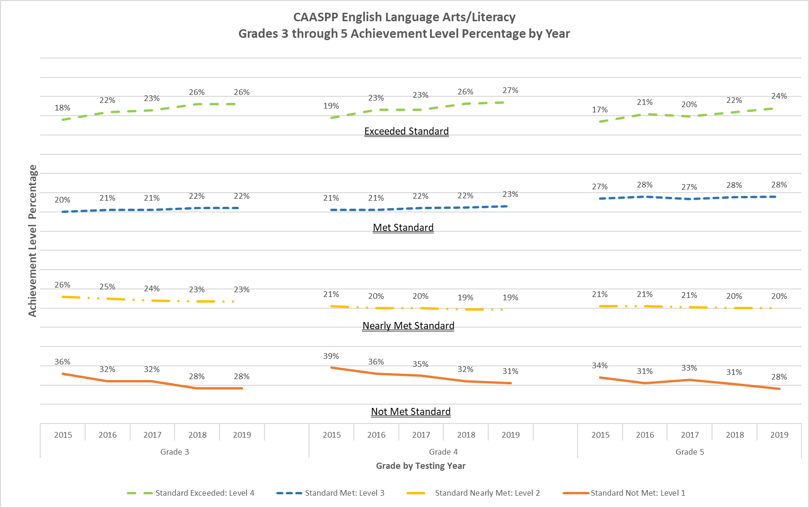
Grade 3 data table for CAASPP English Language Arts/Literacy
Grades 3 through 5 Achievement Level Percentage by Year
Achievement Level | 2015 | 2016 | 2017 | 2018 | 2019
Standard Exceeded: Level 4 | 18% | 22% | 23% | 26% | 26%
Standard Met: Level 3 | 20% | 21% | 21% | 22% | 22%
Standard Nearly Met: Level 2 | 26% | 25% | 24% | 23% | 23%
Standard Not Met: Level 1 | 36% | 32% | 32% | 28% | 28%
Grade 4 data table for CAASPP English Language Arts/Literacy
Grades 3 through 5 Achievement Level Percentage by Year
Achievement Level | 2015 | 2016 | 2017 | 2018 | 2019
Standard Exceeded: Level 4 | 19% | 23% | 23% | 26% | 27%
Standard Met: Level 3 | 21% | 21% | 22% | 22% | 23%
Standard Nearly Met: Level 2 | 21% | 20% | 20% | 19% | 19%
Standard Not Met: Level 1 | 39% | 36% | 35% | 32% | 31%
Grade 5 data table for CAASPP English Language Arts/Literacy
Grades 3 through 5 Achievement Level Percentage by Year
Achievement Level | 2015 | 2016 | 2017 | 2018 | 2019
Standard Exceeded: Level 4 | 17% | 21% | 20% | 22% | 24%
Standard Met: Level 3 | 27% | 28% | 27% | 28% | 28%
Standard Nearly Met: Level 2 | 21% | 21% | 21% | 20% | 20%
Standard Not Met: Level 1 | 34% | 31% | 33% | 31% | 28%

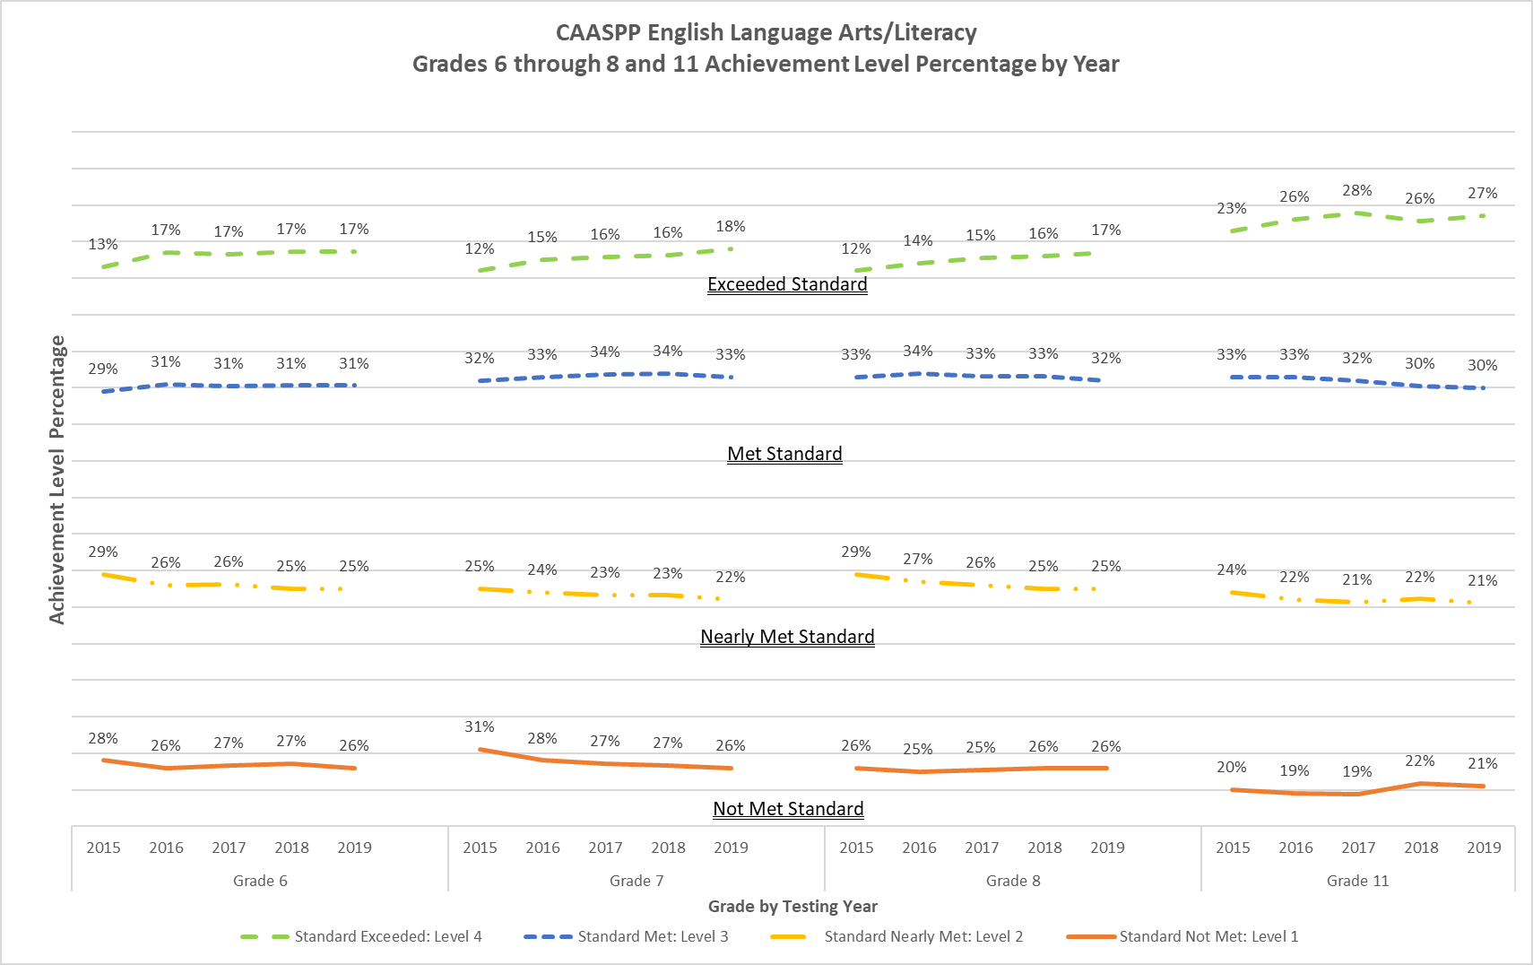

Grade 6 data table for CAASPP English Language Arts/Literacy
Grades 6 through 8 and 11 Achievement Level Percentage by Year
Achievement Level | 2015 | 2016 | 2017 | 2018 | 2019
Standard Exceeded: Level 4 | 13% | 17% | 17% | 17% | 17%
Standard Met: Level 3 | 29% | 31% | 31% | 31% | 31%
Standard Nearly Met: Level 2 | 29% | 26% | 26% | 25% | 25%
Standard Not Met: Level 1 | 28% | 26% | 27% | 27% | 26%
Grade 7 data table for CAASPP English Language Arts/Literacy
Grades 6 through 8 and 11 Achievement Level Percentage by Year
Achievement Level | 2015 | 2016 | 2017 | 2018 | 2019
Standard Exceeded: Level 4 | 12% | 15% | 16% | 16% | 18%
Standard Met: Level 3 | 32% | 33% | 34% | 34% | 33%
Standard Nearly Met: Level 2 | 25% | 24% | 23% | 23% | 22%
Standard Not Met: Level 1 | 31% | 28% | 27% | 27% | 26%
Grade 8 data table for CAASPP English Language Arts/Literacy
Grades 6 through 8 and 11 Achievement Level Percentage by Year
Achievement Level | 2015 | 2016 | 2017 | 2018 | 2019
Standard Exceeded: Level 4 | 12% | 14% | 15% | 16% | 17%
Standard Met: Level 3 | 33% | 34% | 33% | 33% | 32%
Standard Nearly Met: Level 2 | 29% | 27% | 26% | 25% | 25%
Standard Not Met: Level 1 | 26% | 25% | 25% | 26% | 26%
Grade 11 data table for CAASPP English Language Arts/Literacy
Grades 6 through 8 and 11 Achievement Level Percentage by Year
Achievement Level | 2015 | 2016 | 2017 | 2018 | 2019
Standard Exceeded: Level 4 | 23% | 26% | 28% | 26% | 27%
Standard Met: Level 3 | 33% | 33% | 32% | 30% | 30%
Standard Nearly Met: Level 2 | 24% | 22% | 21% | 22% | 21%
Standard Not Met: Level 1 | 20% | 19% | 19% | 22% | 21%

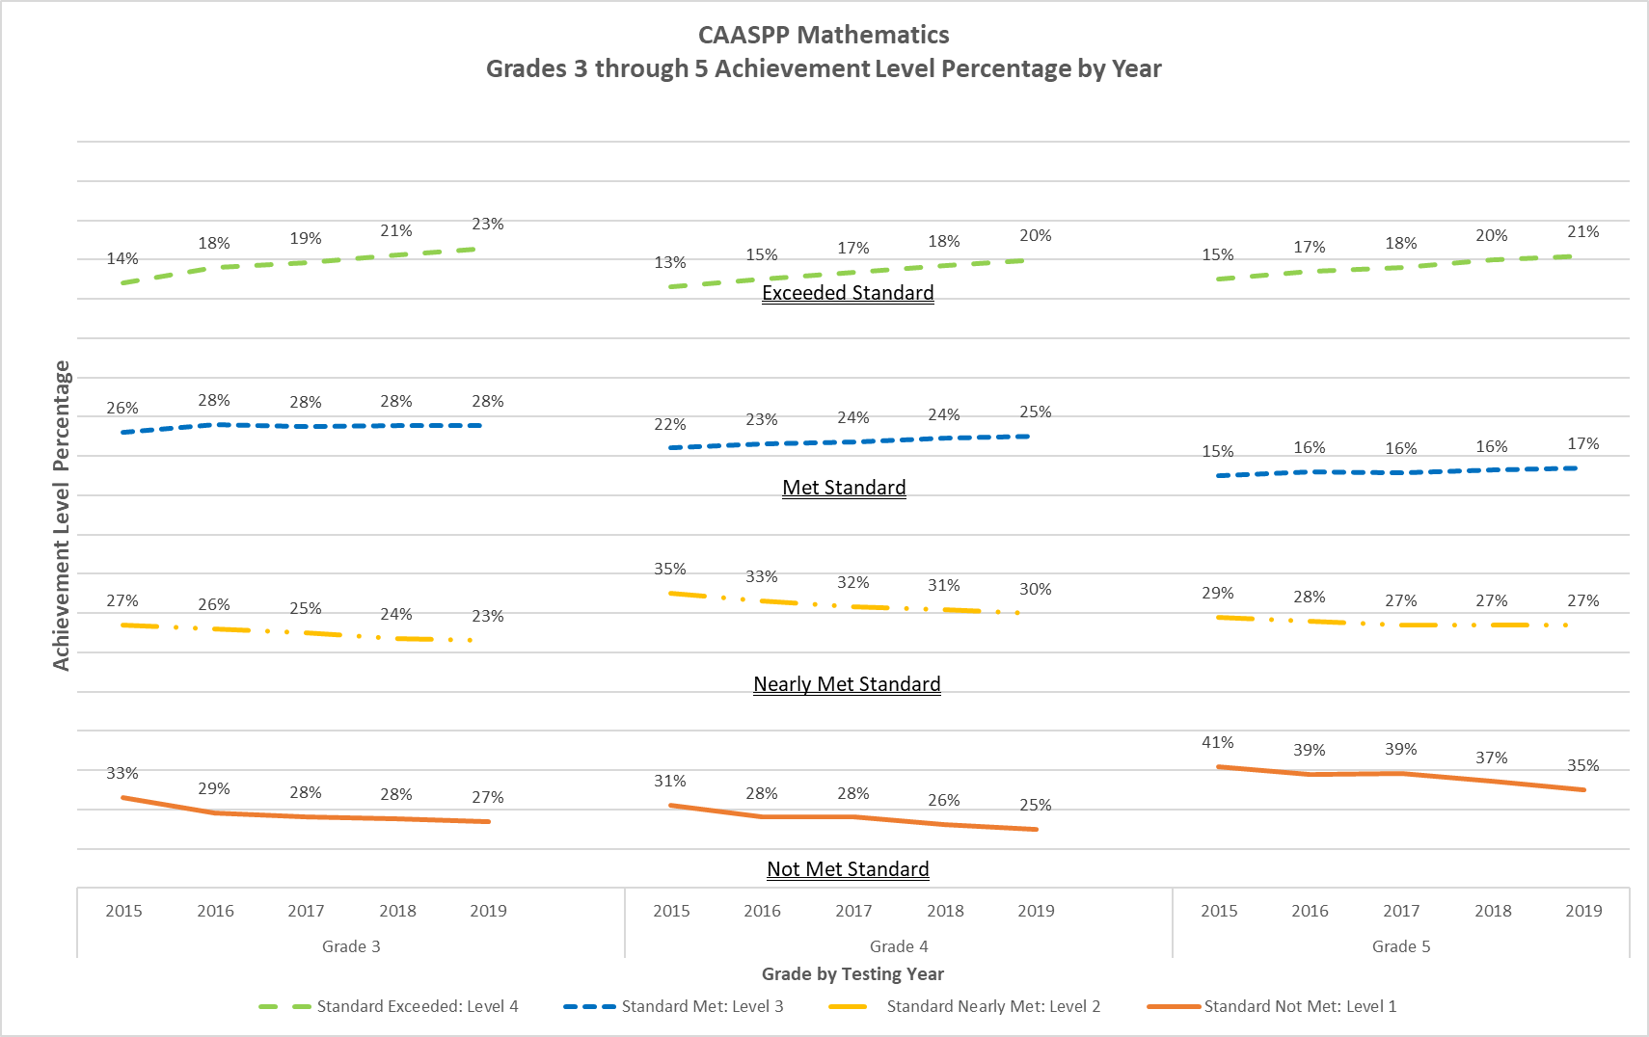

Grade 3 data table for CAASPP Mathematics
Grades 3 through 5 Achievement Level Percentage by Year
Achievement Level | 2015 | 2016 | 2017 | 2018 | 2019
Standard Exceeded: Level 4 | 14% | 18% | 19% | 21% | 23%
Standard Met: Level 3 | 26% | 28% | 28% | 28% | 28%
Standard Nearly Met: Level 2 | 27% | 26% | 25% | 24% | 23%
Standard Not Met: Level 1 | 33% | 29% | 28% | 28% | 27%
Grade 4 data table for CAASPP Mathematics
Grades 3 through 5 Achievement Level Percentage by Year
Achievement Level | 2015 | 2016 | 2017 | 2018 | 2019
Standard Exceeded: Level 4 | 13% | 15% | 17% | 18% | 20%
Standard Met: Level 3 | 22% | 23% | 24% | 24% | 25%
Standard Nearly Met: Level 2 | 35% | 33% | 32% | 31% | 30%
Standard Not Met: Level 1 | 31% | 28% | 28% | 26% | 25%
Grade 5 data table for CAASPP Mathematics
Grades 3 through 5 Achievement Level Percentage by Year
Achievement Level | 2015 | 2016 | 2017 | 2018 | 2019
Standard Exceeded: Level 4 | 15% | 17% | 18% | 20% | 21%
Standard Met: Level 3 | 15% | 16% | 16% | 16% | 17%
Standard Nearly Met: Level 2 | 29% | 28% | 27% | 27% | 27%
Standard Not Met: Level 1 | 41% | 39% | 39% | 37% | 35%

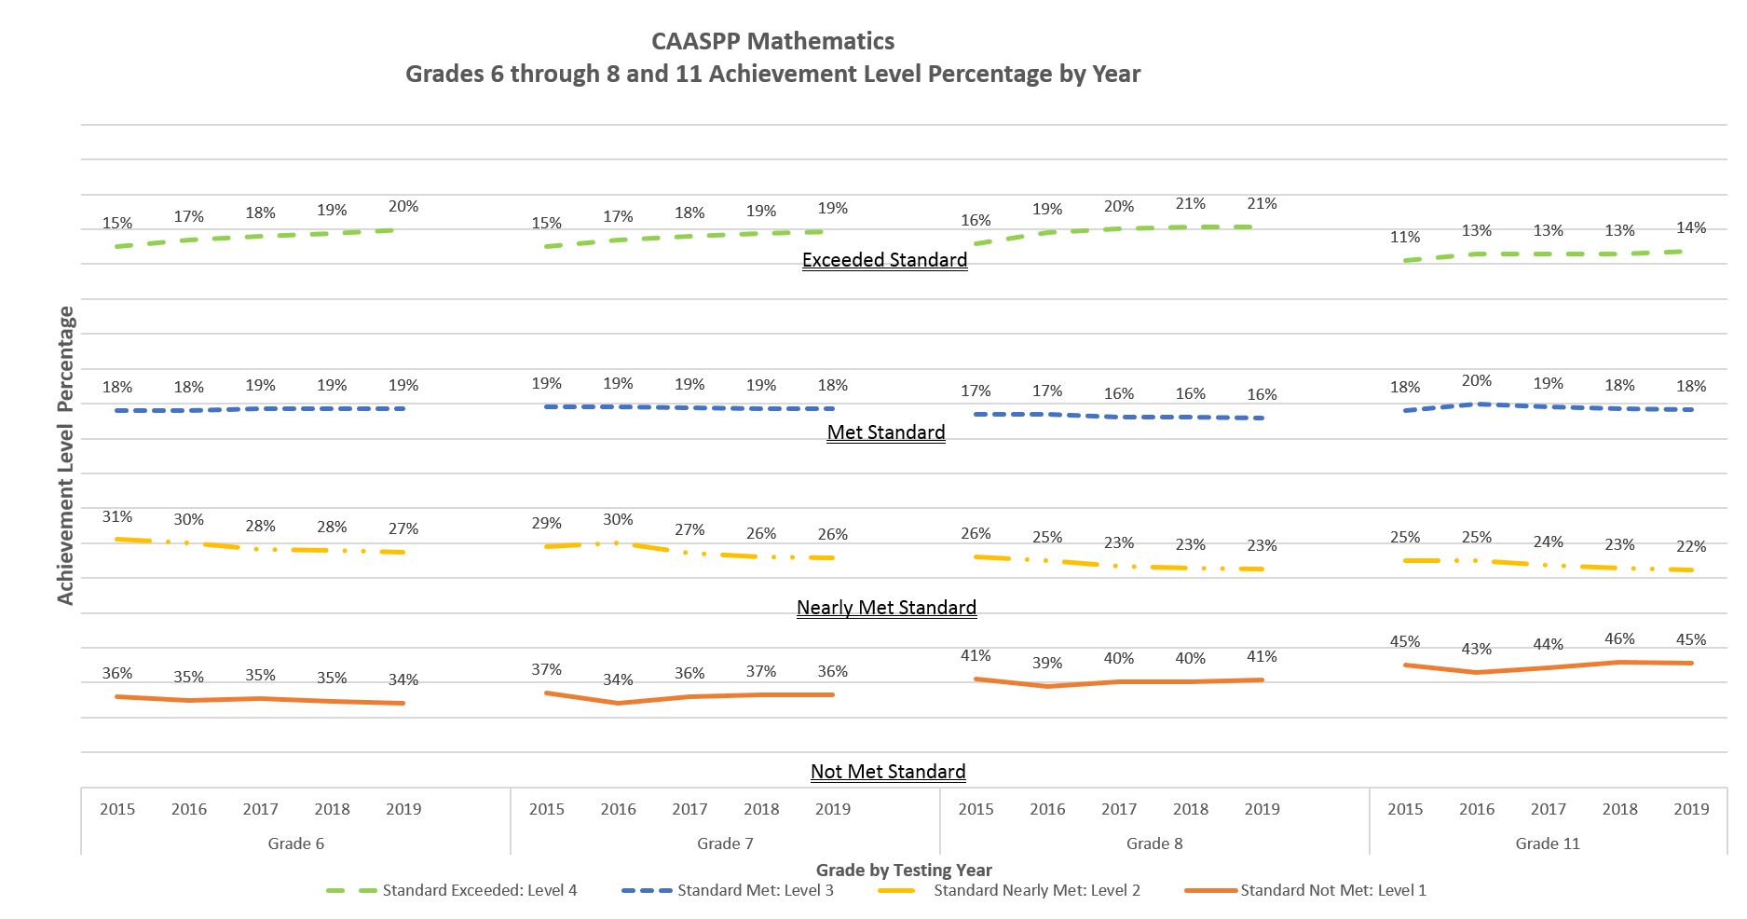

Grade 6 data table for CAASPP Mathematics
Grades 6 through 8 and 11 Achievement Level Percentage by Year
Achievement Level | 2015 | 2016 | 2017 | 2018 | 2019
Standard Exceeded: Level 4 | 15% | 17% | 18% | 19% | 20%
Standard Met: Level 3 | 18% | 18% | 19% | 19% | 19%
Standard Nearly Met: Level 2 | 31% | 30% | 28% | 28% | 27%
Standard Not Met: Level 1 | 36% | 35% | 35% | 35% | 34%
Grade 7 data table for CAASPP Mathematics
Grades 6 through 8 and 11 Achievement Level Percentage by Year
Achievement Level | 2015 | 2016 | 2017 | 2018 | 2019
Standard Exceeded: Level 4 | 15% | 17% | 18% | 19% | 19%
Standard Met: Level 3 | 19% | 19% | 19% | 19% | 18%
Standard Nearly Met: Level 2 | 29% | 30% | 27% | 26% | 26%
Standard Not Met: Level 1 | 37% | 34% | 36% | 37% | 36%
Grade 8 data table for CAASPP Mathematics
Grades 6 through 8 and 11 Achievement Level Percentage by Year
Achievement Level | 2015 | 2016 | 2017 | 2018 | 2019
Standard Exceeded: Level 4 | 16% | 19% | 20% | 21% | 21%
Standard Met: Level 3 | 17% | 17% | 16% | 16% | 16%
Standard Nearly Met: Level 2 | 26% | 25% | 23% | 23% | 23%
Standard Not Met: Level 1 | 41% | 39% | 40% | 40% | 41%
Grade 11 data table for CAASPP Mathematics
Grades 6 through 8 and 11 Achievement Level Percentage by Year
Achievement Level | 2015 | 2016 | 2017 | 2018 | 2019
Standard Exceeded: Level 4 | 11% | 13% | 13% | 13% | 14%
Standard Met: Level 3 | 18% | 20% | 19% | 18% | 18%
Standard Nearly Met: Level 2 | 25% | 25% | 24% | 23% | 22%
Standard Not Met: Level 1 | 45% | 43% | 44% | 46% | 45%

Appendix C.
CAASPP Score Distributions for ELA/L and Mathematics
2015 through 2019

Scale Score Range for Smarter Balanced English Language-Arts/Literacy and Mathematics by Grade
Subject | Grade | Level 1 (Standard Not Met) Minimum Scale Score | Level 1 (Standard Not Met) Maximum Scale Score | Level 2 (Standard Nearly Met) Minimum Scale Score | Level 2 (Standard Nearly Met) Maximum Scale Score | Level 3 (Standard Met) Minimum Scale Score | Level 3 (Standard Met) Maximum Scale Score | Level 4 (Standard Exceeded) Minimum Scale Score | Level 4 (Standard Exceeded) Maximum Scale Score
ELA | 3 | 2114 | 2366 | 2367 | 2431 | 2432 | 2489 | 2490 | 2623
ELA | 4 | 2131 | 2415 | 2416 | 2472 | 2473 | 2532 | 2533 | 2663
ELA | 5 | 2201 | 2441 | 2442 | 2501 | 2502 | 2581 | 2582 | 2701
ELA | 6 | 2210 | 2456 | 2457 | 2530 | 2531 | 2617 | 2618 | 2724
ELA | 7 | 2258 | 2478 | 2479 | 2551 | 2552 | 2648 | 2649 | 2745
ELA | 8 | 2288 | 2486 | 2487 | 2566 | 2567 | 2667 | 2668 | 2769
ELA | 11 | 2299 | 2492 | 2493 | 2582 | 2583 | 2681 | 2682 | 2795
Mathematics | 3 | 2189 | 2380 | 2381 | 2435 | 2436 | 2500 | 2501 | 2621
Mathematics | 4 | 2204 | 2410 | 2411 | 2484 | 2485 | 2548 | 2549 | 2659
Mathematics | 5 | 2219 | 2454 | 2455 | 2527 | 2528 | 2578 | 2579 | 2700
Mathematics | 6 | 2235 | 2472 | 2473 | 2551 | 2552 | 2609 | 2610 | 2748
Mathematics | 7 | 2250 | 2483 | 2484 | 2566 | 2567 | 2634 | 2635 | 2778
Mathematics | 8 | 2265 | 2503 | 2504 | 2585 | 2586 | 2652 | 2653 | 2802
Mathematics | 11 | 2280 | 2542 | 2543 | 2627 | 2628 | 2717 | 2718 | 2862

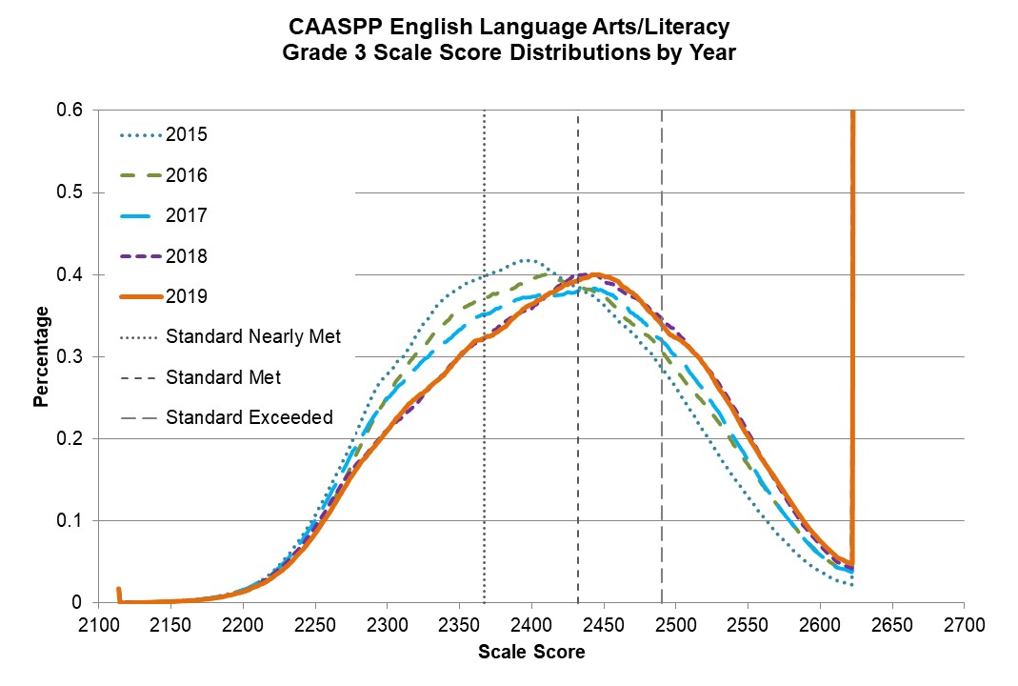
Percentage by Scale Score for the CAASPP English Language Arts/Literacy Grade 3 Score Distribution by Year
Scale Score | Percent at Scale Score in 2015 | Percent at Scale Score in 2016 | Percent at Scale Score in 2017 | Percent at Scale Score in 2018 | Percent at Scale Score in 2019
2114 | 0.018 | 0.017 | 0.013 | 0.013 | 0.018
2150 | 0.002 | 0.001 | 0.002 | 0.002 | 0.002
2200 | 0.016 | 0.013 | 0.016 | 0.014 | 0.014
2250 | 0.107 | 0.087 | 0.101 | 0.093 | 0.085
2300 | 0.279 | 0.251 | 0.250 | 0.211 | 0.210
2350 | 0.384 | 0.357 | 0.333 | 0.300 | 0.301
2400 | 0.418 | 0.395 | 0.373 | 0.359 | 0.364
2450 | 0.363 | 0.373 | 0.380 | 0.392 | 0.399
2500 | 0.263 | 0.284 | 0.301 | 0.331 | 0.324
2550 | 0.130 | 0.168 | 0.174 | 0.208 | 0.203
2600 | 0.039 | 0.059 | 0.059 | 0.071 | 0.075
2623 | 0.483 | 0.874 | 0.901 | 0.995 | 1.240

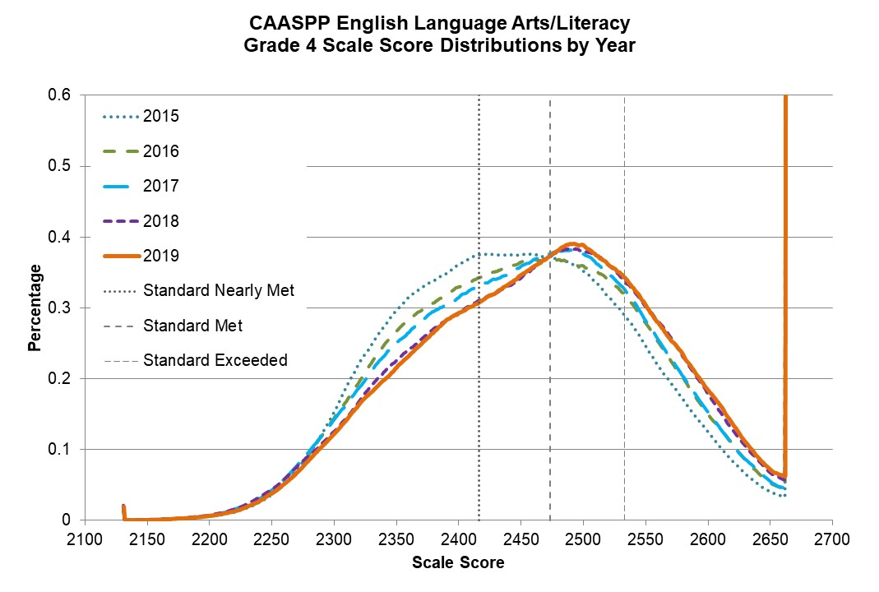
Percentage by Scale Score for the CAASPP English Language Arts/Literacy Grade 4 Score Distribution by Year
Scale Score | Percent at Scale Score in 2015 | Percent at Scale Score in 2016 | Percent at Scale Score in 2017 | Percent at Scale Score in 2018 | Percent at Scale Score in 2019
2131 | 0.012 | 0.013 | 0.018 | 0.021 | 0.020
2150 | 0.001 | 0.001 | 0.001 | 0.001 | 0.001
2200 | 0.006 | 0.005 | 0.007 | 0.007 | 0.007
2250 | 0.036 | 0.037 | 0.043 | 0.044 | 0.039
2300 | 0.152 | 0.143 | 0.142 | 0.125 | 0.123
2350 | 0.296 | 0.266 | 0.251 | 0.226 | 0.216
2400 | 0.360 | 0.329 | 0.314 | 0.293 | 0.294
2450 | 0.375 | 0.364 | 0.358 | 0.342 | 0.347
2500 | 0.352 | 0.359 | 0.376 | 0.380 | 0.389
2550 | 0.247 | 0.279 | 0.283 | 0.302 | 0.304
2600 | 0.125 | 0.150 | 0.153 | 0.180 | 0.185
2650 | 0.040 | 0.053 | 0.056 | 0.068 | 0.072
2663 | 0.825 | 1.192 | 1.286 | 1.772 | 1.920

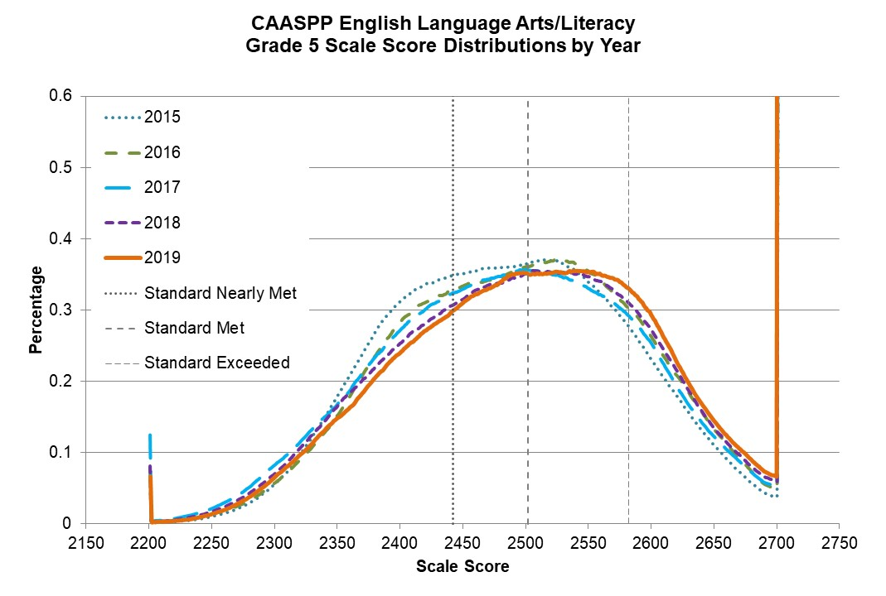
Percentage by Scale Score for the CAASPP English Language Arts/Literacy Grade 5 Score Distribution by Year
Scale Score | Percent at Scale Score in 2015 | Percent at Scale Score in 2016 | Percent at Scale Score in 2017 | Percent at Scale Score in 2018 | Percent at Scale Score in 2019
2201 | 0.061 | 0.078 | 0.125 | 0.082 | 0.067
2250 | 0.011 | 0.013 | 0.022 | 0.018 | 0.014
2300 | 0.056 | 0.057 | 0.083 | 0.071 | 0.066
2400 | 0.312 | 0.283 | 0.272 | 0.254 | 0.240
2450 | 0.351 | 0.333 | 0.330 | 0.315 | 0.310
2500 | 0.364 | 0.361 | 0.357 | 0.352 | 0.352
2550 | 0.339 | 0.354 | 0.331 | 0.348 | 0.354
2600 | 0.231 | 0.262 | 0.254 | 0.273 | 0.294
2650 | 0.110 | 0.132 | 0.123 | 0.134 | 0.145
2700 | 0.039 | 0.048 | 0.053 | 0.060 | 0.067
2701 | 0.881 | 1.251 | 1.456 | 1.744 | 2.066

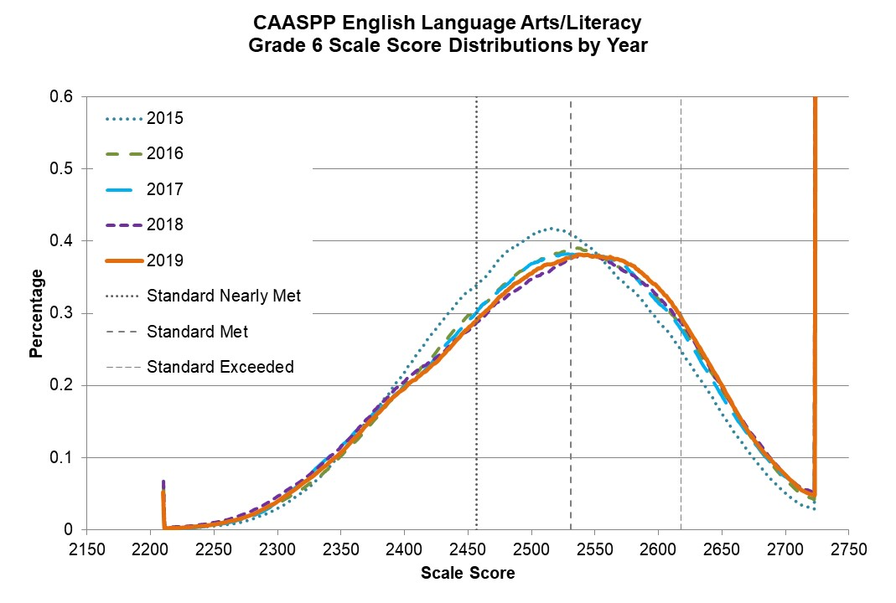
Percentage by Scale Score for the CAASPP English Language Arts/Literacy Grade 6 Score Distribution by Year
Scale Score | Percent at Scale Score in 2015 | Percent at Scale Score in 2016 | Percent at Scale Score in 2017 | Percent at Scale Score in 2018 | Percent at Scale Score in 2019
2210 | 0.045 | 0.061 | 0.028 | 0.067 | 0.052
2250 | 0.006 | 0.008 | 0.006 | 0.010 | 0.008
2300 | 0.030 | 0.037 | 0.039 | 0.046 | 0.040
2350 | 0.107 | 0.103 | 0.116 | 0.115 | 0.107
2400 | 0.219 | 0.201 | 0.198 | 0.205 | 0.196
2450 | 0.330 | 0.298 | 0.290 | 0.275 | 0.279
2500 | 0.408 | 0.369 | 0.369 | 0.347 | 0.355
2550 | 0.384 | 0.384 | 0.379 | 0.379 | 0.379
2600 | 0.288 | 0.321 | 0.315 | 0.324 | 0.336
2650 | 0.162 | 0.195 | 0.186 | 0.198 | 0.200
2700 | 0.051 | 0.070 | 0.074 | 0.076 | 0.076
2724 | 0.699 | 1.163 | 1.370 | 1.353 | 1.303

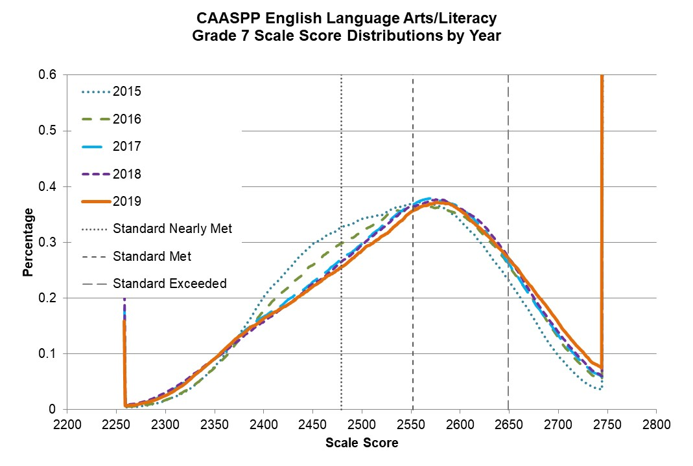
Percentage by Scale Score for the CAASPP English Language Arts/Literacy Grade 7 Score Distribution by Year
Scale Score | Percent at Scale Score in 2015 | Percent at Scale Score in 2016 | Percent at Scale Score in 2017 | Percent at Scale Score in 2018 | Percent at Scale Score in 2019
2258 | 0.104 | 0.099 | 0.182 | 0.206 | 0.159
2300 | 0.017 | 0.017 | 0.028 | 0.031 | 0.026
2350 | 0.078 | 0.076 | 0.091 | 0.091 | 0.092
2400 | 0.203 | 0.177 | 0.167 | 0.158 | 0.164
2450 | 0.298 | 0.260 | 0.230 | 0.225 | 0.221
2500 | 0.343 | 0.322 | 0.299 | 0.295 | 0.285
2550 | 0.368 | 0.358 | 0.367 | 0.364 | 0.355
2600 | 0.338 | 0.350 | 0.361 | 0.360 | 0.358
2650 | 0.230 | 0.256 | 0.260 | 0.271 | 0.270
2700 | 0.096 | 0.127 | 0.133 | 0.139 | 0.156
2745 | 0.904 | 1.567 | 1.696 | 1.672 | 2.230

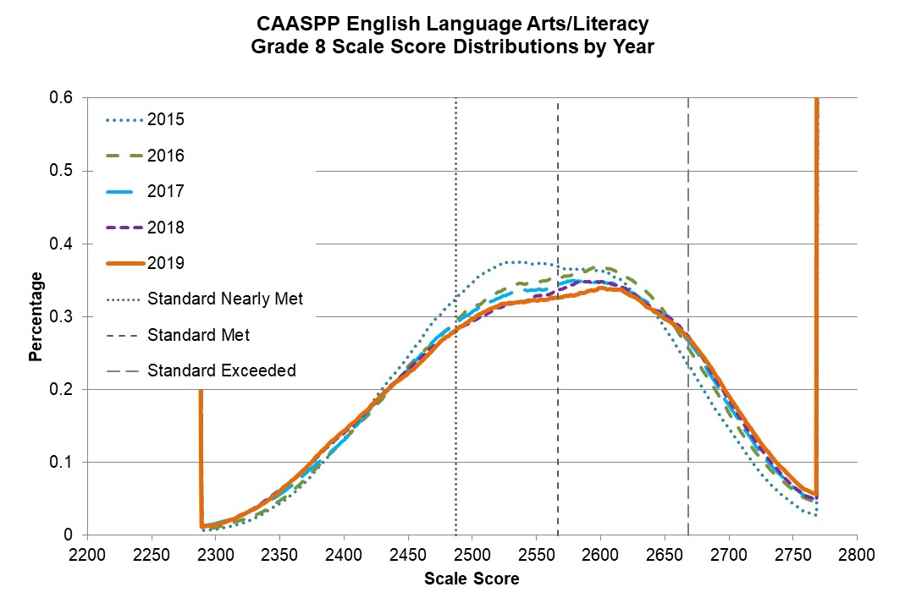
Percentage by Scale Score for the CAASPP English Language Arts/Literacy Grade 8 Score Distribution by Year
Scale Score | Percent at Scale Score in 2015 | Percent at Scale Score in 2016 | Percent at Scale Score in 2017 | Percent at Scale Score in 2018 | Percent at Scale Score in 2019
2288 | 0.153 | 0.191 | 0.317 | 0.277 | 0.283
2300 | 0.009 | 0.011 | 0.016 | 0.015 | 0.014
2350 | 0.045 | 0.048 | 0.057 | 0.063 | 0.061
2400 | 0.134 | 0.133 | 0.131 | 0.141 | 0.143
2450 | 0.246 | 0.233 | 0.227 | 0.227 | 0.222
2500 | 0.347 | 0.312 | 0.307 | 0.295 | 0.297
2550 | 0.373 | 0.347 | 0.337 | 0.329 | 0.322
2600 | 0.363 | 0.368 | 0.348 | 0.349 | 0.339
2650 | 0.284 | 0.304 | 0.300 | 0.302 | 0.297
2700 | 0.146 | 0.167 | 0.178 | 0.185 | 0.191
2750 | 0.044 | 0.062 | 0.066 | 0.067 | 0.077
2769 | 0.666 | 1.261 | 1.417 | 1.463 | 1.862

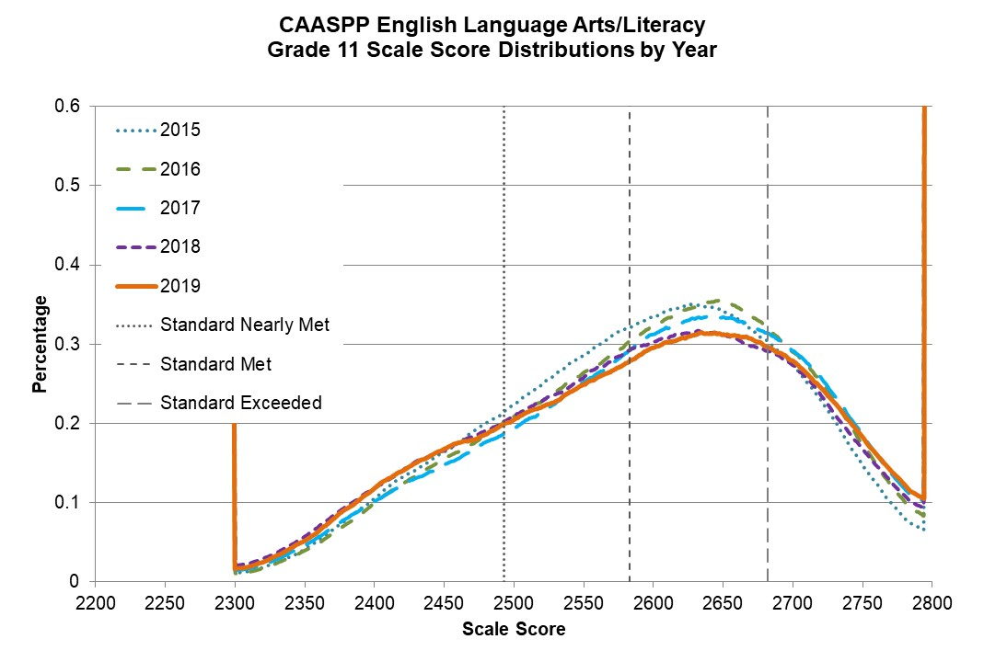
Percentage by Scale Score for the CAASPP English Language Arts/Literacy Grade 11 Score Distribution by Year
Scale Score | Percent at Scale Score in 2015 | Percent at Scale Score in 2016 | Percent at Scale Score in 2017 | Percent at Scale Score in 2018 | Percent at Scale Score in 2019
2299 | 0.237 | 0.284 | 0.377 | 0.577 | 0.497
2300 | 0.011 | 0.010 | 0.015 | 0.021 | 0.017
2350 | 0.041 | 0.039 | 0.047 | 0.058 | 0.052
2400 | 0.105 | 0.100 | 0.102 | 0.118 | 0.119
2450 | 0.164 | 0.155 | 0.148 | 0.166 | 0.168
2500 | 0.224 | 0.208 | 0.194 | 0.209 | 0.205
2550 | 0.286 | 0.264 | 0.253 | 0.258 | 0.250
2600 | 0.335 | 0.323 | 0.313 | 0.302 | 0.296
2650 | 0.342 | 0.354 | 0.335 | 0.313 | 0.312
2700 | 0.273 | 0.290 | 0.292 | 0.274 | 0.279
2750 | 0.148 | 0.174 | 0.185 | 0.169 | 0.183
2795 | 2.141 | 2.733 | 3.800 | 3.606 | 3.950

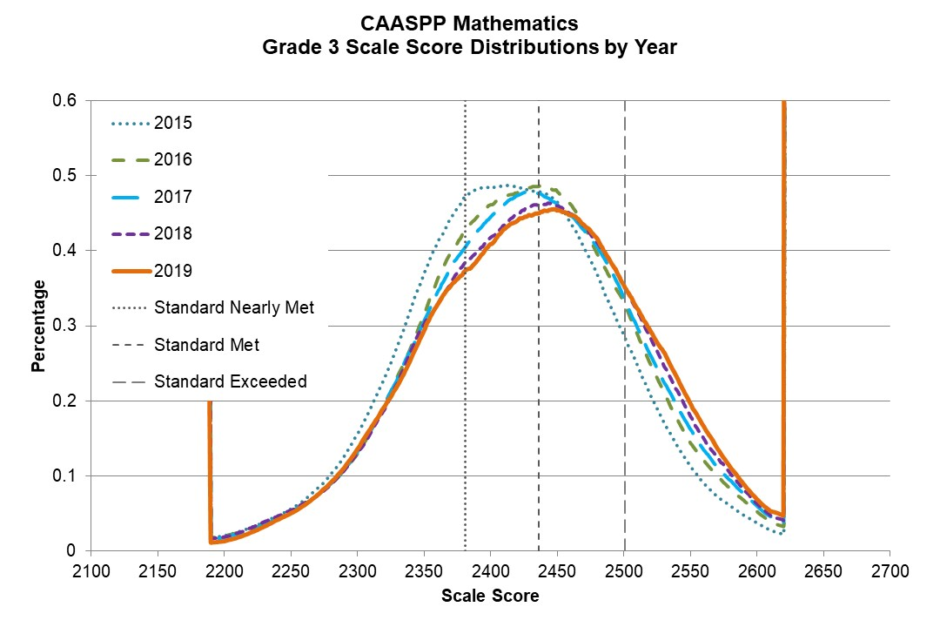

Percentage by Scale Score for the CAASPP Mathematics Grade 3 Score Distribution by Year
Scale Score | Percent at Scale Score in 2015 | Percent at Scale Score in 2016 | Percent at Scale Score in 2017 | Percent at Scale Score in 2018 | Percent at Scale Score in 2019
2189 | 0.518 | 0.547 | 0.414 | 0.409 | 0.214
2200 | 0.020 | 0.020 | 0.018 | 0.019 | 0.012
2250 | 0.056 | 0.051 | 0.053 | 0.054 | 0.049
2300 | 0.156 | 0.130 | 0.132 | 0.131 | 0.135
2350 | 0.370 | 0.315 | 0.307 | 0.302 | 0.293
2400 | 0.483 | 0.462 | 0.445 | 0.418 | 0.409
2450 | 0.465 | 0.479 | 0.461 | 0.459 | 0.454
2500 | 0.286 | 0.331 | 0.337 | 0.353 | 0.355
2550 | 0.113 | 0.143 | 0.162 | 0.179 | 0.197
2600 | 0.037 | 0.052 | 0.060 | 0.063 | 0.069
2621 | 0.568 | 0.781 | 1.033 | 1.248 | 1.383

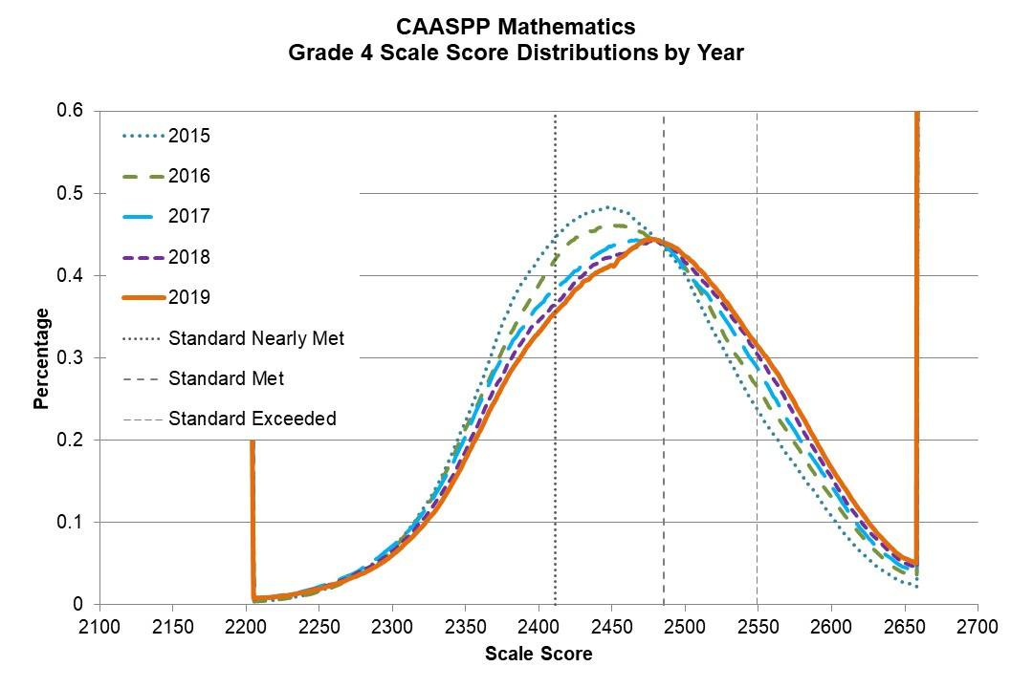

Percentage by Scale Score for the CAASPP Mathematics Grade 4 Score Distribution by Year
Scale Score | Percent at Scale Score in 2015 | Percent at Scale Score in 2016 | Percent at Scale Score in 2017 | Percent at Scale Score in 2018 | Percent at Scale Score in 2019
2204 | 0.130 | 0.103 | 0.258 | 0.255 | 0.221
2250 | 0.018 | 0.016 | 0.022 | 0.021 | 0.019
2300 | 0.071 | 0.068 | 0.072 | 0.066 | 0.061
2350 | 0.225 | 0.215 | 0.206 | 0.189 | 0.178
2400 | 0.423 | 0.390 | 0.363 | 0.346 | 0.331
2450 | 0.482 | 0.460 | 0.436 | 0.424 | 0.413
2500 | 0.401 | 0.409 | 0.406 | 0.416 | 0.424
2550 | 0.235 | 0.260 | 0.285 | 0.302 | 0.313
2600 | 0.108 | 0.130 | 0.143 | 0.154 | 0.166
2650 | 0.027 | 0.038 | 0.045 | 0.051 | 0.056
2659 | 0.756 | 1.107 | 1.287 | 1.543 | 1.793
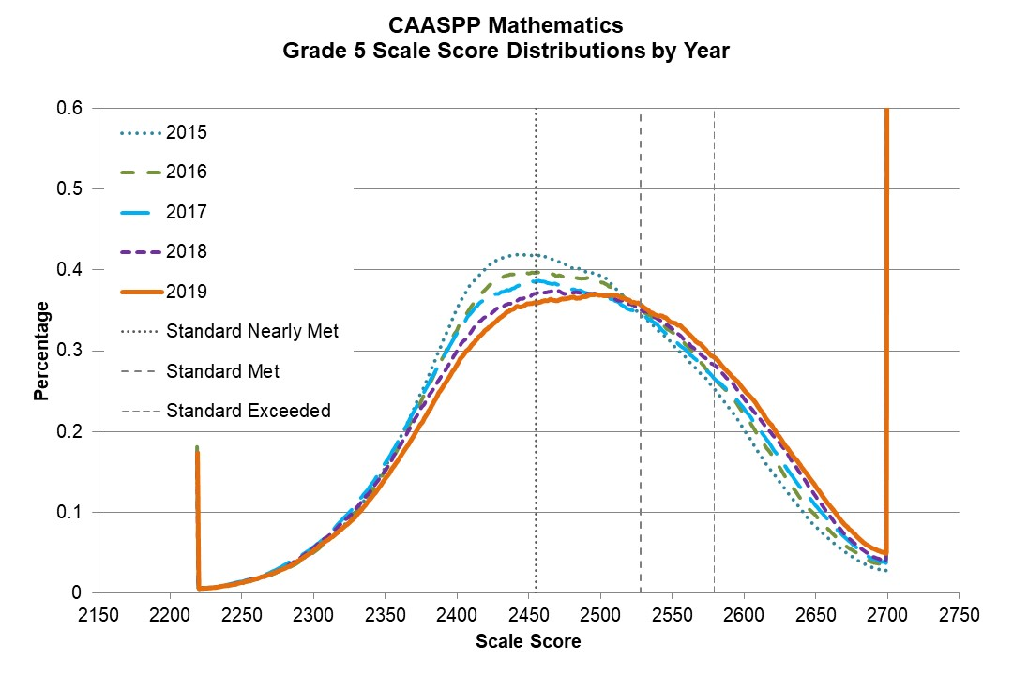

Percentage by Scale Score for the CAASPP Mathematics Grade 5 Score Distribution by Year
Scale Score | Percent at Scale Score in 2015 | Percent at Scale Score in 2016 | Percent at Scale Score in 2017 | Percent at Scale Score in 2018 | Percent at Scale Score in 2019
2219 | 0.164 | 0.181 | 0.175 | 0.170 | 0.175
2250 | 0.011 | 0.013 | 0.014 | 0.014 | 0.013
2300 | 0.051 | 0.050 | 0.057 | 0.056 | 0.053
2350 | 0.155 | 0.151 | 0.161 | 0.152 | 0.143
2400 | 0.351 | 0.325 | 0.321 | 0.300 | 0.284
2450 | 0.418 | 0.396 | 0.385 | 0.367 | 0.359
2500 | 0.393 | 0.385 | 0.371 | 0.371 | 0.370
2550 | 0.309 | 0.323 | 0.315 | 0.327 | 0.336
2600 | 0.203 | 0.222 | 0.229 | 0.241 | 0.252
2650 | 0.082 | 0.096 | 0.108 | 0.120 | 0.132
2700 | 0.745 | 0.997 | 1.106 | 1.314 | 1.697

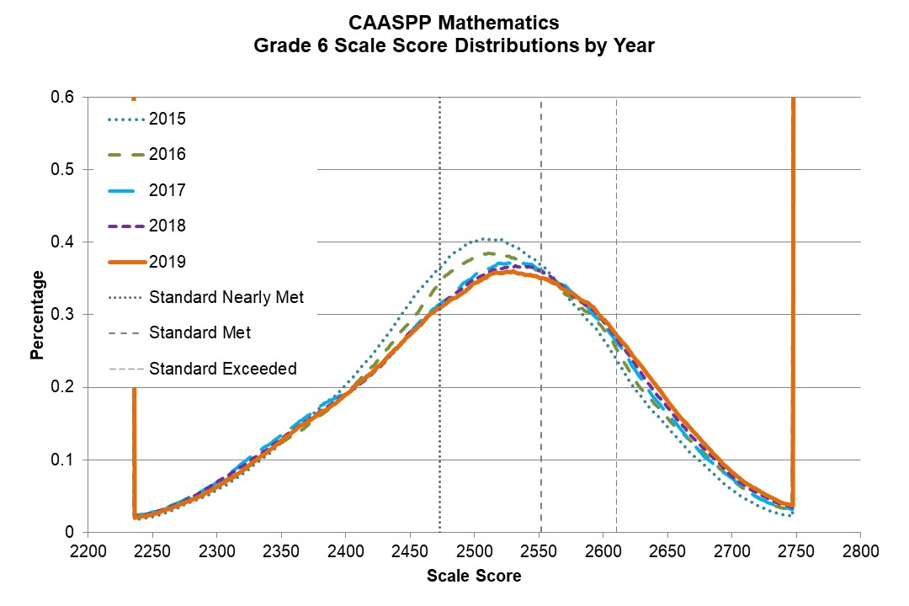

Percentage by Scale Score for the CAASPP Mathematics Grade 6 Score Distribution by Year
Scale Score | Percent at Scale Score in 2015 | Percent at Scale Score in 2016 | Percent at Scale Score in 2017 | Percent at Scale Score in 2018 | Percent at Scale Score in 2019
2235 | 0.884 | 0.991 | 1.049 | 1.085 | 1.045
2250 | 0.021 | 0.027 | 0.028 | 0.028 | 0.025
2300 | 0.058 | 0.067 | 0.069 | 0.070 | 0.063
2350 | 0.123 | 0.123 | 0.134 | 0.129 | 0.127
2400 | 0.203 | 0.190 | 0.194 | 0.191 | 0.191
2450 | 0.317 | 0.292 | 0.275 | 0.276 | 0.273
2500 | 0.401 | 0.379 | 0.355 | 0.348 | 0.344
2550 | 0.371 | 0.361 | 0.363 | 0.361 | 0.351
2600 | 0.266 | 0.281 | 0.288 | 0.292 | 0.294
2650 | 0.145 | 0.158 | 0.163 | 0.173 | 0.180
2700 | 0.058 | 0.074 | 0.075 | 0.078 | 0.083
2748 | 0.727 | 1.119 | 1.297 | 1.322 | 1.586

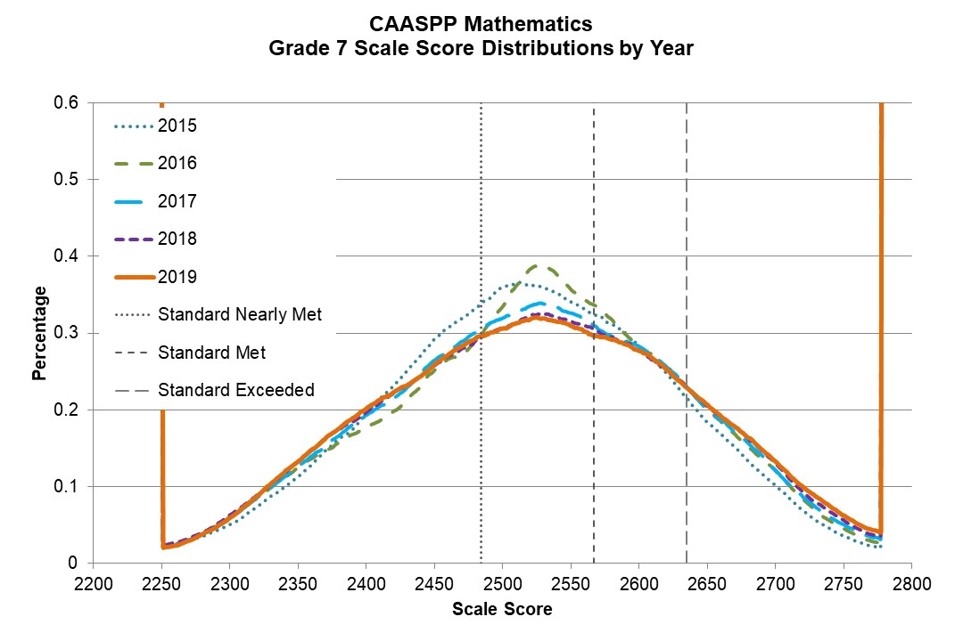

Percentage by Scale Score for the CAASPP Mathematics Grade 7 Score Distribution by Year
Scale Score | Percent at Scale Score in 2015 | Percent at Scale Score in 2016 | Percent at Scale Score in 2017 | Percent at Scale Score in 2018 | Percent at Scale Score in 2019
2250 | 1.130 | 0.740 | 0.828 | 0.930 | 0.701
2300 | 0.050 | 0.060 | 0.059 | 0.063 | 0.059
2350 | 0.112 | 0.124 | 0.127 | 0.133 | 0.132
2400 | 0.194 | 0.176 | 0.193 | 0.197 | 0.202
2450 | 0.292 | 0.251 | 0.265 | 0.258 | 0.260
2500 | 0.359 | 0.334 | 0.320 | 0.306 | 0.306
2550 | 0.341 | 0.357 | 0.327 | 0.315 | 0.309
2600 | 0.282 | 0.283 | 0.283 | 0.277 | 0.277
2650 | 0.184 | 0.200 | 0.202 | 0.205 | 0.206
2700 | 0.101 | 0.120 | 0.122 | 0.131 | 0.132
2750 | 0.035 | 0.045 | 0.051 | 0.057 | 0.062
2778 | 0.742 | 0.867 | 1.370 | 1.228 | 1.567

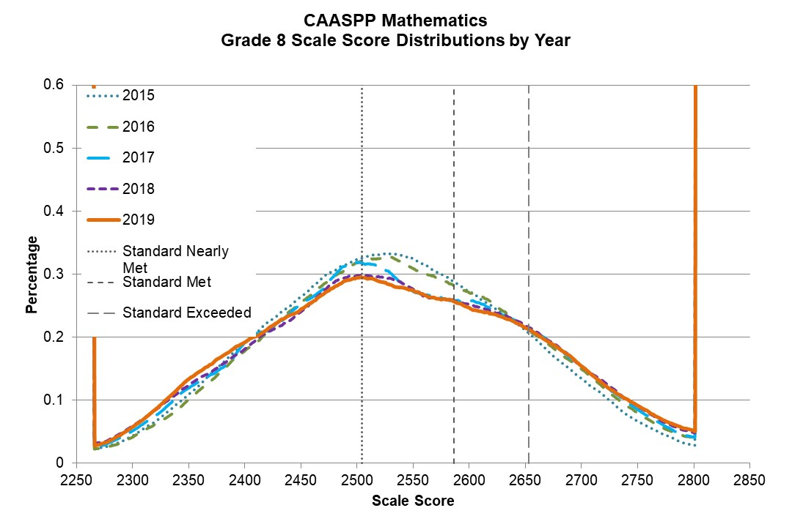

Percentage by Scale Score for the CAASPP Mathematics Grade 8 Score Distribution by Year
Scale Score | Percent at Scale Score in 2015 | Percent at Scale Score in 2016 | Percent at Scale Score in 2017 | Percent at Scale Score in 2018 | Percent at Scale Score in 2019
2265 | 0.959 | 1.005 | 0.934 | 1.090 | 0.906
2300 | 0.043 | 0.041 | 0.051 | 0.059 | 0.058
2350 | 0.109 | 0.101 | 0.119 | 0.124 | 0.134
2400 | 0.190 | 0.178 | 0.192 | 0.182 | 0.192
2450 | 0.264 | 0.254 | 0.254 | 0.240 | 0.244
2500 | 0.323 | 0.319 | 0.318 | 0.298 | 0.294
2550 | 0.324 | 0.309 | 0.273 | 0.276 | 0.274
2600 | 0.272 | 0.270 | 0.258 | 0.252 | 0.246
2650 | 0.211 | 0.214 | 0.216 | 0.218 | 0.214
2700 | 0.134 | 0.150 | 0.154 | 0.153 | 0.153
2750 | 0.067 | 0.080 | 0.085 | 0.091 | 0.091
2800 | 0.029 | 0.041 | 0.042 | 0.049 | 0.051
2802 | 1.186 | 1.728 | 2.248 | 2.394 | 2.635

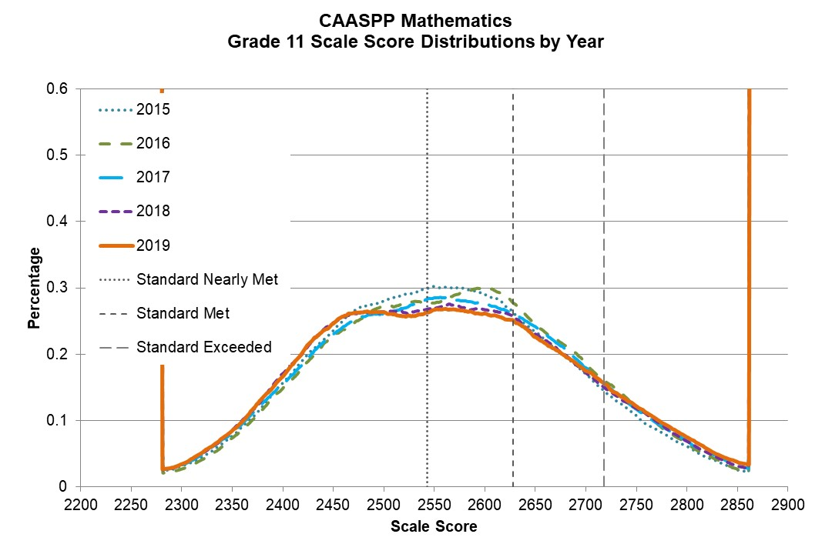
Percentage by Scale Score for the CAASPP Mathematics Grade 11 Score Distribution by Year
Scale Score | Percent at Scale Score in 2015 | Percent at Scale Score in 2016 | Percent at Scale Score in 2017 | Percent at Scale Score in 2018 | Percent at Scale Score in 2019
2280 | 1.169 | 0.846 | 1.067 | 1.165 | 1.179
2300 | 0.032 | 0.027 | 0.033 | 0.034 | 0.034
2350 | 0.077 | 0.074 | 0.082 | 0.086 | 0.085
2400 | 0.157 | 0.149 | 0.156 | 0.172 | 0.166
2450 | 0.236 | 0.229 | 0.231 | 0.248 | 0.246
2500 | 0.280 | 0.273 | 0.262 | 0.264 | 0.263
2550 | 0.302 | 0.278 | 0.286 | 0.270 | 0.267
2600 | 0.290 | 0.299 | 0.275 | 0.267 | 0.262
2650 | 0.234 | 0.245 | 0.242 | 0.231 | 0.226
2700 | 0.169 | 0.186 | 0.180 | 0.172 | 0.175
2750 | 0.107 | 0.121 | 0.118 | 0.119 | 0.121
2800 | 0.061 | 0.066 | 0.070 | 0.069 | 0.075
2850 | 0.025 | 0.027 | 0.032 | 0.032 | 0.037
2862 | 0.846 | 0.842 | 1.051 | 1.101 | 1.426

Appendix D.
2015 to 2019 Performance Trends for Selected Student Groups by Year

Grade 3 CAASPP ELA/L Performance Trends for Selected Student Groups:
Ever English Learners and English Only
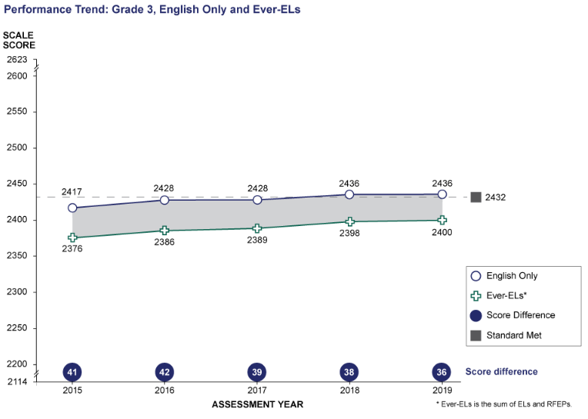

ELA Grade 3: Performance Trend between English Only and Ever-ELs
* Ever-ELs is the sum of ELs and RFEPs
Student Group | 2015 Scale Score Mean | 2016 Scale Score Mean | 2017 Scale Score Mean | 2018 Scale Score Mean | 2019 Scale Score Mean
English Only | 2417 | 2428 | 2428 | 2436 | 2436
Ever-ELs* | 2376 | 2386 | 2389 | 2398 | 2400
Score Difference | 41 | 42 | 39 | 38 | 36

Grade 3 CAASPP ELA/L Performance Trends for Selected Student Groups:
Students with Disabilities and Students with No Reported Disabilities
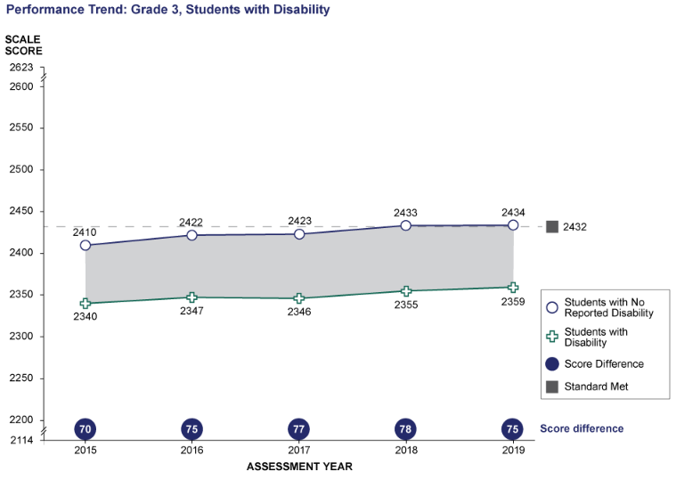
ELA Grade 3: Performance Trend between Students with No Reported Disability and Students with Disability
Student Group | 2015 Scale Score Mean | 2016 Scale Score Mean | 2017 Scale Score Mean | 2018 Scale Score Mean | 2019 Scale Score Mean
Students with No Reported Disability | 2410 | 2422 | 2423 | 2433 | 2434
Students with Disability | 2340 | 2347 | 2346 | 2355 | 2359
Score Difference | 70 | 75 | 77 | 78 | 75

Grade 3 CAASPP ELA/L Performance Trends for Selected Student Groups:
Black or African American and White
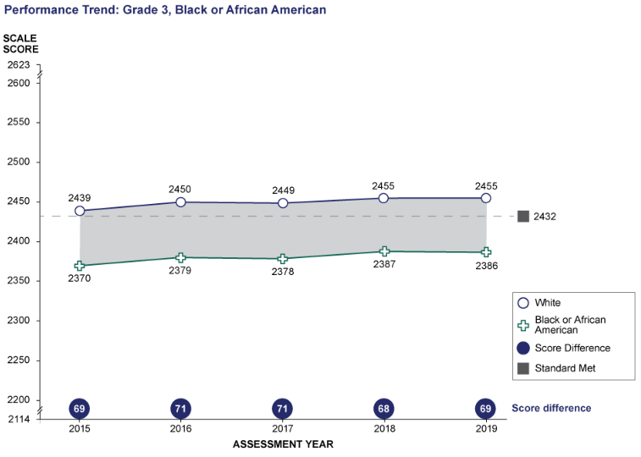
ELA Grade 3: Performance Trend between White and Black or African American
Student Group | 2015 Scale Score Mean | 2016 Scale Score Mean | 2017 Scale Score Mean | 2018 Scale Score Mean | 2019 Scale Score Mean
White | 2439 | 2450 | 2449 | 2455 | 2455
Black or African American | 2370 | 2379 | 2378 | 2387 | 2386
Score Difference | 69 | 71 | 71 | 68 | 69

Grade 3 CAASPP ELA/L Performance Trends for Selected Student Groups:
Hispanic or Latino and White
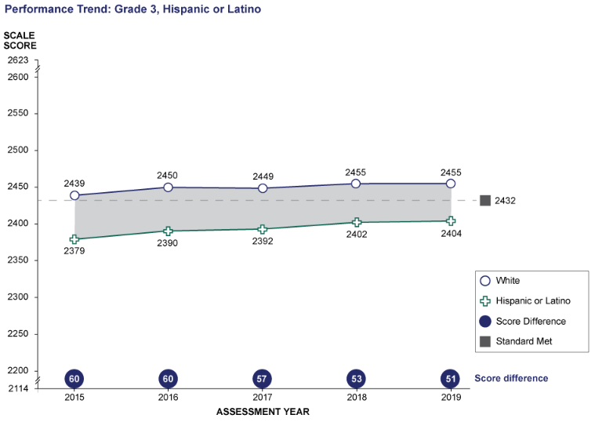
ELA Grade 3: Performance Trend between White and Hispanic or Latino
Student Group | 2015 Scale Score Mean | 2016 Scale Score Mean | 2017 Scale Score Mean | 2018 Scale Score Mean | 2019 Scale Score Mean
White | 2439 | 2450 | 2449 | 2455 | 2455
Hispanic or Latino | 2379 | 2390 | 2392 | 2402 | 2404
Score Difference | 60 | 60 | 57 | 53 | 51

Grade 4 CAASPP ELA/L Performance Trends for Selected Student Groups:
Ever English Learners and English Only
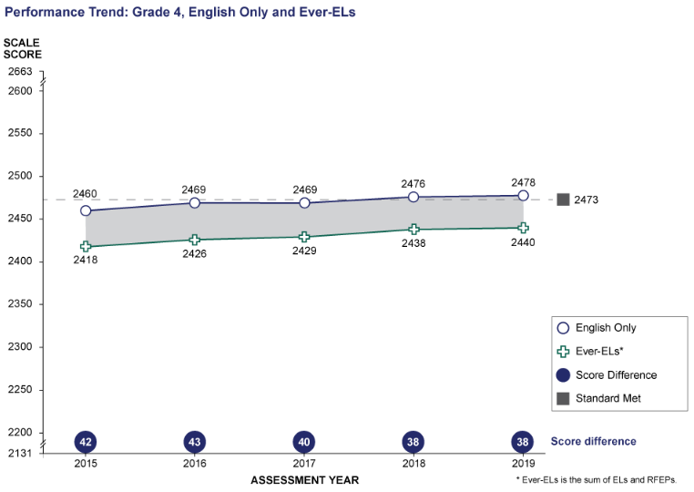
ELA Grade 4: Performance Trend between English Only and Ever-ELs
* Ever-ELs is the sum of ELs and RFEPs
Student Group | 2015 Scale Score Mean | 2016 Scale Score Mean | 2017 Scale Score Mean | 2018 Scale Score Mean | 2019 Scale Score Mean
English Only | 2460 | 2469 | 2469 | 2476 | 2478
Ever-ELs* | 2418 | 2426 | 2429 | 2438 | 2440
Score Difference | 42 | 43 | 40 | 38 | 38

Grade 4 CAASPP ELA/L Performance Trends for Selected Student Groups:
Students with Disabilities and Students with No Reported Disabilities
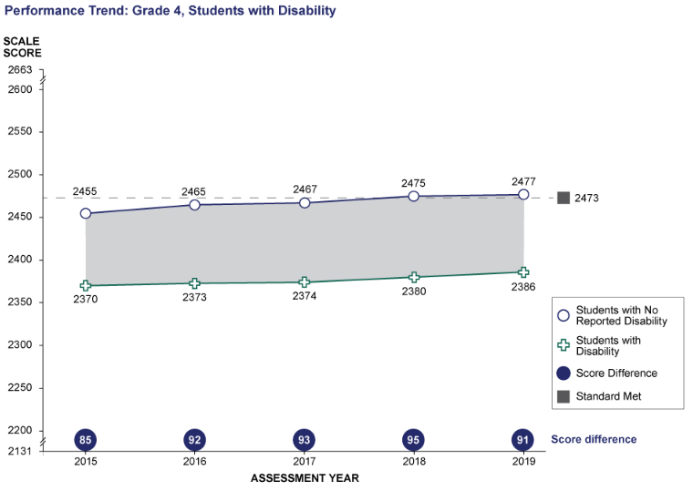
ELA Grade 4: Performance Trend between Students with No Reported Disability and Students with Disability
Student Group | 2015 Scale Score Mean | 2016 Scale Score Mean | 2017 Scale Score Mean | 2018 Scale Score Mean | 2019 Scale Score Mean
Students with No Reported Disability | 2455 | 2465 | 2467 | 2475 | 2477
Students with Disability | 2370 | 2373 | 2374 | 2380 | 2386
Score Difference | 85 | 92 | 93 | 95 | 91

Grade 4 CAASPP ELA/L Performance Trends for Selected Student Groups:
Black or African American and White
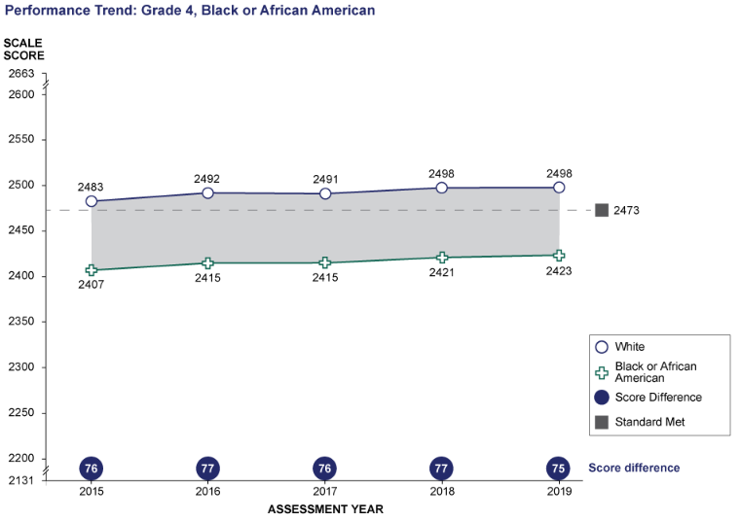
ELA Grade 4: Performance Trend between White and Black or African American
Student Group | 2015 Scale Score Mean | 2016 Scale Score Mean | 2017 Scale Score Mean | 2018 Scale Score Mean | 2019 Scale Score Mean
White | 2483 | 2492 | 2491 | 2498 | 2498
Black or African American | 2407 | 2415 | 2415 | 2421 | 2423
Score Difference | 76 | 77 | 76 | 77 | 75
Grade 4 CAASPP ELA/L Performance Trends for Selected Student Groups:
Hispanic or Latino and White
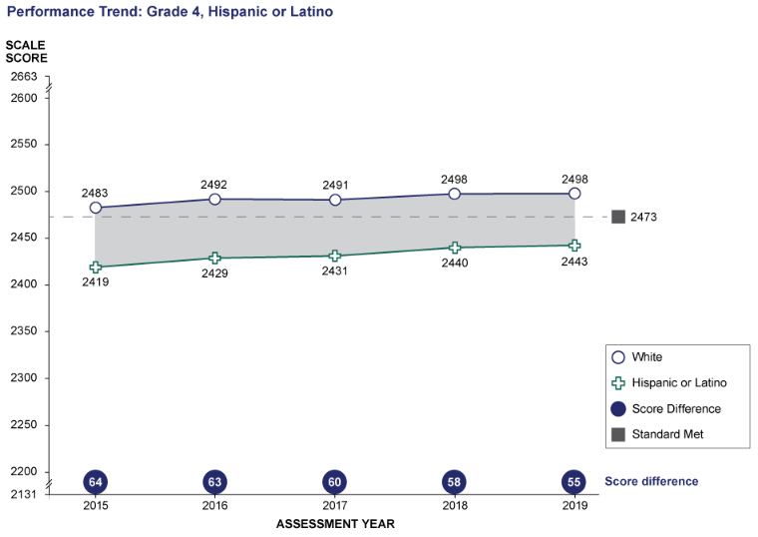
ELA Grade 4: Performance Trend between White and Hispanic or Latino
Student Group | 2015 Scale Score Mean | 2016 Scale Score Mean | 2017 Scale Score Mean | 2018 Scale Score Mean | 2019 Scale Score Mean
White | 2483 | 2492 | 2491 | 2498 | 2498
Hispanic or Latino | 2419 | 2429 | 2431 | 2440 | 2443
Score Difference | 64 | 63 | 60 | 58 | 55

Grade 5 CAASPP ELA/L Performance Trends for Selected Student Groups:
Ever English Learners and English Only
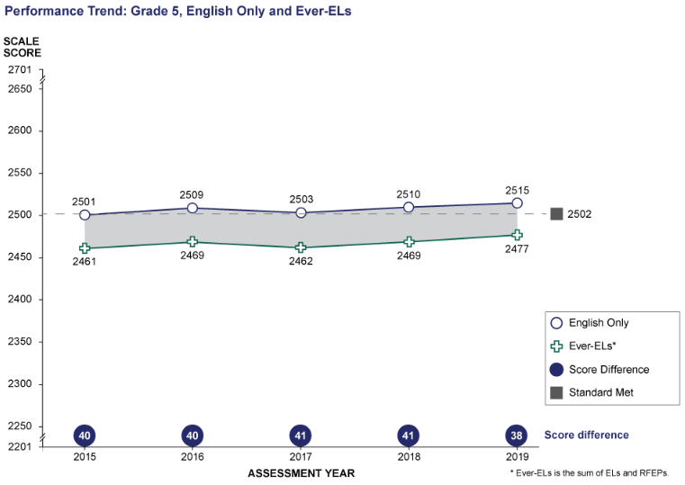
ELA Grade 5: Performance Trend between English Only and Ever-ELs
* Ever-ELs is the sum of ELs and RFEPs
Student Group | 2015 Scale Score Mean | 2016 Scale Score Mean | 2017 Scale Score Mean | 2018 Scale Score Mean | 2019 Scale Score Mean
English Only | 2501 | 2509 | 2503 | 2510 | 2515
Ever-ELs* | 2461 | 2469 | 2462 | 2469 | 2477
Score Difference | 40 | 40 | 41 | 41 | 38

Grade 5 CAASPP ELA/L Performance Trends for Selected Student Groups:
Students with Disabilities and Students with No Reported Disabilities
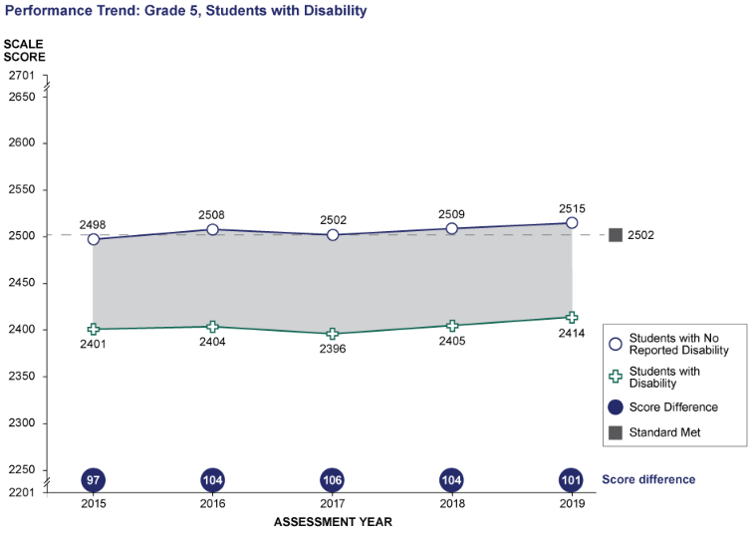
ELA Grade 5: Performance Trend between Students with No Reported Disability and Students with Disability
Student Group | 2015 Scale Score Mean | 2016 Scale Score Mean | 2017 Scale Score Mean | 2018 Scale Score Mean | 2019 Scale Score Mean
Students with No Reported Disability | 2498 | 2508 | 2502 | 2509 | 2515
Students with Disability | 2401 | 2404 | 2396 | 2405 | 2414
Score Difference | 97 | 104 | 106 | 104 | 101

Grade 5 CAASPP ELA/L Performance Trends for Selected Student Groups:
Black or African American and White
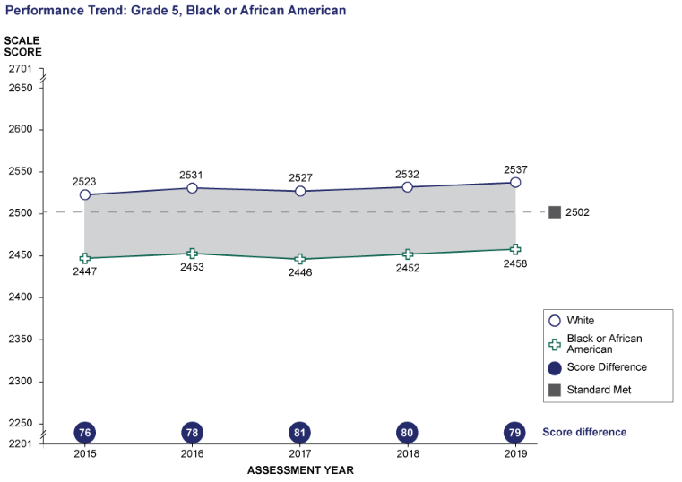
ELA Grade 5: Performance Trend between White and Black or African American
Student Group | 2015 Scale Score Mean | 2016 Scale Score Mean | 2017 Scale Score Mean | 2018 Scale Score Mean | 2019 Scale Score Mean
White | 2523 | 2531 | 2527 | 2532 | 2537
Black or African American | 2447 | 2453 | 2446 | 2452 | 2458
Score Difference | 76 | 78 | 81 | 80 | 79

Grade 5 CAASPP ELA/L Performance Trends for Selected Student Groups:
Hispanic or Latino and White
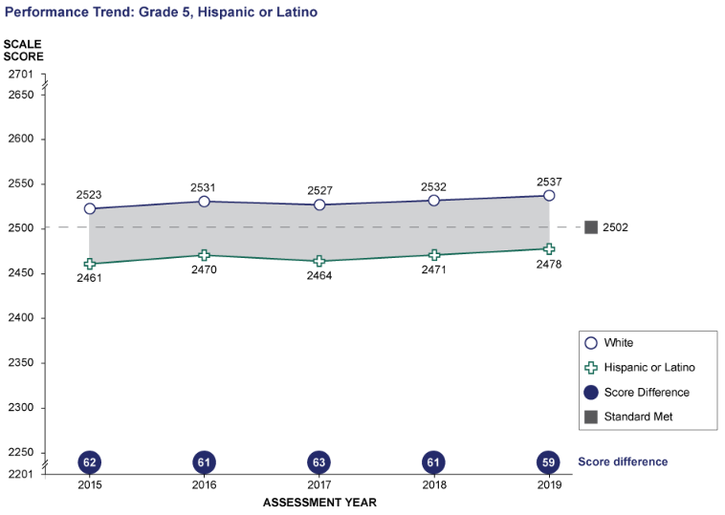
Student Group | 2015 Scale Score Mean | 2016 Scale Score Mean | 2017 Scale Score Mean | 2018 Scale Score Mean | 2019 Scale Score Mean
White | 2523 | 2531 | 2527 | 2532 | 2537
Hispanic or Latino | 2461 | 2470 | 2464 | 2471 | 2478
Score Difference | 62 | 61 | 63 | 61 | 59

Grade 6 CAASPP ELA/L Performance Trends for Selected Student Groups:
Ever English Learners and English Only
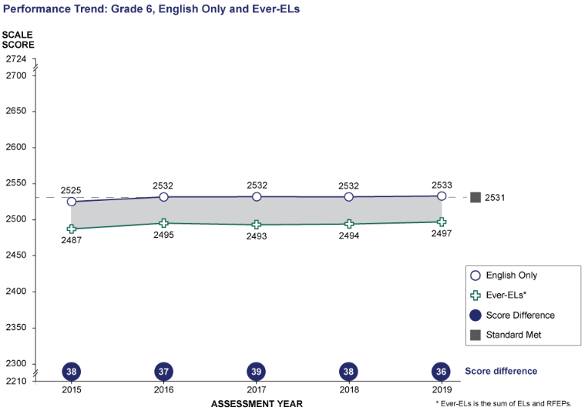
ELA Grade 6 Performance Trend between English Only and Ever-ELs
* Ever-ELs is the sum of ELs and RFEPs
Student Group | 2015 Scale Score Mean | 2016 Scale Score Mean | 2017 Scale Score Mean | 2018 Scale Score Mean | 2019 Scale Score Mean
English Only | 2525 | 2532 | 2532 | 2532 | 2533
Ever-ELs* | 2487 | 2495 | 2493 | 2494 | 2497
Score Difference | 38 | 37 | 39 | 38 | 36

Grade 6 CAASPP ELA/L Performance Trends for Selected Student Groups:
Students with Disabilities and Students with No Reported Disabilities
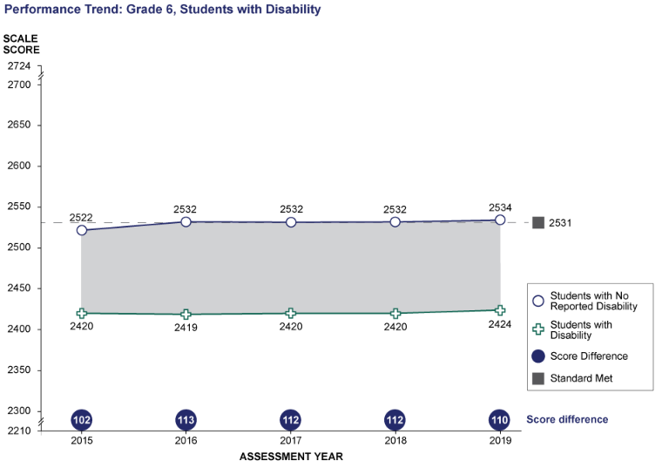
ELA Grade 6: Performance Trend between Students with No Reported Disability and Students with Disability
Student Group | 2015 Scale Score Mean | 2016 Scale Score Mean | 2017 Scale Score Mean | 2018 Scale Score Mean | 2019 Scale Score Mean
Students with No Reported Disability | 2522 | 2532 | 2532 | 2532 | 2534
Students with Disability | 2420 | 2419 | 2420 | 2420 | 2424
Score Difference | 102 | 113 | 112 | 112 | 110
Grade 6 CAASPP ELA/L Performance Trends for Selected Student Groups:
Black or African American and White
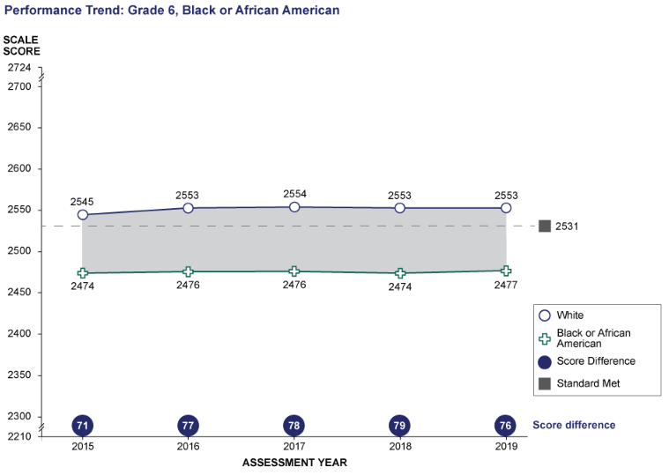
ELA Grade 6: Performance Trend between White and Black or African American
Student Group | 2015 Scale Score Mean | 2016 Scale Score Mean | 2017 Scale Score Mean | 2018 Scale Score Mean | 2019 Scale Score Mean
White | 2545 | 2553 | 2554 | 2553 | 2553
Black or African American | 2474 | 2476 | 2476 | 2474 | 2477
Score Difference | 71 | 77 | 78 | 79 | 76
Grade 6 CAASPP ELA/L Performance Trends for Selected Student Groups:
Hispanic or Latino and White
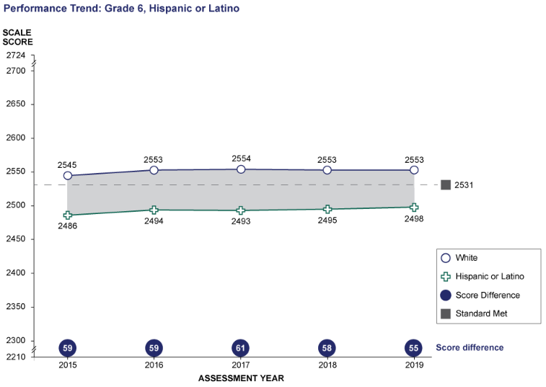
ELA Grade 6: Performance Trend between White and Hispanic or Latino
Student Group | 2015 Scale Score Mean | 2016 Scale Score Mean | 2017 Scale Score Mean | 2018 Scale Score Mean | 2019 Scale Score Mean
White | 2545 | 2553 | 2554 | 2553 | 2553
Hispanic or Latino | 2486 | 2494 | 2493 | 2495 | 2498
Score Difference | 59 | 59 | 61 | 58 | 55

Grade 7 CAASPP ELA/L Performance Trends for Selected Student Groups:
Ever English Learners and English Only
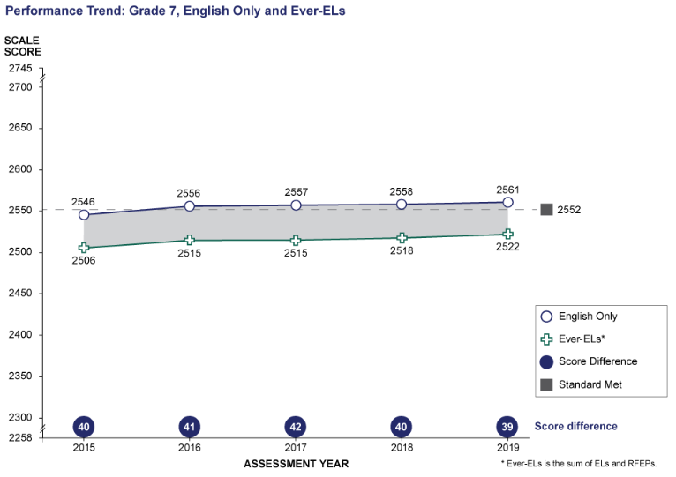
ELA Grade 7: Performance Trend between English Only and Ever-ELs
Student Group | 2015 Scale Score Mean | 2016 Scale Score Mean | 2017 Scale Score Mean | 2018 Scale Score Mean | 2019 Scale Score Mean
English Only | 2546 | 2556 | 2557 | 2558 | 2561
Ever-ELs* | 2506 | 2515 | 2515 | 2518 | 2522
Score Difference | 40 | 41 | 42 | 40 | 39
* Ever-ELs is the sum of ELs and RFEPs

Grade 7 CAASPP ELA/L Performance Trends for Selected Student Groups:
Students with Disabilities and Students with No Reported Disabilities
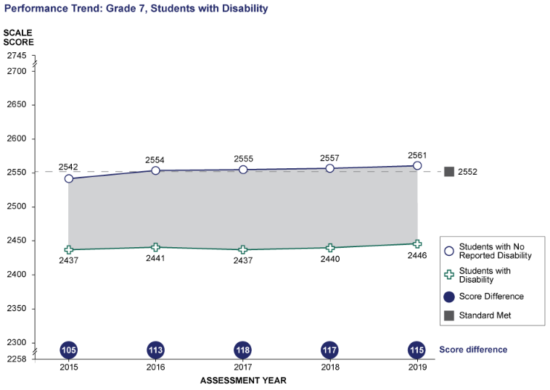
ELA Grade 7: Performance Trend between Students with No Reported Disability and Students with Disability
Student Group | 2015 Scale Score Mean | 2016 Scale Score Mean | 2017 Scale Score Mean | 2018 Scale Score Mean | 2019 Scale Score Mean
Students with No Reported Disability | 2542 | 2554 | 2555 | 2557 | 2561
Students with Disability | 2437 | 2441 | 2437 | 2440 | 2446
Score Difference | 105 | 113 | 118 | 117 | 115

Grade 7 CAASPP ELA/L Performance Trends for Selected Student Groups:
Black or African American and White
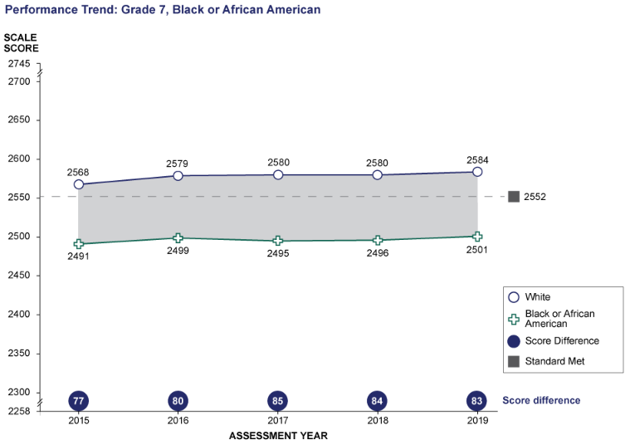
ELA Grade 7: Performance Trend between White and Black or African American
Student Group | 2015 Scale Score Mean | 2016 Scale Score Mean | 2017 Scale Score Mean | 2018 Scale Score Mean | 2019 Scale Score Mean
White | 2568 | 2579 | 2580 | 2580 | 2584
Black or African American | 2491 | 2499 | 2495 | 2496 | 2501
Score Difference | 77 | 80 | 85 | 84 | 83

Grade 7 CAASPP ELA/L Performance Trends for Selected Student Groups:
Hispanic or Latino and White
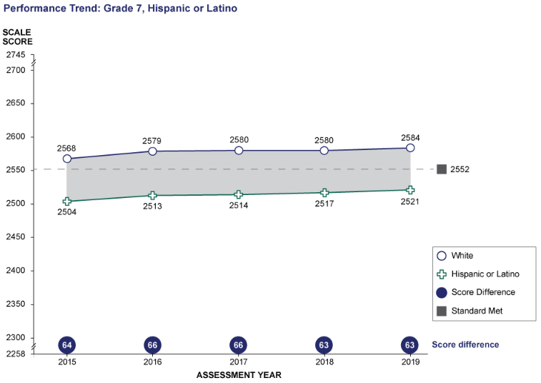
ELA Grade 7: Performance Trend between White and Hispanic or Latino
Student Group | 2015 Scale Score Mean | 2016 Scale Score Mean | 2017 Scale Score Mean | 2018 Scale Score Mean | 2019 Scale Score Mean
White | 2568 | 2579 | 2580 | 2580 | 2584
Hispanic or Latino | 2504 | 2513 | 2514 | 2517 | 2521
Score Difference | 64 | 66 | 66 | 63 | 63

Grade 8 CAASPP ELA/L Performance Trends for Selected Student Groups:
Ever English Learners and English Only
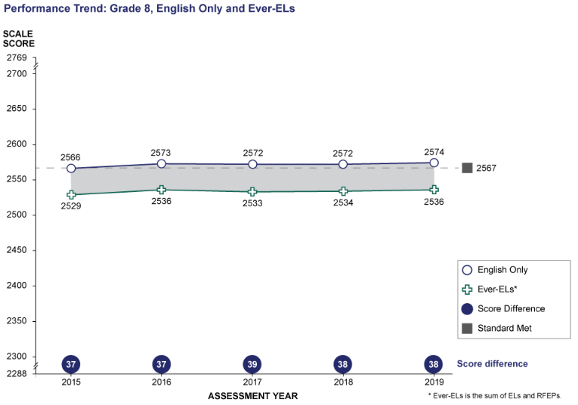

ELA Grade 8: Performance Trend between English Only and Ever-ELs
* Ever-ELs is the sum of ELs and RFEPs
Student Group | 2015 Scale Score Mean | 2016 Scale Score Mean | 2017 Scale Score Mean | 2018 Scale Score Mean | 2019 Scale Score Mean
English Only | 2566 | 2573 | 2572 | 2572 | 2574
Ever-ELs* | 2529 | 2536 | 2533 | 2534 | 2536
Score Difference | 37 | 37 | 39 | 38 | 38

Grade 8 CAASPP ELA/L Performance Trends for Selected Student Groups:
Students with Disabilities and Students with No Reported Disabilities
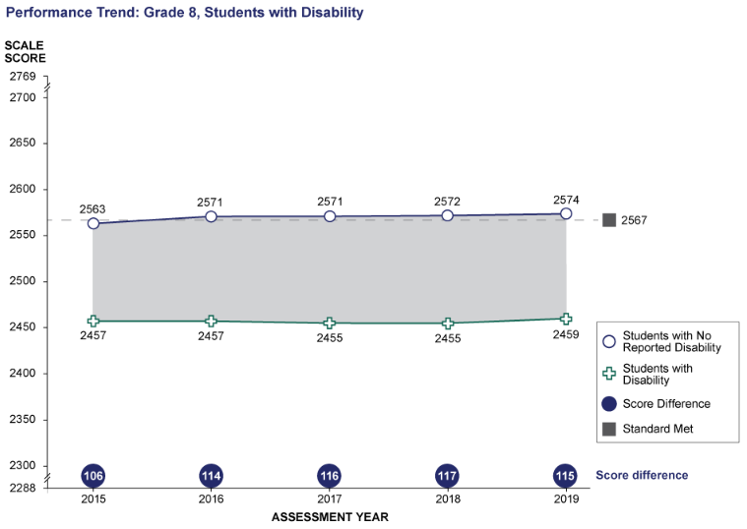
ELA Grade 8: Performance Trend between Students with No Reported Disability and Students with Disability
Student Group | 2015 Scale Score Mean | 2016 Scale Score Mean | 2017 Scale Score Mean | 2018 Scale Score Mean | 2019 Scale Score Mean
Students with No Reported Disability | 2563 | 2571 | 2571 | 2572 | 2574
Students with Disability | 2457 | 2457 | 2455 | 2455 | 2459
Score Difference | 106 | 114 | 116 | 117 | 115

Grade 8 CAASPP ELA/L Performance Trends for Selected Student Groups:
Black or African American and White
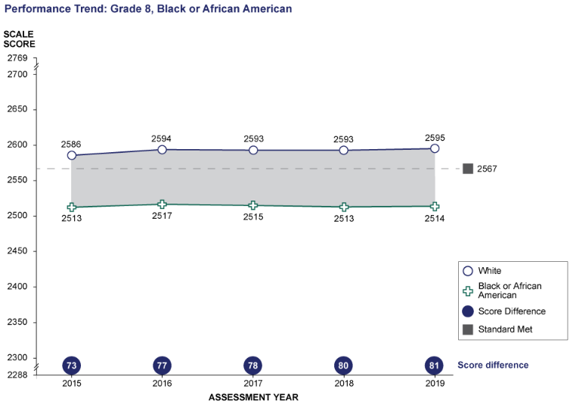
ELA Grade 8: Performance Trend between White and Black or African American
Student Group | 2015 Scale Score Mean | 2016 Scale Score Mean | 2017 Scale Score Mean | 2018 Scale Score Mean | 2019 Scale Score Mean
White | 2586 | 2594 | 2593 | 2593 | 2595
Black or African American | 2513 | 2517 | 2515 | 2513 | 2514
Score Difference | 73 | 77 | 78 | 80 | 81

Grade 8 CAASPP ELA/L Performance Trends for Selected Student Groups:
Hispanic or Latino and White
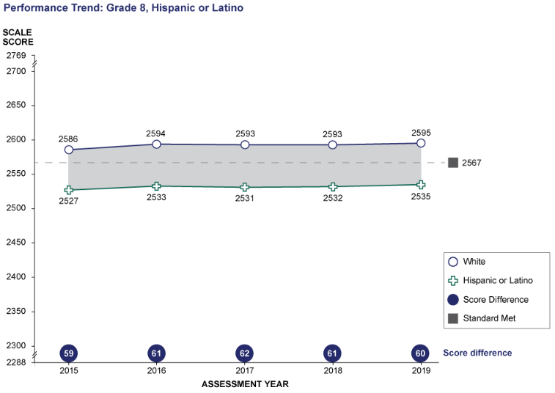
ELA Grade 8: Performance Trend between White and Hispanic or Latino
Student Group | 2015 Scale Score Mean | 2016 Scale Score Mean | 2017 Scale Score Mean | 2018 Scale Score Mean | 2019 Scale Score Mean
White | 2586 | 2594 | 2593 | 2593 | 2595
Hispanic or Latino | 2527 | 2533 | 2531 | 2532 | 2535
Score Difference | 59 | 61 | 62 | 61 | 60

Grade 11 CAASPP ELA/L Performance Trends for Selected Student Groups:
Ever English Learners and English Only
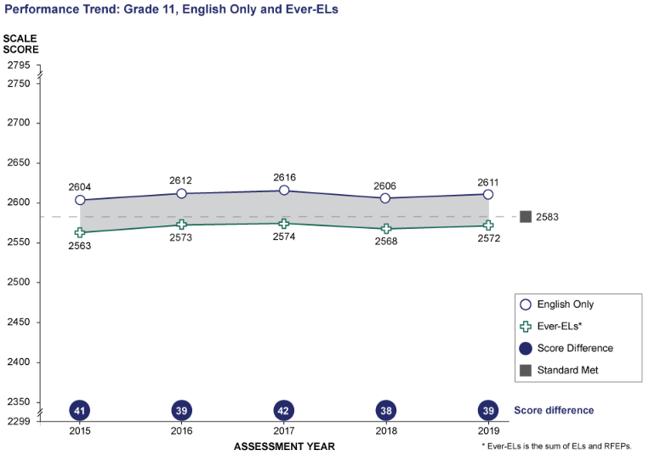
ELA Grade 11: Performance Trend between English Only and Ever-ELs
* Ever-ELs is the sum of ELs and RFEPs
Student Group | 2015 Scale Score Mean | 2016 Scale Score Mean | 2017 Scale Score Mean | 2018 Scale Score Mean | 2019 Scale Score Mean
English Only | 2604 | 2612 | 2616 | 2606 | 2611
Ever-ELs* | 2563 | 2573 | 2574 | 2568 | 2572
Score Difference | 41 | 39 | 42 | 38 | 39

Grade 11 CAASPP ELA/L Performance Trends for Selected Student Groups:
Students with Disabilities and Students with No Reported Disabilities
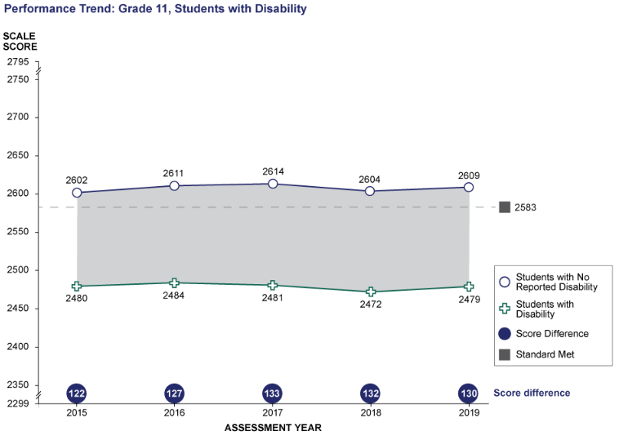
ELA Grade 11: Performance Trend between Students with No Reported Disability and Students with Disability
Student Group | 2015 Scale Score Mean | 2016 Scale Score Mean | 2017 Scale Score Mean | 2018 Scale Score Mean | 2019 Scale Score Mean
Students with No Reported Disability | 2602 | 2611 | 2614 | 2604 | 2609
Students with Disability | 2480 | 2484 | 2481 | 2472 | 2479
Score Difference | 122 | 127 | 133 | 132 | 130

Grade 11 CAASPP ELA/L Performance Trends for Selected Student Groups:
Black or African American and White
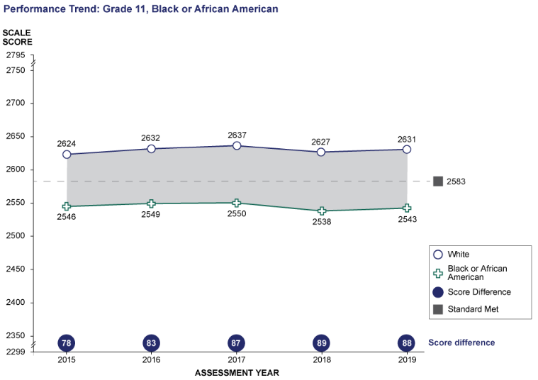
ELA Grade 11: Performance Trend between White and Black or African American
Student Group | 2015 Scale Score Mean | 2016 Scale Score Mean | 2017 Scale Score Mean | 2018 Scale Score Mean | 2019 Scale Score Mean
White | 2624 | 2632 | 2637 | 2627 | 2631
Black or African American | 2546 | 2549 | 2550 | 2538 | 2543
Score Difference | 78 | 83 | 87 | 89 | 88

Grade 11 CAASPP ELA/L Performance Trends for Selected Student Groups:
Hispanic or Latino and White
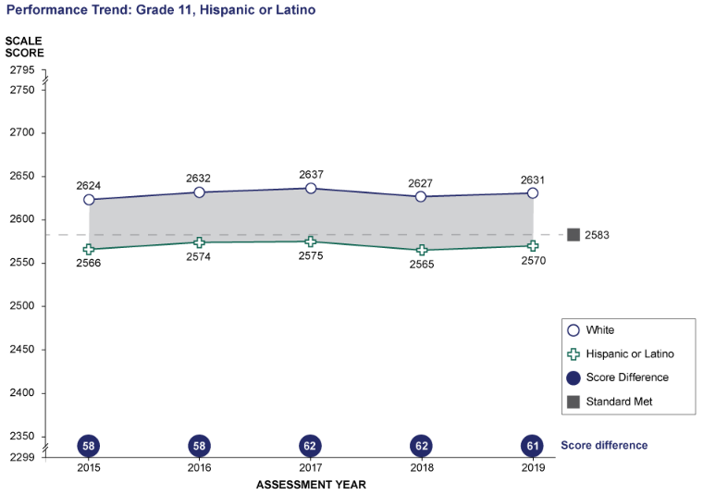
ELA Grade 11: Performance Trend between White and Hispanic or Latino
Student Group | 2015 Scale Score Mean | 2016 Scale Score Mean | 2017 Scale Score Mean | 2018 Scale Score Mean | 2019 Scale Score Mean
White | 2624 | 2632 | 2637 | 2627 | 2631
Hispanic or Latino | 2566 | 2574 | 2575 | 2565 | 2570
Score Difference | 58 | 58 | 62 | 62 | 61

Grade 3 CAASPP Mathematics Performance Trends for Selected Student Groups:
Ever English Learners and English Only
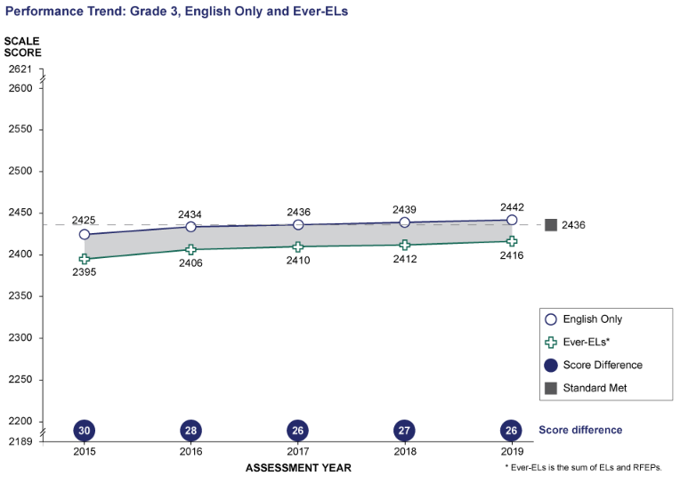

Math Grade 3: Performance Trend between English Only and Ever-ELs
* Ever-ELs is the sum of ELs and RFEPs
Student Group | 2015 Scale Score Mean | 2016 Scale Score Mean | 2017 Scale Score Mean | 2018 Scale Score Mean | 2019 Scale Score Mean
English Only | 2425 | 2434 | 2436 | 2439 | 2442
Ever-ELs* | 2395 | 2406 | 2410 | 2412 | 2416
Score Difference | 30 | 28 | 26 | 27 | 26

Grade 3 CAASPP Mathematics Performance Trends for Selected Student Groups:
Students with Disabilities and Students with No Reported Disabilities
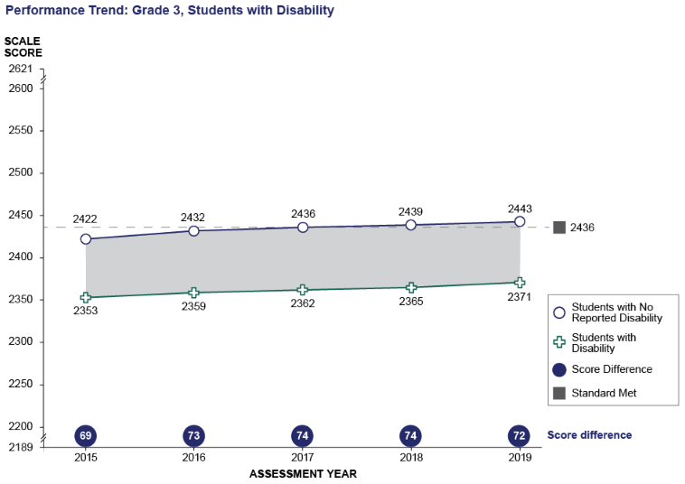
ELA Grade 3: Performance Trend between Students with No Reported Disability and Students with Disability
Student Group | 2015 Scale Score Mean | 2016 Scale Score Mean | 2017 Scale Score Mean | 2018 Scale Score Mean | 2019 Scale Score Mean
Students with No Reported Disability | 2422 | 2432 | 2436 | 2439 | 2443
Students with Disability | 2353 | 2359 | 2362 | 2365 | 2371
Score Difference | 69 | 73 | 74 | 74 | 72

Grade 3 CAASPP Mathematics Performance Trends for Selected Student Groups:
Black or African American and White
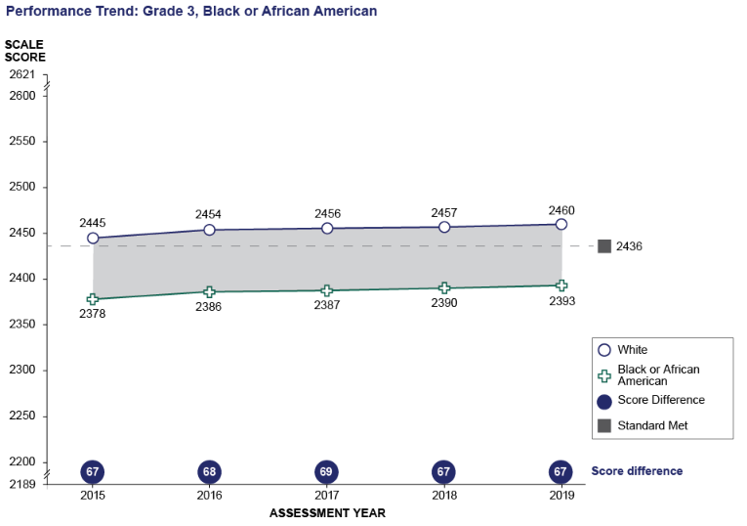

ELA Grade 3: Performance Trend between White and Black or African American
Student Group | 2015 Scale Score Mean | 2016 Scale Score Mean | 2017 Scale Score Mean | 2018 Scale Score Mean | 2019 Scale Score Mean
White | 2445 | 2454 | 2456 | 2457 | 2460
Black or African American | 2378 | 2386 | 2387 | 2390 | 2393
Score Difference | 67 | 68 | 69 | 67 | 67

Grade 3 CAASPP Mathematics Performance Trends for Selected Student Groups:
Hispanic or Latino and White
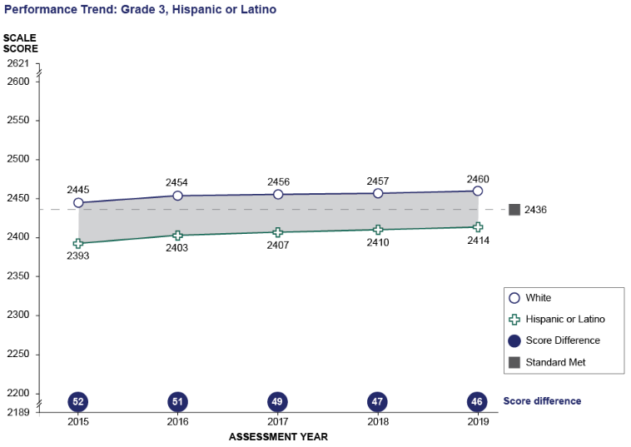
ELA Grade 3: Performance Trend between White and Hispanic or Latino
Student Group | 2015 Scale Score Mean | 2016 Scale Score Mean | 2017 Scale Score Mean | 2018 Scale Score Mean | 2019 Scale Score Mean
White | 2445 | 2454 | 2456 | 2457 | 2460
Hispanic or Latino | 2393 | 2403 | 2407 | 2410 | 2414
Score Difference | 52 | 51 | 49 | 47 | 46

Grade 4 CAASPP Mathematics Performance Trends for Selected Student Groups:
Ever English Learners and English Only
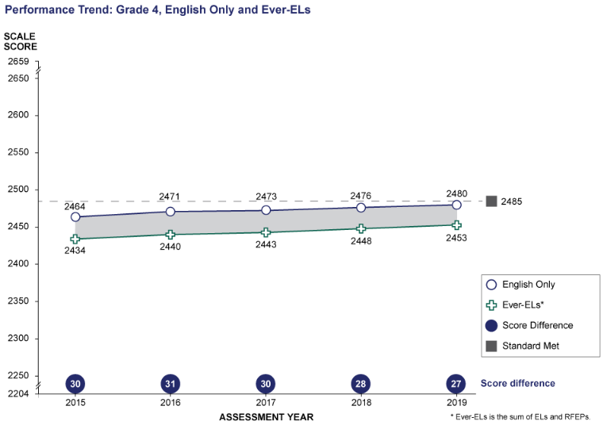
Math Grade 4: Performance Trend between English Only and Ever-ELs
* Ever-ELs is the sum of ELs and RFEPs
Student Group | 2015 Scale Score Mean | 2016 Scale Score Mean | 2017 Scale Score Mean | 2018 Scale Score Mean | 2019 Scale Score Mean
English Only | 2464 | 2471 | 2473 | 2476 | 2480
Ever-ELs* | 2434 | 2440 | 2443 | 2448 | 2453
Score Difference | 30 | 31 | 30 | 28 | 27

Grade 4 CAASPP Mathematics Performance Trends for Selected Student Groups:
Students with Disabilities and Students with No Reported Disabilities
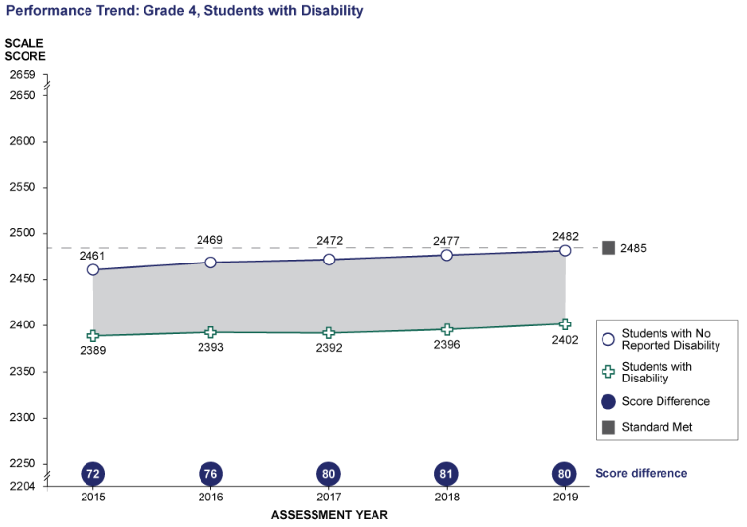
Math Grade 4: Performance Trend between Students with No Reported Disability and Students with Disability
Student Group | 2015 Scale Score Mean | 2016 Scale Score Mean | 2017 Scale Score Mean | 2018 Scale Score Mean | 2019 Scale Score Mean
Students with No Reported Disability | 2461 | 2469 | 2472 | 2477 | 2482
Students with Disability | 2389 | 2393 | 2392 | 2396 | 2402
Score Difference | 72 | 76 | 80 | 81 | 80

Grade 4 CAASPP Mathematics Performance Trends for Selected Student Groups:
Black or African American and White
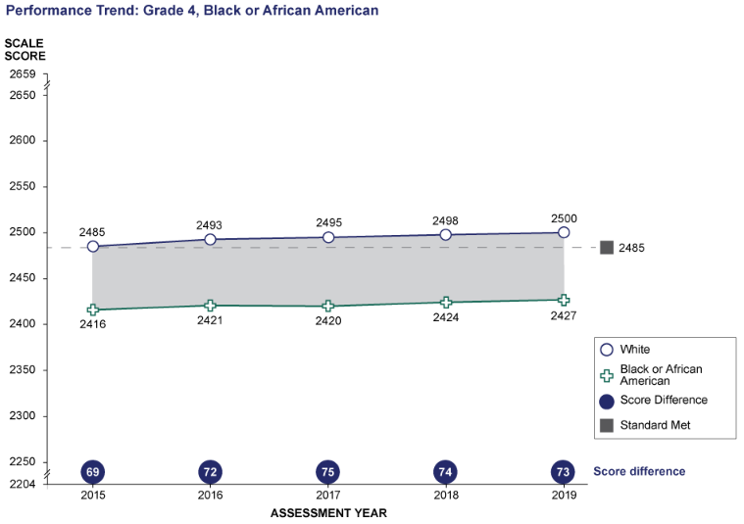
Math Grade 4: Performance Trend between White and Black or African American
Student Group | 2015 Scale Score Mean | 2016 Scale Score Mean | 2017 Scale Score Mean | 2018 Scale Score Mean | 2019 Scale Score Mean
White | 2485 | 2493 | 2495 | 2498 | 2500
Black or African American | 2416 | 2421 | 2420 | 2424 | 2427
Score Difference | 69 | 72 | 75 | 74 | 73

Grade 4 CAASPP Mathematics Performance Trends for Selected Student Groups:
Hispanic or Latino and White
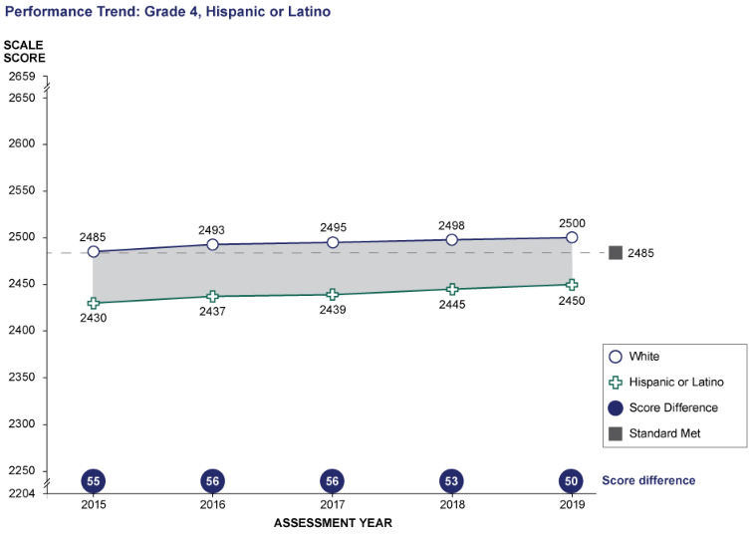
Math Grade 4: Performance Trend between White and Hispanic or Latino
Student Group | 2015 Scale Score Mean | 2016 Scale Score Mean | 2017 Scale Score Mean | 2018 Scale Score Mean | 2019 Scale Score Mean
White | 2485 | 2493 | 2495 | 2498 | 2500
Hispanic or Latino | 2430 | 2437 | 2439 | 2445 | 2450
Score Difference | 55 | 56 | 56 | 53 | 50

Grade 5 CAASPP Mathematics Performance Trends for Selected Student Groups:
Ever English Learners and English Only
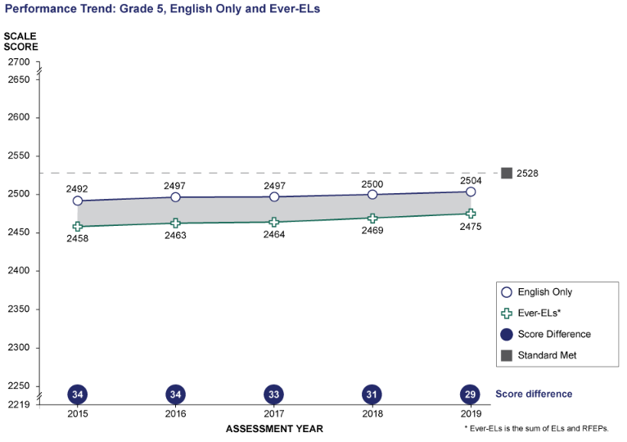
Math Grade 5: Performance Trend between English Only and Ever-ELs
* Ever-ELs is the sum of ELs and RFEPs
Student Group | 2015 Scale Score Mean | 2016 Scale Score Mean | 2017 Scale Score Mean | 2018 Scale Score Mean | 2019 Scale Score Mean
English Only | 2492 | 2497 | 2497 | 2500 | 2504
Ever-ELs* | 2458 | 2463 | 2464 | 2469 | 2475
Score Difference | 34 | 34 | 33 | 31 | 29

Grade 5 CAASPP Mathematics Performance Trends for Selected Student Groups:
Students with Disabilities and Students with No Reported Disabilities
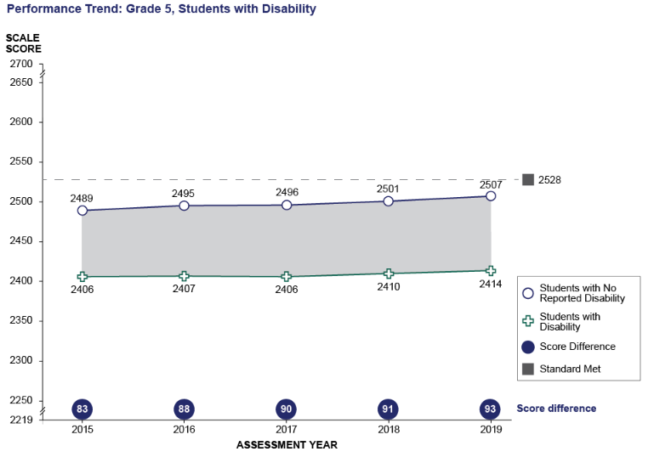
Math Grade 5: Performance Trend between Students with No Reported Disability and Students with Disability
Student Group | 2015 Scale Score Mean | 2016 Scale Score Mean | 2017 Scale Score Mean | 2018 Scale Score Mean | 2019 Scale Score Mean
Students with No Reported Disability | 2489 | 2495 | 2496 | 2501 | 2507
Students with Disability | 2406 | 2407 | 2406 | 2410 | 2414
Score Difference | 83 | 88 | 90 | 91 | 93

Grade 5 CAASPP Mathematics Performance Trends for Selected Student Groups:
Black or African American and White
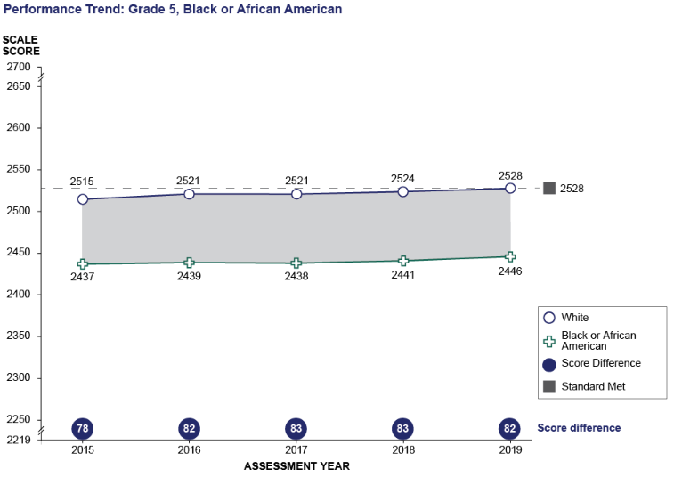
Math Grade 5: Performance Trend between White and Black or African American
Student Group | 2015 Scale Score Mean | 2016 Scale Score Mean | 2017 Scale Score Mean | 2018 Scale Score Mean | 2019 Scale Score Mean
White | 2515 | 2521 | 2521 | 2524 | 2528
Black or African American | 2437 | 2439 | 2438 | 2441 | 2446
Score Difference | 78 | 82 | 83 | 83 | 82

Grade 5 CAASPP Mathematics Performance Trends for Selected Student Groups:
Hispanic or Latino and White
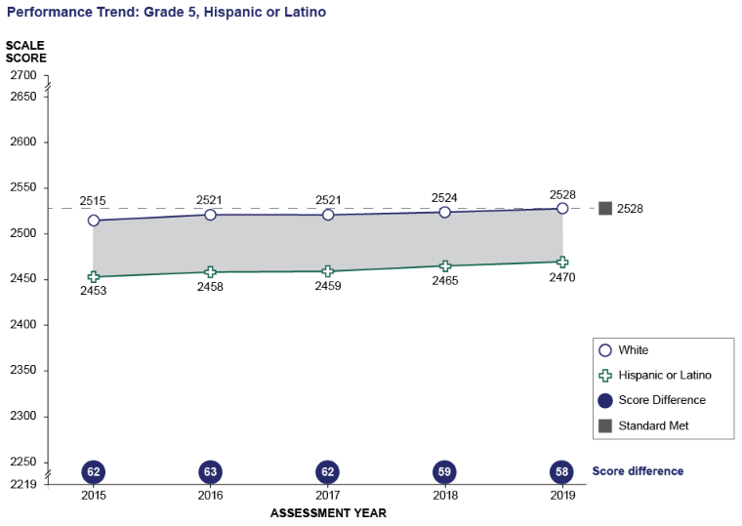
Math Grade 5: Performance Trend between White and Hispanic or Latino
Student Group | 2015 Scale Score Mean | 2016 Scale Score Mean | 2017 Scale Score Mean | 2018 Scale Score Mean | 2019 Scale Score Mean
White | 2515 | 2521 | 2521 | 2524 | 2528
Hispanic or Latino | 2453 | 2458 | 2459 | 2465 | 2470
Score Difference | 62 | 63 | 62 | 59 | 58

Grade 6 CAASPP Mathematics Performance Trends for Selected Student Groups:
Ever English Learners and English Only
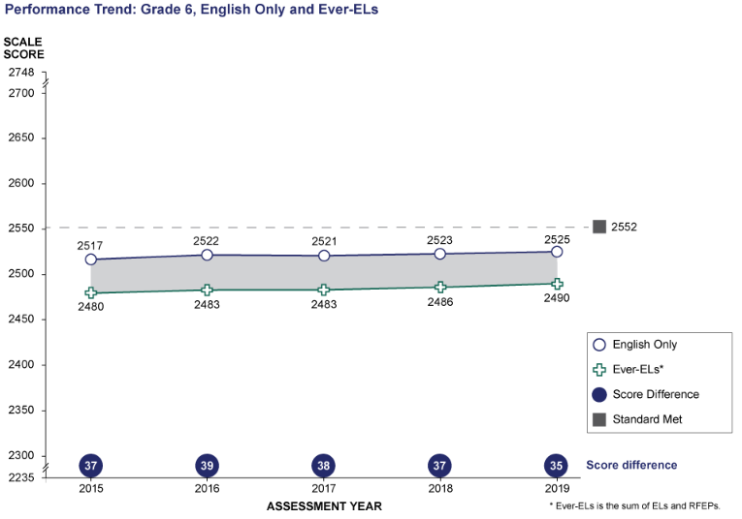
Math Grade 6: Performance Trend between English Only and Ever-ELs
* Ever-ELs is the sum of ELs and RFEPs
Student Group | 2015 Scale Score Mean | 2016 Scale Score Mean | 2017 Scale Score Mean | 2018 Scale Score Mean | 2019 Scale Score Mean
English Only | 2517 | 2522 | 2521 | 2523 | 2525
Ever-ELs* | 2480 | 2483 | 2483 | 2486 | 2490
Score Difference | 37 | 39 | 38 | 37 | 35

Grade 6 CAASPP Mathematics Performance Trends for Selected Student Groups:
Students with Disabilities and Students with No Reported Disabilities
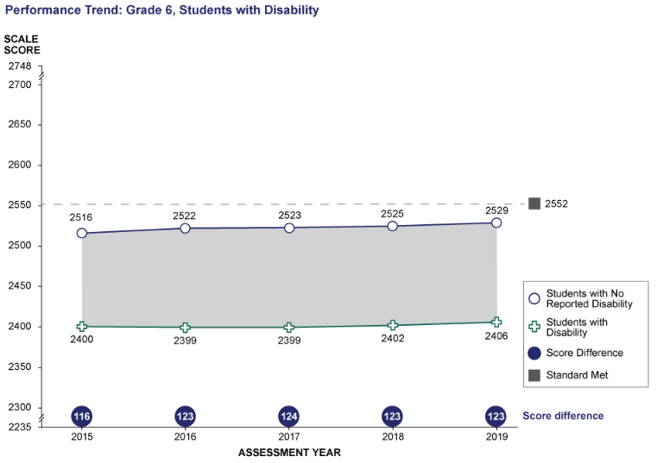
Math Grade 6: Performance Trend between Students with No Reported Disability and Students with Disability
Student Group | 2015 Scale Score Mean | 2016 Scale Score Mean | 2017 Scale Score Mean | 2018 Scale Score Mean | 2019 Scale Score Mean
Students with No Reported Disability | 2516 | 2522 | 2523 | 2525 | 2529
Students with Disability | 2400 | 2399 | 2399 | 2402 | 2406
Score Difference | 116 | 123 | 124 | 123 | 123

Grade 6 CAASPP Mathematics Performance Trends for Selected Student Groups:
Black or African American and White
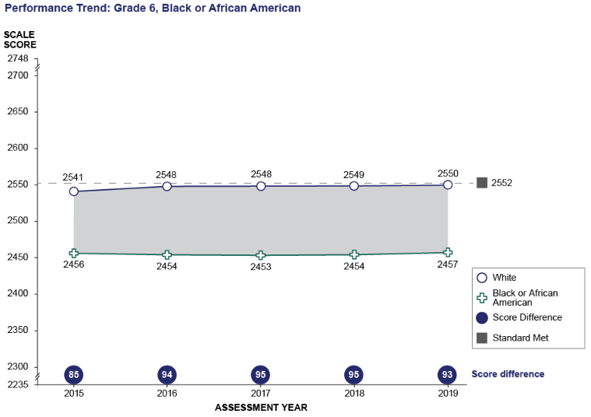
Math Grade 6: Performance Trend between White and Black or African American
Student Group | 2015 Scale Score Mean | 2016 Scale Score Mean | 2017 Scale Score Mean | 2018 Scale Score Mean | 2019 Scale Score Mean
White | 2541 | 2548 | 2548 | 2549 | 2550
Black or African American | 2456 | 2454 | 2453 | 2454 | 2457
Score Difference | 85 | 94 | 95 | 95 | 93

Grade 6 CAASPP Mathematics Performance Trends for Selected Student Groups:
Hispanic or Latino and White
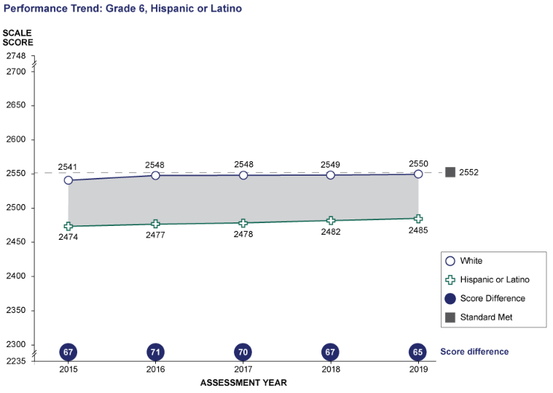
Math Grade 6: Performance Trend between White and Hispanic or Latino
Student Group | 2015 Scale Score Mean | 2016 Scale Score Mean | 2017 Scale Score Mean | 2018 Scale Score Mean | 2019 Scale Score Mean
White | 2541 | 2548 | 2548 | 2549 | 2550
Hispanic or Latino | 2474 | 2477 | 2478 | 2482 | 2485
Score Difference | 67 | 71 | 70 | 67 | 65

Grade 7 CAASPP Mathematics Performance Trends for Selected Student Groups:
Ever English Learners and English Only
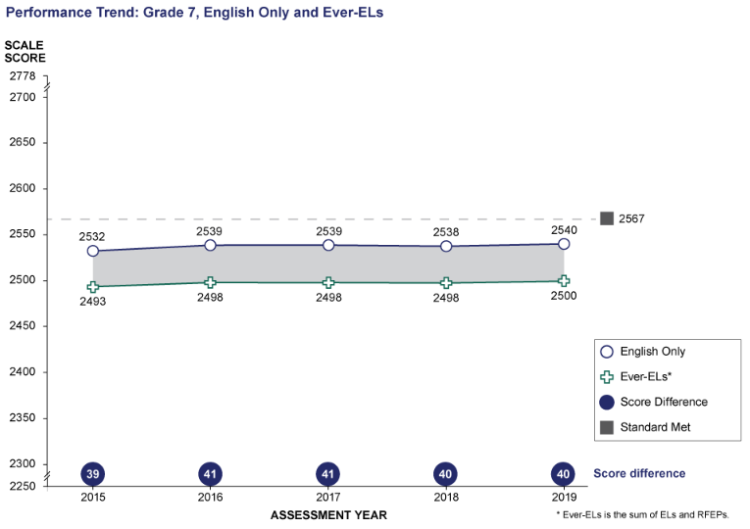

Math Grade 7: Performance Trend between English Only and Ever-ELs
* Ever-ELs is the sum of ELs and RFEPs
Student Group | 2015 Scale Score Mean | 2016 Scale Score Mean | 2017 Scale Score Mean | 2018 Scale Score Mean | 2019 Scale Score Mean
English Only | 2532 | 2539 | 2539 | 2538 | 2540
Ever-ELs* | 2493 | 2498 | 2498 | 2498 | 2500
Score Difference | 39 | 41 | 41 | 40 | 40

Grade 7 CAASPP Mathematics Performance Trends for Selected Student Groups:
Students with Disabilities and Students with No Reported Disabilities
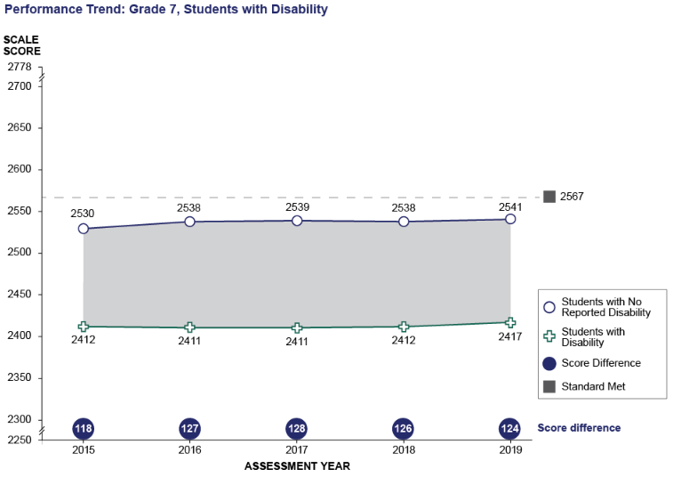
Math Grade 7: Performance Trend between Students with No Reported Disability and Students with Disability
Student Group | 2015 Scale Score Mean | 2016 Scale Score Mean | 2017 Scale Score Mean | 2018 Scale Score Mean | 2019 Scale Score Mean
Students with No Reported Disability | 2530 | 2538 | 2539 | 2538 | 2541
Students with Disability | 2412 | 2411 | 2411 | 2412 | 2417
Score Difference | 118 | 127 | 128 | 126 | 124

Grade 7 CAASPP Mathematics Performance Trends for Selected Student Groups:
Black or African American and White
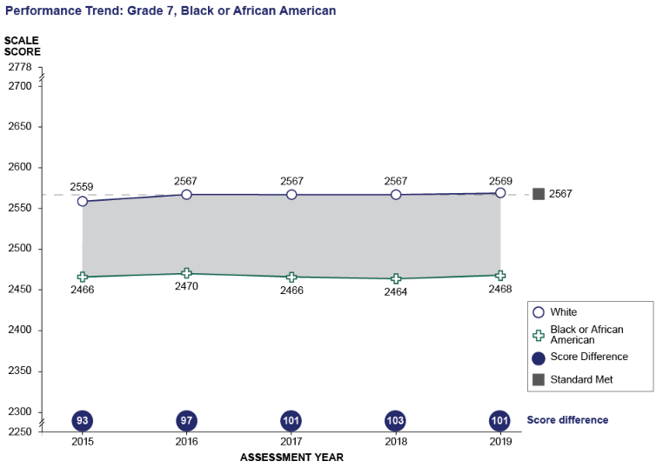
Math Grade 7: Performance Trend between White and Black or African American
Student Group | 2015 Scale Score Mean | 2016 Scale Score Mean | 2017 Scale Score Mean | 2018 Scale Score Mean | 2019 Scale Score Mean
White | 2559 | 2567 | 2567 | 2567 | 2569
Black or African American | 2466 | 2470 | 2466 | 2464 | 2468
Score Difference | 93 | 97 | 101 | 103 | 101

Grade 7 CAASPP Mathematics Performance Trends for Selected Student Groups:
Hispanic or Latino and White
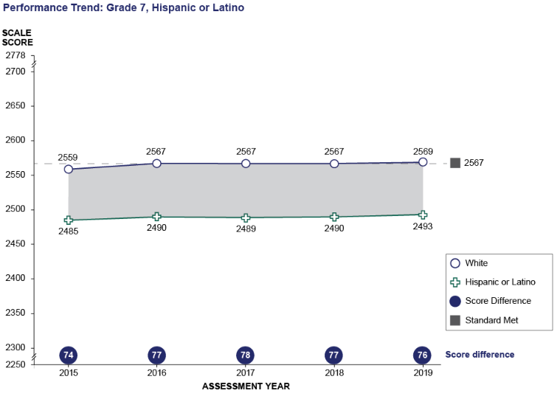
Math Grade 7: Performance Trend between White and Hispanic or Latino
Student Group | 2015 Scale Score Mean | 2016 Scale Score Mean | 2017 Scale Score Mean | 2018 Scale Score Mean | 2019 Scale Score Mean
White | 2559 | 2567 | 2567 | 2567 | 2569
Hispanic or Latino | 2485 | 2490 | 2489 | 2490 | 2493
Score Difference | 74 | 77 | 78 | 77 | 76

Grade 8 CAASPP Mathematics Performance Trends for Selected Student Groups:
Ever English Learners and English Only
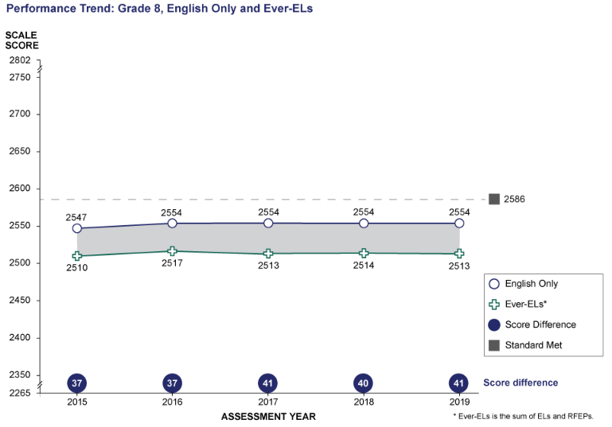
Math Grade 8: Performance Trend between English Only and Ever-ELs
* Ever-ELs is the sum of ELs and RFEPs
Student Group | 2015 Scale Score Mean | 2016 Scale Score Mean | 2017 Scale Score Mean | 2018 Scale Score Mean | 2019 Scale Score Mean
English Only | 2547 | 2554 | 2554 | 2554 | 2554
Ever-ELs* | 2510 | 2517 | 2513 | 2514 | 2513
Score Difference | 37 | 37 | 41 | 40 | 41

Grade 8 CAASPP Mathematics Performance Trends for Selected Student Groups:
Students with Disabilities and Students with No Reported Disabilities
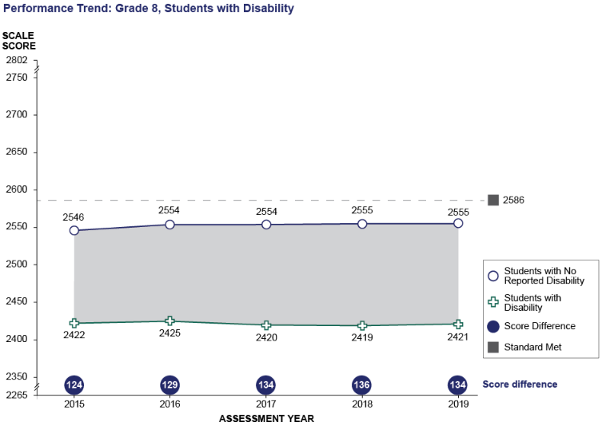
Math Grade 8: Performance Trend between Students with No Reported Disability and Students with Disability
Student Group | 2015 Scale Score Mean | 2016 Scale Score Mean | 2017 Scale Score Mean | 2018 Scale Score Mean | 2019 Scale Score Mean
Students with No Reported Disability | 2546 | 2554 | 2554 | 2555 | 2555
Students with Disability | 2422 | 2425 | 2420 | 2419 | 2421
Score Difference | 124 | 129 | 134 | 136 | 134

Grade 8 CAASPP Mathematics Performance Trends for Selected Student Groups:
Black or African American and White
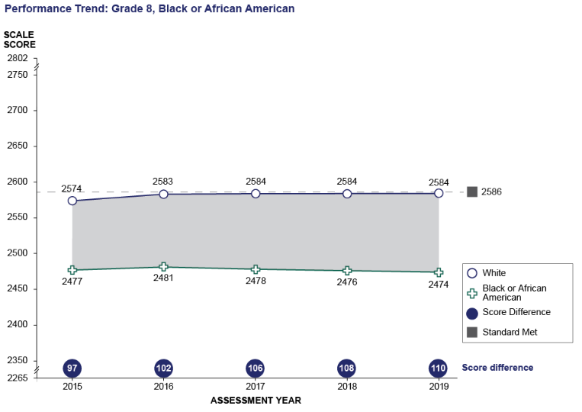
Math Grade 8: Performance Trend between White and Black or African American
Student Group | 2015 Scale Score Mean | 2016 Scale Score Mean | 2017 Scale Score Mean | 2018 Scale Score Mean | 2019 Scale Score Mean
White | 2574 | 2583 | 2584 | 2584 | 2584
Black or African American | 2477 | 2481 | 2478 | 2476 | 2474
Score Difference | 97 | 102 | 106 | 108 | 110

Grade 8 CAASPP Mathematics Performance Trends for Selected Student Groups:
Hispanic or Latino and White
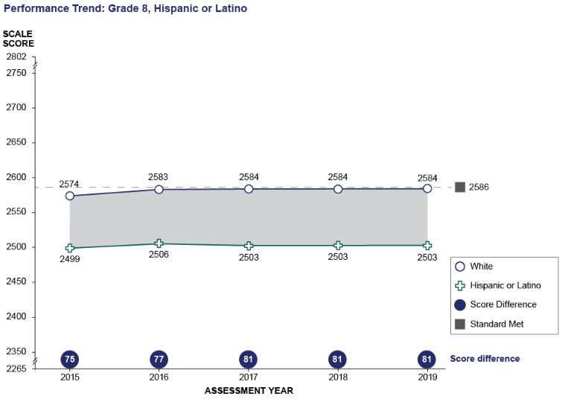
Math Grade 8: Performance Trend between White and Hispanic or Latino
Student Group | 2015 Scale Score Mean | 2016 Scale Score Mean | 2017 Scale Score Mean | 2018 Scale Score Mean | 2019 Scale Score Mean
White | 2574 | 2583 | 2584 | 2584 | 2584
Hispanic or Latino | 2499 | 2506 | 2503 | 2503 | 2503
Score Difference | 75 | 77 | 81 | 81 | 81

Grade 11 CAASPP Mathematics Performance Trends for Selected Student Groups:
Ever English Learners and English Only
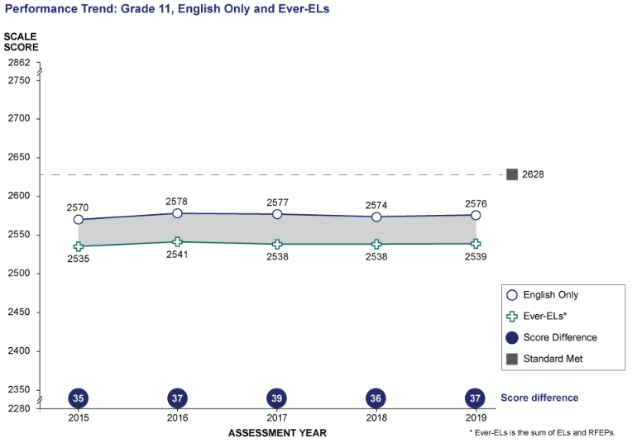
Math Grade 11: Performance Trend between English Only and Ever-ELs
* Ever-ELs is the sum of ELs and RFEPs
Student Group | 2015 Scale Score Mean | 2016 Scale Score Mean | 2017 Scale Score Mean | 2018 Scale Score Mean | 2019 Scale Score Mean
English Only | 2570 | 2578 | 2577 | 2574 | 2576
Ever-ELs* | 2535 | 2541 | 2538 | 2538 | 2539
Score Difference | 35 | 37 | 39 | 36 | 37

Grade 11 CAASPP Mathematics Performance Trends for Selected Student Groups:
Students with Disabilities and Students with No Reported Disabilities
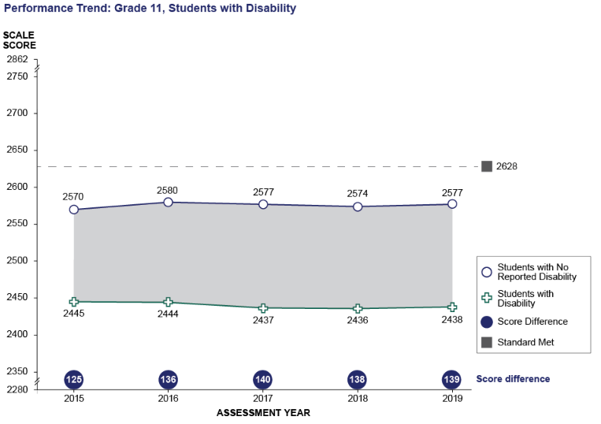
Math Grade 11: Performance Trend between Students with No Reported Disability and Students with Disability
Student Group | 2015 Scale Score Mean | 2016 Scale Score Mean | 2017 Scale Score Mean | 2018 Scale Score Mean | 2019 Scale Score Mean
Students with No Reported Disability | 2570 | 2580 | 2577 | 2574 | 2577
Students with Disability | 2445 | 2444 | 2437 | 2436 | 2438
Score Difference | 125 | 136 | 140 | 138 | 139

Grade 11 CAASPP Mathematics Performance Trends for Selected Student Groups:
Black or African American and White
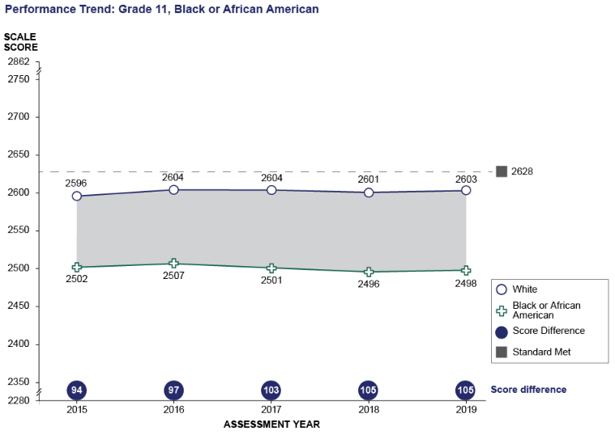
Math Grade 11: Performance Trend between White and Black or African American
Student Group | 2015 Scale Score Mean | 2016 Scale Score Mean | 2017 Scale Score Mean | 2018 Scale Score Mean | 2019 Scale Score Mean
White | 2596 | 2604 | 2604 | 2601 | 2603
Black or African American | 2502 | 2507 | 2501 | 2496 | 2498
Score Difference | 94 | 97 | 103 | 105 | 105

Grade 11 CAASPP Mathematics Performance Trends for Selected Student Groups:
Hispanic or Latino and White
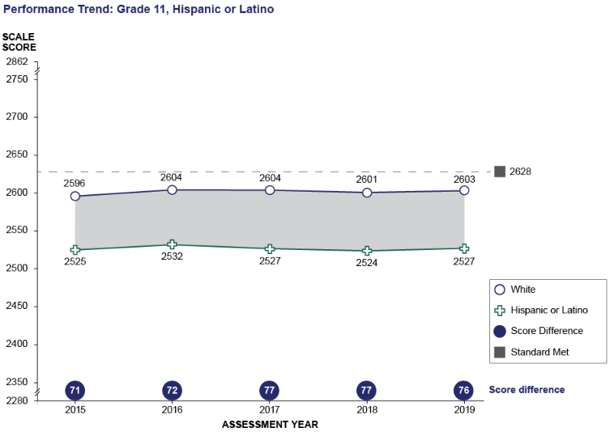
Math Grade 11: Performance Trend between White and Hispanic or Latino
Student Group | 2015 Scale Score Mean | 2016 Scale Score Mean | 2017 Scale Score Mean | 2018 Scale Score Mean | 2019 Scale Score Mean
White | 2596 | 2604 | 2604 | 2601 | 2603
Hispanic or Latino | 2525 | 2532 | 2527 | 2524 | 2527
Score Difference | 71 | 72 | 77 | 77 | 76

