

CCSS, Prioritized English Language Arts CCCs, and Essential Understandings: Writing

All materials in this resource have been approved for public distribution with all necessary permissions. Selected excerpts are accompanied by annotated links to related media freely available online at the time of the publication of this document.
The National Center and State Collaborative (NCSC) is applying the lessons learned from the past decade of research on alternate assessments based on alternate achievement standards (AA-AAS) to develop a multi-state comprehensive assessment system for students with significant cognitive disabilities. The project draws on a strong research base to develop an AA-AAS that is built from the ground up on powerful validity arguments linked to clear learning outcomes and defensible assessment results, to complement the work of the Race to the Top Common State Assessment Program (RTTA) consortia.
Our long-term goal is to ensure that students with significant cognitive disabilities achieve increasingly higher academic outcomes and leave high school ready for post-secondary options. A well-designed summative assessment alone is insufficient to achieve that goal. Thus, NCSC is developing a full system intended to support educators, which includes formative assessment tools and strategies, professional development on appropriate interim uses of data for progress monitoring, and management systems to ease the burdens of administration and documentation. All partners share a commitment to the research-to-practice focus of the project and the development of a comprehensive model of curriculum, instruction, assessment, and supportive professional development. These supports will improve the alignment of the entire system and strengthen the validity of inferences of the system of assessments.
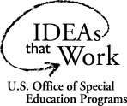
The contents of this lesson were developed as part of the National Center and State Collaborative under a grant from the Department of Education (PR/Award #: H373X100002, Project Officer, Susan.Weigert@Ed.gov). However, the contents do not necessarily represent the policy of the U.S. Department of Education and no assumption of endorsement by the Federal government should be made.
The University of Minnesota is committed to the policy that all persons shall have equal access to its programs, facilities, and employment without regard to race, color, creed, religion, national origin, sex, age, marital status, disability, public assistance status, veteran status, or sexual orientation.
These materials and documents were developed under the National Center and State Collaborative (NCSC) General Supervision Enhancement Grant and are consistent with its goals and foundations. Any changes to these materials are to be consistent with their intended purpose and use as defined by NCSC.
This document is available in alternative formats upon request.
NCSC is a collaborative of 13 states and five organizations.
The states include (shown in blue on map): Arizona, Connecticut, District of Columbia, Florida, Indiana, Louisiana, Pacific Assessment Consortium (PAC-6), Pennsylvania, Rhode Island, South Carolina, South Dakota, Tennessee, and Wyoming.
Tier II states are partners in curriculum, instruction, and professional development implementation but are not part of the assessment development work. They are (shown in orange on map): Arkansas, California, Delaware, Idaho, Maine, Maryland, Montana, New Mexico, New York, Oregon, and U.S. Virgin Islands.
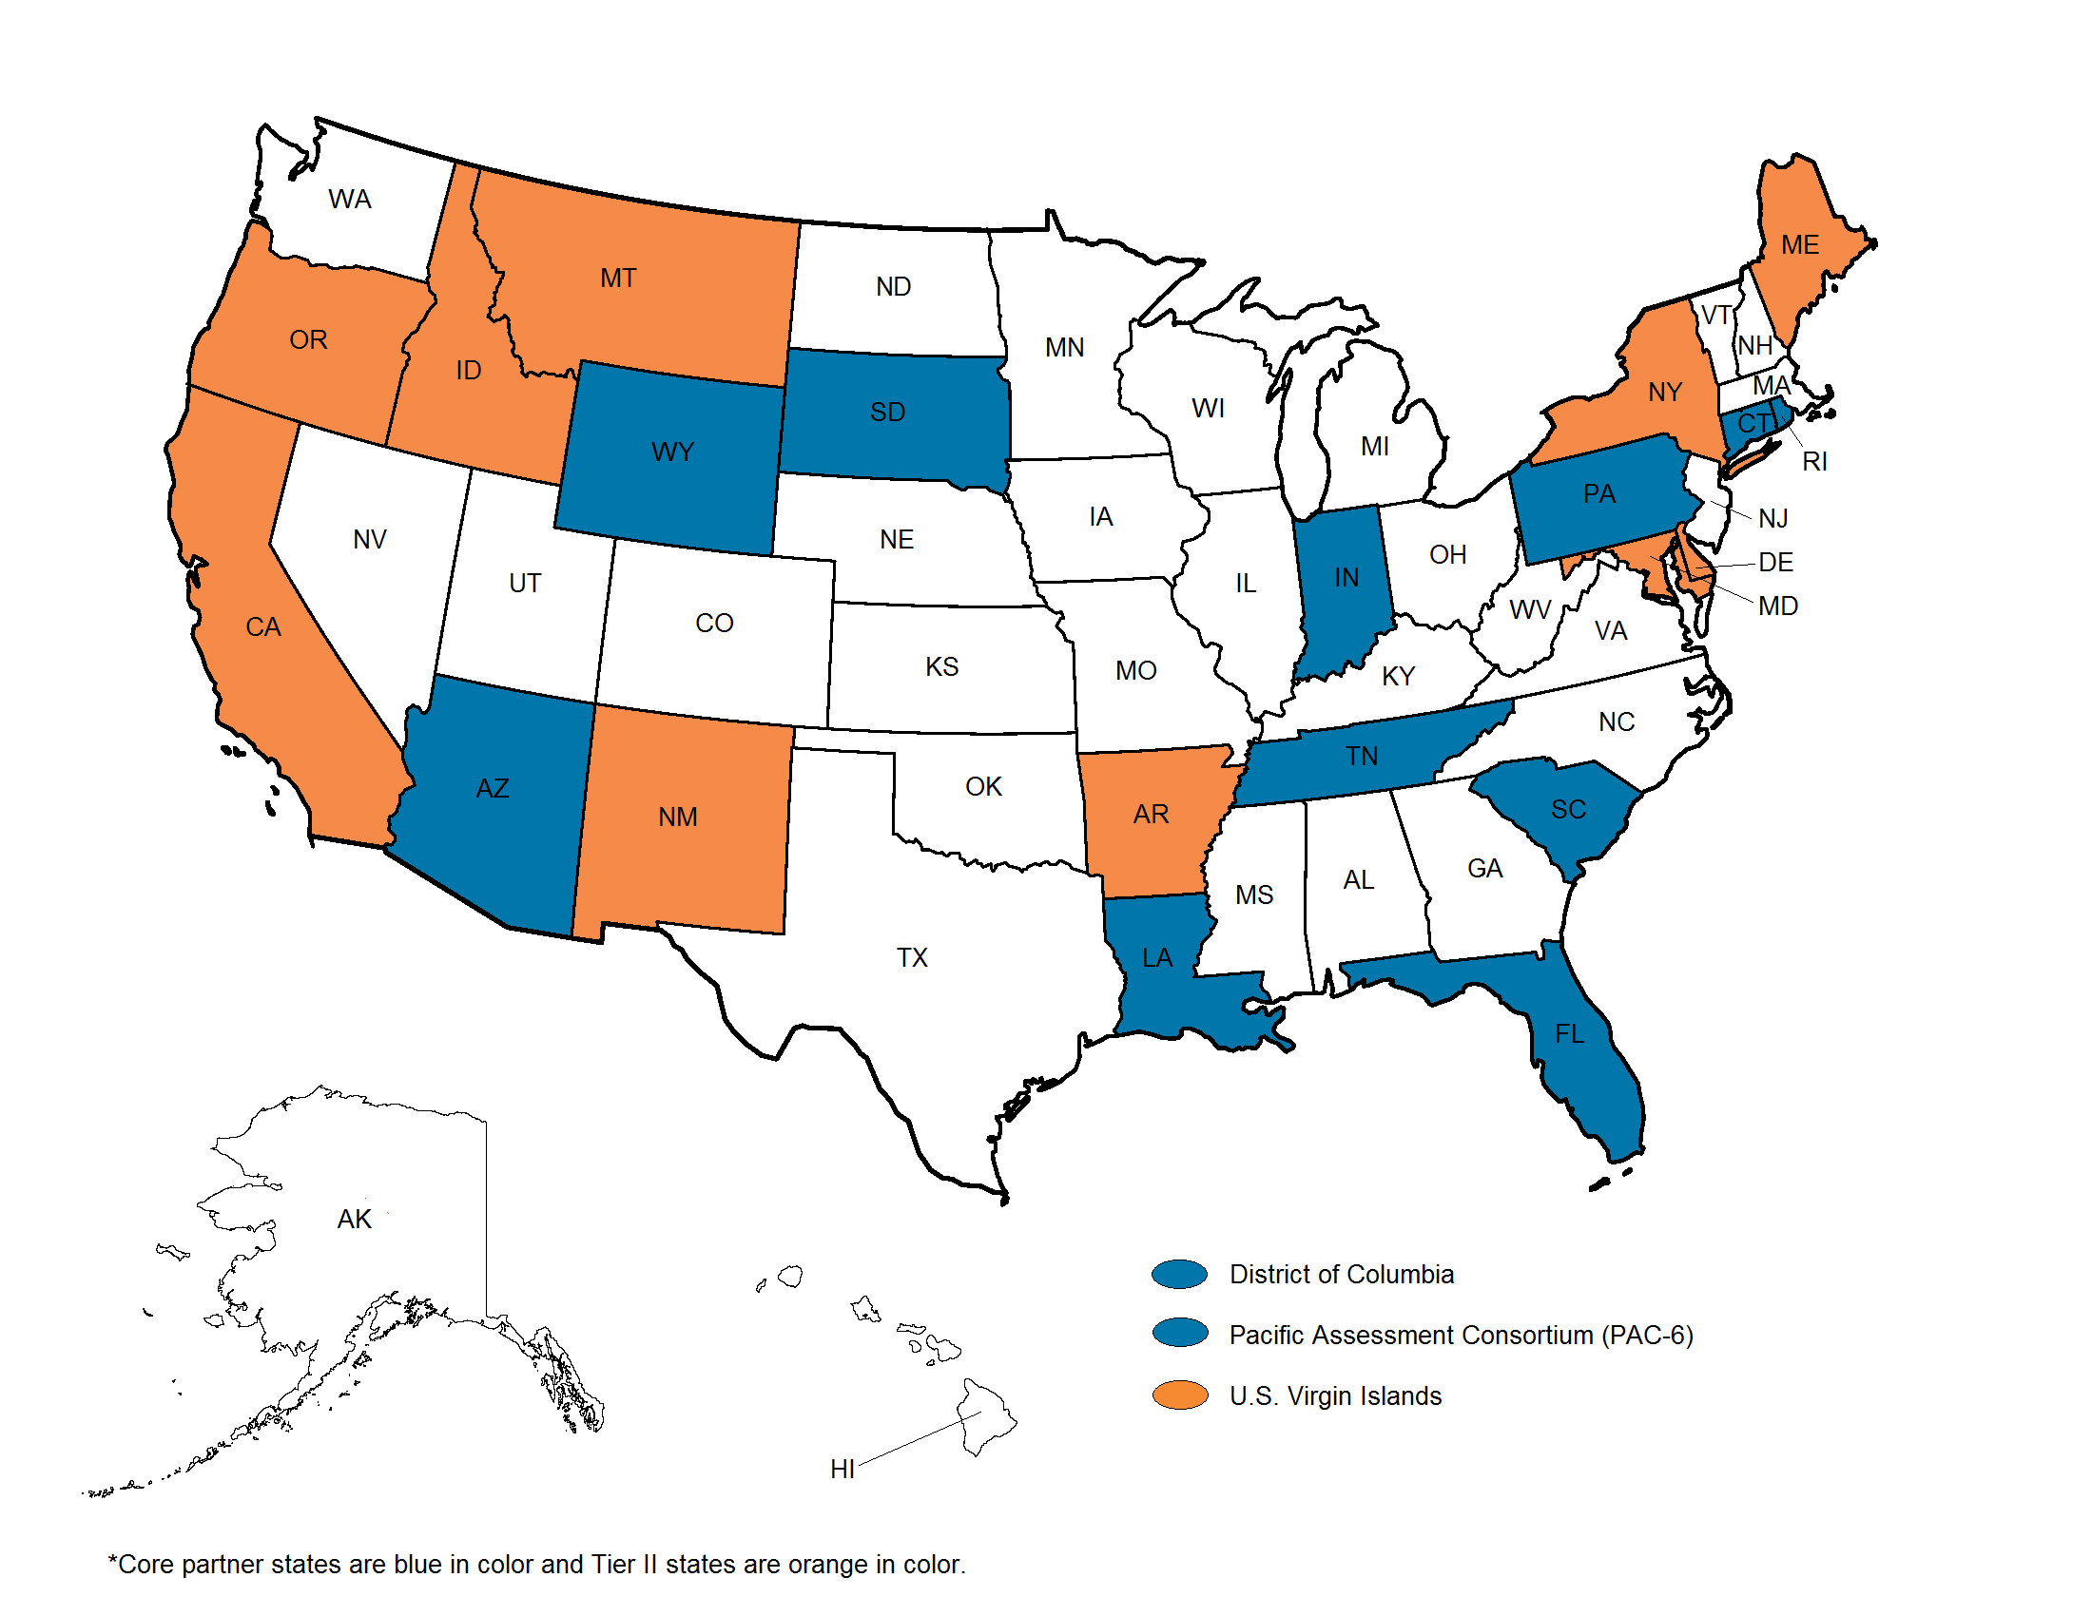
The five partner organizations include: The National Center on Educational Outcomes (NCEO) at the University of Minnesota, The National Center for the Improvement of Educational Assessment (Center for Assessment), The University of North Carolina at Charlotte, The University of Kentucky, and edCount, LLC.





150 Pillsbury Drive SE
207 Pattee Hall
Minneapolis, MN 55455
Phone: 612-708-6960
Fax: 612-624-0879
www.ncscpartners.org

CCSS, Prioritized English Language Arts CCCs, and Essential Understandings: Writing
March 2014

Table of Contents
NCSC CCSS, Prioritized Writing CCCs, and EUs for Grade 3 6
NCSC CCSS, Prioritized Writing CCCs, and EUs for Grade 4 7
NCSC CCSS, Prioritized Writing CCCs, and EUs for Grade 5 8
NCSC CCSS, Prioritized Writing CCCs, and EUs for Grade 6 9
NCSC CCSS, Prioritized Writing CCCs, and EUs for Grade 7 10
NCSC CCSS, Prioritized Writing CCCs, and EUs for Grade 8 11
NCSC CCSS, Prioritized Writing CCCs, and EUs for Grade 11 12

National Center State Collaborative CCSS, Prioritized English Language Arts CCCs, and Essential Understandings

NCSC CCSS, Prioritized Writing CCCs, and EUs for Grade 3
College and Career Readiness Anchor Standards for Writing  (writing type) | CCSS | CCCs |  | Essential Understandings
Text Types and Purposes  (informative/explanatory) | W.3.2 Write informative/ explanatory texts to examine a topic and convey ideas and information clearly.  W.3.2a Introduce a topic and group related information together; include illustrations when useful to aiding comprehension. | 3.WI.p1 Include text features (e.g., numbers, labels, diagrams, charts, graphics) to enhance clarity and meaning. | Identify different types of text features found in informational text.
Research to Build and Present Knowledge  (informative/explanatory) | W.3.8 Recall information from experiences or gather information from print and digital sources; take brief notes on sources and sort evidence into provided categories. | 3.WI.l4 Sort evidence (e.g., graphic organizer) collected from print and/or digital sources into provided categories. | Identify information from print and digital sources on given topics (e.g., pictures of animals).
Production and Distribution of Writing  (narrative) | W.3.4 With guidance and support from adults, produce writing in which the development and organization are appropriate to task and purpose. | 3.WL.o1 With guidance and support from adults, produce a clear, coherent, permanent product that is appropriate to the specific task, purpose (e.g., to entertain), or audience. | Given a specific purpose, produce a permanent product (e.g., select text appropriate to the purpose, identify descriptive sentences, and select a concluding statement).

NCSC CCSS, Prioritized Writing CCCs, and EUs for Grade 4
College and Career Readiness Anchor Standards for Writing  (writing type) | CCSS | CCCs | Essential Understandings
Text Types and Purposes  (informative/explanatory) | W.4.2 Write informative/ explanatory texts to examine a topic and convey ideas and information clearly.  W.4.2a Introduce a topic clearly and group related information in paragraphs and sections; including formatting (e.g., headings), illustrations, and multimedia when useful to aiding comprehension. | 4.WI.p1 Include formatting (e.g., headings, bulleted information), illustrations, and multimedia when useful to convey information about the topic. |  | Identify a concluding sentence that signals a close of a paragraph (e.g., In conclusion…, As a result..., Finally…).
Text Types and Purposes  (informative/explanatory) | W.4.2 Write informative/ explanatory texts to examine a topic and convey ideas and information clearly.  W.4.2e Provide a concluding statement or section related to the information or explanation presented. | 4.WI.q1 Provide a concluding statement or section to support the information presented. |  | Identify the purpose of using different formats, illustrations, or multimedia (e.g., bullets are used for listing items).
Production and Distribution of Writing  (narrative) | W.4.4 Produce clear and coherent writing in which the development and organization are appropriate to task, purpose, and audience. | 4.WL.o1 Produce a clear coherent permanent that is appropriate to the specific task, purpose (e.g. to entertain), or audience. |  | Given a specific purpose, produce a permanent product (e.g., select text appropriate to the purpose, identify descriptive sentences, and select a concluding statement).

NCSC CCSS, Prioritized Writing CCCs, and EUs for Grade 5
College and Career Readiness Anchor Standards for Writing  (writing type) | CCSS | CCCs | Essential Understandings
Text Types and Purposes  (informative/explanatory) | W.5.2 Write informative/ explanatory texts to examine a topic and convey ideas and information clearly.  W.5.2a Introduce a topic clearly, provide a general observation and focus, and group related information logically; include formatting (e.g., headings), illustrations, and multimedia when useful to aiding comprehension. | 5.WI.b3 Organize ideas, concepts, and information (using definition, classification, comparison/contrast, and cause/effect). | Identify relationship of set of items in various categories (definition, classification, compare/contrast, cause/effect).
Text Types and Purposes  (informative/explanatory) | W.5.2 Write informative/ explanatory texts to examine a topic and convey ideas and information clearly.  W.5.2b Develop the topic with facts, definitions, concrete details, quotations, or other information and examples related to the topic. | 5.WI.d1 Support a topic with relevant facts, definitions, concrete details, quotations, or other information and examples. | Identify facts and details related to a specified topic.
Production and Distribution of Writing  (narrative) | W.5.4 Produce clear and coherent writing in which the development and organization are appropriate to task, purpose, and audience. | 5.WL.h1 Produce a clear coherent permanent product that is appropriate to the specific task, purpose (e.g. to entertain), or audience. | Given a specific purpose, produce a permanent product (e.g., select text appropriate to the purpose, identify descriptive sentences, and select a concluding statement).

NCSC CCSS, Prioritized Writing CCCs, and EUs for Grade 6
College and Career Readiness Anchor Standards for Writing  (writing type) | CCSS | CCCs | Essential Understandings
Text Types and Purposes  (narrative) | W.6.3 Write narratives to develop real or imagined experiences or events using effective technique, relevant descriptive details, and well-structured event sequences.  W.6.3a Engage and orient the reader by establishing a context and introducing a narrator and/or characters; organize an event sequence that unfolds naturally and logically. | 6.WL.c1 Organize ideas and events so that they unfold naturally. | Identify the order of events given a short passage/text (e.g., sequence a set of events from an adapted chapter).
Text Types and Purposes  (narrative) | W.6.3 Write narratives to develop real or imagined experiences or events using effective technique, relevant descriptive details, and well-structured event sequences.  W.6.3c Use a variety of transition words, phrases, and clauses to convey sequence and signal shifts from one time frame or setting to another. | 6.WL.c3 Use a variety of transition words, phrases, and clauses to convey sequence and signal shifts from one time frame or setting to another. | Match transition words, phrases, and clauses within a text.
Production and Distribution of Writing  (informative/explanatory) | W.6.4 Produce clear and coherent writing in which the development, organization, and style are appropriate to task, purpose, and audience. | 6.WI.h2 Produce a clear coherent permanent product that is appropriate to the specific task (e.g., topic), purpose (e.g., to inform), and audience (e.g., reader). | Given a specific purpose, produce a permanent product (e.g., select text appropriate to the purpose, identify descriptive sentences, and select a concluding statement).

NCSC CCSS, Prioritized Writing CCCs, and EUs for Grade 7
College and Career Readiness Anchor Standards for Writing  (writing type) | CCSS | CCCs | Essential Understandings
Text Types and Purposes  (narrative) | W.7.3 Write narratives to develop real or imagined experiences or events using effective technique, relevant descriptive details, and well-structured event sequences.  W.7.3d Use precise words and phrases, relevant descriptive details, and sensory language to capture the action and convey experiences and events. | 7.WL.l1 Use precise words and phrases, relevant descriptive details, and sensory language to capture the action and convey experiences and events. | Identify a visual image to match provided text.
Text Types and Purposes  (narrative) | W.7.3 Write narratives to develop real or imagined experiences or events using effective technique, relevant descriptive details, and well-structured event sequences.  W.7.3e Provide a conclusion that follows from and reflects on the narrated experiences or events. | 7.WL.o1 Select or provide a conclusion that follows from the narrated experiences or events. | Provide a conclusion (concluding sentence, paragraph or extended ending) that follows from the narrated experiences or events.
Production and Distribution of Writing  (informative/explanatory) | W.7.4 Produce clear and coherent writing in which the development, organization, and style are appropriate to task, purpose, and audience. | 7.WI.o1 Produce a clear coherent permanent product that is appropriate to the specific task (e.g., topic), purpose (e.g., to inform), and audience (e.g., reader). | Given a specific purpose, produce a permanent product (e.g., select text appropriate to the purpose, identify descriptive sentences, and select a concluding statement).

NCSC CCSS, Prioritized Writing CCCs, and EUs for Grade 8
College and Career Readiness Anchor Standards for Writing  (writing type) | CCSS | CCCs | Essential Understandings
Text Types and Purposes  (argument) | W.8.1 Write arguments to support claims with clear reasons and relevant evidence.  W.8.1a Introduce claim(s), acknowledge and distinguish the claim(s) from alternate or opposing claims, and organize the reasons and evidence logically. | 8.WP.k2 Create an organizational structure in which ideas are logically grouped to support the writer’s claims. | Given a writer’s claims, identify the writer’s perspective on the topic (e.g., pro or con).
Research to Build and Present Knowledge  (argument) | W.8.8 Gather relevant information from multiple print and digital sources, using search terms effectively; assess the credibility and accuracy of each source; and quote or paraphrase the data and conclusions of others while avoiding plagiarism and following a standard format for citation. | 8.WP.j1 Gather relevant information (e.g., highlight in text, quote or paraphrase from text or discussion) from print and or digital sources. | Identify sources of information relevant to the topic (e.g., print and/or digital).
Production and Distribution of Writing  (informative/explanatory) | W.8.4 Produce clear and coherent writing in which the development, organization, and style are appropriate to task, purpose, and audience. | 8.WI.o1 Produce a clear coherent permanent product that is appropriate to the specific task (e.g., topic), purpose (e.g., to inform), and audience (e.g., reader). | Given a specific purpose, produce a permanent product (e.g., select text appropriate to the purpose, identify descriptive sentences, and select a concluding statement).

NCSC CCSS, Prioritized Writing CCCs, and EUs for Grade 11
College and Career Readiness Anchor Standards for Writing  (writing type) | CCSS | CCCs | Essential Understandings
Text Types and Purposes  (informative/explanatory) | W.11-12.2 Write informative/ explanatory texts to examine and convey complex ideas, concepts, and information clearly and accurately through the effective selection, organization, and analysis of content.  W.11-12.2a Introduce a topic; organize complex ideas, concepts, and information so that each new element builds on that which precedes it to create a unified whole; include formatting (e.g., headings), graphics (e.g., figures, tables), and multimedia when useful to aiding comprehension. | 1112.WI.b2 Create an organizational structure for writing that groups information logically (e.g., cause/effect, compare/contrast, descriptions and examples) to support paragraph focus. | Identify information that doesn’t belong in a paragraph based on an organizational structure (e.g., examples, descriptions, cause/effect, compare/contrast).
Text Types and Purposes  (informative/explanatory) | W.11-12.2 Write informative/ explanatory texts to examine and convey complex ideas, concepts, and information clearly and accurately through the effective selection, organization, and analysis of content.  W.11-12.2b Develop the topic thoroughly by selecting the most significant and relevant facts, extended definitions, concrete details, quotations, or other information and examples appropriate to the audience‘s knowledge of the topic. | 1112.WI.b4 Select the facts, extended definitions, concrete details, quotations, or other information and examples that are most relevant to the focus and appropriate for the audience. | Match details, facts, or examples to a topic.
Production and Distribution of Writing  (argument) | W.11-12.4 Produce clear and coherent writing in which the development, organization, and style are appropriate to task, purpose, and audience. | 1112.WP.f1 Produce a clear coherent permanent product that is appropriate to the specific task, purpose (to persuade), and audience. | Given a specific purpose, produce a permanent product (e.g., select text appropriate to the purpose, identify descriptive sentences, and select a concluding statement).

Posted by the California Department of Education, January 2014.

The Pacific Assessment Consortium (including the entities of American Samoa, Commonwealth of the Northern Mariana Islands, Federated States of Micronesia, Guam, Republic of Palau, and Republic of the Marshall Islands) partner with NCSC as one state, led by the University of Guam Center for Excellence in Developmental Disabilities Education, Research, and Service (CEDDERS).

