2022 Dashboard Technical Guide:
INTRODUCTION
An Introduction to California’s Accountability System and the General Rules Applied to the
2022 California School Dashboard.
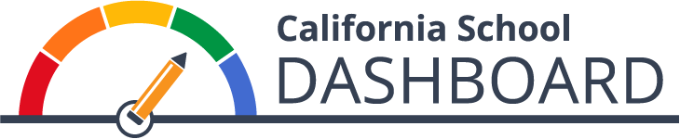
Prepared by the California Department of Education
Available on the CDE California School Dashboard
and System of Support Web Page at:
https://www.cde.ca.gov/dashboard
December 2022

Table of Contents

About this Mini-Guide, Resources, and Contacts 1
California’s Integrated Accountability and Continuous Improvement System 3
Background 3
An Integrated Accountability System 4
State Indicators 6
Local Indicators 6
Annual Review of State and Local Indicators 6
How is Performance Typically Determined? 7
Status Levels and Cut Scores 7
Change Levels and Cut Scores 7
Performance Level (or Color) 8
A Pause in Accountability and a Requirement to Restart 9
Use of “Cell Phone Bars” to Report Status Levels 9
Who Receives a 2022 Dashboard? 10
Who is Held Accountable on the 2022 Dashboard? 11
Dashboard Alternative Schools Status (DASS) 14
How to Navigate Through the 2022 Dashboard 15
What’s New on the Dashboard? 20
General Dashboard Rules 20
School Dashboard Additional Reports 30
A Look at Next Year: What Data Will Be Used for the 2023 Dashboard? 31
Frequently Asked Questions 32
Appendix A: Descriptive Text for Images in Guide 33

About the Guide, Resources, and Contacts

What is the Dashboard Technical Guide?
The California School Dashboard (Dashboard) Technical Guide provides technical information on California’s accountability system, specifically in regards to the state and local indicators that are reported in the Dashboard. The guide is intended for accountability and Dashboard coordinators at local educational agencies (LEAs) to access the calculation methodology and rules used to produce each of the state indicators. It also provides an overview of the local indicators, available resources that are related to the Dashboard, information on the systems of support under the Local Control Funding Formula (LCFF), and information on the identification of schools for comprehensive and targeted support under the Every Student Succeeds Act (ESSA). Because California’s accountability system is founded on meeting requirements under both state and federal law, this guide reflects the requirements that have been met for both. In particular, under federal law, the requirements have to be approved by the U.S. Department of Education (ED) within the state’s ESSA State Plan. The latest version is available through the California Department of Education (CDE) ESSA web page at https://www.cde.ca.gov/re/es/.

This guide is not intended to serve as a substitute for state and federal laws or regulations. The guide should be used in conjunction with information provided through the CDE California School Dashboard and System of Support web page at https://www.cde.ca.gov/dashboard, as well as from e-mails and correspondence disseminated by the CDE to accountability and Dashboard coordinators.

Dividing the Guide into “Mini-Guides”
In prior years, the Dashboard Technical Guide was offered as one large downloadable file consisting of over 260 pages. Beginning with the 2022 Dashboard, the guide has been divided into multiple sections (or mini-guides) to allow viewers to download only the topics of interest. However, to ensure that you do not miss important information and business rules pertaining to the entire Dashboard, we encourage you to review as many of these mini-guides as possible:
- Access the full guide through the CDE 2022 Dashboard Technical Guide web page at https://www.cde.ca.gov/ta/ac/cm/dashboardguide22.asp.

Resources
- The Dashboard Communications Toolkit (https://www.cde.ca.gov/ta/ac/cm/dashboardtoolkit.asp) was developed to support LEAs, parents and communities bring the 2022 Dashboard closer to home.
- The Dashboard Resources web page (https://www.cde.ca.gov/ta/ac/cm/dashboardresources.asp) contains general and technical information, tools for educators, translations, downloadable data files, dedicated state and local indicator web pages, and access to the rules used to determine support for LEAs and schools.

Contacts
Questions about:
- State Indicators (Academic, College/Career, Chronic Absenteeism, English Learner Progress Graduation Rate, and Suspension Rate), contact the Analysis, Measurement, and Accountability Reporting Division by email at Dashboard@cde.ca.gov.
- Logging onto the Dashboard, registering as an LEA Dashboard Coordinator, uploading local indicators into the Dashboard, and the Local Control and Accountability Plan (LCAP), contact the Local Agency Support Systems Office (LASSO) by e-mail at lcff@cde.ca.gov.
- California’s System of Support (Differentiated Assistance and Comprehensive School Support), contact the System of Support Office (SSO) by e-mail at CASystemofSupport@cde.ca.gov.
Material in this publication is not copyrighted and may be reproduced.

California’s Integrated Accountability and Continuous Improvement System

Background
On September 8, 2016, the State Board of Education (SBE) approved key elements of a new integrated accountability and continuous improvement system that evaluates LEA and school performance in areas critical to students’ preparedness for college and career. These areas are founded on the LCFF ten state priorities and include graduation rates, suspension rates, chronic absenteeism rates, college/career preparedness, assessment scores, and the progress of English learners.
With the implementation of the LCFF in 2014, LEAs are held accountable for improving student performance. Specifically, state law requires ten priority areas that school districts and charter schools must report in their Local Control and Accountability Plan (LCAP). (Note: Two of the priority areas are limited to county offices of education.) These priority areas range from student achievement (performance on standardized tests and percent of English learners [ELs] that become English proficient); school climate (administer a Local Climate Survey every other year); student engagement (graduation rates, chronic absenteeism rates, etc.); and parent and family engagement. Information on the LCFF priority areas can be accessed on the CDE State Priority Related Resources web page at https://www.cde.ca.gov/fg/aa/lc/statepriorityresources.asp.
In December 2015, the ESSA was signed into federal law, which reauthorized the Elementary and Secondary Education Act and replaced the No Child Left Behind Act of 2001. One of the requirements under this law is for states to have a new multiple measures accountability system in effect by the 2017–18 school year based on the following five areas:
- Achievement as measured by proficiency based on annual state assessments;
- Four-year cohort graduation rates for high schools or an extended year graduation rate;
- Another academic indicator for elementary and middle schools (e.g., chronic absenteeism);
- Progress in English language proficiency for ELs; and
- At least one other indicator of school quality or student success that is valid, reliable, comparable, and statewide (e.g., postsecondary readiness, student engagement, etc.)
For more information, see the CDE Every Student Succeeds Act web page at https://www.cde.ca.gov/re/es/.

An Integrated Accountability System
Rather than developing two accountability systems––one that meets state requirements (LCFF) and another that meets federal requirements (ESSA)––an integrated local, state, and federal accountability and continuous improvement system founded on the LCFF priority areas that also aligns to ESSA requirements has been developed.
The accountability system, based on multiple measures, uses the Dashboard, which includes state and local performance standards for all LCFF priorities, to report progress. These performance standards will be used to:
- Support LEAs in identifying strengths, weaknesses, and areas for improvement;
- Assist in determining whether LEAs are eligible for assistance; and
- Assist the State Superintendent of Public Instruction in determining whether LEAs are eligible for more intensive state support/intervention.
Table 1 displays the ten LCFF priority areas that California’s accountability system is founded on.
Table 1: State and Local Indicators Listed by Priority Area
Priority Area | State Indicator | Local Indicator
Priority 1: Basic Services or Basic Condition at Schools | N/A | Annual measurement of appropriately assigned teachers, access to curriculum-aligned instructional materials, and safe, clean and functional school facilities.
Priority 2: Implementation  of State Academic  Standards | N/A | Annual measure of progress in implementing state academic standards.
Priority 3: Parent and Family Engagement | N/A | Annual measure of progress in seeking input from parents in decision making and promoting parental participation in programs.
Priority 4: Student  Achievement | - Academic (grades 3–8 and grade 11)  - English Learner Progress | N/A

Table 1: State and Local Indicators Listed by Priority Area (Cont.)
Priority Area | State Indicator | Local Indicator
Priority 5: Student  Engagement | - Graduation Rate  - Chronic Absenteeism | N/A
Priority 6: School Climate | - Suspension Rate | Administration of a local climate survey at least every other year that provides a valid measure of perceptions of school safety and connectedness to students in at least one grade within the grade span(s) that the LEA serves (e.g., K–5, 6–8, 9–12).
Priority 7: Access to a  Broad Course of Study | N/A | Annual measure of progress on the extent students have access to, and are enrolled in, a broad course of study.
Priority 8: Outcomes in a Broad Course of Study | - College/Career | N/A
Priority 9: (COEs Only) Coordination of Services for Expelled Students | N/A | Annual measure of progress in coordinating instruction for expelled students.
Priority 10: (COEs Only) Coordination of Services for Foster Youth | N/A | Annual measure of progress in coordinating services for foster youth.
By reporting performance on multiple measures (or indicators) that impact student performance across the LCFF priorities, the accountability system provides a more complete picture of LEAs and schools, including their accomplishments and challenges. It also promotes equity by clearly identifying the achievement gaps among student groups. For LEAs and schools in need of additional assistance or intervention, the Dashboard helps identify specific areas in need of targeted assistance.

State Indicators
LCFF statute requires that the accountability system include standards for all LCFF priorities. The criteria established for state indicators include: (1) being valid, reliable, and fair, (2) having comparable, state-level data, and (3) the ability to disaggregate data by student groups. These criteria ensure a common and comparable way of measuring performance on the indicators across the state. The state indicators apply to all LEAs, schools, student groups (e.g., race/ethnicity, socioeconomically disadvantaged, English learners, students with disabilities, Foster Youth, and Homeless) and progress on the indicators is reported through the Dashboard.
Each state indicator is described in detail within the Dashboard Measures tab on the CDE Dashboard Resources web page at https://www.cde.ca.gov/ta/ac/cm/dashboardresources.asp. They are also explained in each of the state indicator mini-guides. The details include technical information, the various calculation methodologies, and the business rules used to calculate each of these indicators.

Local Indicators
Comprehensive information on local indicators can be accessed through the Local Indicators mini-guide and the CDE Local Indicators web page (https://www.cde.ca.gov/ta/ac/cm/localindicators.asp). Local indicators reflect local data that are directly submitted to the Dashboard by LEAs, and they apply only to the LEA and charter schools; they do not apply to schools.

Annual Review of State and Local Indicators
In March of each year, the SBE annually reviews state and local indicators and performance standards. The purpose of this annual review process is to determine whether any changes or improvements are necessary based on newly available data, recent research, and/or stakeholder feedback. If changes are necessary, the SBE approves the implementation plan and these changes are documented in the “What’s New” section of each state indicator mini-guide.

How is Performance Typically Determined?
In May 2016, the SBE approved the methodology for calculating performance on the state indicators. The adopted methodology is two-dimensional and uses two data components:
  - Status or current year data, and
  - Change or the difference from prior year data.
The SBE approved that performance should be measured through a combination of Status and Change with both providing equal weight in determining performance. The performance standards are based on the distribution of Status and Change for each indicator (much like grading on a curve) and cut scores have been approved by the SBE resulting in Status levels and Change levels. These Status and Change levels serve as the performance standards for the state indicators and are reported as performance levels (or colors). The performance standards vary by state indicator and will generally remain fixed, until the SBE decides to update the standards.

Status Levels and Cut Scores
For each state indicator, there are five Status levels:
Five Status Levels
Very High
High
Medium
Low
Very Low
An LEA, school, or student group’s current year of data are used to assign a Status level for each applicable indicator. For example:
- A school is assigned a “High” Status level for the Graduation Rate Indicator if its most current year graduation rate falls in the range for the “High” level.
The five Status levels were established for each state indicator through the following process:
- The data used for each indicator were collected for all LEAs and charter schools statewide.
- These results were ordered from highest to lowest.
- Four cut scores were established based the percentile distributions to create five
Status levels.

Change Levels and Cut Scores
“Change” is defined as the difference in results from the current year to the prior year:
Status (Current Year) minus Prior Year = Change
There are five Change levels for each state indicator:
Five Change Levels
Increased Significantly
Increased
Maintained
Declined
Declined Significantly
Every LEA, school, or student group is assigned a Change level for each applicable state indicator. For example:
- The suspension rate among the white student group declined significantly over the past year. Therefore, this student group is assigned a Change level of “Declined Significantly” for that indicator.
The five Change levels were established for each state indicator through the following process:
- The difference in performance was calculated for all LEAs and charter schools statewide.
- The calculated results were grouped into two separate distributions:
- Positive change (ordered from highest to lowest)
- Negative change (ordered from highest to lowest)
- The two distributions (positive and negative change) were combined.
- Four cut scores were established to create five Change levels based on percentile distributions.

Performance Level (or Color)
The combination of the five Status levels and the five Change levels results in 25 performance levels. Each of the 25 performance levels are represented by one of five colors as referenced in Figure 1 below. Refer to Appendix A for the descriptive text.
Figure 1: Performance Levels Represented by Gauges
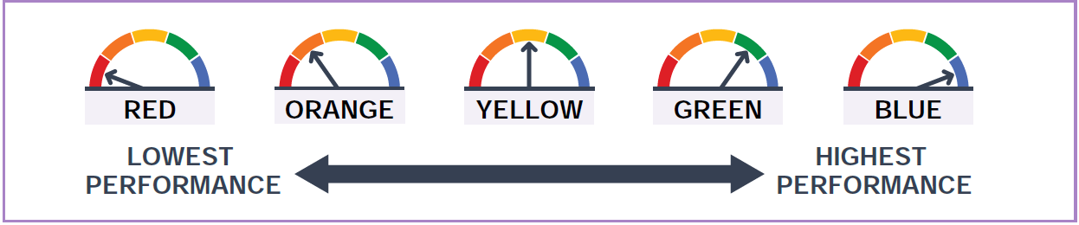

A Pause in Accountability and a Requirement to Restart
Due to the impact of the COVID-19 pandemic on education communities, for the past two school years, the accountability requirements for California were waived or adjusted, which resulted in state indicators not being reported on the 2020 and 2021 Dashboards. However, the requirement to hold LEAs and schools accountable for student outcomes has resumed with the 2021–22 school year and with the release of the 2022 Dashboard.
As a result of restrictions imposed by Assembly Bill 130, the CDE is required to only report current year data (or Status) for the 2022 Dashboard. Unlike in prior years, California cannot display Change or performance colors.
Therefore, with the reporting of Status only for the 2022 Dashboard, performance levels are reported using only the five Status levels based on data from the 2021–22 school year. Change and performance level colors will be reported with the release of the 2023 Dashboard.

Use of “Cell Phone Bars” to Report Status Levels
With the adjustment to report only Status levels, the CDE has revised the design of the Dashboard from using the typical color gauges (i.e., Red, Orange, Yellow, Green, and Blue) as illustrated in Figure 1 to using “cell phone bars” to reflect the five Status levels as depicted in Figure 2 below. (Refer to Appendix A for the descriptive text)
Figure 2: Status Levels Represented through “Cell Phone Bars” (Used for the 2022 Dashboard)
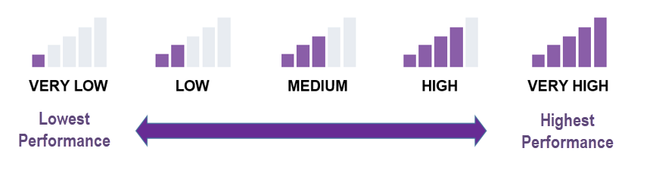
Reverse Goal for Suspension Rate and Chronic Absenteeism Indicators: For most of the other state indicators, the desired outcome is to have a high percentage in the current year and an increase in percentage from the prior year. However, for the Suspension Rate and Chronic Absenteeism Indicators, the desired outcome is reversed, and the goal is to achieve a low suspension rate and a low chronic absenteeism rate with a decrease in percentage from the prior year.
Due to this reverse goal, the Status level associated with the “cell phone bars” for these two state indicators on the 2022 Dashboard is reversed as illustrated in Figure 3 on the following page.

Figure 3: Chronic Absenteeism and Suspension Rate: Reverse Status Levels
Because of this reverse goal, the Status levels for these indicators on the 2022 Dashboard is reversed as illustrated in Figure 3 below. Refer to Appendix A for the descriptive text.
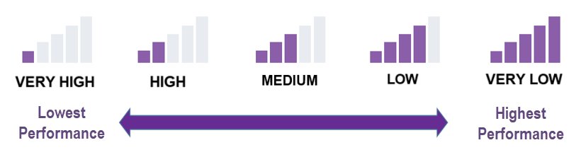
To access the Status cut scores used to determine which Status level LEAs, schools, or student groups receive for the 2022 Dashboard, please refer to the CDE Status Cut Scores for the 2022 Dashboard web page at https://www.cde.ca.gov/ta/ac/cm/perfcutscores22.asp. Note that the Status cut scores are the same cut scores that have been approved by the SBE and used in prior Dashboard reporting cycles.
To access the cut scores set for Status, Change, and performance levels (colors) for each state indicator, please refer to the CDE 2019 Status and Change Five-by-Five Colored Tables web page at https://www.cde.ca.gov/ta/ac/cm/fivebyfivecolortables19.asp.

Who Receives a 2022 Dashboard?

All LEAs and schools, including charter schools and DASS schools, receive Dashboard reports.

Alternative (DASS) and Charter Schools
All Dashboard Alternative School Status (DASS) schools are held accountable for the same indicators as non-DASS schools. These schools’ data are “rolled up” or included in their LEA results.
Charter schools (both traditional and DASS; local and direct-funded) are treated as LEAs under the LCFF. Accordingly, charter schools’ data are not “rolled up” or included in the charter authorizing agency’s results. Charter schools receive school-level reports on the Dashboard.
- The one exception is when the LEA oversees only charter schools or is a Statewide Benefit Charter, the charter schools’ data are “rolled up” and included in the LEA’s Dashboard data.

Who is Held Accountable on the 2022 Dashboard?
LEAs and schools that do not meet specific accountability requirements are eligible to receive specific support:
- For LEAs, the support is referred to as Differentiated Assistance and is an accountability requirement under state law.
- For schools, the support is referred to as Comprehensive Support and Improvement (CSI), Additional Targeted Support and Improvement (ATSI), and Targeted Support and Improvement (TSI) and are accountability requirements under federal law.
Detailed information on the eligibility criteria to receive support are referenced in the mini-guides titled “Local Educational Agency Eligibility: Differentiated Assistance” and “School Eligibility: CSI, ATSI, TSI,” which are available on the CDE 2022 Dashboard Technical Guide web page at https://www.cde.ca.gov/ta/ac/cm/dashboardguide22.asp.
Accountability is triggered based on the number of students in the denominator. The following identifies the number of students needed to be held accountable, what the Dashboard will display, and what the Dashboard will not display when the threshold number is not reached.

30 or More Students
LEAs, schools, and student groups must have at least 30 or more students in the denominator of the state indicator to receive a Status level and be held accountable. As reflected in Figure 4 below, when there are 30 or more students, the Status “cell phone bar” graphic is displayed on the Dashboard showing one of five Status levels, which, in the case of Figure 4 is the High level. The Dashboard also displays the Status data, which is reflected as 93.6 percent graduated in the same figure.
The exception to this rule is that at the LEA-level, the n-size is 15 or more (not 30 or more) for the Foster Youth and Homeless student groups. This is explained in detail in the section titled “Exception: Foster Youth and Homeless.”
Figure 4: Example of When Number of Students is 30 or More (Refer to Appendix A for the descriptive text)
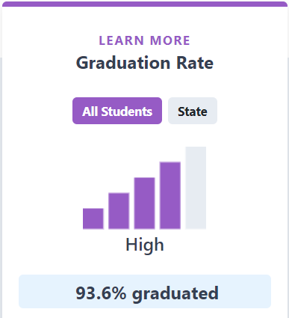
Table 2 below identifies the data and data sources used to determine the N-size of “30 or more” for the state indicators.
Table 2: State and Local Indicators Listed by Priority Area
State Indicator | Data Used to Determine  “30 or More” | Data Source
Academic  (Grades 3 through  8 and Grade 11 in ELA and mathematics) | All students who take the Smarter Balanced Summative Assessments or California Alternate Assessments in grades 3 through 8 and grade 11 who are continuously enrolled* | CAASPP**  file from testing vendor
Chronic Absenteeism | Cumulative Enrollment  (The total number of students who were enrolled in a school for at least 31 instructional days.) | CALPADS
College/Career | Not Reported on the 2022 Dashboard | Not Applicable
English Learner Progress | All grade 1 through 12 students taking the ELPAC*** Summative Assessment in the current year and having an overall performance level in both the current and prior year. | ELPAC*** Summative Assessment file from test vendor
Graduation  Rate | All students in the combined four- and five-year graduation rate. | CALPADS
Suspension  Rate | Cumulative Enrollment  (All students enrolled for at least one day) | CALPADS
*Continuously Enrolled is defined as enrollment from Fall Census Day (first Wednesday in October)] to when the student logged on to the test (CAT or PT) without a gap of more than 30 consecutive calendar days.
**CAASPP: California Assessment of Student Performance and Progress
***ELPAC: English Language Proficiency Assessments for California

11–29 and Less than 11 Students
LEAs, schools, and student groups that have between 11 and 29 students in the denominator of the state indicator are not held accountable. They will receive greyed out Status “cell phone bars” with the words “No Performance Level” as illustrated in the left card in Figure 5 on the following page. However, the Status data will be displayed, which, referencing the same card in Figure 5, is 10.4 points above standard.
When there are less than 11 students in the denominator of the state indicator, a Status level and Status data are not reported on the Dashboard to protect students’ privacy. In this instance, the LEA, school, and student group are not held accountable. Referencing the card to the right in Figure 5 below, the Status “cell phone bars” will be greyed out with the words “No Performance Level.” The area normally displaying Status data will show the words “Less than 11 students – data not displayed for privacy.”
Figure 5: Example of When Number of Students is 11–29 or Less than 11 (Refer to Appendix A for the descriptive text)
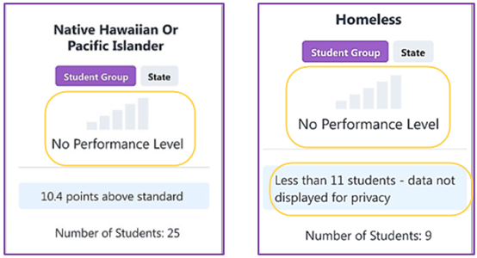

Exception: Foster Youth and Homeless
The number of students needed in the Foster Youth and Homeless student groups to receive a Status level differs at the LEA-level.

- School-level: The N size for both student groups is 30 or more students. Therefore, if the school has 30 or more Foster Youth students or Homeless students, each student group will receive a Status level.

- LEA-level: The N size for both student groups is 15 students (not 30). Therefore, if the LEA has 15 or more Foster Youth students or Homeless students, each student group will receive a Status level.

Note: Charter Schools are treated as schools (not LEAs) when it comes to reporting these two student groups. Charter schools will need at least 30 or more Foster Youth, or 30 or more Homeless students, to receive a Status level for each student group.

Dashboard Alternative School Status (DASS)

In July 2017, the SBE approved the eligibility criteria for schools to qualify under DASS. Since this time, the SBE has approved the use the “modified methods” to be applied to DASS schools for the:
- Academic Indicators – where Status cut scores were modified for the “Very Low” and “Low” levels, and
- Graduation Rate Indicator – where a modified graduation rate (known as the DASS graduation rate) was developed and implemented.
However, beginning with the 2022 Dashboard, the use of modified methods is no longer allowable due to concerns raised by the U.S. Department of Education (ED) regarding California’s use of a DASS modified graduation rate and academic indicator on the Dashboard. The ED issued a subsequent decision in August 2022 to decline a waiver request from the SBE of the requirements of the Every Student Succeeds Act (ESSA) to allow for the continued use of the DASS graduation rate.
Therefore, beginning with the 2022 Dashboard, DASS schools:
- Will receive the combined four-and five-year graduation rate for the Graduation Rate Indicator, and
- Have the same cut scores applied for the Academic Indicators as non-DASS schools.
These data will be used to determine eligibility for Differentiated Assistance at the LEA-level and Comprehensive Support and Improvement (CSI) and Additional Targeted Support and Improvement (ATSI) at the school-level.
Please note that this denial affects the requirements under federal law (ESSA). State law, as provided by the California Education Code Section 52052(d) continues to permit the use of the DASS program and reporting of data separately for alternative schools. Therefore, the CDE will:
- Continue to produce and display the one-year DASS graduation rate, however it will be limited for informational purposes only on the 2022 Dashboard and the School Dashboard Additional Reports (https://www.cde.ca.gov/ta/ac/cm/dbadditionalrpts.asp).
- Continue to seek and recommend opportunities to the SBE to display DASS data in a prominent manner on future Dashboards and in other public reporting of data, such as the CDE’s web reporting system, DataQuest. The reporting of these data is critical to LEAs who support at-promise students in alternative school settings.

Resources on DASS
The CDE DASS web page at https://www.cde.ca.gov/ta/ac/dass.asp contains the DASS eligibility criteria, the application process for schools to apply for a DASS status or to continue their status, and instructions to withdraw from participating in DASS. This page also includes FAQs that addresses common questions received from LEAs.
Information from the ED on the use of the DASS for accountability and next steps are available through the August 2022 State Board of Education Information Memorandum at https://www.cde.ca.gov/be/pn/im/documents/aug22memogad01.docx and the September 2022 State Board of Education Agenda Item at https://www.cde.ca.gov/be/ag/ag/yr22/documents/sep22item03.docx.

How to Navigate Through the 2022 Dashboard
The Dashboard can be accessed on the CDE California School Dashboard and System of Support web page at http://www.cde.ca.gov/ta/ac/cm/. Upon entering the web site, to see the results for a district or school, type the name into the search bar. Alternatively, the search for a district or school can also be conducted by city or county. Next, select the year. Figure 6 below provides an image of the Dashboard landing page.
Figure 6: Dashboard Landing Page (Refer to Appendix A for the descriptive text)
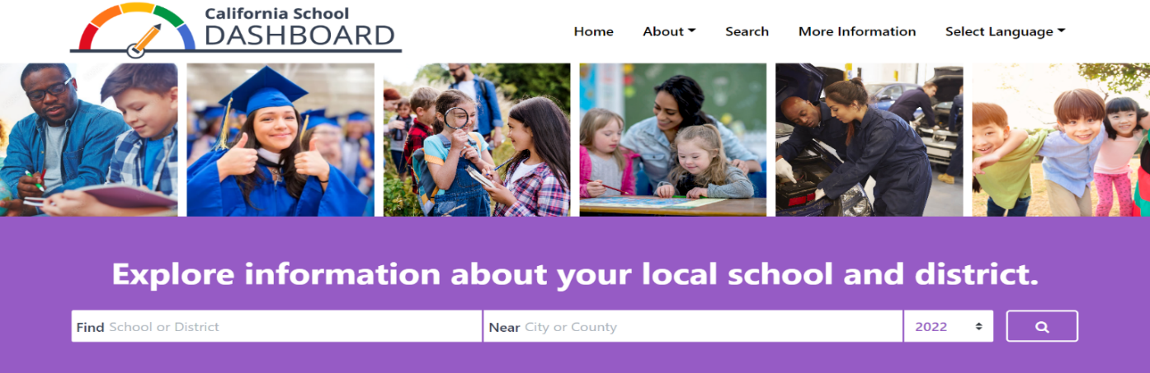

Performance on State and Local Indicators
Once you select your district or school, you’ll be able to see its performance on state and local indicators. Figure 7 below reflects an example for a district. (Refer to Appendix A for the descriptive text.)
Figure 7: Performance on State and Local Indicators
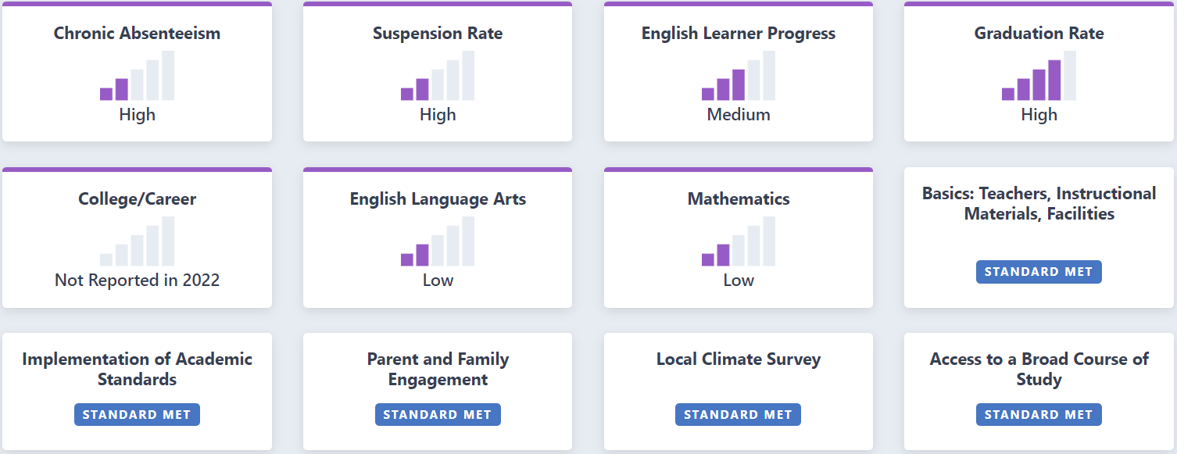
In Figure 7, the district received a High Status level for both Chronic Absenteeism Suspension Rate. The district received a Medium performance level for English Learner Progress, High for Graduation Rate, and Low for both ELA and Mathematics. (Note: Status level for the College/Career Indicator will not be available for the 2022 Dashboard.) The district also satisfied the State Board of Education-adopted local indicator performance standard requirements.

Student Population
General student population data are also available on the main landing page of the Dashboard. Figure 8 below provides an example. (Refer to Appendix A for the descriptive text)
Figure 8: Student Population Data on Main Dashboard Landing Page
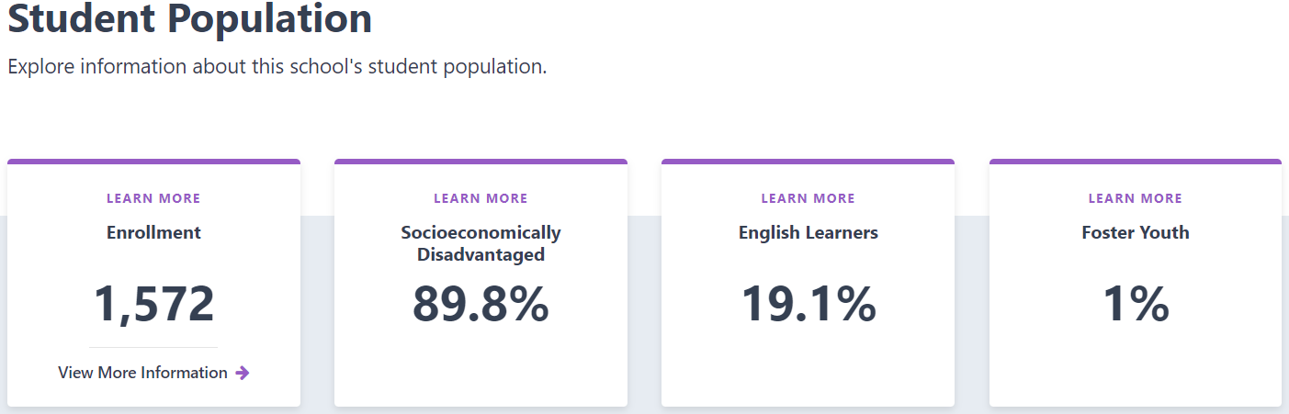
- Enrollment: These data are reflective of the CALPADS 2021 Fall Census Day data. At the LEA-level, the data excludes charter school data. For example, at the LEA-level, enrollment data is based on 2021 Fall Census Day data minus their charter schools’ enrollment data.
  - View More Information: The link at the bottom of the Enrollment card details the demographic data, which includes race/ethnicity and program participation student groups. These data are also based on the 2021 Fall Census Day data in CALPADS.
- Percentage of Students who are Identified as Socioeconomically Disadvantaged, English learners, and Foster Youth: These data are also reflective of the CALPADS 2021 Fall Census Day data. At the LEA-level, the data excludes charter school data.
- Learn More: By selecting the “Learn More” text which appears at the top of each card, viewers can access the definitions for enrollment, socioeconomically disadvantaged, English learners, and Foster Youth. This information is available in Figure 9 on the following page. (Refer to Appendix A for the descriptive text).

Figure 9: Student Population Descriptions
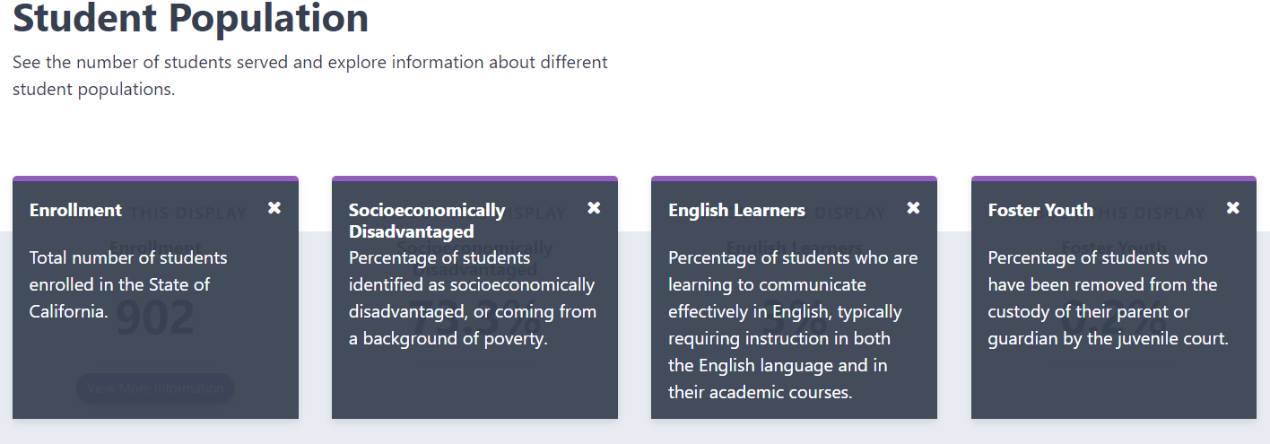

Compare Your Data to the State
The Dashboard also provides buttons at the top of each data card that allow you to compare your school or LEA’s data against statewide results. You can toggle back and forth between the “All Students” and “State” button as shown in Figure 10 below. (Refer to Appendix A for the descriptive text.)
Figure 10: Data for A District Versus State
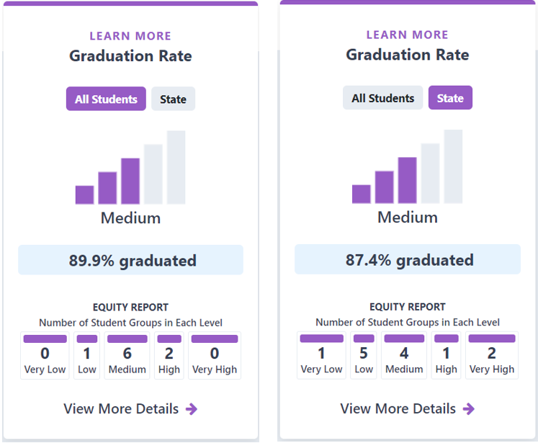

Equity Report
At the bottom of each card for each state indicator is an Equity Report. It identifies the number of student groups placed in each Status level. Figure 11 on the following page reflects the Equity Report for the English Language Arts results displayed on the prior page. The figure shows that zero student groups received a Very Low Status level (the lowest performance level), one student group received a Low Status level, one student group received a Medium Status level, four student groups received a High Status level, and five student group receive a Very High Status level (the highest level).
Figure 11 Equity Report (Refer to Appendix A for the descriptive text.)
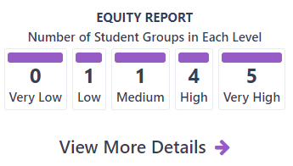

Student Group Performance
Selecting the “View More Details” link below the Equity Report connects the viewer to a page informing how student groups performed on that indicator. Figure 12 below reflects a sample of the “Student Group Details.” (Refer to Appendix A for the descriptive text.)
Figure 12: Student Group Details
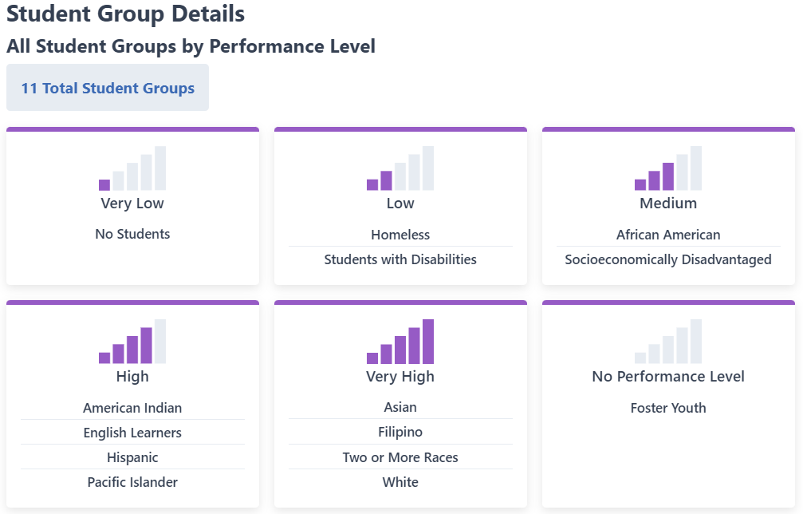

View All Schools
Selecting the “View All Schools” link at the top right of an LEA’s report connects the viewer to a page that gives a snapshot look at how all the schools in an LEA performed on each applicable indicator. Figure 13 illustrates an example. (Refer to Appendix A for the descriptive text)
Figure 13: Viewing All Schools’ Performance At-a-Glance
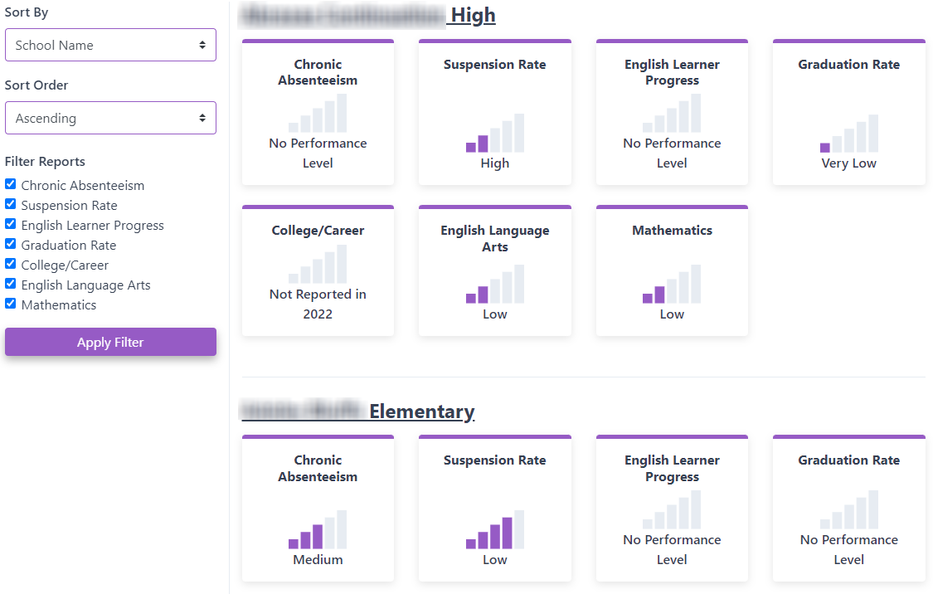

Local Indicators
LCFF statute requires that the accountability system include standards for all LCFF priorities; however, state data is not available for some priority areas identified in the LCFF statute. For these priority areas, the SBE approved “local indicators,” which are based on information collected locally by LEAs. The local indicators apply only at the LEA level, which includes charter schools. These local indicators appear on the LEA and charter school Dashboard with a status of Met or Not Met.
Further details about local indicators can be found within the Local Indicators web page (https://www.cde.ca.gov/ta/ac/cm/localindicators.asp) and the Local Indicators mini-guide, which is available on the CDE 2022 Dashboard Technical Guide web page at https://www.cde.ca.gov/ta/ac/cm/dashboardguide22.asp.

What’s New on the Dashboard?
The 2022 Dashboard now contains the following two new links:

- A connection to the Teacher Assignment Monitoring Outcomes Report within DataQuest. This linkage reflects the first year of teacher assignment data published within local indicator LCFF Priority 1: Basic Services and Conditions.
- A connection to the California Science Test as published on the Test Results for California's Assessments web site. This link is accessible through the “View Additional Reports” button located at the top right of an LEA or school’s Dashboard. This takes the viewer to the School Dashboard and Additional Reports web site where, under the “Additional Links” section, there is a direct link to the California Science Test.

General Dashboard Rules
This section reviews the common rules and definitions that are applied across all state indicators.

Adult Schools/Adult Centers
All adult schools/adult centers do not receive a Dashboard report and are removed from all calculations of state indicators.

Closed Schools
Any school that closed during the 2021–22 academic year will receive a Dashboard as long as the school has data that can be used to report state indicators.

County-District-School Code
In order to have data displayed on the indicators reported in the Dashboard by the CDE, an LEA must have a county-district (CD) code and a school must have a county-district-school (CDS) code. Information regarding CDS code assignments is located on the CDE Schools and Districts web page at https://www.cde.ca.gov/ds/si/ds/.

District of Residence
For LEAs only, an additional step—application of the district of residence rule (also known as the District of Special Education Accountability [DSEA])—is taken to determine which SWDs receive special education services at another district or county office of education and should be “sent back” to the DSEA and included in the DSEA’s Dashboard. This rule ensures that the LEA that receives federal funding—under the Individuals with Disabilities Education Act—for a student will be held accountable for the outcomes of that student. (Note that at the school level, the school of attendance will continue to be held accountable for the student’s performance.)

Which LEA is Responsible for Reporting the District of Special Education Accountability Data?
Since SWDs often attend school in one LEA and receive services from another LEA or county office of education (COE), it can be unclear which LEA is required to report special education data to CALPADS. The responsible LEA for reporting enrollment and special education data to CALPADS is the “Reporting LEA” or the LEA where the student “attends school” or receives the majority of his or her instruction.
The District of Special Education Accountability is the LEA ultimately responsible for the student and held accountable for the student on the Dashboard. In most instances, the Reporting LEA and the DSEA are the same for accountability purposes, as are the DSEA and the District of Geographic Residence. However, note that the District of Geographic Residence field in CALPADS is used for LCFF funding purposes and is not the DSEA field.
Table 3 provides the most common scenarios for determining which LEA is responsible for reporting SWD data, and which LEA will be held accountable on the Dashboard. A full comprehensive list of scenarios is posted on the CDE Reporting Data for Students with Disabilities web page at https://www.cde.ca.gov/ds/sp/cl/swdreporting.asp.
Table 3: Common Scenarios for Determining Which LEA is Held Accountable
Scenario | If the student resides in: | And the student is attending a school in: | And the student receives special education services from: | Then the LEA that reports data for the SWD is: | And the District of Special Education Accountability is:
1 | District A | District A | District A | District A | District A
2 | District A | District A | District B | District A | District A
3 | District A | District B  per the IEP | District B | District B | District A
4 | District A | District B  per an inter-district transfer agreement | District B | District B | District B
- Does the district of residence/DSEA rule impact schools?
No. The rule is only applied at the district level. All schools (i.e., schools providing the special education service and where the student attends) are held accountable for their SWDs, and these students are included in their Dashboard reports.
- Which district is the DSEA when students transfer via a formal inter-district transfer, attend a charter school, attend a private school, or are wards of the court?
- For inter-district transfers, the DSEA is the district that the student transfers to. See Scenario 4 in Table 3 on the previous page.
- For charter schools, because charter schools are treated as LEAs under LCFF, the charter school is held accountable and is the DSEA. (Note that the charter school’s authorizer is not held accountable.)
- For juvenile court and court/community, the DSEA is the LEA serving the student while the student is incarcerated or institutionalized.
- Does the district of residence rule apply to all state indicators?
Yes. The rule applies to all state indicators reported on the 2022 Dashboard:
- Academic Indicator
- Chronic Absenteeism Indicator
- Graduation Rate Indicator
- English Learner Progress Indicator
- Suspension Rate Indicator
- Does the district of residence rule apply only to students with disabilities? Or does the rule apply to all students?
The rule only applies to students with disabilities.
Table 4 below identifies which entity is held accountable for SWDs on the Dashboard.
Table 4: Which Entity is Held Accountable for Students with Disabilities?
State Indicator | School of Attendance | District of Residence  (District of Special Education Accountability) | District of Attendance | Charter School | Charter School Authorizer
Academic | Responsible | Responsible | Not Responsible | Responsible | Not Responsible
Suspension | Responsible | Responsible | Not Responsible | Responsible | Not Responsible
Chronic Absenteeism | Responsible | Responsible | Not Responsible | Responsible | Not Responsible
Graduation Rate | Responsible | Responsible | Not Responsible | Responsible | Not Responsible
CCI | Responsible | Responsible | Not Responsible | Responsible | Not Responsible
ELPI | Responsible | Responsible | Not Responsible | Responsible | Not Responsible
The flyer titled “Updates to the District of Special Education Accountability for Students with Disabilities” flyer posted on the CDE web page at https://www.cde.ca.gov/ta/ac/cm/documents/districtresidencerule.pdf is also available as an additional resource on the topic of DSEA.

LEA and School Type
For some state indicators—such as Academic and Suspension Rate—different cut scores were set by the SBE based on the LEA and school type. For example, the Suspension Rate Indicator has six different sets of cut scores for Status:
  - Three sets based on LEA type
  - Three sets based on school type
Therefore, it is important that the correct “LEA type” and “school type” are identified for each LEA and school so that the appropriate Status cut scores are applied. (An elementary school that is erroneously designated as “high school” will have the high school Status cut scores applied when in reality, the elementary cut scores should be used.) The following section explains how the CDE determines these types.
Note that a school type for K–12 schools is not determined. As a result, for the Suspension Rate Indicator and the Academic Indicators, these schools have the unified school district cut scores applied.

LEA Type for Reporting Purposes
LEA type designations of Unified School District, Elementary School District, and High School District are based off the California School Directory, which are extracted annually on June 30. Specifically, the “district ownership code (DOC)” is used to assign each LEA their type:
- DOC = 52, then the district is designated as an elementary school district
- DOC = 56, then the district is designated as a high school district
- DOC = 00, 03, or 54, then the district is designated as a unified school district
For Dashboard purposes, county offices of education are assigned a Unified School District type.
Single school districts are assigned an elementary or high school district type based on their school type. For example, if the school type for a single school district is “Elementary,” then their district type is “Elementary School District.”

School Type for Reporting Purposes
School type designations of elementary, middle, and high are also based off the California School Directory, which are extracted annually on June 30. The “educational institution level code” (EIL) is mainly used to assign each school their type.
Any school labeled in EIL as “Ungraded” or “Elementary High” will have their school type determined by the information in the “school ownership code (SOC),” which is also available in the California School Directory:
- SOC = 60 or 61, then the school is designated as elementary
- SOC = 62 or 64, then the school is designated as middle
- SOC = 66, 67, or 68, then then the school is designated as high
Schools that have no information in the “educational institution level code” or “school ownership code,” such as K–12 schools, will be assigned the unified school district type.

New Schools
Schools that newly opened during the 2021–22 academic year, and have current data, will have the Status levels and data reported on the 2022 Dashboard.

Standard Rounding Rule
The CDE applies standard rounding rules to calculate Status. These values are rounded to the nearest tenth before they are displayed on the Dashboard.

Student Groups Defined
The Dashboard reports specific student groups as required in California Education Code Section 52052(a)(2):
Race/Ethnicity:
- Black or African American
- American Indian or Alaska Native
- Asian
- Filipino
- Hispanic or Latino
- Native Hawaiian or Pacific Islander
- White
- Two or More Races
Program Participation:
- English learner (EL)
- Socioeconomically Disadvantaged (SED)
- Foster Youth (students whose well-being is the responsibility of a court).
- Student with Disabilities (SWD)
- Homeless

Table 5 below identifies, at-a-glance, the rules used to determine which racial or ethnic student group, or program participation student group, to place students for each state indicator.
Table 5: At-A-Glance: Rules Used to Place Students in Student Groups
State Indicator | Race/  Ethnicity | SED | EL | SWD | Homeless | Foster Youth
Academic  2022 Smarter Balanced Summative Assessments and CAAs (Grades 3–8 and Grade 11) | Most recent race/ ethnicity at the LEA in EOY 3 | SED any time during school year at the school or LEA in EOY 3 | EL any time during school year, including students reclassified within past 4 years (i.e., RFEP’d after June 15, 2018) in EOY 3. | SWD any time during school year at the school or LEA in EOY 3, or took the CAA | Homeless any time during school year at the school or LEA in EOY 3 | Foster any time during school year at the school or LEA based on state match or from local match functionality
Suspension  2021–22 | Most recent race/ ethnicity at the LEA in EOY 3 | SED any time during school year at the school or LEA in EOY 3 | EL any time during school year at the school or LEA in EOY 3 | SWD any time during school year at the school or LEA in EOY 3 | Homeless any time during school year at the school or LEA in EOY 3 | Foster any time during school year at the school or LEA based on state match or from local match functionality

Table 3: At-A-Glance: Rules Used to Place Students in Student Groups (Cont.)
State Indicator | Race/  Ethnicity | SED | EL | SWD | Homeless | Foster Youth
Chronic Absenteeism  2021–22 | Most recent race/ ethnicity at the LEA in EOY 3 | SED any time during school year at the school or LEA in EOY 3 | EL any time during school year at the school or LEA in EOY 3 | SWD any time during school year at the school or LEA in EOY 3 | Homeless any time during school year at the school or LEA in EOY 3 | Foster any time during school year at the school or LEA based on state match or from local match functionality
Combined 4- and 5-Year Graduation Rate  2021–22 | Most recent race/ ethnicity at the LEA in ODS | SED any time during the last 4 or 5 years in high school in ODS | EL any time during the last 4 or 5 years in high school in ODS | SWD any time during the last 4 or 5 years in high school in ODS | Homeless any time during the last 4 or 5 years in high school in ODS | Foster any time during the last 4 or 5 years in high school in ODS
English Learner Progress  (For ELPI, EL is the only student group reported.) | N/A | N/A | Grade 1-12 ELs with an ELPAC Summative Assessment overall performance level in the current and prior year | N/A | N/A | N/A
CAA = California Alternate Assessments; EOY = End-of-Year; ODS = CALPADS Operational Data Store; N/A = Not Applicable

Student Group Definitions and Data Sources
Table 4 below identifies the full definitions and data sources for each student group.

Table 4: Student Group Definitions and Data Source
Student Group | Student Groups Definitions
Race/  Ethnicity | Students are placed in a specific race/ethnicity based on their most recent CALPADS record at the school/LEA. This information is derived from the Student Information (SINF) file and:  - Hispanic or Latino Ethnicity Indicator  - Race Category Code  The following steps are used to determine which race/ethnicity student group a student is included in:  - If the CALPADS student record shows Hispanic or Latino in any field, the student’s results are included in the Hispanic or Latino student group.  - If the CALPADS student record shows non-Hispanic or Latino and only one race, the student’s results are included in the student group of that racial category.  - If the CALPADS student record shows non-Hispanic or Latino and more than one race, the student’s results are included in the Two or More Races student group.  - If the CALPADS student record shows blank in all fields, the student’s results are included in the schoolwide and districtwide data but not in any race/ethnicity student group.  Note:  - Specific Asian groups (i.e., Chinese, Japanese, Korean, Vietnamese, Asian Indian, Laotian, Cambodian, Hmong, or Other Asian) are counted as Asian.  - Native Hawaiian or specific Pacific Islander groups (i.e., Guamanian, Samoan, Tahitian, or Other Pacific Islander) are counted as Native Hawaiian or Pacific Islander.  If multiple groups are marked in the same racial category (e.g., Chinese and Korean), the student is classified as that category (e.g., Asian), not Two or More Races.

Table 4: Student Group Definitions and Data Source (Cont.)
Student Group | Student Groups Definitions
SED | Students are SED if they meet one or more of the following criteria at any time during the school year at the school/LEA:  - Student has a Student Program (SPRG) record with an Education Program Code of:  - 175 – Free or Reduced-Price Meal Program  - 181 – Free Meal Program; or  - 182 – Reduced-Price Meal Program; or  - 135 – Title I Part C Migrant; or  - 191 – Homeless; or  - 193 – Tribal Foster Youth  - Student has been identified in a state-level match as:  - Directly certified to receive free or reduced-price meals through SNAP, TANF, Medi-Cal; or  - Foster Program Eligible - In foster family placement or in family maintenance; or  - Student has a SINF record (Code 14) of Parent Highest Education Level is “Not a High School Graduate”; or  - Student was enrolled in a Juvenile Court school as identified as JUV in the EdOpsCode in the California Public Schools Directory.
EL | Students are EL based on the English Language Acquisition Status (ELAS) information in CALPADS.  For Academic Indicator Only: A student is placed in the EL student group if they were marked as EL at any time during the school year. Students who were reclassified within the past 4 years (i.e., RFEP’d after June 15, 2018) are also included in this student group. The RFEP information can also be accessed using the English Language Acquisition Status information.  For English Learner Progress Only: Students with an ELAS in CALPADS of EL during the ELPAC Summative Testing window (i.e., February 1 to May 31) is placed in the EL student group.
SWD | Students are SWD if they:  - Took the CAA, or  - Had a primary disability code in CALPADS at any time during the school year at the school/LEA.
Homeless | Students are placed in the Homeless student group if they had at any time during school year (at the school/LEA) a “191 – Homeless” record submitted within the SPRG file.

Table 4: Student Group Definitions and Data Source (Cont.)
Student Group | Student Groups Definitions
Foster Youth | Students are placed in the Foster Youth student group if:  - The students have been identified in a state-level match as “in foster placement” or “in family maintenance” or through the local match functionality at any time during school year at the school/LEA; or  - The students were Tribal Foster Youth. This is taken from Education Program Code 193 from the SPRG file.

Additional Student Groups Reported on the Academic Indicators

The Academic Indicators report three additional student groups that are not reported in the other state indicators:
- Current English Learners
- Prior English Learners (Reclassified Fluent-English Proficient [RFEP] Only): ELs who have sufficient English proficiency to be reclassified as a fluent English speaker
- English Only
Table 5 below identifies the rules used to place students in these three student groups. Note that the data used to determine placement in a student group are extracted from CALPADS.
Table 5: Three Additional Student Groups Defined
State Indicator | Current ELs | Prior English Learner Only (RFEP Only) | English Only
Academic  2022 Smarter Balanced Summative Assessments and CAA (Grades 3–8 and Grade 11) | EL at any time during school year at the school or LEA in EOY 3. | Students who are reclassified within the past four years (i.e., reclassified after June 15, 2018) at the school or LEA in EOY 3. | Students who are English Only at the school or LEA in EOY 3.

Student Group Calculations
For each student group reported in the Dashboard, the numerator is based on the number of students in the group that meet the performance standards of the indicator. The denominator is based on the total number of students in the group.

School Dashboard Additional Reports
Each year, the CDE publishes the School Dashboard Additional Reports web site (https://www6.cde.ca.gov/californiamodel/) to provide viewers additional data and insight to their Dashboard results. This site consists of the following reports:
- Status Placement Reports which are new for the 2022 Dashboard. Typically, the Five-by-Five Placement Reports are published in relation to each state indicator as these reports help LEAs and schools identify which one of the 25 performance colors they achieved. However, for the 2022 Dashboard, the Status Placement Reports will identify which Status level (ranging from Very High to Very Low) LEAs, schools, and student groups received.
- College/Career Measures Report contains a break-down of the number of students who achieved each of the measures included in the College/Career Indicator (CCI). This report includes pie charts and heat maps that graphically represent the data for the Prepared and Approaching Prepared performance levels. Because the CCI is not reported in the 2022 Dashboard, the 2022 College/Career Measures Report–to be released in spring 2023–displays the number and percentage of students who completed each of the CCI measures.
- Graduation Rate Report displays the number and percentage of students who are included in the combined four-and five-year graduation rate for all LEAs, schools, and student groups.
- Participation Rate Reports provide the number of students included in the calculation of the participation rates for English language arts/literacy and mathematics. These reports can be used to confirm if the Distance from Standard was adjusted if a district, school, or student group did not meet the federal 95 percent participation rate goal.
- ELPAC Participation Rate Report provides the number of English learner students included in the calculation of the participation rates for the ELPAC Summative assessment. This report can be used to confirm if a school or district was automatically assigned a Low Status level on the English Learner Progress Indicator (ELPI) because the school or district did not test at least 95 percent of their EL students on the ELPAC Summative assessment.
- Student Groups Report displays, at-a-glance, the performance for all student groups across all state indicators. This report can be used when reviewing the data for Differentiated Assistance as the eligibility criteria is based on student group performance. This report will be released in winter 2023.
- District/Charter Performance by County Reports provide viewers with a list of all districts in a county and their performance on each state indicator. A student group filter is also available to allow for an instance look at overall performance for each district in a county by student group. This report will be released in spring 2023.

A Look at Next Year:

What Data Will Be Used for the 2023 Dashboard?
Table 6 identifies the data that will be used to calculate Status and Change for each of the state indicators uploaded to the Dashboard by the CDE for the 2023 Dashboard. The information in the table is subject to change based on any actions by the SBE.
If you would like to access the data that are used to produce the state indicators for the 2022 Dashboard, please refer to the CDE flyer “What Data Will Be Used for the 2022 Dashboard” (https://www.cde.ca.gov/ta/ac/cm/documents/whatdataused2022.pdf).
Table 6: Data that May Be Used for the 2023 Dashboard
State Indicator | Data Used for  Status | Data Used for  Change
Academic:  Grades 3–8 and Grade 11 | Distance from Standard Using 2023 Smarter Balanced Summative Assessments and CAAs* in ELA and mathematics | 2023 Distance from Standard  minus  2022 Distance from Standard
Chronic Absenteeism Rate:  Grades K–8 | 2022–23 Chronic Absenteeism Rate | 2022–23 Chronic Absenteeism Rate  minus  2021–22 Chronic Absenteeism Rate
College/Career:  Grades 9–12 | “Prepared” Graduates based on 2022–23 combined four-and five-year graduation rate | Not Applicable
English Learner Progress:  Grades 1–12 | 2021–22 and 2022–23 ELPAC  Summative Assessment Result Progress | 2021–22 and 2022–23 ELPAC  Summative Assessment Result Progress  minus  2020–21 and 2021–22 ELPAC  Summative Assessment Result Progress
Graduation Rate:  Grades 9–12 | 2022–23 combined four-and five-year graduation rate | 2022–23 combined four-and five-year graduation rate  minus  2021–22 combined four-and five-year graduation rate
Suspension Rate:  Grades K–12 | 2022–23 Suspension Rate | 2022–23 Suspension Rate  minus  2021–22 Suspension Rate
*California Alternate Assessments

Frequently Asked Questions
This section covers the most commonly asked questions about this indicator by LEAs.
- Why do I see Status data but no Status cell phone bars for some of the indicators on my school’s Dashboard?
LEAs, schools, and student groups that have 11–29 students in the denominator of the state indicator will have Status data but the Status level “cell phone bars” will not be displayed on the Dashboard.
- Are data from adult schools included in my district’s Dashboard results?
No. Adult schools do not receive a Dashboard and therefore, these schools’ data are not included in their LEA results.
- Are charter school data included in my LEA’s Dashboard results?
No. Because charter schools are treated as LEAs under LCFF, their data are not included in their authorizer’s Dashboard report.
- The 2022 Dashboard reflects the data I recently updated in CALPADS on December 5, 2022.
No. All data extracted out of CALPADS for the 2022 Dashboard were based on End-of-Year (EOY) certified data, which closed in September 2022.
  - If you updated data after the EOY certification deadline, the updates will not be reflected.
  - If you certified data and updated data without de-certifying and re-certifying, the updates you made before September 2022 will also not be reflected in the Dashboard.

Appendix A: Descriptive Text for Images in Guide
This section contains the descriptive text to the images presented throughout this guide to ensure accessibility to individuals with disabilities as required by Section 508 of the federal Rehabilitation Act of 1973.
Figure 1: Performance Levels Represented by Gauges
There are five gauges lined up in a row which represent performance levels. Each gauge has five-colored segments ranging from Red, Orange, Yellow, Green, and Blue—with an arrow pointing to a specific color. Starting from the right, the first gauge points to blue (with the word Blue underneath); the second gauge points to green (with the word Green underneath); the third gauge points to yellow (with the word Yellow underneath); the fourth gauge points to orange (with the word Orange underneath); and the fifth gauge points to red (with the word Red underneath). Under these five gauges are the words Lowest Performance to the left and Highest Performance to the right with a double-ended arrow between these words.
Figure 2: Status Levels Represented through “Cell Phone Bars” (Used for the 2022 Dashboard)
The image shows five bar graphs lined up in a row with Status level descriptors underneath each graph. The left graph shows one of bars filled with purple with the remaining four bars in gray. Below this graph are the words “Very Low.” The next bar graph to the right shows two bars filled with purple with the remaining three bars in gray. Underneath this graph is the word “Low.” The middle graph shows three bars filled with purple with the remaining two bars in gray. Underneath this graph is the word “Medium.” The next bar graph to the right reflects four of the bars filled with purple with one bar in gray. Below this graph is the word “High.” And finally, the last bar graph to the right shows all five bars filled with purple with the words “Very High” below it. Underneath the Very Low bar graph are the words “Lowest Performance.” Underneath the Very High bar graph are the words “Highest Performance.” In between Lowest Performance and Highest Performance is a double-sided purple arrow.
Figure 3: Chronic Absenteeism and Suspension Rate: Reverse Status Levels
The image reflects five bar graphs lined up in a row with Status level descriptors underneath each graph. The left graph shows one of bars filled with purple with the remaining four bars in gray. Below this graph are the words “Very High.” The next bar graph to the right shows two bars filled with purple with the remaining three bars in gray. Underneath this graph is the word “High.” The middle graph shows three bars filled with purple with the remaining two bars in gray. Underneath this graph is the word “Medium.” The next bar graph to the right reflects four of the bars filled with purple with one bar in gray. Below this graph is the word “Low.” And finally, the last bar graph to the right shows all five bars filled with purple with the words “Very Low” below it. Underneath the Very High bar graph are the words “Lowest Performance.” Underneath the Very High bar graph are the words “Highest Performance.” In between Lowest Performance and Highest Performance is a double-sided purple arrow.
Figure 4: Example of When Number of Students is 30 or More
This image reflects a card for the Graduation Rate. The words Learn More is at the very top which is a hyperlink that leads the viewer to additional information. There are two buttons below the words Graduation Rate: All Students and State. Because the All Students button is selected, this button is reflected in purple while the one for State is in gray. The Status “cell phone bar” graphic is displayed with the word High underneath. Four of the bars are colored in purple with the remaining fifth bar in gray. At the bottom of the card, it reflects that 93.6 percent graduated.
Figure 5: Example of When Number of Students is 11–29 or Less than 11
This image reflects two cards: one for Native Hawaiian Or Pacific Islander and one for Homeless. The card to the right for Native Hawaiian Or Pacific Islander shows two buttons at the top: one that is selected and highlighted in purple with the words Student Group and the other that is not selected and in gray with the words State. The Status cell phone bars reflect No Performance Level and all of the five bars are in gray. The bars and words have a light yellow circle around it. Underneath the bar graphic are the words “10.4 points above standard” and underneath this are the words “Number of Students: 25.” The card to the left for Homeless also shows two buttons at the top: one that is selected and highlighted in purple with the words Student Group and the other that is not selected and in gray with the words State. The Status cell phone bars reflect No Performance Level and all of the five bars are in gray. The bars and words have a light yellow oblong circle around it. Underneath the bar graphic are the words “Less than 11 students – data not displayed for privacy” with a light yellow circle around it. Underneath this are the words “Number of Students: 9.”
Figure 6: Dashboard Landing Page
The image reflects the 2022 Dashboard Homepage. The top of the page has an image of the Dashboard logo consisting of a gauge with the arrow pointing to green with the words California School Dashboard. Tabs from left to right as follows:
- Home
- About
- Search
- More Information
- Select Language
Underneath the tabs, there are six pictures. From left to right: a picture of an adult reviewing a document with a student; a photo of a student in a blue graduation cap and gown; a picture of students on a field trip; a teacher with two students; an adult providing instructions to a student working on an automobile; and a picture of students standing in a row with arms linked. Underneath the pictures, the following words are in bold: Explore information about your local school and district. Below this is a search tab with two search boxes: (1) Find School or District and (2) Near City or County. The box at the right of the search boxes allows the viewer to toggle for a specific year. The default is set at 2022. The button to the right of the year search box is a magnifying glass.

Figure 7: Performance on State and Local Indicators
The image is an example display of the performance on state and local indicators for an LEA. The cards showing from left to right:

First Row:
- Chronic Absenteeism: Two bars filled in purple with the remaining three bars in gray with the word High underneath.
- Suspension Rate: Two bars filled in purple with the remaining three bars in gray with the word High underneath.
- English Learner Progress: Three bars filled in purple with the remaining two bars in gray with the word Medium underneath.
- Graduation Rates: Four bars filled in purple with the remaining one bar in gray with the word Low underneath.
- College/Career: All bars in gray with the word Not reported in 2022 underneath.
- English Language Arts: Two bars filled in purple with the remaining three bars in gray with the word High underneath.
- Mathematics: Two bars filled in purple with the remaining three bars in gray with the word Low underneath.
- Basic Teachers Instructional Materials, Facilities: Indicator is Standard Met
- Implementation of Academic Standards: Indicator is Standard Met
- Parent and Family Engagement: Indicator is Standard Met
- Local Climate Survey: Indicator is Standard Met
- Access to a Broad Course of Study: Indicator is Standard Met
Figure 8: Student Population Data on Main Dashboard Landing Page
The image shows “Student Population” as the title and “explore information about this school’s population.” The cards from left to right describe the following:
- Card 1: Learn More: Enrollment 1,572 with the words “View More Information” with an arrow pointing to the right.
- Card 2: Learn More: Socioeconomically Disadvantaged 89.8%
- Card 3: Learn More: English Learners 19.1%
- Card 4: Learn More: Foster Youth 1%
Figure 9: Student Population Descriptions
The image reflects the backside of Figure 8. Each card provides a short description of the content of the cards pertaining to student population. The top of the image states Student Population. See the number of students served and explore information about different student populations. Underneath this are the following descriptions for each card (from left to right):
- Enrollment: Total number of students enrolled.
- Socioeconomically Disadvantaged: Percentage of students identified as socioeconomically disadvantaged or coming from a background of poverty.
- English Learner: Percentage of students who are learning to communicate effectively in English, typically requiring instruction in both the English language and in their academic courses.
- Foster Youth: Percentage of students who have been removed from the custody of their parent or guardian by the juvenile court.
Figure 10: Data for A District Versus State
This image reflects two cards for the Graduation Rate. Both cards have the words “Learn More” at the top and they both have two buttons below the words Graduation Rate: All Students and State. For the card to the left, because the All Students button is selected, this button is reflected in purple while the one for State is in gray. The Status “cell phone bar” graphic is displayed with the word Medium underneath. Three of the bars are colored in purple with the remaining two bars in gray. At the bottom of the card, it reflects that 89.9 percent graduated. Below this is the Equity Report: Number of Student groups in Each Level. There are five boxes in a row:
- Very Low: 0
- Low: 1
- Medium: 6
- High: 2
- Very High: 0
Underneath the Equity Report it states “View More Details” with an arrow pointing to the right.
For the card to the right, because the State button is selected, this button is reflected in purple while the one for All Students is in gray. The Status “cell phone bar” graphic is displayed with the word Medium underneath. Three of the bars are colored in purple with the remaining two bars in gray. At the bottom of the card, it reflects that 87.4 percent graduated. Below this is the Equity Report: Number of Student groups in Each Level. There are five boxes in a row:
- Very Low: 1
- Low: 5
- Medium: 4
- High: 1
- Very High: 2
Underneath the Equity Report it states “View More Details” with an arrow pointing to the right.
Figure 11: Equity Report
An image of the Equity Report: Number of Student groups in Each Level. There are five boxes in a row:
- Very Low: 0
- Low: 1
- Medium: 1
- High: 4
- Very High: 5
Underneath the Equity Report it states “View More Details” with an arrow pointing to the right.
Figure 12: Student Group Details
The image shows an example of Student Group Details: All Student Groups by Performance Level. There are a total of 11 student groups. There are six cards that reflect the data - starting from left to right:
- Very Low: A bar graph with one bar filled in purple with the remaining four bars in gray with the words Very Low underneath. There are no students in this Status level.
- Low: A bar graph with two bars filled in purple with the remaining three bars in gray with the word Low underneath. There are two student groups (Homeless and Students with Disabilities) in this Status level.
- Medium: A bar graph with three bars filled in purple with the remaining two bars in gray with the word Medium underneath. There are two student groups (African American and Socioeconomically Disadvantaged) in this Status level.
- High: A bar graph with four bars filled in purple with the remaining one bar in gray with the word High underneath. There are four student groups (American Indian, English Learners, Hispanic and Pacific Islander) in this Status level.
- Very High: A bar graph with all five bars filled in purple with the words Very High underneath. There are four student groups (Asian, Filipino, Two or More Races, and White) in this Status level.
- No Performance Level: A bar graph with all five bars filled in gray with the words No Performance Level underneath. There are no student groups in this Status level.
Figure 13: Viewing All Schools’ Performance At-a-Glance
This image reflects how a user can access the performance of all schools in a district in one viewing. Filters are available to the left of the report so that the school name can be ordered in ascending or descending order. A specific indicator can also be selected and ordered by ascending or descending performance by selecting on the following indicators: Chronic Absenteeism, Suspension Rate, English Learner Progress, Graduation Rate, College/Career, English Language Arts, and Mathematics. The image also identifies to the right of the filters one high school with the following seven cards from left to right:
- Chronic Absenteeism: A bar graph with all five bars in gray with the words No Performance Level below the bars.
- Suspension Rate: A bar graph with two bars filled in purple with the remaining three bars in gray with the word High underneath.
- English Learner Progress: A bar graph with all five bars in gray with the words No Performance Level below the bars.
- Graduation Rate: A bar graph with one of the bars filled in purple with the remaining four bars in gray with the words Very Low underneath.
- College/Career: A bar graph with all five bars in gray with the words No Performance Level below the bars.
- English Language Arts: A bar graph with two of the bars filled in purple with the remaining three bars in gray with the word Low underneath.
- Mathematics: A bar graph with two of the bars filled in purple with the remaining three bars in gray with the word Low underneath.

Underneath the image for the high school is an image for an elementary school with the following four cards from left to right:
- Chronic Absenteeism: A bar graph with three bars filled in purple with the remaining two bars in gray with the word Medium underneath.
- Suspension Rate: A bar graph with four bars filled in purple with the remaining one bar in gray with the word Low underneath.
- English Learner Progress: A bar graph with all five bars in gray with the words No Performance Level below the bars.
- Graduation Rate: A bar graph with all five bars in gray with the words No Performance Level below the bars.

