California Department of Education
Executive Office
SBE-003 (REV. 11/2017)
imb-amard-may21item01

California State Board of Education
May 2021 Agenda
Item #04

Subject
Update on the Implementation of the Integrated Local, State, and Federal Accountability and Continuous Improvement System: Recommended Action on the Adoption of the Student Growth Model Methodology, and Update on the Continuing Development Work and Revisions under Consideration for Future California School Dashboards.

Type of Action
Action, Information

Summary of the Issue(s)
In this item, the California Department of Education (CDE) is recommending approval of the growth model methodology and seeking guidance on the proposed accountability related activities for 2021. Since 2017, the CDE, the Educational Testing Services (ETS), and the State Board of Education (SBE) have been engaged in developing a student growth model for California’s schools and local educational agencies (LEAs). This work has been shared and refined based on feedback from stakeholders, including educators, advocacy groups, and the general public. After exploring several different models over a multi-year period, the SBE directed the CDE to pursue the “residual gain” (RG) method.

In June 2018, an ETS report on the evaluation of the RG growth model indicated low cross-year stability. In order improve the accuracy and stability of the RG model, in 2020 ETS developed and tested a new methodology to aggregate the RG scores at the LEA, school and student group levels– the Empirical Best Linear Prediction (EBLP). While EBLP is not a growth model proper, it uses a weighted average of the individual growth scores generated from the RG model to create a more accurate aggregate measure of those scores than one obtained from the simple average of the individual RG scores. Using both the EBLP and the simple average, a hybrid approach, significantly increases the accuracy and year-to-year stability of the growth model methodology.

Attachment 1 includes a review of the methodology. It is important to note that the data provided shows the impact of the new methodology on improving accuracy and year-to year stability and displays growth scores at the LEA and school levels based on the spring 2017, 2018, and 2019 assessments. Therefore, it is not anticipated that this will be actionable data. Also, the attachment does not ascribe value to the results, nor does it contain information on how the growth model could eventually be incorporated into the accountability system.

This item also provides an update on the accountability and reporting work plan for 2021. With the approval of the accountability system in May 2016, the SBE established an annual review process of the California School Dashboard (Dashboard). This process includes the review of state and local indicators and performance standards to consider necessary changes or improvements based on newly available data, recent research, and/or stakeholder feedback. Under this process, the CDE includes state and local indicators that need revisions or updates in the work plan presented at each March SBE meeting. This process allows for a gradual and deliberate approach to improving the state and local indicators and incorporating changes prior to the annual release of the Dashboard in December. In 2021, the presentation of the workplan was delayed from the March SBE meeting to May due to the COVID-19 pandemic and recent accountability wavier announced by the U.S. Department of Education (ED) in February 2021. New initiatives proposed for 2021 are detailed in Attachment 2.
The CDE is proposing the following activities for 2021:

- Options for reporting local indicator data, including teacher data under the Local Control Funding Formula (LCFF) Priority Area 1

- Developing a modified Dashboard to report data elements to assist LEAs in the development of their Local Control and Accountability Plans (LCAPs)

- Collection and reporting of new data, including a positive transition rate for Dashboard Alternative School Status (DASS) schools, enrollment data for students attending and transitioning between DASS and non-DASS schools, and student-level data files for the College/Career Indicator (CCI) and Academic Indicator

- Development of a report that displays the English Language Proficiency Assessments for California (ELPAC) levels with growth score results.

- Rolling out of the student growth model

- Development of new CCI measures
This information was shared at the February 2021 the California Practitioners Advisory Group (CPAG) and members support the 2021 accountability work plan and provided feedback.
Finally, Attachment 3 provides an update on the outreach activities completed on the Dashboard.

Recommendation
The CDE recommends that the SBE adopt the student growth model methodology, which includes using RG scores and the EBLP hybrid approach to report aggregated student growth, and that the following score reporting be adopted:

- Report the EBLP weighted average for:

- Schools

- Student groups in a school

- The “All” student group in an LEA

- Student groups in a district with 500 or fewer students (with test scores)

- At the LEA level, report the simple average for all race/ethnicity and program participation student groups with more than 500 scores.

Additionally, the CDE recommends that the SBE take additional action related to the 2021 accountability workplan as deemed necessary and appropriate

Brief History of Key Issues

Student Growth Model
In April of 2017, CDE requested that ETS, CDE’s testing vendor, conduct a statistical analysis of three growth models based on a review of the various growth models by stakeholder groups, including, but not limited to, the Technical Design Group (TDG) and the CAASPP Technical Advisory Group.
- “Change-in-Distance-to-Met” (CDTM) measures absolute growth of each student from the prior year to the current year using Distance from Level 3 as the measurement threshold.

- “Conditional percentile rank of the gain” (CPR) ranks the growth of students who are grouped together, as a result of having the same prior year test scores, in the same subject and grade.

- “Residual gain” (RG) is the difference between a student’s predicted test score and actual test score. Note: the predicted test score is based on both prior English language arts/literacy (ELA) and mathematics test scores, as well as the scores of all other students in the same grade.

The CDE presented the technical data from the February 2018 ETS Report on the three models at the May 2018 SBE meeting, and the SBE directed the CDE and ETS to carry out further analysis on the RG model using an additional year of data. Findings from this analysis were summarized in a second ETS report, which was presented in a June 2018 SBE Information Memorandum. The report showed that, while the RG model performed statistically similar in both years, there was low year-to-year stability within the outcomes.
Based on these findings, the SBE voted to delay the implementation of the RG model and directed the CDE to explore technical adjustments to increase accuracy and year-to-year stability. The SBE also directed the CDE to convene a stakeholder work group tasked with identifying the specific information that stakeholders sought in a growth model. The California Comprehensive Center (CCC), now known as the Region 15 Comprehensive Center, facilitated the Growth Model Stakeholder Group, which met regularly throughout 2019. In November 2019, the SBE received an Information Memorandum, providing a summary of the growth model stakeholder feedback group process.
In July 2020, the CDE made a presentation to the SBE on the progress toward the development of the RG growth model, and ETS presented a proposed methodology – the Estimated Best Linear Predictor (EBLP) – to stabilize the RG model and improve the accuracy of aggregated growth measures (AGMs).
ETS compared the EBLP weighted-average approach to the simple-average approach in terms of accuracy and stability at both the school and LEA levels. The results for a three student groups (The “All” student group, students with disabilities, and socioeconomically disadvantaged) were shared with the SBE at the September 2020 meeting. Given distinct results at the LEA level, further explorations were conducted in support of a hybrid approach for calculating AGM for LEAs—assigning the EBLP weighted average in some cases and the simple average in others. The impact of the hybrid approach for all student groups is provided in this item. At the November 2020 meeting, the SBE confirmed the decision that student group data be comparable and made a slight adjustment to the EBLP methodology.
Upon adoption of the growth model, CDE plans to report historical student growth scores in 2021 at the LEA, school, and student group levels. To support educators, families, and the public, the CDE is developing a communications plan to assist the public with the interpretations and purpose of these data. The CDE will continue to solicit feedback from focus groups and stakeholders on the best approach to display this data in the future. In addition, the CDE will develop a report that displays the English Language Proficiency Assessment for California levels with growth score results.

It is important to note that the next time a growth model using current data can be produced is in December 2024. Three years of the California Assessment of Student Performance and Progress (CAASPP) summative assessment scores are required to produce growth results. Due to the suspension of summative assessments in the spring of 2020 and subsequent action related to assessments in 2021, there will likely be a two-year gap in statewide assessment results. It would be inappropriate to use data prior to the pandemic in the calculation of future growth scores. Therefore, the next growth results will include CAASPP assessments from the spring of 2022, 2023, and 2024.

Accountability Waiver
At their February 2021 meeting, the SBE discussed the flexibilities offered by ED for accountability. The SBE directed CDE to prepare a waiver, consistent with the federal template, regarding the flexibilities offered by the U.S. Department of Education (ED) for accountability and school identification, which includes decoupling accountability from this year’s assessments and waiving the requirement that the Academic Achievement indicator be adjusted to account for a participation rate below 95 percent as applicable. This waiver was submitted to the ED on April 2, 2021. On April 6, 2021, the ED approved the waiver. The CDE is in conversations with the California State Legislature to ensure alignment with state accountability requirements.

Summary of Previous State Board of Education Discussion and Action

Student Growth Model
In a June 2016 Information Memorandum, the CDE provided a progress update and clarified key issues related to the design of a school- and district-level accountability model, as opposed to reporting individual student-level growth and performance (https://www.cde.ca.gov/be/pn/im/documents/memo-dsib-amard-jun16item01.doc).
In February 2016, the SBE received an Information Memorandum that provided an overview of student-level growth models that can be used to communicate Smarter Balanced Summative Assessment results (https://www.cde.ca.gov/be/pn/im/documents/memo-dsib-amard-feb16item01.doc).
In January 2017, the SBE discussed criteria for selecting a growth model used for school and district accountability (https://www.cde.ca.gov/be/ag/ag/yr17/documents/jan17item02.doc).
Following the SBE discussion in January 2017, the CDE further consulted with ETS, the TDG, the CAASPP Technical Advisory Group (TAG), and the Statewide Assessment Stakeholder Group, regarding potential growth models. Three models were selected for simulation. The discussion and recommendations of the groups were summarized and presented to the SBE in a June 2017 Information Memorandum (https://www.cde.ca.gov/be/pn/im/documents/memo-asb-adad-jun17item03.doc).
In February 2018, the SBE received an Information Memorandum with the results of the ETS Growth Study, which provided a statistical analysis of three proposed growth models (https://www.cde.ca.gov/be/pn/im/documents/memo-pptb-amard-feb18item01.docx).
In May 2018, the SBE reviewed analyses of the three student-level growth models conducted by ETS and directed the CDE to further explore the Residual Gain model for possible inclusion in the Dashboard (https://www.cde.ca.gov/be/ag/ag/yr18/documents/may18item02.docx).
At its July 2018 meeting, the SBE directed the CDE to conduct further analyses on the Residual Growth model, including the impact of future years of assessment data, changes in the model to reduce year-to-year volatility, consideration of additional growth models or options, and an examination of growth models implemented in other states (https://www.cde.ca.gov/be/ag/ag/yr18/documents/jul18item01.docx).
The CDE engaged the California Comprehensive Center to conduct this research and facilitate a stakeholder process on the future direction of this work. In February 2019, the SBE received an Information Memorandum, providing a summary of the first student growth model stakeholder meeting (https://www.cde.ca.gov/be/pn/im/documents/memo-pptb-amard-feb19item03.docx).
In April 2019, the SBE received an Information Memorandum, providing a summary of the second growth model stakeholder feedback group meeting (https://www.cde.ca.gov/be/pn/im/documents/memo-pptb-amard-apr19item02.docx).
In November 2019, the SBE received an Information Memorandum, providing a summary of the growth model stakeholder feedback group process (https://www.cde.ca.gov/be/pn/im/documents/nov19memoamard01.docx).
At the March 2020 meeting, the SBE directed the CDE to provide a presentation at the May 2020 meeting regarding the work conducted to date on the development of a student-level growth model. Due to the national health crisis, this presentation was postponed until the July 2020 SBE meeting (https://www.cde.ca.gov/be/ag/ag/yr20/documents/mar20item05.docx).
In June 2020, the SBE received an Information Memorandum, providing the history and background on the student growth model work to date (https://www.cde.ca.gov/be/pn/im/documents/memo-imb-amard-june20item01.docx).
At the July 2020 SBE meeting, the CDE provided a presentation regarding the work conducted to data on the development of a student-level growth model (https://www.cde.ca.gov/be/ag/ag/yr20/documents/jul20item02.docx).
In September 2020, the CDE presented an update on the progress by the CDE on refining the statistical methodology used to develop a student growth model. In addition, the ETS presented the results of its study on the potential of the EBLP method to estimate aggregate growth measures for LEAs and schools (https://www.cde.ca.gov/be/ag/ag/yr20/documents/sep20item02.docx).
In November 2020, the CDE presented an item recommending that the SBE adopt a single subject EBLP methodology to improve growth model communication (https://www.cde.ca.gov/be/ag/ag/yr20/documents/nov20item06.docx).
In February 2021, the SBE received an Information Memorandum, providing the final ETS report on the student growth model and recommendations for criteria for determining the assignment of the EBLP or simple average. (https://www.cde.ca.gov/be/pn/im/documents/feb21memoamard02.docx).

Reporting Options for 2021
In February 2021, the SBE directed CDE to prepare a waiver, which includes decoupling accountability from this year’s assessments. (https://www.cde.ca.gov/be/ag/ag/yr21/documents/feb2124item02addendum.docx).

Reporting of Enrollment Data
In July 2017, the SBE approved criteria for schools to apply for DASS (https://www.cde.ca.gov/be/ag/ag/yr17/documents/jul17item01.doc).

In March 2018, the SBE reviewed proposed revisions for the 2018 Dashboard, including the incorporation of modified methods for DASS schools (https://www.cde.ca.gov/be/ag/ag/yr18/documents/mar18item01.docx).

In May 2018, the SBE approved methodology for calculating the one-year graduation rate and directed the California Department of Education (CDE) to conduct analyses of enrollment data when it became available (https://www.cde.ca.gov/be/ag/ag/yr18/documents/may18item02.docx).

In August 2019, the CDE presented the SBE with an Information Memorandum, identifying the enrollment data for DASS and non-DASS schools and the rates of transition from non-DASS to DASS schools during the 2017-18 and 2018-19 school years (https://www.cde.ca.gov/be/pn/im/documents/memo-pptb-amard-aug19item01.docx).

Reporting on a Positive Transition Rate for Students Graduating from DASS High Schools
In November 2020, the SBE received the California Advisory Task Force on Alternative Schools Report and Recommendations, which included the incorporation of a new local indicator into California’s accountability system: positive transition rate. This indicator would apply to DASS schools only and focus on students’ continued path to education in their post-secondary years (https://www.cde.ca.gov/be/ag/ag/yr20/documents/nov20item06.docx)

Ineffective and Out-of-Field Teachers

In November 2019, the SBE adopted updated teacher equity definitions under Every Student Succeeds Act and state reporting requirements based on feedback from LEAs (https://www.cde.ca.gov/be/ag/ag/yr19/documents/nov19item05rev.docx).
In August 2020, the SBE received an Information Memorandum which provided background information and an implementation plan for Education Code 52064.5 related to the Standards for Local Indicators (https://www.cde.ca.gov/be/pn/im/documents/aug20amard01.docx).

In September 2020, the CDE presented an update on the implementation of Education Code (EC) Section 52064.5, related to local indicators. (https://www.cde.ca.gov/be/ag/ag/yr20/documents/sep20item02.docx),

Development of New Measures for the College/Career Indicator
In July 2016, the SBE reviewed and approved the CCI as a state indicator to be part of the design of the local control funding formula (LCFF) evaluation rubrics (which is currently reported through the Dashboard) (https://www.cde.ca.gov/be/mt/ms/documents/finalminutes1314jul2016.doc).

In September 2016, the SBE reviewed and approved Status performance levels for the CCI based on the 2013–14 cohort data file, and approved the re-evaluation of the performance levels in September 2017 once the first year of results of Smarter Balanced assessment were included in the CCI. The SBE also directed the removal of the “Well Prepared” category until additional data on career readiness becomes available (https://www.cde.ca.gov/be/ag/ag/yr16/documents/sep16item01.doc).
In September 2017, the SBE reviewed a three-year implementation plan for the CCI. In addition, the SBE reviewed a clarification to one of the CCI criterion in the “Approaching Prepared” level within the CCI and the recommended revised Status cut scores based on the Class of 2016. The SBE approved the revised cut scores for Status. The SBE also reviewed the three-year plan timeline for fully building out this indicator to include additional career and college measures (https://www.cde.ca.gov/be/ag/ag/yr17/documents/sep17item02.doc).
In February 2018, the SBE received an Information Memorandum that provided an update on the status of the three-year CCI timeline and the development of new career measures, including Leadership/Military Science (https://www.cde.ca.gov/be/pn/im/documents/memo-pptb-amard-feb18item02.docx).
In March 2018, the SBE was informed of the revisions made to the Fall 2017 Dashboard, including items that were being prepared for the 2018 Dashboard release, such as the potential use of the following three CCI measures: State Seal of Biliteracy, Golden State Seal Merit Diploma, and Articulated Career Technical Education Courses (https://www.cde.ca.gov/be/ag/ag/yr18/documents/mar18item01.docx).
In April 2018, the SBE received an Information Memorandum that provided an overview of the research conducted in the development of the CCI and the rigorous vetting criteria and processes that were applied to select CCI measures (https://www.cde.ca.gov/be/pn/im/documents/memo-pptb-amard-apr18item02.docx).
In May 2018, the SBE held a Study Session on the CCI and received an overview of the indicator and presentation from an LEA on their local use of the CCI (https://www.cde.ca.gov/be/ag/ag/yr18/documents/may18item02slides.pdf).
In August 2018, the SBE received an Information Memorandum on the additional measures proposed for the CCI for the 2019 Dashboard
(https://www.cde.ca.gov/be/pn/im/documents/memo-pptb-amard-aug18item02.docx).
In September 2018, the SBE approved the State Seal of Biliteracy and Leadership/Military Science for inclusion in the CCI. In addition, the SBE approved placement criteria for the two new measures (https://www.cde.ca.gov/be/ag/ag/yr18/documents/sep18item01.docx).
In November 2018, the SBE approved Status and Change cut scores for the CCI. (https://www.cde.ca.gov/be/ag/ag/yr18/documents/nov18item04.docx)
In April 2019, the CDE provided an Information Memorandum on the history, implementation, and purpose of the CCI in the Accountability System which was used for the May Study Session (https://www.cde.ca.gov/be/pn/im/documents/memo-pptb-amard-apr19item01.docx).
In May 2019, the SBE held a study session on the CCI (https://www.cde.ca.gov/be/ag/ag/yr19/documents/may19item01studysession.docx).
In June 2019, the SBE received an Information Memorandum providing an update on the definitions used in California Longitudinal Pupil Achievement Data System (CALPADS) and California Special Education Management Information System (CASEMIS) for career measures collected in 2018–19 and 2019–2020 for possible inclusion in the CCI (https://www.cde.ca.gov/be/pn/im/infomemojun2019.asp).
As shared with the SBE in an August 2019 Information Memorandum, the CDE is examining the inclusion of civic as a potential career measure in the CCI (https://www.cde.ca.gov/be/pn/im/documents/memo-branch-eeed-aug19item02.docx).
At the March 2020 SBE meeting, the CDE reviewed the career measures collected in 2018–19 and its plans to conduct simulations for each of these measures to determine if the measures are valid and reliable and to set criteria that graduates must meet to be placed in the Prepared or Approaching Prepared CCI levels (https://www.cde.ca.gov/be/ag/ag/yr20/documents/mar20item05.docx).
At the May 2020 SBE meeting, the CDE shared its data analyses on several new career measures currently being collected in CALPADS for future incorporation into the CCI. (https://www.cde.ca.gov/be/ag/ag/yr20/documents/may20item02.docx).
In September 2020, the SBE adopted four career measures for inclusion in the CCI: Pre-Apprenticeships, State or Federal Job Programs, Transition Work-Based Learning Experiences, and Transition Classroom-Based Learning Experiences (https://www.cde.ca.gov/be/ag/ag/yr20/documents/sep20item02.docx
In September 2020, the SBE adopted the State Seal of Civic Engagement (SSCE), and the SBE directed the CDE to determine how to incorporate civic engagement into the CCI. (https://www.cde.ca.gov/be/ag/ag/yr20/documents/sep20item05rev.docx)

Fiscal Analysis (as appropriate)
The 2020–21 state budget funds the Proposition 98 Minimum Guarantee at $70.9 billion. This reflects state funding of $45.1 billion and local funding of $25.8 billion, accounting for $10,654 in transitional kindergarten through grade twelve per-pupil funding. In addition, this funding includes deferrals from 2019–2020 of $1.9 billion and 2020–21 of $11 billion (with $5.8 billion to be triggered off in 2020–21 if the federal government provides sufficient funding to be used for this purpose). Additionally, the state budget provided $450,000 in one-time Proposition 98 General Funds to the State Department of Education to support the alignment and integration of the online platforms supporting the Dashboard, the Local Control and Accountability Plan Electronic Template System, and the School Accountability Report Card.

Attachment(s)
- Attachment 1: Proposed Student Growth Model Methodology (28 Pages)
- Attachment 2: Activities under Consideration for 2021 (8 Pages)
- Attachment 3: California School Dashboard Educational Outreach Activities
(7 Pages)

Attachment 1

Proposed Student Growth Model Methodology
The California Department of Education (CDE) began exploring the incorporation of a student growth model for grades four through eight into the Accountability system in the fall of 2015. The State Board of Education (SBE) paused the incorporation of a student growth model into the Accountability System in July 2018 following the results of an evaluation study on student growth models by Educational Testing Services (ETS) and subsequent stakeholder outreach on the results. The selected growth model, the Residual Gain (RG) model, showed high volatility in the cross-time school and local educational agency (LEA) results. Additionally, there was confusion concerning what information the growth model should provide about school/LEA achievement.
In 2019, the CDE began a year-long process partnering with the California Comprehensive Center (CCC), now known as the Region 15 Comprehensive Center, to engage stakeholders in conversations and learning opportunities around student-level growth. These discussions clarified the goals that stakeholders wanted the growth model to meet, as well as set expectations for interpretations of the results. As a result, the CDE recommended continuing the work on the RG model in 2020. (Note that, as directed by the SBE during the initial work, and affirmed at the November 2020 SBE meeting, student demographics will not be included as a control variable in the growth model.)
The CDE worked closely with ETS to enhance the validity and cross-time stability of the Residual Gain (RG) model, which is based on simple averages of growth measures. ETS developed the Empirical Best Linear Prediction (EBLP), which creates an approximate weighted average of student growth measures from multiple school years. This gives greater weight to data from the most recent year and less weight to data from previous school years. Weights are specific to each school and LEA and are dependent on the number of growth scores for that school or LEA.

While the EBLP was found to increase accuracy and stability in the growth scores for schools and small student group populations, it did not consistently increase the accuracy when larger numbers of scores were involved. The ETS conducted further investigations and shared its findings with the Technical Design Group (TDG) at its December 2020 meeting. Based on ETS’ findings, which were presented in-depth in the February 2021 Information Memorandum, the TDG recommended that a hybrid approach be applied to the student growth model as follows:
- The weighted average (i.e., the EBLP model) is applied at the school level, inclusive of all student groups at the school level; at the overall LEA level; and, at the LEA level for student groups with 500 or fewer growth scores.
- At the LEA level only, the simple average is applied for student groups when there are more than 500 growth scores in a student group.
In February 2021, the SBE received an Information Memorandum summarizing the most recent work on the student growth model based on the TDG recommendations, as provided above. The Memorandum also included the following student group data as requested by the SBE.

Table 1. Student Group Abbreviations
Student Group  Abbreviation | Student Group Name
ALL | All Students
AA | Black/African American
AI | American Indian or Alaska Native
AS | Asian
FI | Filipino
HI | Hispanic
PI | Pacific Islander
WH | White
MR | Multiple Races/Two or More
EL | English Learner (Academic Accountability definition: ELs plus Reclassified ELs for up to four years)
ELO | English Learners Only
RFP | Reclassified fluent English proficient only
EO | English Only
SED | Socioeconomically Disadvantaged
SWD | Students with Disabilities
FOS | Foster Youth
HOM | Homeless Youth

Table 2. Improvement in Accuracy of Growth Estimates Using Two-Year EBLP Weighted Averages Versus Simple Averages at the School Level
Student Group | Subject | 2018–19 School Size¹ | Number of Schools | Mean Accuracy Ratio | Percentage of Schools with Improved Accuracy²
ALL | ELA | 11–29 | 186 | 1.56 | 100%
ALL | ELA | 30–149 | 2,172 | 1.18 | 100%
ALL | ELA | ≥150 | 5,019 | 1.08 | 100%
ALL | Mathematics | 11–29 | 179 | 1.49 | 100%
ALL | Mathematics | 30–149 | 2,176 | 1.14 | 100%
ALL | Mathematics | ≥150 | 5,016 | 1.06 | 100%
AA | ELA | 11–29 | 1,421 | 1.67 | 100%
AA | ELA | ≥30 | 967 | 1.34 | 99%
AA | Mathematics | 11–29 | 1,417 | 1.72 | 100%
AA | Mathematics | ≥30 | 967 | 1.41 | 99%
AI | ELA | ≥11 | 113 | 1.66 | 99%
AI | Mathematics | ≥11 | 113 | 1.84 | 98%
AS | ELA | 11–29 | 1,300 | 1.61 | 100%
AS | ELA | 30–149 | 1,219 | 1.28 | 100%
AS | ELA | ≥150 | 279 | 1.05 | 92%
AS | Mathematics | 11–29 | 1,296 | 1.56 | 100%
AS | Mathematics | 30–149 | 1,220 | 1.27 | 100%
AS | Mathematics | ≥150 | 278 | 1.07 | 95%
FI | ELA | 11–29 | 816 | 1.52 | 100%
FI | ELA | ≥30 | 372 | 1.28 | 100%
FI | Mathematics | 11–29 | 817 | 1.51 | 100%
FI | Mathematics | ≥30 | 372 | 1.26 | 100%
HI | ELA | 11–29 | 847 | 1.61 | 100%
HI | ELA | 30–149 | 3,478 | 1.26 | 100%
HI | ELA | ≥150 | 2,645 | 1.09 | 100%
HI | Mathematics | 11–29 | 848 | 1.53 | 100%
HI | Mathematics | 30–149 | 3,478 | 1.21 | 100%
HI | Mathematics | ≥150 | 2,644 | 1.08 | 100%
PI | ELA | 11–149 | 114 | 1.56 | 100%
PI | Mathematics | 11–149 | 113 | 1.90 | 100%
WH | ELA | 11–29 | 1,395 | 1.55 | 100%
WH | ELA | 30–149 | 2,778 | 1.24 | 100%
WH | ELA | ≥150 | 782 | 1.07 | 100%
WH | Mathematics | 11–29 | 1,398 | 1.43 | 100%
WH | Mathematics | 30–149 | 2,776 | 1.17 | 100%
WH | Mathematics | ≥150 | 781 | 1.06 | 100%
MR | ELA | 11–29 | 1,600 | 1.59 | 100%
MR | ELA | ≥30 | 617 | 1.32 | 100%
MR | Mathematics | 11–29 | 1,598 | 1.47 | 100%
MR | Mathematics | ≥30 | 615 | 1.26 | 100%
EL | ELA | 11–29 | 1,194 | 1.63 | 100%
EL | ELA | 30–149 | 3,937 | 1.29 | 100%
EL | ELA | ≥150 | 1,357 | 1.11 | 100%
EL | Mathematics | 11–29 | 1,189 | 1.57 | 100%
EL | Mathematics | 30–149 | 3,940 | 1.25 | 100%
EL | Mathematics | ≥150 | 1,355 | 1.09 | 100%
ELO | ELA | 11–29 | 1,867 | 1.59 | 100%
ELO | ELA | 30–149 | 3,322 | 1.31 | 100%
ELO | ELA | ≥150 | 326 | 1.12 | 100%
ELO | Mathematics | 11–29 | 1,869 | 1.56 | 100%
ELO | Mathematics | 30–149 | 3,321 | 1.29 | 100%
ELO | Mathematics | ≥150 | 323 | 1.12 | 100%
RFP | ELA | 11–29 | 2,024 | 1.57 | 100%
RFP | ELA | 30–149 | 3,260 | 1.30 | 100%
RFP | ELA | ≥150 | 447 | 1.11 | 100%
RFP | Mathematics | 11–29 | 2,024 | 1.50 | 100%
RFP | Mathematics | 30–149 | 3,262 | 1.28 | 100%
RFP | Mathematics | ≥150 | 445 | 1.12 | 100%
EO | ELA | 11–29 | 571 | 1.54 | 100%
EO | ELA | 30–149 | 4,182 | 1.23 | 100%
EO | ELA | ≥150 | 2,535 | 1.08 | 100%
EO | Mathematics | 11–29 | 568 | 1.45 | 100%
EO | Mathematics | 30–149 | 4,190 | 1.17 | 100%
EO | Mathematics | ≥150 | 2,526 | 1.06 | 100%
SED | ELA | 11–29 | 612 | 1.54 | 100%
SED | ELA | 30–149 | 3,455 | 1.22 | 100%
SED | ELA | ≥150 | 3,085 | 1.08 | 100%
SED | Mathematics | 11–29 | 612 | 1.46 | 100%
SED | Mathematics | 30–149 | 3,460 | 1.17 | 100%
SED | Mathematics | ≥150 | 3,078 | 1.07 | 100%
SWD | ELA | 11–29 | 3,436 | 1.49 | 100%
SWD | ELA | ≥30 | 3,041 | 1.28 | 100%
SWD | Mathematics | 11–29 | 3,440 | 1.41 | 100%
SWD | Mathematics | ≥30 | 3,034 | 1.22 | 100%
FOS | ELA | 11–29 | 49 | 1.46 | 100%
FOS | Mathematics | 11–29 | 48 | 1.48 | 100%
HOM | ELA | 11–29 | 1,093 | 1.47 | 100%
HOM | ELA | ≥30 | 632 | 1.24 | 100%
HOM | Mathematics | 11–29 | 1,095 | 1.48 | 100%
HOM | Mathematics | ≥30 | 629 | 1.24 | 100%
- The size intervals are based on the number of students within schools with growth scores in grade levels four through eight in 2018–19 for the student group and subject of interest (indicated in the first two columns).
- The percentage of schools with improved accuracy for the two-year EBLP versus the simple average represents the percentage of schools whose estimated accuracy for the two-year EBLP is as good as or better than that of the simple average.

Table 3. Cross-Year Stability of the 2018–19 Two-Year EBLP Weighted Average and the Simple Average for Schools
Student Group | Subject | 2018–19 School Size¹ | Number of Schools | Correlation Between the 2017–18 and 2018–19 Simple Average | Correlation Between the 2017–18 and 2018–19 2-year EBLP
ALL | ELA | 11–29 | 154 | 0.32 | 0.65
ALL | ELA | 30–149 | 2,142 | 0.30 | 0.47
ALL | ELA | ≥150 | 4,989 | 0.42 | 0.49
ALL | Mathematics | 11–29 | 148 | 0.38 | 0.66
ALL | Mathematics | 30–149 | 2,146 | 0.41 | 0.53
ALL | Mathematics | ≥150 | 4,986 | 0.58 | 0.62
AA | ELA | 11–29 | 1,245 | 0.16 | 0.58
AA | ELA | ≥30 | 955 | 0.28 | 0.56
AA | Mathematics | 11–29 | 1,244 | 0.20 | 0.61
AA | Mathematics | ≥30 | 955 | 0.32 | 0.60
AI | ELA | ≥11 | 93 | 0.12 | 0.58
AI | Mathematics | ≥11 | 94 | 0.05 | 0.59
AS | ELA | 11–29 | 1,124 | 0.07 | 0.51
AS | ELA | 30–149 | 1,211 | 0.30 | 0.53
AS | ELA | ≥150 | 279 | 0.46 | 0.55
AS | Mathematics | 11–29 | 1,124 | 0.29 | 0.61
AS | Mathematics | 30–149 | 1,212 | 0.52 | 0.69
AS | Mathematics | ≥150 | 278 | 0.73 | 0.77
FI | ELA | 11–29 | 617 | 0.03 | 0.45
FI | ELA | ≥30 | 368 | 0.33 | 0.53
FI | Mathematics | 11–29 | 617 | 0.30 | 0.61
FI | Mathematics | ≥30 | 368 | 0.48 | 0.68
HI | ELA | 11–29 | 764 | 0.17 | 0.56
HI | ELA | 30–149 | 3,453 | 0.27 | 0.49
HI | ELA | ≥150 | 2,631 | 0.40 | 0.48
HI | Mathematics | 11–29 | 767 | 0.25 | 0.58
HI | Mathematics | 30–149 | 3,453 | 0.36 | 0.52
HI | Mathematics | ≥150 | 2,630 | 0.52 | 0.58
PI | ELA | 11–149 | 86 | 0.08 | 0.40
PI | Mathematics | 11–149 | 86 | 0.19 | 0.69
WH | ELA | 11–29 | 1,216 | 0.12 | 0.51
WH | ELA | 30–149 | 2,754 | 0.29 | 0.50
WH | ELA | ≥150 | 775 | 0.43 | 0.49
WH | Mathematics | 11–29 | 1,218 | 0.18 | 0.49
WH | Mathematics | 30–149 | 2,752 | 0.41 | 0.55
WH | Mathematics | ≥150 | 774 | 0.61 | 0.65
MR | ELA | 11–29 | 1,323 | 0.11 | 0.53
MR | ELA | ≥30 | 610 | 0.21 | 0.51
MR | Mathematics | 11–29 | 1,324 | 0.30 | 0.61
MR | Mathematics | ≥30 | 608 | 0.47 | 0.66
EL | ELA | 11–29 | 1,091 | 0.15 | 0.57
EL | ELA | 30–149 | 3,913 | 0.28 | 0.52
EL | ELA | ≥150 | 1,350 | 0.43 | 0.52
EL | Mathematics | 11–29 | 1,087 | 0.37 | 0.68
EL | Mathematics | 30–149 | 3,916 | 0.45 | 0.62
EL | Mathematics | ≥150 | 1,348 | 0.57 | 0.64
ELO | ELA | 11–29 | 1,620 | 0.06 | 0.48
ELO | ELA | 30–149 | 3,302 | 0.28 | 0.51
ELO | ELA | ≥150 | 324 | 0.32 | 0.44
ELO | Mathematics | 11–29 | 1,621 | 0.24 | 0.60
ELO | Mathematics | 30–149 | 3,301 | 0.35 | 0.57
ELO | Mathematics | ≥150 | 321 | 0.40 | 0.51
RFP | ELA | 11–29 | 1,854 | 0.14 | 0.53
RFP | ELA | 30–149 | 3,241 | 0.32 | 0.55
RFP | ELA | ≥150 | 447 | 0.43 | 0.52
RFP | Mathematics | 11–29 | 1,853 | 0.34 | 0.63
RFP | Mathematics | 30–149 | 3,243 | 0.50 | 0.67
RFP | Mathematics | ≥150 | 445 | 0.62 | 0.69
EO | ELA | 11–29 | 515 | 0.24 | 0.60
EO | ELA | 30–149 | 4,145 | 0.29 | 0.49
EO | ELA | ≥150 | 2,519 | 0.50 | 0.56
EO | Mathematics | 11–29 | 515 | 0.26 | 0.56
EO | Mathematics | 30–149 | 4,153 | 0.42 | 0.56
EO | Mathematics | ≥150 | 2,510 | 0.64 | 0.68
SED | ELA | 11–29 | 530 | 0.13 | 0.54
SED | ELA | 30–149 | 3,423 | 0.27 | 0.46
SED | ELA | ≥150 | 3,067 | 0.40 | 0.48
SED | Mathematics | 11–29 | 532 | 0.23 | 0.54
SED | Mathematics | 30–149 | 3,428 | 0.37 | 0.51
SED | Mathematics | ≥150 | 3,060 | 0.53 | 0.58
SWD | ELA | 11–29 | 3,205 | 0.04 | 0.42
SWD | ELA | ≥30 | 3,025 | 0.19 | 0.44
SWD | Mathematics | 11–29 | 3,210 | 0.04 | 0.36
SWD | Mathematics | ≥30 | 3,019 | 0.16 | 0.36
FOS | ELA | 11–29 | 29 | -0.02 | 0.35
FOS | Mathematics | 11–29 | 29 | -0.35 | 0.11
HOM | ELA | 11–29 | 767 | 0.21 | 0.56
HOM | ELA | ≥30 | 617 | 0.21 | 0.44
HOM | Mathematics | 11–29 | 768 | 0.30 | 0.61
HOM | Mathematics | ≥30 | 614 | 0.38 | 0.59
- The size intervals are based on the number of students within schools with growth scores in grade levels four through eight in both 2017–18 and 2018–19 for the student group and subject of interest (indicated in the first two columns). Given that not all schools have estimates in both years, the number of schools in each interval may be smaller than that reported in Table 2.

Table 4. Cross-Year Stability of the 2018–19 Two-Year EBLP Weighted Average and the Simple Average for LEAs
Student Group | Subject | 2018–19 LEA Size¹ | Number of LEAs | Correlation Between the 2017–18 and 2018–19 Simple Average | Correlation Between the 2017–18 and 2018–19 2-year EBLP
ALL | ELA | 11–149 | 200 | 0.32 | 0.59
ALL | ELA | 150–1,499 | 323 | 0.37 | 0.47
ALL | ELA | ≥1,500 | 299 | 0.65 | 0.66
ALL | Mathematics | 11–149 | 200 | 0.33 | 0.57
ALL | Mathematics | 150–1,499 | 324 | 0.43 | 0.51
ALL | Mathematics | ≥1,500 | 298 | 0.85 | 0.85
AA | ELA | 11–149 | 226 | 0.13 | 0.59
AA | ELA | ≥150 | 110 | 0.67 | 0.73
AA | Mathematics | 11–149 | 226 | 0.08 | 0.64
AA | Mathematics | ≥150 | 110 | 0.63 | 0.84
AI | ELA | 11–1,499 | 217 | 0.17 | 0.60
AI | Mathematics | 11–1,499 | 216 | 0.11 | 0.61
AS | ELA | 11–149 | 212 | -0.03 | 0.48
AS | ELA | ≥150 | 184 | 0.53 | 0.59
AS | Mathematics | 11–149 | 212 | 0.33 | 0.72
AS | Mathematics | ≥150 | 184 | 0.80 | 0.86
FI | ELA | ≥11 | 305 | 0.06 | 0.50
FI | Mathematics | ≥11 | 305 | 0.18 | 0.54
HI | ELA | 11–149 | 256 | 0.20 | 0.61
HI | ELA | 150–1,499 | 305 | 0.41 | 0.61
HI | ELA | ≥1,500 | 185 | 0.63 | 0.68
HI | Mathematics | 11–149 | 257 | 0.22 | 0.62
HI | Mathematics | 150–1,499 | 306 | 0.44 | 0.57
HI | Mathematics | ≥1,500 | 184 | 0.72 | 0.74
PI | ELA | 11–1,499 | 169 | 0.06 | 0.43
PI | Mathematics | 11–1,499 | 169 | 0.13 | 0.51
WH | ELA | 11–149 | 316 | 0.21 | 0.51
WH | ELA | ≥150 | 422 | 0.48 | 0.60
WH | Mathematics | 11–149 | 316 | 0.28 | 0.53
WH | Mathematics | ≥150 | 422 | 0.59 | 0.65
MR | ELA | 11–29 | 102 | 0.18 | 0.63
MR | ELA | 30–149 | 197 | 0.23 | 0.59
MR | ELA | ≥150 | 139 | 0.52 | 0.69
MR | Mathematics | 11–29 | 102 | 0.13 | 0.67
MR | Mathematics | 30–149 | 198 | 0.47 | 0.66
MR | Mathematics | ≥150 | 138 | 0.70 | 0.76
EL | ELA | 11–149 | 246 | 0.06 | 0.62
EL | ELA | 150–1,499 | 304 | 0.50 | 0.71
EL | ELA | ≥1,500 | 120 | 0.70 | 0.80
EL | Mathematics | 11–149 | 246 | 0.30 | 0.72
EL | Mathematics | 150–1,499 | 304 | 0.67 | 0.86
EL | Mathematics | ≥1,500 | 120 | 0.82 | 0.90
ELO | ELA | 11–149 | 277 | 0.05 | 0.49
ELO | ELA | ≥150 | 334 | 0.44 | 0.58
ELO | Mathematics | 11–149 | 276 | 0.29 | 0.72
ELO | Mathematics | ≥150 | 334 | 0.60 | 0.77
RFP | ELA | 11–149 | 259 | 0.15 | 0.63
RFP | ELA | ≥150 | 330 | 0.51 | 0.64
RFP | Mathematics | 11–149 | 260 | 0.23 | 0.70
RFP | Mathematics | ≥150 | 330 | 0.76 | 0.86
EO | ELA | 11–149 | 262 | 0.31 | 0.62
EO | ELA | 150–1,499 | 345 | 0.46 | 0.56
EO | ELA | ≥1,500 | 205 | 0.69 | 0.70
EO | Mathematics | 11–149 | 262 | 0.24 | 0.48
EO | Mathematics | 150–1,499 | 346 | 0.60 | 0.64
EO | Mathematics | ≥1,500 | 204 | 0.86 | 0.86
SED | ELA | 11–149 | 257 | 0.15 | 0.55
SED | ELA | 150–1,499 | 330 | 0.43 | 0.57
SED | ELA | ≥1,500 | 199 | 0.58 | 0.62
SED | Mathematics | 11–149 | 257 | 0.25 | 0.54
SED | Mathematics | 150–1,499 | 330 | 0.42 | 0.52
SED | Mathematics | ≥1,500 | 199 | 0.74 | 0.75
SWD | ELA | 11–29 | 114 | -0.06 | 0.37
SWD | ELA | 30–149 | 232 | 0.05 | 0.46
SWD | ELA | ≥150 | 322 | 0.51 | 0.60
SWD | Mathematics | 11–29 | 113 | -0.18 | 0.27
SWD | Mathematics | 30–149 | 232 | 0.04 | 0.35
SWD | Mathematics | ≥150 | 322 | 0.49 | 0.56
FOS | ELA | 11–1,499 | 180 | 0.02 | 0.61
FOS | Mathematics | 11–1,499 | 176 | 0.07 | 0.51
HOM | ELA | 11–29 | 100 | -0.03 | 0.58
HOM | ELA | 30–149 | 149 | 0.09 | 0.53
HOM | ELA | ≥150 | 101 | 0.52 | 0.64
HOM | Mathematics | 11–29 | 100 | 0.04 | 0.49
HOM | Mathematics | 30–149 | 149 | 0.05 | 0.44
HOM | Mathematics | ≥150 | 101 | 0.65 | 0.77
- The size intervals refer to the number of students within LEAs with growth scores in grades four through eight in both 2017–18 and 2018–19 for the student group and subject of interest (indicated in the first two columns).

Table 5. Improvement in Accuracy of Growth Estimates Using the Hybrid Approach Versus Simple Averages for Student Groups Within LEAs
Student Group | Subject | 2018–19 LEA Size¹ | Number of LEAs | Mean Accuracy Ratio | Percentage of LEAs with Improved Accuracy²
AA | ELA | 11–500 | 308 | 1.56 | 94%
AA | ELA | >500 | 42 | 1.00 | 100%
AA | Mathematics | 11–500 | 308 | 1.95 | 100%
AA | Mathematics | >500 | 42 | 1.00 | 100%
AI | ELA | 11–500 | 233 | 2.17 | 100%
AI | Mathematics | 11–500 | 232 | 2.33 | 100%
AS | ELA | 11–500 | 312 | 1.34 | 95%
AS | ELA | >500 | 90 | 1.00 | 100%
AS | Mathematics | 11–500 | 312 | 1.37 | 81%
AS | Mathematics | >500 | 90 | 1.00 | 100%
FI | ELA | 11–500 | 303 | 1.68 | 99%
FI | ELA | >500 | 18 | 1.00 | 100%
FI | Mathematics | 11–500 | 302 | 1.53 | 92%
FI | Mathematics | >500 | 18 | 1.00 | 100%
HI | ELA | 11–149 | 264 | 1.73 | 100%
HI | ELA | 150–500 | 152 | 1.20 | 91%
HI | ELA | >500 | 338 | 1.00 | 100%
HI | Mathematics | 11–149 | 265 | 1.65 | 100%
HI | Mathematics | 150–500 | 153 | 1.15 | 94%
HI | Mathematics | >500 | 337 | 1.00 | 100%
PI | ELA | 11–500 | 175 | 1.59 | 95%
PI | ELA | >500 | 1 | 1.00 | 100%
PI | Mathematics | 11–500 | 175 | 1.98 | 100%
PI | Mathematics | >500 | 1 | 1.00 | 100%
WH | ELA | 11–149 | 324 | 1.58 | 100%
WH | ELA | 150–500 | 199 | 1.14 | 96%
WH | ELA | >500 | 223 | 1.00 | 100%
WH | Mathematics | 11–149 | 324 | 1.43 | 100%
WH | Mathematics | 150–500 | 200 | 1.09 | 100%
WH | Mathematics | >500 | 222 | 1.00 | 100%
MR | ELA | 11–29 | 114 | 1.88 | 100%
MR | ELA | 30–149 | 197 | 1.57 | 100%
MR | ELA | 150–500 | 117 | 1.22 | 90%
MR | ELA | >500 | 22 | 1.00 | 100%
MR | Mathematics | 11–29 | 113 | 1.74 | 100%
MR | Mathematics | 30–149 | 198 | 1.36 | 96%
MR | Mathematics | 150–500 | 116 | 1.00 | 53%
MR | Mathematics | >500 | 22 | 1.00 | 100%
EL | ELA | 11–149 | 252 | 1.88 | 100%
EL | ELA | 150–500 | 160 | 1.25 | 84%
EL | ELA | >500 | 264 | 1.00 | 100%
EL | Mathematics | 11–149 | 251 | 2.13 | 100%
EL | Mathematics | 150–500 | 161 | 1.40 | 83%
EL | Mathematics | >500 | 263 | 1.00 | 100%
ELO | ELA | 11–149 | 289 | 1.59 | 100%
ELO | ELA | 150–500 | 164 | 1.05 | 75%
ELO | ELA | >500 | 170 | 1.00 | 100%
ELO | Mathematics | 11–149 | 289 | 1.87 | 99%
ELO | Mathematics | 150–500 | 165 | 1.09 | 65%
ELO | Mathematics | >500 | 169 | 1.00 | 100%
RFP | ELA | 11–149 | 273 | 1.71 | 100%
RFP | ELA | 150–500 | 164 | 1.12 | 78%
RFP | ELA | >500 | 166 | 1.00 | 100%
RFP | Mathematics | 11–149 | 273 | 2.04 | 100%
RFP | Mathematics | 150–500 | 165 | 1.39 | 83%
RFP | Mathematics | >500 | 165 | 1.00 | 100%
EO | ELA | 11–149 | 265 | 1.50 | 100%
EO | ELA | 150–500 | 158 | 1.13 | 100%
EO | ELA | >500 | 392 | 1.00 | 100%
EO | Mathematics | 11–149 | 265 | 1.38 | 100%
EO | Mathematics | 150–500 | 158 | 1.09 | 100%
EO | Mathematics | >500 | 392 | 1.00 | 100%
SED | ELA | 11–149 | 270 | 1.50 | 100%
SED | ELA | 150–500 | 165 | 1.12 | 88%
SED | ELA | >500 | 364 | 1.00 | 100%
SED | Mathematics | 11–149 | 270 | 1.44 | 100%
SED | Mathematics | 150–500 | 166 | 1.09 | 92%
SED | Mathematics | >500 | 363 | 1.00 | 100%
SWD | ELA | 11–29 | 121 | 1.78 | 100%
SWD | ELA | 30–149 | 232 | 1.35 | 100%
SWD | ELA | 150–500 | 189 | 1.10 | 96%
SWD | ELA | >500 | 133 | 1.00 | 100%
SWD | Mathematics | 11–29 | 121 | 1.66 | 100%
SWD | Mathematics | 30–149 | 232 | 1.27 | 100%
SWD | Mathematics | 150–500 | 189 | 1.07 | 95%
SWD | Mathematics | >500 | 133 | 1.00 | 100%
FOS | ELA | 11–500 | 194 | 1.97 | 100%
FOS | ELA | >500 | 1 | 1.00 | 100%
FOS | Mathematics | 11–500 | 191 | 2.13 | 100%
FOS | Mathematics | >500 | 1 | 1.00 | 100%
HOM | ELA | 11–29 | 130 | 1.65 | 100%
HOM | ELA | 30–500 | 214 | 1.24 | 87%
HOM | ELA | >500 | 39 | 1.00 | 100%
HOM | Mathematics | 11–29 | 129 | 1.75 | 100%
HOM | Mathematics | 30–500 | 214 | 1.41 | 99%
HOM | Mathematics | >500 | 39 | 1.00 | 100%
- The size intervals refer to the number of students within LEAs with growth scores in grade levels four through eight in 2018–19 for the student group and subject of interest (indicated in the first two columns).
- The percentage of LEAs with improved accuracy for the hybrid approach versus the simple average represents the percentage of LEAs whose estimated accuracy for the hybrid approach is as good as or better than that of the simple average.

Aggregated growth scores for student groups at the LEA and school-levels are presented in Figures 1-6. To meet 508 compliance requirements, each figure is followed by a table that contains the data used to generate the Figure. Please note that the growth scores have been converted to a positive scale. A score exceeding 100 means that students on average are exceeding their growth expectation. A score below 100 means that students on average are not meeting their growth expectation.

Each color in the Figures 1-6 represents the range of scores for the designated percentiles (i.e., 0 to10, 10 to 30, 30 to 50, 50 to 70, 70 to 90, and 90 to 100) and allow comparison across groups. Both the bottom percentile (0 to 10) and the top percentile (90 to 100) contain the largest range of growth scores. In Figure 1 for the “ALL” student group the range for the bottom percentile is 48.8 points to 90 points and the range at the top percentile is 109.8 points to 130.9 points.

Guide to Interpreting the Data
Figures 1 through 4, pages 16-23, display the hybrid methodology results for student groups based on the statewide distributions for LEAs and schools. CDE has traditionally shared accountability data results in a vertical percentile chart, as seen in the table below. (Note: The 0 Percentile equals the minimum score observed in the data, the 100 Percentile equals the maximum score observed in the data, and the 10-90 Percentiles equal the score observed at each respective percentile break.)

Percentile | Growth Scores
0 | 42.1
10 | 87.8
20 | 92.8
30 | 96.2
40 | 99.0
50 | 101.4
60 | 103.9
70 | 106.5
80 | 109.6
90 | 113.6
100 | 150.5

However, Figures 1-4 display the percentiles in a bar chart, similar to the chart below. Each color corresponds to a range of the distribution (i.e., Navy blue represents the zero to 10th percentile, teal the 10-30th percentile, purple the 30-50th percentile, orange the 50-70th percentile, red the 70-90th percentile, and bright blue the 90-100th percentile results). The dark black line at 100 represents the average statewide growth score.

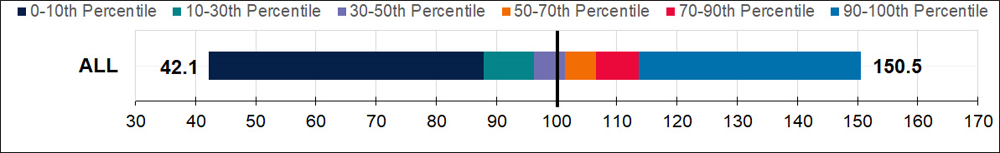
For LEAs, ELA and math growth scores are provided by: 1) race/ethnicity groups, 2) program participation, and 3) English Learner Status. Note: The EL “Academic Accountability” student group includes current EL students plus EL students reclassified for up to four years. The EL “Only” student group includes students who are currently EL.
For schools, ELA and math growth scores are provided by: 1) race/ethnicity groups, 2) program participation, 3) English Learner Status, and 4) school type.

Figure 1: Distributions of Growth Scores for Student Groups at the LEA Level for English Language Arts (ELA) during the 2018–19 School Year
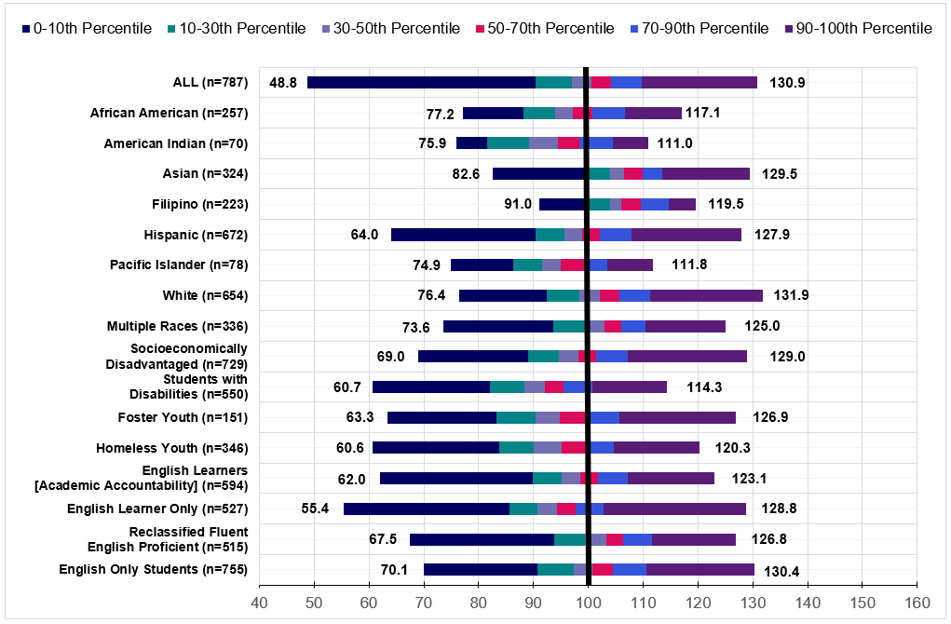

Descriptive Text for Figure 1: Distributions of Growth Scores for Student Groups at the LEA Level for English Language Arts (ELA) during the 2018–19 School Year
Student Group | n-size | Minimum  (Zero Percentile) | 10th Percentile | 30th Percentile | 50th Percentile | 70th Percentile | 90th Percentile | Maximum (100th Percentile)
ALL | 787 | 48.8 | 90.3 | 97.0 | 100.6 | 104.1 | 109.7 | 130.9
African American | 257 | 77.2 | 88.2 | 93.9 | 97.2 | 100.8 | 106.8 | 117.1
American Indian | 70 | 75.9 | 81.5 | 89.1 | 94.5 | 98.3 | 104.5 | 111.0
Asian | 324 | 82.6 | 99.7 | 103.9 | 106.5 | 110.0 | 113.5 | 129.5
Filipino | 223 | 91.0 | 99.7 | 103.9 | 106.1 | 109.5 | 114.7 | 119.5
Hispanic | 672 | 64.0 | 90.3 | 95.6 | 98.9 | 102.1 | 107.9 | 127.5
Pacific Islander | 78 | 74.9 | 86.2 | 91.5 | 94.9 | 100.0 | 103.5 | 111.8
White | 654 | 76.4 | 92.4 | 98.4 | 102.1 | 105.6 | 111.3 | 131.9
Multiple Races | 336 | 73.6 | 93.5 | 99.3 | 103.0 | 106.0 | 110.5 | 125.0
Socioeconomically Disadvantaged | 729 | 62.0 | 89.9 | 95.1 | 98.5 | 101.8 | 107.2 | 123.1
Students with Disabilities | 550 | 70.1 | 90.8 | 97.3 | 100.8 | 104.6 | 110.6 | 130.4
Foster Youth | 151 | 67.5 | 93.7 | 99.5 | 103.3 | 106.3 | 111.7 | 126.8
Homeless Youth | 346 | 55.4 | 85.6 | 90.7 | 94.4 | 97.6 | 102.8 | 128.8
English Learners (Academic Accountability Definition) | 594 | 62.0 | 89.9 | 95.1 | 98.5 | 101.8 | 107.2 | 123.1
English Learner Only | 527 | 55.4 | 85.6 | 90.7 | 94.4 | 97.6 | 102.8 | 128.8
Reclassified Fluent English Proficient | 515 | 67.5 | 93.7 | 99.5 | 103.3 | 106.3 | 111.7 | 126.8
English Only Students | 755 | 70.1 | 90.8 | 97.3 | 100.8 | 104.6 | 110.6 | 130.4
The LEA growth scores for ELA in the 30th to the 70th percentile for race/ethnicity student groups and program participation student groups are very similar (no more than 14.8 points difference).

Figure 2: Distributions of Growth Scores for Student Groups at the LEA Level for Mathematics during the 2018–19 School Year
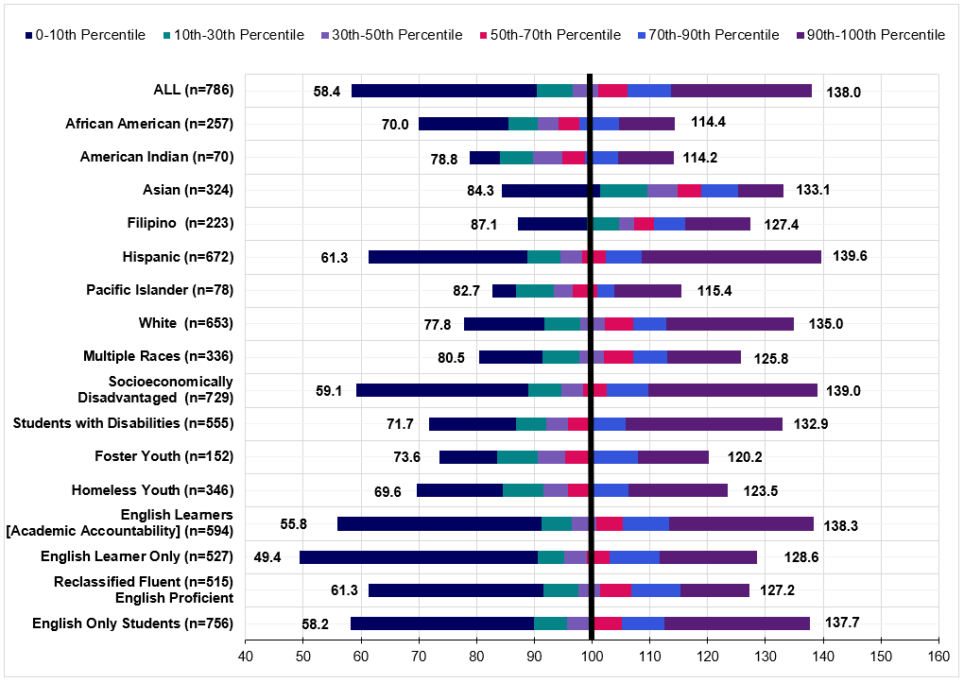

Descriptive Text for Figure 2: Distributions of Growth Scores for Student Groups at the LEA Level for Mathematics during the 2018–19 School Year
Student Group | n-size | Minimum (Zero Percentile) | 10th Percentile | 30th Percentile | 50th Percentile | 70th Percentile | 90th Percentile | Maximum (100th Percentile)
ALL | 786 | 58.4 | 90.4 | 96.6 | 101.0 | 106.1 | 113.7 | 138.0
African American | 257 | 70.0 | 85.4 | 90.7 | 94.1 | 97.8 | 104.6 | 114.4
American Indian | 70 | 78.8 | 84.0 | 89.8 | 94.8 | 98.8 | 104.5 | 114.2
Asian | 324 | 84.3 | 101.4 | 109.6 | 114.8 | 118.9 | 125.3 | 133.1
Filipino | 223 | 87.1 | 99.1 | 104.7 | 107.3 | 110.7 | 116.1 | 127.4
Hispanic | 672 | 61.3 | 88.8 | 94.5 | 98.3 | 102.3 | 108.6 | 139.6
Pacific Islander | 78 | 82.7 | 86.8 | 93.4 | 96.7 | 101.0 | 103.8 | 115.4
White | 653 | 77.8 | 91.7 | 97.9 | 102.2 | 107.0 | 112.8 | 135.0
Multiple Races | 336 | 80.5 | 91.5 | 97.8 | 102.1 | 107.0 | 113.0 | 125.8
Socioeconomically Disadvantaged | 729 | 59.1 | 89.0 | 94.7 | 98.4 | 102.6 | 109.8 | 139.0
Students with Disabilities | 555 | 71.7 | 86.9 | 92.1 | 95.7 | 99.9 | 105.8 | 132.9
Foster Youth | 152 | 73.6 | 83.6 | 90.5 | 95.4 | 100.1 | 108.0 | 120.2
Homeless Youth | 346 | 69.6 | 84.5 | 91.5 | 95.8 | 100.3 | 106.3 | 123.5
English Learners (Academic Accountability Definition) | 594 | 55.8 | 91.3 | 96.5 | 100.6 | 105.3 | 113.3 | 138.3
English Learner Only | 527 | 49.4 | 90.6 | 95.1 | 99.1 | 103.1 | 111.6 | 128.6
Reclassified Fluent English Proficient | 515 | 61.3 | 91.6 | 97.6 | 101.4 | 106.9 | 115.2 | 127.2
English Only Students | 756 | 58.2 | 90.0 | 95.7 | 99.9 | 105.1 | 112.5 | 137.7
LEA math growth scores in the 30th to the 70th percentile for race/ethnicity student group and program participation student groups have a wider range than ELA—up to 21.1 points vs. 14.8 for ELA.

Figure 3: Distributions of Growth Scores for Student Groups at the School Level for ELA during the 2018–19 School Year
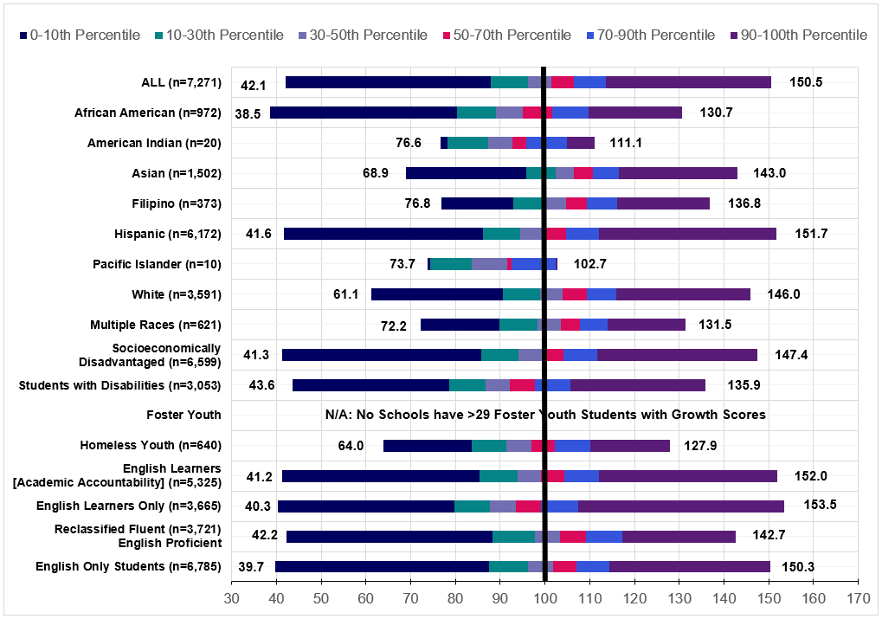

Descriptive text for Figure 3: Distributions of Growth Scores for Student Groups at the School Level for ELA during the 2018–19 School Year
Student Group | n-size | Minimum (Zero Percentile) | 10th Percentile | 30th Percentile | 50th Percentile | 70th Percentile | 90th Percentile | Maximum (100th Percentile)
ALL | 7,271 | 42.1 | 87.8 | 96.2 | 101.4 | 106.5 | 113.6 | 150.5
African American | 972 | 38.5 | 80.4 | 89.0 | 95.0 | 101.6 | 109.7 | 130.7
American Indian | 20 | 76.6 | 78.1 | 87.4 | 92.6 | 95.8 | 104.9 | 111.1
Asian | 1,502 | 68.9 | 95.8 | 102.4 | 106.5 | 110.7 | 116.4 | 143.0
Filipino | 373 | 76.8 | 92.9 | 100.3 | 104.7 | 109.4 | 116.2 | 136.8
Hispanic | 6,172 | 41.6 | 86.1 | 94.5 | 99.9 | 104.6 | 112.1 | 151.7
Pacific Islander | 10 | 73.7 | 74.3 | 83.6 | 91.5 | 92.4 | 102.3 | 102.7
White | 3,591 | 61.1 | 90.5 | 98.8 | 103.9 | 109.3 | 115.9 | 146.0
Multiple Races | 621 | 72.2 | 89.9 | 98.3 | 103.5 | 107.8 | 113.9 | 131.5
Socioeconomically Disadvantaged | 6,599 | 41.3 | 85.7 | 94.0 | 99.2 | 104.2 | 111.8 | 147.4
Students with Disabilities | 3,053 | 43.6 | 78.6 | 86.6 | 92.2 | 97.7 | 105.7 | 135.9
Foster Youth | n/a* | n/a | n/a | n/a | n/a | n/a | n/a | n/a
Homeless Youth | 640 | 64.0 | 83.6 | 91.3 | 96.9 | 102.3 | 110.1 | 127.9
English Learners (Academic Accountability Definition) | 5,325 | 41.2 | 85.3 | 93.8 | 99.1 | 104.3 | 112.0 | 152.0
English Learner Only | 3,665 | 40.3 | 79.8 | 87.8 | 93.4 | 99.0 | 107.4 | 153.5
Reclassified Fluent English Proficient | 3,721 | 42.2 | 88.2 | 97.7 | 103.4 | 109.2 | 117.4 | 142.7
English Only Students | 6,785 | 39.7 | 87.5 | 96.3 | 101.8 | 107.1 | 114.5 | 150.3
*Note: No schools had a n-size of 30 or more for foster youth. The range of school level ELA growth scores in the 30th to 70th percentiles is slightly larger than at the LEA level –up to 18.8 points vs. 14.8 points

Figure 4: Distributions of Growth Scores for Student Groups at the School Level for Mathematics during the 2018–19 School Year
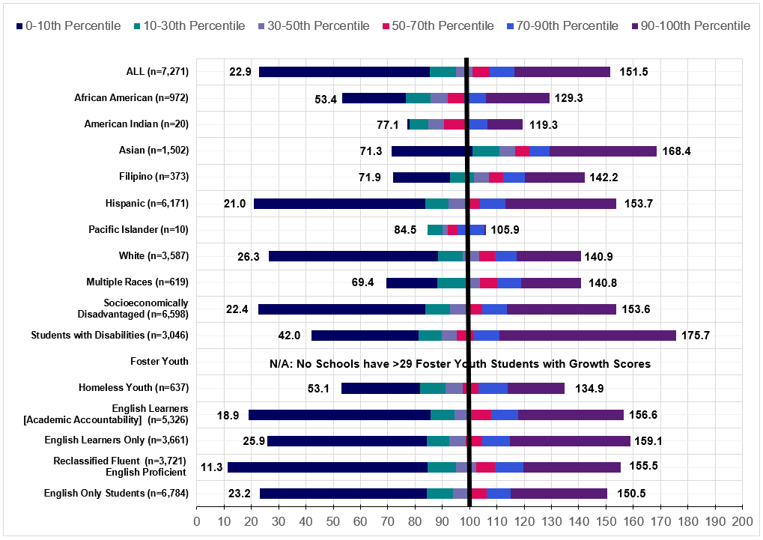

Descriptive Text for Figure 4: Distributions of Growth Scores for Student Groups at the School Level for Mathematics during the 2018–19 School Year
Student Group | n-size | Minimum (Zero Percentile) | 10th Percentile | 30th Percentile | 50th Percentile | 70th Percentile | 90th Percentile | Maximum (100th Percentile)
ALL | 7,271 | 85.4 | 94.9 | 101.1 | 107.4 | 116.3 | 151.5 | 22.9
African American | 972 | 76.6 | 85.7 | 92.1 | 97.9 | 106.0 | 129.3 | 53.4
American Indian | 20 | 78.1 | 85.0 | 90.6 | 98.7 | 106.5 | 119.3 | 77.1
Asian | 1,502 | 101.1 | 111.0 | 116.8 | 121.8 | 129.4 | 168.4 | 71.3
Filipino | 373 | 92.7 | 101.7 | 107.0 | 112.4 | 120.2 | 142.2 | 71.9
Hispanic | 6,171 | 83.7 | 92.4 | 98.3 | 103.9 | 113.1 | 153.7 | 21.0
Pacific Islander | 10 | 84.5 | 89.9 | 91.9 | 95.6 | 105.3 | 105.9 | 84.5
White | 3,587 | 88.4 | 97.6 | 103.5 | 109.4 | 117.3 | 140.9 | 26.3
Multiple Races | 691 | 88.3 | 98.9 | 103.7 | 110.0 | 118.9 | 140.8 | 69.4
Socioeconomically Disadvantaged | 6,598 | 83.9 | 92.8 | 98.8 | 104.7 | 113.7 | 153.6 | 22.4
Students with Disabilities | 3,046 | 81.3 | 89.8 | 95.3 | 101.3 | 111.0 | 175.7 | 42.0
Foster Youth | n/a* | n/a | n/a | n/a | n/a | n/a | n/a | n/a
Homeless Youth | 637 | 81.9 | 91.2 | 97.4 | 103.4 | 114.0 | 134.9 | 53.1
English Learners (Academic Accountability Definition) | 5,326 | 85.6 | 94.5 | 100.8 | 107.8 | 117.7 | 156.6 | 18.9
English Learner Only | 3,661 | 84.4 | 92.5 | 98.5 | 104.6 | 114.9 | 159.1 | 25.9
Reclassified Fluent English Proficient | 3,721 | 84.7 | 95.1 | 102.3 | 109.3 | 119.6 | 155.5 | 11.3
English Only Students | 6,784 | 84.2 | 93.9 | 100.2 | 106.2 | 115.2 | 150.5 | 23.2
*Note: No schools had an n-size of 30 or more for foster youth. The range of school level mathematics growth scores in 30th to 70th percentiles is slightly larger than at the LEA level –up to 26.2 points vs. 21.1

Figure 5: Distributions of Growth Scores for School Type at the School Level for ELA during the 2018-19 School Year
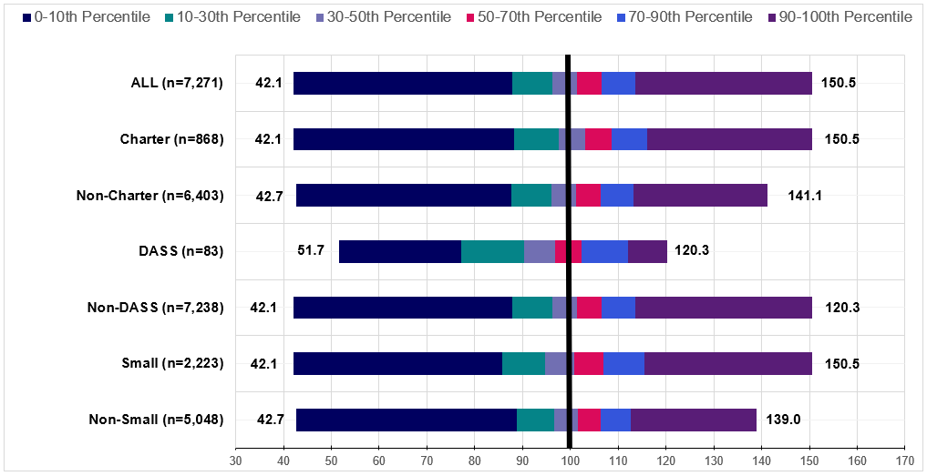

Descriptive Text for Figure 5: Distributions of Growth Scores for School Type at the School Level for English Language Arts (ELA) during the 2018–19 School Year
School Type | n-size | Minimum  (Zero Percentile) | 10th Percentile | 30th Percentile | 50th Percentile | 70th Percentile | 90th Percentile | Maximum (100th Percentile)
ALL | 7,271 | 42.1 | 87.8 | 96.2 | 101.4 | 106.5 | 113.6 | 150.5
Charter | 868 | 42.1 | 88.2 | 97.5 | 103.1 | 108.6 | 116.1 | 150.5
Non-Charter | 6,403 | 42.7 | 87.7 | 96.0 | 101.2 | 106.3 | 113.1 | 141.1
DASS | 83 | 51.7 | 77.1 | 90.2 | 96.9 | 102.3 | 112.0 | 120.3
Non-DASS | 7,238 | 42.1 | 87.8 | 96.2 | 101.4 | 106.5 | 113.6 | 150.5
Small | 2,223 | 42.1 | 85.8 | 94.7 | 100.9 | 106.8 | 115.5 | 150.5
Non-Small | 5,048 | 42.7 | 88.8 | 96.7 | 101.6 | 106.3 | 112.7 | 139.0
By school type, the difference in the ELA growth score range in the 30th to 70th percentiles are smaller than at the LEA level. By school type, the range is 7.5 points compared to 14.8 points at the LEA level.

Figure 6: Distributions of Growth Scores for School Type at the School Level for Mathematics during the 2018–19 School Year

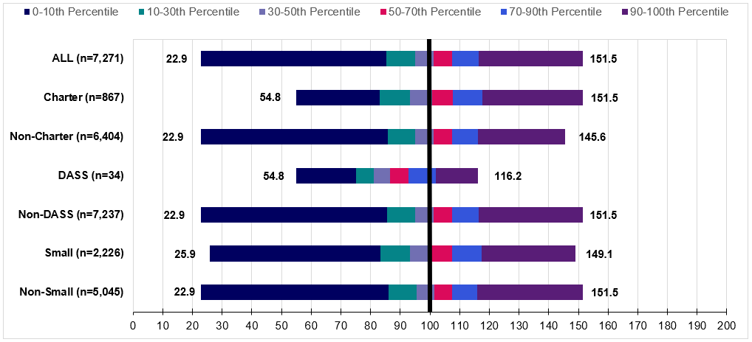

Descriptive Text for Figure 6: Distributions of Growth Scores for School Type at the School Level for Mathematics during the 2018–19 School Year
School Type | n-size | Minimum  (Zero Percentile) | 10th Percentile | 30th Percentile | 50th Percentile | 70th Percentile | 90th Percentile | Maximum (100th Percentile)
ALL | 7,271 | 22.9 | 85.4 | 94.9 | 101.1 | 107.4 | 116.3 | 151.5
Charter | 867 | 54.8 | 83.0 | 93.3 | 100.7 | 107.6 | 117.6 | 151.1
Non-Charter | 6,404 | 22.9 | 85.8 | 95.0 | 101.2 | 107.4 | 116.2 | 145.6
DASS | 34 | 54.8 | 75.2 | 81.2 | 90.2 | 92.7 | 101.9 | 116.2
Non-DASS | 7,237 | 22.9 | 85.5 | 95.0 | 104.1 | 107.4 | 116.4 | 151.5
Small | 2,226 | 25.9 | 83.4 | 93.2 | 103.5 | 107.3 | 117.4 | 149.1
Non-Small | 5,045 | 22.9 | 86.2 | 95.5 | 104.3 | 107.4 | 116.0 | 151.5
By school type, the difference in the mathematics growth score range in the 30th to 70th percentiles is also smaller than at the LEA level. By school type the range is 14.9 points compared to 21 points at the LEA level.

The CDE recommends that the SBE adopt the student growth model and the following methodologies be used to report aggregated student growth:

- Report the EBLP weighted average for:

- Schools

- Student groups in a school

- The “All” student group in an LEA

- Student groups in a district if 500 or fewer students (with test scores make up the student group

- At the LEA level, report the simple average for all race/ethnicity and program participation student groups with more than 500 scores.

Attachment 2

Activities under Consideration for 2021
The State Board of Education (SBE) annually reviews the California School Dashboard (Dashboard) indicators and performance standards to consider whether changes or improvements are needed based on newly available data, recent research, new statutory requirements, and feedback from stakeholders. The annual review process requires that the California Department of Education (CDE) update the SBE at their March meeting on which indicators are under consideration for review and/or revisions for action by the SBE. In 2021, the presentation of the workplan was delayed from the March SBE meeting to May due to the recent accountability wavier announced by the U.S. Department of Education (ED) in February 2021 and granted to California in March 2021.

DASS Positive Transition Rate
In November 2020, the California Advisory Task Force on Alternative Schools (Task Force) presented a report and recommendations to the SBE. One recommendation was to develop a new local indicator for DASS schools: positive transition rate. Such a measure would focus on alternative school students’ continued path to further education and might include:
- A return to a traditional comprehensive high school,
- Enrollment in a non-DASS General Education Diploma program or Adult Education program,
- Joining the military, or
- Participating in the Job Corps or Youth Build Program.
While the Task Force recommended that this data be reported through a local indicator, any changes to LCFF criteria would require a change in current statute. An alternative option is for the CDE to report this data, captured using the California Longitudinal Pupil Achievement Data System (CALPADS) exit codes for DASS students, in an Additional Report. The Task Force, as indicated in their report (John W. Gardner Center, 2020, p. 13), would use the data in the following manner:

These data would provide a more complete picture of how many youth are continuing on an education path and how many are actually dropping out altogether, since not all students who exit K-12 secondary schools are dropping out of a continuing education pathway. Indeed, a central goal of many DASS schools is to prepare students for a transition back to a traditional comprehensive school within their district. A positive transition rate would recognize the success rate of schools with a transfer-back school design or goal for students.

As well, a positive transition rate would create incentives for alternative schools to prepare all youth to persist in a positive continuing education pathway beyond those available in the traditional K-12 system. Some schools, including the court schools and county-run community day schools, are specifically designed to help youth make successful transitions to other educational settings beyond the K-12 system, to youth employment, or to other postsecondary pathways. A positive transition rate would help these types of “second chance” programs to adequately measure progress toward their academic re-engagement and student persistence goals.

DASS Enrollment Patterns
In May 2018, when the SBE approved the methodology to calculate the DASS graduation rate, members raised concerns about the modified Graduation Rate Indicator’s potential to impact mobility between non-alternative and DASS schools. Specifically, there was concern around the potential increase of student transfers from non-alternative high schools into DASS high schools. The SBE directed the CDE to conduct analyses of enrollment data when it became available.

In August 2019, the CDE presented the SBE with an Information Memorandum, identifying the trends in student transfers from non-alternative to DASS high schools during the 2017–2018 and 2018–2019 school years (https://www.cde.ca.gov/be/pn/im/documents/memo-pptb-amard-aug19item01.docx).

The analyses showed that transfer patterns from 2017–2018 continued into the
2018–2019 school year. Monthly counts, race/ethnicity student group counts, and program student group counts all stayed relatively consistent between the 2017–2018 and 2018–2019 school years. The only exception was the notable decrease in Foster Youth in the 2018–2019 transfers. Overall, transfer patterns were not significantly different within this two-year span. Nevertheless, the CDE committed to conduct additional transfer analyses for the next two years. In April 2021, the CDE reported the enrollment patterns of DASS and non-DASS schools for the 2019–20 school year in an SBE Information Memorandum.

Student-Level Data Files
The CDE is proposing to produce student-level data files for the CCI and Academic Indicator to share with authorized LEA staff. For the past several years, LEAs have requested access to student-level reports that identify student results in both indicators. Currently, LEAs can connect to specific student-level CALPADS reports that are tied to the following Dashboard state indicators: graduation rate, chronic absenteeism, and suspension rate. While LEAs can also access CCI results through these reports, the process is cumbersome, as the indicator contains multiple measures and LEAs have to connect to multiple CALPADS reports. By developing a streamlined student-level report for the CCI and Academic Indicator, LEAs will have the data necessary to conduct deep analyses for all state indicators.

Teacher Assignment Monitoring Data
The CDE is currently preparing teacher data to meet federal reporting under the Every Student Succeeds Act (ESSA), for Dataquest, in the School Accountability Report Cards (SARCs), and on the Dashboard in response to new state requirements.

The CDE has worked with the California Commission on Teacher Credentialing (CTC) to meet the necessary reporting requirements in California’s ESSA State Plan. In February 2021, the CDE received individual teacher and course level data on “Ineffective” and “Out-of-Field” teachers for the 2019–20 academic year from the CTC. This was the first time the CDE received teacher assignment status data from the CTC. The CDE also plans on reporting information on ineffective and out of field teachers. The CDE is processing the data received by CTC for reporting purposes and anticipates making the data from the 2019–20 school year publicly available on DataQuest in spring 2021. This data will be based on the teacher equity definitions used for these reports were adopted by the SBE on November 6, 2019.

The CDE has recently collected the necessary data from the 2020–21 school year to begin the process of working with the CTC to collect the required teacher authorization and credential information to report on this data set. While the data is being processed, CDE is exploring options to use this data for state-level 2021 data reporting.

Ineffective Teacher Definition

Under this definition, teachers with the following limited emergency permits would be considered ineffective: Provisional Internship Permits; Short-Term Staff Permits;
Variable Term Waivers; or Substitute permits or Teaching Permits for Statutory Leave holders serving as the teacher of record.

Pursuant to California’s ESSA State Plan, the SBE defined an ineffective teacher as any of the following: an individual whose assignment is legally authorized by an emergency permit that does not require possession of a full teaching license; or a teacher who holds a teaching credential but does not possess a permit or authorization that temporarily allows them to teach outside of their credentialed area (misassigned); or an individual who holds no credential, permit, or authorization to teach in California.

Out of Field Teacher Definition

A credentialed out-of-field teacher is defined as: a credentialed teacher who has not yet demonstrated subject matter competence in the subject area(s) or for the student population to which he or she is assigned.

Under this definition, the following limited permits will be considered out of field: General Education Limited Assignment Permit (GELAP); Special Education Limited Assignment Permit (SELAP); Short-Term Waivers; Emergency English Learner or Bilingual Authorization Permits; or Local Assignment Options.
CTC Assignment Monitoring

CTC used the teacher assignment and course data collected in the 2019–20 Fall 2 CALPADS submission to evaluate each teacher assignment against the corresponding teacher credentials in CTC’s system to ensure proper qualification for the multiple attributes of a given course. These attributes included Subject Matter qualification, English Learner instructional strategy qualification, as well as Special Education instructional strategy qualification.

Example of a Teacher Assignment Use Case

Table 1 is an example of a teacher assignment use case illustrating examples of “Clear”, “Out of Field”, and “Ineffective” course assignments and how these would be reported as part of Full Time Employment (FTE) status.

Table 1: Ms. Smith’s Schedule by Period with Assignment Status and Authorization
Period | Course | Assignment Status | Authorizations
1 | Algebra (No Els) | Clear | Foundational Math
2 | Algebra (With EL) | Out of Field | Foundational Math  Emergency CLAD
3 | Algebra (No Els) | Clear | Foundational Math
4 | Life Science (No Els) | Out of Field | GELAP Science
5 | Algebra (With EL) | Out of Field | Foundational Math  Emergency CLAD
6 | Physical Education | Ineffective | No authorization - Misassigned

Table 2: Ms. Smith’s Assignment Status by Full Time Employment
Assignment Status | Periods | Total Periods | FTE reporting at 1.0 FTE
Clear | 2 | 6 | 0.33
Ineffective | 1 | 6 | 0.17
Out of Field | 3 | 6 | 0.5

Data Reporting Opportunities

The CDE met with stakeholders on several occasions to discuss options for reporting this data to the public. One option is to link this data, which will first be reported via DataQuest, to an additional report on the Dashboard to provide information on appropriately assigned and fully credentialed teachers by school and district. Additionally, once two years of data are available, the CDE is committed to exploring how to build out reporting on Priority Area 1 consistent with the requirements of Senate Bill 75.

DataQuest Reports and Downloadable Files

Specifically, in Spring 2021, the CDE plans to report:

- 2019–20 Teacher Assignment Monitoring related reports (on DataQuest) and downloadable files

In Summer 2021, the CDE will report on:

- 2019–20 New Staff, Course, and Class related reports (on DataQuest) and downloadable files (this will include enhanced functionality along with new supporting downloadable files)

California School Dashboard

In Fall 2021, with only one year of these data available, the CDE is currently evaluating the possibility of creating an additional report on the Dashboard focused on appropriately assigned and fully credentialed teachers by school and district. Note that two years of data are required to determine objective criteria for these data to be utilized as a statewide metric pursuant to California Education Code Section 52064.5 in order to meet the reporting requirements on Priority Area 1 under Senate Bill 75.

School Accountability Report Cards (SARCs)

For the 2020–21 School Accountability Report Card (due February 1, 2022), the CDE is prepared to pre-populate the staff tables with this data. The CDE is currently working to update these tables on the SARC and anticipate presenting the SARC template for approval at the July 2021 SBE meeting.

In summary, the CDE remains committed to continue engaging stakeholders regarding a plan for appropriately reporting teacher assignment data on our DataQuest and Downloadable web pages, on the Dashboard, and in SARCs.

Rolling Out the Communication of the Student Growth Model
In May 2021, the CDE will recommend that the SBE adopt the student growth model, which includes the Residual Gain (RG) model and the Empirical Best Linear Prediction (EBLP) methodology, as detailed in a February 2021 SBE Information Memorandum. If the SBE adopts this model, CDE will begin to report historical student growth scores in 2021. In addition, the CDE will develop a report that displays the English Language Proficiency Assessments for California (ELPAC) levels with a growth score.

CDE will also begin the development of a communication plan for the student growth model, based on feedback from focus groups and outreach to stakeholder groups.

Upon adoption of the growth model, CDE plans to report historical student growth scores in 2021 at the LEA, school, and student group levels. To support educators, families, and the public, the CDE is developing a communications plan to assist the public with the interpretations and purpose of these data. The CDE will continue to solicit feedback from focus groups and stakeholders on the best approach to display this data in the future. In addition, the CDE will develop a report that displays the English Language Proficiency Assessment for California levels with growth score results.

It is important to note that the next time a growth model using current data can be produced is in December 2024. Three years of the California Assessment of Student Performance and Progress (CAASPP) summative assessment scores are required to produce growth results. Due to the suspension of summative assessments in the spring of 2020 and subsequent action related to assessments in 2021, there will likely be a two-year gap in statewide assessment results. It would be inappropriate to use data prior to the pandemic in the calculation of future growth scores. Therefore, the next growth results will include CAASPP assessments from the spring of 2022, 2023, and 2024.

Update on the Development of New College/Career Indicator Measures
The CDE remains committed to building out the CCI over several years as data becomes available to include additional career measures. In 2021, the CDE will work with the CCI Work Group and Task Force to develop two new measures for possible inclusion in the CCI: civic engagement and industry certifications.

As shared with the SBE in an August 2019 Information Memorandum, the CDE is examining the inclusion of civic engagement as a potential career measure in the CCI. California Education Code sections 51470–51474 direct the State Superintendent of Public Instruction to develop, and the SBE to adopt, a set of criteria for awarding the SSCE, a seal to be awarded to students who have demonstrated excellence in civics education and participation and an understanding of the United States Constitution and the democratic system of government. In September 2020, the SBE adopted the State Seal of Civic Engagement (SSCE), and the SBE directed the CDE to determine how to incorporate civic engagement into the CCI. The CDE convened a policy and technical work group – the Civic Engagement Work Group (CEWG) – to conduct research on how other states were incorporating civic engagement into their accountability systems and explore possible criteria for a civic engagement measure that could be included in California’s CCI. The CEWG has met three times since spring 2020. Due to much-needed systemic improvements to the CALPADS and a re-architecture of the system to increase its ability to ingest and process data, no new data will be collected in CALPADS during the 2021–22 school year. However, the CDE will continue to develop this measure throughout 2021 so that it can be added to the CALPADS collection system in the 2022–23 school year.

The CDE is developing an industry certification measure for possible inclusion in the CCI. Due to the systemic improvements to the CALPADS during the 2021–22 school year, industry certifications will not be collected in CALPADS until the 2022–23 school year. CDE will work closely with the CCI Work Group and the Alternative Task Force, throughout 2021 to refine the measure and propose placement criteria so that it can be collected in CALPADS in the 2022–23 school year.

As consistent with the adoption process for other CCI measures, the CDE will conduct simulations for each measure under consideration and share its analyses with the Technical Design Group (TDG), along with the CCI Work Group, the Task Force, and the CPAG, in order to: (1) determine if the measures are valid and reliable, and (2) set criteria that graduates must meet to be placed in the Prepared or Approaching Prepared CCI levels. Once these determinations are made, the CDE will make its recommendations to the SBE for consideration.

Update on the English Learner Progress Indicator

The CDE remains committed to reporting on the ELPI Status, Change, and overall performance color when three years of valid and reliable ELPAC Summative assessment results are available.

2021 Reporting
The ED invited states to request a waiver for the 2020–21 school year of the accountability and school identification requirements in the Elementary and Secondary Education Act of 1965 (ESEA). A state receiving this waiver would not be required to implement and report the results of its accountability system, including calculating progress toward long-term goals and measurements of interim progress or indicators or to annually meaningfully differentiate among its public schools using data from the 2020–21 school year.
On April 6, 2021, the ED approved the waiver. The CDE is in conversations with the California State Legislature to ensure alignment with state accountability requirements. In place of reporting the typical Dashboard, the CDE is proposing to develop reports inspired by the LCFF Priority Snapshots, which were produced prior to the CDE’s development of the Dashboard for informational purposes only for LEAs and schools. These reports would not contain performance determinations, but would reside in the Dashboard, as a modified Dashboard, and provide data at the LEA, school, and student-group levels in three priority areas – student achievement, student engagement, and school climate – and assist LEAs in the development of their Local Control and Accountability Plans. Data elements that could be included in these reports include:
- Enrollment Data
- English learner (EL) reclassification rates
- Chronic absenteeism rates
- Suspension rates
- Expulsion rates
- Graduation rates (combined and DASS one-year graduation rates)
- High school dropout rates
- High school graduates’ completion rates for “a-g,” CTE pathway, state seal of biliteracy, apprenticeships, and other CCI measures
- Advanced Placement Exams
- Percentage of students earning college credit

Hosting a modified Dashboard would also allow LEAs to upload their local indicator data, providing greater transparency.

Attachment 3

California School Dashboard Educational Outreach Activities

Table 1.
California Department of Education Policy Work Group Meetings

Date | Organization | Estimated Number of Attendees | Topics
November 19, 2020 | Technical Design Group (TDG) | 8 | - Update on Assessments: Moving to Short Form  - Update on student growth model  - Modifying the Participation Rate for Dashboard Alternative School Status (DASS) Schools  - Suspension Rate Indicator
December 15, 2020 | TDG | 8 | - Student growth model  - Chronic Absenteeism Indicator

Table 2.
Virtual Meetings/Conferences

Date | Organization | Estimated Number of Attendees | Topics
November 16, 2020 | Regional Assessment Network (RAN) | 24 | - Student growth model  - New Absent-by-Type Reports
November 18, 2020 | Bilingual Coordinators’ Network (BCN) | 110 | - 2020-21 School Year English Learner Progress Indicator (ELPI) Workplan  - EL Student Group Web Page
December 2, 2020 | San Bernardino County Accountability Network (SBCAN) | N/A | - Data Reported in 2020 Dashboard  - What Does 2021 Hold for the Dashboard?
December 4, 2020 | State and Federal Program Directors (SFPD) | 298 | - Transformation of Growth Scores  - Topics for December 2020 California Practitioners Advisory Group (CPAG) Meeting
December 11, 2020 | California Practitioners Advisory Group (CPAG) | 36 | - Student growth model  - Update on DASS Accountability under ESSA State Plan and Amendments
January 15, 2021 | SFPD | 293 | - Update on the 2020 Dashboard  - Update on the student growth model
January 14, 2021 | Association of California School Administrators (ACSA) Middle Grades Education Council | 94 | - Statewide assessment plan for 2020-21  - What data will be reported on the 2020 California School Dashboard  - Status of schools identified for Comprehensive Support and Improvement (CSI) and Additional Targeted Support and Improvement (ATSI)
January 21, 2021 | Los Angeles Unified School District | 46 | - Overview of the CCI  - New CCI measures
January 25, 2021 | ACSA Elementary Grades Education Council | 120 | - Update on actions taken by the SBE in January 2021 and pending work for 2021
January 27, 2021 | ACSA Secondary Education Council | 98 | - Update on actions taken by the SBE in January 2021 and pending work for 2021
February 3, 2021 | San Diego CTE Leaders Network Meeting | 37 | - Update on CCI measures
February 11,2021 | Advisory Commission on Charter Schools | 9 | - Assembly Bill 1505 performance category criteria
February 12, 2021 | State and Federal Program Directors (SFPD) | 264 | - 2021 Accountability Work Plan  - Overview of ELPI Status and Change  - 2021 ELPI Update  - EL Students in California Web Page
February 17, 2021 | Advisory Commission on Special Education (ACSE) | 25 | - What Data Are and Are Not Available at the State Level?  - California Longitudinal Pupil Achievement Data System (CALPADS) Reports that Reflect California School Dashboard (Dashboard) Data
February 19, 2021 | California Practitioners Advisory Group | 22 | - Reporting Options for 2021  - Recommendations for the student growth model
February 23, 2021 | Juvenile Court, Community and Alternative School Administrators of California  (JCCASAC) | 71 | - October 2020 Letter from U.S. Department of Education (ED) on the Dashboard Alternative School Status (DASS) and Next Steps  - February 24, 2021 SBE Meeting  - College/Career Indicator (CCI): Collecting New Career Measures in 2020-21  - Modified Participation Rate for DASS Schools  - Local Indicator: Positive Transition Rate for DASS Schools
February 23, 2020 | Local Control Funding Formula (LCFF) Stakeholder Meeting | 14 | - Student growth model
March 2, 2021 | Sacramento County CTE Leaders Network Meeting | 22 | - Update on CCI measures
March 3, 2021 | San Bernardino Counselors Conference | 6 | - Overview of Available Data  - Absenteeism by Reason DataQuest Report  - College/Career Indicator (CCI)
March 19, 2021 | State and Federal Program Directors (SFPD) | 285 | - February and May 2021 State Board of Education (SBE) Meetings and Accountability Waiver Request to U.S. Department of Education (ED)  - Future Dashboard Reporting  - What Data Could We Report in 2021–22?  - Feedback from Members
March 23, 2021 | Southern Coastal Region CTE Meeting | 8 | - February and May SBE Meetings and Waiver Request to ED  - Responding to Your CCI Questions  - Update on New Career Measures
March 23, 2021 | California Association of Bilingual Educators | 275 | - Update on English Language Progress Indicator (ELPI)  - Description of English Learner Typologies
March 24, 2021 | Regional Assessment Network (RAN) | 51 | - February and May 2021 SBE Meetings and Accountability Waiver Request to ED  - Future Dashboard Reporting  - What Data Could We Report in 2021–22?  - Feedback from Members
March 26, 2021 | Riverside County Assessment Network (RCAN) | 75 | - February and May 2021 SBE Meetings and Accountability Waiver Request to ED  - Future Dashboard Reporting  - What Data Could We Report in 2021–22?  - Feedback from Members
March 26, 2021 | ACSA Elementary, Middle Grades, and Secondary Education Councils | 25 | - February and May 2021 SBE Meetings and Accountability Waiver Request to ED  - Future Dashboard Reporting  - What Data Could We Report in 2021–22?  - Feedback from Members
March 26, 2021 | California Association of Bilingual Educators | 75 | - Update on English Learners in the System of Support and data used for Local Control Accountability Plan (LCAP)  - Update on locally available English Learner data in the CALPADS system
March 30, 2021 | Bilingual Coordinators Network | 75 | - Update on English Learner Accountability  - Update on the 2021 English Learner Progress Indicator (ELPI) Work Plan
March 30, 2021 | Network to Advance State Attendance Policy and Practice | 24 | - Overview of California’s reporting of Chronic Absence and Absence by Type Reports

Table 3

Webinars

Date | Organization | Estimated Number of Attendees | Topics
November 10, 2020 | Supports for English Learners through California’s System of Support | 440 | - English Learner (EL) RFEP, LTEL, and AR-LTEL DataQuest Reports  - State Level Educational Outcomes of ELS  - Accountability Outcomes for ELs on the Dashboard  - EL Students in California Web Page  - District and School Support for ELs
November 18, 2020 | California Education and Research Association Annual Conference | 78 | - How California will be measuring and reporting Student-Level Academic Growth for schools, districts, and student groups  - Update on the California School Dashboard (Dashboard) and Accountability Data in 2020
December 8, 2020 | AB 1505 Verified Data Technical Assistance Webinar | 293 | - Background Information  - Adopted Academic Progress Indicators  - Utilizing CAASPP Data  - Adopted Postsecondary Indicators
January 28, 2021 | CDE Tuesday @ 2 Webinar Series: Information on 2020 Data | 879 | - Update on data available for the 2019-20 school year in absence of state and local indicators being reported on the Dashboard.  - Overview of where to find related data in CALPADS.
February 18, 2021 | CDE Tuesday @ 2 Webinar Series: Information on 2020 Data, Part II | 480 | - EL data on DataQuest  - EL Reports in CALPADS  - EL Students in California Web Page
March 24, 2021 | CDE | 1,400 | - Assessment, Accountability, and System of Support Update

