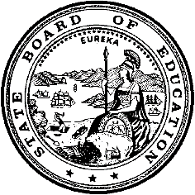
California Department of Education
Executive Office
SBE-003 (REV. 11/2017)
sbe-may26item01

California State Board of Education
May 2026 Agenda
Item #01

Subject
STATE BOARD PROJECTS AND PRIORITIES.
Including, but not limited to, future meeting plans; agenda items; and officer nominations and/or elections; State Board appointments and direction to staff; declaratory and commendatory resolutions; Bylaw review and revision; Board policy; approval of minutes; Board President and liaison reports; training of Board members; and other matters of interest.

Type of Action
Action, Information

Summary of the Issue(s)
- State Superintendent of Public Instruction’s Report
- State Board of Education President’s Report
- SBE Draft Preliminary Report of Actions/Minutes for the March 11-12, 2026 meeting
- Board member liaison reports

Recommendation
The SBE staff recommends that the SBE:
- Approve the Preliminary Report of Actions/Minutes for the March 11-12, 2026 meeting. (Attachment 1)

Brief History of Key Issues
At each regular meeting, the State Board has traditionally had an agenda item under which to address “housekeeping” matters, such as agenda planning, non-closed session litigation updates, non-controversial proclamations and resolutions, bylaw
review and revision, Board policy; Board minutes; Board liaison reports; and other matters of interest. The State Board has asked that this item be placed appropriately on each agenda.

Fiscal Analysis (as appropriate)
Not applicable.

Attachment(s)
Attachment 1: State Board of Education Draft Preliminary Report of Actions/Minutes for the March 11-12, 2026 meeting (16 Pages) may be viewed at the following link: http://www.cde.ca.gov/be/mt/ms/.

