Science SMC Meeting
March 18, 2016
Attachment 7: High School Vignette

High School ESS Vignette: Keeping it cool – Engineering solutions to urban heat islands
Performance Expectations
Students who demonstrate understanding can:
HS-ESS2-4. Use a model to describe how variations in the flow of energy into and out of Earth’s systems result in changes in climate. [Clarification Statement: Examples of the causes of climate change differ by timescale, over 1-10 years: large volcanic eruption, ocean circulation; 10-100s of years: changes in human activity, ocean circulation, solar output; 10-100s of thousands of years: changes to Earth's orbit and the orientation of its axis; and 10-100s of millions of years: long-term changes in atmospheric composition.] [Assessment Boundary: Assessment of the results of changes in climate is limited to changes in surface temperatures, precipitation patterns, glacial ice volumes, sea levels, and biosphere distribution.]
HS-ESS3-1. Construct an explanation based on evidence for how the availability of natural resources, occurrence of natural hazards, and changes in climate have influenced human activity. [Clarification Statement: Examples of key natural resources include access to fresh water (such as rivers, lakes, and groundwater), regions of fertile soils such as river deltas, and high concentrations of minerals and fossil fuels. Examples of natural hazards can be from interior processes (such as volcanic eruptions and earthquakes), surface processes (such as tsunamis, mass wasting, and soil erosion), and severe weather (such as hurricanes, floods, and droughts). Examples of the results of changes in climate that can affect populations or drive mass migrations include changes to sea level, regional patterns of temperature and precipitation, and the types of crops and livestock that can be raised.]
HS-ESS3-4. Evaluate or refine a technological solution that reduces impacts of human activities on natural systems.* [Clarification Statement: Examples of data on the impacts of human activities could include the quantities and types of pollutants released, changes to biomass and species diversity, or areal changes in land surface use (such as for urban development, agriculture and livestock, or surface mining). Examples for limiting future impacts could range from local efforts (such as reducing, reusing, and recycling resources) to large-scale geoengineering design solutions (such as altering global temperatures by making large changes to the atmosphere or ocean).]
HS-ESS3–5. Analyze geoscience data and the results from global climate models to make an evidence-based forecast of the current rate of global or regional climate change and associated future impacts to Earth systems. [Clarification Statement: Examples of evidence, for both data and climate model outputs, are for climate changes (such as precipitation and temperature) and their associated impacts (such as on sea level, glacial ice volumes, or atmosphere and ocean composition).] [Assessment Boundary: Assessment is limited to one example of a climate change and its associated impacts.]
HS-ETS1-1. Analyze a major global challenge to specify qualitative and quantitative criteria and constraints for solutions that account for societal needs and wants.
HS-ETS1-2. Design a solution to a complex real-world problem by breaking it down into smaller, more manageable problems that can be solved through engineering.
HS-ETS1-3. Evaluate a solution to a complex real-world problem based on prioritized criteria and trade-offs that account for a range of constraints, including cost, safety, reliability, and aesthetics, as well as possible social, cultural, and environmental impacts.
*The performance expectations marked with an asterisk integrate traditional science content with engineering through a practice or disciplinary core idea.

Highlighted  Science and Engineering Practices  Asking questions and defining problems  Planning and carrying out investigations  Analyzing and interpreting data  Developing and using models  Constructing explanations and designing solutions  Engaging in argument from evidence | Highlighted  Disciplinary Core Ideas  ESS3.D Global Climate Change  ESS3.C: Human Impacts on Earth Systems | Highlighted  Crosscutting Concepts  Systems and system models  Energy and matter: Flows, cycles, and conservation
Highlighted California Environmental Principles & Concepts:
Principle I The continuation and health of individual human lives and of human communities and societies depend on the health of the natural systems that provide essential goods and ecosystem services.
Principle II The long-term functioning and health of terrestrial, freshwater, coastal and marine ecosystems are influenced by their relationships with human societies.
Principle V Decisions affecting resources and natural systems are complex and involve many factors.
CA CCSC Math Connections: MP.1, MP.2, MP.3, MP.4, MP.7, S-ID 3, S-ID 5, S-ID 9, S-IC 6
CA CCSC ELA/Literacy Connections: W.9-10.1a-f, W.9-10.6, SL.9-10.1a-d, RST.9-10.1, RST.9-10.3, RST.9-10.7, RST.9-10.9, WHST.9-10.1a-e, WHST.9-10.6, WHST.9-10.7, WHST 9-10.9
CA ELD Connections: ELD.9-10.P1.1.Ex–Br, ELD.9-10.P1.3.Ex–Br, ELD.9-10.P1.6.Ex–Br, ELD.9-10.P1.10.Ex–Br

Introduction
By discovering that certain urban areas are much hotter than their surroundings, students apply and refine their existing model about Earth’s energy balance. They articulate the mechanisms by which human activities can alter the local climate system and ultimately design measures to reduce that impact.

Length and position in course – This vignette describes 2-3 weeks of instruction and could serve as the first lesson in an instructional segment on urban geoscience. It describes how different land uses involve changes to surface materials. Activities related to the water cycle will naturally follow from this vignette because these same changes to the surface also have a dramatic impact on the hydrosphere.

Prior knowledge – This vignette could support and extend students’ existing models [SEP-2] of Earth’s energy balance (as introduced in IS2 of this course), or the vignette could provide students initial exposure to the factors that affect a system’s temperature (that could later be extended to the global scale [CCC-3] of Earth’s climate).

Students will need basic skills in navigating digital maps (such as Google Earth). They will need to interpret aerial and satellite imagery, which is a unique skill (i.e., can they distinguish a small home from a commercial building in a satellite image?). While this vignette provides opportunities to develop those skills, they are not specifically addressed in this lesson outline.

Teacher background – Urban scientists use the term ‘built’ environment to describe landscapes that have been constructed and altered by humans (i.e., ‘man-made’). Urban heat islands are a well-known phenomenon where materials of the built environment absorb and retain energy more readily than surrounding natural landscapes. Urban areas that use these materials surrounded by more rural landscapes with more natural materials are like islands of warm temperatures. There are three main ways that urban land use alters the local energy balance: 1) Natural materials tend to reflect more light than artificial materials; 2) Natural landscapes retain water but most urban surfaces are designed to drain water very efficiently. Since water has such a high heat capacity, natural landscapes that retain it heat up slower than built ones. That water can also evaporate, which takes thermal energy with it and leaves the surface cooler; and 3) Human activities generate excess heat locally. Heating and cooling buildings, combusting fuels in vehicles, using electrical appliances, and industrial processes are all examples that generate heat.

Urban settings – The urban geoscience unit is focused on issues facing the local community, and this vignette introduces a range of local data available freely on the Internet. Despite the use of the word ‘urban’, heat island effects occur most places that humans modify landscapes. Small towns, farm houses, and even different species of crops have different thermal properties and affect local temperatures. As such, this vignette should have broad application in most California communities, urban and rural.

5E Learning – This sequence is based on an iterative 5E model where each activity has a role in the 5Es, but each activity also needs to include each of the 5Es along the way. The 5Es parallel the science and engineering practices (SEPs) of NGSS in many ways, but apply them in the perspective of lesson design. While SEPs should be shared explicitly with students, the 5Es are only for the benefit of the teacher.

Day 1: Built and natural environments  Students explore the differences between the natural and built environment and begin to consider the interactions between these environments and the Sun. | Days 2-3: Neighborhood temperature from satellite  Students use satellite images displayed in Google Earth to investigate temperature differences in their neighborhood. | Days 4-5: X-factor temperature investigation on the schoolyard  Students use digital thermometers to investigate different factors that affect the local temperature in their school.
Day 6: Historical land-use changes from online aerial photos  Students analyze land use changes in their neighborhood over the last several decades using online historical air photos. | Days 7-9: Urban design engineering challenge  Students design and evaluate a city plan based on principles that will reduce the urban heat island effect. | Day 10: Systems within systems  Students consider implications for other Earth systems (most notably, the water cycle and relationships to global climate change).

Day 1 – Interactions between the built and natural environment (Engage)
Dr. D has written a short skit that activates students’ prior everyday experiences involving temperature variations at different locations in their own community. She assigns different students roles in the skit and they act out their parts, pretending to be hanging out after school and discussing the hot weather. In the skit, Andrea suggests that they all go to the beach, but Raul doesn’t like to leave his car in the hot parking lot and his feet always get burnt on the hot sand. Sara knows this one bench at the local park that always seems much cooler than everywhere else. The skit finishes with the students agreeing that wherever they go, they need to leave the hot concrete steps of the school. Dr. D tells students that over the next two weeks, they will understand many details about the processes that affect temperatures in their community.

With these ideas in mind, Dr. D has an activity she hopes will motivate students to think about their community as a system with interacting components. She places students in their standard groups of four and gives each student a different card with a picture of an object from their community on it. She asks students to identify their object as either natural (like a plant, a rock, or an animal) or an object from the built environment (like a building, a parking lot, or a fountain). She has students brainstorm about how the four different objects in their group might interact. Casey is the class clown and comes up with a crazy story to relate the fire engine, grass, apartment building, and butterfly in his group: a butterfly sitting on the grass narrowly escapes a lawnmower and flies up to land on the apartment balcony, distracting the resident from her cooking, which leads to a disastrous fire that needs to be put out using the fire hydrant. Dr. D loves the story and invites Casey to relate the story to the whole class. She uses the opportunity to emphasize that some interactions are simple and plausible and some are not. She asks students to tape their cards to poster board and decide on plausible interactions between the objects that they think are most important to the functioning of the community. After a few minutes, she has each group pair up with a group that received a different set of objects. Students from one group communicate [SEP-8] their models [SEP-2] to the other group and then switch cards. Students need to extend their model by adding the new objects. Dr. D then adds the final and most important object. She hands each group a card showing the Sun and asks students to draw interactions between their object and the Sun. The Sun is at the heart of Earth’s energy balance and has an effect on every object in our community. She asks them to consider if there are differences between the way the natural objects and the built objects interact with the Sun.

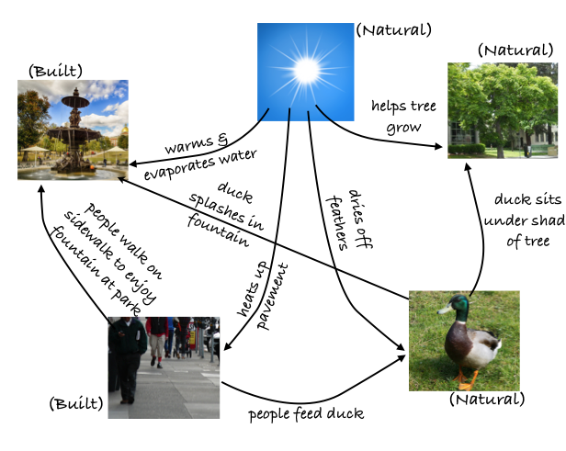
Example student work showing relationships between objects.
Source: (CC-BY-NC-SA) by M. d’Alessio with Creative Commons images:
(CC-BY) Jordan 2012; (CC-BY-SA) Kilby 2013; (CC-BY) radcliffe dacanay 2008; (Public Domain) JCKlein 2010; (Public Domain) npcorp 2012.

Days 2-3 – Neighborhood temperature from satellite (Explore)
Earth scientists depend heavily on images collected by satellites to study what is happening on Earth. Today, Dr. D’s class will analyze [SEP-4] two different types of satellite pictures, one that students are already familiar with and one that they are not. She begins by engaging students with an internet video clip of a building inspector demonstrating applications of thermal infrared camera. The inspector holds up a mug with cold water and one with hot coffee and shows how the camera distinguishes between the two. Dr. D uses this to motivate a brief introduction to the physics of black body radiation. She knows that the students will be using this idea again in the study of stars, so she gives a brief lecture about how objects at different temperature objects emit energy at different wavelengths. She explains that some satellites have cameras that record the temperature of the land surface by the radiation the land emits in infrared. The students will compare these thermal maps with the standard aerial photographs available in Google Earth, looking for patterns [CCC-1] in the relationship between the temperature and the type of landscape and land use (different types of natural and built environments).

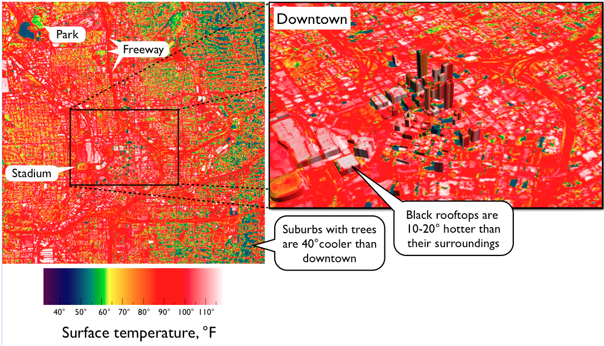
Satellite images in infrared reveal that different land uses cause dramatically different temperatures in urban areas.
Source: NASA 2015; Scott 2006.

Before walking over to the computer lab, Dr. D uses her classroom computer to demonstrate how students will obtain the data and how it can be viewed in Google Earth. She demonstrates map navigation and explains the color scale on the thermal map. She emphasizes that there is a big range of temperatures and tests students’ basic ability to identify the relative temperature of different regions from the color by asking a few clicker questions that the students answer using a smartphone app. She also shows students the data entry form on the course website where all student observations will be collected and analyzed together.

Once they walk over to the computer lab, she helps students log into the computers and download the satellite data file she preloaded on her website under today’s agenda and open up the data collection online form. She encourages students to explore freely in Google Earth for about 3 minutes after everyone is logged in, knowing this is an exciting tool. She eventually calls the students to attention and instructs them to begin their data collection. They work diligently, exploring different locations on the map and recording their map location, temperature, and land use category. The class period ends and Dr. D ensures that students have all hit submit on their data collection form.

When students arrive the next day, the whole class’ submissions are combined in an online spreadsheet so that everyone can analyze the large data set [SEP-4]. The students all found that the airport runway was among the hottest places on the entire map, and that most of the large shopping centers were very hot as well. “That makes sense because you can feel the heat when you walk across the parking lot,” offered Micah. Many people found that parks in the city were cooler than average, but there were a few discrepancies. Since each student submitted the latitude and longitude of their observation, Dr. D zooms in on one of these outliers. The location is much hotter than average, but it is clear that this location is a parking lot and not a park, so the submitter made an error. Casey admits that the submission was his and apologizes to the class, saying “It was big like a park…” The students were surprised to see that many of the schools in the city were hotter than average, but not all of them. The students were skeptical of the data and insisted that Dr. D zoom in to check the observations, and were satisfied after the data quality was confirmed for the first few submissions. They asked questions [SEP-1] about what made one school different from another.

After the whole class discussion, Dr. D has students individually create a one paragraph summary communicating [SEP-8] the overall class findings, with an emphasis on the patterns [CCC-1] in the data. She then randomly selects one student from each team to share his or her paragraph with the others. The team members offer improvements, additions, and edits, which are implemented in real-time. At the end of class, Dr. D collects the one edited team submission and gives each team a group grade for the final product. She confirms that students left class with the general understanding that many natural landscapes are cooler than average while the built environment is often warmer than average. Students have also come up with an appreciation that there are complexities and exceptions to this general pattern.

Days 4-5 – X-factor temperature investigation on the schoolyard (Explain)
Dr. D starts off class with aerial pictures of two schools from their city and she asks the students to predict which one will be warmer. She intentionally selected two schools that appear similar in the photos but that have fairly different temperature profiles in the satellite temperature data so that she motivates students to think about the full range of possibilities that could explain [SEP-6] the difference. “The grass looks greener in one, do you think that makes a difference?” “Maybe, but look at the parking lots. One is on the south side of the school and the other is smaller and is on the north side of the school.” The students ask Dr. D for the answer and she replies that she honestly doesn’t know. The students have offered up many plausible ideas that will motivate further investigation, but in real science there is no answer key. They have already made some interesting claims about possible influences on the school’s temperature, but today they will need to gather evidence [SEP-7] to see if they can support those claims. Each group must plan and carry out an investigation [SEP-3] into a single factor that could affect temperature (the “X-factor”). Each group gets one digital stick thermometer that reads temperatures with a precision of 0.1 degrees (They cost about $25 each and the chemistry teacher at Dr. D’s school lets her borrow a class set). Students all agree on a general protocol that thermometers should always be shaded with a book, that they should be held at arm’s distance away about one meter off the ground, and that they should not record the temperature until the thermometer has stabilized to within 0.1 degrees for at least 30 seconds. Beyond that, individual students must decide their own procedure that will ensure sufficient data to show a repeatable signal.

Some of the projects the students decided include measuring temperature as a function of:
- distance away from a building
- distance from the center of a grassy field out towards the edges
- distance from an air conditioning unit attached to the classroom
- position along the track for the 100 m dash
- different sides of the building, as measured a fixed distance away
- type of ground surface material, as measured at several locations close to one another
- elevation, as measured out the windows of different floors of the building.
- air speed, as measured while riding a bicycle at different speeds

Dr. D knows that some of these factors should not affect the temperature.

After collecting their data, students present their experiment, their findings, and propose an explanation [SEP-6] for the data [SEP-4]. Unlike a typical controlled laboratory experiment, students cannot completely isolate a single variable. As they present their project reports, they must account for any unexpected variations and construct an argument [SEP-7] that either their X-factor is the most important determiner of temperature, that their X-factor turned out to be unimportant, or that an unintended variable interfered with the ability to conclude either way. Quite often, students discover a factor that they did not anticipate that becomes more important than their original idea.

After the project presentations, Dr. D has students summarize all the findings in a two column table: factors that cause [CCC-2] temperature to be warmer and those that cause temperatures to be cooler. She then gives a short lecture defining the framework for a model [SEP-2] of energy balances in systems [CCC-4], including the energy input, output, and storage within the system. She refers back to a few examples from students’ X-factor analysis during her lecture, but now she asks students to sort all the items in their original table into three new rows corresponding to factors that affect the amount of energy coming into a spot (e.g., shade from trees decreases the input), the energy output (e.g., shiny surfaces reflect light back out), or the energy retained (e.g., water has a high heat capacity and so a large amount of energy can be absorbed without causing the temperature to change much). Students apply this model to writing a scientific explanation [SEP-6] about why built environments seem to be hotter than natural ones.

Day 6 – Historical land-use changes from online aerial photos (Elaborate)
Cities are not static. Dr. D engages students by asking them if anything in the city has changed since they were younger. How might those changes [CCC-7] affect the temperature of the city? Students use online archives of aerial photographs to document some of these land use changes. Google Earth has archives going back one or two decades, and other Web sites include photos going back more than 50 years. Students communicate their information [SEP-8] with a simple timeline where they note changes in land use and indicate whether or not they think that these changes increased or decreased the local temperature and whether this change affected the inputs, outputs, or energy retention properties of the system. Students love seeing how their city has grown. Amara asks, “Didn’t they know that they were heating up the city when they replaced that marshy area with the shopping mall?”

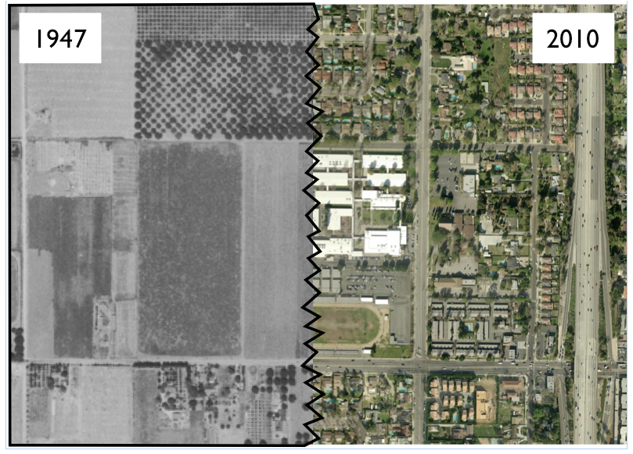
Comparison of aerial images around a local high school.
Source: (CC-BY-NC-SA) by M. d’Alessio with public domain images downloaded from United States Geological Survey 2015b

Days 7-9 – Urban design engineering challenge (Evaluate)
Dr. D begins the day by showing two different designs by two different people for the same space. She asks the students to think about the process the designers went through to create the plans. What did they consider? (HS-ETS1-1; CA EP&C V). She reviews the engineering design process and explains that it can be applied to a wide range of different types of problems, including some that they may not have even thought of as ‘engineering’ before. For this scenario, the city has recognized the urban heat island problem and is considering solutions. A developer plans to rebuild a large city block and the city council will evaluate a range of options. Students play the role of green urban planners presenting their proposal to a city council design review board (HS-ETS1-2). They discuss the constraints (i.e., what materials are available, how many people need to live on the block, the shape and size of the available land, etc.) and the criteria for measuring success (local temperature). They draw up a site plan, visualization sketches, and a bill of materials. As part of their argument [SEP-7] to the city council, they must identify the specific components of the design that reduce urban heat island effects. Audience members evaluate the plan and help iteratively improve the design by offering specific suggestions for reducing urban heating even further (HS-ETS1-3).

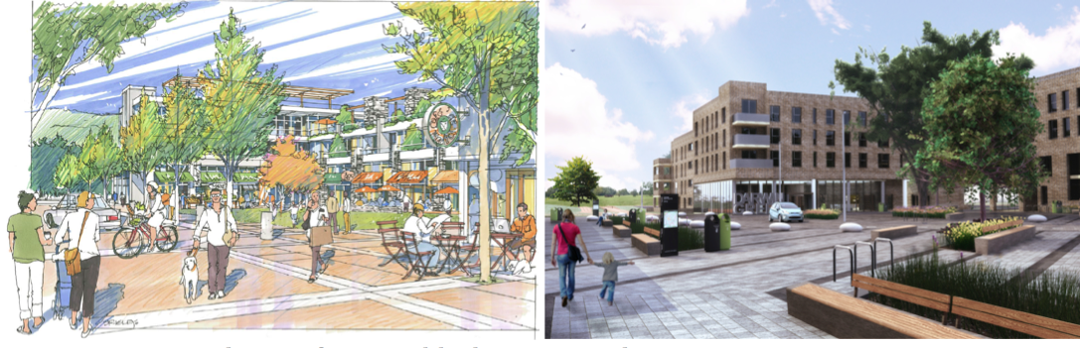
Two competing designs for a city block produced by professional design companies.
Source: Corporation of the District of Vancouver 2015; Cedeon Design 2015

Day 10 – Systems within systems (Elaborate/Extend)
Dr. D uses this day to explicitly relate urban heating to global climate change. She engages students by asking them to describe how their behavior changes on really hot days. She then provides students with the results of simulations that indicate that the number of extreme heat days in their city will likely go up significantly as a result of global warming (Cal-Adapt 2015), and that this change [CCC-7] will be more pronounced in urban areas because of the urban heat island effect. This data analysis [SEP-4] activity can support HS-ESS3-5.

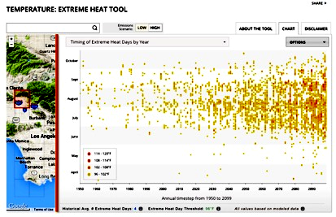
Snapshot of global climate forecast of extreme heat days available for all of California on the Cal-Adapt website. Source: Cal-Adapt 2015

The urban heat island effect is very similar to what is going on at a global scale [CCC-3] with the greenhouse effect. Students compare the models [SEP-2] of the energy balance of the Earth as a whole and the energy balance of a city. So far, students have primarily focused on the interactions between the anthrosphere and the geosphere, but now Dr. D asks students to draw a concept map relating urban heat island effects to other earth systems [CCC-4] (CA EP&Cs I & II). Their maps include the biosphere (evapotranspiration causes [CCC-2] and elevated urban temperatures stress plants and animals), the atmosphere (increased temperatures cause increased evaporation), and the hydrosphere (water runs off artificial materials instead of infiltrating into the ground). The connections to the hydrosphere offer an excellent transition into the next topic of study, urban hydrology and water resources.

Vignette Debrief
Science and engineering practices. After students perform two investigations [SEP-3] of temperature variations at a range of scales [CCC-3], they ask questions [SEP-1] about what is causing the dramatic heat island effects. They analyze their data [SEP-4] to help figure out the relationship between different components in the system [CCC-4] they study. They use these relationships to develop a model [SEP-2] of the system. They use the data from their investigations along with the reasoning of their model to construct an explanation [SEP-6] about what causes [CCC-2] urban heat islands. In the engineering design challenge, they employ engineering practice by defining the parameters of the problem [SEP-1] and designing solutions [SEP-6]. They then create a compelling argument [SEP-7] that their design is an effective way to mitigate human impacts on local temperature. On Day 10, students briefly explore the results of computational [SEP-5] simulations that forecast how urban heat islands will cause an even greater impact in the future.

Disciplinary core ideas. Urban heat islands are a tangible example of human impacts on Earth systems (ESS3.C) and a microcosm of the entire energy balance in the global climate system (ESS2.D). Students begin to characterize variations in Earth materials and the impact of these variations (ESS2.A), acknowledging that the built environment is a key part of Earth’s systems.

Crosscutting concepts. Students apply the crosscutting concept of systems and system models [CCC-4] to represent the flow of energy [CCC-5] and the interactions between energy and matter. Students look for patterns [CCC-1] in temperature data [SEP-4] to test for cause and effect [CCC-2] relationships between land use and heat islands. The model [SEP-2] that they develop is valid at a range of scales [CCC-3] from a single city block to a whole city or the entire planet.

California’s Environmental Principles and Concepts. Urban heat islands affect the welfare of humans in their everyday lives, and students discover that many of the best solutions to the problem involve the successful integration of natural ecosystems within the urban core (Principle I). At the same time, the effect of urban heat islands extends to natural systems [CCC-4] within and beyond the urban core. For example, excess heat from urban areas can drive evaporation that stresses ecosystems (Principle II). Day 10 emphasizes these relationships. The engineering design challenge is a realistic scenario where students must support the needs of the people living in an urban city block while reducing urban heat island effects. Their design must consider a range of factors (Principle V).

Resources for the Vignette
- Several of the activities described in this vignette were adapted from other sources and are cited within. Please refer to them for more detail.
- The introductory lesson on the built environment and the historical aerial photo analysis are two lessons in a much broader series of activities by Arizona State University’s Ecology Explorers. They offer additional activities that could extend ideas in Day 10 of this vignette to investigate impacts on human heat illness, an investigation into evapotranspiration, and more. https://ecologyexplorers.asu.edu/overview/urban-heat-island/
- The X-factor urban temperature analysis is a published activity: http://pdxscholar.library.pdx.edu/cgi/viewcontent.cgi?article=1010&context=esm_fac
- Temperature data from Day 2 come from the ASTER GED 100 m data set, which can be downloaded at https://earthexplorer.usgs.gov. At this point, viewing images downloaded at that site requires specialized tools, but a service by Google called “Earth Engine” provides convenient and user-friendly access to the ASTER GED surface temperature data (https://earthengine.google.org/). There are plans to create a simple educational interface for the entire state of California specifically for this activity.

California Department of Education: March 2016
MODEL VIGNETTE – High School

Google Earth instructions https://support.google.com/earth/answer/148094?hl=en
Historic Aerials, http://www.historicaerials.com/

