California Department of Education
Curriculum Framework Revision/Development Process
This chart illustrates the major steps in the curriculum framework revision/development process. All meetings are open to the public.
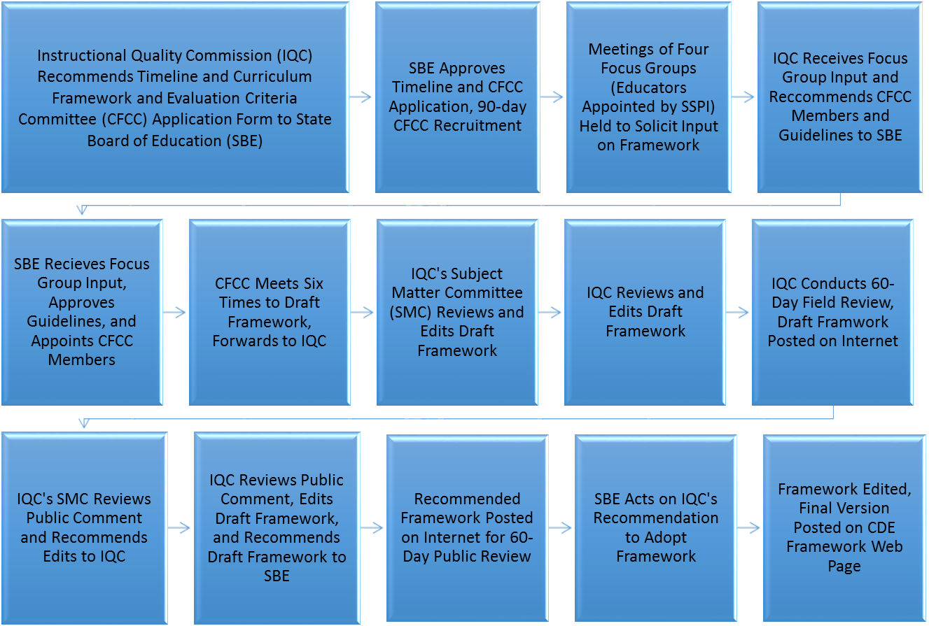
Item 6.C.
Health SMC
January 22, 2016
California Department of Education – Updated December 2015

