Edmund G. Brown Jr., Governor
State of California

Instructional Quality Commission

An advisory body to the California State Board of Education

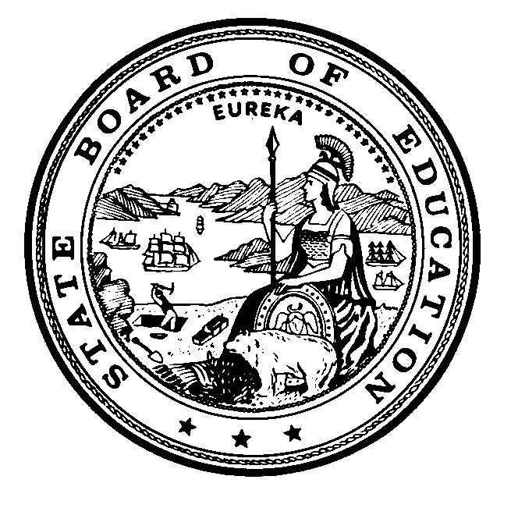
California Department of Education 1430 N Street Sacramento, CA 95814-5901

2016
Instructional Quality Commission Meeting Dates
Commission approved on November 21, 2014
*Pending Commission approval on November 19, 2015

Thursday–Friday, January 21–22, 2016

*Proposed — Friday, February 19, 2016 Science SMC

*Proposed — Friday, March 18, 2016 Science SMC

*Proposed — Thursday–Friday, March 24–25, 2016 HSS SMC

Thursday–Friday, May 19–20, 2016

Thursday–Friday, September 22–23, 2016

Thursday–Friday, November 17–18, 2016

All meetings, unless otherwise indicated, will be held at the
California Department of Education Building
1430 N Street, Room 1101
Sacramento, CA 95814

Item 1.H.1.
Full Commission
November 19–20, 2015
© California Department of Education

