Item 1.H.2.
Full Commission
November 19–20, 2015
© California Department of Education
Edmund G. Brown Jr., Governor
State of California

Instructional Quality Commission

An advisory body to the California State Board of Education

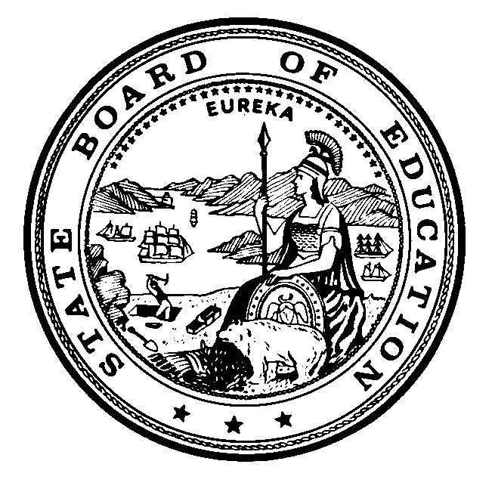
California Department of Education 1430 N Street Sacramento, CA 95814-5901

Instructional Quality Commission Meeting Dates
Commission will consider for approval on November 19, 2015

Proposed 2017

Thursday–Friday, January 19–20, 2017

Thursday–Friday, May 18–19, 2017

Thursday–Friday, September 21–22, 2017

Thursday–Friday, November 16–17, 2017

Proposed 2018

Thursday–Friday, January 18–19, 2018

Thursday–Friday, May 17–18, 2018

Thursday–Friday, September 20–21, 2018

Thursday–Friday, November 15–16, 2018

All meetings, unless otherwise indicated, will be held at the
California Department of Education Building
1430 N Street, Room 1101
Sacramento, CA 95814

