California Department of Education

Executive Office

SBE-004 (REV. 11/2017)

addendum-jun25item01

# ITEM ADDENDUM

**DATE:** June 12, 2025

**TO:** MEMBERS, California Practitioners Advisory Group

**FROM:** TONY THURMOND, State Superintendent of Public Instruction

**SUBJECT:** Item 01 — Handout for CPAG Exercises listed on slides 107 and 114.

## Summary of Key Issues

This addendum includes the attachment that will be provided as a handout to the California Practitioners Advisory Group (CPAG) members at the June 13, 2025, meeting, for the exercises listed on slides 107 and 114 of Item 01.

## Attachment(s)

Attachment 1: Handout for CPAG Exercises, Item 01, Slides 107 and 114. (5 pages)

### Potential Labels for Growth Categories

| Option Number | Level 1 Growth | Level 2 Growth | Level 3 Growth | Level 4 Growth | Level 5 Growth |
| --- | --- | --- | --- | --- | --- |
| **2024 Dashboard Labels** | n/a | Below Typical Growth | Typical Growth | Above Typical Growth | n/a |
| **Option 1** | Minimal Growth | Moderate Growth | Strong Growth | Accelerated Growth | Exceptional Growth |
| **Option 2** | Far Below Typical Growth | Below Typical Growth | Typical Growth | Above Typical Growth | Far Above Typical Growth |
| **Option 3** | Very Low Growth | Low Growth | Medium Growth | High Growth | Very High Growth |
| **Option 4** | Limited Growth | Some Growth | Typical Growth | High Growth | Accelerated Growth |
| **Option 5** | Starting Growth | Progressing Growth | Advancing Growth | Strong Growth | Outstanding Growth |
| **Option 6** | Limited Growth | Developing Growth | Typical Growth | Enhanced Growth | Exceptional Growth |
| **Option 7** | Seedling Growth | Budding Growth | Blossoming Growth | Thriving Growth | Flourishing Growth |

### Options for Growth Dashboard Card

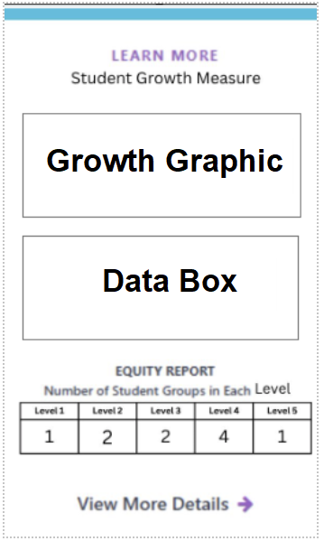

### Options for Growth Graphic

#### Option 1 for Growth Graphic

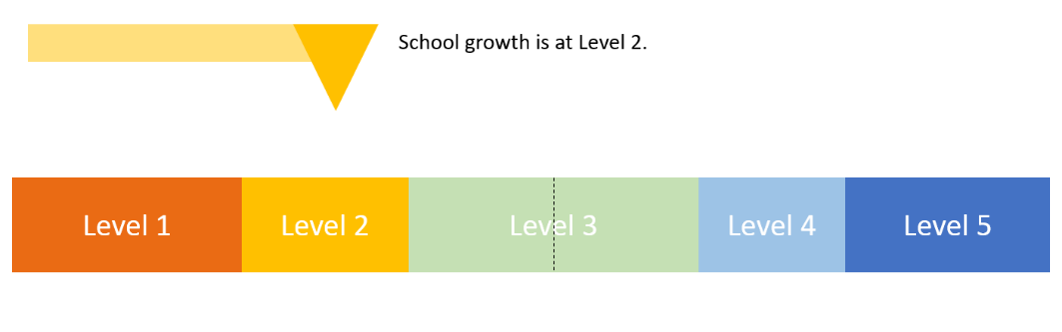

#### Option 2 for Growth Graphic

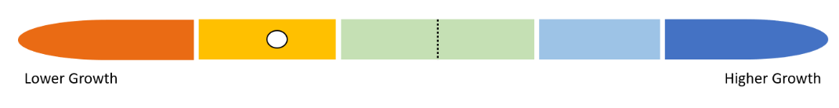

#### Option 3 for Growth Graphic

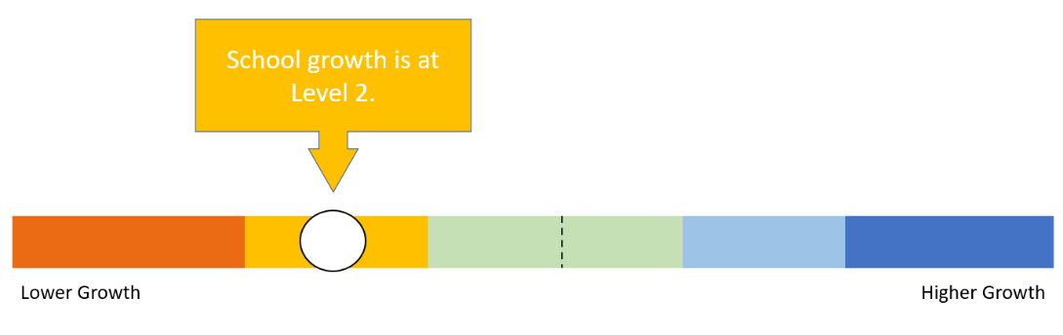

#### Option 4 for Growth Graphic

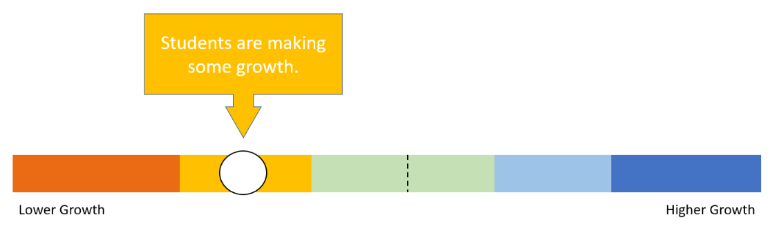

### **Options for Data Box Text**

1. Numerical Value of Score
   1. 4 points below typical growth
2. Percent of Students with Typical or Above Typical Growth
   1. 52% of students had typical or above typical growth
3. Percent of Students whose scores improved from the prior year
   1. 75% of students improved their score from the prior year
4. Growth category sentence
   1. The average growth of students at this school is [blank].
   2. Students are making minimal growth relative to where they started last year.
   3. Students are making minimal growth compared to their prior-grade performance.
   4. Students are making minimal growth compared to their peers in California.

### 2024 Dashboard Sections (for reference for Growth and Science)

* Academic Performance
  + Academic - English Language Arts (ELA) Indicator (State)
  + Academic – Mathematics (Math) Indicator (State)
  + English Learner Progress Indicator (State)
  + College/Career Indicator (State)
  + Implementation of Academic Standards (Local)
* Academic Engagement
  + Chronic Absenteeism Indicator (State)
  + Graduation Rate Indicator (State)
  + Access to a Broad Course of Study (Local)
* Conditions and Climate
  + Suspension Rate Indicator (State)
  + Basics: Teachers, Instructional Materials, Facilities (Local)
  + Parent and Family Engagement (Local)
  + Local Climate Survey (Local)
* Informational Purposes
  + Science