California Department of Education

Executive Office

SBE-004 (REV. 11/2017)

memo-itb-amard-aug25item01

**MEMORANDUM**

**DATE:** August 8, 2025

**TO:** MEMBERS, State Board of Education

**FROM:** TONY THURMOND, State Superintendent of Public Instruction

**SUBJECT:** Summary of July 2025 State Board of Education Actions Related to 2025 and 2026 Accountability Workplans.

## Summary of Key Issues

The State Board of Education (SBE) took final action on the 2025 Accountability Workplan at their July 2025 meeting. This memorandum provides an update on action by the SBE at the July 2025 meeting related to the 2025 and 2026 Accountability Workplan items. This memorandum provides a short overview of the actions by the SBE for the 2025 California School Dashboard (Dashboard) and items currently pending for the 2026 Accountability Workplan.

The California Department of Education (CDE) is currently implementing the changes adopted by the SBE at their July 2025 meeting in preparation for the release of the 2025 Dashboard. In addition, local educational agencies are in the process of finalizing the reporting of student-level data to the California Longitudinal Pupil Achievement Data System which is scheduled to close the 2024–25 data collections on August 8, 2025. Following the close of the data collection, the CDE can begin working to process these data, apply the accountability requirements, and support the field with the release of the 2025 Dashboard no later than November 15, 2025. In January 2026, the CDE will bring the 2026 Accountability Workplan for formal adoption at the SBE meeting. Additionally, the SBE will address the following budget trailer bill language in Assembly Bill (AB) 121 related to differentiated assistance and the system of support:

No later than July 15, 2026, the state board shall update the performance criteria, taking into consideration the findings and recommendations from the state-funded evaluation of the state’s differentiated assistance system and its implementation, and the need to appropriately focus resources and supports where the demonstrated needs are greatest.

## 2025 California School Dashboard

1. **Incorporation of the Student-Level Growth Model for Grades 4 through 8 in English Language Arts (ELA) and Mathematics (Math) into the Dashboard**
2. **Performance Category Levels:** The SBE adopted the names and cut scores for the five performance category levels from the lowest level of growth to highest level of growth as follows: Minimal Growth (growth scores less than 20 below), Moderate Growth (growth scores between 20 below and 5 below), Average Growth (growth scores between 5 below and 5 above), Accelerated Growth (growth scores between 5 above and 20 above), and Exceptional Growth (growth scores higher than 20 above).
3. **Growth Model Dashboard Display:** The data box on the Growth Dashboard card will display the percent of students whose scores improved from the prior year. For example*, 75 percent of students improved their score from the prior year.*
4. **ELA and Math Growth Indicators:** The inclusion of ELA and Math Growth Indicators on the Dashboard will be for informational purposes and the SBE affirmed that they should be used as additional information for charter school renewal purposes. The ELA and Math Growth Indicators will be displayed in the Informational Purposes section of the 2025 Dashboard.
5. **Science Indicator**
6. **Informational Use Only:** The Science Indicator, with its status levels, change levels, and color performance categories previously adopted at the SBE meeting in March 2025, will be used for informational purposes and will not impact Local Control Funding Formula (LCFF) Eligibility Determinations on the 2025 Dashboard.
7. **Dashboard Placement:** The Science Indicator, with newly added performance colors, will continue to appear in the Informational Purposes section of the 2025 Dashboard, as it did with the 2024 Dashboard.
8. **College/Career Indicator (CCI) Measures**
9. **Removal of ROC/P Participation:** The SBE approved the removal of Regional Occupational Center/Program (ROC/P) participation from the State and Federal Job Programs measure of the College/Career Indicator.
10. **Inclusion of AP Course Passage:** The SBE approved the inclusion of Advanced Placement (AP) course passage with a grade of C- or better in the CCI for both the Prepared and Approaching Prepared performance levels.
11. **Modification to Transition Classroom and Work-Based Learning Experiences:** This measure has been updated to include students who are awarded a diploma in accordance with California *Education Code* sections 51225.31 and 51225.32.
12. **State Seal of Civic Engagement:** The CDE will continue to collect and analyze data related to the State Seal of Civic Engagement for inclusion in the 2026 Dashboard.
13. **New Career Measures:** The CDE will continue to collect and analyze data related to new career measures for potential inclusion in future Dashboards; Internships, Student Led Enterprises, Simulated Work-Based Learning, Armed Services Vocational Aptitude Battery.
14. **Differentiated Assistance (DA) Eligibility Based on California Longitudinal Pupil Achievement Data System (CALPADS) Submissions:**
15. **Timeline for DA Eligibility Criteria:** The SBE adopted a phased-in timeline for DA eligibility criteria related to the submission of data to the California’s student-level data system, CALPADS:
    1. For the 2024–25 academic year, any district or CDE that fails to meet a CALPADS certification deadline for the Fall 1, Fall 2, or End-of-Year (EOY) 1, 2, 3, or 4 data submissions may be eligible for CALPADS Differentiated Assistance (CALPADS DA).
    2. For the 2025–26 academic year, in addition to the eligibility requirements for districts and COEs that did not certify any one or more of the CALPADS data submissions by the certification deadline, districts and COEs that are identified as having a data quality issue will be eligible for CALPADS DA.
16. **Review of Priority 1 Teacher Assignment Data:**
17. **Modifications to Priority 1:** The SBE took the following actions for the 2025 Dashboard:
    1. The SBE adopted a “Modified Option 2” to display a new Dashboard card on each school and LEA Dashboard landing page, as displayed below, that links to the LEA's Priority 1 detailed information upon clicking "View More Details."

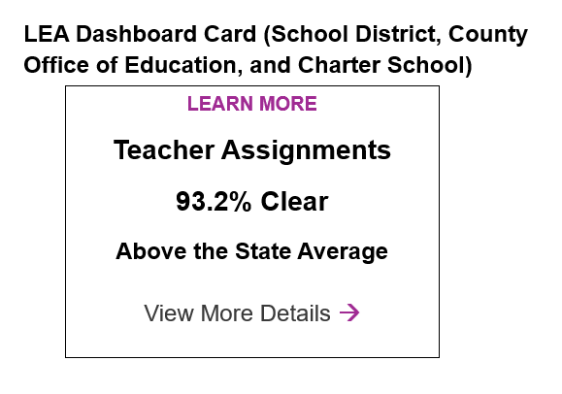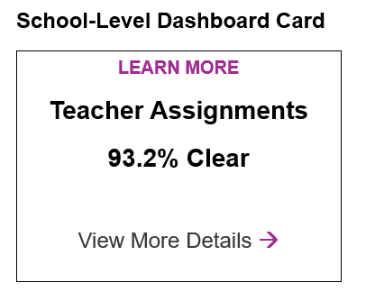

* 1. The SBE agreed to title the new LEA and school Dashboard cards “Teacher Assignments.” Additionally, recognizing the term “Clear” for describing teacher status may, by itself, be confusing, the SBE agreed to work with the CDE to ensure the teacher assignment data terminology on the Dashboard cards is accessible and aligned with the terminology used in the School Accountability Report Card, which clarifies “Clear” is in reference to Fully (Preliminary or Clear) Credentialed for Subject and Student Placement (properly assigned).

1. **Review of Long-Term English Learner (LTEL) Results on the Dashboard:**
2. **Eligibility Criteria Priority 4:** Modify the LCFF eligibility criteria for LTELs under Priority 4 to include Orange on the English Learner Progress Indicator (ELPI), in addition to the current Red on the ELPI, and exclude performance on English Language Arts (ELA) and Mathematics.
3. **Dashboard Alternative School Status (DASS) Application/ Renewal Criteria**
   * 1. **Revision to DASS Criteria Regarding Wards of the Court:** Modify the DASS criteria to remove Wards of Court.

## 2026 Accountability Workplan Items

1. **Student-Level Growth Model for Grades 4 through 8 in English Language Arts and Mathematics as full indicators**
2. **ELA and Math Growth as State Indicators:** Consider full state indicator status for ELA and Math Growth, starting with the 2026 Dashboard. Full state indicator status adds the Indicator to state and/or federal support determination criteria.
3. **Science Indicator**
4. **Full State Indicator Status:** Consider full state indicator status for the Science Indicator, beginning with the 2026 Dashboard. Full state indicator status adds the Indicator to state and/or federal support determination criteria.
5. **College/Career Indicator**
   1. **Study Session:** The SBE will hold a Study Session to provide a wholistic review of the CCI, including goals for the indicator, current measures, and future path for adding new measures to the indicator.
   2. **International Baccalaureate (IB) Courses:** Provide an analysis of the IB program to identify possible courses for inclusion on the CCI.
   3. **Cambridge International:** Consider options for adding Cambridge International courses and exams as a measure of the CCI.
6. **State Seal of Civic Engagement:** Consider options for adding the State Seal of Civic Engagement to the CCI for the 2026 Dashboard.
   1. **New Career Measures:** Evaluate new career measures for potential inclusion in the CCI including: Internships, Student Led Enterprises, Simulated Work-Based Learning, and the Armed Services Vocational Aptitude Battery. In addition, the SBE indicated it would like to examine how other career measures, such as apprenticeships, may be addressed within the CCI, and how to include students with extensive support needs.
   2. **Removal of Course Code “9227 - Other”:** The SBE adopted to remove College Credit Course Code “9227 – Other” from the list of approved courses for future classifications, not to be done retroactively, beginning with the 2026 Dashboard, meaning that beginning with the 2027 graduating cohort, course code “9227- Other” will not be an approved course code for CCI purposes.
7. **Dashboard Alternative School Status (DASS) Application/ Renewal Criteria**
8. **Credit Deficient Students:** Evaluate the DASS criteria as they address credit-deficient students.
9. **Priority 1 Teacher Assignment Data**
10. **Align Teacher Assignment Data Terminology:** Ensure clarity of teacher assignment data terminology on the Dashboard, the School Accountability Report Card (SARC), and the Teaching Assignment Monitoring Outcomes report to ensure data terms are aligned and accessible to the public.
11. **Obtain Additional Interest Holder Feedback, including on Intra-District Comparisons:** The SBE will seek additional feedback and guidance related to Priority 1 Teacher Assignment Data on the Dashboard, including considerations for intra-district comparison data. This effort should reflect the intent of the SBE and the CDE to engage with external agencies and partners in shaping future enhancements and ensuring meaningful, collaborative input.
12. **LTEL Student Group**
13. **Include Recently Reclassified Students (RFEP) in the ELPI:** Augment the ELPI calculation to include students who have recently reclassified to fluent English proficient status.
14. **Suspension Indicator:** Consider whether modifications for LTEL students in the Suspension Rate Indicator are warranted.
15. **Participation Rate for Academic Indicators and Science**
    1. **Participation Rate Grace Periods:** Explore removal of the participation rate grace periods for the Academic Indicators and the Science Indicator.