California Department of Education
Executive Office
SBE-002 (REV. 11/2017)
memo-imab-adad-feb22item01

MEMORANDUM
DATE: February 11, 2022
TO: MEMBERS, State Board of Education
FROM: TONY THURMOND, State Superintendent of Public Instruction
SUBJECT: California Assessment System Feedback: 2021 Assessment Coordinator Survey Report and 2021 California Assessment Conference Post-Conference Report.

Summary of Key Issues
The California Department of Education (CDE) is committed to providing resources and professional development support to assist local educational agencies (LEAs) in the successful implementation of the California Assessment System, which includes the California Assessment of Student Performance and Progress (CAASPP) and the English Language Proficiency Assessments for California (ELPAC). The CDE has an existing contract with the Sacramento County Office of Education (SCOE) through which SCOE gathers feedback and recommendations from attendees at valuable meetings, trainings, structured feedback sessions, and surveys, and then provides the CDE with reports that include an analysis of any feedback and recommendations based on attendees’ input and any other related information gathered. These reports provide information and recommendations for the CDE to consider in determining future trainings and outreach efforts to meet the needs identified by LEAs and other interest holders.
Two such reports are provided as attachments to this Information Memorandum. They are as follows:
- 2021 Assessment Coordinator Survey Report
- 2021 California Assessment Conference Post-Conference Report

2021 Assessment Coordinator Survey Report
The 2021 Assessment Coordinator Survey Report is the culmination of a large-scale campaign to identify helpful resources to address needs of LEA coordinators to successfully implement the activities required to administer the CAASPP and ELPAC tests. After surveying coordinators, the SCOE analyzed the survey responses and compiled a report of the findings for the CDE. This report provides information and recommendations for the CDE to consider in determining future outreach efforts needed in response to the survey of LEA CAASPP and ELPAC coordinators. Highlights of the recommendations include the following:
- Continue efforts to revise existing documents and improve their readability and accessibility for end users.
- Continue collaboration with Educational Testing Service (ETS) on the creation of a style guide to use when developing deliverables that are engaging and easily navigated, follow data visualization best practices, and fully comply with Section 508 accessibility requirements.
- Initiate and support the creation of a statewide charter school assessment coordinator network via a collaboration with the Regional Assessment Network and county offices of education. A majority of respondents who identified as charter school assessment coordinators expressed interest in a support network of fellow coordinators specific to charter schools/organizations, as their experience differs from that of other LEA coordinators.
- Continue to promote the California Educational Reporting System (CERS) and develop a CERS training to be launched in the 2022–23 school year.
- Continue to refine the process of welcoming new coordinators to their role and informing them of the New Coordinator Training Series.

2021 California Assessment Conference Post-Conference Report
The 2021 California Assessment Conference Post-Conference Report provides feedback from the survey for the third annual California Assessment Conference (CAC), held virtually in October 2021. A survey was sent to each attendee of the conference sessions, and a post-conference survey was sent to all registrants, as the zoom meeting platform was not able to monitor who attended each session. The purposes of the CAC were to (1) replace the multiple training sessions that had been held in previous years; and (2) provide participants with the opportunity to learn about the various components of the California Assessment System. Approximately 720 participants joined this two-day conference to learn how assessment tools and resources can be used to support teaching and learning in California classrooms. The SCOE made recommendations, based on respondents’ feedback, for the CDE to consider for the 2022 CAC, which is tentatively scheduled for October 18–20, 2022, at the Riverside Convention Center. Highlights of the recommendations include the following:
- Hold the 2022 CAC in person. An in-person conference offers many benefits that are not available in a virtual conference model, such as networking. Providing a learning environment away from work/home minimizes distractions and increases engagement.
- Create a hybrid model to be used for the 2022 CAC, with one or two sessions per time slot in the agenda being provided virtually.
- Include expert panels. Attendees would like to hear from presenters with distinct assessment experience—in grade school versus high school, with students with disabilities, and in other areas of expertise.
- Continue to offer a large number of shared-practice sessions featuring local schools and districts at the 2022 CAC.
- Continue to ensure that each time slot for breakout sessions includes options for multiple content areas so no attendees feel as though their preferred content area is not available during a breakout strand.

Attachment(s)
- Attachment 1: 2021 Assessment Coordinator Survey Report (36 Pages)
- Attachment 2: 2021 California Assessment Conference Post-Conference Report (28 Pages)

2021 Assessment Coordinator Survey Report
CN180112 • January 2022

Contents
Contents 2
Introduction 3
Respondents’ Demographic Information 4
Findings 7
Recommendations 19
Appendix A: Survey Questions 21
Appendix B: Data Tables 34

Introduction
In September 2021, the California Department of Education (CDE) Assessment Development and Administration Division launched the fourth annual local educational agency (LEA) Assessment Coordinator Survey. This work was undertaken by the Sacramento County Office of Education (SCOE) under the Assessment Validity and Outreach contract with the CDE. The survey, which was sent via email to all California Assessment of Student Performance and Progress (CAASPP) and English Language Proficiency Assessments for California (ELPAC) coordinators in the state, was designed to gather feedback and input on currently available assessment-related resources, training opportunities, CDE webinars, and the California Educator Reporting System (CERS).
This report provides a detailed summary of the feedback received from the survey respondents as well as a set of recommendations for improving the type and quality of support the CDE provides for LEA assessment coordinators.

Survey Announcement
The 2021 Assessment Coordinator Survey was emailed directly to LEA CAASPP and ELPAC coordinators on September 16, 2021. Information about the survey was included in issue 157 of the CDE’s Assessment Spotlight, and coordinators received a follow-up email one week before the closing of the survey window, reminding them to submit their responses.

Survey Responses
Out of the 2,261 unique LEA coordinators who were contacted (coordinators holding both CAASPP and ELPAC coordinator roles were counted only once), 732 responded to the survey. Eight of the respondents (one percent) were screened out because they indicated they were not in an LEA coordinator role. Answers from the remaining 724 respondents are shown in this report and have been compared to those in the 2020 Assessment Coordinator Survey Report where appropriate.
724 survey respondents
32 percent response rate

Respondents’ Demographic Information
Staff from LEAs with an enrollment of 1,000–5,999 students were the single most highly represented group among survey respondents. Staff from LEAs with fewer than 1,000 students cumulatively represented 47 percent of respondents, whereas staff from LEAs with 6,000 students or more cumulatively represented 21 percent of respondents. Figure 1 illustrates the LEA size representation.
Figure 1. LEA Size Representation, Based on Student Enrollment
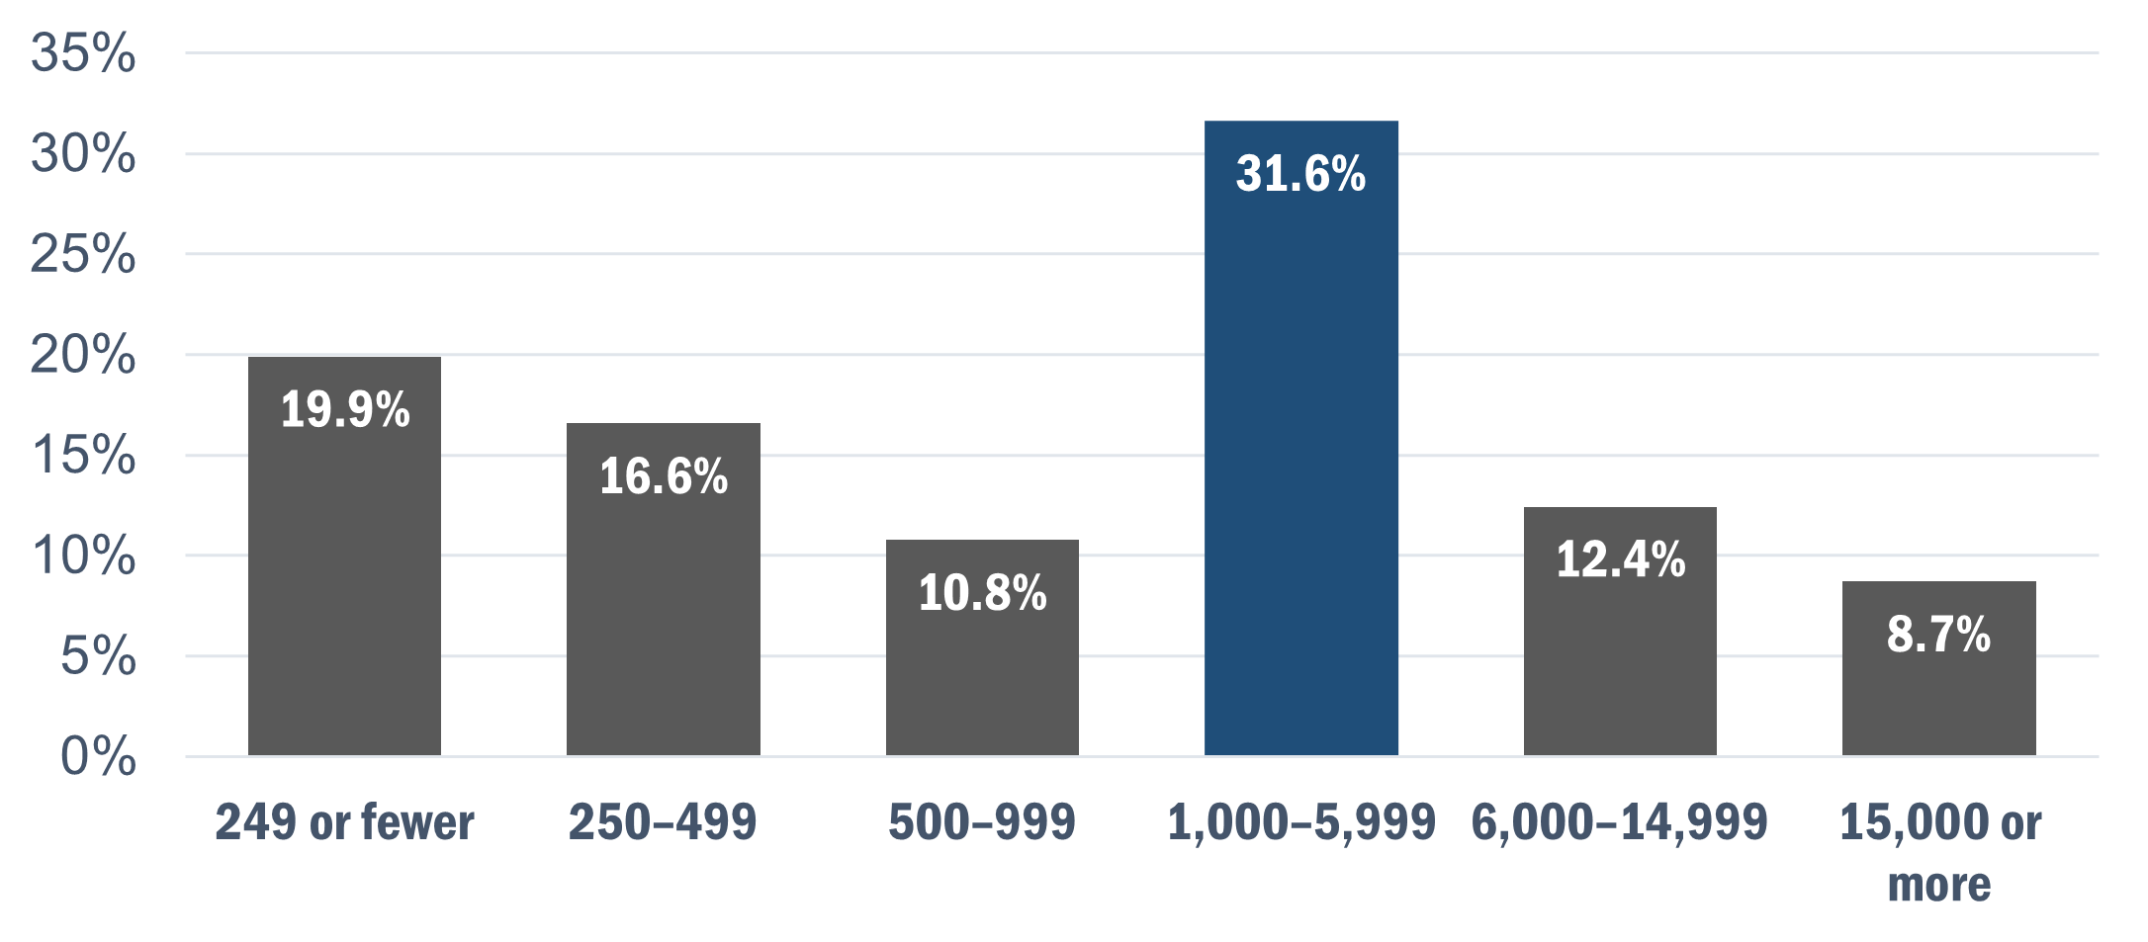
More than 85 percent of respondents represented LEAs whose enrollment consisted of students in elementary and middle school grade levels (through grade eight). Figure 2 illustrates the LEA grade-level representation. Survey respondents were instructed to select multiple responses if applicable, resulting in a response total greater than 100 percent.
Figure 2. LEA Grade-Level Representation
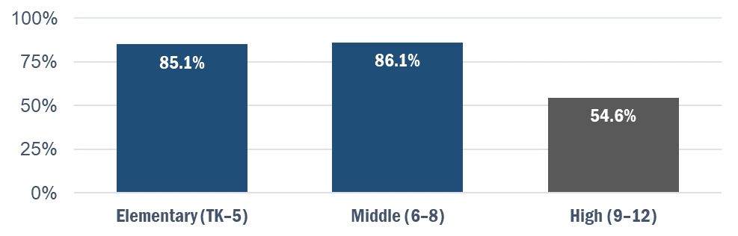
More than one third of survey respondents represented charter schools and organizations, as illustrated in figure 3.
Figure 3. Charter School/Organization Representation
Sixty-five percent of respondents indicated that English learner students represented 25 percent or less of their LEA’s student population. A majority of respondents reported an English learner student enrollment of 10–25 percent in their LEA. A breakdown of the percentages is illustrated in figure 4.
Figure 4. English Learner Students in LEA—Percentage of Total Student Enrollment
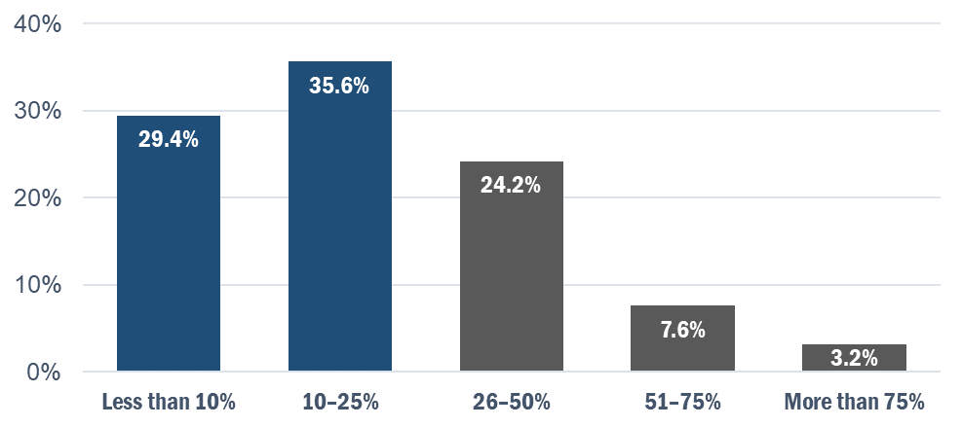
The percentage of new CAASPP coordinators among respondents decreased from 2020 to 2021. In 2021, 50 percent of respondents reported serving in their role as CAASPP coordinator for three years or less, compared to 57 percent in 2020.
The percentage of new ELPAC coordinators among respondents also decreased from 2020 to 2021. In 2021, 51 percent of respondents reported serving in their role as ELPAC coordinator for three years or less, compared to 55 percent in 2020.

Fifty-nine percent of respondents served as both the CAASPP and ELPAC coordinators in their LEA, as illustrated in figure 5. This is an increase from 56 percent of respondents in the 2020 Assessment Coordinator Survey Report.
Figure 5. Respondents’ Coordinator Roles
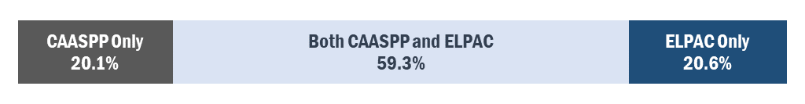
Respondents who served as both CAASPP and ELPAC coordinator were more likely to represent a small LEA. Thirty-four percent of these coordinators represented an LEA with 1,000–5,999 enrolled students. Forty-six percent of respondents who served in both roles represented an LEA with fewer than 1,000 students. Figure 6 illustrates a breakdown of the percentages.
Figure 6. LEA Size Among Coordinators in Both CAASPP and ELPAC Roles
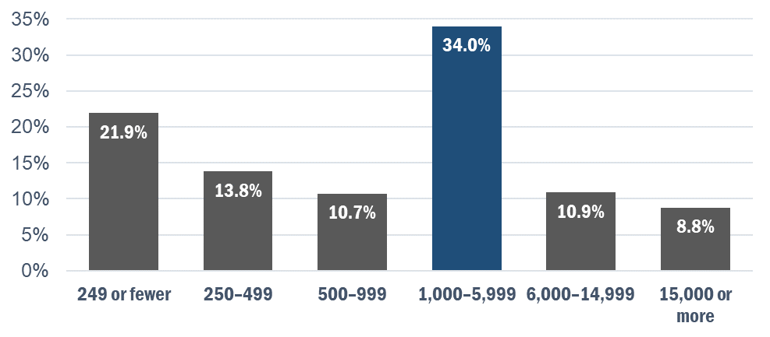

Findings
The findings in this report are organized into four sections based on the structure of the survey:
- Resources
- Charter School Assessment Coordinators
- California Educator Reporting System
- Training Opportunities and Webinars
A complete list of survey questions can be found in Appendix A.

Resources
This section analyzes respondents’ overall satisfaction with existing resources (documents and videos) as well as their specific feedback on these documents: the 2021–22 ELPAC Information Guide, the CAASPP and ELPAC Student Score Report (SSR) cover letter templates, and the test examiner (TE), test administrator (TA), and site coordinator checklists. This feedback was gathered to help the CDE and SCOE to update existing resources and inform the development of future deliverables.
The results in this section include data from the LEA assessment coordinator surveys conducted in 2019, 2020, and 2021.

Overall Satisfaction with Existing CAASPP and ELPAC Resources
More than 85 percent of respondents were satisfied with the amount of existing CAASPP and ELPAC resources, as illustrated in figure 7. Satisfaction among ELPAC coordinators (those who reported being either “Satisfied” or “Very Satisfied”) increased to 87 percent in 2021 from 85 percent in 2020, whereas satisfaction among CAASPP coordinators decreased from 87 percent in 2020 to 85 percent in 2021.
Figure 7. Satisfaction with the Amount of Current Resources (2019–21)
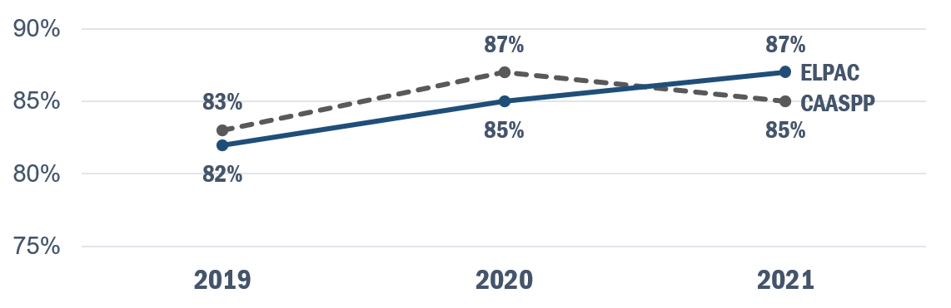
Respondents’ overall satisfaction with the quality of existing resources has also increased over time, as shown in figure 8.
Figure 8. Satisfaction with the Quality of Current Resources (2019–21)
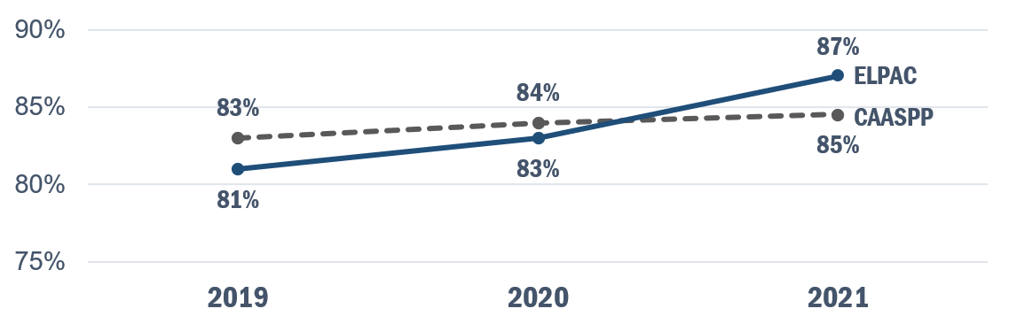

2021–22 ELPAC Information Guide
The 2020 Assessment Coordinator Survey Report showed that respondents reported various assessment-related manuals and guides being difficult to engage with (in regard to formatting and language). In response, the CDE committed to improving the readability of and access to existing manuals and guides. The first example of that commitment came with the 2021–22 updating of the manual ELPAC Information Guide. The updates made to this manual included simplifying the language and adding heading levels to improve the overall readability.
The 2021–22 ELPAC Information Guide is available as a Microsoft Word document on the CDE website at https://www.cde.ca.gov/ta/tg/ep/documents/elpacinfoguide21.docx.
Seventy-two percent of respondents found the formatting updates to be at least moderately helpful. Approximately 21 percent of survey respondents were unsure about the helpfulness of these updates, and less than one percent believed them to be unhelpful. A breakdown of the percentages is illustrated in figure 9.
Figure 9. Helpfulness of Formatting Updates to the ELPAC Information Guide
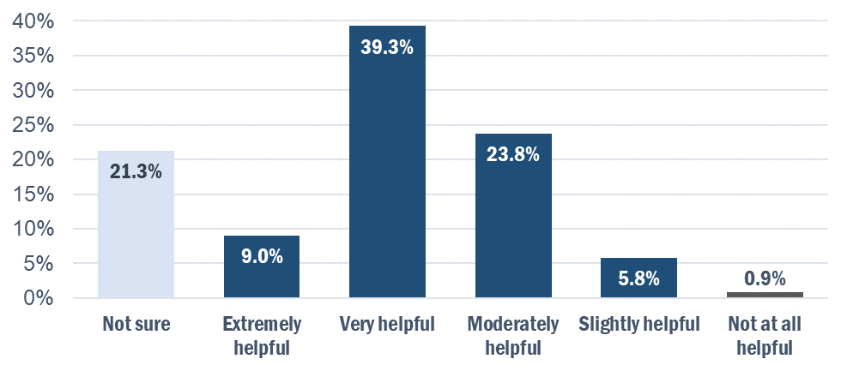
Sixty-nine percent of respondents found the language updates to be at least moderately helpful. Approximately 25 percent of survey respondents were unsure about the helpfulness of these updates, and less than one percent believed them to be unhelpful. A breakdown of the percentages is illustrated in figure 10.
Figure 10. Helpfulness of Language Updates to the ELPAC Information Guide
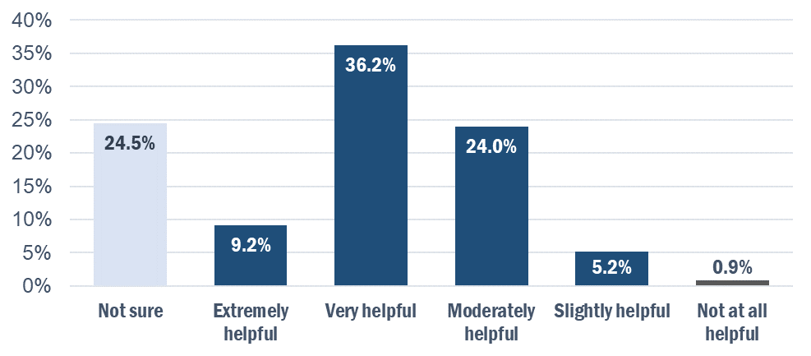

CAASPP and ELPAC SSR Cover Letter Templates
Ninety-three percent of respondents’ LEAs deliver SSRs to families either by mail (50 percent) or through an online parent/student portal (43 percent). Coordinators were asked about the existing set of parent/guardian SSR cover letter templates that LEAs can send to parents along with printed SSRs or with instructions on how to access the SSRs electronically.
The SSR letter templates are available on the CAASPP Score Reporting web page at https://www.caaspp.org/administration/reporting/index.html and the ELPAC Score Reporting web page at https://www.elpac.org/test-administration/reporting/.
Seventy-three percent of respondents reported using the SSR letter templates.
Among respondents who stated that they did not use the templates, 84 percent reported sending communications to families when SSRs are available. These communications predominantly consisted of email notifications (used by 58 percent of respondents) and/or LEA-created letters (used by 52 percent of respondents). A breakdown of percentages is illustrated in figure 11. Survey respondents were instructed to select multiple responses if applicable, resulting in a response total greater than 100 percent.
Figure 11. Other Methods of Communication with Families Regarding SSR Availability
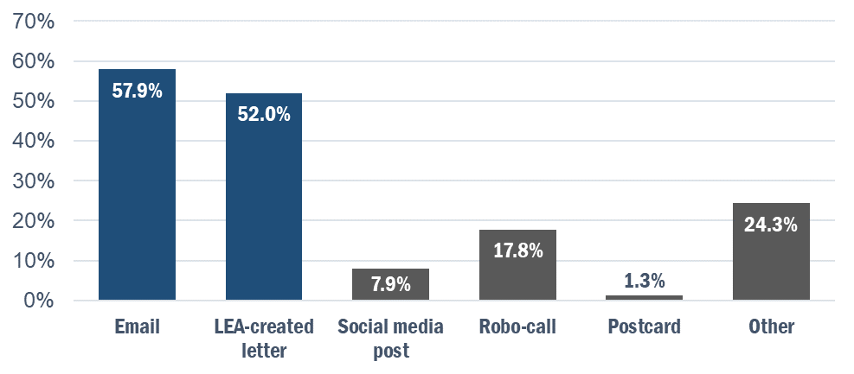
Forty-three percent of respondents learned about the SSR letter templates from the CAASPP and/or ELPAC website. The CDE Assessment Spotlight email was reported as a source of SSR letter template information by 32 percent of respondents.
Among respondents who used the SSR letter templates, 67 percent used most of the provided language and added some of their own before sending them to families. Twenty-five percent of respondents added their logo and sent them as-is.
Ninety-one percent of respondents rated the SSR letter templates as “Excellent” or “Good” quality.
Ninety-eight percent of respondents reported that they were likely to use the SSR letter templates in the future.
Ninety-seven percent of respondents reported that they were likely to recommend the SSR letter templates to a colleague.

TE, TA, and Site Coordinator Checklists
In addition to the LEA CAASPP and ELPAC coordinator checklists, the CDE has developed a set of customizable checklists to support the work of TEs, TAs, and site coordinators. These checklists are meant to organize the activities necessary to ensure the successful administration of the CAASPP and ELPAC.
The checklists are available on the CAASPP Manuals and Instructions web page at https://www.caaspp.org/administration/instructions/index.html and on the ELPAC Manuals and Instructions web page at https://www.elpac.org/test-administration/instructions/.
Seventy-six percent of respondents were aware of the checklists. Among these respondents, 47 percent learned about them through the CAASPP website, and 41 percent cited the ELPAC website and/or conferences and trainings as sources of checklist information. Survey respondents were instructed to select multiple responses if applicable, resulting in a response total greater than 100 percent.
Respondents primarily distributed the TE, TA, and site coordinator checklists to site coordinators (59 percent of respondents). They were less likely to be shared directly with TEs and TAs (47 percent of respondents), and were rarely shared outside of these groups. Survey respondents were instructed to select multiple responses if applicable, resulting in a response total greater than 100 percent.
Eighty-six percent of respondents reported that they were likely to share the checklists with these groups in the future.
Ninety percent of respondents rated the checklists as “Excellent” or “Good” quality.
Ninety-three percent of respondents reported that they were likely to recommend the checklists to a colleague.

Charter School Assessment Coordinators
Respondents who indicated that their LEA was a charter school/organization were asked to rate their agreement with a series of statements regarding their role as charter school assessment coordinator. A table containing all of the response data for each statement can be found in the Charter School Assessment Coordinators section of Appendix B. This feedback informs the development of future projects pertaining to charter schools and organizations.
Seventy-nine percent of respondents reported that they were confident in their role as a charter school assessment coordinator.
Seventy-seven percent of respondents found the existing resources for assessment coordinators helpful in their role.
Seventy-three percent of respondents reported that they knew where to reach out for assistance with all aspects of their work. However, only 21 percent agreed that they currently belonged to a network of charter school assessment coordinators. This ties in with the finding that more than half of these respondents expressed interest in a statewide charter school assessment coordinator network.

California Educator Reporting System
The online California Educator Reporting System (CERS) provides teachers and schools with access to assessment results to help guide instruction. This section analyzes respondents’ awareness of CERS and the CERS Sandbox tool. This feedback was gathered to help the CDE and SCOE to develop effective messaging, training opportunities, and deliverables pertaining to CERS.

Use of CERS
Fifty-seven percent of survey respondents were aware of and had personally accessed CERS. Among these respondents, 51 percent reported occasional use. Twenty-five percent reported that they had rarely accessed CERS, and the remaining 24 percent had accessed it frequently.
A majority of respondents (59 percent) did not create groups of students for teachers so they could use CERS. However, out of the 41 percent who did, student groups were primarily created by manually uploading files into CERS, as illustrated in figure 12.
Figure 12. Student Group Creation Methods
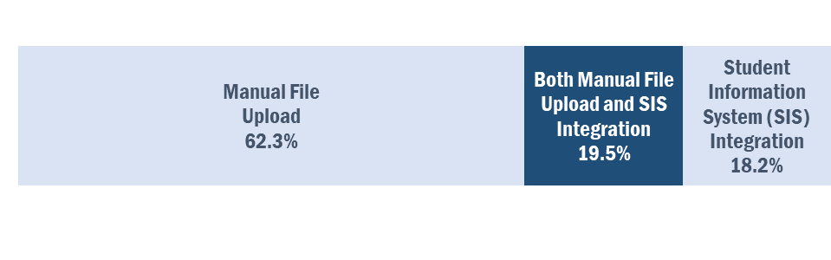
Respondents reported accessing CERS for a variety of purposes, predominantly to review and analyze individual student results and student group results (55 percent of respondents) and to explore CERS to become familiar with its features (54 percent). A table containing all of the reported reasons for accessing CERS can be found in the CERS section of Appendix B.
Nearly 90 percent of respondents who did access CERS used the system to access summative assessment results, individually (46 percent of respondents) and in conjunction with interim assessment results (44 percent). A breakdown of percentages is illustrated in figure 13. Values were rounded, resulting in a response total greater than 100 percent.
Figure 13. Assessment Results Accessed in CERS
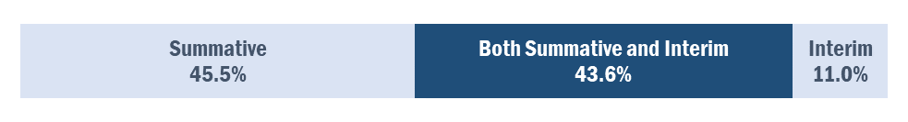

Results for the Smarter Balanced Summative Assessments for English language arts/literacy (ELA) and mathematics were the summative assessment results accessed most frequently in CERS by respondents who did access the system, followed by Summative ELPAC results. Figure 14 illustrates a breakdown of the percentages of the results accessed in CERS by respondents. Survey respondents were instructed to select multiple responses if applicable, resulting in a response total greater than 100 percent.
Figure 14. Summative Assessment Results Accessed in CERS
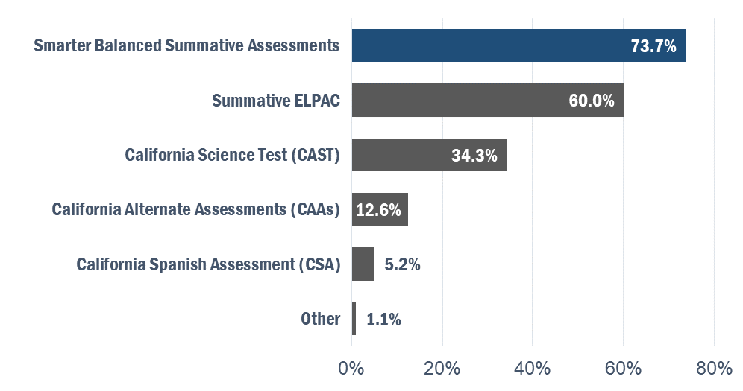

Average scale scores are the most frequently accessed summative assessment information in CERS (accessed by 69 percent of respondents who reported using CERS). Figure 15 illustrates a breakdown of the percentages of types of information accessed in CERS by respondents. Survey respondents were instructed to select multiple responses if applicable, resulting in a response total greater than 100 percent.
Figure 15. Summative Assessment Information Accessed in CERS
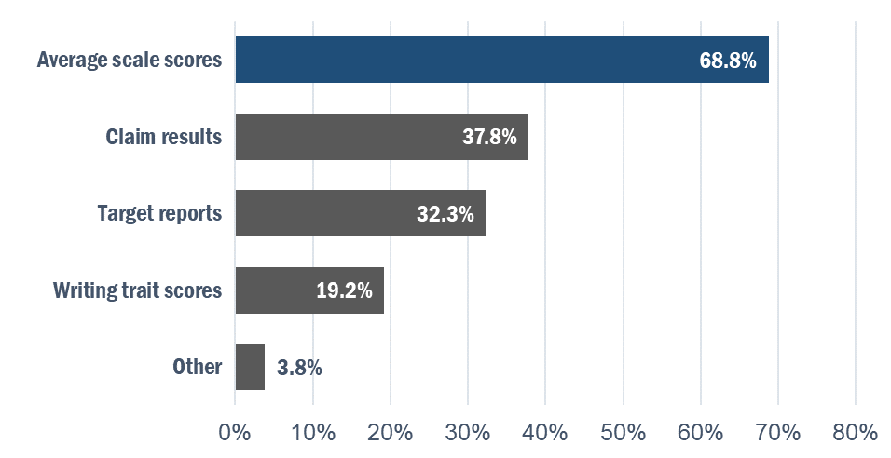
Respondents who used CERS also reported accessing the system for interim assessment information, predominantly to access overall average scale scores for student groups (41 percent of respondents) and individual student scale scores (40 percent). A table containing all of the reported interim assessment information accessed in CERS can be found in the CERS section of Appendix B. Survey respondents were instructed to select multiple responses if applicable, resulting in a response total greater than 100 percent.
Among respondents who stated that they have not used CERS, most did not know how to use it (37 percent) or were not aware that it existed (30 percent). Twenty percent of respondents reported that their district uses a different data system to view student results from state assessments.

CERS Sandbox
The CERS Sandbox is a nonsecure training and demonstration environment that uses fictitious computer-generated data. It can be accessed on the Smarter Balanced CERS Sandbox web page at http://cerssandbox.smarterreporting.org/.
Only 16 percent of respondents reported having used the CERS Sandbox.
Among respondents who stated that they had not used the CERS Sandbox, most were not aware that it existed (56 percent of respondents). Twenty-six percent of respondents did not know how to use it.

Training Opportunities and Webinars
This section analyzes respondents’ familiarity with training opportunities for coordinators as well as their feedback on CDE webinars, Office Hours, and Coffee Sessions. This feedback was gathered to inform the CDE and SCOE on the creation of upcoming training opportunities and webinar schedules.

New Coordinator Trainings
All respondents were asked about their awareness of the yearlong training plan available to new coordinators.
Nineteen percent of respondents identified as new coordinators, a significant decrease from 2020 (36 percent of respondents).
Seventy-two percent of all respondents were aware of the training plan. Awareness of the training plan among new coordinators was slightly lower (69 percent of new coordinators in 2021). However, this represents a significant increase in training plan awareness among new coordinators (up from 59 percent in the 2020 Assessment Coordinator Survey Report, prior to the implementation of recommended welcome emails for new coordinators).
Seventy-one percent of respondents who identified as new coordinators attended the 2020–21 New Coordinator Trainings.

CDE Webinars, Office Hours, and Coffee Sessions
In January 2020, the CDE began hosting regular Assessment Update webinars, Office Hours, and Coffee Sessions to provide educators with current and timely information about student assessments.
Recordings and materials from these sessions can be accessed on the CAASPP Past Training Opportunities web page at https://www.caaspp.org/training/training-opportunities-archive.html and on the ELPAC Past Training Opportunities web page at https://www.elpac.org/training/training-opportunities-archive/.
Ninety-three percent of all respondents were aware of the Assessment Update webinars, Office Hours, and Coffee Sessions. Among these respondents, 77 percent had attended at least one session.
Eighty-one percent of respondents who had attended at least one session reported satisfaction with the information provided by the CDE.
A majority of respondents preferred monthly Assessment Update webinars for 2021–22, as illustrated in figure 16.
Figure 16. Preferred Frequency of Assessment Update Webinars for 2021–22
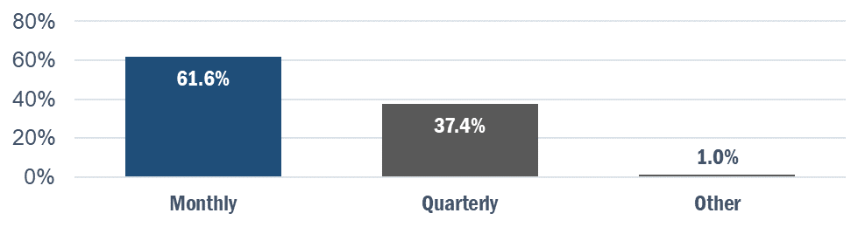
A majority of respondents also preferred monthly Coffee Sessions for 2021–22, as illustrated in figure 17.
Figure 17. Preferred Frequency of Coffee Sessions for 2021–22
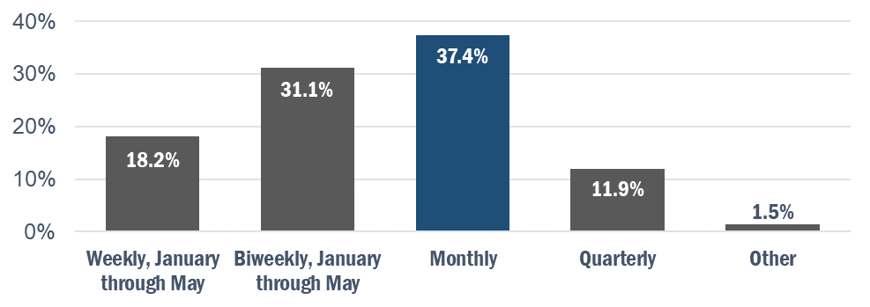

Recommendations
The recommendations set forth by SCOE in this section are the direct result of feedback and data collected in the Assessment Coordinator Survey. The recommendations are organized into four sections—Resources, Charter School Assessment Coordinators, CERS, and Training Opportunities and Webinars—which are based on the structure of the survey. The survey responses will also inform the development of the Training Plan and Educator Engagement Plan for the 2022–23 school year.

Resources
Recommendation 1: Continue efforts to revise existing documents and improve their readability and accessibility. Survey results indicate high levels of satisfaction with these efforts among coordinators. SCOE should continue to edit existing deliverables (e.g., the 2021–22 ELPAC Information Guide, SSR letter templates) based on survey feedback.
Recommendation 2: Continue collaboration with ETS on the creation of a style manual to use when developing deliverables to ensure that they are engaging and easily navigated, follow data visualization best practices, and are fully compliant with Section 508 accessibility requirements.

Charter School Assessment Coordinators
Recommendation 3: Initiate and support the creation of a statewide charter school assessment coordinator network via a collaboration with the Regional Assessment Network and county offices of education. A majority of respondents who identified as charter school assessment coordinators expressed interest in a support network of fellow coordinators specific to charter schools/organizations, as their experience differs from that of other LEA coordinators.

CERS
Recommendation 4: Continue with the current CERS marketing efforts, including the development of a training to be launched in the 2022–23 school year. Many respondents were not familiar with CERS or the CERS Sandbox. Among those who were aware of these systems, many respondents did not know how to use them. Marketing efforts should focus on building awareness with engaging communications and supporting the use of CERS through training opportunities.

Training Opportunities and Webinars
Recommendation 5: Continue to refine the process of welcoming new coordinators to their role and informing them of the New Coordinator Training Series. Since the implementation of the New Coordinator Welcome emails (recommended in the 2020 Assessment Coordinator Survey Report), awareness of training opportunities among new coordinators has increased significantly. Resources delivered to new coordinators should be updated to ensure current and timely assessment information.
Recommendation 6: Continue to implement data visualization best practices when creating PowerPoint presentations and notetaking guides for trainings.
Recommendation 7: Continue to provide the public with timely assessment information on a monthly basis, at minimum, while ensuring that coordinators do not experience webinar fatigue. A majority of respondents agreed that monthly updates were preferred and most helpful.

Appendix A: Survey Questions
The logic that was programmed into the survey (e.g., skipping questions based on responses) is shown beside questions and response options where applicable.

2021 LEA Coordinator Survey
The purpose of this survey is to gather information from local educational agency (LEA) CAASPP and ELPAC coordinators about communication materials, training, and other resources needed to support them in the successful administration of the CAASPP and ELPAC assessment programs.

District Demographics
Q1. How many students are enrolled in your LEA?
- 249 or fewer
- 250–499
- 500–999
- 1,000–5,999
- 6,000–14,999
- 15,000 or more
Q2. Is your LEA a charter school/organization?
- Yes
- No
Q3. What grade levels does your LEA serve? (Select all that apply.)
- Elementary (TK–5)
- Middle (6–8)
- High (9–12)
Q4. Is your LEA:
- Rural
- Suburban
- Urban

Q5. What percentage of students in your LEA are English learner students?
- Less than 10%
- 10–25%
- 26–50%
- 51–75%
- More than 75%

Charter School Assessment Coordinator
(This section appears only to respondents who indicated that their LEA is a charter school/organization on Q2.)
Q6. Please rate your agreement with the following statements on a scale of 1 to 5 (1=Strongly Disagree, 5=Strongly Agree):
- I am confident in my role as a charter school assessment coordinator.
- I find the existing resources for assessment coordinators helpful in my role.
- I customize the existing resources to fit my needs as a charter school assessment coordinator.
- I know where to reach out for assistance with all aspects of my work.
- I belong to a network of charter school assessment coordinators.
- My charter school assessment coordinator network helps me with the unique aspects of my work.
- I am interested in participating in a state-wide network of charter school assessment coordinators.

CAASPP Coordinator
Q7. Are you the LEA CAASPP coordinator?
- Yes (Survey continues.)
- No (Skip to ELPAC Coordinator section.)
Q8. How long have you served in this role? (Please include your time as STAR Coordinator, if applicable.)
- Less than 1 year
- 1–3 years
- 4–6 years
- 7–10 years
- More than 10 years
Q9. How satisfied are you with the amount of resources (documents and videos) available to support you with the CAASPP System?
- Very satisfied
- Satisfied
- Somewhat satisfied
- Not at all satisfied
Q10. How satisfied are you with the quality of resources (documents and videos) available to support you with the CAASPP System?
- Very satisfied
- Satisfied
- Somewhat satisfied
- Not at all satisfied
Q11. What additional resources or supports are needed to help you be more successful in your role as the LEA CAASPP coordinator? (Open-ended response.)

ELPAC Coordinator
Q12. Are you the LEA ELPAC coordinator?
- Yes (Survey continues.)
- No (Skip to Student Score Report Cover Letter Templates section.)
Q13. How long have you served in this role? (Please include your time as CELDT Coordinator, if applicable.)
- Less than 1 year
- 1–3 years
- 4–6 years
- 7–10 years
- More than 10 years
Q14. How satisfied are you with the amount of resources (documents and videos) available to support you with the ELPAC System?
- Very satisfied
- Satisfied
- Somewhat satisfied
- Not at all satisfied

Q15. How satisfied are you with the quality of resources (documents and videos) available to support you with the ELPAC System?
- Very satisfied
- Satisfied
- Somewhat satisfied
- Not at all satisfied
Q16. What additional resources or supports are needed to help you be more successful in your role as the LEA ELPAC coordinator? (Open-ended response.)

2021–22 ELPAC Information Guide
(This section appears only to ELPAC coordinators.)
In the 2020 Coordinator Survey, respondents reported that manuals and guides were difficult to engage with, regarding both formatting and language. The California Department of Education (CDE) is committed to improving the readability of and access to manuals and guides. The first example of an updated manual is the 2021–22 ELPAC Information Guide. Some of the updates include simplifying language, including references to California Education Code and California Code of Regulations as footnotes, and adding additional heading levels to improve formatting and readability.
When responding to the following questions, please think about the 2021–22 ELPAC Information Guide provided at https://www.cde.ca.gov/ta/tg/ep/documents/elpacinfoguide21.docx (DOCX).
Q17. How helpful did you find the formatting updates to the 2021–22 ELPAC Information Guide?
- Extremely helpful
- Very helpful
- Moderately helpful
- Slightly helpful
- Not at all helpful
- Not sure

Q18. How helpful did you find the language updates to the 2021–22 ELPAC Information Guide?
- Extremely helpful
- Very helpful
- Moderately helpful
- Slightly helpful
- Not at all helpful
- Not sure
Q19. Do you have any suggestions for improvement? (Open-ended response.)

Student Score Report Cover Letter Templates
The California Department of Education (CDE) has created a set of parent/guardian Student Score Report (SSR) cover letter templates that LEAs can send to parents along with printed SSRs or with instructions on how to access the SSRs electronically.
When responding to the following questions, please think about the set of SSR cover letter templates provided on the CAASPP Score Reporting web page at https://www.caaspp.org/administration/reporting/index.html and the ELPAC Score Reporting web page at https://www.elpac.org/test-administration/reporting/.
Q20. What is the main way you send SSRs to families?
- Online parent/student portal
- Different electronic method
- Print and mail
- Other, please specify (Open-ended response.)
Q21. Do you use the CDE SSR letter templates?
- Yes (Skip to Q24.)
- No (Survey continues.)
Q22. If you do not use the SSR letter templates, do you send a communication to families when the SSRs are available?
- Yes (Survey continues.)
- No (Skip to TE, TA, and Site Coordinator Checklists section.)

Q23. How do you communicate with families that SSRs are available? (Select all that apply.) (After this question, skip to TE, TA, and Site Coordinator Checklists section.)
- Email
- LEA-created letter
- Social media post
- Robo-call
- Postcard
- Other, please specify (Open-ended response.)
Q24. How did you learn about the SSR letter templates? (Select all that apply.)
- CAASPP website
- ELPAC website
- CDE Assessment Spotlight email
- CDE website
- At a conference, training, or workshop
- Word of mouth/colleague
- Other, please specify (Open-ended response.)
- Not sure
Q25. How would you rate the quality of the SSR letter templates?
- Excellent
- Good
- Fair
- Poor
- If poor, please explain (Open-ended response.)
Q26. How do you use the SSR letter templates?
- Add our logo and send them as-is
- Use most of the language and add some of our own
- Use some of the language but mostly create our own
- Other, please specify (Open-ended response.)
Q27. How likely are you to use the SSR letter templates in the future?
- Very likely
- Likely
- Unlikely
- Very unlikely
Q28. How likely are you to recommend the SSR letter templates to a colleague?
- Very likely
- Likely
- Unlikely
- Very unlikely

TE, TA, and Site Coordinator Checklists
In addition to the LEA CAASPP and ELPAC coordinator checklists, the CDE has developed a set of customizable checklists to be distributed to test examiners (TEs), test administrators (TAs), and site coordinators. These TE, TA, and site coordinator checklists are meant to organize the activities necessary to ensure the successful administration of the CAASPP and ELPAC.
When responding to the following question, please think about the checklists provided on the CAASPP Manuals and Instructions web page at https://www.caaspp.org/administration/instructions/index.html and on the ELPAC Manuals and Instructions web page at https://www.elpac.org/test-administration/instructions/.
Q29. Are you aware of the TE, TA, and site coordinator checklists?
- Yes (Survey continues.)
- No (Skip to CDE Webinars, Office Hours, and Coffee Sessions section.)
Q30. How did you learn about the TE, TA, and site coordinator checklists? (Select all that apply.)
- CAASPP website
- ELPAC website
- CDE Assessment Spotlight email
- CDE website
- At a conference, training, or workshop
- Word of mouth/colleague
- Other, please specify (Open-ended response.)
- Not sure

Q31. Which of the following stakeholder groups have you shared the TE, TA, and site coordinator checklists with? (Select all that apply.)
- Test examiners
- Test administrators
- Site coordinators
- Other, please specify (Open-ended response.)
- None of the above
Q32. How likely are you to share the TE, TA, and site coordinator checklists with these stakeholder groups in the future?
- Very likely
- Likely
- Unlikely
- Very unlikely
- If unlikely, please explain (Open-ended response.)
Q33. How would you rate the quality of the TE, TA, and site coordinator checklists?
- Excellent
- Good
- Fair
- Poor
- If poor, please explain (Open-ended response.)
Q34. How likely are you to recommend the TE, TA, and site coordinator checklists to a colleague?
- Very likely
- Likely
- Unlikely
- Very unlikely
- If unlikely, please explain (Open-ended response.)

CDE Webinars, Office Hours, and Coffee Sessions
The CDE has been hosting regular Assessment Update webinars, Office Hours, and Coffee Sessions to provide educators with current and timely information about student assessments.
When responding to the following question, please think about the webinars, Office Hours, and Coffee Sessions. Recordings and materials from these sessions can be accessed on the CAASPP Past Training Opportunities and Materials web page at https://www.caaspp.org/training/training-opportunities-archive.html.
Q35. Are you aware of the webinars, Office Hours, and Coffee Sessions?
- Yes (Survey continues.)
- No (Skip to New Coordinator Trainings section.)
Q36. Did you attend any of the webinars, Office Hours, or Coffee Sessions?
- Yes (Survey continues.)
- No (Skip to New Coordinator Trainings section.)
Q37. How satisfied are you with the information provided by the CDE during these webinars, Office Hours, and Coffee Sessions?
- Very satisfied
- Satisfied
- Somewhat satisfied
- Not at all satisfied
Q38. The 2020–21 Assessment Update webinars allowed the CDE to share assessment updates in November, January, and March. How frequently would you prefer to receive assessment information via CDE webinars in 2021–22?
- Monthly
- Quarterly
- Other, please specify (Open-ended response.)

Q39. Coffee Sessions, hosted by the CDE and ETS, are entirely dedicated to answering questions about assessments and topics of interest from testing coordinators and providing timely updates. How frequently would you prefer to receive assessment information via Coffee Sessions in 2021–22?
- Weekly, January through May
- Biweekly, January through May
- Monthly
- Quarterly
- Other, please specify (Open-ended response.)
Q40. Do you have any suggestions for improvement? (Open-ended response.)

New Coordinator Trainings
Q41. Are you aware that there is a year-long training plan available for LEA coordinators who are new to their role?
- Yes
- No
Q42. Were you a new coordinator in 2020–21?
- Yes
- No
Q43. Did you attend any of the 2020–21 New Coordinator Trainings?
- Yes (Survey continues.)
- No (Skip to California Educator Reporting System section.)

New Coordinator Welcome Letter
Q44. A “Welcome to Your Role” letter was included in the confirmation email coordinators received when they were designated for the 2020–21 school year. Did you receive the New Coordinator Welcome Letter?
- Yes (Survey continues.)
- No (Skip to California Educator Reporting System section.)
- Not sure (Skip to California Educator Reporting System section.)

Q45. Did you read the New Coordinator Welcome Letter?
- Yes
- No
- Not sure

California Educator Reporting System (CERS)
California’s online educator reporting systems provide teachers and schools with assessment results to help guide instruction. Information about the CERS can be found on the CDE California Educator Reporting System web page at https://www.cde.ca.gov/ta/tg/ca/caaspporsys.asp.
Q46. Have you used the CERS?
- Yes (Survey continues.)
- No (Skip to Q55.)
Q47. How often do you access the CERS?
- Frequently
- Occasionally
- Rarely
Q48. Did you or your designee create groups of students for your teachers so they could use the CERS?
- Yes (Survey continues.)
- No (Skip to Q50.)
Q49. Which of the following methods do you use to create student groups for your teachers?
- Manual file upload into the CERS
- Student information system (SIS) integration with the CERS
- Both manual file upload and SIS integration

Q50. How do you use the CERS? (Check all that apply.)
- Explore it to become familiar with the features
- Review and analyze student group results
- Review and analyze individual student results
- Review and analyze individual item responses
- Review the rubrics and exemplars for items
- Review key/distractor analysis for interim assessment items
- Compare student groups
- Compare different administrations of interim assessments
- Other, please specify (Open-ended response.)
Q51. What types of assessment results have you accessed in the CERS?
- Summative assessment results
- Interim assessment results
- Both summative and interim assessment results
Q52. Which summative assessment results have you accessed in the CERS? (Check all that apply.)
- Smarter Balanced Summative Assessments for English language arts/literacy and mathematics
- Summative ELPAC
- California Science Test (CAST)
- California Spanish Assessment (CSA)
- California Alternate Assessments (CAAs)
- Other, please specify (Open-ended response.)
- None, I do not access summative assessment results in the CERS
Q53. What summative assessment information have you accessed in the CERS? (Check all that apply.)
- Average scale scores
- Claim results
- Writing trait scores
- Target reports
- Other, please specify (Open-ended response.)
- None, I do not access summative assessment information in the CERS

Q54. What interim assessment information have you accessed in the CERS? (Check all that apply.) (After this question, skip to CERS Sandbox section.)
- Overall average scale scores for groups of students
- Individual student scale scores
- Student responses to individual items
- Group performance on individual items
- Key/distractor analysis for items
- Other, please specify (Open-ended response.)
- None, I do not access interim assessment information in the CERS
Q55. Why have you not used the CERS?
- I was not aware of it
- I do not know how to use it
- My district uses another data system to view student results from state assessments
- Other, please specify (Open-ended response.)

CERS Sandbox
The CERS Sandbox is a non-secure training and demonstration environment that uses fictitious computer-generated data. The CERS Sandbox can be accessed on the Smarter Balanced CERS Sandbox web page at http://cerssandbox.smarterreporting.org/.
Q56. Have you used the CERS Sandbox training tool to get familiar with the features of the CERS?
- Yes (Survey ends.)
- No (Survey continues.)
Q57. Why have you not used the CERS Sandbox?
- I was not aware of it
- I do not know how to use it
- Other, please specify (Open-ended response.)

Appendix B: Data Tables
This appendix provides complete tables of response data organized by survey structure.

Charter School Assessment Coordinators
The following responses were provided only by respondents who indicated that their LEA was a charter school/organization.
Table 1. Charter School Assessment Coordinator Statement Ratings
Statement | Strongly Disagree | Disagree | Neutral | Agree | Strongly Agree | Unsure
I am confident in my role as a charter school assessment coordinator. | 3.35% | 7.95% | 9.62% | 43.93% | 34.73% | 0.42%
I find the existing resources for assessment coordinators helpful in my role. | 2.09% | 3.35% | 17.15% | 45.61% | 31.38% | 0.42%
I customize the existing resources to fit my needs as a charter school assessment coordinator. | 2.09% | 6.28% | 16.32% | 45.61% | 28.03% | 1.67%
I know where to reach out for assistance with all aspects of my work. | 3.77% | 8.37% | 13.81% | 38.08% | 35.15% | 0.84%
I belong to a network of charter school assessment coordinators. | 32.64% | 25.94% | 12.55% | 12.55% | 8.79% | 7.53%
My charter school assessment coordinator network helps me with the unique aspects of my work. | 25.10% | 17.99% | 23.85% | 11.30% | 8.37% | 13.39%
I am interested in participating in a state-wide network of charter school assessment coordinators. | 9.21% | 7.95% | 23.85% | 28.45% | 25.10% | 5.44%

CERS
The following responses were provided only by respondents who reporting accessing CERS.
Table 2. Reasons for CERS Access
Reason for CERS Access | Access Rate
Explore it to become familiar with the features | 54.25%
Review and analyze student group results | 55.07%
Review and analyze individual student results | 54.52%
Review and analyze individual item responses | 24.66%
Review the rubrics and exemplars for items | 20.82%
Review key/distractor analysis for interim assessment items | 18.36%
Compare student groups | 28.22%
Compare different administrations of interim assessments | 14.79%
Other | 6.30%

Table 3. Interim Assessment Information Accessed in CERS
Interim Assessment Information Accessed in CERS | Access Rate
Overall average scale scores for groups of students | 40.82%
Individual student scale scores | 40.00%
Student responses to individual items | 29.32%
Group performance on individual items | 28.77%
Key/distractor analysis for items | 19.18%
Other | 1.37%

2021
California Assessment Conference Post-Conference Report

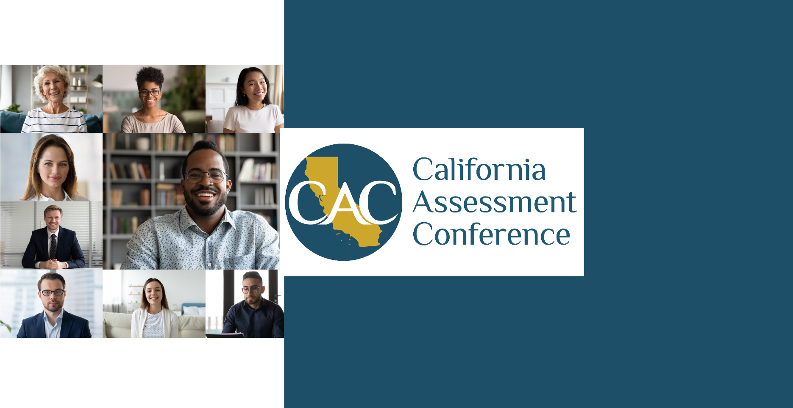
January 2022 CN210046

Contents

Introduction 3
Conference Attendance and Demographics 3
Summary of Survey Participants 3
CAC Survey Responses 4
SCOE Recommendations 6
Recommendations for Changes 6
Recommendations for Continued Practices 7
Appendix A Conference Schedule and Session Descriptions 8
Appendix B Attendee Counts 20
Appendix C Individual Session Surveys 25

Introduction
The third annual California Assessment Conference (CAC) was held October 12–14, 2021, as a virtual event. The California Department of Education (CDE) and the Sacramento County Office of Education (SCOE) initially planned the 2021 CAC as an in-person event for 1,000 attendees, to be held at the Riverside Convention Center in Riverside, California. The continuing novel coronavirus 2019 pandemic and associated restrictions on travel and public gatherings, however, necessitated a shift from an in-person event to a virtual one. The full schedule of the 2021 CAC is available in Appendix A.
The 2021 CAC was billed as a training opportunity for educators with a connection to classroom instruction—classroom teachers, teachers on special assignment (TOSAs), teacher coaches, and site administrators. While registration was open to all educators at any level and in any role, the content of the conference sessions was intended to inform classroom instruction.

Conference Attendance and Demographics
The 2021 CAC drew 720 registrants. Due to the conference happening across multiple Zoom accounts it is impossible to obtain a unique attendee count; instead the attendee count per session is available in Appendix B.
354 of the 720 registrants (49 percent) were classroom educators or site administrators.

Summary of Survey Participants
Two methods were used to collect attendees’ feedback.

Method 1: Post-Session Surveys
At the end of each Zoom session, attendees were presented with a survey that asked them to rate the session, on a scale of one (needs improvement) to five (excellent), in the following three areas:
- Presenters
- Materials
- Session overall
Appendix C contains survey response averages for each session.

Method 2: Post-Conference Survey
The post-conference survey was delivered to conference registrants via direct email. Registrants received a follow-up email one week prior to the closing of the survey. A reminder email was also sent the day before the survey closed. These reminders helped to draw a response rate of 18 percent.
131 survey respondents
18 percent response rate
The body of this report focuses on feedback gathered from registrants via the post-conference survey.

CAC Survey Responses
All findings on pages three and four are based on answers from the 131 survey respondents. Attendees were asked several questions about their overall conference experience. In general, the vast majority of survey respondents reported a positive learning experience and would recommend this professional development opportunity to their peers and colleagues.
96 percent of respondents agreed that they could immediately apply the things they learned at the CAC to their work.
98 percent of respondents agreed that attending the CAC helped them better meet the needs of their students.
95 percent of respondents agreed that the conference was a productive use of their time.
92 percent of respondents would recommend the CAC to their colleagues.
Respondents were asked what worked well in the virtual conference.
Training Team and Materials
98 percent of respondents agreed that the presenters were knowledgeable. Respondents were asked which sessions they enjoyed most.
98 percent of respondents agreed that the presenters shared real-life examples and experiences.
98 percent of respondents agreed that the presenters were able to address their questions.
98 percent of respondents agreed that the training materials supported their learning.
Opening and Closing Keynote
The conference was opened by Teacher of the Year Keisa Brown. Keisa Brown teaches at the University Heights Middle School in Riverside, California. She lives and teaches “Ubuntu”, which is a Bantu term meaning humanity. She spoke about the power of student assessments in the context of equity and social-emotional wellbeing of students.
83 percent of respondents agreed Teacher of the Year Keisa Brown’s session was relevant to their work.
79 percent of respondents agreed Teacher of the Year Keisa Brown’s session was inspiring.
The closing keynote speaker was Professor John Hattie. Professor Hattie is an award-winning education researcher and best-selling author with nearly 30 years of experience examining what works best in student learning and achievement. He spoke on student assessment and assessment literacy.
85 percent of respondents agreed Professor John Hattie’s session was relevant to their work.

81 percent of respondents agreed Professor John Hattie’s session was inspiring.
Coffee Sessions
In an attempt to provide opportunities for networking and engagement during the virtual 2021 CAC, virtual Coffee Sessions were included in the conference schedule. During these sessions, attendees could chat with fellow educators, as well as CDE and ETS staff, about various assessment-related topics. These sessions provided an opportunity for attendees to connect with others and engage in conversation first thing in the morning, mimicking a typical conference experience.
50 percent of respondents indicated that they attended one of the Coffee Sessions.
87 percent of respondents who attended a Coffee Session agreed that it was engaging.

SCOE Recommendations
The SCOE has reviewed the 2021 conference costs as well as the feedback obtained from the CDE and SCOE staff, trainers, and survey respondents. For the 2022 CAC, the SCOE proposes continuing some practices from previous years and implementing some changes.

Recommendations for Changes
Below are the SCOE recommendations for changes to be incorporated into the 2022 CAC.

Method of Delivery
The SCOE recommends holding the 2022 CAC in person. An in-person conference offers many benefits that are not available in a virtual conference model, such as networking; learning in an environment away from work/home, which minimizes distractions; and increasing engagement.
At the same time, a virtual conference can reach educators who are unable to travel. To that end, the SCOE further recommends that a hybrid model be used for the 2022 CAC, with one or two sessions per agenda time slot being provided virtually. This will allow attendees to select the attendance method that works better for them. The SCOE recommends different conference fees for in-person vs. virtual attendance. In addition, due to the set-up and technology required to host virtual sessions, the SCOE recommends that sessions be presented to virtual and in-person audiences separately to minimize the burden on presenters and to increase engagement.

Include Expert Panel Discussions
While attendees enthusiastically welcomed hearing from each other in presentations, they also would appreciate an opportunity to discuss additional topics in a format different from a presentation. Attendees would like to hear from presenters with distinct-level experience in assessment in grade school versus high school, with students with disabilities, and various other areas of expertise.

Recommendations for Continued Practices
Below are the SCOE recommendations for continued practices.

Continue to Provide Shared Practice Sessions
The SCOE recommends that the 2022 CAC continue the feature of providing a large number of shared practice sessions. Attendees like to hear from other local educational agency (LEA) staff and other educators from throughout the state. The SCOE also recommends increasing the diversity of the shared practice sessions to include presenters who work with various age groups, students with disabilities, and other student groups.

Provide Multiple Content Area Options in Each Time Slot
The SCOE recommends ensuring that each time slot for breakout sessions includes options for multiple content areas so no attendees feel as though their preferred content area is not available during a breakout strand.

Appendix A
Conference Schedule and Session Descriptions
Appendix A contains the full conference schedule and the session descriptions.

Prerecorded Sessions

101 Sessions
This series of introductory sessions on varying assessment topics allowed attendees to gain foundational knowledge in areas of their choosing before engaging in two days of deeper learning. These sessions provided an overview of the California Assessment of Student Performance and Progress (CAASPP) and English Language Proficiency Assessment for California (ELPAC).
- Formative Assessment 101
- Interim Assessment 101
- Summative Assessment 101
- California Science Test (CAST) 101
- ELPAC 101
- California Alternate Assessments (CAAs) for English Language Arts/Literacy (ELA), Math & Science 101
- California Spanish Assessment (CSA) 101
- Accessibility 101

Lab Sessions
The 2021 CAC included three prerecorded lab sessions on the following topics:
- Digging into Tools for Teachers
- Exploring the Interim Assessment Viewing System
- Exploring the California Educator Reporting System (CERS)
These sessions allowed attendees to follow along with instruction while delving into components of the comprehensive assessment system.

Day 1 Live Sessions

12:30–1:45 p.m. | Breakout Strand One

CAASPP: Progress Outside the Comfort Zone
"Michael John Bobak said, “All progress takes place outside the comfort zone.” Administering CAASPP remotely to our scholars was definitely outside our comfort zone! The results: we increased our participation rates by 20%! Join Beth Sneyd, Assessment Coordinator, and Brenda Lasley, Supervising Teacher and Assessment ToSA from Compass Charter Schools, as we present how we implemented Test Prep for our scholars, training for our teachers, and remotely administered state testing. Compass Charter Schools is one of California’s leading WASC-accredited virtual charter schools of choice."

Inquiry in Math
How can inquiry-based instruction in mathematics help students prepare for the CAASPP and be used as formative assessments? Using research from my doctoral research project, teachers, administrators, and curriculum staff will learn about using inquiry-based instructional strategies to teach mathematics and how those strategies correlate with CAASPP and their use as formative assessments by teachers. We will focus on two instructional strategies, discourse and Notice & Wonder. Participants will be able to immediately apply inquiry-based instructional strategies in math using techniques learned.

Rough Draft Assessments
An assessment should not be a "gotcha." The formative assessment strategy of a rough draft test provides teachers a chance to obtain formative data and provide feedback. The concept of a rough draft assessment provides student the opportunity to take an assessment and get feedback. Students can use this feedback to refine their responses. This strategy is about students demonstrating their understanding of content and applying a growth mindset. Additionally, students benefit by having a truer assessment of what they know and understand.

Standardized Assessments in the Alternative Education Environment
This session will highlight the successes of administering the various standardized assessments in an alternative education environment, while also identifying the barriers and challenges faced.

Using Progress Monitoring for English Learner Success
In this session, participants will share their current practice for English learner progress monitoring and build common definitions of assessment practices. They will align the ELD standards with the assessment practices and explore how ELPAC rubrics can be used as a resource for preparing English learners for the summative ELPAC as well as how those rubrics can be used as progress monitoring tools. Participants will have the opportunity to explore formative assessment tools in the domains of listening, speaking, reading, and writing.

2:15–3:30 p.m. | Breakout Strand Two

Assessment for Learning: Shifting Assessment Practices to Support Mathematics Learning
Assessment for Learning (AFL) is a series of professional development that highlights an interrelated set of practices, and processes to deepen students’ development of knowledge and skills, foster greater ownership and agency over learning. The design of AFL engages grades 38 educators through collaborative discussions utilizing SBAC-aligned items to shift assessment practices. Tools, resources, and professional development materials will be shared for teams to use for replication.

Designing Designated ELD Lessons to Support the ELPAC
In this session, participants will explore the components of robust designated ELD instruction. They will develop familiarity with reflective questions that support cognitive instructional planning for designated ELD as well as how to develop and use ELPAC-aligned matrices to create and build a series of lessons designed to support language acquisition for English learners as well as success on the ELPAC.

LEA Testing Coordinators Unite—Together Is Better!
This session is for LEA testing coordinators as they prepare and support school sites with ELPAC and CAASPP. In San Bernardino City Unified, developing and improving systems has been instrumental in meeting federal and state requirements. We have taken pride in meeting the 95% participation rates and have used the trainer of trainers model in building the capacity of over 75 site testing coordinators. Successful practices for our district include: creating an annual timeline for testing, ongoing communication with stakeholders, resources developed to ensure testing success, as well as reflections and best practices from the field.

Plan to Assess, Assess to Plan
When do you create your assessments? Do you measure what you taught or what students should know? How do your assessments influence your lessons? This session will investigate assessment creation as a framework for creating lesson plans. Participants will explore the advantages of creating assessments first, crafting lesson plans from those assessments, and then how to adjust yours plans to meet your students' needs based on assessment data.

The Smarter Balanced Ecosystem: But Wait!!! There's More!!!
The Smarter Balanced Ecosystem is a one-stop shop for all of your assessment, data system, and instructional needs for your classroom/school system. This presentation will take participants through the different pieces of the Smarter Balanced Ecosystem and the resources associated with it while really honing in on the interconnectedness of all parts. The best part of this system is that ALL parts of it are available to schools and districts for FREE and will not require the “3 easy payments.”

Day 2 Live Sessions

8:00–8:30 a.m. | Coffee Sessions
Attendees were encouraged to grab a cup of coffee and log on to chat about a variety of topics with staff from the CDE and testing contractor ETS. The following coffee sessions were offered on Day 2:
- Questions from the 101s and Labs
- Alternate Assessments
- Science Assessments
- Interim Assessments and Use in 2021–22
- Outreach

8:30–9:15 a.m. | Breakout Strand Three

A Balanced Approach to Assessment: Diagnosing and Mitigating Learning Loss Through Assessment-Informed Instruction
Assessment can and should be an integral part of instruction, providing students, teachers, parents, and administrators with timely information about student progress toward learning goals. In this session, participants will explore how formative assessment practices, interim assessment tools, and summative assessments can be integrated into a comprehensive approach to monitoring and improving student learning. A thoughtful, planned, balanced approach to assessment can support educators to diagnose learning gaps and target instruction to mitigate learning loss and move learning forward.

Formative Assessment Strategy: Mini White Boards
The Mini White Board is a strategy used to quickly assess students’ understanding of a concept and who may or may not need additional support.
Using this strategy can help students: work independently or in pairs on a problem, receive immediate feedback and engage in rigorous problems. We will focus on the use and management of this instructional strategy.

Observational Protocol for Teachers of English Learners
The California Department of Education has been in the process of developing the new Observational Protocol for Teachers of English Learners (OPTEL). This process has involved working with educators in its design. This session will provide participants with an opportunity to provide feedback to an exciting update on its development, opportunities for field testing in 2021–22, and a timeline for full implementation. Join us to learn how this tool will assist educators of English learners in confirming students' English Language Proficiency Assessments for California (ELPAC) results in classroom applications that demonstrate a student is sufficiently proficient to be reclassified.

Plan to Assess, Assess to Plan
When do you create your assessments? Do you measure what you taught or what students should know? How do your assessments influence your lessons? This session will investigate assessment creation as a framework for creating lesson plans. Participants will explore the advantages of creating assessments first, crafting lesson plans from those assessments, and then how to adjust yours plans to meet your students' needs based on assessment data.

Navigating the California Educator Reporting System
This session will provide you with a basic understanding of the California Educator Reporting System (CERS), including the purpose, types of assessment results available, and resources to support educator use of the system.

9:50–10:15 a.m. | Stretch Break
This session will be optional, offering an opportunity to engage in guided, mindful stretching exercises.

10:15-11:30 a.m. | Breakout Strand Four

Assessment Ecosystem Reboot
"Michael John Bobak said, “All progress takes place outside the comfort zone.” Administering CAASPP remotely to our scholars was definitely outside our comfort zone! The results: we increased our participation rates by 20%! Join Beth Sneyd, Assessment Coordinator, and Brenda Lasley, Supervising Teacher and Assessment ToSA from Compass Charter Schools, as we present how we implemented Test Prep for our scholars, training for our teachers, and remotely administered state testing. Compass Charter Schools is one of California’s leading WASC-accredited virtual charter schools of choice."

Using Progress Monitoring for English Learner Success
In this session, participants will share their current practice for English learner progress monitoring and build common definitions of assessment practices. They will align the ELD standards with the assessment practices and explore how ELPAC rubrics can be used as a resource for preparing English learners for the summative ELPAC as well as how those rubrics can be used as progress monitoring tools. Participants will have the opportunity to explore formative assessment tools in the domains of listening, speaking, reading, and writing.

Formative Assessment in the Mathematics Classroom
The use of Formative Assessment practices can have a transformative effect on both teachers and students. We have to collect the right data and use it as a tool to improve instruction and provide feedback. We will model what this can look like in a Mathematics classroom.

Stats Are Sexy! How to Ensure You Are Using Valid Results
This presentation will focus defining different types of item and test statistics, where they may be found and how they can be used for decision making.

Who Owns the Learning? Building Student Ownership and Efficacy Through Formative Assessment
Teachers, students, and parents regularly call for increased student involvement in and ownership of their own learning. This session will explore how the formative assessment process can support building student efficacy and help students own their learning outcomes. Participants will build a shared understanding of the research on the impact of formative assessment on student learning and explore formative assessment strategies that explicitly engage students in teaching and learning, including instructional and professional learning resources available through the Tools for Teachers platform.

12:30–1:45 p.m. | Breakout Strand Five

A Balanced Approach to Assessment: Diagnosing and Mitigating Learning Loss Through Assessment-Informed Instruction
Assessment can and should be an integral part of instruction, providing students, teachers, parents, and administrators with timely information about student progress toward learning goals. In this session, participants will explore how formative assessment practices, interim assessment tools, and summative assessments can be integrated into a comprehensive approach to monitoring and improving student learning. A thoughtful, planned, balanced approach to assessment can support educators to diagnose learning gaps and target instruction to mitigate learning loss and move learning forward.

Aligning Classroom Literacy Strategies with Content in Math and Language Arts
The state test seems like a formidable assessment for students and teachers, but it doesn’t need to be so. During this session, attendees will learn strategies to increase student achievement on interim and summative assessments in both math and language arts. Additionally, culturally responsive teaching will be enhanced when using the language of the standards and providing assessments in alignment with state expectations. The goal for students is to increase their proficiency levels utilizing input that is both high-interest and rigorously designed.

Data to Drive your Needs Assessment
Does your system use data to drive your Needs Assessment? Data is readily available to anyone involved in your system, but the correct data to drive your work is critical to everyone involved; micro systems (i.e. the classroom) all the way to macro systems (i.e The entire district). Join this session and dive into learning and reflecting on how you use data, within your system, to determine the needs of your students, staff, and community. Leave with a process that allows you to engage in reflective thinking about how data can help you determine your system’s needs.

NGSS 3D Classroom Summative Assessment Tools
Do you want to learn how to develop Next Generation Science Standards (NGSS) 3D classroom summative assessments? Participants will learn how to analyze and modify existing assessment items and create new assessments aligned with unpacked performance expectations. This workshop will assist participants in using three tools to develop high-quality 3D classroom summative assessments.

Using Accessibility Resources in Daily Instruction
How to observe students using assigned accessibility resources and how to make adjustments throughout the year based on those observations.

1:50–2:15 p.m. | Stretch Break
This session will be optional, offering an opportunity to engage in guided, mindful stretching exercises.

2:15–3:30 p.m. | Breakout Strand Six

Supporting English Learners with the Tools for Teachers Website
Tools for Teachers is a powerful new website for teachers that contains high-quality instructional resources aligned with California’s English language arts/literacy and mathematics standards. This session will describe how Tools for Teachers supports teachers in using formative assessment and accessibility strategies to guide teaching and learning, particularly for students who are English learners. In addition, this session will show how the Tools for Teachers Connections Playlists support use of the Smarter Balanced Interim Assessments.

Constructing Scientific Explanations Using Defining Sentences
This fifth-grade lesson activity has students constructing defining sentences using previously learned science vocabulary. Students consider the specific vocabulary needs of their audience in explaining a scientific phenomenon.

Focus on Formative
The session will highlight the importance of the formative component in any assessment. Attendees will have an opportunity to reflect on practices and will be able to explore more ways to bring formative assessments into their mathematics classrooms. Some research-based evidence will be shared, and attendees will have resources that they can take away and use to begin right off the bat.

Stats Are Sexy! How to Ensure You Are Using Valid Results
This presentation will focus defining different types of item and test statistics, where they may be found, and how they can be used for decision making.

The Smarter Balanced Ecosystem: But Wait!!! There's More!!!
The Smarter Balanced Ecosystem is a one-stop shop for all of your assessment, data system, and instructional needs for your classroom/school system. This presentation will take participants through the different pieces of the Smarter Balanced Ecosystem and the resources associated with it while really honing in on the interconnectedness of all parts. The best part of this system is that ALL parts of it are available to schools and districts for FREE and will not require the “3 easy payments.”

Day 3 Live Sessions

8:00–8:30 a.m. | Coffee Sessions
Attendees were encouraged to grab a cup of coffee and log on to chat about a variety of topics with staff from the CDE and ETS. The following coffee carts were offered on Day 3:
- Questions from the 101s and Labs
- Smarter Balanced Reporting 21–22
- What Can Educators Do with Focused Interim Assessment Blocks?
- CA Educator Reporting System (CERS)
- LEA- and Site-Level Coordinators

8:30–9:45 a.m. | Breakout Strand Seven

A SmART Approach to Writing Instruction: Working with the Smarter Balanced Annotated Response Tool (SmART)
In this session, educators will learn the key features and functionality of the Smarter Balanced Annotated Response Tool (SmART). This includes viewing sample items, student responses as well as score annotations for responses at all levels. Following a brief demo of the application's features, educators will work together and build their understanding of how the SmART can be used to support educator collaboration and learning as well within classroom instruction.

An Introduction to The Lexile Framework for Reading
This presentation will offer an introduction to The Lexile Framework for Reading and address the following points:
- What is The Lexile Framework for Reading?
- What are Lexile measures for students and Lexile measures for text?
- Where are Lexile measures found?
- How can The Lexile Framework be used?
- What are the benefits of The Lexile Framework?
- What resources for The Lexile Framework are available?

Assessment Ecosystem Reboot
"Michael John Bobak said, “All progress takes place outside the comfort zone.” Administering CAASPP remotely to our scholars was definitely outside our comfort zone! The results: we increased our participation rates by 20%! Join Beth Sneyd, Assessment Coordinator, and Brenda Lasley, Supervising Teacher and Assessment ToSA from Compass Charter Schools, as we present how we implemented Test Prep for our scholars, training for our teachers, and remotely administered state testing. Compass Charter Schools is one of California’s leading WASC-accredited virtual charter schools of choice."

Supporting English Learners with the Tools for Teachers Website
Tools for Teachers is a powerful new website for teachers that contains high-quality instructional resources aligned with California’s English language arts/literacy and mathematics standards. This session will describe how Tools for Teachers supports teachers in using formative assessment and accessibility strategies to guide teaching and learning, particularly for students who are English learners. In addition, this session will show how the Tools for Teachers Connections Playlists support use of the Smarter Balanced Interim Assessments.

Trig on My Tree
This hands-on trigonometry activity will guide students in applying right triangle trigonometry in a real-life world problem: measuring the length of shadows to determine the height of trees. This activity encourages students to communicate their procedure and mathematical reasoning and brings a traditional word problem type to life. This hands-on activity also highlights several natural phenomena: tree height and shadows. Focusing on these ideas allows teachers to begin to see the interplay between science and math and the importance of these connections for the classroom.

9:50–10:15 a.m. | Stretch Break
This session will be optional, offering an opportunity to engage in guided, mindful stretching exercises.

10:15-11:30 a.m. | Breakout Strand Eight

Who Owns the Learning? Building Student Ownership and Efficacy Through Formative Assessment
Teachers, students, and parents regularly call for increased student involvement in and ownership of their own learning. This session will explore how the formative assessment process can support building student efficacy and help students own their learning outcomes. Participants will build a shared understanding of the research on the impact of formative assessment on student learning and explore formative assessment strategies that explicitly engage students in teaching and learning, including instructional and professional learning resources available through the Tools for Teachers platform.

An Introduction to The Quantile Framework for Mathematics
This presentation will offer an introduction to The Quantile Framework for Mathematics and address the following points:
- What is The Quantile Framework for Mathematics?
- What are Quantile measures for students and Quantile measures for math materials?
- Where can Quantile measures be found?
- What can be done with Quantile measures?
- How can Quantile measures be used in the classroom?
- What resources for The Quantile Framework are available?

Assessment Validity and Reliability and Bias Issues in Assessments
So many assessments, so little time! Ensure that your assessments are as bias free and are of sound validity and reliability.

Capitalizing on Student Knowledge and Experience to Guide Professional Learning
Leveraging the power of student insight allowed our schools to develop professional learning and resources for novel instructional models that centered student experiences. When we, like so many other public school systems, found ourselves in the uncharted territory of providing online education for all students, we sought feedback about what was working and what wasn’t. We tried surveys, but wanted to go deeper to understand how distance learning could be successful. So, we turned to our students as our teachers to learn what was effective instructional practice. Though the era of remote instruction for all is nearing an end, the District will continue to tap students as a professional learning resource. Participants will learn about how to set up student panels effectively for meaningful input and how to use student input to drive professional development, teacher resources, and program design, including future plans for student voice application. We will also share enduring learning gleaned from students.

Parallels of Listening on the CAASPP and ELPAC
This presentation will take participants through a systemic approach to instructing and monitoring the listening claim on the CAASPP and listening domain on the ELPAC. Participants will have the opportunity to view items that connect to the Interim Assessments and practice items on the ELPAC to help weave and not stack instructional practices along with finding resources in the Smarter Balanced Ecosystem to support all students, especially language learners.

12:30–2:45 p.m. | Breakout Strand Nine

Distance Learning Lesson Learned: How Assessment Will Look Different in My Classroom Going Forward
This session will describe five specific ways my in-person teaching has changed after over a year of distance learning. Distance learning forced me to add new tools to my teacher toolbox. During the session, I will share how my view on assessment has changed, specific lessons learned from distance learning that will change my in-person practice, and a new look at the instructional response to student learning data.

Formative Assessment Strategies
Check student learning and adjust instruction in real-time!
Maximize teaching and help your students achieve their learning goals using formative assessment strategies. Add these strategies to your instructional toolkit to establish routines that engage students, check understanding, and allow you to respond in real time. These strategies can be implemented in just a few minutes to gauge student progress and move learning forward.

Goal-Getters! Val Verde Unified’s Approach to Leveraging Interim Assessments to Support Teaching and Learning
Need a practical approach to leveraging the Interim Assessments to support teaching and learning in your classroom, at your site, or in your district? Val Verde Unified will share key insights into the system of Smarter Balanced teaching resources educators are using to increase learning. We will share strategies, systems and protocols from the classroom, site, and district that build a positive, goal-focused approach to leveraging interim assessments at every level. Hear from multiple levels of the organization including the Superintendent, Site Principal, and an Instructional Coach, and gain access to ready-made digital resources and examples to get started and/or enhance current practices.

RFEP: Means & Methods on How to Get Our Students to Reclassification!
To familiarize our students with ELPAC and the tasks involved in the standardized language assessment, attendees will be given creative ways to incorporate ELPAC task assignments within their unit curriculum. ELPAC task assignments include, but are not limited to, writing assignments, reading and analysis assignments, presentations, and bootcamp ideas. In addition, rubrics will be reviewed and applied to each assignment for data input of student progress and growth.

Tools for Teachers: Supporting Assessment-Informed Instruction
This session will focus on the explicit links between Smarter Balanced Interim Assessments and instructional resources in the Tools for Teachers platform. Participants will have an opportunity to engage in a guided exploration of some of the CAASPP and Smarter Balanced systems in which they will view student learning results in the California Educator Reporting System (CERS), link to the aligned Connections Playlist in Tools for Teachers, review the key topics and student performance progressions delineated within the Playlist, select an instructional resource, and explore a detailed lesson guide with purposefully embedded formative assessment practices and accessibility strategies.

Appendix B
Attendee Counts
Appendix B contains counts for all live CAC sessions as well as the number of views for the recordings posted for conference attendees to view after the fact. For the live sessions, the counts are unique to each Zoom account; however, the SCOE has no way to separate out duplicate counts across the sessions. If attendees joined one session, logged out, and joined another session, they will be counted twice for the strand.

Day 1 Live Sessions

10:15–11:30 a.m. | Keynote Speaker Kesia Brown
Session Name | Attendee Count
Keynote by Kesia Brown | 341

12:30–1:45 p.m. | Breakout Strand One
Session Name | Attendee Count
CAASPP: Progress Outside the Comfort Zone | 125
Inquiry in Math | 83
Rough Draft Assessments | 69
Standardized Assessments in the Alternative Education Environment | 75
Using Progress Monitoring for English Learner Success | 190
Total | 542

2:15 p.m.–3:30 p.m. | Breakout Strand Two
Session Name | Attendee Count
Assessment for Learning: Shifting Assessment Practices To Support Mathematics Learning | 81
Designing Designated ELD Lessons to Support the ELPAC | 127
LEA Testing Coordinators Unite—Together Is Better! | 99
Plan to Assess, Assess to Plan | 66
The Smarter Balanced Ecosystem: But Wait!!! There's More!!! | 112
Total | 485

Day 2 Live Sessions

8:00–8:30 a.m. | Coffee Sessions
Session Name | Attendee Count
Questions from the 101s and Labs | 23
Alternate Assessments | 38
Science Assessments | 24
Interim Assessments and use in 2021–22 | 51
Outreach | 13
Total | 149

8:30–9:45 a.m. | Breakout Strand Three
Session Name | Attendee Count
A Balanced Approach to Assessment: Diagnosing and Mitigating Learning Loss Through Assessment-Informed Instruction | 110
Formative Assessment Strategy: Mini White Boards | 40
Observational Protocol for Teachers of English Learners | 129
Plan to Assess, Assess to Plan | 49
Navigating the California Educator Reporting System (CERS) | 117
Total | 445

10:15–11:30 a.m. | Breakout Strand Four
Session Name | Attendee Count
Assessment Ecosystem Reboot | 70
Using Progress Monitoring for English Learner Success | 71
Formative Assessment in the Mathematics Classroom | 61
Stats Are Sexy! How to Ensure You Are Using Valid Results | 120
Who Owns the Learning? Building Student Ownership and Efficacy Through Formative Assessment | 113
Total | 435

12:30–1:45 p.m. | Breakout Strand Five
Session Name | Attendee Count
A Balanced Approach to Assessment: Diagnosing and Mitigating Learning Loss Through Assessment-Informed Instruction | 62
Aligning Classroom Literacy Strategies with Content in Math and Language Arts | 81
Data to Drive Your Needs Assessment | 125
NGSS 3D Classroom Summative Assessment Tools | 52
Using Accessibility Resources in Daily Instruction | 76
Total | 396

2:15–3:30 p.m. | Breakout Strand Six
Session Name | Attendee Count
Supporting English Learners with the Tools for Teachers Website | 94
Constructing Scientific Explanations Using Defining Sentences | 36
Focus on Formative | 42
Stats Are Sexy! How to Ensure You Are Using Valid Results | 72
The Smarter Balanced Ecosystem: But Wait!!! There's More!!! | 57
Total | 301

Day 3 Live Sessions

8:00–8:30 a.m. | Coffee Sessions
Session Name | Attendee Count
Questions from the 101s and Labs | 17
Smarter Balanced Reporting 21–22 | 36
What can educators do with FIABs? | 34
CA Educator Reporting System (CERS) | 22
LEA- and Site-Level Coordinators | 13
Total | 122

8:30–9:45 a.m. | Breakout Strand Seven
Session Name | Attendee Count
A SmART Approach to Writing Instruction: Working with the Smarter Balanced Annotated Response Tool (SmART) | 110
An Introduction to The Lexile Framework for Reading | 73
Assessment Ecosystem Reboot | 80
Supporting English Learners with the Tools for Teachers Website | 89
Trig on My Tree | 32
Total | 384

10:15–11:30 a.m. | Breakout Strand Eight
Session Name | Attendee Count
Who Owns the Learning? Building Student Ownership and Efficacy Through Formative Assessment | 60
An Introduction to The Quantile Framework for Mathematics | 74
Assessment Validity and Reliability and Bias Issues in Assessments | 82
Capitalizing on Student Knowledge and Experience to Guide Professional Learning | 76
Parallels of Listening on the CAASPP and ELPAC | 104
Total | 396

12:30–1:45 p.m. | Breakout Strand Nine
Session Name | Attendee Count
Distance Learning Lesson Learned: How Assessment Will Look Different in My Classroom Going Forward | 50
Formative Assessment Strategies | 43
Goal-Getters! Val Verde Unified’s Approach to Leveraging Interim Assessments to Support Teaching and Learning | 69
RFEP: Means & Methods on How to Get Our Students to Reclassification! | 123
Tools for Teachers: Supporting Assessment-Informed Instruction | 56
Total | 341

2:00–3:15 p.m. | Keynote Speaker John Hattie
Session Name | Attendee Count
Keynote by John Hattie | 295

Prerecorded Sessions
The counts below show the number of views for each prerecorded session as of 12/31/2021.
Session Name | Viewer Count
Formative Assessment 101 | 115
Interim Assessment 101 | 47
Smarter Balanced Summative 101 | 47
CAST 101 | 56
CAAs for ELA, math and science 101 | 28
CSA 101 | 12
ELPAC 101 | 69
ELPAC 102 | 45
Accessibility 101 | 34
Lab Session—Tools for Teachers | 76
Lab Session—Interim Assessments | 27
Lab Session—CERS | 49

Appendix C
Individual Session Surveys
At the end of each Zoom session, attendees were presented with a survey that asked them to rate the session, on a scale of one (needs improvement) to five (excellent), in the following three areas:
- Presenters
- Materials
- Session overall
Appendix C contains survey response averages for each session.
12:30–1:45 p.m. | Breakout Strand One
Session Name | Presenters | Materials | Session
CAASPP: Progress Outside the Comfort Zone | 3.90 | 3.86 | 3.86
Inquiry in Math | 4.24 | 4.19 | 4.14
Rough Draft Assessments | 4.57 | 4.33 | 4.43
Standardized Assessments in the Alternative Education Environment | 4.86 | 4.62 | 4.71
Using Progress Monitoring for English Learner Success | 4.65 | 4.63 | 4.58
2:15 p.m.–3:30 p.m. | Breakout Strand Two
Session Name | Presenters | Materials | Session
Assessment for Learning: Shifting Assessment Practices to Support Mathematics Learning | 4.41 | 4.71 | 4.35
Designing Designated ELD Lessons to Support the ELPAC | 4.5 | 4.55 | 4.55
LEA Testing Coordinators Unite—Together Is Better! | 4.65 | 4.58 | 4.65
Plan to Assess, Assess to Plan | 4.67 | 4.5 | 4.5
The Smarter Balanced Ecosystem: But Wait!!! There's More!!! | 4.81 | 4.81 | 4.88

Day 2 Live Sessions

8:30–9:45 a.m. | Breakout Strand Three
Session Name | Presenters | Materials | Session
A Balanced Approach to Assessment: Diagnosing and Mitigating Learning Loss Through Assessment-Informed Instruction | 4.61 | 4.58 | 4.5
Formative Assessment Strategy: Mini White Boards | 4 | 4 | 4.13
Observational Protocol for Teachers of English Learners | 4.42 | 4.47 | 4.47
Plan to Assess, Assess to Plan | 4.46 | 4.62 | 4.54
Navigating the California Educator Reporting System (CERS) | 4.67 | 4.55 | 4.55

10:15–11:30 a.m. | Breakout Strand Four
Session Name | Presenters | Materials | Session
Assessment Ecosystem Reboot | 4.59 | 4.45 | 4.36
Using Progress Monitoring for English Learner Success | 4.65 | 4.63 | 4.58
Formative Assessment in the mathematics classroom | 4.84 | 4.63 | 4.63
Stats Are Sexy! How to Ensure You Are Using Valid Results | 4.83 | 4.38 | 4.76
Who Owns the Learning? Building Student Ownership and Efficacy Through Formative Assessment | 4.61 | 4.52 | 4.61

12:30–1:45 p.m. | Breakout Strand Five
Session Name | Presenters | Materials | Session
A Balanced Approach to Assessment: Diagnosing and Mitigating Learning Loss Through Assessment-Informed Instruction | 4.85 | 4.77 | 4.69
Aligning Classroom Literacy Strategies with Content in Math and Language Arts | 4.47 | 4.59 | 4.47
Data to Drive Your Needs Assessment | 4.53 | 4.32 | 4.35
NGSS 3D Classroom Summative Assessment Tools | 4.84 | 4.84 | 4.68
Using Accessibility Resources in Daily Instruction | 4.94 | 4.94 | 4.94

2:15–3:30 p.m. | Breakout Strand Six
Session Name | Presenters | Materials | Session
Supporting English Learners with the Tools for Teachers Website | 4.52 | 4.52 | 4.52
Constructing Scientific Explanations Using Defining Sentences | 3.64 | 3.36 | 3.64
Focus on Formative | 4.4 | 4.4 | 4.3
Stats Are Sexy! How to Ensure You Are Using Valid Results | 5 | 4.91 | 5
The Smarter Balanced Ecosystem: But Wait!!! There's More!!! | 4.65 | 4.76 | 4.71

Day 3 Live Sessions

8:30–9:45 a.m. | Breakout Strand Seven
Session Name | Presenters | Materials | Session
A SmART Approach to Writing Instruction: Working with the Smarter Balanced Annotated Response Tool (SmART) | 4.57 | 4.71 | 4.57
An Introduction to The Lexile Framework for Reading | 4.29 | 4.38 | 4.33
Assessment Ecosystem Reboot | 4.86 | 4.62 | 4.67
Supporting English Learners with the Tools for Teachers Website | 4.79 | 4.92 | 4.79
Trig on My Tree | 3.78 | 4.11 | 3.89

10:15–11:30 a.m. | Breakout Strand Eight
Session Name | Presenters | Materials | Session
Who Owns the Learning? Building Student Ownership and Efficacy Through Formative Assessment | 4.76 | 4.65 | 4.71
An Introduction to The Quantile Framework for Mathematics | 3.84 | 4.16 | 3.95
Assessment Validity and Reliability and Bias Issues in Assessments | 4.04 | 4.57 | 4.64
Capitalizing on Student Knowledge and Experience to Guide Professional Learning | 4.47 | 4.47 | 4.53
Parallels of Listening on the CAASPP and ELPAC | 4.7 | 4.61 | 4.65

12:30–1:45 p.m. | Breakout Strand Nine
Session Name | Presenters | Materials | Session
Distance Learning Lesson Learned: How Assessment Will Look Different in My Classroom Going Forward | 4.41 | 4.24 | 4.35
Formative Assessment Strategies | 4.33 | 4.33 | 4.33
Goal-Getters! Val Verde Unified’s Approach to Leveraging Interim Assessments to Support Teaching and Learning | 4.96 | 4.84 | 4.84
RFEP: Means & Methods on How to Get Our Students to Reclassification! | 4.8 | 4.8 | 4.77
Tools for Teachers: Supporting Assessment-Informed Instruction | 4.94 | 4.94 | 4.94

